Canberra Health Services
Procedure
Education and Training – Governance Processes and Staff Requirements

Contents

Contents 1
Purpose 3
Scope 3
Section 1 – Territory-wide Education and Training Framework - Pillars, Tiers and Employee groups of training 3
Section 2 – Mandatory Training and Orientation 5
Section 3 – Recognition of Prior Learning 6
Principles of RPL 6
Application process 8
Assessment process 8
Outcomes 8
Section 4 – Competency Assessment Process 10
Section 5 – Education or Training Request Processes 10
Who makes education and training requests? 11
What types of requests are made? 11
What is the process to make a request and who makes decisions? 11
How are decisions related to mandatory training or requirements for professional groups communicated? 12
Section 6 – Delegations 14
Section 7 – Consumers and Carers in Education 15
Section 8 – External Access and Fee Structure 16
Applying for Access 17
Fee Structure 17
Section 9 – Cancellation/Non-attendance Conditions 18
Personal Leave/Unexpected Operational Requirements 18
When an Employee Ceases Employment 19
Workforce Capability Process 19
Booking Transfer/Substitute 19
Section 10 – Education and Training Course Evaluation 19
Evaluation 20
Related Policies, Procedures, Guidelines and Legislation 20
Definition of Terms 20
Search Terms 21
Attachments 21
Attachment 1 – Territory-wide Education and Training Framework 23
Attachment 2 – Education and Training Matrix (Mandatory training) 24
Attachment 3 – Induction and Orientation Guide for Agency Workers, Contractors, Locums, Visiting Medical Officers and Volunteers 27
Attachment 4 – Recognition of Prior Learning (RPL) Form 32
Attachment 5 – Delegation for Education and Training Activities 34
Attachment 6 – Workplace Assessor Application 35
Attachment 7 – Education and Training Request Form 37
Attachment 8 – Education and Training Sub-Committee Terms of Reference 41
Attachment 9 – Request to Access CHS Training and Education 44
Attachment 10 – Education and Training Course Evaluation Guide 46

Purpose

The purpose of this procedure is to outline clinical governance processes related to education and training which is aligned with National Safety and Quality Health Service Standards.

Education is provided to all people who work within Canberra Health Services (CHS) to support the delivery of ‘Exceptional Care’ in partnership with the people we care for.

CHS is responsible to provide education and training, and monitor compliance with relevant health legislation, CHS and ACT Government policies, procedures and accreditation requirements across all health care services.

Education is developed in partnership with Territory healthcare and academic partners, along with healthcare consumers to ensure content supports positive staff-patient interactions, consistent approaches to shared care and decision making, and improvements to patient experiences and outcomes.

Back to Table of Contents

Scope

This procedure applies to all CHS employees, agency staff, contractors, locums, medical officers, visiting medical officers and volunteers.

Out of Scope
This procedure does not cover studies assistance, if staff would like to apply for studies assistance please refer to the Studies Assistance Procedure, available on the Policy and Guidance Documents Register (https://actgovernment.sharepoint.com/sites/intranet-health/PPR/default.aspx).

Back to Table of Contents

Section 1 – Territory-wide Education and Training Framework - Pillars, Tiers and Employee groups of training

The Territory-wide Education and Training Framework (the Framework) is designed to enable a skilled and responsive workforce to provide consistent, exceptional services to the ACT and surrounding New South Wales community. By extension, the ACT seeks to be recognised as a centre of excellence by peers and the wider community.

The following ideals underpinned the development of the Framework:
- Learning Partnerships
- High expectations and equity
- Ongoing learning and reflective practice

Philosophies that informed the Framework included:
- Staff working across CHS, ACT Heath Directorate and Calvary Public Hospital in the ACT would have access to consistent, evidenced-based education and training, including but not limited to specified mandatory employment training to safely and competently perform their role.
- As appropriate, employees, volunteers, students, and others can access a dynamic and interactive vocational, role-based education and training program. They are using advanced digital technologies to identify the needs of a role and record and report activities undertaken to support Continual Professional Development (CPD) and career progression.
- Programs such as leadership, management, cultural awareness, and resilience will be considered in the Framework to support and build capacity in the workforce.
- The Framework will align with ACT Public Health workforce strategies to ensure staff are “job-ready” and can move across health services without duplicating education and training requirements.
- The Framework will support novice to expert career pathways across all professional and vocational employee groups and promote standardisation to improve patient care outcomes.

Five guiding principles underpinned the Framework design.
- Collaborative educational partnerships.
- A scaffolding structure allowing customisation within and across disciplines and employee groups.
- Key modules owned and developed by each organisation, shared in partnership through effective governance and funding agreements if required.
- Training consistency from entry-level to experienced workforce across and between all disciplines and employee groups.
- An IT system that is easy to access from various devices can upload presentation formats including video, eLearning and live streaming and which is customisable and easy to modify.

Education and Training is divided into five pillars of training (refer to the Framework at Attachment 1):
- Employee Groups
- Strategy, Culture and Leadership
- Staff Wellbeing
- Research and Service Improvement and
- Corporate, Safety and Sustainability.

A matrix for CHS sits behind the Framework and is segmented as follows:
- Mandatory to Canberra Health Services
- Requirement of the Professional Group
- Requirement of the Role
- Career Pathways.

Groups that define relevant types of training that each employee is required to complete are divided into the following tiers:
- All staff (training identified in this group is applicable for all employees at CHS)
- Administration and Patient Support
- Allied Health
- Medicine
- Nursing and Midwifery
- Other indirect employee groups.

Back to Table of Contents

Section 2 – Mandatory Training and Orientation

Mandatory training forms one of the pillars of education and training within CHS and must be completed by all CHS employees.

Mandatory training includes three components that inform mandatory education and training for all CHS employees:
- Statutory/legislative requirements
- A mandatory requirement for all staff of the National Safety & Quality Health Services Standards (NSQHSS)
- An ACT Government or CHS policy directive.

The attached CHS Education and Training Matrix (Attachment 2) outlines the suite of training each group/role is required to complete.

One of the mandatory training requirements within the Education and Training Matrix (Attachment 2) is CHS orientation. CHS orientation provides an outline of the roles and responsibilities for clinicians, and any other employed, contracted, locum, agency, student or volunteer members of the organisation under National Safety and Quality Health Service Standard: 1.19b.

Every employee of CHS is required to complete orientation when they commence their employment. Orientation includes:
- CHS Welcome Book
- CHS Induction
- Divisional Orientation (please note, some Divisions do not have a divisional orientation program - refer to your Manager/Supervisor)
- Local area Orientation
- Executive Orientation
- Manager Orientation

Executives who are new to CHS or new to the role can access a range of relevant orientation topics including the ACT Public Sector Executive Orientation Program, via the HealthHUB (https://healthhub.act.gov.au/employment-resources/staff-development/key-programs/orientation/executive-induction-and-orientation).

Managers who are new to CHS or new to the role can access resources and links to education and training modules to support their orientation and development, via the HealthHUB (https://healthhub.act.gov.au/employment-resources/staff-development/key-programs/orientation/manager-induction-and-orientation).

Agency workers, contractors, locums, Visiting Medical Officers and volunteers receive orientation and induction into the workplace to ensure they understand the quality and safety systems across CHS, as well as their role and responsibilities in relation to quality and safety. They must also complete other education and training relevant to their role.

The Orientation/Induction Guide for these workers (Attachment 3) can be accessed via the HealthHub, https://healthhub.act.gov.au/employment-resources/staff-development/key-programs/orientation/agency-workers-contractors-locums, and is completed with the work area Manager, Supervisor or Team Leader on commencement of employment with CHS. A copy of the completed form is to be returned to staffdevelopment@act.gov.au as evidence orientation has occurred. A copy is retained in the local work area records and the person should retain a copy to provide evidence of orientation if they work in different parts of the organisation. Local area work safety procedures must be provided in each new location as per the Work Safety Act 2011.

Back to Table of Contents

Section 3 – Recognition of Prior Learning

CHS recognises that those working at CHS may have expertise or prior learning. Recognition of Prior Learning (RPL) is the formal recognition of learning experiences obtained to avoid unnecessary duplication and re-completion of training/education/learning. RPL aims to ensure a rigorous and well-documented process has been undertaken when granting an employee exemption from one or more training/education activity requirements within CHS.

Principles of RPL

Validity
The learning experience must be relevant to the training/education activity. Validity of the learning experience is assessed against the relevant standards, and consideration is given to content, level of training, education and experience.

Authenticity
The employee is required to give true and accurate information related to their prior learning experience in their application.

Currency
The learning experience must be current and adhere to timelines specified in standards, legislation and other CHS related policy and guidance documents. See the section Related Policies, Procedures, Guidelines and Legislation.

Reliability
Evidence of the learning experience must demonstrate consistency and repeatability of the competency; the observable abilities related to a specific activity that integrates knowledge, skills, values and attitudes. The assessment tools used to provide evidence of competency should be reliable and comparable to that of the CHS required relevant training/education activity.

Comparability
The learning experience must be comparable in terms of content, breadth of experience, level of responsibility, rigour of training requirements, assessment process, supervision and training setting. Comparability ensures that the prior learning experience has similar value to that of the training/education activity.

Continuity
The learning experience must meet experience requirements and standards applicable to the training/education activity for which RPL is sought.

Evidence-based
The employee must provide sufficient evidence of the learning experience to demonstrate that the standards have been achieved, and to enable the assessor to judge the appropriateness of the learning expertise.

Eligible categories of RPL
An application which meets the RPL principles and eligibility criteria will be considered under one or more of the following categories of learning:
- CHS training/education activity
Training that has been completed and certified as part of a CHS training/education activity may be eligible for RPL
- Training/education activity completed with a recognised body and or/association
Training completed, or partially completed, under the supervision of another recognised training body/association in Australia or New Zealand.
- Relevant post-graduate coursework and research.
- A course of study completed through a tertiary, trade, university or similar institution
- Completion of similar training/education in another health setting within Australia/New Zealand.
- Holding an academic qualification/post in a relevant field.
- Academic research, institutional research including a master’s degree by research or coursework, or independent supervised research that meets the requirements of the training / education activity.

Application process
It is the responsibility of the employee/applicant to complete the RPL application form (Attachment 4) and provide all necessary documentation and evidence to demonstrate the learning experience meets the principles and eligibility criteria as outlined in this procedure.

Assessment process
Applications will be assessed by the relevant training/education officer or their delegate (see Attachment 5) for further information on Delegates.

Each application will be considered on its merits and the outcome will depend on:
- The completeness and relevance of evidence provided by the applicant/employee;
- The extent to which the evidence demonstrates that the application meets RPL criteria and principles; and
- Whether the evidence demonstrates that the learning experience meets the learning outcomes of the category of RPL applied for.

Outcomes
One of the following outcomes will be communicated in relation to each application:
- Request granted
The applicant’s request meets the required standard and is granted.
- Request not granted
It is not appropriate for the assessor to grant any part of the application and the employee will be required to complete the specified training/education requirement.
- Appeals
If the employee/applicant is not satisfied with the outcome of the application, they may appeal. This appeal must be in writing (via email) to the CHS Education and Training Steering Committee (chseducationandtraining@act.gov.au). The relevant delegate on the CHS Education and Training Steering Committee will review the application and provide an outcome to the applicant, ensuring the relevant training/education officer/delegate is also advised of the final outcome and processing (if required).
- Requests that were granted, but not appropriately followed/demonstrated
If the request for recognition of prior learning was recognised and granted, but not appropriately followed/demonstrated after the prior learning being recognised and granted, then the matter becomes a performance management issue and relevant CHS underperformance processes is then followed.

The following flowchart outlines the RPL Process:

Recognised training/education evidence list
The following is a listing of evidence that can be supplied, if relevant to the subject/training/education the employee/applicant is submitting for recognition of prior learning:
- Doctoral degree
- Masters degree
- Graduate diploma
- Graduate certificate
- Bachelor degree
- Associate degree
- Graduate diploma
- Advanced diploma
- Diploma
- Graduate certificate
- Certificate
- Training course certificates
- Transcript/s from learning management system/s
- Licences/registrations/membership with recognised professional body/ies
- An on-the-job assessment record
- Performance management report
- Published journal article

To further support the application for RPL, a curriculum and/or learning outcomes from the subject/training/education may be supplied in the RPL form.

Back to Table of Contents

Section 4 – Competency Assessment Process

CHS uses its training systems to assess the competency of its workforce (NSQHSS: 1.20a) by ensuring the people who are assessing the clinical competence of others have been trained and are competent in assessment techniques and processes.

CHS offers a range of options to train people in effective competency assessment processes, a register of competent assessors is maintained by Workforce Capability, People & Culture.
Assessors who have a background in education and assessment outside of CHS programs can request RPL and be placed on the register. A copy of formal education or training and assessment certificates are suitable to be provided as evidence of assessment competence.

A sample of the Workplace Assessor Application is at Attachment 6 and supporting resources can be accessed via the CHS Intranet.

Back to Table of Contents

Section 5 – Education or Training Request Processes

All education and training at CHS aims to enable exceptional care using adult learning principles, along with the following principles:
- Education is based on evidence-based best practice guidelines and policies, including relevant Legislation and NSQHSS (second edition);
- Health care consumers are involved in the design, delivery and evaluation of education programs;
- Staff and other workers are involved in the design, delivery and evaluation of education programs and supported by digital literacy principles;
- Education priorities are aligned with CHS Strategic and Corporate plans and the Our People Framework;
- Education is evaluated to measure short, medium and long-term educational objectives related to identified learning outcomes and improvements in patient care.
Staff complete the CHS Education and Training Request form (Attachment 7) before approval is given for a new education or training course. The applicant provides information on the planning, development, implementation and evaluation of education and training within CHS.

All proposed training is reviewed by the CHS Education and Training Sub-committee (Attachment 8 - Terms of Reference) to ensure it is pedagogically sound, cost effective and sustainable prior to approval by the Education and Training Steering Committee and Our People Committee.

The Education and Training Request Form assists in the determination on what stream the request is considered under:
- Mandatory (based on the three definitions that inform mandatory education and training);
- Required professional education and training (if the education/training is specifically for a professional group);
- Required job role specific (if the education/training is specific to a job role) or;
- Career and personal progression education and training.

Who makes education and training requests?
- Clinical and Non-Clinical Divisions
- Quality and Safety Committees
- ACT Health Directorate
- Calvary Public Hospital
- ACT Government
- External Healthcare Partners
- Universities and Vocational Education Partners
- Working Groups and organisation project teams.

What types of requests are made?
- Education packages for specific specialties e.g. Intensive Care Unit, Emergency Department, Women’s Youth and Children, Mental Health, Justice Health, Alcohol and Drug.
- Education related to NSQHSS – e.g. Aseptic Technique (Preventing and Controlling Healthcare-Associated Infection) for professional groups or frontline services.
- External healthcare partners requests to access CHS Education and Training.
- Education and Training requirements which are mandatory, requirements for professional groups, and training which relates directly to a specific role or to meet an identified learning gap.

What is the process to make a request and who makes decisions?
Decision Tree:
- Sub-Committee - Decisions about local area education and recommendations for professional and mandatory training for all CHS staff.
- Steering Committee - Decisions about education for professional groups or a Division, and recommendations about education for all CHS staff e.g. Mandatory Training.
- Our People – Decisions about education required for all CHS staff and professional groups are endorsed or noted.
- CHS Governance – Decisions noted.

Request Process:
- Contact Workforce Capability via email – CHSEducationandTraining@act.gov.au.
- Complete Education and Training Request Form.
- Notification of approximate timelines for approval will be provided to applicant from the administration officer.
- Education and Training Request added to agenda of monthly CHS Education and Training Sub-Committee.
- Sub-Committee considers and assesses the request and either endorses, declines or requests modifications dependent on the type of training/education, the request may be recommended to the Steering Committee – feedback/information is provided to applicant.
- Recommendation to Steering Committee, decision to endorse, decline or request modification (depending on request) – feedback is provided to requestor.
- Recommendation or submission to Our People (depending on type of training/education request) – decision made – feedback to requestor.
- Information noted at Clinical Governance and CHS Governance – final outcome provided to requestor (depending on type of request).

How are decisions related to mandatory training or requirements for professional groups communicated?
A multi-layered approach to communication about education and training is taken. The following strategies are applied:
- Presentations to leadership groups across CHS;
- Organisation-wide communication via The ‘Check-Up’ and CEO Senior Manager Forum
- Information about requirements for professional groups and indirect support staff is communicated through email via professional leads and Executive Directors/Executive Group Managers.
- Information about role-based training is communicated via the relevant Executive Directors/ Executive Group Managers, Directors, Senior Managers, Managers and/or education team.
- Messages are updated on the Learning Management System.
- Each staff member will be notified by email if their education or training requirements have changed.

CHS Education and Training Governance Process

Back to Table of Contents

Section 6 – Delegations

CHS provides guidance on who holds the delegations regarding certain functions related to Education and Training within CHS, including who can endorse and/or support the development of new education and training activities.

Types of delegation for education and training:
There are two types of delegations regarding education and training in CHS, those who:
- Support and endorse the development and delivery of education and training activities and
- Make decisions to endorse education and training activities that have a financial impact including:
- Time off from normal duties to attend professional/personal development (Study Leave)
- Time off from normal duties to attend mandatory professional development
- Scholarships
- Conferences and external education and training activities
- Studies Assistance support e.g. days to attend post graduate education tutorials/lectures/clinical placement/exams.

Delegations for education and training defined (see Attachment 5):
Delegations for education and training are defined as an Executive Director/Executive Group Manager or higher level in CHS. Applications to develop and deliver a new education and training activity must be endorsed by either the Executive Director or Executive Group Manager of the requesting Division. This endorsement is an indication of support for the development and/or delivery of the education and training activity.

Education and Training development and delivery requirements in CHS are requested via the CHS Education and Training governance process (see Section 5) using the CHS Education and Training Request Form (Attachment 7). Endorsement delegation by Executive Director/ Executive Group Manager or higher level in CHS does not give authority to develop or deliver the education or training activity, this is determined by the relevant CHS Education and Training Committees.

Definition for those who have delegation for education and training activities are defined and listed in the table at Attachment 5.

Back to Table of Contents

Section 7 – Consumers and Carers in Education

There are many ways that consumers and carers can be involved in the planning and development of education and training. This includes through:
- Provision of Consumer feedback
- Collecting of patient stories/journeys
- Consumers/carers - lived experience and/or consumer organisations
- Development of content with consumers/carers
- Content delivered/co-delivered with consumers/carers
- Content which is reviewed by consumers/carers
- Evaluation of training programs by consumers/carers.

Consumers and carers should reflect, where possible, the diversity of the target group for the education being developed.

Identifying the need for education:
Feedback from consumers and carers through patient stories, surveys and consumer feedback (complaints and compliments) can identify a gap in knowledge of staff or may identify some positive experiences that may not be embedded across the organisation. This can inform the development of a new education and training program or the review of existing ones.

Information through consumer/carer representatives and through consumers with lived experiences on our reference groups/committee may also identify a need for education and training. Example- Complaints regarding staff conduct may influence change in current performance management training.

Developing education:
When developing educational content and the method of delivery, consumer and carer involvement can be sought in many ways as noted above and below:
- Approach community groups or local consumer organisations to provide feedback and input into the development of training materials and resources
- Involve consumers in committees or advisory groups tasked with developing or reviewing training materials and resources.
- Informally talking with consumers and carers in waiting areas, or holding focus groups, about what they would include in training for the workforce.
- Have consumers/carers review eLearning programs, the link where these are reviewed can be accessed by consumers.

For example: Working with Consumer Representatives was co-designed with CHS and Health Care Consumers Association (HCCA).

Delivering education:
Involve consumers in the delivery of training where possible. If consumer or carer stories are used in training, ensure that this information is treated sensitively, that privacy and confidentiality are maintained, and that consumers or carers are supported to share their experiences and stories to the extent that they are comfortable.

This can include the use of patient stories that provide a unique perspective of the consumer experience of the health service organisation. These may be videos, audio recordings, or snippets from feedback received or by inviting consumers or carers to present on their experiences.

Undertaking exercises in which members of the workforce ‘live in the patient’s shoes’ to gain an understanding of the experience of consumers. For example have staff try to find their way to an area they are unfamiliar with, to understand way finding, or have staff try and open meal packages using only one hand.

Some education and training will be delivered by consumer organisations or external groups.
For example: Allied Health Person Centred Care training is co-delivered by HCCA and CHS staff.

Evaluation of education:
- Invite consumers and carers to attend and review training sessions to ensure that the training reflects their needs and perspectives.
- Review feedback on education and training in relevant governance committees where consumer/carer representatives are members.
- Ensure evaluation measures are considered as to how they impact patients.
- For example: reduction in complaints related to staff conduct.
- When consumers are involved in delivering education the Consumer and Carer Reimbursement Procedure applies.

Back to Table of Contents

Section 8 – External Access and Fee Structure

CHS is committed to providing quality, evidenced based training and education.

There are varied delivery types of training and education in CHS, they include (but are not limited to): face-to-face/instructor-led, eLearning, simulation, videos/recordings, web based-online, seminars, assessments, blended approach.

Many training and education courses/programs in CHS are provided free-of-charge to CHS employees. Some courses/programs do incur a fee/cost to deliver/provide training, such as Paediatric Life Support and externally provided training courses such as those delivered by ACT Government contracts. These fees/costs are specified at the time of course enrolment either by the course organiser/manager/owner or via the relevant booking system, such as the Learning Management System.

Some external healthcare associated employees may request to access CHS training and education published via the CHS Learning Management System, they include (but are not limited to):
- ACT Government Directorates
- ACT Health Directorate
- Calvary Public Hospital
- External Healthcare Partners
- Universities and Vocational Education Partners.

People and organisations external to CHS can request access to CHS based training using the Request to Access CHS Education and Training form (Attachment 9).

Applying for Access
- Organisation/healthcare employees’ requests access to CHS education and training via the Request to Access CHS Education & Training form.
- Workforce Capability [WC] (CHS) will review the request, discuss availability and capacity with course coordinator (for access to face to face programs) and provide advice about training course availability or access to eLearning.
- If access is granted the organisation/healthcare employee/governing body will be invoiced the applicable fees (as stated below).
- Once payment has been received, access to the relevant training course/s will be assigned (this process may take up to three [3] business days [Monday-Friday]). User profiles to the CHS Learning Management System will be created for access to eLearning and/or face to face programs.

Fee Structure
Training / Education type | Fee charge (per individual)
Face-to-face – Full workday (8 hours) | $300.00
Face-to-face – Half day (or less) [up to 4 hours] | $150.00
eLearning – access to 1-3 CHS eLearning modules | $150.00
eLearning – unlimited access to CHS eLearning modules | $300.00
Assessments (this fee does not include eLearning access or any face-to-face training components) | $50.00
Cancellation/Non-Attendance fee* | $300.00
*Cancellation/non-attendance without notification within three (3) working days will be charged a non-attendance fee.

Back to Table of Contents

Section 9 – Cancellation/Non-attendance Conditions

There may be situations where employees are unable to attend training courses. It is important to note that many training courses have high booking requests and reserve lists, due to their popularity and limitations on numbers in training rooms. The following conditions on training and education cancellation/non-attendance conditions will be applied:
- CHS Trainer/Educator training course cancellation
If a training course is cancelled by CHS Trainer/Educator, participants will be notified of the cancellation using email details specified in the Learning Management System. If a course is cancelled at late notice (for example: the day before or day of training) the trainer should also attempt to email the manager/supervisor and/or contact the participant by telephone.
- Training Course Cancellation by Participant (and/or Manager/Supervisor)
Participants and/or Manager/Supervisors may self-cancel attendance at a training course up to three (3) business days (Monday-Friday) before the start date via the Learning Management System. Cancellations within three (3) business days (Monday-Friday) of a course must be advised in writing, citing the cancellation reason, via email to the Trainer/Educator/Organiser of the training course and Workforce Capability (staff.development@act.gov.au).
- Non-attendance/Late attendance at a training course
If a registered participant does not attend a booked training course, the work area of the individual may be charged/journaled a non-attendance fee of $300 per non-attendee. If a registered participant arrives late to a training course they may not be admitted, as important information may be missed. The work area of the individual may be charged / journaled a non-attendance fee of $300 per non-attendee.

Valid reasons for non-attendance include personal leave, or unexpected operational requirements as confirmed by the supervisor. Non-valid reasons may include moving to a new work area without cancelling booked courses, or non-attendance without a valid reason provided.

Note:
Some externally procured training courses may result in a different cancellation/non-attendance fee.

Personal Leave/Unexpected Operational Requirements
Participants and/or Manager/Supervisors to advise in writing via email, citing the non-attendance reason to the Trainer/Educator/Organiser of the training course and/or Workforce Capability (staff.development@act.gov.au) so exceptions can be arranged and the non-attendance cancellation fee is revoked.

When an Employee Ceases Employment
Participants and/or Manager/Supervisor must advise in writing via email, citing the termination date to cancel booked training sessions of the staff member to Workforce Capability (staff.development@act.gov.au).

Workforce Capability Process
Notification of non-attendance will be emailed to the nominated Supervisor of the individual specified on the Learning Management System.

Supervisors must respond within seven (7) business days (Monday-Friday) of notification email to advise of the reason why non-attendance of the individual occurred. The reason will be considered and if valid, the fee may be waived. If no return notification occurs within seven (7) days or the reason to why the non-attendance is not valid. The work area cost centre will be charged/journaled for non-attendance fee of $300 per individual non-attendance.

Booking Transfer/Substitute
If a registered participant is unable to attend the training course, the Manager/Supervisor can substitute another person to attend in their place. Please note, the Manager/Supervisor should contact the Trainer/Educator/Organiser to advise of the substitution.

Back to Table of Contents

Section 10 – Education and Training Course Evaluation

All education and training is evaluated to gauge the effectiveness on the participants; the areas they work in and; the organisation. Clearly defined results will increase the likelihood that resources will be used most effectively and efficiently to accomplish the learning outcomes. Consumers are also involved in the evaluation of education and training in CHS to ensure that the training / education is tailored to ensure best practice and positive consumer outcomes.

All ongoing education and training in CHS is reviewed and reported, on an annual basis and are to be submitted to the CHS Education and Training Steering and Sub-Committees as well as the Our People Committee for noting/comment.

The Education and Training Course Evaluation Guide (Attachment 10) provides detailed evaluation methodologies and guidance around evaluating training and education in CHS.

Back to Table of Contents

Evaluation

Outcome
The CHS Education and Training Procedure will be evaluated to ensure governance processes continue to support high quality education and training which enables exceptional care.

Method
Measurable outcomes include an annual organisation-wide training needs analysis, incorporating a range of quality and safety evidence as well as participant and consumer feedback. CHS Education and Training Compliance Reporting is reported monthly to the Our People Committee through the relevant CHS Education and Training Steering and Sub-Committees.

Back to Table of Contents

Related Policies, Procedures, Guidelines and Legislation

Policies
- Volunteer Services Policy

Procedures
- Studies Assistance Procedure
- Consumer and Carer Reimbursement Procedure

Legislation
- Health Records (Privacy and Access) Act 1997
- Human Rights Act 2004
- Work Health and Safety Act 2011
- Children and Young People Act 2008
- Public Sector Management Act 1994
- National Safety and Quality Health Service Standards (second edition)

Back to Table of Contents

Definition of Terms

Agency Staff is a person engaged by CHS to perform work for a short period on an irregular or non-systematic basis.

Contractor refers to a person or business which provides goods or services to CHS under terms specified in a contract.

Employee means a permanent, casual or temporary employee, employed or engaged in CHS.

Locum is a person who holds a position for someone else of the same profession, where they act as a substitute or fills a position on a temporary basis.

Student refers to any student undertaking a course of study at a tertiary institution who undertakes a placement in an CHS facility.

Visiting Health Officer (VHO) Honorary is a Nurse or Research Assistant (anyone else who is not a practitioner) who provides experience, advice or supervision without remuneration from CHS except for reasonable travel expenses.

Visiting Medical Officer (VMO) is a doctor or dentist who is engaged, or who the Territory proposes to engage, under a service contract within CHS.

VMO Honorary is a contracted practitioner who provides experience, advice or supervision without remuneration from CHS except for reasonable travel expenses.

Volunteer is a person who performs unpaid voluntary work within an CHS facility.

Back to Table of Contents

Search Terms

Mandatory Training; Essential Education; Education and Training; Training; Education.

Back to Table of Contents

Attachments

Attachment 1 – Territory-wide Education and Training Framework, 2021
Attachment 2 – Education and Training Matrix, March 2021
Attachment 3 – Induction and Orientation Guide for Agency Workers, Contractors, Locums, Visiting Medical Officers and Volunteers
Attachment 4 – Recognition of Prior Learning (RPL) Form
Attachment 5 – Delegation for Education and Training Activities
Attachment 6 – Workplace Assessor Application
Attachment 7 – Education and Training Request Form
Attachment 8 – Education and Training Sub-committee Terms of Reference
Attachment 9 – Request to Access CHS Training and Education
Attachment 10 – Education and Training Course Evaluation Guide

Disclaimer: This document has been developed by Canberra Health Services specifically for its own use. Use of this document and any reliance on the information contained therein by any third party is at his or her own risk and Canberra Health Services assumes no responsibility whatsoever.

Policy Team ONLY to complete the following:
Date Amended | Section Amended | Divisional Approval | Final Approval
28/04/2021 | Complete Review | Janine Hammat, ED P&C | CHS Policy Committee
03/06/2021 | Intranet links for orientation documentation added to section Section 2 – Mandatory Training and Orientation | Karen O’Brien, Senior Director Workforce Capability, People and Culture | CHS Policy Team

This document supersedes the following:
Document Number | Document Name
DGS15-002 | Essential Education Policy
DGS15-002 | Essential Education Guideline

Attachment 1 – Territory-wide Education and Training Framework

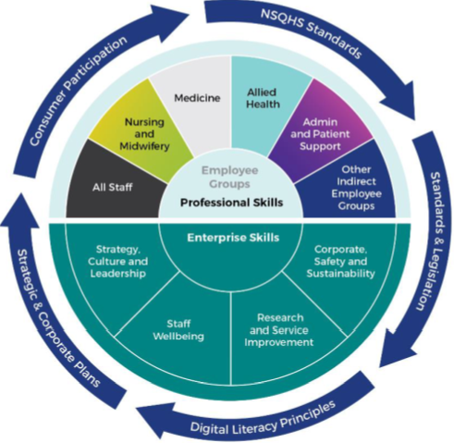
ACT Health and Wellbeing Partnership Board

Attachment 2 – Education and Training Matrix (Mandatory training)

Click here for the full Education and Training Matrix which includes “Required Training” by work group (as of March 2021).

PROGRAM TITLE |  | REQUIRED BY: | REPEAT Frequency | MODE OF DELIVERY | CONTENT SOURCE | DURATION | Additional comments
Definition of All Staff mandatory training:
1. Statutory/Legislative Requirement
2. ACT Government or CHS policy directive and endorsed by the CHS Education and Training Steering Committee
3. Mandatory requirement for all staff of the National Safety & Quality Health Services Standards (NSQHSS)
1 | Orientation and Induction |  | ONCE |  | CHS | VARIABLE | The CHS welcome booklet is a living document provided electronically to staff when they sign their contract of employment. It includes a Welcome statement from the CEO, basic outline and links to the Vision, Role and Values, Strategic and Corporate Plans, Health Services and information about Our People. The booklet also includes an introduction of Professional Conduct, Cultural Diversity and the National Safety and Quality Standards. Mandatory training requirements including timeframes to complete and how to access training, is included. Induction is site and area specific in the form of a checklist to be completed over 6/12 and concludes when probation report is signed off by the manager.
2 | My Role in National Safety and Quality Service Standards |  | ONCE |  | CHS | 10/60 | eLearning explains the key points of the NSQHS standards and describes staff role in application to the day to day work place. Includes clinical governance.
3 | Hand Hygiene |  | ANNUAL |  | Hand Hygiene Australia | 30/60 | External eLearning with link provided in the welcome book. PPE awareness and Pandemic Safety (Social distancing and zoning) to be added as an adjunct course.
4 | Fire and Emergency |  | ANNUAL |  | CHS | 30/60 | eLearning of basic actions and response required in the event of a fire. Further site and area information is identified in the induction checklist and provided by the manager or delegate at local orientation.
5 | Two components: a) Working with Aboriginal and Torres Strait Islander Patient and Clients and b) Cultural Competence and Inclusion |  | ONCE |  | CHS | 60/60 | Consider viewing ACTGOV Learn package "Aboriginal and Torres Strait Islander Awareness" eLearning developed by SBS as additional resource for all staff.
6 | Family Violence |  | ONCE |  | CHS | 50/60 | Additional face to face training for managers
7 | Workplace Health & Safety Fundamentals |  | ONCE |  | CHS | 40/60 | In development - Includes Work, Health and Safety ACT 2011, Manual Tasks Principles, Setting up your workstation, 5S of good housekeeping. Additional face to face training relating to WH&S is required for managers. Face to Face manual tasks training is provided within service areas during induction periods.
8 | Workplace Behaviours |  | ONCE |  | CHS | 30/60 | To be developed - consideration of including the following into one package: Code of conduct, Workplace Behaviour Policy & Procedure, Social Media Usage Policy, Integrity, Fraud, Corruption and Public Interest Disclosure.
9 | Child Protection - level 1 |  | ONCE |  | CHS | 30/60 | Risk assessed as per area of work and interaction with children with Level 2 and 3 required for staff with frequent or primary interaction with children. All staff are required to complete Level 1 training. Consider including reportable conduct.
10 | Personal Safety and Conflict Awareness |  | ONCE |  | MAYBO | 15-30/60 per module | 5 Modules + evaluation provided by MAYBO. Further practical training provided to staff based on risk assessment and area of work.
Total (approximately) 8 hours

Attachment 3 – Induction and Orientation Guide for Agency Workers, Contractors, Locums, Visiting Medical Officers and Volunteers
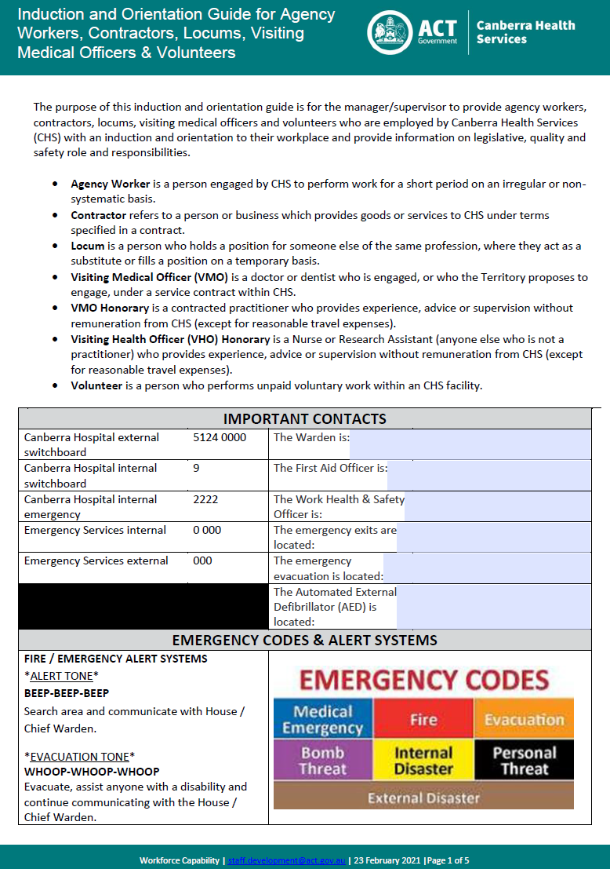
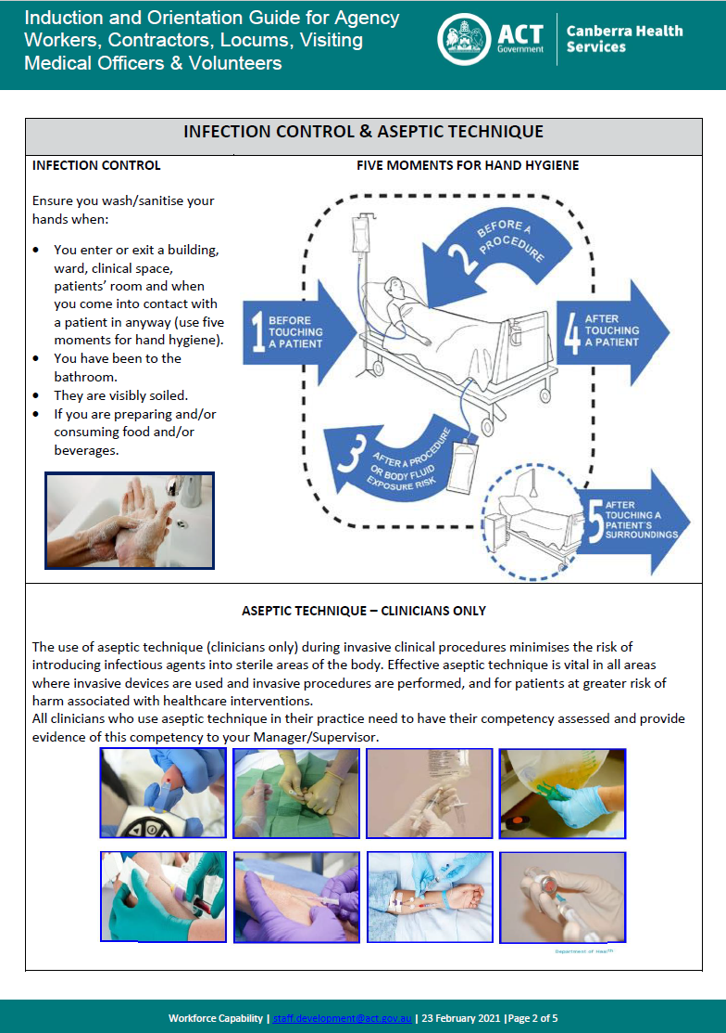

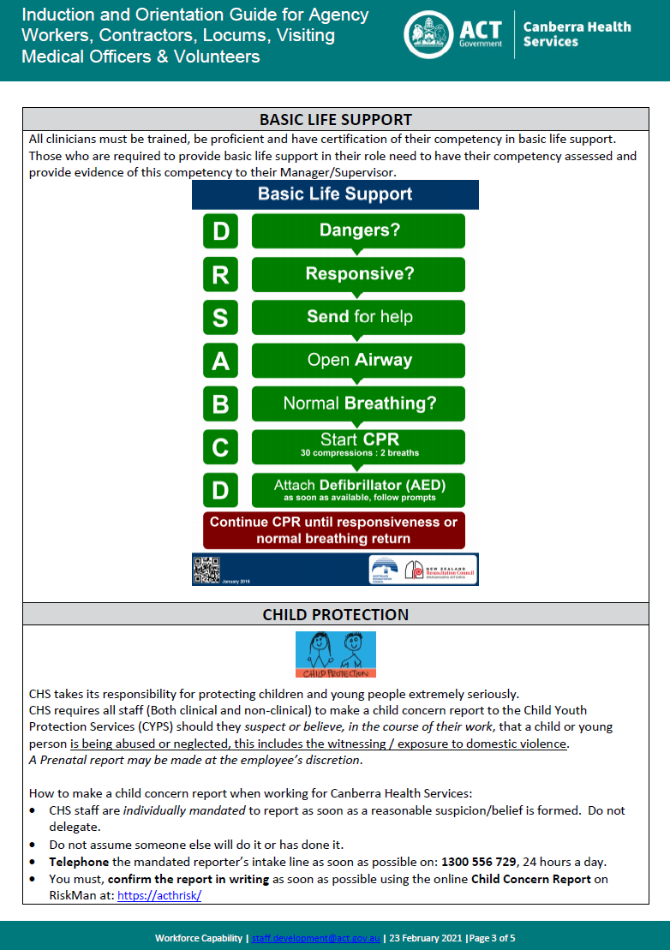
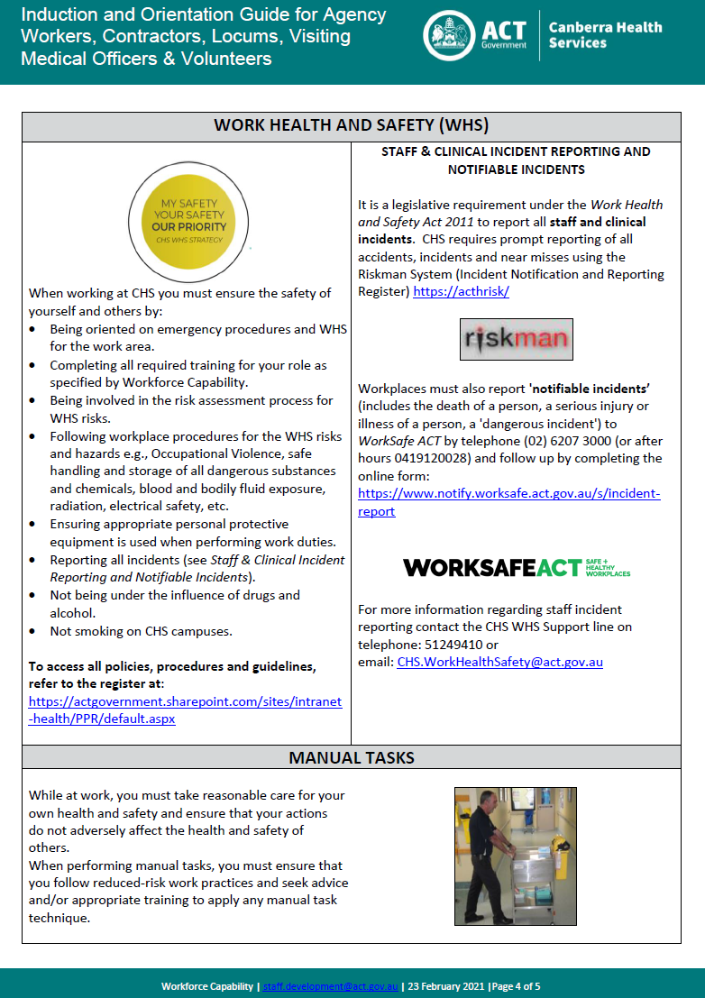
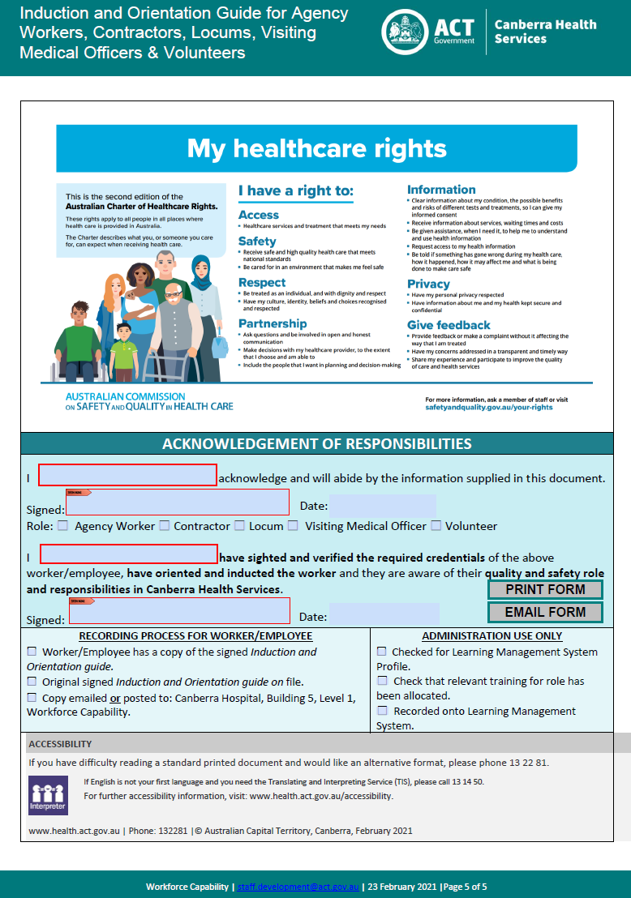

Attachment 4 – Recognition of Prior Learning (RPL) Form

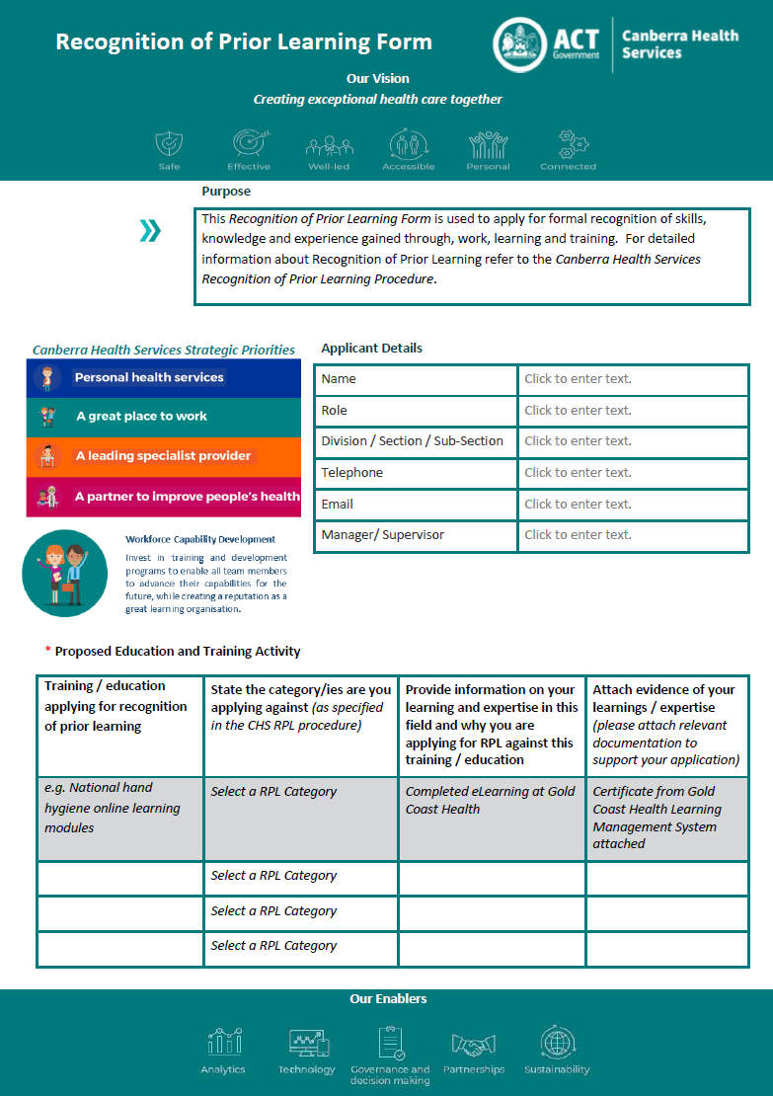

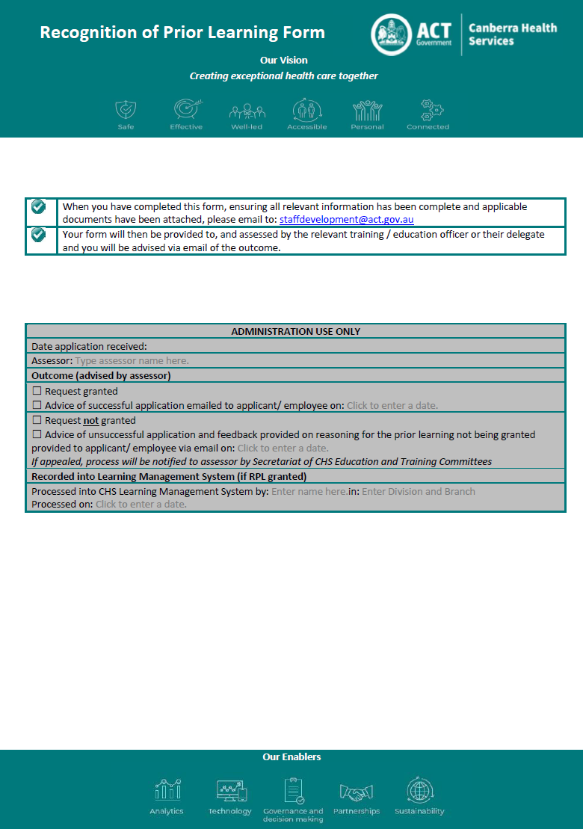

Attachment 5 – Delegation for Education and Training Activities

Definition for those who have delegation for education and training activities are defined and listed in the table below:
Education Type | Situation | Approval type | Delegation responsibilities Sections 220-223
Professional / Personal Development / Education and Training | Approval for training / education professional or personal development | Attendance | Those with identified delegation, as specified in CHS Delegations Manual (People & Culture)
 |  | Financial | Those with financial delegation, as specified in CHS Financial Delegation Guidelines
Programmed Professional Development | Attendance at a pre-arranged (programmed) training / education activity that relates to professional development | Attendance | Those with identified delegation, as specified in CHS Delegations Manual (People & Culture)
 |  | Financial | Those with financial delegation, as specified in CHS Financial Delegation Guidelines
Scholarships | Application / endorsement / attendance / completion / funding of scholarships | Refer to the relevant policy / procedure / guideline relating to scholarship approval requirements | Refer to the relevant policy / procedure / guideline relating to scholarship delegation requirements
Conferences and external education and training activities | Approval for training / education at Conferences | Attendance | Those with identified delegation, as specified in CHS Delegations Manual (People & Culture)
 |  | Financial | Those with financial delegation, as specified in CHS Financial Delegation Guidelines
Studies Assistance | Approval for Studies Assistance | Refer to the studies assistance guideline for information | Refer to the studies assistance guideline for delegation definition
eLearning and /or face-to-face education and training | Approval for education and training attendance and completion via eLearning and /or face-to-face | Attendance | Those with identified delegation, as specified in CHS Delegations Manual (People & Culture)
 |  | Financial | Those with financial delegation, as specified in CHS Financial Delegation Guidelines

Attachment 6 – Workplace Assessor Application
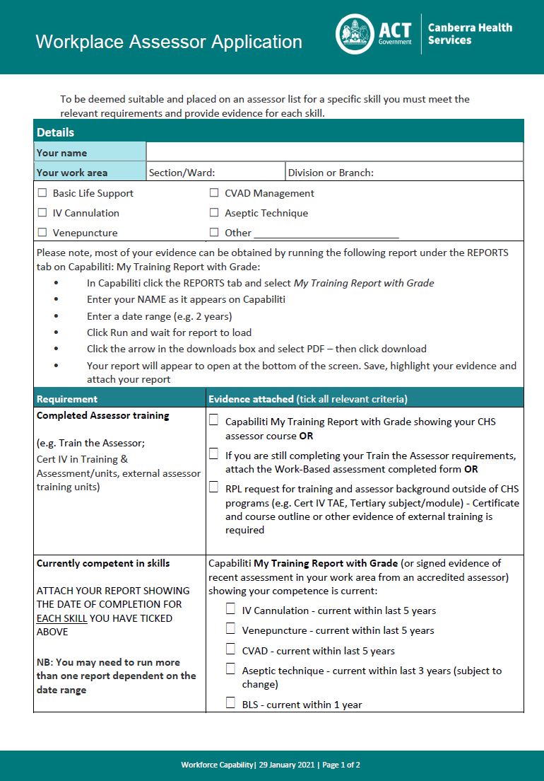
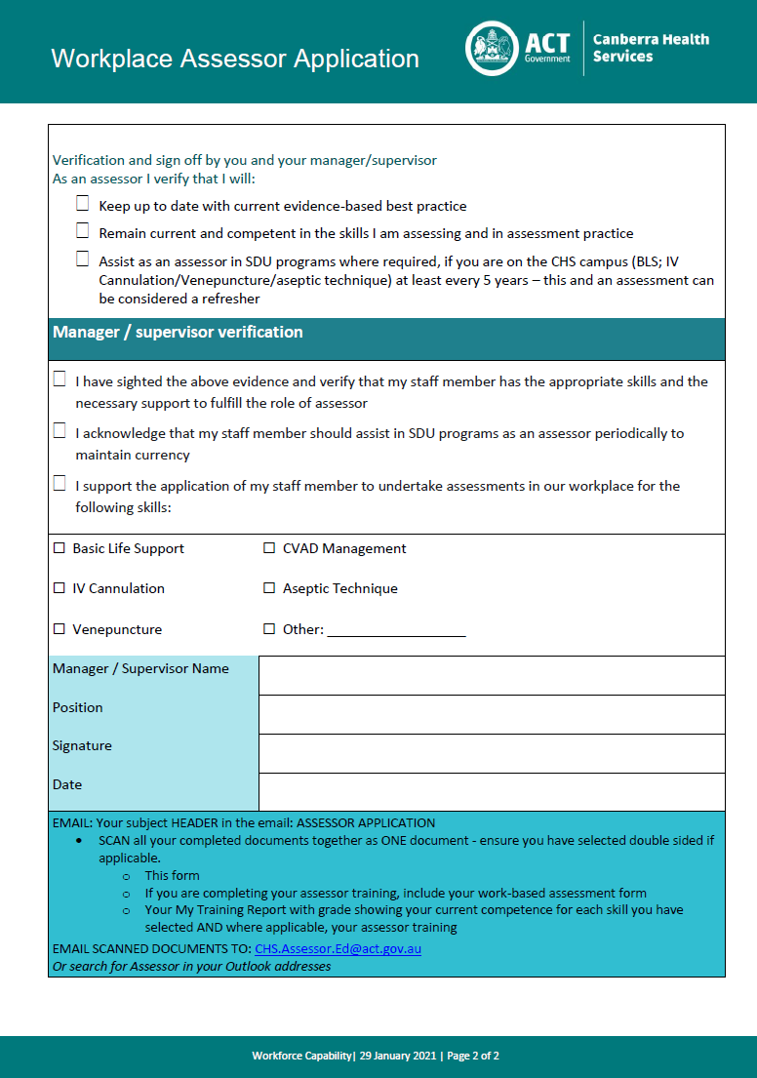

Attachment 7 – Education and Training Request Form
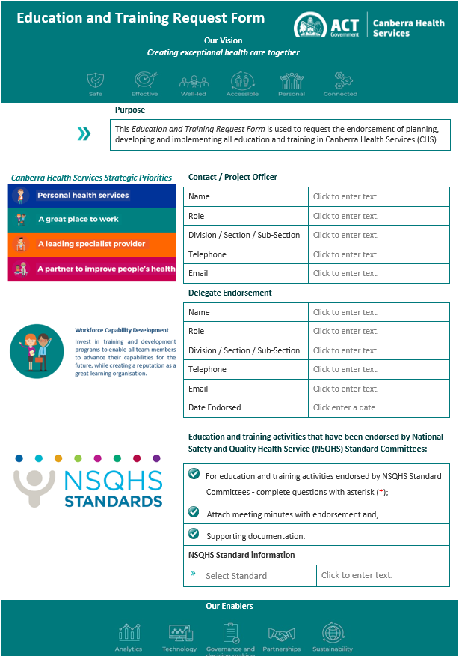
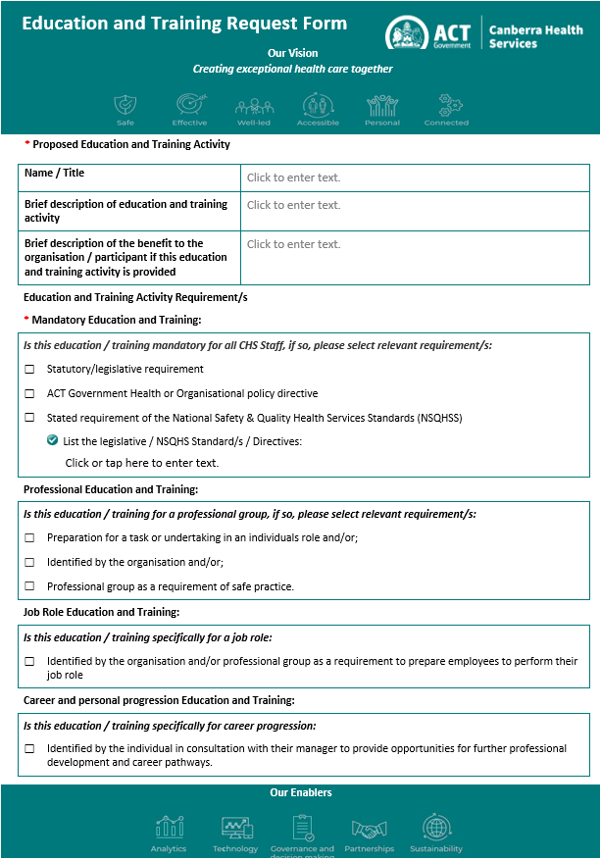
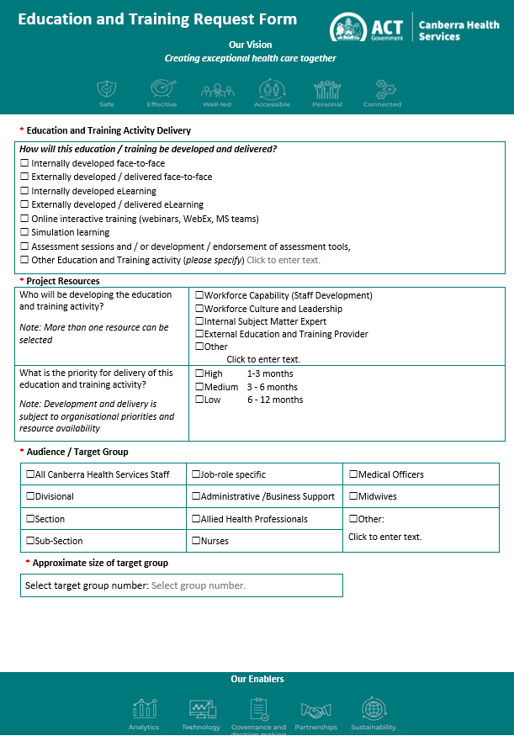
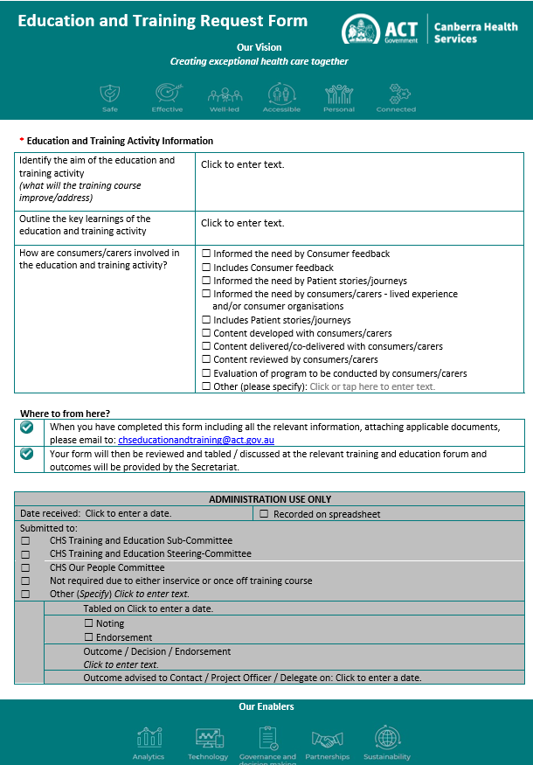

Attachment 8 – Education and Training Sub-Committee Terms of Reference

Purpose
The Education and Training Sub-Committee will provide advice and guidance relating to education and training in Canberra Health Services (CHS). The Sub-Committee will report to the Education and Training Steering Committee, who will consider proposals and make decisions related to education and training for CHS.

Accountability
The Education and Training Sub-Committee is accountable to the Education and Training Steering Committee via the Our People Committee, and indirectly to the CHS Education and Research Advisory Committee.

The Education and Training Sub-Committee will report through other governance channels as required, including but not limited to:
- the ACT Health and Wellbeing Partnership Board; and
- the ACT Health and Wellbeing Workforce Education and Training Working Group
- National Safety and Quality in Health Services Standards Committees.

Objectives
The objectives of the Education and Training Sub-Committee is to:
- provide advice, guidance and governance related to all education and training across CHS through education policy and processes;
- research and provide advice and assistance about CHS training and education, including recommendations from quality and safety committees;
- review and identify opportunities to reduce duplication and improve coordination in education and training;
- provide advice to link application of research into clinical practice and identify the educational approach;
- identify opportunities to increase collaborative, interprofessional education between teams across CHS;
- ensure consumers views and inputs are included in the development and delivery of workforce training;
- improve organisational reporting and evaluation of the education and training provided;
- provide advice about access to training to meet the Territory-wide Education and Training Framework;
- research and provide advice regarding visibility of education and training provided;
- receive and review discussion papers, proposals, reports and other material as required and;
- provide advice and guidance for other matters that may be required by the Sub-Committee.

Membership
Member | Position
Member / Chair | Director, Workforce Capability, People and Culture
Member / Deputy Chair | Allied Health Clinical Education Coordinator
Member | Allied Health Division
Member | Cancer & Ambulatory Support
Member | Critical Care
Member | Finance & Business Intelligence
Member | Infrastructure & Health Support Services
Member | Medicine
Member | Mental Health, Justice Health, Alcohol & Drug Services
Member | Nursing & Midwifery
Member | Pathology
Member | Patient Support Services
Member | Workforce Culture and Leadership
Member | Quality, Safety, Innovation & Improvement
Member | Rehabilitation, Aged and Community Services
Member | Surgery
Member | Women, Youth & Children
Member | Intensive Care Unit
Delegate | Communications

Chair
The Sub-Committee will be chaired initially by the Director, Workforce Capability, People and Culture. Rotating Chair options will be available every 6 months.
Deputy Chair will be the Allied Health Clinical Education Coordinator.

Member responsibilities
Commitment to the purpose and objectives of the Sub-Committee..

Secretariat
To be provided by the Learning and Development Manager, Workforce Capability.

Additional officers
Additional officers may be co-opted at the discretion of the Chair/Deputy Chair to provide specific expertise depending on the nature of the matter under consideration.

Operating Procedures
Quorum
Minimum of 6 people for decision including Chair and/or Deputy Chair.

Meeting Frequency and duration
The Sub-Committee will meet each month for a minimum of 1 hour or more often by exception.
The agenda, relevant papers and documents will be provided to members in advance of each meeting.

Minutes will be kept of each meeting and submitted to members for endorsement at the next meeting.

Conflict of Interest
Members are required to declare any actual or perceived conflict of interest in any agenda item at the commencement of each meeting. The Chair has the authority to request members to withdraw from discussion as they deem necessary.

Out of session papers and endorsement
The Secretariat may distribute out of session papers for consideration and endorsement by members via electronic communication.

Terms Of Reference Review
Terms of Reference are reviewed annually.

Endorsed 29 October 2020

Attachment 9 – Request to Access CHS Training and Education
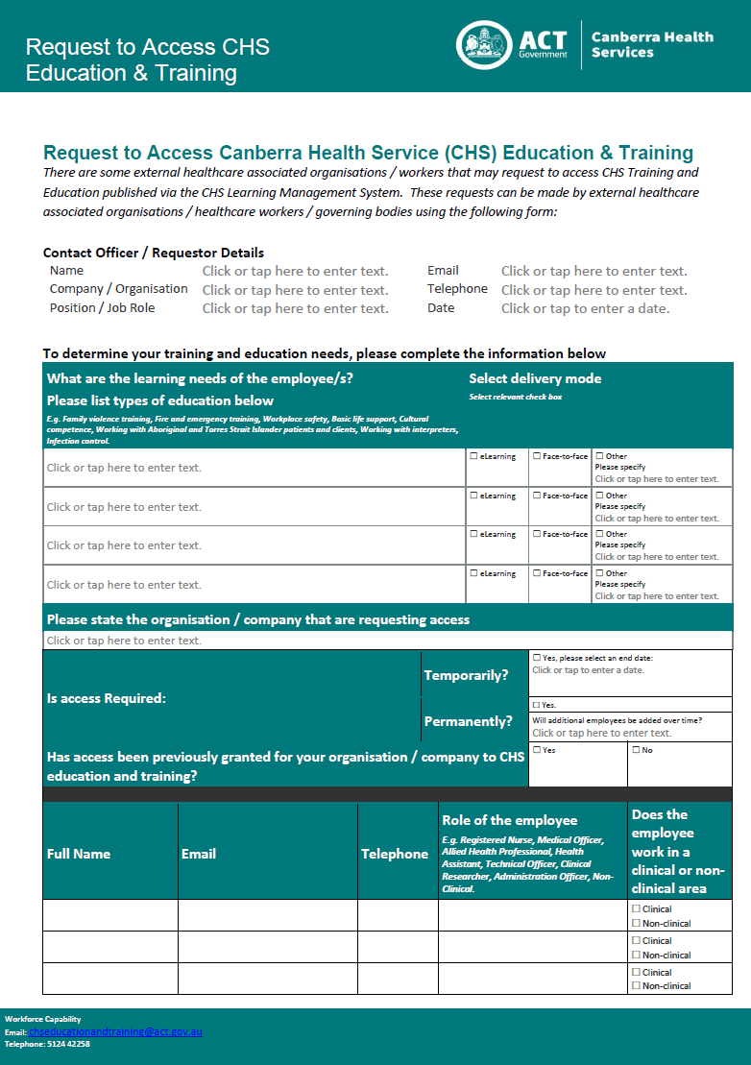
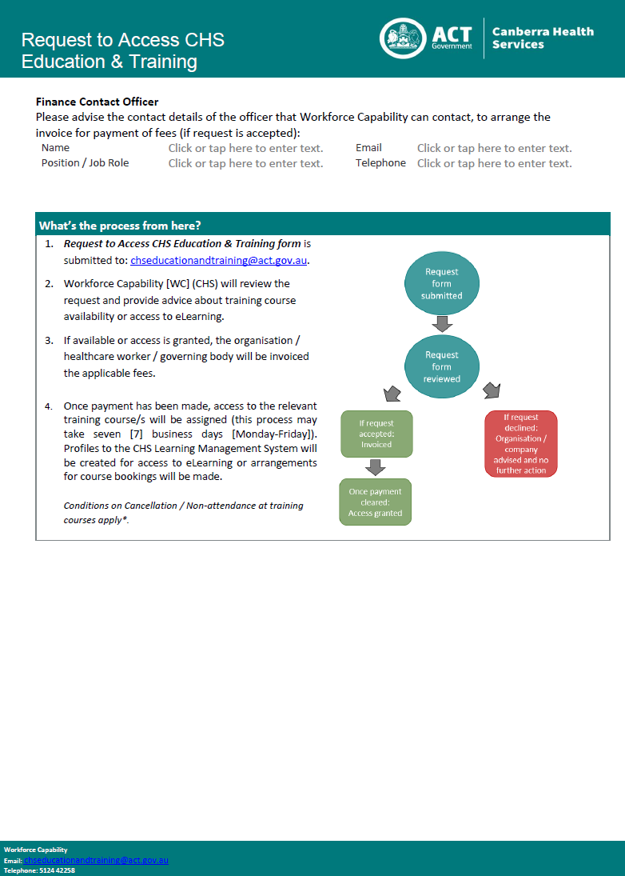

Attachment 10 – Education and Training Course Evaluation Guide

