Canberra Health Services

Guide to Managing and Investigating Potential Breaches of the Australian Code for the Responsible Conduct of Research
CHS26/042

Purpose
Canberra Health Services (CHS) has adopted the National Health and Medical Research Council’s (NHMRC) Guide to Managing and Investigating Potential Breaches of the Australian Code for the Responsible Conduct of Research 2018 (the NHMRC Guide).
The NHMRC Guide establishes the national framework for ensuring integrity, quality, and accountability in the conduct of research in Australia. It sets out principles and responsibilities that guide researchers and institutions in promoting honest, ethical, and rigorous research practices, preventing and addressing breaches of research integrity, and maintaining public trust in the research process. The NHMRC Guide provides a consistent standard for the responsible management, review, and reporting of research across all disciplines and institutions.

Scope
The NHMRC Guide applies to all CHS staff employed in the ACT Public Sector (ACTPS) under the Public Sector Management Act 1994 (PSM Act), and to board and committee members, contractors, volunteers, honorary staff and consultants.
CHS includes the inpatient and outpatient facilities at Canberra Hospital, Clare Holland House, North Canberra Hospital, University of Canberra and community-based services.
The NHMRC Guide only applies in contexts where research related work is being undertaken and should be read in conjunction with the following:
- ACT Public Sector (ACTPS) Code of Conduct (available at https://www.cmtedd.act.gov.au/__data/assets/pdf_file/0018/2004921/ACTPS-Code-of-Conduct-2022.pdf)
- ACTPS Enterprise Agreements (available at https://www.cmtedd.act.gov.au/employment-framework/for-employees/agreements
- relevant ACTPS and CHS misconduct and conflict of interest policies where appropriate (available on the Policy and Guidance Documents Register and at https://www.cmtedd.act.gov.au/employment-framework/for-employees/a-z).
- the Australian Code for the Responsible Conduct of Research (the Code), available at https://www.nhmrc.gov.au/about-us/publications/australian-code-responsible-conduct-research-2018
Concerns or complaints unrelated to research are out of scope of this procedure and will be referred to the relevant CHS processes for resolution.
The NHMRC Guide is designed for universities and research institutions. Attachment A maps its roles, officers, and committees to equivalent positions within CHS. Attachment B includes the NHMRC Guide’s process overview and Attachments C, D E and F include the checklists provided in the guide.

The NHMRC Guide and ACT Employment Framework
The NHMRC guide services as CHS’ policy for managing research misconduct. While most matters are addressed under this framework, some cases may also require different action under the ACTPS employment framework. The following steps outline how CHS ensures compliance with both.

Preliminary assessment definition
Under the NHMRC guide, a preliminary assessment is a fact-finding process to determine whether a potential breach of the Code warrants investigation. It is not disciplinary and does not make findings of misconduct. In contrast, under the employment framework, a preliminary assessment is an employment-related process that considers whether an employee may have engaged in misconduct under the CHS and ACTPS frameworks, which is governed by the PSM Act, Public Sector Standards 2016, and relevant enterprise agreements. While the NHMRC process focuses on research integrity and the ACTPS process on employment obligations, both serve the same purpose, which is an initial, objective fact-gathering step to determine next actions. To ensure compliance, assessors should inform the employee that the preliminary assessment is being undertaken under both frameworks.

When to commence an employment framework misconduct investigation
The decision to initiate an employment misconduct investigation during a research misconduct process depends on the facts of each case. To ensure that employees are afforded procedural fairness and that decisions are made by appropriately delegated decision-makers, referral to People and Culture may occur at three points:
- Upon receipt of the complaint, where an example of serious misconduct is evident (e.g., a clear example of fraud relating to grant funding).
- Following the conclusion of the fact-finding (preliminary assessment) stage if evidence suggests potential misconduct under employment provisions.
- Following completion of a formal research misconduct investigation, where findings substantiate behaviour that may constitute misconduct.
This approach ensures alignment between research integrity obligations and employment frameworks, avoiding duplication of processes, and ensuring that both research and employment responsibilities are managed consistently and transparently.

Which areas in Canberra Health Services can I contact for further information?

Office of Education, Research and Academic Partnerships
For any further information or support regarding all research misconduct matters, please contact Office of Research and Education Team:
- Phone: 5124 7135
- Email: CHS.ORE@act.gov.au

People & Culture
For any further information or support regarding matters that may constitute misconduct under the employment framework, or interpretation of Enterprise Agreement provisions, please contact the HR Advisory Team:
- Phone: 5124 9610
- Email: CHS.HRAdvisory@act.gov.au

How can I access the document?
The National Health and Medical Research Council Guide can be found on the NHMRC website at:
https://www.nhmrc.gov.au/sites/default/files/documents/reports/guide-managing-investigating-potential-breaches.pdf

Search terms
Ethics, Workplace Behaviour, Misconduct, ACTPS Values, CHS Values, Impartiality, Accountability, Responsiveness, Reasonable Care, Procedural Fairness, Research, Integrity, Employment Framework, Investigation, north.

For Policy Team to complete:
Date amended | Section amended | Divisional approval | Final approval
24 February 2026 | New document | Professor Imogen Mitchell, Executive Director of Education, Research and Academic Partnerships | Jacqui Clissold, co-chair, Policy Document Review Panel
This document supersedes the following:
Document number | Document name

Disclaimer
This document has been developed by Canberra Health Services specifically for its own use. Use of this document and any reliance on the information contained therein by any third party is at his or her own risk and Canberra Health Services assumes no responsibility whatsoever.
Acknowledgement of Country  Canberra Health Services acknowledges the Ngunnawal people as traditional custodians of the ACT and recognises any other people or families with connection to the lands of the ACT and region. We acknowledge and respect their continuing culture and contribution to the life of this region.  © Australian Capital Territory, Canberra 2024 | Accessibility  call (02) 5124 0000   Interpreter call 131 450  canberrahealthservices.act.gov.au/accessibility  

Attachment A – Roles and Responsibilities
Table 1 - CHS designated officers and committees in accordance with the Guide
Role Term used in the Guide | Responsibility | CHS Role
Responsible Executive Officer (REO) | • A senior officer in the organisation who has final responsibility for receiving reports of the outcomes of processes of assessment or investigation of potential or found breaches of the Guide and deciding on the course of action to be taken. | Chief Executive Officer
Designated Officer (DO) | • A senior professional or academic institutional officer or officers appointed to receive complaints about the conduct of research and potential breaches of the Guide and or research misconduct and oversees their management and investigation, where required. | The Executive Director, Education, Research and Academic Partnerships
Research Integrity Committee (RIC) | • Committee to assist DO in guiding the investigation and management process. | Human research: The DO, Chair ACT Health and Community Services Directorate HREC and Director, ROCT.  Animal research: The DO, Chair ANU AEC and Director, ROCT.
Research Integrity Office (RIO) | • Manages all administrative matters associated with the CHS Research Integrity matters. | Part of the CHS Office of Research and Education.
Research Integrity Officer | • A Senior Officer in the Office of Research and Education – assigned the Research Integrity Officer responsibilities as part of their role.  • Manages all administrative matters associated with the CHS Research Integrity Office. | Senior Director Research Strategy and Capability -
Assessment Officer (AO) | • Officer appointed by the RIC to conduct a Preliminary Assessment of a complaint about research. | A Senior Officer - usually from Office of Research and Education, Research Integrity Office
Research Integrity Advisor (RIA) | A person or persons with knowledge of the Guide and institutional processes nominated by CHS Research Integrity Office to promote the responsible conduct of research and provide advice to those with concerns or complaints about potential breaches of the Guide. The RIA’s role does not extend to investigation or assessment of the complaint. | Appointed CHS staff member/s with research integrity experience and training.
Review Officer (RO) | • A senior officer responsible for receiving requests for a procedural review of an investigation of a breach of the Guide. | A Senior Officer member not fulfilling any of the roles described above.
Line Managers and People and Culture Representatives are to participate in the process as required.

Conflict of interest management:
If the specified CHS role delegates have a perceived conflict of interest (for example, if the complaint concerns a member of his/her laboratory or research program) or if s/he is unavailable, then another suitable member of the respective executive or team will act in the position, for example as the DO, Research Integrity Committee member or CHS Research Integrity Officer.

Attachment B– NHMRC Guide Overview
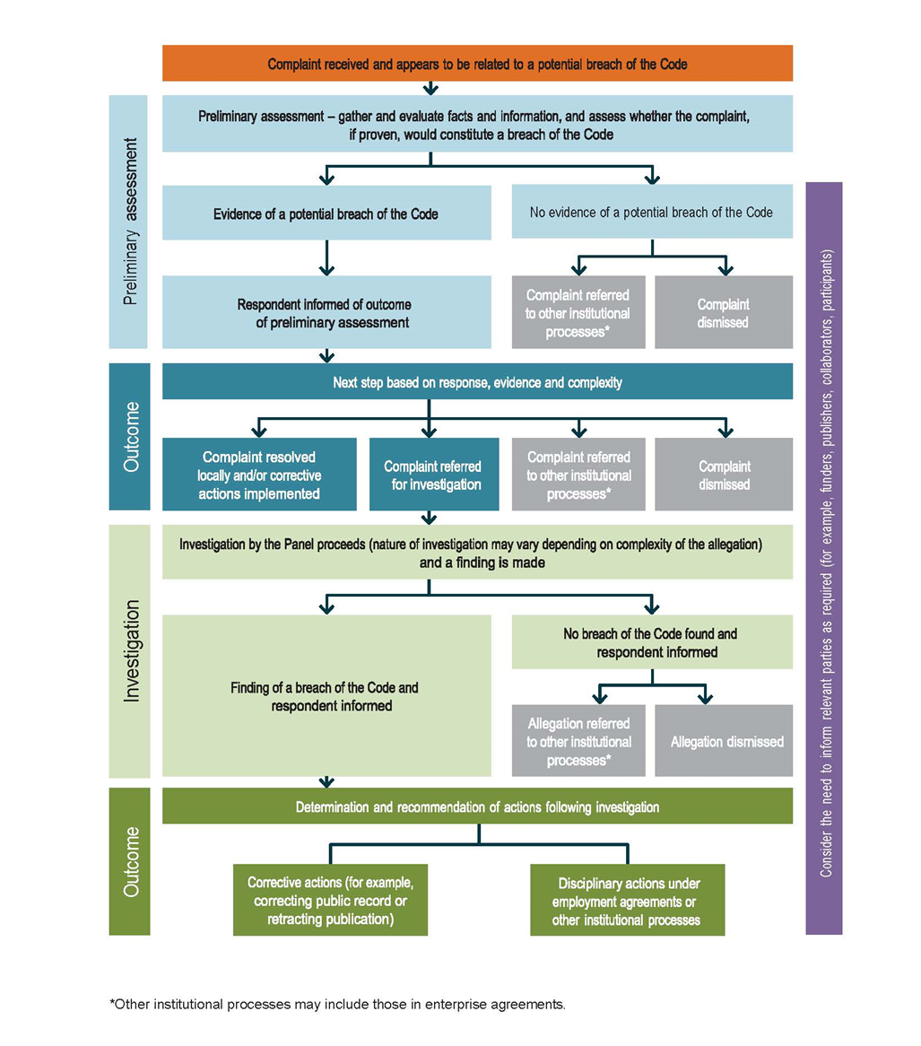
Source: National Health and Medical Research Council, Australian Research Council and Universities Australia. NHMRC Guide to Managing and Investigating Potential Breaches of the Australian Code for the Responsible Conduct of Research 2018. Commonwealth of Australia, Canberra.

Attachment C – NHMRC Guide: Checklist for Preliminary Assessment
 DO assigns the complaint to a suitable AO.
Prepare and retain records of the preliminary assessment.
Obtain information provided by the complainant and seek further facts and information as required.
Gather and secure facts and information.
Clarify facts and/or information with the respondent if appropriate.
Obtain facts, information and/or advice from across the institution if required.
Determine if and how other institutions need to be involved in the matter.
Written advice provided to DO that includes:
  - a summary of the process that was undertaken
  - an inventory of the facts and information that were gathered and analysed
  - an evaluation of facts and information
  - how the potential breach relates to the principles and responsibilities of the Code and/or institutional processes
  - recommendations for further action.
Assess all facts and information to determine outcome, i.e., complaint is to be
  - dismissed
  - resolved locally
  - referred for investigation
  - referred to other institutional processes.
Outcome of preliminary assessment advised to the complainant, respondent and other relevant parties such as funding bodies, as appropriate.
Source: National Health and Medical Research Council, Australian Research Council and Universities Australia. NHMRC Guide to Managing and Investigating Potential Breaches of the Australian Code for the Responsible Conduct of Research 2018. Commonwealth of Australia, Canberra.

Attachment D – NHMRC Guide: Checklist for Terms of Reference for Investigation Panel
The terms of reference for the Panel may include the following:
The date the complaint was received, the name of the complainant (where appropriate), a brief description of the matter.
The name of the respondent and a list of the specific allegations.
 A statement that the Panel is duly constituted in accordance with the institution’s processes for investigating potential breaches of the Code.
List of the Panel members.
A detailed outline of the scope and purpose of the Panel, which may include the following:
  - to investigate the matter
  - to ensure that procedural fairness is afforded at all stages in the process to all involved
  - where possible, to maintain the confidentiality of all persons involved
  - to consider the protection of all involved
  - to review the allegations
  - to review the responses to the allegations provided by the respondent
  - to review the preliminary assessment report (including any external expert advice)
  - to identify and gather any other relevant evidence
  - to interview the relevant parties
  - to consider the evidence in the context of the principles and responsibilities of the Code
  - to make findings in accordance with this Guide
  - to provide a report to the DO in a timely manner.
A statement about the secretariat support to be provided by the institution (for example, RIO).
An indicative timetable for the conduct of the investigation.
Source: National Health and Medical Research Council, Australian Research Council and Universities Australia. NHMRC Guide to Managing and Investigating Potential Breaches of the Australian Code for the Responsible Conduct of Research 2018. Commonwealth of Australia, Canberra.

Attachment E – NHMRC Guide: Checklist for Investigation Procedure
Develop terms of reference and scope for the Panel that are appropriate and proportionate to the nature of the allegation (see Attachment D.)
Determine size and composition of the Panel.
Establish provision of secretariat support.
Where the allegation involves outside parties determine whether the involvement of other institutions, or of their staff, is necessary and, if so, whether an agreement needs to be established setting out the scope of their involvement.
Inform the relevant institutional office (for example, Executive, Human Resources, Higher Degree Research or equivalent) of the investigation as required.
Advise the respondent (and possibly the complainant) on the composition of the Panel and provide opportunity to raise valid concerns.
Establish the Panel.
Provide the Panel with an opportunity to comment on the terms of reference and scope.
Provide respondent opportunity to respond to allegation and inform them about the conduct of the investigation, including the role of a support person and the circumstances under which legal representation would be allowed.
Notify those required to attend the investigation.
Provide guidance on the appropriate procedures for the investigation to the Panel, such as the NHMRC Guide, the Code and any relevant government or institutional processes. This may also include definitions of a breach of the Code and, if relevant, research misconduct (according to the institution’s processes).
Provide the Panel with all available information that will inform the investigation, which may include:
  - the initial complaint
  - all relevant information assembled by the AO
  - records of the conduct of the preliminary assessment
  - the report of the preliminary assessment
  - records of any communications on the matter involving the DO, the AO, the complainant and/or the respondent.
Ensure that the Panel has the authority to access all relevant information and documentation
Support the Panel to develop an investigation plan that includes the following:
  - identification of the avenues of inquiry, including interviewing people who the Panel considers relevant to the matter
  - the frequency of Panel meetings
  - the timeline for conducting interviews
  - the timeframe for submitting draft report to respondent
  - the timeframe for submitting the report to the DO.
Inform the Panel of the reporting requirements (Attachment F).
Source: National Health and Medical Research Council, Australian Research Council and Universities Australia. NHMRC Guide to Managing and Investigating Potential Breaches of the Australian Code for the Responsible Conduct of Research 2018. Commonwealth of Australia, Canberra.

Attachment F – NHMRC guide: Checklist for Reporting the Findings of the Investigation
The Panel should formulate a comprehensive report that includes the following:
 The names and affiliations of the Panel members
The name of the respondent
A summary of all relevant research projects, including project summary, duration and funding
The specific allegations considered
The terms of reference of the Panel
A description of the processes that were followed
 A description of the evidence considered, including the documents and other information and the names of all persons interviewed
Summaries of the interviews conducted
The findings of fact that have been reached
A conclusion as to whether or not a breach of the Code occurred and whether or not the respondent is responsible for the breach
Identification of any systemic issues that were contributing factors
A recommendation about the seriousness of any breach
Any recommendations (for example, for corrective action), where appropriate and consistent with the terms of reference
Any recommendations about other institutions/organisations that should be advised of the outcome (for example, funders, external stakeholders).
Source: National Health and Medical Research Council, Australian Research Council and Universities Australia. NHMRC Guide to Managing and Investigating Potential Breaches of the Australian Code for the Responsible Conduct of Research 2018. Commonwealth of Australia, Canberra.

