Canberra Health Services
Guideline
Silver fluoride for children and adults

Contents
Contents 1
Guideline Statement 2
Background 2
Key Objective 2
Scope 2
Section 1 – Clinical considerations 2
Section 2 – Patient information 4
Section 3 – Instructions for use 4
Section 4 – Application frequency 6
Section 5 – Adverse reactions 7
Evaluation 7
Related Policies, Procedures, Guidelines and Legislation 7
References 8
Definition of Terms 8
Search Terms 9
Attachments 9
Attachment 1: Before and after silver fluoride application images: 10
Attachment 2 - Instructions for Use: CSDS (Silver fluoride) 11
Attachment 3 - Instructions for Use: Riva Star (Silver Diamine Fluoride) 12
Attachment 4 - American Dental Association Caries Classification System 14

Guideline Statement

Background
Silver Fluoride (AgF) and Silver Diamine Fluoride (SDF) can arrest dental caries and prevent progression. It can be an appropriate alternative for patients where traditional restorative regimes are not suitable due to limited compliance from the patient. It is a quick, minimally invasive procedure that requires no operative intervention (removal of affected or infected dentine) to achieve caries arrest.

AgF and SDF are both approved for use in Australia by the Therapeutic Goods Administration (TGA).
- AgF (CSDS®) - Carious Status Disclosing Solution - dental caries detecting stain - ARTG ID 230364
- SDF (Riva Star®) - ARTG ID 201267
- SDF (Riva Star Aqua) – ARTG ID 403254

Key Objective
The purpose of this guideline is to provide dental practitioners with evidence-based information on the benefits of silver fluoride when used to reduce sensitivity and arrest carious lesions on the teeth of children and adults. This guideline will help ensure a consistent approach to treatment recommendations and material selection amongst clinicians.

Back to Table of Contents

Scope

The Clinical Guideline – Silver fluoride for children and adults applies to all dental practitioners (dentists, dental therapists, and oral health therapists), and dental assistants, who examine and treat children and adults accessing Oral Health Services.

Back to Table of Contents

Section 1 – Clinical considerations

Indications for use:
- Case selection is similar to the Hall Technique for stainless steel crowns (SCC) case selection. Caries must be confined to dentine with no pulpal involvement or pathology (clinically or radiographically*).
- High caries-risk patients with anterior** or posterior active cavitated lesions.
- Patients with multiple cavitated caries lesions that may not all be treated in one visit. Note: A maximum of five lesions/cavities per visit is recommended for child under 10kgs (approx. 1yo child).
- Active cavitated carious lesions with International Caries Detection and Assessment System (ICDAS) of 4-6 (see attachment 4).
- Cavitated carious lesions in individuals who have minimal compliance for dental procedures.
- Non cavitated lesions where good access can be gained to proximal lesions on posterior teeth.
- Carious deciduous second molars (E’s) when permanent first molars (6’s) have not yet erupted (to avoid SSC placement and potential impaction).
- Root caries.
- Symptomatic molar incisor hypomineralisation**.
- Patients without access to, or with difficulty, accessing dental care.
- Currently has TGA approval as a desensitising agent (only for silver diamine fluoride Riva Star) – inform patient/parent of this and explain that arresting of caries as a by-product.

* AgF should not be considered if carious lesion/s are identified within 0.5mm of pulp tissue, and SDF should not be considered for use if carious lesion/s are identified within one (1) mm of pulp tissue (e.g., a half millimetre or a one millimetre respectively bridge of unaffected dentine should be observed radiographically between pulp and caries).

** In most cases AgF/SDF should not be used on anterior D1 and D2 lesions (see attachment 4) on permanent teeth or hypomineralisation because of aesthetic staining issues, where aesthetics are an issue.

Contraindications for use:
- Patients undergoing thyroid gland therapy (taking Thyroxine) when using potassium iodine (ingredient in Riva Star).
- History of chemical/metal allergies – tin, silver, potassium, iodine, ammonia, methacrylates.
- Active cavitated caries lesions with clinical signs of pain or pulpal involvement, or pulpal pathology.
- Lesions in anterior teeth where aesthetics are important.
- Inability to achieve isolation due to patient compliance.
- Do not use if carious lesion is in close proximity to pulp (0.5mm - 1mm band of sound dentine should be seen radiographically when using AGF and SDF respectively).

Other clinical considerations regarding use:
- Radiographs (bitewings) are preferable/recommended prior to use of AgF or SDF.
- Where possible, clinicians should consider covering arrested areas with a glass ionomer cement (GIC) at a future appointment when either product is used.
- Do not place intermediate restorative material (IRM) or Zinc Oxide Eugenol over a tooth treated with AgF (it inhibits the formation of a ‘black callus’ (arrested dentine) and the tooth/teeth may continue the caries process).
- If a carious lesion is 1 mm in proximity to pulp tissue, clinicians should consider using 40% AgF/10% SnF2 (pH ~6) as opposed to 38% SDF/KI (pH ~10-13).
- Treating children less than 10 kg in weight: A maximum of one drop each visit is recommended.
- AgF or SDF use on Permanent Teeth: Clinicians are requested to discuss with the Senior Clinician or Clinical Director prior to use of either AgF of SDF on any permanent tooth/teeth.

Back to Table of Contents

Section 2 – Patient information

Discuss with the patient/parent/guardian:
- Currently has TGA approval as a desensitising agent (only for silver diamine fluoride Riva Star) – inform patient/parent of this and explain that arresting of caries as a by-product.
- The benefits of the AgF or SDF (atraumatic process, provides effective caries arrest and is well tolerated etc).
- Parents must be warned that carious lesions treated with AgF or SDF will turn black, and there is a risk of staining of skin and clothes.
- Periodic review and reapplication, if required, of AgF or SDF for disease control is recommended in instances where restoration is not possible.

Note: ensure that relevant discussions with the patient/parent/guardian on the benefits and risks are noted within the patient’s clinical record. This includes the risk of a transient burn (SDF) as this has a pH 10-13 (contains ammonia – very alkaline) as opposed to AgF which has a pH of 6.3 (water based).

Back to Table of Contents

Section 3 – Instructions for use

Silver Fluoride – CSDS Two Step (AgF + SnF2):
- Obtain consent prior to application of 40% AgF - 10% SnF2 from the parent or guardian and document in the patient’s clinical record.
- Bitewing radiographs should be taken where possible. If it is not possible consideration can be given to intra-oral photography.
- Removal of debris or food remnants only. No operative intervention (e.g., affected or infected dentine removal) is necessary or advised to achieve caries arrest.
- Application of a soft tissue barrier to lips and surrounding skin is recommended (e.g., Vaseline, Cocoa butter etc.)
- Dry and isolate tooth with cotton rolls.
- Apply Part A: 40% AgF (silver fluoride) with microbrush, wait at least 1 minute, 3 minutes is ideal.
- Apply Part B: 10% SnF2 (stannous fluoride) with separate microbrush, wait until colour change is observed. Blot with cotton pellet to remove excess.
  - NB – Part B is clear until it touches the area where Part A was applied. It quickly becomes dark, resembling soy sauce. Take care not to stain surrounding tissues (if this occurs, advised patients it may take 1-2 weeks for stain to subside on any tissue/surface other than the carious lesion)
- Cover the treated site with a smear of Orabase Protective Paste or Duraphat.
- Provide post-op instructions (POIG), for example: no food or drinks for 60 min, and document in your notes.
- Mop up the remaining solution in each dappen dish with the end of a cotton wool roll. Wrap used microbrushes and dappen dishes in a paper towel or a used glove and dispose of it carefully.
- Review the treated site in 3 weeks. If the surface of the lesion remains black, it is a sign of caries arrest.
- A restorative material (GIC) can be now placed if determined appropriate.
- The tooth/teeth can be topped up with additional AgF/SnF2 every 3-6 months if required.
- Patients may brush with fluoridated toothpaste as per regular routine following AgF or SnF2 application.

Riva Star Step 1 (SDF) & Riva Star Step 2 (KI):
(More compliant patients)
- Obtain consent prior to application of 38% SDF-KI from the parent or guardian and document in the patient’s clinical record.
- Bitewing radiographs should be taken where possible. If it is not possible consideration can be given to intra-oral photography.
- Prepare the tooth/teeth:
  - Tooth preparation is not required if using SDF to arrest decay and not proceeding with immediate restoration. Removal of debris or food remnants only. No operative intervention (e.g., affected or infected dentine removal) is necessary to achieve caries arrest.
  - Tooth preparation is required when a restoration is to be placed at the time of SDF appointment. Do not use with resin based composite materials on the same day.
- Application of a soft tissue barrier is required (e.g., Vaseline, Cocoa butter etc).
- Dry and isolate tooth with cotton rolls or other suitable isolation material (NeoDRY’s, Garmer’s clamps, gauze).
- If tooth was prepared, apply etch (34-37% phosphoric acid) for 5 seconds then wash and air dry. Not recommended in anxious/restless patients (avoid this step in paediatric patients particularly where compliance issues exist).
Do not dispense solution from grey label bottle or green label bottle until ready to use.
- Dispense one (1) drop of the step 1 solution (grey label) into a dappen dish.
- Carefully apply solution to treatment site using a medium sized micro brush.
- Immediately after, and only if wanting to restore a permanent tooth right away, dispense two (2) drops of the step 2 solution (green label) into a fresh dappen dish. Apply a generous amount of the solution to treatment site using a medium sized micro brush.
- Apply the same solution to any other tooth surfaces that may have come into contact with the solution from the grey bottle. Note: Treatment surface initially appears creamy white, keep applying Riva Star Step 2 solution (green label) until it turns clear.
- Wash thoroughly with water for at least 10 seconds and air dry. Note: Do not desiccate surface if a self-cure glass ionomer cement is to be used.
- Remove all protective/isolation materials used in the mouth.
- Note: One (1) drop of Riva Star Step 1 and two (2) drops of Riva Star Step 2 can treat up to 5 teeth per patient. Limit of one (1) drop of Riva Star Step 1 and two (2) drops of Riva Star Step 2 drops per visit. If needed (for additional teeth or if no black colour change observed at review) a second application of Riva Star may be administered after 1 week.
- Provide post-op instructions (for better results, no eating or drinking for 30-60 minutes). Document the POIG in your notes.
- A restoration (GIC/SSC) can be placed if determined appropriate and as compliance allows.
- The tooth/teeth can be topped up with additional SDF every 6 months if required.
- Patients may brush with fluoridated toothpaste as per regular routine following SDF application.
- IMPORTANT : Ensure that both Step 1 and Step 2 bottle surfaces (E.g., tip, neck, thread and inside the cap) are wiped thoroughly with an absorbent paper towel to remove any excess solution and prevent build-up of dried material.

Back to Table of Contents

Section 4 – Application frequency

- Depending on the size of the lesion and the location of the tooth and the lesion, the effectiveness of a one-time AgF/SDF application in arresting dental caries lesions ranges from 47 percent to 90 percent.
- It is recommended teeth treated with AgF (CSDS®) and SDF (Riva Star®) are reviewed 3-4 weeks post initial treatment. Lesions can be retreated if arrest of caries has not been achieved.
- Annual application of AgF/SDF is more effective in arresting carious lesions than application of five percent sodium fluoride varnish (Duraphat®) four times per year.
- A comprehensive caries management plan needs to be implemented with careful monitoring and behavioural intervention to reduce individual risk factors. Monitoring is recommended based on patient’s disease activity and caries risk level (every three to six months). This aims not only to sustain arrest of existing carious lesions, but also to prevent new carious lesions from developing.

Back to Table of Contents

Section 5 – Adverse reactions

- AgF/SDF should not be placed on exposed pulps.
- Teeth with deep carious lesions should be closely monitored clinically and radiographically.
- Serum concentration of fluoride following manufacturer recommendations of AgF/SDF application posed little toxicity risk and was below National Health and Medical Research Council (NHMRC) oral reference dose.
- The following adverse effects have been noted in the literature:
  - Metallic/bitter taste.
  - Temporary staining to skin which resolves in 2-14 days.
  - Mucosal irritation/lesions resulting from inadvertent contact with AgF/SDF, resolved within 48 hours.
- The hallmark of AgF/SDF is a visible dark staining that is a sign of caries arrest on treated dentine lesions. This dark discoloration is permanent unless restored. A recent study that assessed parental perceptions and acceptance of AgF/SDF based on the staining found that staining on posterior teeth was more acceptable than on anterior teeth.

Back to Table of Contents

Evaluation

Outcome
- Cohesive approach to treatment planning amongst dental clinicians within Oral Health Services.
- Appropriate and consistent material selection based on clinical needs of the child or adult patient.
- Anticipated reduction in caries progression, and reduction/elimination of pain associated with tooth decay and symptomatic MIH.
- Possible reduction in number of patients on the OHS general anaesthetic wait-list.

Measures
- Snapshot review and treatment plan auditing to ensure compliance with this guideline - reporting to relevant managers.
- Regular case discussions amongst clinicians.
Back to Table of Contents

Related Policies, Procedures, Guidelines and Legislation

Policies
- Informed Consent (Clinical) Policy

Procedures
- Infection Prevention and Control Procedure
- Patient Identification and Procedure Matching Procedure
- Aseptic Technique Procedure
- Clinical Records Management Procedure

Guidelines
- Clinical Practice Guidelines – Updated September 2019
- Oral Health Services – Infection Prevention and Control Operational Guideline

Legislation
- ACT Health Records (Privacy and Access) Act 1997
- Human Rights Act 2004
- Work Health and Safety Act 2011

Other
• Australian Charter of Healthcare Rights

Back to Table of Contents

References
- Galui S, Pal S, Pabale SL, Saha S, Sarkar S. Stretching new boundaries of caries prevention with silver diamine fluoride: A review of literature. Int J Pedod Rehabil 2018;3:1-4
- American Academy of Pediatric Dentistry developed guidance and an evidence-based recommendation regarding the application of 38 percent SDF to arrest caries:
- Boyce, C. Use of a silver fluoride followed by stannous fluoride desensitisation in the treatment of hypomineralised molar teeth: Two case reports. The Australian & New Zealalnd Journal of Dental and Oral Health Therapy, 2021;9(1):22-24.
- Modasia D, and Modasia R. Application of silver diamine fluoride as part of the atraumatic restorative technique. British Dental Journal, 2021;28(8):42-43.
- Steffen R, Kramer N, and Bekes K. The Wurzburg MIH concept: the MIH treatment need index (MIH TNI). European Archives of Paediatric Dentistry. 2017;18:355-361.
- Young, D., et al. The American dental association caries classification system for clinical practice, JADA [internet]. 2015; 146(2):79-86. Available from: https://www.researchgate.net/publication/271648327_The_American_Dental_Association_Caries_Classification_System_for_Clinical_Practice

Back to Table of Contents

Definition of Terms

- AgF: Silver fluoride
- AgF/SnF2: Silver fluoride + stannous fluoride (e.g., CSDS 2 step)
- CSDS: Caries status disclosing solution
- KI: Potassium iodide
- MIH: molar-incisor-hypomineralisation
- SDF: Silver diamine fluoride
- SnF2: Stannous fluoride

Back to Table of Contents

Search Terms
Silver fluoride, AgF, Stannous fluoride, SnF2, caries status disclosing solution, CSDS, silver diamine fluoride, SDF.

Back to Table of Contents

Attachments
Attachment 1 - Before and after silver fluoride application images
Attachment 2 - Instructions for Use: CSDS (Silver fluoride)
Attachment 3 - Instructions for Use: Riva Star (Silver Diamine Fluoride)
Attachment 4 - American Dental Association Caries Classification System

Disclaimer: This document has been developed by Canberra Health Services specifically for its own use. Use of this document and any reliance on the information contained therein by any third party is at his or her own risk and Canberra Health Services assumes no responsibility whatsoever.

Policy Team ONLY to complete the following:
Date Amended | Section Amended | Divisional Approval | Final Approval
10/05/2024 | New Document | CHS Policy team | CHS Policy Team

This document supersedes the following:
Document Number | Document Name

Attachment 1: Before and after silver fluoride application images:

Image retrieved from ARM-ER brochure - patients.pdf (armer.com.au) on 4 Aug 2023.
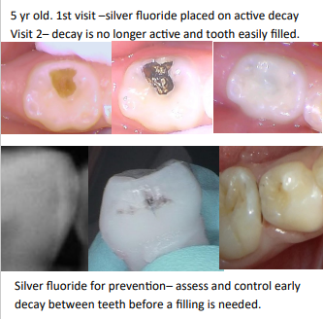

Image retrieved from ARM-ER brochure - clinicians.pdf (armer.com.au) on 4 Aug 2023.
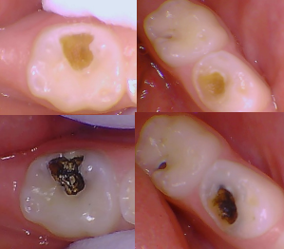

Attachment 2 - Instructions for Use: CSDS (Silver fluoride)

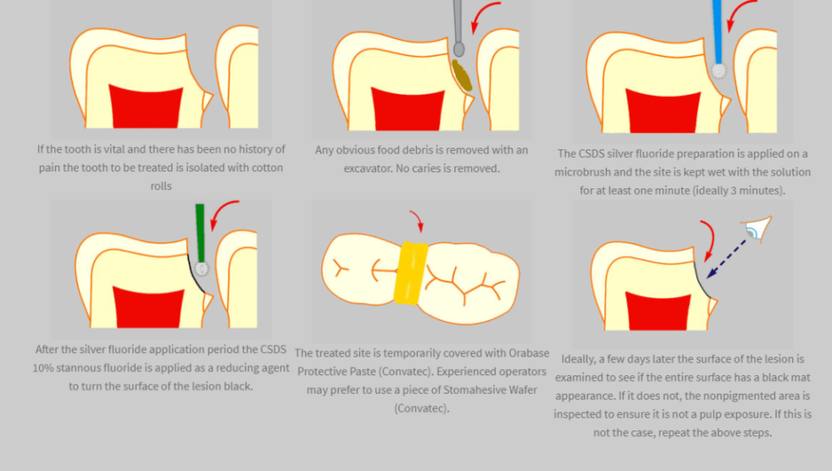

Attachment 3 - Instructions for Use: Riva Star (Silver Diamine Fluoride)
Adapted from SDI Riva Star Instructions for use (Bottle)
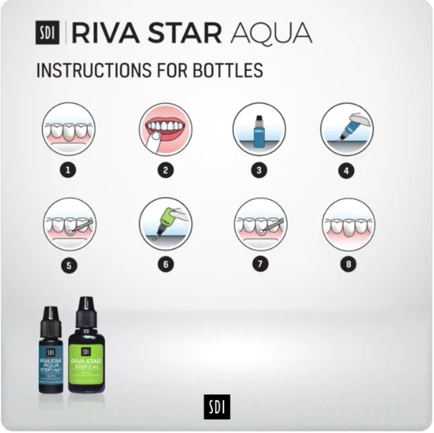
1. Using a non-fluoride prophylaxis paste in a rubber cup, clean the tooth/teeth to be treated and abutting teeth.
2. Assess condition of teeth. Only teeth with sound dentine and enamel should be treated.
3. Dry area to be treated and isolate it using rubber dam or a light curable Gingival Barrier (SDI Limited).
4. Protect any exposed gingival tissues and lips with petroleum jelly/ cocoa butter taking care not to contaminate treatment site. When not using rubber dam, isolate area with cotton rolls.
5. Riva Star Step 1: Dispense one (1) drop of solution onto non-absorbent mixing pad or dappen dish.
6. Carefully apply solution to treatment site only, a medium sized micro brush, such as Points (SDI Limited) is recommended.
7. Riva Star Step 2: Immediately after, dispense two (2) drops of solution onto fresh non-absorbent mixing pad.
8. Apply a generous amount of the solution to treatment site, a medium sized micro brush, such as Points (SDI Limited) is recommended. Apply same solution to any other tooth surfaces that may have come into contact with the solution from Riva Star Step 1 (grey label). Note: Treatment surface initially appears creamy white, keep applying Riva Star Step 2 solution until it turns clear.
9. Blot dry.
10.Remove all protective/isolation materials used in the mouth. IMPORTANT: Ensure that both Step 1 and Step 2 bottle surfaces (Eg : tip, neck, thread and inside the cap) are wiped thoroughly with an absorbent paper towel to remove any excess solution and prevent build up of dried material.
11. Clean dappen dishes and discard used mixing pads and microbrushes in accordance with local regulations.
DOSAGE: • One (1) drop of Riva Star Step 1 and two (2) drops of Riva Star

Attachment 4 - American Dental Association Caries Classification System

Retrieved from https://www.researchgate.net/publication/271648327_The_American_Dental_Association_Caries_Classification_System_for_Clinical_Practice on 24 Aug 2023.

