Canberra Health Services
Procedure
North Canberra Hospital (NCH) – Prevention, Diagnosis and Management of Delirium in the Acute Setting

Contents
Canberra Health Services 1
Contents 1
Purpose 2
Scope 2
Section 1 – Principles 2
Section 2 – Early Screening 3
Section 4 – Assessing for Delirium 4
Section 5 – Interventions to Prevent Delirium 5
Section 6 – Identifying and Treating Underlying Causes 6
Section 7 – Preventing Falls and Pressure Injury 8
Section 8 – Minimising Use of Antipsychotic Medicines 9
Section 9 – Indications and Recommendations for Pharmacological Management of Neuropsychiatric Symptoms 10
Section 10 – Transition from Hospital Care 11
Related Policies, Procedures, Guidelines and Legislation 12
References 13
Definition of Terms 13
Search Terms 14
Attachments 14
Attachment A – Safety and Quality Pathway for Patients with Cognitive Impairment or at Risk of Delirium 15
Attachment B – Infographic Outlining Rationale and Strategies for Reducing Inappropriate Use of Antipsychotics 16
Attachment C – CAM ICU 17
Attachment D – Sunflower tool 18

Purpose

This procedure aims to improve the prevention of delirium in patients at risk and to improve the early diagnosis and treatment of patients with delirium, so as to reduce the severity and duration of delirium.

The activities within this procedure align with the requirements of the second edition of the National Safety and Quality Health Service (NSQHS) Standards and the Delirium Clinical Care Standards.

Back to Table of Contents

Scope

This document pertains to North Canberra Hospital (NCH) patients over the age of 18 who present with suspected delirium and adult inpatients at risk of developing delirium whilst in care. It outlines the care they are to receive through transition to primary care.

This document applies to the following employees working within their scope of practice at NCH:
- Medical Officers
- Nurses and Midwives
- Student Nurses under direct supervision.
Back to Table of Contents

Section 1 – Principles

The overarching principles that guide clinical care of patients with (or at risk of) cognitive impairment are:
- Early Screening: Cognitive screening for at-risk individuals and comprehensive documentation of existing cognitive impairments on presentation to hospital.
- Assessing for Delirium: Prompt assessment of any changes in memory, thinking or behaviour (compared to the individual’s baseline).
- Interventions to prevent delirium: Appropriate interventions to prevent delirium and minimise experiences of Behavioural and Psychological Symptoms of Dementia (BPSD).
- Identifying and treating underlying causes: Appropriate interventions to treat delirium.
- Preventing falls and pressure injuries: To minimise the risk of hospital-acquired complications for people with delirium and cognitive impairment.
- Minimising use of antipsychotic medicines: Non-pharmacological support of patients experiencing delirium and/or BPSD throughout their hospitalisation as the first-line approach. Pharmacological treatment is only considered after other therapies are implemented and the patient’s distress cannot be relieved or the patient is at risk of harm to self or others.
- Transition from hospital care: Discharge planning includes the patient, their support persons, the multi-disciplinary team and the patient’s General Practitioner. Delirium or cognitive impairment is documented in the electronic discharge summary.

Note: This procedure does not replace clinical judgement. The decision to proceed with care as outlined in this document is made on clinical grounds, by appropriately trained and qualified employees.

Attachment A summarises the pathway to improve the early recognition of, and response to, patients at risk of delirium or behaviours associated with cognitive impairment to reduce harm and ensure they receive safe and high-quality care.

Back to Table of Contents

Section 2 – Early Screening

Risk screening
Patients with one or more of the following risk factors must be screened using the 4AT, which is available in the DHR:
- Age > 65yrs (> 45yrs for Aboriginal and Torres Strait Islander peoples)
- A known/existing cognitive impairment (e.g. dementia)
- A severe medical illness e.g. sepsis
- Current hip fracture
- Any concerns raised by the patient or significant other regarding recent changes

Following any surgical procedure the above patients at risk of developing delirium must be screened within 24 hours of the procedure due to the risk of post-operative delirium.

High Risk
Behavioural and Psychological Symptoms of Dementia (BPSD): Assessment and Management
People living with dementia are at greater risk of experiencing delirium and/or BPSD and associated adverse outcomes during a hospital admission. All employees can help minimise exacerbations of BPSD for patients living with dementia by applying non-pharmacological delirium prevention strategies as outlined below and in Attachment B.

Detailed information about the individual’s diagnosis is essential to facilitating better hospital care. Where possible clinicians must liaise with the patient, family member and/or carer to identify and document:
- When the dementia was first diagnosed
- The type of dementia
- Name of practitioner who diagnosed the dementia
- The individual’s usual symptoms, support and communication needs

When a patient with dementia presents with changes in memory, thinking or behaviour (compared to their baseline), there is a basic decision pathway through which clinicians can navigate, according to clinical form BPSD, see Attachment A.

These basic decision points involve:
- Early screening and assessment (using 4AT) and management as per this procedure
- Personalising care using non-pharmacological considerations and approaches (e.g. pain review, medication review, Sunflower tool – Attachment D).
- If necessary, consider referral to available specialist services

Back to Table of Contents

Section 4 – Assessing for Delirium

Signs and symptoms of delirium may fluctuate throughout the day and night and may include:
- Acute onset
- Difficulty focusing or sustaining attention
- Disorganised thinking
- Disturbance of sleep/wake cycle
- Speech or language disturbance
- Disorientation to time or place
- Disturbance in psychomotor behaviour
  - Increased e.g. agitation
  - Decreased e.g. lethargy
- Mood swings
- Misinterpretations of the senses/hallucinations/illusions

Cognitive assessment
Cognitive assessment should be completed to assess for delirium or cognitive impairment using the 4AT. The 4AT establishes a baseline, but cannot be used for daily measurement. A score of 4 or more on the 4AT indicates possible delirium or cognitive impairment and further investigations are required as outlined in section 6 of this procedure. A score of 1-3 indicates the patient has a possible cognitive impairment and is at risk of developing a delirium. During admission an acute change in cognition is a prompt to screen for delirium using the 4AT.

In addition to administering the 4AT, clinicians must ask the patient and/or family member or other informant about any recent changes (within hours or days) in the patient’s behaviour and thinking.

If the 4AT score is suggestive of a possible cognitive impairment or delirium, arrangements should be made for follow up after discharge from hospital (e.g. follow up with GP, or consider Geriatrician referral).

Note that delirium prevention strategies must be applied as a minimum approach to supporting patients with an existing dementia diagnosis during hospitalisation.

Intensive Care Unit (ICU)
Routine monitoring of delirium in adult ICU patients is required due to the association with increased mortality and post-ICU cognitive impairment in adult ICU patients.

CAM-ICU (Attachment C) is the recommended and most valid tool for assessing and monitoring delirium in the ICU as it can be used when patients are mechanically ventilated. CAM-ICU should be completed at least once per nursing shift and also if there is a change in the patient’s level of consciousness or behaviour.

A positive CAM identifies that delirium is present and should prompt action:
- Notify treating medical team
- Document in medical records
- Commence investigation into the cause of delirium
- Develop and document a delirium management plan incorporating non-pharmacological strategies
- Provide information and education to patient/resident and carer.

Back to Table of Contents

Section 5 – Interventions to Prevent Delirium

The prevention of delirium is possible and more effective than early detection and treatment. Multicomponent interventions reduce the incidence of delirium and may prevent complications, such as falls. Regular monitoring of patients at risk of delirium for changes in behaviour, cognition and physical condition can assist the prompt detection of delirium.

Interventions to prevent delirium include:
- Medication review
- Correction of dehydration, malnutrition, constipation and urinary retention
- Mobility activities
- Oxygen therapy
- Pain assessment and management
- Regular reorientation and reassurance – ensure patient board is up to date and correct clock in room
- Activities for stimulating cognition
- Non-drug measures to help promote sleep
- Assistance for patients who usually wear hearing and visual aids
- Line of sight nursing where possible and consistent nursing staff
- Reduction of stress and disruption through minimising room changes or tests in medical imaging
- Limit use of indwelling urinary catheter
- Educate the patient and family/carers regarding delirium prevention
- Encourage significant others to provide familiar personal items and re-orientate the patient
- Avoid use of restrains

These interventions should be implemented for patients at risk of delirium as well as for those with delirium.

In the Intensive Care Unit sedation medication may be required to facilitate invasive procedures and decrease stress related to invasive treatments. The use of non-benzodiazepine medications (propofol and dexmedetomidine) are recommended over benzodiazepine medications.

Back to Table of Contents

Section 6 – Identifying and Treating Underlying Causes

Delirium is considered a serious medical condition. As such the primary goal is to identify the presence of delirium and causative factors as quickly as possible.

Clinicians must recognise that family members or other informants are often the first to notice a change in the patient’s memory, thinking or behaviour.

Delirium can have many potential causes, but the most common cause is infection. Note that causes for any individual are often multifactorial, and, a specific cause may never be clearly identified. Assessment should be based on a biopsychosocial framework and include a detailed history of the onset and course of the delirium, previous episodes of delirium, sensory deficits, safety issues, alcohol use and social and environment circumstances. Pre-morbid functional activities of daily living, symptoms of underlying causes and co-morbid illnesses should also be included.

Common Causes of Delirium
- Infection (e.g. UTI or pneumonia)
- Medications (including polypharmacy and/or medication changes)
- Electrolyte imbalance (also think dehydration)
- Medication (withdrawal or uncontrolled pain)
- Alcohol withdrawal
- Reduced sensory input (e.g. vision or hearing deficit)
- Neurological (e.g. stroke, subdural)
- Urinary retention or faecal impaction
- Hypoxia (Myocardial/pulmonary)

Investigations
- C-reactive protein (CRP)
- Full blood count
- Urea and electrolytes
- Glucose
- Calcium
- MSU
- Chest x-ray
- Drug levels if toxicity suspected
- ECG
- Bladder scan and/or abdominal x-ray
- Cardiac enzymes
- Drug and alcohol screen
- Liver function tests

Other tests may be considered, including arterial blood gases, thyroid function, CT brain, lumbar puncture and CSF examination and EEG.

Note: Investigations that disturb the patient (e.g. tests in Medical Imaging) will place patients at further risk so consider what is essential to establish diagnosis.

Medication review
Some medication may affect cognitive function and worsen delirium including:
- Opioid
- Medications with anticholinergic effects
- Anticonvulsants, e.g. phenytoin, carbamazepine, valproate
- Anti-Parkinson drugs, e.g. levodopa, rotigotine, pergolide, bromocriptine
- Alcohol
- Antipsychotics
- Benzodiazepines
- Corticosteroids (high dose)
- Cardiovascular medications, e.g. digoxin, metoprolol, propranolol
- Some anti-bacterial and antivirals, e.g. acyclovir, trimethoprim with sulfamethoxazole, ciprofloxacin

Diagnosis
Note: When diagnosing delirium, the subtype should be determined and specified in the documentation. The most common types are hypoactive and mixed delirium presentations.

Patients with hyperactive delirium can:
- Be hyperactive, hyper-alert, combative, uncooperative
- Appear to be responding to internal stimuli

Patients with hypoactive delirium can:
- Appear to be sleeping on and off throughout the day
- Be unable to sustain attention when awakened, due to falling back to sleep
- Miss meals, medications and appointments due to being too drowsy
- Be easily missed or overlooked as they will not be drawing staff attention
- Have higher mortality rates and poorer outcomes if not identified and supported

Patient with mixed delirium will present with a combination of the above two subtypes.

Back to Table of Contents

Section 7 – Preventing Falls and Pressure Injury

- All patients identified as at risk of delirium or cognitive impairment require falls and pressure injury risk assessment on admission and at least once a week throughout admission, see NCH Falls Risk Minimisation and Management Procedure.
- The Malnutrition Screening Tool (MST) must also be completed on admission and appropriate referrals for nutrition support put in place as part of the comprehensive care plan.
- Delirium is a fluctuating condition. Potential risks should be identified and interventions included in the care plan to ensure the safety of the older person, visitors and staff. Risks should be re-evaluated on a regular basis.
- Staff should not assume that a person with delirium will remember any instructions; their safety may rely on staff observation. Falls and pressure injury risks should be assessed and documented according to the corresponding policies.

Back to Table of Contents

Section 8 – Minimising Use of Antipsychotic Medicines

Interventions to treat the cause and manage delirium
The first-line approach to supporting patients with cognitive impairment is non-pharmacological interventions, tailored to the individual’s presentation, preferences and needs.

Non-Pharmacological Management of Delirium
Non-pharmacological management of delirium includes optimal management of the following known precipitating factors. These include:
- Hydration and nutrition: Oral diet and fluids should be encouraged and fluid balance and food intake charts should be routinely in place.
- Mobility: A falls risk assessment should be attended routinely and a mobility assessment conducted when appropriate. Bed and chair alarm devices may be useful for acutely delirious patients. Safe mobility should be encouraged.
- Bowel and bladder function: A stool chart and urine output should be monitored. A toileting regime may be included in the care plan. Remove IDC as soon as no longer clinically required.
- Sleep: Good sleep routines should be promoted, e.g. some quiet time without electronic devices or mental stimulation prior to sleep time, ensure noise minimisation, comfortable room temperature and darkened, avoid caffeine prior to sleep time.
- Sensory input: Ensure that spectacles, dentures and hearing aids are in place if they are usually required
- Pain: Pain should be assessed and managed appropriately, a non-verbal pain assessment tool e.g. Abbey Pain Scale or PAINAD should be used for patients who have difficulty with communication.
- Promoting cognition: Provide an environment which supports orientation; consider the use of calendars and clocks and lighting appropriate to the time of day and an environment that is not over or under stimulating, encourage family to bring a few familiar objects.
- Communication: Use clear and simple language, giving one message at a time to assist understanding. Provide visual cues with verbal messages to assist communication e.g. show the meal and talk about it being lunchtime.
- Family/Carers: Discuss patient’s individual likes and dislikes, social history and usual routine, encourage family/carer to stay with patient when possible. Provide delirium brochure in the appropriate language to assist family/carer with an understanding of delirium.
- Emotional well-being: Provide reassurance and support to the patient/resident and family/carer.

Back to Table of Contents

Section 9 – Indications and Recommendations for Pharmacological Management of Neuropsychiatric Symptoms

Note: The use of psychotropic medications requires informed consent from the patient’s ‘person responsible’.

Consultation with a geriatrician or psycho-geriatrician is recommended. If a geriatrician or psycho-geriatrician is not available, consultation must be made with a senior medical officer with experience in the management of delirium or cognitive impairment prior to prescribing.

Pharmacological interventions for neuropsychiatric symptoms of delirium and/or BPSD and their behavioural manifestations must only be applied adjunctively with personalised, non-pharmacological support strategies for the patient. Even when medications have been administered, non-pharmacological approaches to care must be continued as the first-line management approach.

There is limited evidence of efficacy of medications and significant risk of adverse effects. Antipsychotics and benzodiazepines can worsen delirium. There are no specific medication treatments and, in particular, medications are not helpful for calling out or wandering.
There is no evidence that antipsychotics or sedatives improve prognosis. Only consider pharmacological treatment if:
- Severe agitation and aggression associated with risk of harm
- Delusions or hallucinations that are distressing to the patient
- As ongoing treatment of a co-morbid, pre-existing mental illness
- The person’s degree of agitation/aggression interferes with their (or other people’s) ability to receive essential nursing or medical care

Cautions in the use of psychotropic medications in patients with delirium
When pharmacological intervention is clinically indicated for neuropsychiatric symptom management, the following recommendations apply:
- Start low, go slow, review often and titrate off when possible
- Document indications & observed efficacy clearly in the prognosis notes. Review regularly. Clearly document the required frequency of physician review in the notes
- Use the oral route of administration if possible
- Monitor vital signs closely during and after the administration of psychotropic drugs
- Avoid the use of ‘as needed’ (prn) orders unless both the indication for administration and maximum dose per 24 hours are clearly specified. Use of ‘as needed’ medication must be reviewed daily because of the changing clinical situation
- Diligent behavioural observation charting and associated progress note documentation must be completed on each shift for any patient on a newly prescribed psychotropic medication while in hospital
- Dosage and frequency of antipsychotic regimen should be titrated against level of patient agitation or distress at each review
- Review the need for ongoing treatment before discharge and involve support persons/family in decisions for pharmacological management

When an antipsychotic medication is newly prescribed to assist the management of delirium, a plan must be developed and documented for review and cessation of the medication when it is no longer required.

Additional considerations when supporting patients with cognitive impairment
- At all times, clinicians must consider the patient’s right to informed consent. It is important that clinicians assist the patient and their family or other support persons to make decisions – particularly those relating to treatment and pharmacological interventions – by providing a full explanation of potential risks and benefits of the relevant treatment
- Prior to commencing a 1:1 Enhanced Supervision for a patient, refer to the ‘Care of Patients requiring Enhanced Supervision/Approval Procedure to ensure best care is provided for the patient.

Physical Restraint
It is recognised that restraint is a precipitating factor for delirium and increases morbidity and mortality. Restraints should only be used as a last resort to maintain the safety of the patient, staff or others. Refer to the Restrictive Practitices for People NOT detained under the Mental Health Act 2015 to ensure restraint is only used in appropriate situations.

Back to Table of Contents

Section 10 – Transition from Hospital Care

Discharge Planning
Before the patient leaves hospital, an individualised care plan must be developed in collaboration with the patient, their support persons and other relevant stakeholders (e.g. GP). Where appropriate, coordination for follow-up by relevant community based services must be initiated prior to discharge.

The discharge plan must be provided to the GP and other ongoing clinical providers within 48hrs of discharge

In addition to any other relevant details, the patient and/or their support persons must be offered the following information in preparation for discharge:
- A copy of the Sunflower tool (Attachment D)
- A copy of the discharge summary, which must outline any non-pharmacological or pharmacological interventions utilised
- If the patient was diagnosed with delirium during hospitalisation, they and/or support persons must also be offered a personalised copy of the ‘Delirium’ brochure to facilitate understanding and self-advocacy at any future medical appointments.

Review for psychotropic medication cessation at discharge: Medication for management of delirium symptoms or BPSD should not usually be continues at discharge due to adding to the patient’s medication burden and increasing risk or associated complications (e.g. falls). Furthermore, patients should not be discharged on haloperidol. If an agent is to be continued on discharge, an atypical antipsychotic is preferred. This transition should be done in hospital over 4-7 days. A plan for treatment review every four weeks should also be organised.

The individualised care plan care plan should provide the patient and carer with information about ways of reducing the patient’s risk of future delirium, any changes in medications including reason for ceasing or changed and if antipsychotic medication has been commenced, include a plan for review and withdrawal.

Back to Table of Contents

Related Policies, Procedures, Guidelines and Legislation

Policies
- Informed Consent – Clinical

Procedures
- Infection Prevention and Control
- Patient Identification and Procedure Matching
- NCH Falls Risk Minimisation and Management
- Pressure Injury Prevention and Management - Adults, Children and Neonates
- Restrictive Practitices for People NOT detained under the Mental Health Act 2015
- Challenging Behaviour Guideline

Legislation
- Health Records (Privacy and Access) Act 1997
- Human Rights Act 2004
- Work Health and Safety Act 2011

Other
• Australian Charter of Healthcare Rights

Back to Table of Contents

References

- Australian Commission on Safety and Quality in Health Care. A better way to care: Safe and high-quality care for patients with cognitive impairment (dementia and delirium) in hospital – actions for clinicians. Sydney. ACSQHC. 2014.
- Australian Commission on Safety and Quality in Health Care. Delirium Clinical Care Standard. Sydney. ACSQHC. 2016.
- Bellelli G, Morandi A, Davis DH, et al. Validation of the 4AT, a new instrument for rapid delirium screening: a study in 234 hospitalised older people. Age Ageing. 2014; 43:496-502.
- Delirium Best care for older people www.health.vic.gov.au
- Department of Health and Aging-Delirium in Older people www.health.gov.au16/6/2014
- Devlin JW, Skrobik Y, Gelinas C, et al. Clinical Practice Guidelines for the Prevention and Management of Pain, Agitation/Sedation, Delirium, Immobility, and Sleep Disruption in Adult Patients in the Intensive Care Unit. Critical Care Medicine. 2018; 46:e825-e873.
- Inouye SK, Bogardus ST, Baker DI, et al. The Hospital Elder Life Program: A model of care to prevent cognitive and functional decline in older hospitalized patients. J Am Geriatric Soc. 2000; 48:1697-706.
- Inouye SK, Westendorp RG, Saczynski JS. Delirium in elderly people. Lancet, 2014; 383:911-22.
- Maclullich AM, Anand A, Davis DH, et al. New horizons in the pathogenesis, assessment and management of delirium. Age Ageing, 2013; 42:667-74.

Back to Table of Contents

Definition of Terms

Delirium: “a transient organic mental syndrome, characterised by a disorder of cognition (thinking), attention, a reduced or heightened level of consciousness (awareness), abnormally reduced or increased psycho-motor activity and a disturbance of sleep wake cycle” Lipowski, 1989).
Disturbed Behaviour: relates to the disturbance of the persons responses to any stimuli and behaviours exhibited due to the above condition or simular behaviour.
Inattention: Reduced ability to direct, focus, sustain and shift attention.
Disturbance in awareness: The person has a reduced orientation to the environment and their place in the environment.
Disturbance in cognition: Memory deficit, disorientation, language, visuospatial ability or perception.
Fluctuate: Continually changing or shifting unpredictably.

Back to Table of Contents

Search Terms

Delirium, Cognition, Cognitive Impairment, Dementia, BPSD

Back to Table of Contents

Attachments

Attachment A – Safety and Quality Pathway for Patients with Cognitive Impairment or at Risk of Delirium
Attachment B – Infographic Outlining Rationale and Strategies for Reducing Inappropriate Use of Antipsychotics
Attachment C – CAM ICU
Attachment D – Sunflower tool

Disclaimer: This document has been developed by Canberra Health Services specifically for its own use. Use of this document and any reliance on the information contained therein by any third party is at his or her own risk and Canberra Health Services assumes no responsibility whatsoever.

Policy Team ONLY to complete the following:
Date Amended | Section Amended | Divisional Approval | Final Approval
22/02/2024 | NCH Transition Document | Kathryn Daveson, NCH EDMS | CHS Policy Team

This document supersedes the following:
Document Number | Document Name
 | Prevention Diagnosis and Management of Delirium in acute setting.docx

Attachment A – Safety and Quality Pathway for Patients with Cognitive Impairment or at Risk of Delirium
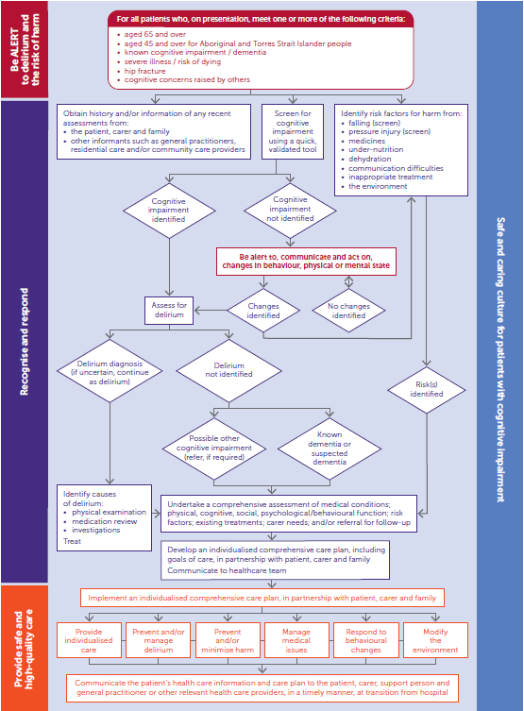

Attachment B – Infographic Outlining Rationale and Strategies for Reducing Inappropriate Use of Antipsychotics

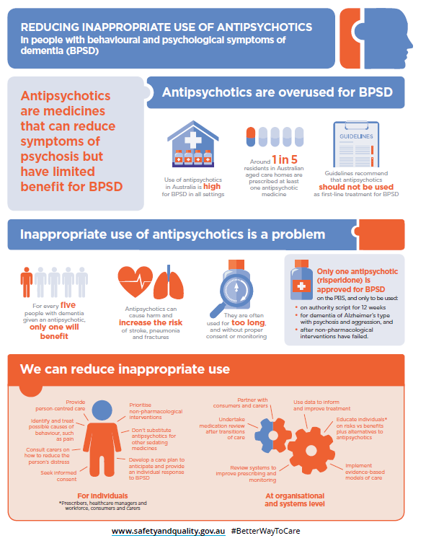

Attachment C – CAM ICU

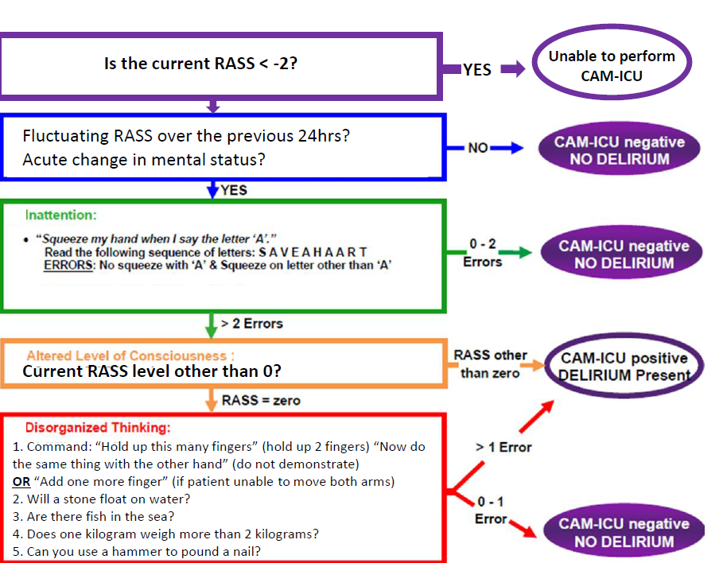

Attachment D – Sunflower tool

Background:
Engaging in conversation with someone who has dementia or a cognitive impairment can sometimes be difficult. This sunflower tool used for patients with dementia or a cognitive impairment. The poster aims to improve communication between patients and health-care providers. The topics displayed on this poster will allow health-care providers to know more about the patient and will be used as a prompt to start conversation. The poster should include things such as the patient’s likes, dislikes, needs and interests. This poster aims to improve and build relationships between the health-care workers and patients and to support a person-centred approach to care.
How can we communicate?
Does the patient communicate verbally, pointing, using a word chart, using gestures or by means of a mixture? Can the patient read and write and does the patient prefer to write things down?
Topics of conversation to consider:
Leisure | Board games, collecting, playing cards, puzzles/crosswords, listening to the radio, reading, watching television/movies, eating out, listening to music
Productivity | Cooking, gardening, home maintenance, DIY/repairing, pet/animal ownership
Sport | Aerobics/gym, swimming, walking, bowling, darts, golf, tennis, boxing, football, netball
Creativity | Sewing/fashion, craft/needlework, singing, painting/drawing, photography, pottery, writing, woodwork
Educational interests | foreign languages, history, news and current affairs, politics, science
Entertainment interests | Bingo, cinemas, concerts, dancing, museums, shopping, places of interest, travelling holidays
Outdoor pursuits | animals, camping, climbing, fishing, horse riding, water sports
Social | family (children/grandchildren), club memberships, eating out, religious/cultural activities, voluntary work
Past experiences | Previous employment, travel experiences, different places they have lived, skills they have learnt e.g. playing an instrument
A typical day/routines that are important | Watching the news at 7pm, starting the day with a cup of tea and reading the newspaper, calling their daughter of an evening.

