Canberra Health Services
Procedure
North Canberra Hospital (NCH)- Cleaning Theatre Floors

Contents

Contents 1
Purpose 2
Scope 2
Section 1 – Responsibilities 2
Section 2 – Procedure 3
Related Policies, Procedures, Guidelines and Legislation 6
References 6
Definition of Terms 6
Search Terms 6

Purpose

To document systems of floor cleaning in theatre which control the risk of slips due to slippery floors.
This procedure seeks to embed procedures to ensure optimal infection control and safe practices, thereby minimising patient and employee injury, in particular preventing further occurrences of serious injuries from slips which have occurred in theatre since the implementation of bucketless mops.
Back to Table of Contents

Scope

This procedure applies to North Canberra Hospital:
- Operating Theatres Ward Support Officers and Nurses
- Infection Control Deparatment
- Manager in charge of Environmental Services and
- Contract cleaners.

Back to Table of Contents

Section 1 – Responsibilities

Responsible group 1: Infection Control Department Manager/Department Manager
- Ensure the procedure is communicated to their employee and employee know where to find the procedure
- Monitor compliance to procedure in their area
- Provide employee with opportunities to attend education and training
- Ensure resources are available to adhere to the procedure
- Investigate any incidents of non-compliance to the procedure in RiskMan
- Ensure that the procedure is up to date and ensure that the procedure is reviewed in line with the expiry date.
Responsible group 2: Employee/Particular department the document applies to / Domestic Services Manager
- Comply with the procedure
- Notify non-compliance to the procedure to the manager and in RiskMan.

Back to Table of Contents

Section 2 – Procedure

Frequency of mopping:
- The floor of theatres (except eye theatres) will be mopped between every case
- On completion of mopping the floor should be left as dry as possible
- Regardless as to how dry the floor is, a ‘Wet Floor’ sign is to be placed at the theatre entry
- The employee who has mopped the floor must verbally warn other employees if the floor is not dry
- Sufficient time needs to be provided for the floor to dry between surgeries
- Employees should avoid entering the theatre until the floor has dried.
- Anaesthetic bays will be mopped as required
- The five precautionary measures above need to be adhered to after mopping is completed
- Corridors and areas outside theatres will be cleaned by contract cleaners after business hours.

Person responsible:
- A Ward Support Officer (WSO) will usually conduct the mopping of theatres between operations. Sometimes a nurse will mop
- The contract cleaners may be required to undertake a clean between surgeries if the theatre requires an Infectious Clean
- A terminal clean (including disinfecting) of each theatre by contract cleaners will occur daily, after 5pm
- All Theatre and corridor floors are cleaned daily by contract cleaners using the microfibre mops, after 5pm
- Contract cleaners also conduct periodic cleans (involving the cutback and re-polishing of hard floors and/or the steam-cleaning of soft floors) twice yearly.

Cleaning Products:
- Bucketless Microfibre mops will be used to control the risk of reinfection from buckets
- A clean Microfibre mop head will be used for each individual theatre clean
- When cleaning large spills, several mop heads will be taken into the theatre and changed. Catch mop heads with frilled edges will be used after orthopaedic surgery to pick up bone. Dirty Microfibre mop heads will be delivered to the washing machines once per day in red buckets
- Clean Microfibre mop heads will be delivered back to theatre once per day in blue buckets

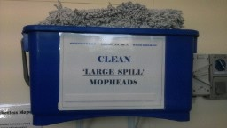

- Mops will be stored, upside down on the hooks provided at each mop station, thereby avoiding any damage to the detergent delivery component of the mop

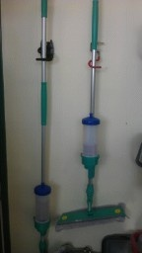
- Mops will be filled using detergent from the mixing station without dilution 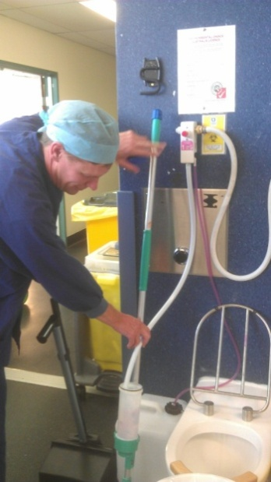

- Ward Support Officers (WSO) will refill the detergent canisters on the mops as required and clean them once per day
- The Senior Theatre Ward Support Officer will arrange maintenance to cleaning equipment
- The Manager in charge of Environmental Services will ensure a stock of spare parts for mops and arrange repairs to cleaning equipment.
Technique:
- Minimal detergent should be delivered at the front of the mop head and spread in a figure of 8
- Use the back of the mop head to dry the floor
- If the floor is still visibly wet, replace the mop-head with a fresh dry Microfibre mop head.
Training:
- Supervisors are responsible to ensure that during area specific orientation new employees/contractors will be given a copy of this procedure and trained in the correct procedures for mopping
- All employees/ contractors required to mop the floor will be trained prior to undertaking this task as far as is reasonably practicable
- An integral component of the training will be to highlight the potential hazard of slips and falls that may arise by noncompliance with this procedure.
Monitoring /accountability:
- All slips and near misses will be reported in Riskman
- Supervisors are responsible to ensure compliance with these procedures.

Back to Table of Contents

Related Policies, Procedures, Guidelines and Legislation

Procedures
- Infection Prevention and Control

Legislation
- Work Health and Safety Act 2011

Back to Table of Contents

References

- Work Health and Safety Act 2011
Back to Table of Contents

Definition of Terms

- Terminal Clean- means thorough clean and disinfecting of all surfaces.

Back to Table of Contents

Search Terms

Floors, Theatre, clean, terminal ,slips, slippery, operating theatres, cleaning, theatre floors

Back to Table of Contents

Disclaimer: This document has been developed by Canberra Health Services specifically for its own use. Use of this document and any reliance on the information contained therein by any third party is at his or her own risk and Canberra Health Services assumes no responsibility whatsoever.

Policy Team ONLY to complete the following:
Date Amended | Section Amended | Divisional Approval | Final Approval
12/04/2024 | New Document | David Booty ED Surgery NCH | CHS Policy Team

This document supersedes the following:
Document Number | Document Name

