Canberra Health Services
Guideline
Persistent Pulmonary Hypertension of the Newborn and Inhaled Nitric Oxide Therapy (Neonates and Infants)

Contents

Contents 1
Guideline Statement 2
Scope 2
Section 1 – Introduction 3
Section 2 – Patient Assessment 3
Section 3 – Treatment 5
Section 4 – Specific Patient Groups 10
Section 5 – Commencing Nitric Oxide Therapy in NICU 11
Section 6 – Nitric Oxide Setup on Shuttle Transport Cot 16
Section 7 – Nitric Oxide Setup on Neonatal System (ERIC) during NETS Retrievals 19
Evaluation 26
Related Policies, Procedures, Guidelines and Legislation 26
References 27
Search Terms 27
Attachments 27
Attachment 1: Inhaled nitric oxide initiation flow chart 29
Attachment 2: Inhaled Nitric Oxide Weaning Flow Chart 30
Attachment 3: Low Calibration with Pre-Use Procedure Check, and High Calibration Check 31
Attachment 4: Pre-Use Assembly INOmax DSIR Nitric Oxide Plus Machine 33
Attachment 5: Connection to Various Breathing Systems 35
Attachment 6: Cylinder Size Duration Chart and Changing INOmax Cylinder Procedure 40
Attachment 7: DSIR Plus Nitric Pack Contents List 42
Attachment 8: NETS Nitric Oxide Observations Chart – N2012 INOmax DSIR Plus 44

Guideline Statement

Background
Persistent Pulmonary Hypertension of the Newborn (PPHN) is an important condition to recognise and manage in neonatal patients and may require intensive care treatment.

Key Objective
This guideline outlines the safe and effective management of neonate with this condition, including medical and nursing management and equipment set up and use. The use of inhaled nitric oxide gas as a therapy for PPHN is covered in this guideline.

Alerts
- Management of PPHN is multi-faceted. This guideline will refer to all facets however some may be covered in more detail in other guidelines including (but not limited to):
- Respiratory Support- Invasive and non-invasive (Neonates and Infants)
- Neonatal Intensive Care Drug Manual/Australasian Neonatal Medicines Formulary (ANMF)
- Care Of The Extremely Preterm And Low Birth Weight Neonate
- Ultrasounds And Echocardiograms in The Department Of Neonatology- Neonates
- Neonatal Emergency Transport Service, Australian Capital Territory (NETS ACT) – Back-transfer, Elective Retrievals, Retrievals & Paediatric Stabilisations
- Inhaled nitric oxide treatment is recorded electronically and billed by the pharmaceutical supplier per hour with current pricing in excess of $100 per hour. Failure to close cylinder valve when treatment is not actively being delivered (i.e. after system set up/checked but not in use or after treatment finished) may lead to a large expense for no patient benefit.

Back to Table of Contents

Scope

This document applies to neonates/newborns and infants nursed under the care of the Department of Neonatology: Neonatal Intensive Care Unit (NICU) and Special Care Nursery (SCN).
This document applies to the following Canberra Health Service (CHS) staff working within their scope of practice:
- Medical Officers
- Nurses and Midwives
- Medical and Nursing Students under direct supervision

Back to Table of Contents

Section 1 – Introduction

Persistent pulmonary hypertension (PPHN) of the newborn is a cardiopulmonary disorder resulting from a failure to transition from fetal to postnatal physiology. The key clinical feature is hypoxaemia often with differential pre and post-ductal oxygen saturations.

Normal Fetal to Neonatal Cardiorespiratory Transition:
Involves pulmonary vasodilation and increased pulmonary blood flow which occurs in response to lung distention with air and the effects of oxygen on the pulmonary vasculature. Increased pulmonary blood flow and breathing air result in gas exchange in the lungs as the placental circulation ceases after birth and the cord is clamped. Increasing pulmonary blood flow increases venous return to the left atrium, thus raising left atrial pressure and forcing the flap of septal tissue to reduce the patent foramen ovale (PFO) shunt which also usually becomes left to right due to the relative right and left atrial pressures. With the low resistance placental circulation removed, the systemic vascular resistance increases at the same time as the pulmonary vascular resistance falls and the patent ductus arteriosus (PDA) shunt therefore becomes left to right. The PDA usually closes soon after birth (24-48 hours) as it contains contractile tissue which constricts in response to rising partial pressure of oxygen, changing haemodynamics and the loss of placentally derived prostaglandins which help maintain ductal patency in utero.

Pathophysiology of PPHN:
PPHN can result from problems at many of the steps that lead to successful transition, but the key step appears to be initiation of respiration and aeration of the lungs. Therefore, the majority of PPHN is secondary to lung pathology or perinatal events (e.g. asphyxia) where the newborn does not initiate effective respiration soon after birth. PPHN can also be secondary to congenital heart disease and thoracic malformations which affect lung development, and a small proportion of cases may be primary PPHN (no known underlying cause, also known as idiopathic PPHN). There is an association from case-control and cohort studies (and a meta-analysis) linking maternal selective serotonin reuptake inhibitors (SSRI; a class of antidepressants) use in pregnancy to PPHN however the risk to maternal mental health of untreated illness is usually considered to outweigh the risk of PPHN in the newborn. A meta-analysis concluded 1615 women needed to be treated with an SSRI to cause one additional case of PPHN ¹.

Back to Table of Contents

Section 2 – Patient Assessment

Newborns with PPHN usually present with signs of the underlying primary pathology, usually lung disease with increased work of breathing and hypoxia. In PPHN the hypoxia is usually a prominent feature and if pre and post ductal saturations are measured simultaneously, the post-ductal saturation is usually >5% lower than the preductal. Those without lung disease often have hypoxia initially without significant increased work of breathing and therefore PPHN and cyanotic congenital heart disease are key differential diagnoses.

Clinical Assessment:
Should follow an A, B, C approach ensuring significant abnormalities are dealt with as the assessment continues. In serious cases PPHN represents a resuscitation scenario.
Airway
- Ensure patent and maintained in neutral position. Intubation may be required.
Breathing
- Assess work of breathing, air entry and effectiveness of breathing (saturation monitoring and an early blood gas may assist in assessing gas exchange, transcutaneous carbon dioxide (CO₂ ) monitoring may be useful for ongoing monitoring). Does respiratory support improve work of breathing and/or oxygenation? E.g. continuous positive airway pressure (CPAP), mask intermittent positive pressure ventilation (IPPV)
- Calculating oxygenation index (OI) may help assess severity of PPHN (OI=MAP x (FiO₂/PaO₂) (MAP= Mean Airway Pressure (cmH₂O), FiO₂= Fraction of inspired oxygen (%), PaO₂= Partial pressure of Oxygen in arterial blood (mmHg)). OI >20 is an indication for inhaled nitric oxide (iNO); consider at OI >15. OI is unreliable in cyanotic congenital heart disease.
- Rule out pneumothorax and significant congenital anomalies with clinical assessment and chest x ray (CXR)
- Decompress any abdominal distention which may compromise diaphragmatic movement with an orogastric tube (OGT)/nasogastric tube (NGT)
- Consider need for immediate intubation or other interventions to improve breathing effectiveness
Circulation
- Assess heart rate, blood pressure, pulse characteristics, central and peripheral perfusion
- In severe cases, invasive blood pressure (BP) monitoring should be established as soon as possible
- Consider acid base status on cord and postnatal blood gases, acknowledging that abnormalities may reflect past events (e.g. in utero) rather than current status. Progress over time is important
- A pre to post-ductal saturation difference is evidence of deoxygenated blood being shunted right to left through the patent ductus arteriosus (PDA) and/or PFO and contributing blood to the post-ductal circulation
- Also consider the effectiveness of the circulation, urine output, neurological status acknowledging that it takes time to measure urine output and past events may have an influence on current assessment
- Clinician performed ultrasound (CPU) assessment of the heart may assist in the diagnosis and management of PPHN and coexisting conditions such as myocardial injury due to hypoxia or ischaemia. CPU can assess cardiac function and contractility, cardiac filling and estimate pulmonary arterial pressure by assessing PDA shunt and presence of tricuspid regurgitation. Importantly it can rule out congenital heart disease and if a neonate with suspected PPHN behaves atypically or fails to respond to treatment a CPU heart is essential to ensure the correct diagnosis is being treated.
Disability (Neurological status)
- Assess for encephalopathy and for its causes: is the infant encephalopathic due to past events? (e.g. in utero) or due to current abnormalities in airway, breathing and circulation? (e.g. hypoxia, hypercarbia, inadequate perfusion).
- Check blood glucose level (BGL) and treat if low
Additional points
- Pay attention to temperature, hypothermia may make PPHN worse, and hyperthermia increases oxygen demand and may worsen the adverse effects of any hypoxic-ischaemic injury
- Severe PPHN with FiO2 >0.8 or ongoing hypoxia is a contraindication to therapeutic cooling for hypoxic ischaemic encephalopathy although cooling may be started later (if still <6 hours of age) once PPHN is treated and controlled
- Persistent hypoxia and poor perfusion may lead to organ injury, consider appropriate investigations if infant considered at risk (Neonatal intensive care profile (electrolytes, calcium, magnesium and phosphate; NICP), liver function tests (LFTs), Coagulation, full blood count (FBC), Troponin I)
- Perinatal infection may contribute to or cause PPHN, most infants will be investigated and treated for potential infection until test results and clinical progress allows the clinicians to determine the need for ongoing treatment at 36 hours with the benefit of investigation results and information on clinical progress.
Parental consent
- Where possible parents should be informed of the clinical assessment and diagnosis and treatment plan and verbal consent obtained prior to initiation of therapy. In clinical emergencies parents should be informed as soon as possible when appropriate clinicians are able to step back from direct clinical care to provide this information. With regard to ongoing care and changes to treatment, parents can be consulted on the information they wish to be updated on but in all cases significant clinical deterioration or changes to treatment plans should be communicated as soon as practical.

Back to Table of Contents

Section 3 – Treatment

Treatment of PPHN has three main components:
- ensuring adequate lung recruitment, ventilation and oxygen delivery
- pulmonary vasodilation
- supporting cardiac function and the systemic circulation

Mild cases may only need respiratory support with pulmonary vasodilation resulting from these basic interventions, whereas severe cases will need intensive treatment across all three domains.

Monitoring:
Patients should be cared for in Neonatal Intensive Care Unit (NICU) with standard cardio-respiratory monitoring plus the addition of pre and post ductal saturations.
Invasive BP monitoring is ideal in severe cases as it also facilitates blood gas sampling. Transcutaneous CO₂ monitoring should be utilised in ventilated patients (acknowledging it has limitations when skin perfusion is poor due to disease or treatment).

Oxygen Targeting:
Oxygen therapy can assist in reversing the pulmonary vasoconstriction and as such targeting higher preductal saturations 95-98% and PaO₂ of 80mmHg may be appropriate for term and near-term infants. Usual oxygen saturations of 90-95% should be targeted for preterm infants.

Respiratory support
Respiratory support is the key treatment. Without adequate alveolar recruitment, oxygen delivery and ventilation other treatments are unlikely to get an adequate response to ensure clinical improvement. In mild cases, especially where lung disease is the primary cause, nasal prong bubble CPAP may be adequate to recruit alveoli and therefore improve oxygenation and ventilation with subsequent pulmonary vasodilation due to these effects. As the lung disease improves, oxygen and CPAP can be weaned and then stopped. CPAP may be used to deliver inhaled nitric oxide (iNO) a pulmonary vasodilator (See Pulmonary Vasodilation). The ideal cases for this are:
- PPHN without underlying cause (primary PPHN)
- When lung disease is relatively mild and lungs are well recruited on CXR, but hypoxia does not respond to CPAP alone (PPHN out of proportion to lung disease)

In more severe lung disease, most infants are intubated due to severe hypoxia and/or work of breathing. Ventilation strategy should aim for good lung recruitment and normal pCO₂ as acidosis may contribute to pulmonary vasoconstriction. Conventional or high frequency ventilation may be used. If inadequate response to ventilation, then iNO may be delivered via the ventilation circuit. In difficult cases a repeat CXR may be useful to assess for complications (e.g. pneumothorax or pulmonary interstitial emphysema) and level of recruitment. Overdistention is counterproductive and may increase pulmonary vascular resistance and also impair cardiac function. Ventilation pressures should be weaned if overdistention is present. For more detailed information please see Respiratory Support - Invasive and Non-Invasive (Neonates and Infants).

Surfactant therapy may improve lung function (and PPHN) in neonatal respiratory distress syndrome (RDS/surfactant deficiency) and other conditions where surfactant inactivation may occur.

Pulmonary vasodilation
Achieving pulmonary vasodilation is multifactorial. Oxygen is a potent pulmonary vasodilator, hence the focus on lung recruitment and respiratory support above. Acidosis may contribute to pulmonary vasoconstriction, so it is important to achieve normal pCO₂ and consider the impact of a metabolic acidosis on the infant being treated. Bicarbonate may be appropriate in some cases of metabolic acidosis, however ensuring tissue oxygenation by improving hypoxia and perfusion should remain the key focus.

The key medication in acute treatment of PPHN in CHS NICU is iNO. Refer to Section 5 - Commencing Nitric Oxide Therapy in NICU. Starting dose of iNO for PPHN is 20ppm (parts per million). iNO usage is guided by initiation and weaning flow charts (Attachments 1 and 2). It is important to assess the response to treatment as per the initiation chart which then guides further management. A failure of response may indicate severe disease or an alternative diagnosis and requires senior medical involvement if not already present and a reassessment of diagnosis and management. At this point a cardiac CPU scan is an essential component of the reassessment. If an alternative diagnosis is found, consider a rapid wean to stop iNO within 1 hour as suggested on the initiation chart. If severe (non-responsive) PPHN is the likely diagnosis iNO may be continued and other treatments added.

Sildenafil (a phosphodiesterase 5 inhibiter) is another medication which causes pulmonary vasodilation and is usually used in the subacute or chronic phases of PPHN or if iNO was unavailable. It is generally used to aid weaning from iNO and dose is titrated up over time if required (Refer to Neonatal Intensive Care Drug Manual/ANMF). Some infants may benefit from chronic use if there are ongoing concerns clinically or on cardiac ultrasound regarding raised pulmonary blood pressure. These infants should have cardiologist follow up. Intravenous (IV) sildenafil is manufactured but is not readily available at CHS. If required, it is ordered by pharmacy and requires approval from the Drug and Therapeutics Committee (DTC).

There are other drugs with pulmonary vasodilatory effects however they also affect the systemic circulation and are discussed below.

Support for Cardiac Function and the Systemic Circulation
Most newborns with PPHN secondary to lung disease or primary PPHN do not initially have significant cardiac dysfunction and have a normal systemic blood pressure. In mild to moderate PPHN, these infants are unlikely to need medication or fluid to support the systemic circulation and are usually treated with respiratory support with or without iNO. Infants with severe PPHN due to these causes may require a vasoconstricting inotrope (noradrenaline usual first line option) to increase systemic blood pressure and thus reduce the shunting of deoxygenated blood right to left through the PDA. Reduced shunting improves oxygenation to the post-ductal circulation. As PPHN improves the vasoconstrictor may be weaned.

There are another group of newborns with PPHN due to a variety of causes where cardiac dysfunction (poor contractility) is a key component of the clinical illness and may both be made worse by the effects of the PPHN and worsen the PPHN in a “vicious cycle.” The commonest causes of PPHN with cardiac dysfunction are perinatal asphyxia (commonly in association with Hypoxic Ischaemic Encephalopathy), fetal/early onset postnatal infection usually with a bacteraemia or significant systemic inflammatory response and significant fetal blood loss (often with coexistent perinatal asphyxia). Cardiac dysfunction in these cases is usually global although one ventricle may be more affected than the other. It may not be obvious on vital signs (may have normal heart rate and blood pressure) but is usually obvious clinically with reduced pulses, poor perfusion and a persistent (or sometimes worsening) metabolic acidosis on blood gas examination. Cardiac CPU is an essential investigation in infants with PPHN who are at risk of cardiac dysfunction to ensure both the cardiac dysfunction and the PPHN are managed.

Cardiovascular support for infants with cardiac dysfunction should initially focus on supporting contractility and cardiac output as any treatment that increases afterload will likely further impair cardiac function. Judicious use of saline or blood products to improve cardiac filling may be useful in the minority of cases with evidence of hypovolaemia. Inotropic support usually starts with dobutamine as it supports contractility without increasing afterload on the ventricles. For those infants who have persistent pre to post ductal saturation difference adding a vasoconstrictor to increase systemic blood pressure may assist in reducing the right to left shunt through the PDA and/or PFO. Noradrenaline is the usual drug of choice for this in most cases although an adrenaline infusion may be used instead for those with persistent poor contractility despite dobutamine. Dopamine is not recommended due to evidence suggesting it may increase pulmonary blood pressure by a greater amount than it increases systemic blood pressure. When using multiple inotropes, especially if their effectiveness has been suboptimal, hydrocortisone is also recommended.

In cases with significant left ventricular (LV) dysfunction (usually evidenced by poor contractility, mitral regurgitation, left atrial (LA) enlargement, left to right atrial shunt and right to left PDA shunt) caution should be used with iNO as it may worsen pre-existing pulmonary venous hypertension and cause pulmonary oedema. In such cases milrinone (phosphodiesterase 3 inhibitor) may be useful due to its actions to improve cardiac contractility as well as vasodilate. Milrinone should be avoided with pre-existing systemic hypotension and may precipitate hypotension so a noradrenaline (norepinephrine) or adrenaline (epinephrine) infusion should be running or available for use in response to this ².

In cases of persistent PPHN without initial cardiac dysfunction, right ventricular (RV) hypertrophy and dilation may develop over time due to the abnormal afterload imposed by PPHN. In most cases, this does not require specific treatment but if progressive, cardiac consultation is recommended.

Alprostadil (also known as prostin or prostaglandin E₁) is a potent vasodilator and may be useful in severe PPHN especially in the presence of a closing PDA where the duct is functioning to relieve pressure on a failing RV. Alprostadil will cause systemic hypotension and a noradrenaline or adrenaline infusion should be running or available prior to starting alprostadil.

TABLE OF MEDICATIONS FOR MANAGING PPHN
Medication | Main Actions | Contraindications | Adverse effects
Inhaled nitric oxide (iNO) | - Pulmonary vasodilator  - Acute management of PPHN | LV dysfunction with raised LA pressure | Methaemoglobinaemia
Sildenafil | - Pulmonary vasodilator  - Subacute management of PPHN  - Facilitates weaning of iNO |  | Hypotension  Dose to be increased over time
Dobutamine | - Increases cardiac contractility/cardiac output  - Increases heart rate  - Vasodilation |  | Tachycardia
Milrinone | - Increases cardiac contractility/cardiac output  - Systemic and pulmonary vasodilator | Systemic hypotension | Systemic hypotension
Noradrenaline | Vasoconstriction  (systemic > pulmonary) | May worsen cardiac output with pre-existing poor contractility | Hypertension
Adrenaline | - Increases cardiac contractility/cardiac output  - Increases heart rate  - Vasodilation at low doses  - Vasoconstrictor at high doses |  | - May increase lactate production  - Tachycardia
Dopamine | Vasoconstriction  (pulmonary > systemic) | PPHN | Potential to worsen PPHN  Not recommended
Alprostadil | - Vasodilation  - Maintains PDA patency |  | Hypotension
Vasopressin | Systemic vasoconstriction | Rarely used, may be used for intractable cases | - Fluid retention  - Hyponatraemia
Hydrocortisone | - Adjunctive therapy with inotropes  - May increase effectiveness of inotropes and increase BP via direct endocrine actions |  | - Adrenal suppression- slow wean after prolonged use  - Multi-system long term effects- consult pharmacology references

Other aspects of care
General care of the newborn with PPHN is similar to other infants (Refer to the Neonatal Routine Care and Developmental Care in the Neonatal Intensive Care and Special Care Nursery) however special attention may need to be paid to minimising distress and instability with procedures and cares. Infants’ routine cares may be done 6 hourly to minimise instability in appropriate cases. Analgesia and sedation for the infant with severe PPHN is important to minimise instability due to discomfort from procedures and treatments and should follow relevant guidelines and pain scoring utilised. The severest cases may need to be heavily sedated, and muscle relaxed until their illness starts to improve.

Severe cases of PPHN require intensive care to also monitor and treat other organ systems which may be adversely affected by the underlying problem. Fluid and electrolytes, blood glucose, jaundice and hepatic synthetic function albumin and coagulation), haematopoiesis and endocrine function may need to be monitored and treated. Use of iNO can have small effects on coagulation time. An early Head ultrasound (CPU or formal) is suggested where possible for infants receiving iNO who may be at risk of intracranial bleeding (especially preterm and infants who suffered a perinatal asphyxial insult). Management of these issues should follow relevant protocols with senior guidance.

Back to Table of Contents

Section 4 – Specific Patient Groups

Note:
For the transport of patients requiring iNO therapy (e.g., post-delivery or surgery) refer to Section 6 - Nitric Oxide Setup on Shuttle Transport Cot or Section 7 - Nitric Oxide Setup on Neonatal System (ERIC) during NETS Retrievals.

Prolonged Prelabour Rupture Of Membranes
Prolonged prelabour rupture of membranes (PPROM) is a condition that may lead to pulmonary hypoplasia (small lungs) and maldevelopment due to the reduction in amniotic fluid volume and its effect on lung development. PPROM occurring before 22 weeks leads to the most severe cases of hypoplasia which is associated with PPHN which may be severe. However later rupture can also cause issues if delivery does not occur for many weeks, including a condition known as “dry lung” where initial resuscitation may require high ventilatory pressures to open the dry airways. After the potentially difficult initial resuscitation, infants often do well, and dry lung is usually associated with milder PPHN.

For infants with PPROM and suspected pulmonary hypoplasia a senior team should be present at the delivery and inhaled nitric oxide is usually initiated in the delivery room. Most infants will require high levels of respiratory support and lung protective strategies should be employed to minimise further injury to the lung. iNO is managed using the PPHN flow charts (Attachment 1 & 2) and guided by clinical assessments and cardiac CPU scans.

Congenital Diaphragmatic Hernia
Congenital diaphragmatic hernia (CDH) is a thoracic malformation leading to pulmonary hypoplasia (small lung or lungs) and maldevelopment. In many cases cardiac development may also be affected specifically LV growth and post-natal LV function may be reduced. iNO is often initiated very early in the management of CDH, often in the delivery room after intubation and is an important therapy to assist with fetal to neonatal transition which may otherwise be compromised. Post-natal assessment of infants with CDH should include early cardiac CPU to assess both PPHN but also LV function. Consideration should be given to using milrinone rather than ongoing iNO therapy in the setting of significant LV dysfunction leading to LA dilation (an indication of raised LA pressure).

iNO therapy in CDH should be managed similarly to infants with PPHN (Refer to Attachment 1 & 2) however consideration should be given to not weaning around the time of surgical repair which usually leads to a period of worsening PPHN.

Bronchopulmonary Dysplasia Associated Pulmonary Hypertension
Management of bronchopulmonary dysplasia (BPD) is covered in the Respiratory Support – Invasive and Non-Invasive (Neonates and Infants) guideline however it is known that a subgroup of patients with BPD may have significant pulmonary vascular disease leading to pulmonary hypertension (PH). This is different from PPHN but may respond to some of the same treatments. The mainstay of pulmonary vasodilator therapy for BPD associated PH is sildenafil which can be easily managed as an oral medication over an extended period of time. iNO may be used in the case of an acute deterioration using the flow charts (Attachment 1 & 2) as iNO for PPHN. Cardiac CPU should be used to guide management and oral sildenafil initiated early to facilitate weaning as BPD associated PH is a chronic problem. Engagement with paediatric cardiology may also be helpful in such cases.

Back to Table of Contents

Section 5 – Commencing Nitric Oxide Therapy in NICU

Note:
- This procedure applies to the INOmax DSIR Nitric Oxide (NO) machine in the Neonatal Intensive Care Unit at CHWC
- It is important that prior to commencing Nitric Oxide therapy on a patient, that the high calibration and low calibration test has been attended and has been passed.
- For Low and High Calibration procedure on INOmax DSIR NO machine, see Attachment 3.
- The INOmax DSIR Nitric Oxide (NO) machine should be pre-assembled with pneumatic pre-use set up before commencement.

Equipment
- Alcohol based hand rub (ABHR)
- Nitric oxide Machine (e.g. INOmax DSIR)
- Flow injector module
- Nitric oxide (NO) delivery line
- NO sampling line
- Oxygen/Air tubing
- Connector for sampling port
- NeoPuff
- NeoPuff tubing
- Resuscitation Equipment

Additional Equipment depending on Respiratory Support:
- Ventilator (e.g. Leoni or Servo-N)
  - 22M/15F Adaptor
  - 22F/22M One-way Valve Adaptor
  - 22mm ID /22mm ID Adaptor
  - Ventilator (Leoni Ventilator and Servo-N Ventilator)
  - Ventilator circuit
- F&P Bubble CPAP and Optiflow High Flow Nasal Prong
  - 22F X 15M Adapter
  - 22M/15F X 22M/15F Adapter

Procedures
- Perform hand hygiene (HH)
- Identify and confirm patient identity
- Where possible inform parents prior to the initiation of iNO treatment and gain verbal consent
- Place patient identification sticker on NO Patient Log Book (every NO machine will have a log book)
- Gather and assemble equipment
  - Ensure that low calibration and purge of NO machine has been done in the last 12 hours. See logbook with NO machine.
  - If low calibration and purge was done >12 hours ago, attend to low calibration procedure before commencing therapy
  - Make sure that the system is purged if therapy is not started within 10 minutes.
- For Connection Guides to Breathing Systems refer to Attachment 5.
  - Use adaptors to connect iNO injector module to the humidifier base and to the gas source (e.g. to the ventilator’s inspiratory port using blue tubing or to blender and flow meter for CPAP/humidified high flow nasal prong (HHFNP)). Example: Ventilator Connection. See Image A, below
  - Connect Sampling Line to patient ventilator tubing connection with Connector for Sampling Port. See Image B, below
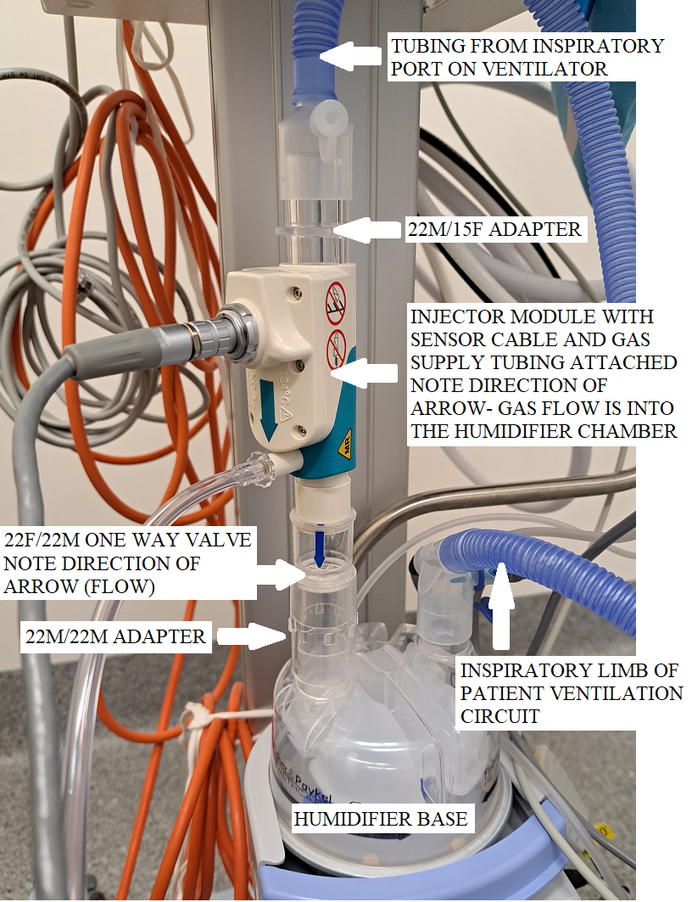
Image A: Connections required for nitric oxide therapy during mechanical ventilation.
Note: when checking the setup:
Arrows on injector module and one way valve indicate direction of gas flow
Connections should be in the following order
1. Gas source (Inspiratory outlet of ventilator or O2/air blender for CPAP/HHFNP)
2. Injector module (injector is always on the “dry” side of the humidifier)
3. Humidifier
4. Inspiratory limb of patient circuit (with sampling port connected)(“wet side”)
5. Patient interface (endotracheal (ET) tube/flow sensor OR CPAP snorkel OR HHFNP prongs)
6. Expiratory limb of patient circuit (returning to expiratory valve of ventilator or bubble chamber of CPAP (HHFNP does not have an expiratory limb).
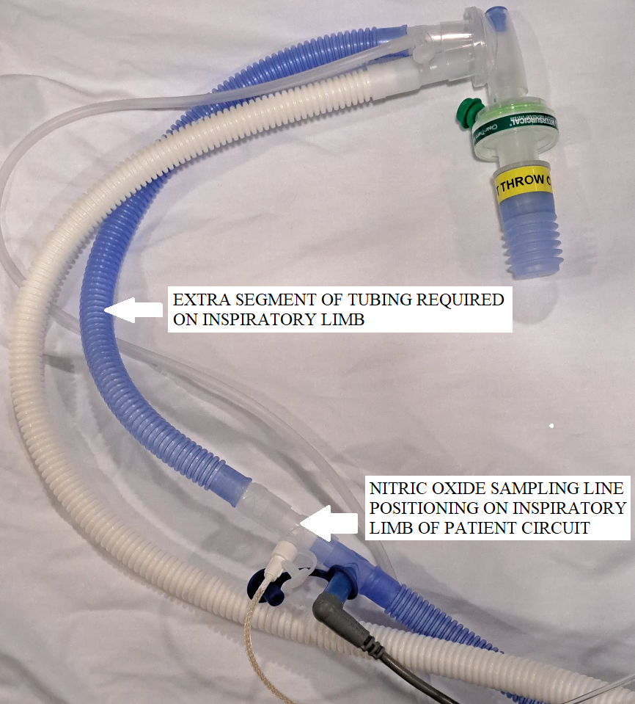
Image B: Sampling line positioning on patient circuit.

- Set up resuscitation equipment:
  - Connect oxygen tubing attached to blender of INOmax DSIR to Neopuff
  - Connect oxygen supply of INOmax DSIR to Air/Oxygen blender at patient’s bedspace. See Attachment 5 – Connection to Various Breathing Systems.
- If planned, neonatologist to attend to investigations stated in Alerts below. If need for nitric oxide is confirmed, bedside nurse to commence therapy. See Attachment 1. Initiation Therapy
- Commence nitric oxide therapy at 20ppm (Inspired Oxygen (FiO2) 100%) or as directed by consultant. See Attachment 1: Inhaled Nitric Oxide Initiation Flow Chart
- Assess response to iNO therapy- changes in oxygen saturations and FiO2, arterial blood gas sample 30-60 minutes after initiation of therapy, cardiac CPU, and general clinical status
- Minimise disconnection times to maintain continuity of nitric oxide delivery and maintain therapeutic vasodilatory effects, as nitric oxide has a very short half life
- Use a closed suction system for endotracheal suction in order to minimize disconnection time

Alert:
- Consider cranial ultrasound if possible prior to commencement of iNO therapy in infants <32 weeks gestation to exclude intraventricular haemorrhage (IVH). iNO therapy was associated with IVH in early uncontrolled studies of iNO in preterm infants however later controlled studies have not found the same association. iNO however can increase bleeding time in treated infants so caution should be used in infants at risk of bleeding/IVH
- Perform cardiac CPU if possible, prior to commencement of nitric oxide therapy to confirm the presence of pulmonary hypertension and exclude congenital heart disease
- Nitric oxide should not be administered to neonates with congenital heart disease who depend on a right-to-left shunt or have severe left heart failure
- Commence nitric oxide therapy when clinical or cardiac CPU/echo evidence of PPHN and FiO2 >0.4 or oxygenation index (OI)exceeds 15 despite other measures.
(OI=MAP x (FiO₂/PaO₂) (MAP= Mean Airway Pressure (cmH₂O), FiO₂= Fraction of inspired oxygen (%), PaO₂= Partial pressure of Oxygen in arterial blood (mmHg)).

- Monitor methaemoglobin levels 12 hourly and platelet levels and coagulation profile 24-48 hourly
- Nitric oxide concentration should be reduced or discontinued if methaemoglobin levels exceed 5-7 per cent
- Perform daily low calibration of nitric oxide unit as per instructions in Inovent® manual
- Record both NO and NO2 levels on respiratory flowsheet in DHR.
- Attend to patient care as per Neonatal Routine Care, Developmental Care in the Neonatal Intensive Care Unit and Special Care Nursery, and Respiratory Support – Invasive and Non-Invasive (Neonates and Infants)

Alert:
- Make sure to check cylinder has >500psi. If ≤500psi, replace cylinder. Refer to Attachment 6: Cylinder Size Duration Chart and Changing INOmax Cylinder Procedure
- NO₂ levels above 3ppm are considered toxic to the neonate and may require nitric oxide therapy to be weaned or discontinued.

- Follow pathways for response to therapy and weaning as per iNO stewardship protocol. See Attachments 1 and 2: Inhaled Nitric Oxide initiation and Weaning Flow Charts
- Once patient is successfully weaned as per Attachment 2 and has not met Weaning Failure Criteria, the Nitric Oxide may be disconnected from patient. Discuss with medical officer before doing so

Alert: Make sure to turn Nitric Oxide cylinder OFF once iNO therapy is ceased.

- When disconnecting the Nitric Oxide Injector Module and Sampling Line/Connector for Sampling Port, make sure:
  - Medical Officer is informed prior to procedure
  - 2 staff are available for the procedure (required)
  - Resuscitation Equipment is nearby and ready
  - Perform HH
  - One staff member to provide Neopuff IPPV (or CPAP if appropriate) with appropriate ventilation settings and oxygen
  - The second staff member to disconnect and remove module and sampling port
  - Provide appropriate response to changes in patient vital signs.
- Dispose of single use equipment and return reusable parts and Nitric Oxide to Equipment area for cleaning and reassembly. Refer to Attachment 4 - Pre-Use Assembly INOmax DSIR Nitric Oxide Machine.

Back to Table of Contents

Section 6 – Nitric Oxide Setup on Shuttle Transport Cot

The Shuttle Transport System is a battery powered mobile transport system with attached Neopuff and invasive and non-invasive respiratory support equipment. It is used to transport neonates and infants from different areas in the Canberra Hospital and Centenary Hospital for Women and Children such as Emergency Department, or Delivery Suite. If a neonate/infant requires NO during transport, the INOmax DSIR NO machine can be connected to the Neopuff System for iNO to be administered in transit. This procedure requires a Neonatologist/Advanced Trainee and nitric trained retrieval nurse. iNO therapy can be delivered in two ways using Shuttle Transport System:
- INO-blender (Manual Adjustment)
- INOmax DSIR (Digital Adjustment)

Equipment
- ABHR
- Shuttle Transport Cot
  - Neopuff
  - F&P Humidifier Base with pre-assembled CPAP equipment
- Giraffe Isolette, Giraffe Open Care Centre, or Panda Resuscitaire
- Nitric Oxide Machine (e.g. INOmax DSIR)
- Oxygen/Air tubing
- Connector for sampling port
- NO sampling line
- Additional Equipment for INOmax DSIR (Digital Adjustment) Procedure
  - Flow injector module
  - 22F X 15M Adapter
  - 22M/15F X 22M/15F Adapter
  - Neopuff humidifier circuit (Can also be used with INO-blender (Manual Adjustment) procedure)
  - Grey (Temperature) Wire

Alert:
- Ensure low and pre-use calibration and purge on INOmax DSIR has been attended in previous 12 hours
- Make sure to check cylinder has >500psi. If ≤500psi, replace cylinder. Refer to Attachment 6: Cylinder Size Duration Chart and Changing INOmax Cylinder Procedure
- Consider taking spare size C pinned Oxygen cylinder or size D Oxygen cylinder as an additional gas supply as a high FiO2 is expected for these infants.

Procedure

INO-blender (Manual Adjustment) see Image C for picture of set-up
- If humification required add in the Neopuff humidifier circuit to F&P humidifier base the shuttle. Refer to Care of the Extremely Preterm and Low Birth Neonate on how to set up Neopuff Humidifier Circuit
- Power cord not required. Remember no audible or visual alarms
- Remove the spare flow meter from air/oxygen blender on the shuttle.
- Add the NO white oxygen cable to the blender this enables the oxygen (O₂) delivered to be titrated.
- Attach the oxygen/air tubing from the INO-blender to front of Neopuff
- Open Air and O₂ cylinders on shuttle
- Turn on NO machine cylinder (no audible or visual alarms to prompt or remind you cylinder is on or off)
- Set iNO to 20ppm using INOblender manual dial
- Set INO-blender flow to 10L/min
- Set FiO₂ from the Air/O₂ blender dial of shuttle
- Set Positive Inspiratory Pressure (PIP) and/or Positive End-Expiratory Pressure (PEEP) as per MO
- Provide CPAP/IPPV with Neopuff as per Neonatologist instructions
- Once patient vital signs are stable or available treatments in the delivery room have been optimised, transport patient to NICU for ongoing care/additional treatments
- On arrival, safely change iNO therapy to required respiratory support with INOmax DSIR. Refer to Section 5- Commencing Nitric Oxide Therapy in NICU
- Identify and confirm patient identity
- Place patient identification sticker on NO Patient Log Book (every NO machine will have a log book)
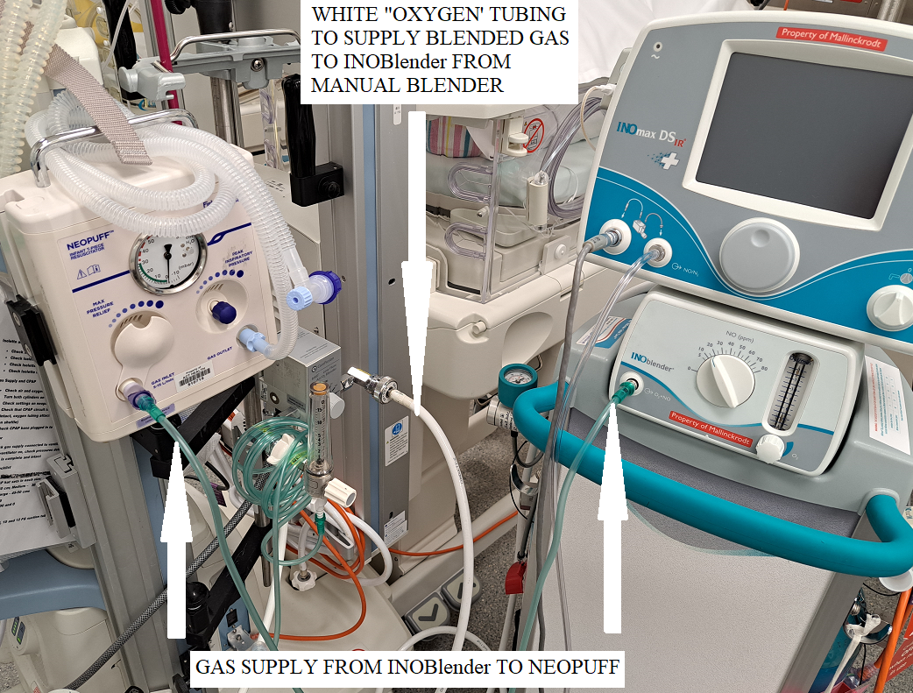
Image C: iNO blender set-up.

INOmax DSIR (Digital Adjustment) refer to Image D for picture of setup
- Add in the Neopuff humidifier circuit to F&P humidifier base the shuttle and attach to Neopuff. Refer to Care of the Extremely Preterm and Low Birth Neonate for how to set up Neopuff Humidifier Circuit
- Plug the NO machine to Shuttle
- Attach the Air/O₂ tubing from the Shuttle’s flow meter to the Neopuff
- Add injector module to dry side of humidifier base using connectors. Refer to Attachment 5 – Connection to Various Breathing Systems Attachment
- Add in sampling line to blue Neopuff tubing near grey wire close to neonate
- Turn on F&P humidifier base
- Open Air and O₂ cylinders on Shuttle
- Turn Shuttle flow meter to 10L/min
- Set FiO₂ from the Air/O₂ blender dial of shuttle
- Set Positive Inspiratory Pressure (PIP) and/or Positive End-Expiratory Pressure (PEEP) as per Medical Officer instructions
- Provide CPAP/IPPV as per Neonatologist/Advanced Trainee instructions
- Turn power on to INOmax DSR main screen
- Open NO cylinder and make sure >500psi
- Dial iNO dose to 20ppm (or as per Neonatologist/Advanced Trainee instructions)
- Once patient vital signs are stable or available treatments in the delivery room have been optimised, transport patient to NICU for ongoing care/additional treatments
- On arrival, safely change iNO therapy to respiratory support. Refer to Section 5- Commencing Nitric Oxide Therapy in NICU and Attachment 5 – Connection to Various Breathing Systems Attachment
- Identify and confirm patient identity
- Place patient identification sticker on NO Patient Log Book (every NO machine will have a log book)
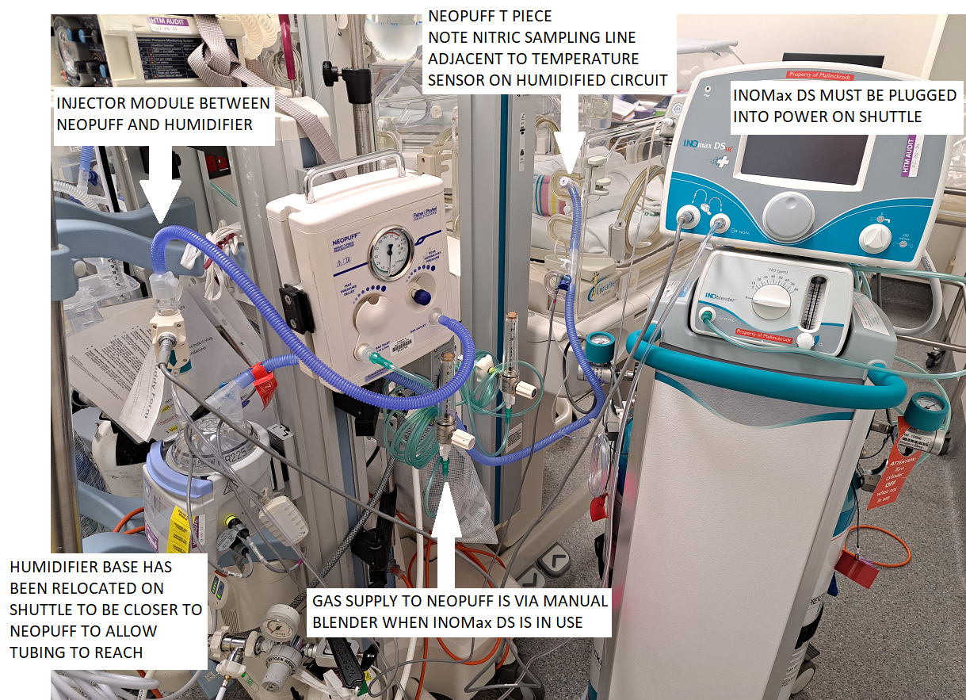
Image D: INOmax DSIR (Digital Adjustment) set up

Back to Table of Contents

Section 7 – Nitric Oxide Setup on Neonatal System (ERIC) during NETS Retrievals

Note: Refer to Neonatal Emergency Transport Service, Australian Capital Territory (NETS ACT) - Back-transfer, Elective Retrievals, Retrievals & Paediatric Stabilisations Procedure

Clinical management of PPHN in a retrieval environment should aim to replicate as closely as possible what would be done in the NICU. However, there are obvious limitations and logistic challenges. In most cases a retrieval team for a neonate with severe PPHN would require a 3-person team due to the severity of the illness and the extra equipment being utilised, however this should not incur delays in reaching the acutely unwell patient. Care of the patient with PPHN on retrieval should account for the inherent discomforts involved in transport (movement/vibration/noise/etc.) and efforts made to maximise comfort with hearing protection, non-pharmacological comfort measures and analgesia and sedation. Higher doses of analgesia and sedation may need to be used during retrieval.

Equipment
- ABHR
- Neonatal System (ERIC)
- Transport Nitric Oxide INOmax DSIR plus system w/ D-size Cylinder (located in the equipment room with assembled delivery circuit attached ready for pre-use checkout)
- Environmental monitors must be stored with the Nitric Oxide at all times.
- DSIR Plus Nitric Pack (See Attachment 7: DSIR Plus Nitric Pack Contents List)
- NETS Nitric Oxide Observations Chart – N2012 INOmax DSIR Plus (See Attachment 8)
- Laerdal Bag (Neonatal and Paediatric Size)

Procedure
Alert:
- Ensure that Transport Nitric Oxide INOmax DSIR plus system is pre-assembled and that low calibration and purge has been attended. If not refer to Attachment 9 - Nitric Oxide INOmax DSIR plus system Pre-assembly Procedure.
- Make sure to check cylinder has >500psi. If ≤500psi, replace cylinder. Refer to Attachment 6: Cylinder Size Duration Chart and Changing INOmax Cylinder Procedure
- Air, O_{2,} and NO Cylinders turned OFF until needed, to conserve gas supply

- Assemble retrieval team and assign roles
- Refer to retrieval process in Neonatal Emergency Transport Service, Australian Capital Territory (NETS ACT) - Back-transfer, Elective Retrievals, Retrievals & Paediatric Stabilisations Procedure
- Trained NETS ACT Retrieval staff to attach Transport Nitric Oxide INOmax DSIR plus system to Neonatal System
  - Unclip and remove the storage bin black net, the raincoat and its netting. The bin net can be left in the storage bin on the system. The raincoat and its net can be left on the cleaning shelf in the Equipment room at Base. See image E below.
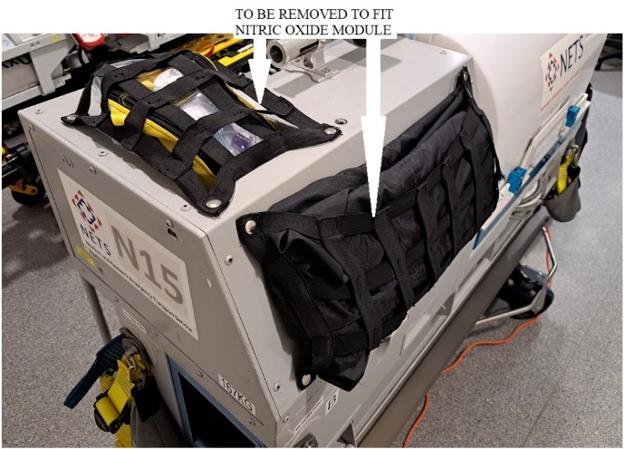
Image E: Neonatal system
  - With a minimum of two staff members, use the two handles to slide the Transport Nitric Unit on to the Neonatal system and secure in place via the three screw points. As per Image F below.
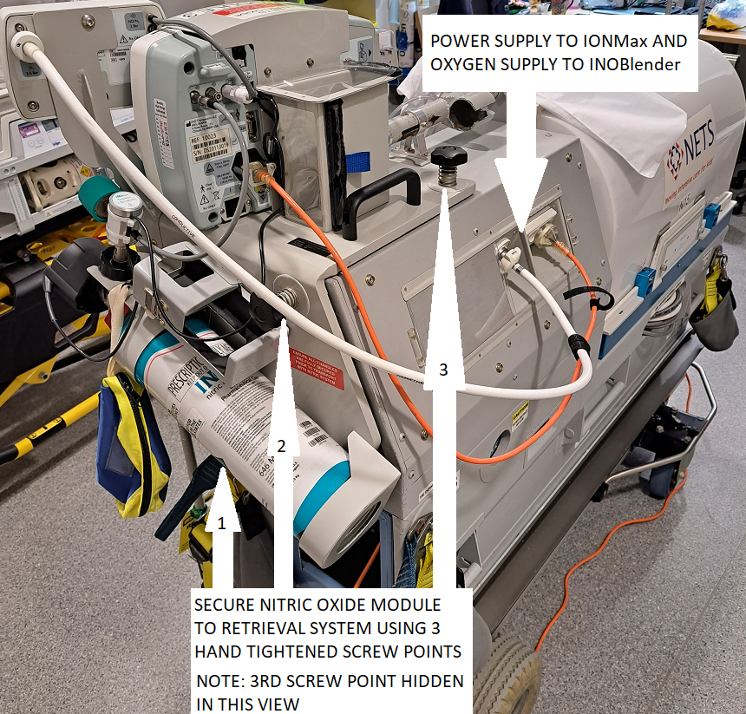
Image F: Nitric Oxide Module attached to neonatal system

  - Ensure Nitric Unit power source and high pressure oxygen hose is connected to the back of the N2012 system and the power is switched on.
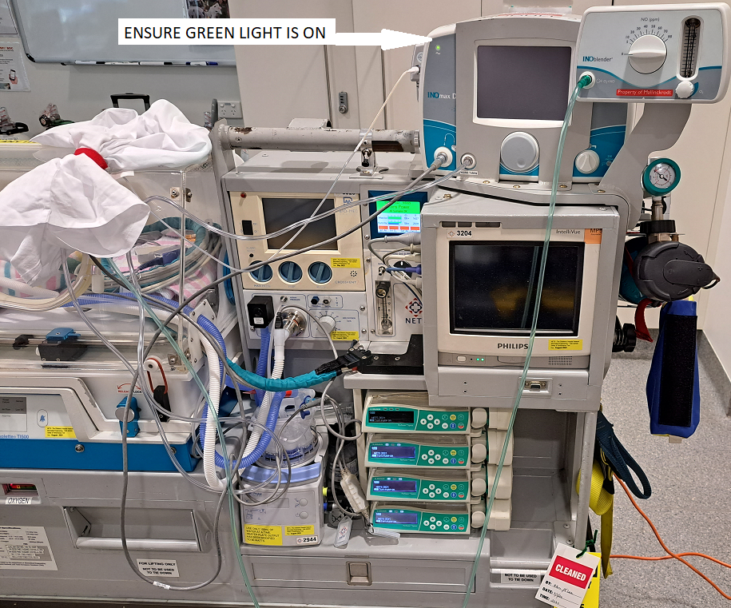
Image G: Pre-use setup (in pillowcase) connected to system with power connected (green light)
- When Neonatal System is ready (See Image G above), Retrieval Team to depart for referring hospital.
- On arrival to referring hospital, retrieval team to stabilise patient and commence appropriate respiratory support
- Medical Officer to prescribe iNO
- When ready to apply iNO therapy:
  - TURN ON AIR, O_{2,} and NO cylinders
  - Remove the blue corrugated tubing and sample line connector from the setup and checking circuit and place in Nitric accessories pack
  - Attach the patient sample line to the ventilator circuit sample connector from the crossvent circuit accessories packet then connect on the blue inspiratory limb of the ventilator circuit just above the temperature probe at patient end.
  - Add a 22F x 15M adapter to the humidifier base PRE HUMIDIFIER (dry side) and the 22M /15F x 22M / 15F to the other end of the injector module (Ventilator end)
  - Connect the injector module with the arrow pointing DOWN on the PREHUMIDIFICATION side of the humidifier chamber. See Image H and I below.
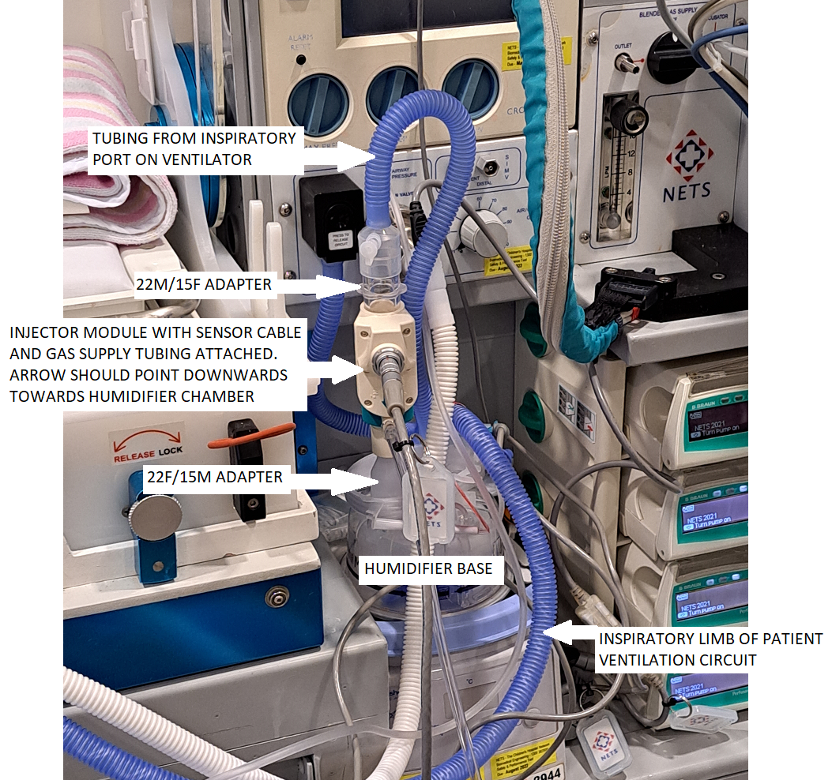
Image H: Ventilator and Humdifier set up

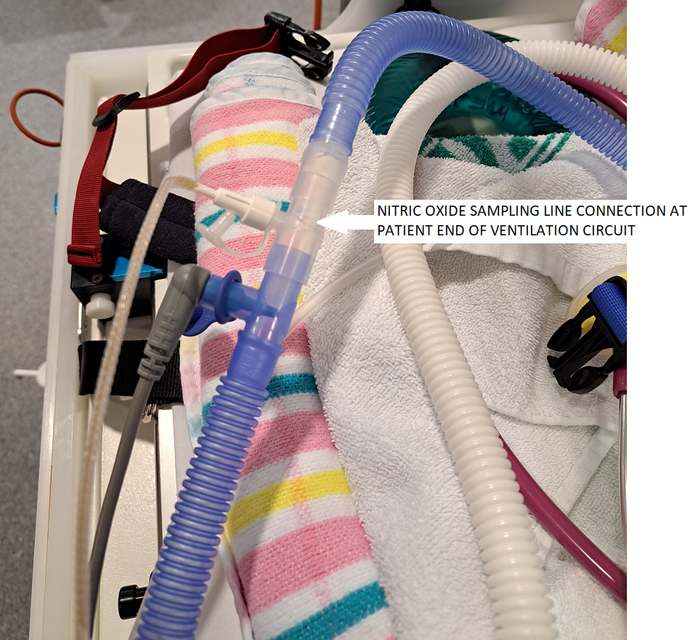
Image I: Sampling line set up.

- Connect Laerdel Bag to INO-blender flow outlet and can be stowed in the box behind Nitric Module
  - To be used for hand ventilating in an emergency during transfers
  - While in the ambulance there is a Neopuff available for manual ventilation in an emergency (preferred to Laerdal bag due to ability to give PEEP). This should be appropriate set up and connected to the INO Blender
- Turn power on to INOmax DSR main screen
- Dial iNO dose to 20ppm or as per Neonatologist/Advanced Trainee instructions
- Once patient vital signs are stable (or as stable as can be reasonably achieved in retrieval environment), ready infant/neonate for transport
- On commencement of iNO therapy document quarter hourly the set NO dose and administered reading (ppm); NO2, cylinder contents level (psi) and environmental monitor readings on INOmax DSIR Plus observation chart, and continue until infant is admitted to NICU bed
- Departing Referring Hospital:
  - Securely position environmental monitors so display can be viewed by clinical team, see Image J below
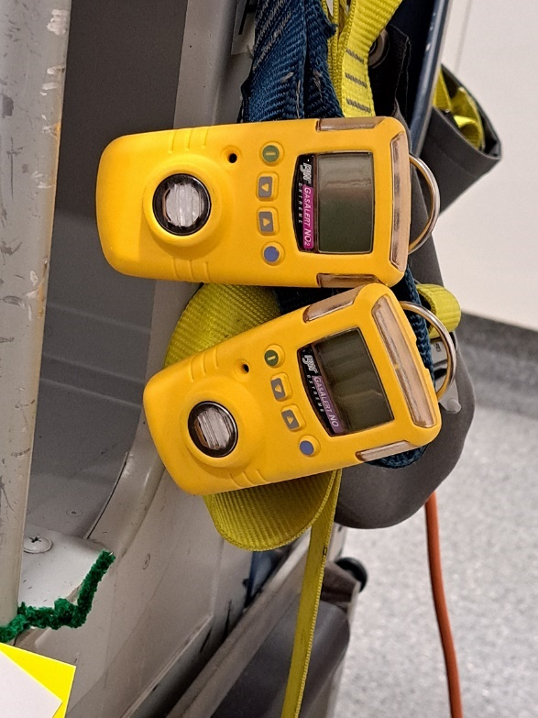
Image J: monitoring modules secured to strap on retrieval system
  - Ensure protective eyewear and oxygen masks are available in the event of a major leak
  - The Nitric team member must initiate discussion with other team members and porter/driver about the risks of disconnection of the iNO setup when moving in and out of vehicles/buildings and along corridors, footpaths etc. and agree on a plan in relation to movement of system
  - Ensure emergency vehicle operator is aware that Nitric Oxide is in use
- In-transit:
  - Ensure the Neonatal System power and gas supply are connected to vehicle supply during transport – this will supply the nitric module with power and medical gases
  - The nitric cylinder gauge must be visible to at least one team member
  - NO2 is toxic at greater than 3ppm. The NO2 should not exceed 0.5ppm on retrieval. If this occurs check gas flows and circuit integrity
- On arrival to Receiving Hospital:
  - Ensure ventilator and iNO is set up and working
  - When ready to transfer patient, disconnect ventilator and place test lung with HME on ventilator circuit
  - Connect patient to receiving unit ventilator and nitric set-up
  - Document contents of cylinder
  - Document number on digital display
  - Turn off INOmax cylinder and remove transport cap assembly
  - Replace red safety cap. “ ” should be seen on the digital display
Note: Ensure the N2012 system is always connected to the vehicle or hospital main power and gas supply unless moving to or from the vehicle. This minimises the risk of depleting the system internal battery and medical gas cylinders.

- Post-retrieval and restocking:
  - Ensure cylinder is closed and red safety cap in place
  - Purge nitric from system (grey regulator hose)
  - Remove Nitric set-up from ventilator circuit
  - Remove and wipe down grey injector module cable (non-disposable item)
  - Place Injector Module in the container marked “Injector module” and send to inhalation therapy for cleaning.
  - Remove and wipe down water trap and replace back on Nitric System (non-disposable item)
  - Remove and dispose of all single use equipment including:
    - Water separator cartridge
    - Clear nitric injector module tubing
    - Plastic adapters on either end of the injector module
    - Patient sample line
  - Restock paperwork, non-consumables and consumables
  - If cylinder > 500psi at the end of the retrieval a replacement will be required. Please inform NICU equipment officer as a new cylinder will need to be ordered
  - Ensure that Transport Nitric Oxide INOmax DSIR plus system is pre-assembled and low calibration and purge is completed
  - Ensure the contents of accessories pack are complete and ready for use then seal with a blue tag
  - Clean the Neonatal system as normal and resecure the bin netting and the system raincoat and netting.
Back to Table of Contents

Evaluation

Outcome
- Management of PPHN will be guided by this guide and overseen by senior staff
- Use of nitric oxide will follow the initiation and weaning flow charts
- Set up and use of equipment will follow this guidance

Measures
- Where a case is identified as having significant morbidity or mortality, it will be reviewed in detail at a Neonatal Mortality and Morbidity meeting.

Back to Table of Contents

Related Policies, Procedures, Guidelines and Legislation
Policy
Informed Consent - Clinical
Nursing and Midwife Board of Australia Requirements for Practice

Procedures
Respiratory support- Invasive and Non Invasive (Neonates and Infants)
Management of Neonatal Pneumothorax
Surfactant Therapy for Newborns
Neonatal Resuscitation and Airway Management
Neonatal Emergency Transport Service, Australian Capital Territory (NETS ACT) - Back-transfer, Elective Retrievals, Retrievals & Paediatric Stabilisations

Guidelines
Neonatal Intensive Care Drug manual

Legislation
Health Records (Privacy and Access) Act 1997
Human Rights Act 2004
Work Health and Safety Act 2011
Carers Recognition Act 2021

Other
Australian Charter of Health Care Rights

Back to Table of Contents

References

- Ng QX, Venkatanarayanan N, Ho CYX, Sim WS, Lim DY, Yeo WS. Selective Serotonin Reuptake Inhibitors and Persistent Pulmonary Hypertension of the Newborn: An Update Meta-Analysis. J Womens Health (Larchmt). 2019 Mar;28(3):331-338. doi: 10.1089/jwh.2018.7319. Epub 2018 Nov 8. PMID: 30407100.
- Lakshminrusimha S, Keszler M. Persistent pulmonary hypertension of the newborn. NeoReviews 2015 Vol 16 No12 e680-692
- NETS NSW inhaled Nitric oxide policy
- INOmax DSIR product information from Mallingkrodt Pharmaceuticals

Back to Table of Contents

Search Terms
Persistent Pulmonary Hypertension of the Newborn, PPHN, iNO, Nitric Oxide, Neonatal, Neonate, Department Of Neonatology, NICU, SCN, Neonatal Intensive Care, CPAP, ventilation

Back to Table of Contents

Attachments
Attachment 1: Inhaled nitric oxide initiation flow chart
Attachment 2: Inhaled Nitric Oxide Weaning Flow Chart
Attachment 3: Low Calibration with Pre-Use Procedure Check, and High Calibration Check
Attachment 4: Pre-Use Assembly INOmax DSIR Nitric Oxide Plus Machine
Attachment 5: Connection to Various Breathing Systems
Attachment 6: Cylinder Size Duration Chart and Changing INOmax Cylinder Procedure
Attachment 7: DSIR Plus Nitric Pack Contents List
Attachment 8: NETS Nitric Oxide Observations Chart – N2012 INOmax DSIR Plus

Disclaimer: This document has been developed by Canberra Health Services specifically for its own use. Use of this document and any reliance on the information contained therein by any third party is at his or her own risk and Canberra Health Services assumes no responsibility whatsoever.

Policy Team ONLY to complete the following:
Date Amended | Section Amended | Divisional Approval | Final Approval
22/09/2023 | New document | Suzanne Freiburg, ED WY&C | CHS Policy Committee

This document supersedes the following:
Document Number | Document Name

Attachment 1: Inhaled nitric oxide initiation flow chart
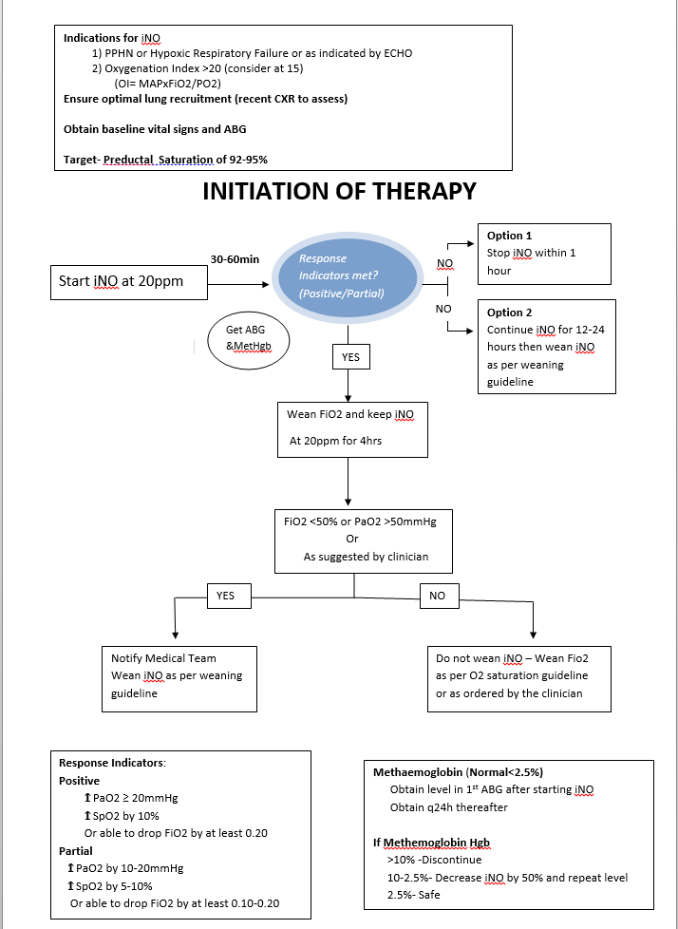

Attachment 2: Inhaled Nitric Oxide Weaning Flow Chart
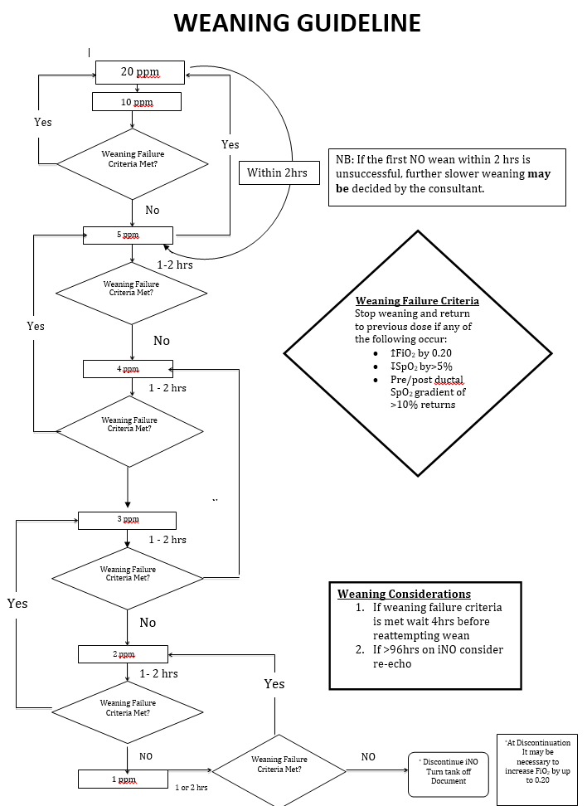

Attachment 3: Low Calibration with Pre-Use Procedure Check, and High Calibration Check
Note:
The INOmax DSIR Plus System Low and High Calibration Check is automated. Staff are to follow digital prompts. However, staff are required to be competent in using as well as be familiar with the purpose and location of the specific parts of the machine

If low or high calibration test fails, send to Equipment Officer and use a different INOmax DSIR Plus System. Alternatively, refer to INOmax DSIR Plus Operation Manual

Low Calibration with Pre-Use Procedure Check
- Turn ON The INOmax DSIR Plus System
- Low Calibration will automatically start
- Pre-Use wizard will provide step-by-step instructions to complete pre-use procedure. It will instruct you to check the following:
  - Water bottle and water separator cartridge in place
  - Cables and hoses for signs of damage or wear and make sure that everything is in place
  - Cylinder check
  - The INOmax regulator is securely connected to cylinder and no leak is evident
  - Integrated Backup Delivery System is working
  - Performance iNO delivery testing of INOmax DSIR Plus
  - INOblender test
  - The regulator line is depressured/purged after pre-use test
- To manually activate a Low Calibration Test
  - Click on Menu Button on top left of INOmax DSIR Plus screen
  - Press Low Cal and it will initiate low calibration. This will take ~3 minutes

High Calibration Check

Note: High Calibration Check to be done once a month and is usually undertake by Equipment Officer of Department of Neonatology

- Turn ON The INOmax DSIR Plus System
- Click on Menu Button on top left of INOmax DSIR Plus screen
- On Menu page, select High Cal and the next screen will have O₂, NO₂, and NO calibrations with due dates. If date is flashing, the calibration is past due
- High O₂ Calibration
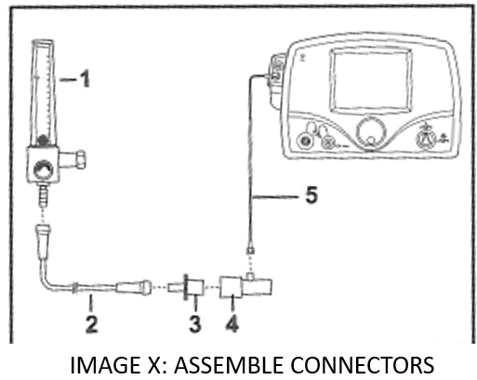
  - Press 100% O₂ button
  - Assemble connectors and set O₂ flow to 5L/min. See Image X: Assemble Connectors.
    - 100% O₂ Source
    - O₂ Tubing
    - 15M x 4.5 mm I.D Adapter
    - Gas Sample Tee
    - Patient Gas Sample Line with Nafion
  - Press Start Cal, and calibration will take 3 minutes
  - Green Bar should appear under O₂
- NO Sensor High Calibration
      - INO regulator, tubing adapter should be attached to INO NO calabration cylinder. See Image Y: NO calibration Gas below
      - Press 45ppm NO
      - Attach tubing kit to patient gas sample line
      - Press Start Cal, calibration will take 3 minutes
      - Green Bar should appear under NO
- NO₂ Sensor High Calibration
      - INO regulator, tubing adapter should be attached to INO NO₂ Cal cylinder. See Image Z: NO₂ Calibration Gas
      - Press 10ppm NO
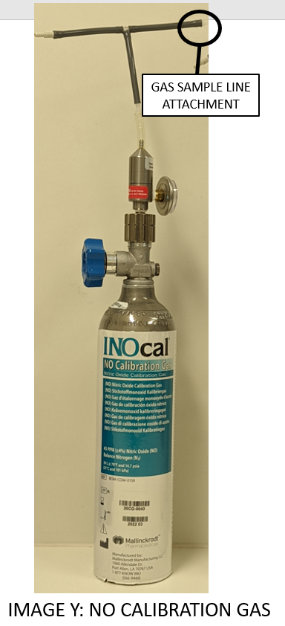
      - Attach tubing kit to patient gas sample line
      - Press Start Cal, calibration will take 3 minutes
      - Green Bar should appear under NO₂
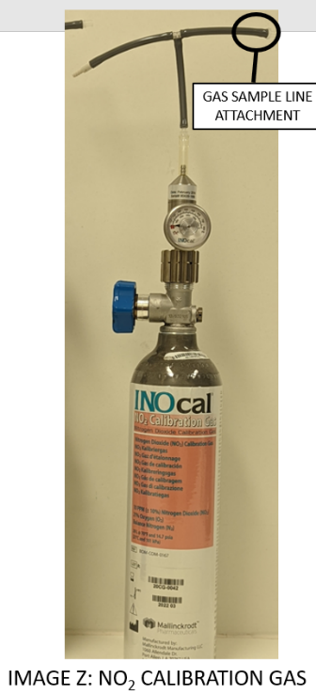

Attachment 4: Pre-Use Assembly INOmax DSIR Nitric Oxide Plus Machine
Equipment
- ABHR
- Disinfectant and Detergent Wipes
- INOmax DSIR Nitric Oxide Plus Machine
- Water Bottle
- Water Seperator Cartridge
- Gas Sampling Line with Nafion
- Injector Module
- Injector Module Cable
- NO/NO₂ Injector Tubing
- INOmax Cylinder
- INOmax regulator with hose
- INOblender inlet hose
- O₂ Tubing
- 15M x 4.5mm Adapter
- 22M/ 15F x 22M/15F Adapter
- 300mm of 22 mm Hose
- Gas Sample Tee

Procedure
- Perform HH
- Wipe machine and leads with Disinfectant and Detergent Wipes
- Replace water bottle and water separator cartridge. See Image I: Water Bottle and Water Cartridge.
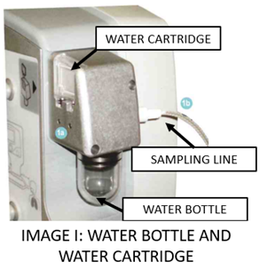
- Replace injector module and injector tubing
  - Used injector module to be sent to pre-rinse for sterilisation
- Replace cylinder if needed (<500psi)
  - Reconnect regulator to cylinder
- Check cables behind INOmax DSIR. See Image J: INOmax cables below.
Make sure that:
  - INOmax regulator hose is connected to INOmax inlets
  - INOblender inlet hose is connected to the INOblender outlet with white-quick connect cover
  - O₂ supply hose is fitted to the back of the INOblender
  - Infrared cable from INOmax DSIR cart is connected to the back of the INOmax DSIR Plus
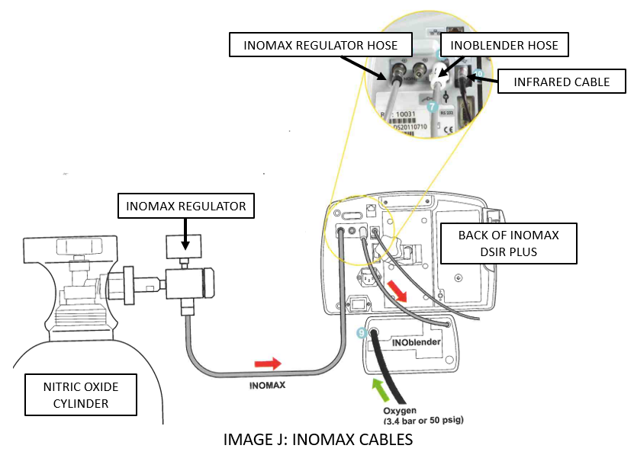

- Assemble pre-use set-up connectors and tubing. See Image K: Pre use set up
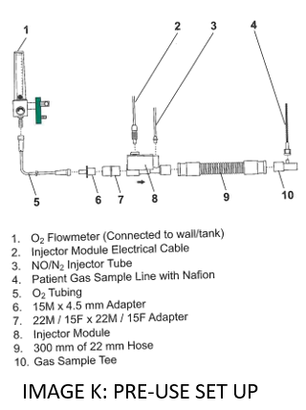

- Attend to Low Calibration with Pre-Use Procedure Check. See Attachment 4

Attachment 5: Connection to Various Breathing Systems

Bagging System using Injector Module
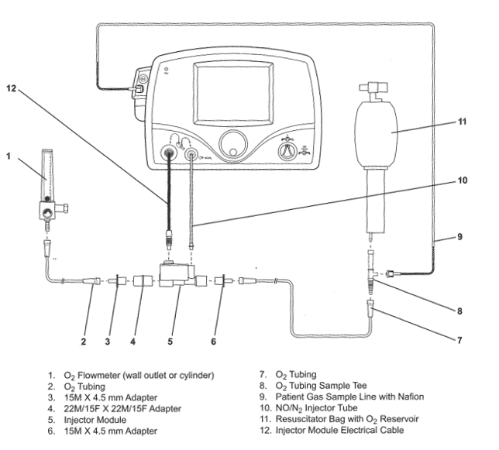

INOblender use with Neopuff
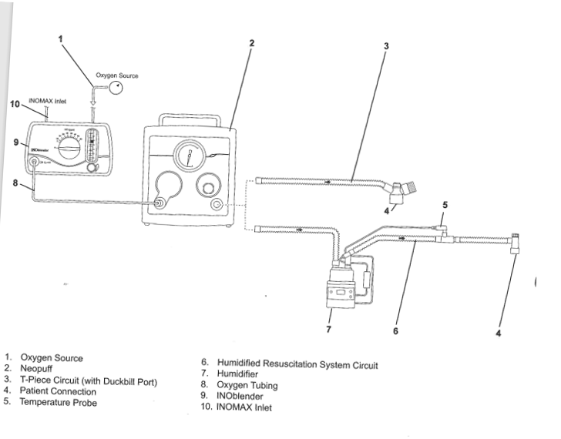

Heinen & Lowenstein Leoni-plus Ventilator and Servo-N
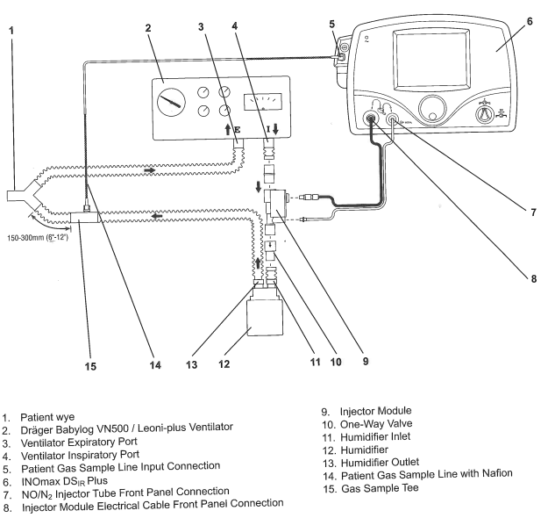

Fisher and Paykel Healthcare Bubble CPAP
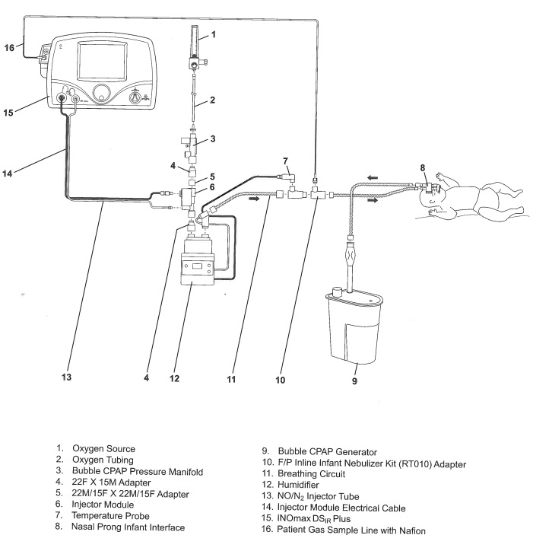

Fisher and Paykel Healthcare Optiflow Breathing Circuit
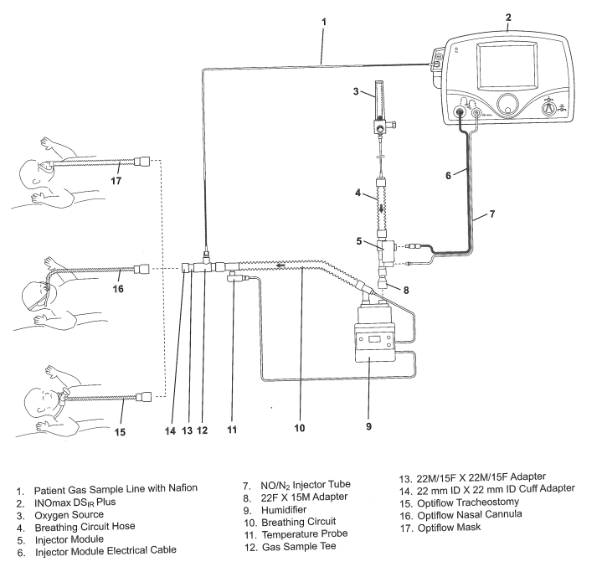

Attachment 6: Cylinder Size Duration Chart and Changing INOmax Cylinder Procedure

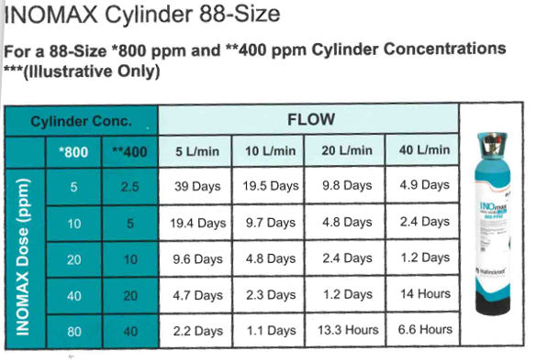
Changing the INOmax DSIR 88-Size Cylinder
- Check the INOmax cylinders for correct product identity, cylinder concentration, and expiration date.
- Verify cylinder has at least 500psi and ensure regulator fitting is tight to the INOmax cylinder.
- Attach a second INOmax SDIR Plus regulator which currently not in use
- Open and close the valve on the new INOmax cylinder. Check for adequate cylinder pressure.
- Monitor gauge for 30 seconds for any signs of leak
  - If there is decrease, check for leaks around hose connections and cylinder valve connector using soapy water
- Insert the NO/N₂ quick-connect fitting into the purge port on the back of the INOmax DSIR Plus and firmly push regulator pressure gauge reads zero
Alert: Make sure to purge system to ensure patient does not receive excessive levels of NO₂

- Prior to connecting a regulator hose, ensure the inlet connectors, on the INOmax DSIR Plus, have the knurled sleeve set in the back position
- Open the cylinder valve on the new cylinder (may active 2 cylinders alarm)
- Close the cylinder valve on the empty cylinder and remove the supply line from the back of the INOmax DSIR Plus
- Depressurize by using the purge port on the back of the INOmax DSIR Plus prior to removing the regulator from the empty cylinder
- Replace the empty cylinder with a full cylinder on the cart.

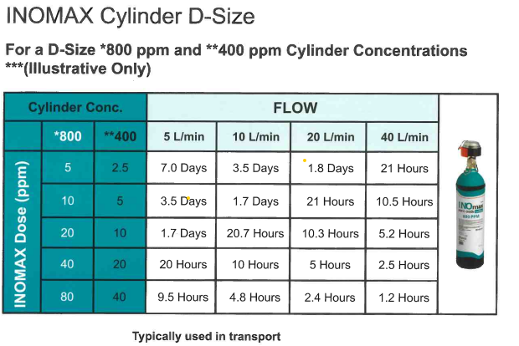

Changing Transport INOmax DSIR D-Size Cylinders
- Remove INOmeter wrapping (if applicable).
- Remove INOmeter lock
- Attach spare transport regulator/cap assembly to new cylinder
- Open, then close cylinder valve
- Confirm cylinder pressure is at least 500psi
- Observe that gauge pressure is steady for 30 seconds
- Purge regulator using purge port on the back of the INOmax DSIR
- Re-open new cylinder valve
- Connect new cylinder regulator hose to the available INOmax inlet
- Remove previously used cylinder regulator hose from the INOmax inlet
- Replace current IR cable with the IR cable from the spare transport regulator/cap assembly to the back of the INOmax DSIR Plus
- Close previously used cylinder valve
- Purge regulator on previously used cylinder
- Insert INOmeter lock on previously used cylinder

Attachment 7: DSIR Plus Nitric Pack Contents List
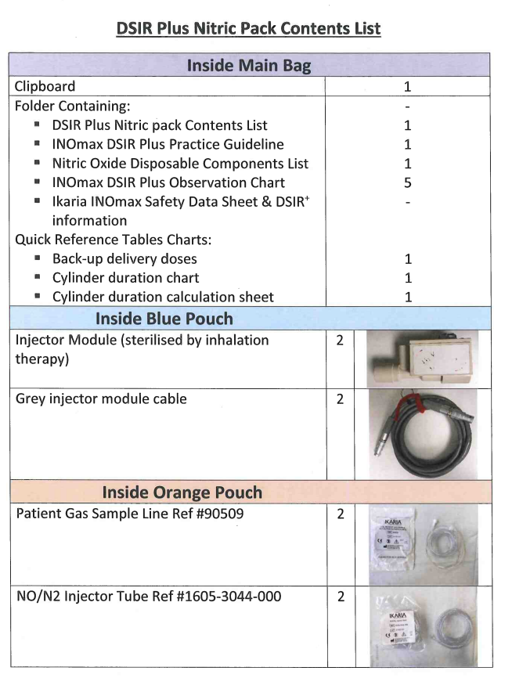
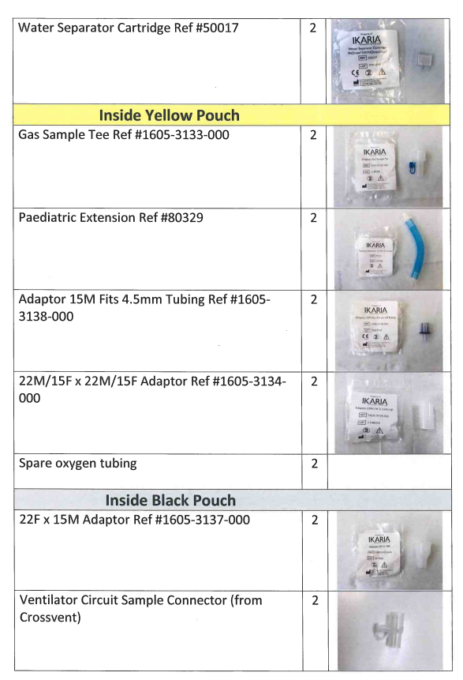
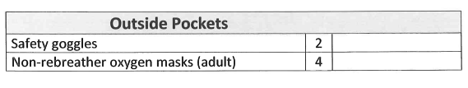

Attachment 8: NETS Nitric Oxide Observations Chart – N2012 INOmax DSIR Plus


