Procedure | Canberra Health Services
Laryngectomy Management in Adult Patients
CHS24/477

Contents
Purpose 2
Alerts 2
Scope 2
Section 1 – General Information 3
Section 2 – Pre-Operative Management and Assessment of Communication 4
Section 3 – Management of a Post-Operative Patient with Laryngectomy 6
Section 4 – Management of a Patient with an Acute Laryngectomy on the Ward 18
Section 5 – Emergency Management 22
Section 6 – Role of the Speech Pathologist 25
Section 7 – Communication Post Laryngectomy 26
Section 8 – Voice Rehabilitation and Voice Prostheses 31
Section 9 – Dysphagia (Swallowing Dysfunction) Post Laryngectomy 49
Section 10 – Management of an Established Laryngectomy 50
Section 11 – Discharge Planning and Community Care Program 51
Evaluation 53
Related policies, procedures, guidelines and legislation 53
References 54
Definition of terms 56
Search terms 57

Purpose
The purpose of this procedure is to outline safe, evidence-based management of adult patients undergoing laryngectomy surgery, including pre- and post-operative care, and for those with an established laryngectomy stoma within Canberra Health Services (CHS).

Exclusions:
This procedure does not apply to:
- the management of a paediatric patient with a laryngectomy
- the management of a patient with a tracheostomy. Please see Tracheostomy Management Adult Patients Procedure or Tracheostomy Care and Management – Infants, Children and Adolescents Guideline.
Back to Contents

Alerts
A laryngectomy is the surgical removal of the larynx resulting in a permanent separation of the trachea and the oesophagus, with the creation of a tracheostoma. The person can no longer breathe through their nose or mouth. The person is a total neck breather, and resuscitation and airway management are only possible via the stoma.
Note: A patient with an acute laryngectomy is defined as a patient with a newly formed laryngectomy stoma or an established laryngectomy stoma who is respiratory compromised. The procedure will impact the way the patients breathe, speak, swallow, smell and taste.
Back to Contents

Scope
This document applies to all CHS staff working within their scope of practice and involved in the care and management of adult patients with a laryngectomy including:
- Medical Officers
- Physiotherapists
- Speech Pathologists
- Nurses and Midwives
- Students under direct supervision.
Training requirements for a patient with a post-operative or acute laryngectomy with a laryngectomy tube OR an inner cannula / tracheostomy tube in situ are as follows:
- All nursing staff caring for patients with a laryngectomy tube/tracheostomy tube or an acute laryngectomy are to be assessed as competent by their Clinical Nurse Consultant (CNC) or Clinical Development Nurse (CDN).
- CDN’s can refer staff to the Tracheostomy ‘Self Directed Learning Package’ eLearning course available through HRIMS called CHS - Tracheostomy (el-2018-V2), which includes a ‘Tracheostomy Skills Assessment’.
- Speech Pathology staff working with patients with a laryngectomy, should complete the Speech Pathology Laryngectomy Learning Pathway and be deemed independent and competent in this specialist area by their clinical supervisor/senior.
- Physiotherapy staff working with patients with a laryngectomy tube/tracheostomy tube or an acute laryngectomy, must be assessed as competent in this specialist area by their clinical supervisor/senior
- Medical staff working with patients with a laryngectomy tube/tracheostomy tube or an acute laryngectomy, must be assessed as competent by their clinical supervisor or department director.
Back to Contents

Section 1 – General Information
A total laryngectomy is a surgical procedure which involves removal of the larynx, along with the epiglottis, thyroid cartridge, several tracheal rings and the hyoid bone. The procedure is primarily performed to treat patients with advanced laryngeal and hypopharyngeal cancer. In some cases, this surgery may also be conducted when patients have a non-functional larynx that does not provide adequate airway protection. Patients undergoing a total laryngectomy will lose their voice permanently.
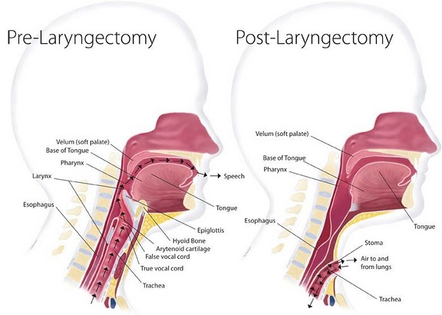

Reference http://trachs.com/laryngectomy/
Back to Contents

Section 2 – Pre-Operative Management and Assessment of Communication
A complete pre-operative physical assessment, a comprehensive review of the patient’s past medical and social history, as well as patient education, is required prior to a patient undergoing laryngectomy surgery. To facilitate this, the patient will need to be seen by the surgeon, anaesthetist, speech pathologist and head and neck cancer nurse specialist (if applicable).
As part of the pre-operative management, the patient will need:
- a medical assessment
- risk assessment for respiratory illness (influenza like symptoms)
- an assessment of the patient’s needs and support on discharge
- education regarding wound care, nasogastric or other enteral feeding, oral care, and airway management
- information about lifestyle changes
- education about communication/voice replacement options and what to expect initially in relation to their speech/communication ability post-surgery
- encouragement to involve family members or carers in the pre-operative assessment and education.
Note: Effective pre-operative discussion and education helps to reduce the patient’s and family members or carers anxiety, ensures true informed consent, and will promote a positive post-operative recovery.
Pre-operative patient education needs to be directed at the patient’s level of understanding.
A multidisciplinary pre-operative education and discussion session with the patient and family or carers is recommended as best practice.

Pre-operative Education & Assessment of Communication
Assessment of communication options post laryngectomy should commence in the pre-operative counselling sessions and may include discussion of the following laryngeal communication options:

Tracheoesophageal Speech using a voice prosthesis
Pre-Assessment suitability for tracheoesophageal speech:
Pre-assessment of suitability for primary or secondary Tracheoesophageal Puncture (TEP) and tracheoesophageal speech is undertaken during the pre-operative counselling session(s) and is best made in a multidisciplinary context with an Ear Nose and Throat (ENT) Specialist and Speech Pathologist. Primary TEP refers to creation of the puncture at the time of surgery whilst the term secondary TEP refers to when the procedure is undertaken at a separate time, after the total laryngectomy has been completed.
Some considerations for suitability for primary TEP:
- Indication that primary TEP is suitable from an ENT surgical team point of view
- Motivation must be high and ability to learn cleaning and voice prosthesis changing and emergency procedures, is essential
- Vision and manual dexterity must be adequate to handle a silicon tube approximately 3cm long
- The ability of the oesophagus to vibrate may be assessed using an air insufflation test (completed by ENT/Speech Pathologist) and, if required, is made on an outpatient basis by the ENT surgeon and the Speech Pathologist.
Other issues to be considered include:
- Speech intelligibility, including integrity of speech articulators e.g., lingual range of movement
- Cognition
- Planned surgical resection and reconstruction
- Planned prior or secondary radiation treatment
- Social supports and networks
- Proximity to a managing Speech Pathologist locally, e.g., rural and remote patients.
If the individual is deemed an unsuitable candidate for primary TEP, consideration for secondary TEP may be appropriate in the future. If a primary TEP is made at the time of surgery, the voice prosthesis may be placed at the time of surgery or, if not possible, the nasogastric feeding tube (NGT) can be placed in the TEP, to stent it open until suitable for initial voice prosthesis placement post-surgery.
Provox Vega Puncture Sets are stocked in theatres in sizes 17Fr 8mm, 17Fr 10mm and 17Fr 12.5mm. Decision regarding appropriate size voice prothesis to be inserted during primary or secondary TEP, is primarily made by the ENT surgeon, in consultation with the Speech Pathologist. Factors to be considered include previous radiation, presence and location of flap, and the individual patient’s tissue integrity/thickness.
A secondary TEP may be appropriate if in line with the above and following criteria:
- Period after laryngectomy operation is at least 6 months
- Stoma size and shape will allow easy insertion of prosthesis
- Vision and manual dexterity are adequate
- Ability of the oesophagus to vibrate, may be assessed using an air insufflation test (completed by ENT and Speech Pathologist) or a video fluoroscopy, on an outpatient basis by the Speech Pathologist
- Demonstrated ability to care for the stoma and voice prosthesis is essential.

Artificial Laryngeal Speech
The electrolarynx may be considered a communication option post-operatively. If there are concerns regarding oedema and/or pain of the neck tissues in the immediate post operative period, it could be initially used with an intraoral adaptor/attachment or with cheek placement. Patients require structured and consistent practice with a trained Speech Pathologist.
Consideration may need to be given to the following:
- Speech intelligibility including integrity of articulators
- Dexterity to hold the device
- Cognition
- Motivation for acquisition of artificial laryngeal speech
- Proximity to a managing Speech Pathologist locally, e.g., rural and remote patients.

Oesophageal Speech
Pre-operative education should also introduce the method of voice production for oesophageal speech.
Consideration may need to be given to the following:
- Physical factors, e.g., extent of surgery, structural integrity and status of pharyngo-oesophageal (PE) segment
- Cognition
- Availability of trained Speech Pathologists.
Back to Contents

Section 3 – Management of a Post-Operative Patient with Laryngectomy
Patients who have undergone laryngectomy surgery will be nursed in the Intensive Care Unit immediately following surgery. An Alert Management System needs to be submitted on the patient’s file in the Digital Health Record (DHR), stating that they are a “Neck Breather”. This will be displayed on the patient’s Storyboard – ideally placed immediately post-surgery, otherwise as soon as practicable by medical, nursing or allied health staff. A surgical airway must also be added to the patient’s Avatar. Once the patient is deemed suitable, they will be transferred to a ward bed on a tracheostomy designated ward.
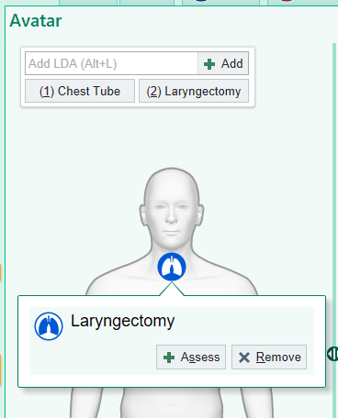
Lines, Drains, Airways (LDA) Avatar Image

Patient DHR icon to alert staff the patient is a Neck Breather
Note: A patient with a newly formed laryngectomy will require a single ward bed if available. This is due to infection control and aerosol generating procedures. Patients will be allocated to a tracheostomy accredited ward to ensure appropriately trained staff can care for the patient. Patients undergoing a total laryngectomy are permanently left without a voice. It is important to ensure that every effort to promote non-verbal communication is given to the patient. Please see Section 7- Communication Post Laryngectomy.

Note: All post-operative patients with a laryngectomy require a tracheostomy competent nurse escort when leaving the ward.

Equipment
All equipment must be available at the bedside when a patient who has undergone a laryngectomy returns to the ward. The same equipment must also be kept in a portable Laryngectomy Emergency Kit and is to accompany the patient when leaving the ward for a procedure or transfer to another ward.
Laryngectomy Emergency Kit must contain the following:
- Tracheal dilators
- Functioning wall oxygen and suction (portable oxygen and suction required when patient is leaving the ward for a procedure or transfer to another ward)
- Laryngectomy suitable (tracheostomy) oxygen mask and oxygen tubing
- Nebuliser mist chamber
- Hard or soft laryngectomy tube sized by the Speech Pathologist / ENT (if in use)
- Tracheostomy tube (if in use)
- Neck straps or ties for the Laryngectomy/Tracheostomy tube (if in use)
- Humidifier (e.g., Fisher & Paykel AIRVOTM (AIRVO)
- Consumable Heat Moisture Exchange (HME) cassettes +/- base plates (if in use)
- Neonatal mask
- Y-Suction catheters (size dependent on patient’s requirements and tube sizing)
- Yankauer sucker
- Light source (i.e. torch)
- Personal protective equipment (PPE)
- Alcohol based hand rub (ABHR)
- Mouth swabs
- Sterile gauze
- 0.9% sodium chloride 10mL ampoules
Note: If a laryngectomy patient requires a tracheostomy tube or hard laryngectomy tube with inner cannula in situ, the same size tube and one size smaller must be available at the bedside and in the Laryngectomy Emergency Kit, in case of dislodgement.

Note: A full oxygen cylinder and portable suction (with suction tubing) must accompany the patient if leaving the ward. The Laryngectomy Emergency Kit is the responsibility of the nurse caring for the patient and is to be checked each shift for completeness. The stock in the kit is for emergency management only.

Clinical Management

Humidification
In normal breathing, the upper respiratory tract filters, warms and moistens inhaled air. Following a laryngectomy, this protective system is bypassed, and the patient will require additional humidification, to prevent crusting around and in the stoma/trachea, thickened sputum, and sputum plugs. Warm humidification is administered by the Fisher & Paykel AIRVOTM (AIRVO) system or via HME cassettes, fitted to a base plate or laryngectomy tube. An AIRVO can be obtained from central equipment stores and cassettes will be prescribed by the Speech Pathologist from ward consumables stock.
Note: Stoma plugging and difficulty maintaining stoma patency, could result in a partial or complete occlusion of the patient’s airway.

Equipment
Humidification circuits must be changed weekly.
- AIRVO humidifier
- Disinfection tube (cleaning tube)
- Corrugated humidification tubing/heated breathing tube
- Humidification chamber/water chamber
- IV pole
- Sterile water (1000mL)
- Power cord
- Connector straight flexi tube
- Tracheostomy oxygen mask or tracheostomy direct connection (If tracheostomy tube or hard laryngectomy tube with inner cannula is in situ)
- Oxygen inlet extension kit
Note: All equipment is single patient use, excluding the AIRVO humidifier and disinfection tube. The AIRVO humidifier needs to be returned for cleaning, to Central Equipment Stores when no longer in use.
Throughout the procedure, perform hand hygiene as per the 5 moments of hand hygiene and don and doff PPE where required, as per the Infection Prevention and Control Procedure.
Mucous accumulated on the HME should not be utilised for respiratory testing, as it may contain virus from an inhaled exposure that has not resulted in infection.

Procedure (Setting up AIRVO in hospital)
- Explain the procedure to the patient and gain consent.
- Ensure privacy.
- Water chamber: Remove water chamber from packaging, remove blue port caps from chamber, insert supplied adapter over the two vertical ports. Fit water chamber to the unit by pushing the blue finger guard, the chamber should firmly lock into place.
- Hang sterile water bag on IV pole above the unit, insert spike from the humidification chamber into the sterile water bag. Check water flows into the chamber and is maintained below the fill line (arrow around circumference of chamber). If the water rises above the line, change the chamber immediately.
- Insert the blue plastic connector of the heated breathing tube into the humidifier; connect the other end of the heated breathing tube into the inspiration outlet of the ‘Y Connector’. A connector straight flexi tube may be used on the expiration outlet. If using a tracheostomy mask/interface, attach to the end of the heated breathing tube.
- Plug the unit’s power cord into the power socket.
- Turn the unit on by pressing “on/power” button. When the unit has warmed up, the “Ready for Use symbol - tick” will be displayed, with the temperature below. The unit will continue to warm up until 37˚C is reached.
- Flow setting: is pre-set to a selected flow in Hospital Mode. Flow can be set in 5L/min increments, within a range of 15-45L/min. To check the pre-set flow, press right arrow button. If the lock symbol is displayed, the flow is locked at displayed flow rate. To unlock flow, press and hold the up and down buttons simultaneously until a beep sounds (3 seconds). Use the up-down buttons to adjust the flow. Press the button on the right to return to the main display. A medical officer should document the flow settings in the patient’s clinical records. Flow rate should be documented in Flow sheets when vital signs are checked and recorded.
- Oxygen Therapy: Check the oxygen inlet port on the back of the unit, is connected properly to the filter holder and check that the filter holder is connected correctly to the unit. Connect oxygen tubing onto oxygen port and dial up oxygen to achieve FiO₂ based on flow setting. Refer to oxygen chart sticker titled “Unit Airflow Settings on AIRVO (L/min)”.
- The humidification air/oxygen mixture is ready for use when the “Ready for Use symbol - tick” appears and the temperature is displayed.
- Attach the interface to the patient’s stoma (If the patient is wearing an HME cassette, this should be removed prior to placing the mask over the stoma).
- The humidifier chamber, circuit, and patient interface must be changed every 7 days or when visibly soiled.
- When unit is no longer required, press the on/off button for 3 seconds.
- Wipe down the humidifier with a detergent wipe before returning it to central equipment stores for cleaning.
Refer to AIRVOTM Hospital Use Operating Manual Fisher & Paykel HEALTHCARE for full product and safety information and the AIRVO 2 User Manual, http://www.fphcare.com/product-overview/ProductAlphaCategories$category-abc/airvo.html .

Stoma Care
The laryngectomy stoma is cleaned every four hours or more frequently as clinically indicated to remove any visible sputum plugs or crusting.
Note: Never occlude the stoma, this is the patient’s only airway.
Care must be taken when cleaning to reduce the risk of introducing fluid (saline or water) into the stoma i.e. to avoid aspiration.
Cotton wool or tissues must not be used to clean around the stoma due to the fibres that can irritate or migrate into the airway.
Precautions need to be taken when showering to avoid any water entering the stoma (the Speech Pathologist may provide a shower shield attachment for a laryngectomy tube (if being used) for the patient to use – please note the shower shield attachment will help prevent water entering the tracheostoma but does not eliminate risk).

Equipment
- PPE including gloves, eye protection, and mask
- ABHR
- Sterile dressing pack
- Sterile sodium chloride 0.9% for irrigation
- Extra sterile gauze if required
- Sterile metal forceps
- Torch or adequate light source
- Cavilon Advance Skin Protectant cream for surrounding skin
- Mirror if patient is self-caring or receiving education/training on management of the stoma
- Tracheostomy dressing if tracheostomy tube in situ
- Tracheostomy cleaning brush if tube insitu.
Note: Throughout the procedure perform hand hygiene as per the 5 moments of hand hygiene and don and doff PPE where required, as per the Procedure Infection Prevention and Control Procedure. P2/N95 mask to be worn for all aerosol generating procedures.

Procedure
- Explain the procedure to the patient and gain consent.
- Ensure privacy.
- Set up dressing trolley and equipment.
- Remove any dressings from the stoma site if present. If the patient is using a laryngectomy tube or +/- HME or base plate with HME, remove both.
- Use light source to inspect the stoma for crusting.
- Encourage the patient to cough and clear stoma. If any sputum or crusting visible, remove any crusting gently with forceps. If crusting is dry and adhered to skin, humidification may be required first to soften prior to removing to avoid trauma to the skin. If bleeding occurs outside the stoma during crust removal, apply gentle pressure using sterile gauze until bleeding has ceased.
Note: If bleeding occurs within the stoma, if possible, apply gentle pressure using sterile gauze, without occluding or compromising airflow and inform the treating medical team immediately.
- If there is crusting visible, the method of humidification may need to be reviewed by the treating medical team.
- Clean the skin around the stoma using a moistened gauze swab using sterile 0.9% sodium chloride.
- Clean gently to avoid damage to the surrounding skin and do not use over wet gauze to minimise fluid entering the stoma.
- Maintain aseptic technique as per the Aseptic Technique Procedure.
- After cleaning completed, apply a thin smear of Cavilon skin protectant to protect the stoma and reduce crusting – use minimal amount to prevent maceration of skin.
- Observe for signs of infection, notify the treating medical team if infection present and document this in the patient’s clinical record.
- Assess the stoma including size, skin integrity, colour, and swelling. Notify the treating medical team of any abnormalities and document in the patient’s clinical record.
- Apply a tracheostomy dressing (gauze or antimicrobial) beneath the laryngectomy or tracheostomy tube if a tube is present.
- Replace, clean and dry laryngectomy tube and HME (if in use).
- Doff PPE and perform hand hygiene.
- Document stoma integrity and care in patient’s clinical record.

Suctioning
Suctioning of a laryngectomy is used to maintain a patent airway and assist with the removal of secretions for patients who are unable to clear secretions independently. Patients should be encouraged to clear their own airway by coughing. A Yankauer sucker may be used for removing the secretions from the stoma if required. Patients usually only require suctioning in the acute post-operative period; however, it is also used for patients with both acute and established laryngectomies. Suction is to be applied via an open circuit unless a tracheostomy tube or hard laryngectomy tube with inner cannula is in situ. In these cases, closed circuit suction can be used.
The procedure described below is for open circuit suctioning. For suctioning a laryngectomy stoma with a tracheostomy tube or hard laryngectomy tube with inner cannula in situ, please refer to the Tracheostomy Management – Adult Patients Procedure, Section 3 – Suctioning”.

Scope of Suctioning
Suctioning of adult patients with a laryngectomy, a hard laryngectomy tube with inner cannula, or a tracheostomy tube, is within the scope of appropriately trained Medical, Nursing and Allied Health staff.

Training Requirements
- Nursing Staff: All nursing staff caring for patients with a laryngectomy need to be assessed as competent with tracheostomy care and management by their CNC or CDN.
CDN’s can refer staff to the Tracheostomy ‘Self Directed Learning Package’ eLearning course available through HRIMS called CHS - Tracheostomy (el-2018-V2), which includes a ‘Tracheostomy Skills Assessment’.
- Allied Health: Allied health staff need to be assessed as competent using suction by their clinical supervisor/department.
- Medical Staff: Must be assessed as competent using suction by their clinical supervisor or department director.

Objectives of Suctioning
- To maintain a patent airway
- To ensure adequate oxygenation and ventilation
- To reduce the patient’s work of breathing

Indications for Suctioning
- As part of a respiratory assessment:
  - coarse breath sounds on auscultation of the patient’s chest
  - tactile fremitus (palpable secretions in chest)
  - inability to generate an effective spontaneous cough
- The need to maintain patency and integrity of the airway
- Visible secretions in either the tube or stoma
- Audible upper respiratory tract noises
- To remove any aspirated material via the TEP or a leaking voice prosthesis
- Deterioration of the patient’s Arterial Blood Gas (ABG) results
- Deterioration of the patient’s Oxygen saturation (SpO₂)
- It is clinically apparent that the patient’s breathing is requiring more effort
- Chest X-Ray (CXR) changes consistent with sputum retention
- The need to obtain a sputum specimen

Contraindications & Precautions
Suctioning is contraindicated in patients with:
- Platelets less than 50 (high risk of bleeding)
- Pulmonary Haemorrhage
Suctioning should be only used with extreme precaution in patients with:
- Severe bronchospasm
- Unstable haemodynamics
- Uncontrolled intercranial pressure (ICP) greater than 20mmHg.
If the patient has a ‘precaution’ to suction condition, the benefits of suctioning need to be weighed against the associated risks. If in doubt, the decision to suction needs to be made early in consultation with the medical team and documented clearly in the patient’s clinical record.

Monitoring
It is strongly recommended to continuously monitor the following patient vital signs:
- SpO₂ & Heart Rate (HR) with pulse oximeter
- ICP & Blood Pressure (BP) if relevant
- Patient’s colour and physical response to suctioning

Suctioning a Laryngectomy Stoma (open suctioning as per p11)
Suctioning of a laryngectomy stoma is performed as a sterile procedure.

Equipment
- ABHR
- Wall suction, suction canister and suction tubing
- Y suction catheter
- PPE, including gloves (clean and sterile), gown, goggles, face mask
- Oxygen
- Resuscitation bag
- Water for irrigation bottle
- Patient monitoring as above
Note: Throughout the procedure perform hand hygiene as per the 5 moments of hand hygiene and don and doff PPE where required, as per Infection Prevention and Control Procedure. P2/N95 mask to be worn for all aerosol generating procedures.

Procedure
- Explain the procedure to the patient and gain consent.
- Ensure privacy.
- Check the wall suction device is attached to the wall correctly:
  - Check canister is attached to wall suction device
  - Replace canister insert once three quarters full or the suction pressure is adversely affected
  - Check suction tubing is attached to the canister
  - Set desired suction pressure using the dial or tap on the wall suction device. Suction pressure for adults should be set between 100-150 mmHg.
Note: Wall suction dials may not be accurate, so it is recommended to use the glove test to check pressure.
‘Glove test’ - suction pressure should just pull glove away from a gloved hand for adult airway.
- Position patient in a high sitting position, if able and within medical limits.
- Ensure the patient has adequate oxygenation, pre-oxygenate the patient if necessary
  - Ensure the patient’s SpO2 is monitored throughout the procedure
  - Apply supplemental oxygen to the patient if required.
- Assess the patient’s secretions and respiratory status.
- The assessment will determine if the patient requires shallow suction or deep suction.
- Open suction catheter packet to expose adaptor only. Hold the adaptor with your dominant hand. Use your non-dominant hand to attach to suction tubing.
- Secure suction catheter with attached tubing under axilla of dominant arm so both hands are free.
- Put a sterile glove on dominant hand (over the top of glove if performing a double gloved procedure).
- Carefully slide catheter out of packaging with clean hand on adaptor and with sterile hand securing suction catheter to ensure sterility of the catheter is maintained.
- Introduce the catheter into the laryngectomy stoma using dominant/sterile hand without applying any suctioning.
- Insert catheter until the patient’s cough reflex is stimulated, gentle resistance is felt, or at a pre-determined length. Depth of suctioning will be dependent on need for suctioning, e.g., to clear mucous plug vs removing shallow secretions.
- Withdraw the catheter 1 cm and commence suction by placing your clean thumb over the suction port. Slowly remove suction catheter while suction is applied.
- Suction should be applied for no longer than 15 seconds during each pass of the catheter.
- Assess whether the patient needs further suctioning by listening for audible secretions and assessing the amount of sputum obtained.
- The suction catheter may be reintroduced into the stoma a second time if the tubing has remained sterile. If further suctioning is required, a new suction catheter is required
- Dispose of suction catheter, gloves and packaging.
- Clean suction tubing with water for irrigation by placing the suction tubing in a sterile water container.
- Monitor patient’s vital signs and appearance as directed.
- Document the suctioning and any significant findings in the patient’s clinical record. Notify the patient’s medical team of any concerns.

Care of the Tracheostomy and Hard Laryngectomy Tube with Inner Cannula
Some patients with a newly formed laryngectomy may have a tracheostomy or hard laryngectomy tube with inner cannula in situ. These are used to maintain a patent airway and stoma size following a laryngectomy procedure. For care and management of these tubes please refer to the Tracheostomy Management - Adult Patients Procedure.
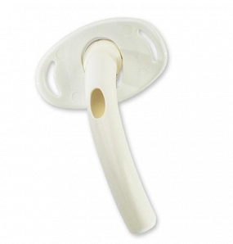
Shiley Hard Laryngectomy Tube
Reference: https://www.medline.com/product/Shiley-Cuffless-Laryngectomy-Tubes-by-Medtronic/Tracheal-Airways/Z05-PF263220 Date accessed: 23/10/2024

Care of the Soft Laryngectomy tube
Some patients with a newly formed or established laryngectomy may have a soft laryngectomy tube or laryngectomy button in situ. These are used to maintain a patent airway and stoma size following a laryngectomy procedure and to house HME cassettes. The tubes are usually shorter and a different shape than normal tracheostomy or hard laryngectomy tubes and are always uncuffed.
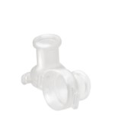
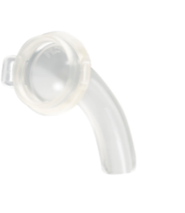
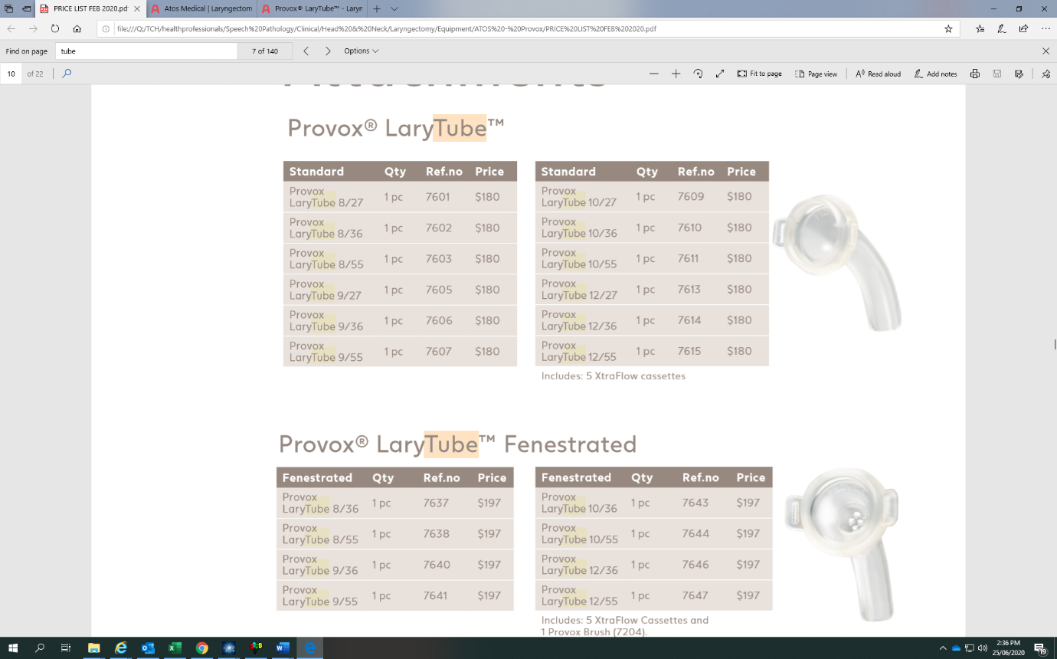
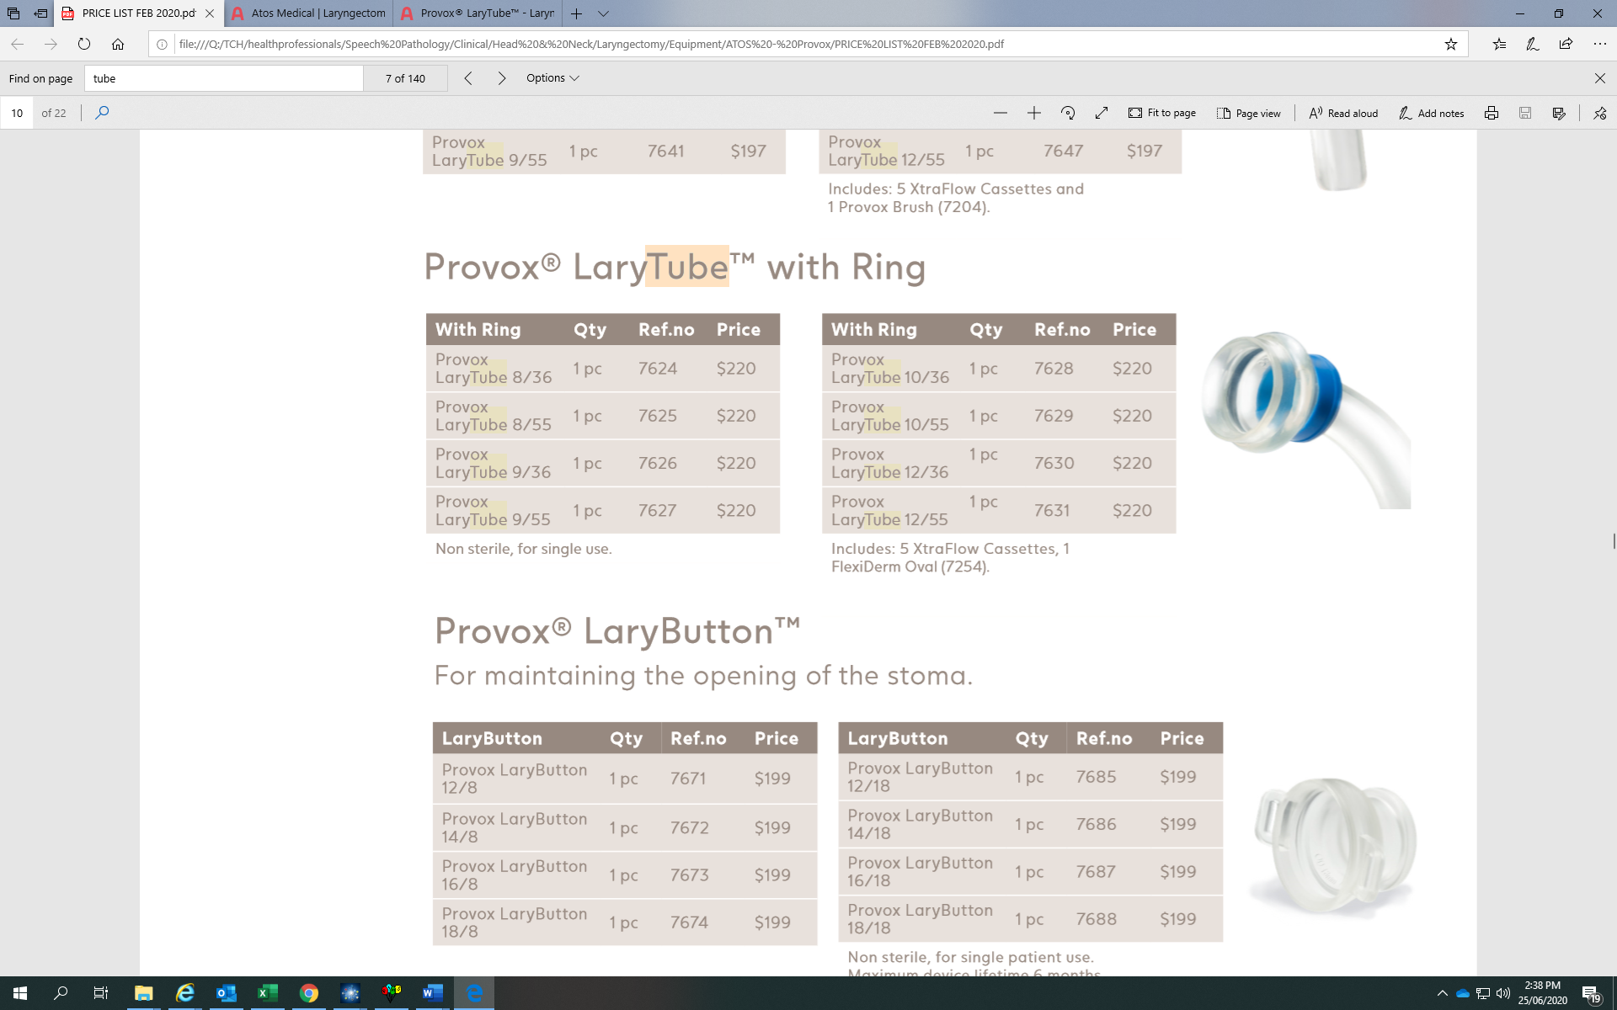

A variety of ‘Soft’ Provox Laryngectomy Tubes (non-fenestrated; fenestrated; with ring; lary button)
Reference: Atos Medical https://www.atosmedical.com.au/products. Date accessed: 19/6/24
Note: A build-up of secretions within the soft laryngectomy tube reduces the patient’s airway diameter and contributes to the formation of sputum plugs within the airway.

Equipment
- ABHR
- Light source (i.e. torch)
- Kidney dish
- ABHR and PPE
- Sterile water
- Cleaning brush (if required)
Note: Throughout the procedure perform hand hygiene as per the 5 moments of hand hygiene and don and doff PPE where required, as per Infection Prevention and Control Procedure. P2/N95 mask to be worn for all aerosol generating procedures.

Procedure
- Explain the procedure to the patient and gain consent
- Ensure privacy
- Remove HME cassette (if in use)
- Visually inspect the patient’s laryngectomy tube for build-up of secretions (use the torch as required). Laryngectomy tubes must be removed and cleaned 2-4 hourly and more frequently as clinically indicated
- If secretions are present in tube, instruct the patient to cough to try and clear the tube
- If the patient is unable to move the secretions, don PPE and remove the tube from the laryngectomy stoma
- Wash the tube in sterile water in the kidney dish using the cleaning brush if required
Note: Do not clean the laryngectomy tube in the hand basin due to the risk of contamination
- Shake the laryngectomy tube to remove all the water, allow the tube to completely dry and then reinsert the tube into the patient’s stoma
- Document the procedure and any significant findings in the patient’s clinical record. Notify treating medical team if any concerns.

Nutrition Supplement
Note: A patient can only commence on an oral feeding regime once they have been assessed as safe to do so by their treating medical team and by Speech Pathology.
For the first 24 – 48 hrs post-operative laryngectomy, feeding cannot be commenced via the nasogastric tube. It can only be used to remove gastric contents. Only the treating medical team are to manipulate, remove, or re-insert the patient’s nasogastric tube. Nurses should not insert a nasogastric tube for patients following a laryngectomy due to changes in normal tracheoesophageal anatomy.
For the management of a nasogastric tube, including feeding via a nasogastric tube please refer to Nasogastric Tube (NGT) Management – Adults Only Procedure.
Once the patient is assessed as able to commence tube feeding 24- 48 hours post-surgery, the Dietitian will review the patient and commence the patient on nasogastric feeds to suit their nutritional needs.
To maintain safe and effective nutrition of the patient in the post-operative phase, the following is required:
- regular Dietitian review
- regular Speech Pathologist review
- daily weighing of the patient
- regular monitoring of the patient’s blood chemistry
- maintenance of a strict fluid balance chart for the patient.
When the patient is nutritionally stable, daily monitoring can be reduced as per the direction of the treating allied health and medical teams.

Swallowing
Patients following a total laryngectomy may have difficulties swallowing (particularly if there has been tongue base involvement), delayed swallow initiation, and reduced efficiency of pharyngeal transit, including post swallow pharyngeal residue.
A patient is usually considered for commencing eating or drinking at 7-10 days post laryngectomy and should not commence without approval from the treating medical team. Most patients have a barium swallow test prior to commencing food/fluid trials to ensure there is no pharyngocutaneous fistula present prior to commencing oral intake.
Once cleared by the treating medical team, patients will commence with fluids, progressing to puree, semi-solids and soft diet, dependent on the patient’s swallowing ability. If the patient is unable to tolerate food or fluid in the usual timeframe, further studies may be required (e.g., video fluoroscopy swallow study with a Speech Pathologist). Progression of diet consistencies and the need for assessment of swallowing by a Speech Pathologist should occur, in consultation with the patient’s treating team. Clinical assessment of the patient’s swallowing should consist of an assessment of oromotor function as well as food and fluid trials as appropriate.

Communication
Effective communication strategies are essential for the patient post-laryngectomy. All staff should ensure that the patient with a laryngectomy has at least one form of communication available at all times. Communication strategies will be discussed with the patient and monitored by the Speech Pathologist. Examples of communication strategies immediately post-operative include a pen and paper, ‘magic’ or white board, alphabet and picture boards or text to speech apps. Longer term communication strategies include electrolarynx, oesophageal voice, and tracheoesophageal voice, using a voice prosthesis.
The patient’s communication method(s) will be recorded in the patient’s clinical record. For patients with identified complex communication needs such as requiring an interpreter, refer to the Language Services - Interpreters and Translated Materials Procedure. For detailed information on communication options refer to Section 7- Communication Post Laryngectomy.

Oral Care
Oral hygiene is essential for all patients with a newly formed laryngectomy in the post-operative period.
Back to Contents

Section 4 – Management of a Patient with an Acute Laryngectomy on the Ward
A patient with an acute laryngectomy is defined as a patient with a newly formed laryngectomy stoma or a patient with an established laryngectomy stoma who is respiratory compromised.
Note: A patient with an acute laryngectomy will require an ICU admission or a single ward bed if available on a tracheostomy accredited ward ,to ensure appropriately trained staff are available to care for the patient.
All patients with an acute laryngectomy will require a tracheostomy competent nurse escort when leaving the ward.

Clinical Management
For all management of stoma care, tracheostomy/laryngectomy (hard & soft) tube management, humidification with humidified oxygen, suctioning, communication, and oral care please refer to Section 3 – Management of a Post-Operative Patient with a Laryngectomy.

Humidification
For detailed instructions on humidification, please refer to Section 3 – Management of a Post-Operative Patient with a Laryngectomy.
For all patients with an acute laryngectomy that do not have a tracheostomy tube or hard laryngectomy tube with inner cannula in situ, humidification management is via a Nebulised Moisture Exchange or HME cassette (housed in either a soft laryngectomy tube or base plate). A patient with an established laryngectomy who does not require active/warm humidification should use either 0.9% sodium chloride nebulisers, delivered via a tracheostomy mask, and/or HME system to humidify inhaled air.

Care of the Heat Moisture Exchange System
A Heat Moisture Exchange system, also known as an HME, restores the filtration, warming and humidification of the air breathed in.
A HME is a device designed for patients breathing through a stoma and consists of a baseplate or soft laryngectomy tube/button and a cassette, which houses a calcium chloride (antibacterial and water retaining agent) treated foam sponge. The baseplate is placed around the stoma, with the cassette clipped in. The HME humidifies and heats inhaled air by retaining heat and moisture from exhaled air in the device. It is a single-use device, which requires changing at least every 24 hours.
If the base plate or HME cassette become soiled (e.g., the patient coughs into the cassette causing blockage), change both the HME cassettes and base plates immediately (they are both single use only). The patient should be instructed to remove the HME cassette prior to coughing to prevent this occurring.
All patients need to be trained and independent in the correct and appropriate use of nebulisers and/or HMEs (with laryngectomy tube/button or base plate), if using, prior to discharge.
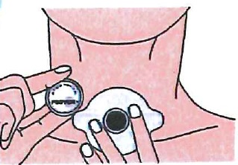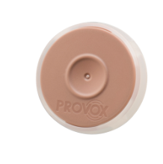
HME Cassettes
Reference: https://www.atosmedical.com.au/products/provox-xtramoist-hme
Date accessed: 05/01/2024
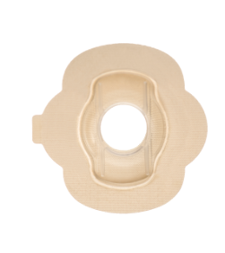
Adhesive Base Plates
Reference: https://www.atosmedical.com.au/products/provox-flexiderm
Date accessed 05/01/2024

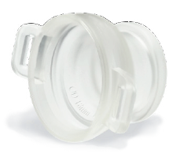 | 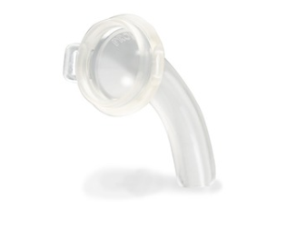
Laryngectomy Button | Laryngectomy Tube
Reference: https://www.atosmedical.com.au/products/provox-larytube
Date accessed: 05/01/2024

Equipment to change a HME
- ABHR
- PPE
- HME Cassette
- Adhesive Base Plate, Laryngectomy tube, or Laryngectomy Button (depending on which system the patient uses)
- Straps or ties to hold laryngectomy tube or button in place (if applicable)
- Sterile Gauze
- Sodium chloride 0.9% 10mL tubes
Note: Throughout the procedure perform hand hygiene as per the 5 moments of hand hygiene and don and doff PPE where required, as per the Infection Prevention and Control Procedure. P2/N95 mask to be worn for all aerosol generating procedures.

Procedure
- Explain the procedure to the patient and gain consent.
- Ensure the patient’s privacy is maintained throughout the procedure.
- If the patient is using a base plate:
- Remove HME cassette from the base plate.
- Gently remove the adhesive baseplate (if in use) from the patient’s skin.
- Clean the skin around the patient’s stoma gently using adhesive remover with saline soaked gauze to remove any silicone glue – ensure excess fluid is removed from gauze prior to using near the patient’s stoma to prevent accidental aspiration.
- Allow the skin surrounding the patient’s stoma to dry.
- Apply the Skin Barrier wipe to the skin surrounding the patient’s stoma to protect the skin and improve adhesion of the base plates and protection of the skin.
- Apply a new base plate to the patient’s stoma.
- Adhere the HME cassette to the base plate.
If the patient has a laryngectomy tube or button in situ:
- Clean the tube and button as per Section 2 – Management of a post-operative laryngectomy – laryngectomy tube management.
- Remove HME cassette prior to cleaning the patient’s tube or button.
- Replace the HME cassette once laryngectomy tube or button has been placed in the patient’s stoma.
Note: Unintentional or accidental pressure on the housing of the HME cassette may cause the patient to experience difficulty in breathing or suffocation.
- Document the procedure and any significant findings in the patient’s clinical record. Notify treating medical team of any concerns.

Administration of sodium chloride 0.9% via a Nebuliser
Administer 5mL of sodium chloride 0.9% via a nebuliser every two to four hours or more often if required and as documented by the treating medical team.

Equipment
- ABHR
- Tracheostomy mask
- Nebuliser canister
- Oxygen tubing
- 5mL Syringe
- Sodium chloride 0.9% 10mL ampules
- Nebuliser unit or wall oxygen
- Tissues
Note: Throughout the procedure perform hand hygiene as per the 5 moments of hand hygiene and don and doff PPE where required, as per Infection Prevention and Control Procedure. P2/N95 mask to be worn for all aerosol generating procedures.

Procedure
- Explain the procedure to the patient and gain consent.
- Ensure privacy, set up equipment
- Remove any devices from the stoma such as HME base plate/laryngectomy tube.
- Draw up 5mL of sodium chloride 0.9% into syringe.
- Remove top of nebuliser canister and place sodium chloride 0.9% into collection chamber, replace top
- Connect the nebuliser canister to the tracheostomy mask, place the mask over the patient’s stoma and secure around the patient’s neck firmly with elastic strap.
- Turn on nebuliser at switch or dial up wall oxygen to around 6-10L
- After 5 to 10 minutes, turn off the nebuliser unit and remove the Tracheostomy mask from the stoma
- Disconnect the nebuliser canister from the mask. Remove top of the nebuliser canister and discard any unused sodium chloride 0.9%.
- The same mask and nebuliser cannister can be used for the same patient over a 24-hour period. Cleaning of the mask and canister are described below.
- Encourage the patient to cough up secretions into a tissue
- Document procedure in the patient’s DHR.

Cleaning Nebuliser and Mask
- At the end of the day, wash the nebuliser canister and tracheostomy mask in warm soapy water, rinse with tap water and allow to air dry in a clean container.
- Two reusable nebuliser canisters plus reusable tracheostomy masks are used on alternate days, so one is washed and drying while one is in use.
- The nebuliser canister and tracheostomy mask are to be inspected daily for signs of wear and tear, discard when they are no longer in good condition.
- The nebuliser canister and tracheostomy mask can be used indefinitely for the same patient in the above way if they remain in good condition. They are to be discarded when the patient is discharged.
Back to Contents

Section 5 – Emergency Management

Note: For all patient’s experiencing respiratory distress call for the MET (Medical Emergency Team) by dialling 2222 on any internal phone. Commence Basic Life Support (BLS) as per the Adult Basic Life Support Algorithm. On arrival of the MET, inform any MET member that the patient is a total neck breather. All attempts at ventilation of the patient must be via the stoma. Breaths are delivered using the bag-valve and a paediatric mask (all emergency trolleys are equipped with a paediatric mask) directly over the stoma. If a tracheostomy tube or hard laryngectomy tube is present, connect the bag-valve directly to the tube. Intubation of the patient via the stoma may be attempted with a size 6 cuffed tracheostomy tube or a size 6 or smaller endotracheal tube (ETT).

Respiratory Distress
When a patient is experiencing respiratory distress, call a MET and then conduct the following actions:
- Assess and clear the patient’s stoma (the patient’s stoma is their only airway).
- Visualise the patient’s stoma by removing all equipment from the stoma.
- If the patient has a tracheostomy tube or hard laryngectomy tube with inner cannula in situ, remove the inner cannula and replace with spare inner cannula from the emergency box.
- If the patient has a laryngectomy tube or a laryngectomy button (with/without a HME cassette) in situ, remove from the stoma.
- Check to see if the patient has a voice prosthesis. If a voice prosthesis is present, check where it is sitting and if it is obstructing the patient’s airway. Notify the treating medical team if voice prosthesis is not in the right position, i.e., in the patient’s TEP or is obstructing the airway. If it cannot be located, it should be treated as an inhaled foreign body.
- Apply oxygen to the patient’s stoma via a tracheostomy oxygen mask (a paediatric oxygen mask can be used until a tracheostomy mask is sourced).
- Clear any visible sputum or crust from the patient’s stoma. The patient may require suctioning to remove sputum from their airway..
- Use tracheal dilators from the emergency box if required to support stoma remaining patent.
- Consider ventilation if the patient remains in respiratory distress.

Patient management post respiratory distress incident
- Keep patient strictly NBM until treating allied health and medical team assess the patient safe to tolerate diet
- Reassure the patient and keep them comfortable.
- Assess the patient every 30 minutes including:
  - Check the patient’s stoma is patent
  - Suction/remove any sputum or visible crust when inspecting the patient’s stoma
  - Monitor the patient’s stoma secretions
  - Monitor vital signs as per the Vital Signs & Early Warning Scores Procedure
  - Review the patient’s humidification needs
  - Document all findings and procedures in the patient’s clinical record
  - Notify the patient’s treating medical team of any changes.

Non-acute respiratory complications
- If the patient has a voice prosthesis that cannot be located, attempt to pass a suction catheter through the tracheoesophageal puncture (TEP) once the patient has a patent airway and is stable from a respiratory perspective.

Prosthesis Missing from TEP/Open TEP
- When a voice prosthesis has been dislodged and there is an open TEP (i.e. nothing in the TEP), this is considered a medical emergency as the patient can aspirate secretions and/or food fluid via an open TEP.
- Investigate where the dislodged voice prosthesis is. Aspiration of the voice prosthesis requires urgent ENT surgical review to remove the device using flexible bronchoscopy.
- Patients should be placed Nil by Mouth to prevent aspiration of food and fluids. They may still be at risk of aspirating their secretions.
- A catheter or voice prosthesis needs to be placed into the TEP as soon as possible post dislodgement. This will avoid the TEP shrinking in size/closing up and can help prevent aspiration of secretions and allow the patient to return to eating and drinking.
- All patients should be trained in emergency management for an open TEP. If the patient is at home when the voice prosthesis is dislodged, they will need to seek urgent medical assistance if the voice prosthesis has been aspirated. If they have the voice prosthesis, they will need to insert a catheter into the open TEP and seek review by a Speech Pathologist and/or ENT surgeon.

Procedure for inserting a catheter into an open TEP

Equipment
- ABHR
- Catheter (12Fr-16Fr, dependent on TEP size) confirming suction catheter, not sterile urinary catheter
- Lubricant
- PPE.
Note: As all TEPs created at CHS are either 17Fr or 16Fr, a 16Fr catheter should be inserted. However, if the TEP has been open for some time, it may not be possible to insert that sized catheter (due to possible shrinkage), and it may be necessary to trial a smaller size catheter e.g., 14Fr or 12Fr etc.

Note: Throughout the procedure, perform hand hygiene as per the 5 moments of hand hygiene and don and doff PPE where required, as per Infection Prevention and Control Procedure. P2/N95 mask to be worn for all aerosol generating procedures.

Procedure
- Explain the procedure to the patient and gain their consent.
- Ensure privacy.
- Remove all devices from stoma if applicable. For example, the HME cassette/laryngectomy tube.
- Position patient in a high sitting position, if able and within medical limits.
- Assess patient’s secretions and respiratory status. This will determine if the patient requires suctioning before the insertion of the TEP.
- If the patient requires suctioning, refer to Section 3 - Management of a post-operative patient with a laryngectomy.
- Open the selected catheter packaging. TEPs created at the time of laryngectomy surgery are generally 16Fr or 17Fr therefore a size 16Fr or smaller should be used. If the TEP has been open for some time, it may only be possible to fit a small catheter e.g., 12Fr or 10Fr.
- Apply lubricant to the tip of the catheter to assist insertion.
- Slowly insert the catheter into the open TEP and into the oesophagus. Ensure it is not threaded into the trachea down the stoma.
- The catheter should be inserted to approximately 10-20 cm (dependent on body size) and then taped to the chest.
Note: Keep the patient strictly NBM until treating allied health and medical teams deem the patient safe to tolerate diet.
Back to Contents

Section 6 – Role of the Speech Pathologist
A Speech Pathologist is part of the treating team for patients undergoing a laryngectomy. The Speech Pathologist supports the patient from diagnosis to reintegration into community life. The Speech Pathologist has an important role in pre- and post-operative education, voice/communication rehabilitation, swallowing management and counselling.
Pre-operatively, the Speech Pathologist will provide education to the patient and their family jointly with the Head & Neck Cancer Specialist Nurse. At the pre-operative education session/s, the Speech Pathologist will discuss the following:
- The Speech Pathologist’s role with laryngectomy rehabilitation
- Changes the patient can expect post-laryngectomy regarding communication, swallowing, and anatomy/physiology
- Explanation and demonstration of post-laryngectomy voice restoration options including maintenance, cost and funding options
- Identification, in consultation with the treating medical team, of appropriate candidates for receiving a tracheoesophageal puncture (TEP) for voice prosthesis placement
- General lifestyle changes the patient may experience post-laryngectomy
- Humidification options and how to care for their stoma in relation to use of HME cassettes
- Options for covering and protecting the stoma if not using a HME system, e.g., foam stoma covers and/or laryngectomy bib
- Option of talking to/meeting with a trained Laryngectomee Visitor (i.e., a volunteer living in the community who has had a laryngectomy)
- Pre-operative assessment and management of the patient’s swallowing function, if required, and education regarding potential long-term impact to their swallow function.

Post-operative actions include:
- Provision of ongoing support and education to patient and family
- Monitoring of the patient’s swallowing function and progression to oral diet and fluids, as directed by the ENT medical team
- In consultation with ENT medical team, measure, size and provide the patient with a suitable soft laryngectomy tube or button as required
- Provide education and training for the patient and their carer in stoma care and humidification including stoma covers, insertion and removal of laryngectomy tubes/buttons or base plates and HME cassettes
- Provide ongoing education and therapy for the patient on post laryngectomy communication including voice prosthesis, electro-larynx or alternative communication options
- In consultation with nursing staff and Head and Neck Cancer Specialist Nurse, arrange all equipment and services needed for discharge (e.g., stoma covers, shower shields, loan electrolarynx (if applicable), and outpatient speech pathology appointments)
- Commence documentation of the “discharge of a new laryngectomy” form on the DHR and ensure relevant multidisciplinary team members complete the form. This is printed and provided to the patient on discharge.
- Provide ongoing management of the patients swallowing function, as required. Objective swallow assessment to be ordered for the patient as indicated/required via Video Fluoroscopic Swallow Study (VFSS) or Fibreoptic Endoscopic Swallow Study (FESS)
- Provide guidance and education for the patient on financial assistance available for speech aids or HMEs, through relevant authorities i.e. ACT Equipment Scheme (ACTES/DORSS), Enable NSW, NDIS or DVA.
Back to Contents

Section 7 – Communication Post Laryngectomy
Following total laryngectomy, natural voicing by the patient can no longer be achieved. Education and assessment of the patient regarding voice rehabilitation/voice restoration options post laryngectomy commences in the pre-operative period.
Communication options post laryngectomy are dependent on a variety of factors such as the extent and invasiveness of the surgery, post-operative swelling, need for post-operative radiation, the ability of the patient to care for and manage the voice rehabilitation option and patient preference.
Each patient is individually assessed for the most suitable and appropriate method of communication. There are three main methods of voice rehabilitation post-surgery:
- Tracheoesophageal speech (i.e. a voice prosthesis)
- Artificial laryngeal speech (i.e. electrolarynx)
- Oesophageal speech
The most used methods of communication post laryngectomy are tracheoesophageal speech (a voice prosthesis) and the electrolarynx.
Each of these methods of communication will require time and practice for the patient to become proficient.
It is important to note that each method of communication does not need to be used exclusively – individuals commonly use two communication options in the early phases of rehabilitation, until they are proficient in their communication option of choice. For a small number of patients, they will continue to use a range of multi-modal communication options depending on their communication setting and other individual factors (e.g., fatigue, partner preference, and environment). Other methods of communication such as gesture, writing, yes/no head nods, text messaging or text to speech apps may be utilised as a main form of communication for the patient or as an additional communication method to the above-mentioned formal communication methods.

Tracheoesophageal Speech
Tracheoesophageal speech voice prostheses are the voice rehabilitation choice for voice restoration after a total laryngectomy. This type of voice rehabilitation most closely resembles the mechanism of normal laryngeal speech production. For tracheoesophageal speech, the following needs to occur:
- A Tracheoesophageal Puncture (TEP): The surgical creation of a hole in the tracheoesophageal wall i.e. an opening in the wall separating the trachea and oesophagus. The term primary puncture is used when the hole is created at the time of surgery. The term secondary puncture is used when the procedure is undertaken as a separate procedure – this could be weeks or years after the laryngectomy.
- Standard practice is for the voice prosthesis to be inserted at the time of the puncture. The selection of the most appropriate voice prosthesis is made by the ENT surgeon and Speech Pathologist. A voice prosthesis is a removable silicon tube with a one-way valve which is placed in the surgically created opening between the trachea and the oesophagus. The one-way valve prevents food/fluid entering the airway but allows air to enter the oesophagus from the trachea.
- The ENT surgeon may decide it is not appropriate to insert the voice prosthesis at the time of surgery and will place the NGT through the puncture. Once cleared by ENT, the Speech Pathologist will undertake inserting the initial voice prosthesis, with ENT support if required, post-surgery.
- Once the prosthesis is in place, the patient produces a voice in the following way:
  - Air is inhaled into the lungs through the stoma.
  - Whilst the patient is exhaling, the patient covers the stoma with his/her finger or by pushing on a HME (housed in a base plate or laryngectomy tube) if in use.
  - As the air can no longer escape via the stoma, it is redirected through the one-way valve of the voice prosthesis into the oesophagus and up into the pharynx.
  - This air causes vibration of the patient’s mucosa of the pharyngoesophageal (PE) segment (or neoglottis) which produces a sound.
  - The sound travels up and out of the mouth and the patient articulates/mouths words normally to produce speech.
- The quality of the voice produced is dependent on several factors including the anatomy and physiology of the patient’s neoglottis, breath support and extent of surgery and reconstruction required.
- Some patients may be suitable candidates for hands-free communication devices (with or without HME). Factors affecting successful hands-free usage include anatomy of the patient’s stoma, speaking pressure and tonicity of the PE segment. Hands-free devices can be attached to the stoma using either a baseplate or tracheostoma tube.
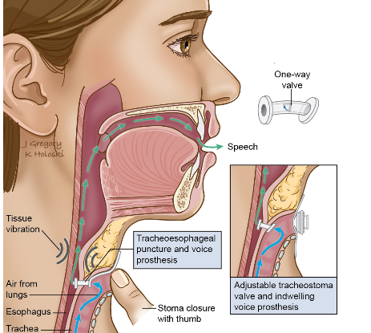
Figure 1: Image depicting voice rehabilitation following total laryngectomy using a voice prosthesis.
Reference: Speech & Swallow Therapy ‣ THANC Guide Date accessed: 18/6/24

Advantages of tracheoesophageal speech
- Tracheoesophageal speech is often attained quicker with simple and more rapid training; however, voice quality is highly variable between patients depending on the anatomy and physiology of the neoglottis.
- It is often more intelligible and natural sounding speech in comparison to oesophageal speech
- The TEP can provide a convenient route for alternative feeding (using a nasogastric tube-if primary placement of VP is not undertaken at the time of surgery) or should the voice prosthesis become dislodged.

Disadvantages of tracheoesophageal speech
- Daily cleaning and maintenance demands
- Patient must have good manual dexterity and adequate vision for maintenance and cleaning of the voice prosthesis
- Patient must have adequate pulmonary reserve to perform tracheoesophageal speech
- Ongoing costs of voice prostheses and related equipment, if not eligible for funding
- Additional surgery is required for the creation of a secondary TEP.

Artificial Laryngeal Speech
Artificial laryngeal speech utilises an electronic device. Several types of electronic devices are available and can be broadly classified as external (i.e. neck, cheek placement) or internal (i.e. intra-oral adaptor)
- For the neck type, the electrolarynx is held to the neck, under the chin or on the cheek. A button is depressed to turn the device on which then generates sound vibrations. These sound vibrations are transmitted through the tissues into the vocal tract and the sound is then formed into speech via movements and shaping of the mouth in the usual manner.
- The intraoral type is generally used for patients who cannot achieve adequate sound conduction on the skin and/or in the post-operative period when tenderness prevents correct neck placement. The intraoral type has a small tube attached, which can be placed in the mouth to deliver the vibrations directly to the mouth.
- Most external placement devices can be converted into an intraoral device by using an intraoral adapter (a small tube).
- Several types of electronic devices are available, e.g., Servox, NuVois or Tru Tone. Most of these devices will incorporate a volume and/or pitch button, while some of these devices are also available with a hands-free option.
- The electrolarynx could be considered as a communication option in the immediate post-operative days. It may initially be used with an intraoral adaptor/attachment or with cheek placement due to oedema, staples and/or pain in the neck tissues. Patients require structured and consistent practice with guidance from a trained Speech Pathologist.
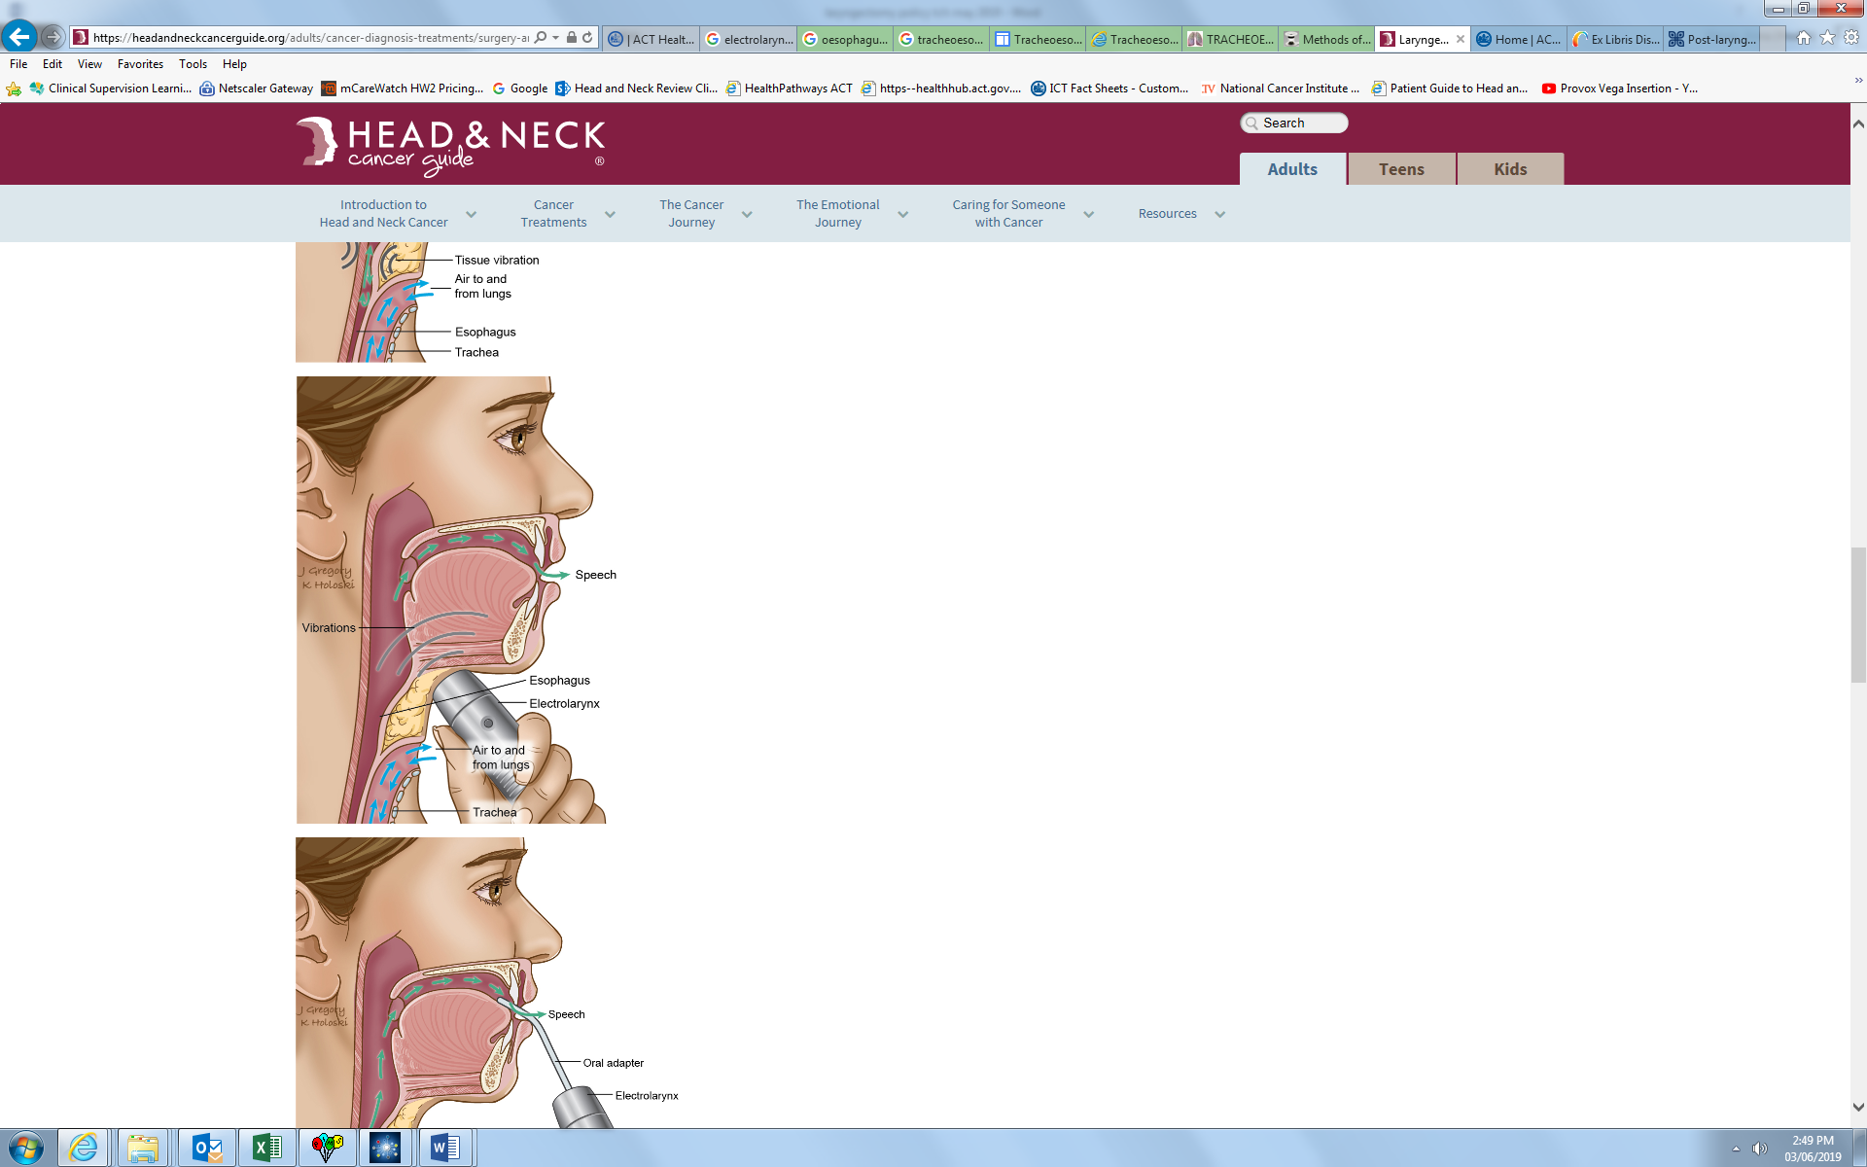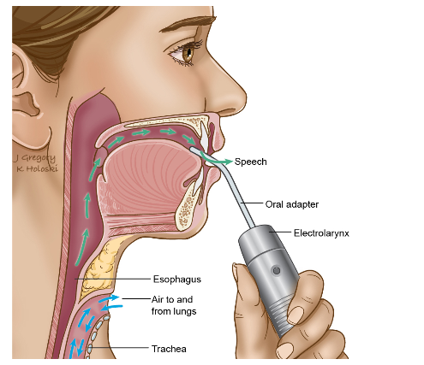
Figure 2: Image depicting voice rehabilitation following total laryngectomy using an electrolarynx. From: https://headandneckcancerguide.org

Speech & Swallow Therapy ‣ THANC Guide Date accessed: 18/6/24
Artificial Laryngeal Speech remains a popular choice of communication following a total laryngectomy. As discussed, it can be used in the immediate post-operative period as an early means of communication or in the long term as a back up to oesophageal or tracheoesophageal speech, or as the primary means of communication. Training with an electrolarynx can occur early in the post-operative period (as early as day 2 to 4) depending on clearance from the treating medical team.

Advantages of Artificial Laryngeal Speech
- Generally, it takes a short period of time to master but will require consistent therapy and motivation to become proficient in its use
- Training can commence once cleared by surgical team
- Increased availability
- Relatively low cost considering the amount of usage, however, for some patients it can be prohibitive, depending on funding eligibility
- Requires minimal maintenance on behalf of the patient.

Disadvantages of Artificial Laryngeal Speech
- Mechanical/robot-like speech quality, although newer models allow for more variation in speech
- Requires a period of intensive therapy to become proficient
- Requires use of your hand to operate
- Dependence on batteries or a need to recharge, however newer devices have a longer lasting charge
- Maintenance of intraoral tubes (can become blocked)
- Poor sound is produced when there is fibrosis of the neck/cheek tissue from radiotherapy and/or surgery.

Oesophageal Speech
Oesophageal speech is based on the technique in which the patient transports a small amount of air from the mouth into the oesophagus. The air is then forced back past the pharyngo-oesophageal (PE) segment to induce resonance (making the sound like a burp). This resonance is the sound source that allows speech. Rapid repetition of the air transport can produce understandable speech. This method of communication takes a long time to learn and requires intensive therapy with a trained Speech Pathologist. Oesophageal speech was the mainstay of a laryngeal communication until the early 1980s. It is now used less frequently than the other methods of voice restoration due to the intensity of speech therapy required and the time it takes a patient to learn.
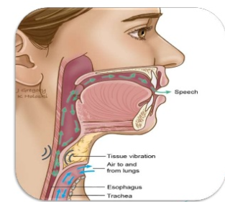
Figure 3: Image depicting voice rehabilitation following total laryngectomy using oesophageal speech. From: https://www.slideshare.net/9495515571/larynx-69454205
Reference: Speech & Swallow Therapy ‣ THANC Guide Date accessed: 18/6/24

Advantages of Oesophageal Speech
- Nil cost
- Hands-free speech
- Speech sounds more natural than Artificial Laryngeal Speech
- Training can commence immediately post-operation.

Disadvantages of Oesophageal Speech
- Intensive training required with low success rate
- Reduced intelligibility in comparison to other speech options.

Other Communication Methods
For a small number of patients, the above communication methods may not be suitable or preferred. For these patients, they may continue to use other methods of communication such as gesture, writing, yes/no head nods in response to question or text messaging. There are also a variety of text to speech apps which can be utilised. The patient can be guided and provided therapy on use of such apps to ensure best fit. Some of these types of communication methods can result in reduced efficiency of communication and increase frustration as a result.
Back to Contents

Section 8 – Voice Rehabilitation and Voice Prostheses

Tracheoesophageal Speech
The decision regarding when a patient can commence voicing post-operatively needs to be made in consultation with the patient’s treating medical team. Historically, a patient started voicing once adequate surgical healing had occurred at approximately 7-14 days following total laryngectomy. More extensive surgery or surgical complications may delay the onset of a patient commencing voicing. A voice prosthesis may be placed at the time of surgery; however, this prosthesis should not be used by the patient until the treating medical team provide approval.

About Voice Prostheses
The Voice Prosthesis is a removable silicon tube which is placed in a surgically created opening (TEP) between the trachea and the oesophagus. Refer to Section 7- Communication Post Laryngectomy- Figure 1.
The three primary functions of the prosthesis are to:
- allow air to flow from the trachea to the oesophagus for voicing. Sound is produced by vibration of the air within the patient’s neoglottis/pharyngoesophageal or PE segment
- prevent saliva or food entering the trachea during swallowing using the one-way valve
- prevent the puncture (fistula) from closing.

Types of Voice Prostheses
There are two over-arching types of voice prostheses: indwelling and non-indwelling. When the prosthesis is in position, the tracheal flange will be in the trachea and the oesophageal flange will be in the oesophagus.

Indwelling:
- Typically have larger with more rigid flanges to help secure the prosthesis and facilitate longer-term placement
- Only to be removed and refit by a trained Speech Pathologist
- Are sturdier and can be cleaned while in place
- Remain in the TEP for longer periods of time

Non-indwelling:
- Has smaller flanges that help secure the prosthesis but also allow for repeated insertion and removal
- Can be removed and changed by the patient once they have received adequate training and are assessed as independent by a Speech Pathologist trained in laryngectomy management, making them more self-sufficient. However, the patient’s ability to self-exchange the prosthesis should be routinely checked by their Speech Pathologist
- Needs to be secured to the skin of the neck with a safety strap to prevent accidental aspiration
- Only successful when the patient is able to take excellent care of the prosthesis and will recognise potential problems in time to see a Speech Pathologist for assessment
- Patients with high anxiety about self-care and/or problems of uncontrolled bleeding are not considered good candidates for a non-indwelling device. Patients with tissue problems or poor condition due to other treatments may not be able to tolerate the frequent changes of a non-indwelling device
- For patients who live some distance away from their professional caregivers, the use of a non-indwelling prosthesis may be more convenient.
All voice prostheses will have two measures:
- The diameter of the valve that is in the tracheoesophageal wall is measured in French gauge (FG) e.g., 16Fr , 17Fr, or 20Fr.
- The length of the valve measured in mm (come in sizes from 6mm-28mm). The thickness of the patient’s tracheoesophageal wall will determine the size of the valve required – the Speech Pathologist will measure to ensure the correct valve size is placed. It is important that the length of the prosthesis matches the length of the TEP.

Non-indwelling Voice Prostheses
Non-indwelling voice prostheses are available in duckbill and low-pressure types. There are two brands commonly used, Blom-Singer and Provox.
Blom-Singer Duckbill Voice Prosthesis
A duckbill voice prosthesis may be the initial voice prosthesis of choice as it is easier to insert due to the shape of the tip. The tip however may be too long and impinge on the posterior wall of the oesophagus causing leakage and/or poor speech.
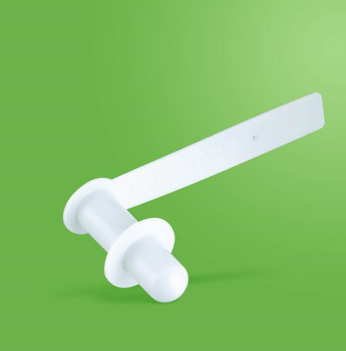
Blom Singer Duckbill Voice Prosthesis Reference: https://mainmed.com.au/products/blom-singer-duckbill-voice-prosthesis Date accessed 18/06/2024
Low Pressure Voice Prosthesis
A low-pressure voice prosthesis has a trap door which offers low resistance to opening pressures and requires less effort to produce voice.

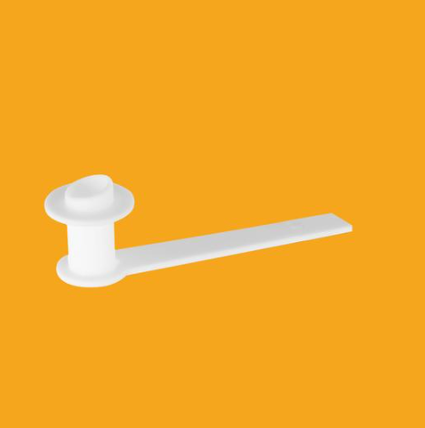
Blom Singer Low Pressure Voice Prosthesis https://mainmed.com.au/products/blom-singer-low-pressure-voice-prosthesis-16fr Date Accessed 18/6/24

Indwelling Voice Prostheses
There are two commonly used brands of indwelling voice prostheses, Blom-Singer and Provox. Indwelling are the voice prostheses of choice generally, as they require less maintenance than a non-indwelling voice prosthesis. There are different equipment and loading procedures for each of the various voice prostheses and clinicians should follow individual manufacturer instructions.
Blom-Singer Indwelling
Blom-Singer create a few different types, such as a Classic Blom-Singer or Advantage All Silicone, which has the valve coated with silver oxide to protect against Candida, and therefore reduces the need for anti-fungal agents. These voice prostheses can last from 6-12 months, but this can be variable depending on the individual patient. They are replaced by a trained Speech Pathologist or ENT team. They require a gel cap for insertion. Blom Singer voice prostheses are available in 16Fr or 20Fr size, depending on the type.
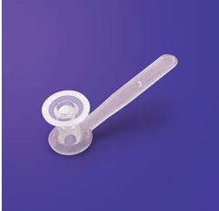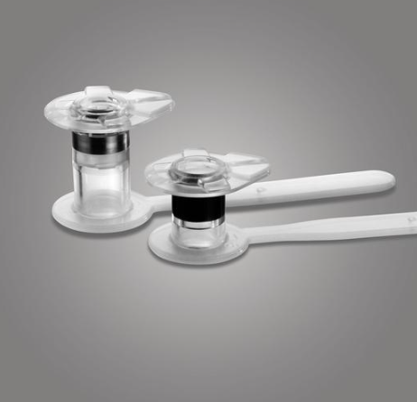
Blom-Singer Classic Indwelling Blom-Singer Advantage Indwelling
Reference: https://www.inhealth.com/category_s/44.htm
https://mainmed.com.au/collections/voice-prosthesis/products/blom-singer-advantage-all-silicone-voice-prosthesis-16fr Date accessed 18/6/2024
Provox Vega Indwelling
Provox produces an indwelling voice prosthesis. There are various methods of insertion. These are to be replaced by a trained Speech Pathologist or ENT team. Provox voice prostheses are available in 17Fr, 20Fr and 22.5Fr size.
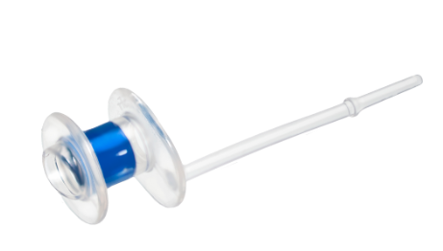
Provox Vega indwelling Voice Prosthesis
Reference: https://www.atosmedical.com.au/products/provox-vega Date Accessed 05/01/2024
In addition to the ‘routine’ types of voice prostheses, there are individual specially modified voice prostheses available for patients with particular issues. For example, a voice prosthesis with a larger oesophageal flange can help resolve leakage around the voice prosthesis in enlarged TEPs. Additionally, dual valve voice prostheses, which as the name suggests, contains a second valve, may be used to help prevent leakage through the voice prosthesis. A trained Speech Pathologist should assess a patient to determine cause of early, repeat voice prosthesis failure before making any recommendations for specially modified VPs.
Note: CHS Speech Pathology Department use Blom-Singer or Provox voice prostheses for patients. The procedures below refer to Blom-Singer procedure and the Provox procedure for insertion – should a patient present to CHS with a different type of voice prosthesis, please contact the Speech Pathology Department to discuss.

Sizing a Voice Prosthesis
A voice prosthesis requires initial sizing (length of prosthesis). If a patient is undergoing primary puncture and placement of a voice prosthesis i.e. at time of surgery, the ENT, in collaboration with the Speech Pathologist, will determine which size voice prosthesis to place at time of surgery. Considerations for determining size of VP at time of surgery may include if the patient has had previous radiation therapy (RTx) or if the patient is likely to require a flap as part of the surgery.
Proper length of the prosthesis is critical as fitting a prosthesis that is too long or too short will result in problems that can affect both the patient’s tissue health and vocal output. Re-sizing may be required if:
- a patient is undergoing radiotherapy (may need different size voice prosthesis to account for swelling)
- patient’s weight changes
- patient is less than one-month post laryngectomy and size of tracheoesophageal wall is reducing (can reduce about 4mm in size).

Indicators for resizing
- Voice prosthesis protruding into trachea and not fitting well or pistoning (i.e. moving forward and backwards) in the Tracheoesophageal Puncture (TEP).
- Leakage around the voice prosthesis possibly indicating incorrect size is in situ.

Equipment
- ABHR
- PPE (gown, gloves and safety eyewear, face masks as required)
- 18Fr Tracheoesophageal Puncture Dilator (for 16Fr TEP/prosthesis) or 22Fr Tracheoesophageal Puncture Dilator (if 20Fr TEP/prosthesis)
- Voice Prosthesis Sizer with inserter stick
- A range of prosthesis sizes or Ryles tube (catheter) if appropriate size not available
- Lubricant.
Note: Throughout the procedure perform hand hygiene as per the 5 moments of hand hygiene and don and doff PPE where required, as per Infection Prevention and Control Procedure.

Procedure
- Explain the procedure to the patient and gain consent.
- Ensure privacy of the patient will be maintained during the procedure.
- Remove the patient’s stoma cover, laryngectomy tube/button/base plates or HMEs (if in place).
- If initial sizing post-surgery, ask the patient to swallow prior to removal of their NGT/voice prosthesis or catheter.
- Alternatively, remove voice prosthesis or catheter from the patient’s TEP.
- Add some lubricant to the dilator and insert dilator into the patient’s TEP – push in slowly to dilate up to 18Fr (or 22Fr).
- Remove the dilator and insert the sizer on an insertion stick. You should feel a ‘pop’ as the flange of the sizer goes through and opens on the oesophageal side of the patient’s TEP.
- Once the sizer is in place, pull back gently on the insertion stick and read the number on the sizer to determine the length of the patient’s TEP.
- Determine length and size of voice prosthesis required and insert (see procedure below).
- Best clinical practice recommends insertion of a slightly longer voice prosthesis than a slightly smaller length. Inserting a voice prosthesis that is too small in length can result in granulation tissue around the puncture on the patient’s tracheal or oesophageal wall with the potential to block the TEP or embed the voice prosthesis in the surrounding tissue.
- Document the procedure completed in the patient’s clinical record.

Changing a Voice Prosthesis
Routine voice prosthesis changes should be done with a trained Speech Pathologist and a colleague to assist with passing equipment to the clinician completing the procedure and for safety purposes. Fitting or placement of the prosthesis, as below, should follow relatively quickly after completion of the measurement process, as stated in the procedure above.
If there are any concerns about changing a voice prosthesis for a patient, the Speech Pathologists should work with an ENT surgeon/registrar to complete the procedure. Some patients who are particularly sensitive during the voice prosthesis change and may require administration of local anaesthetic to the area by the ENT surgeon/registrar to suppress excessive coughing or discomfort.
Non-indwelling voice prostheses can be changed by the patient themselves after training with a trained Speech Pathologist and the Speech Pathologist has assessed the patient as proficient and safe in their ability to undertake the change.

Non-Indwelling Voice Prosthesis Management

Indicators for cleaning and changing a non-indwelling voice prosthesis
- Voice prosthesis has been dislodged or removed. Location of the dislodged prosthesis should be determined to ensure it has not been aspirated by the patient
- Prosthesis is leaking when the patient is eating and drinking – either centrally or around the voice prosthesis
- The patient has difficulty achieving voicing
- Routine cleaning (for non-indwelling voice prostheses every 1-2 weeks)

Cleaning and Changing a Tracheoesophageal Non-indwelling Voice Prosthesis

Equipment
- ABHR
- PPE (gown, gloves and safety eyewear, face masks as required)
- Adequate lighting – overhead, adjustable is preferred to facilitate viewing of the TEP/voice prosthesis
- Mirror (not handheld)
- Lubricant
- 18Fr Tracheoesophageal Puncture Dilator (for 16Fr TEP/prosthesis) or 22Fr Tracheoesophageal Puncture Dilator (if 20Fr TEP/prosthesis)
- 14Fr, 16Fr and 18Fr catheters (for emergency)
- Tape and scissors to fix the safety strap of the voice prosthesis in place after insertion
- Container of warm soapy water for the removed voice prosthesis
- Forceps
- Inserter stick
- Tissues or wipes
- Pipe cleaners
- 3% Hydrogen peroxide solution
- Replacement (new) valve if being replaced.
Note: Throughout the procedure perform hand hygiene as per the 5 moments of hand hygiene and don and doff PPE where required, as per Infection Prevention and Control Procedure.

Procedure
Part 1: Preparation
- Explain the procedure to the patient and gain consent
- Ensure privacy
- Remove the patient’s stoma cover.
Part 2: Removal of Voice Prosthesis
- Remove tape that is securing the prosthesis to the patient’s skin
- Ask the patient to swallow prior to removal of the voice prosthesis strap and then request that the patient does not swallow if possible, during the valve change/clean when there is no prosthesis or dilator in place
- Firmly holding the strap, pull out the voice prosthesis horizontally. The patient is likely to cough but it is important to continue at this stage
- With a small amount of lubricant coating the dilator, immediately insert the dilator into the patient’s TEP. Either tape the dilator in place or ask the patient to hold the dilator in place while cleaning the current prosthesis or preparing for reinsertion of new voice prosthesis. To ensure ease of movement and reduce possibility of drying and dilator sticking to the patient, while you clean the prosthesis or prepare the new prosthesis, ensure you intermittently slide the dilator in and out of the patient’s TEP.
Part 3: Cleaning the Non-Indwelling Voice Prosthesis
- To clean the voice prosthesis:
- Soak in warm water
- Scrub the outside and strap with pipe cleaners or an old soft toothbrush
- Use pipe cleaner to clean out inner tube of the voice prosthesis – do not push through the valve or you may cause damage
- An overnight soak (every 2 weeks) in hydrogen peroxide helps to disinfect the prosthesis. Rinse the voice prosthesis after soaking and ensure it is fully dry before reinsertion.
Note: When cleaning, be careful not to damage trap door valve of the prosthesis and avoid pushing pipe cleaner through the valve.
Part 4: Loading the Non-indwelling Voice Prosthesis
- Each voice prosthesis has specific manufacturer instructions for loading – please read these carefully
- For Blom-Singer prosthesis:
- Place the prosthesis onto the inserter stick
- Ensure the strap is secured on the pin on the inserter stick and firmly attached throughout insertion.
Part 5: Reinserting the Non-Indwelling Voice Prosthesis
Once the voice prosthesis has been loaded as per manufacturer’s instructions:
- Position the light to ensure you have clear view of the patient’s TEP/stoma
- Remove the tracheoesophageal dilator from the patient’s TEP
- Apply a small amount of lubricant on the end of the voice prosthesis
- Line the prosthesis up with the patient’s TEP and once you are sure the prosthesis is in the hole, push it through the TEP – careful not to push too far. You should feel a gentle pop as the flange goes through and opens on the oesophageal side
- With your other hand, take the strap off the pin, hold the strap between your thumb and finger and continue holding the strap as you gently remove the inserter stick
- Check placement of the voice prosthesis by pulling gently on the strap. If voice prosthesis has been placed correctly, you will feel some resistance when pulling gently to indicate the oesophageal flange has opened. If, when gently pulling on the voice prosthesis it starts to pull through the TEP, this indicates the flange has not opened and you may need restart the process to ensure correct placement
- If the patient starts coughing do not stop the process unless the coughing is significantly interrupting the process
- Document the procedure completed in the patient’s clinical record.

Indwelling Voice Prosthesis Management

Indicators for changing an Indwelling voice prosthesis
- Valve has been dislodged or removed. Location of the dislodged valve should be determined to ensure it has not been aspirated.
- Valve is leaking with eating and drinking – either centrally or around the voice prosthesis
- The patient has difficulty achieving voicing.
- It has been 12 months since the last voice prosthesis change.

Cleaning a Tracheoesophageal Voice Indwelling Prosthesis

Equipment
- ABHR
- PPE (gown, gloves and goggles, face masks as required)
- Adequate lighting – overhead, adjustable is preferred to facilitate viewing of the patient’s TEP/voice prosthesis
- 14Fr, 16Fr and 18Fr catheters (for emergency management)
- Lockable forceps
- Tweezers
- Cleaning brush
- Turbulent air flushing device
- Drinking water if flushing with water required
- Tissues or wipes

Cleaning and Flushing an Indwelling Voice Prosthesis
All patients should be educated and trained on how to clean (brush and flush) their indwelling voice prostheses. Patients should follow all guidelines and only use equipment provided by the manufacturer. Cleaning of voice prostheses should occur at least twice per day and ideally after all meals.
Note: Throughout the procedure perform hand hygiene as per the 5 moments of hand hygiene and don and doff PPE where required, as per Infection Prevention and Control Procedure. P2/N95 mask to be worn for all aerosol generating procedures.

Cleaning and Flushing an Indwelling Voice Prosthesis Procedure
Part 1: Preparation
- Explain the procedure to the patient and gain consent
- Ensure privacy
- Use manufacturer supplied, correct sized brush for cleaning an indwelling voice prosthesis
- Remove the patient’s stoma cover, laryngectomy tube/button, base plate or HME cassette (if necessary and/or if in use).
Part 2: Brushing and Flushing
- Gently insert cleaning brush through the centre of the voice prosthesis or into the lumen of voice prosthesis and twist/turn back and forth gently to remove any secretions/debris. Do this as many times as required to clear away all secretions from the voice prosthesis.
- After brushing, the patient flushes ‘turbulent air’ through the voice prosthesis using the supplied flushing device.
- Gently insert the tip of the flushing device through the centre of the voice prosthesis/into the lumen of the prosthesis and direct air through the prosthesis by compressing the syringe bulb.
- If appropriate, it may also be suitable to flush the prosthesis with water after conducting an air flush. To flush the voice prosthesis with water, load the supplied air flushing device with drinking water.
- Insert the tip of the flushing device through the centre of the voice prosthesis/into the lumen of the prosthesis and direct the water through the prosthesis into the oesophagus by compressing the syringe bulb. Care needs to be taken that the water does not enter the airway.
- Document procedure in the patient’s clinical record.

Changing an Indwelling Voice Prosthesis Procedure (Blom Singer)
A trained Speech Pathologist or ENT surgeon/registrar is required to change an indwelling voice prosthesis.
Note: Throughout the procedure perform hand hygiene as per the 5 moments of hand hygiene and don and doff PPE where required, as per Infection Prevention and Control Procedure. P2/N95 mask to be worn for all aerosol generating procedures.

Equipment
- ABHR
- PPE (gown, gloves and goggles, face masks as required)
- Adequate lighting – overhead, adjustable is preferred to facilitate viewing of the patient’s TEP/voice prosthesis
- Lubricant
- 18Fr Tracheoesophageal Puncture Dilator (for 16Fr TEP/prosthesis) or 22Fr Tracheoesophageal Puncture Dilator (if 20Fr TEP/prosthesis)
- 14Fr, 16Fr and 18Fr catheters (for emergency)
- Tape and scissors to fix the safety strap of the voice prosthesis in place after insertion – if the patient prefers for strap to remain
- Lockable forceps
- Tweezers
- Drinking water if flushing with water required
- Inserter stick
- Tissues or wipes
- Replacement valve and gel caps
- Coloured water
Part 1: Preparation
- Explain the procedure to the patient and gain consent
- Ensure privacy
- Remove the patient’s stoma cover, laryngectomy tube/button, base plate or HME cassette (if necessary and/or if in use)
- ENT surgeon/registrar administers local anaesthetic spray to the patient’s TEP if required
- Position light to ensure a clear view of the patient’s TEP/stoma/prosthesis.
Part 2: Removal of Voice Prosthesis
- Remove tape (if present) that is securing the prosthesis strap to the patient’s skin.
- Using tweezers, remove any dried secretions from around the patient’s voice prosthesis.
- Using tweezers, hold onto the edge of the tracheal flange of the voice prosthesis and gently attempt to rotate the voice prosthesis in situ to ensure adequate movement prior to removal. If not rotating easily, or if you are concerned that prosthesis may embedded or cause trauma if removed, request support from ENT surgical team.
- If the voice prosthesis moves easily when rotated, with tweezers still holding edge of tracheal flange, gently pull on voice prosthesis to determine if pistoning (i.e., moving forward and backwards in the TEP) of voice prosthesis is occurring. This may indicate incorrect size of prosthesis and Speech Pathologist may proceed to resizing if required (see procedure for sizing).
- Prepare dilator (correct size i.e. 18Fr for 16Fr voice prosthesis or 20Fr for 18Fr voice prosthesis) for insertion by placing it close to hand with small amount of lubricant on dilator for easier insertion.
- Position lockable forceps on tracheal flange of voice prosthesis.
- Ask the patient to swallow prior to removal of the voice prosthesis and then request no swallowing if possible while there is nothing in the TEP.
- Firmly holding the forceps, pull out the voice prosthesis horizontally.
- Immediately post removal of the voice prosthesis, insert the pre-prepared dilator into the TEP. The patient may cough once the dilator is in place. Request your colleague or the patient to hold the dilator in place while preparing the new voice prosthesis for insertion. This will allow the TEP to dilate sufficiently to accept the new voice prosthesis.
- While you clean the prosthesis or prepare the new prosthesis ensure you or your colleague intermittently slide the dilator in and out of the patient’s TEP to ensure ease of movement and reduce the possibility of drying and dilator sticking.
Part 3: Loading & Reinserting the Indwelling Voice Prosthesis
The Blom-Singer indwelling voice prosthesis uses a gel cap insertion method. Other voice prostheses have different insertion methods, please refer to manufacturer instructions to ensure correct procedure. The procedure below is for the Blom-Singer indwelling voice prosthesis.
- Load gel cap onto new, correctly sized, Blom-Singer voice prosthesis.
- Load the voice prosthesis with gel cap onto the inserter stick and firmly attach the strap to the pin. Ensure this strap is firmly attached to the pin throughout insertion.
- Place a small amount of lubricant onto the gel cap just prior to insertion – if added too soon, the gel cap will dissolve.
- Remove the tracheoesophageal dilator from the patient’s TEP.
- Insert voice prosthesis with gel cap into the patient’s TEP. You may feel a gentle pop as the prosthesis is inserted. Hold the inserter stick in place until gel cap dissolves. Asking the patient to swallow can assist in dissolving the gel cap. Additionally, giving the patient one small sip of water can assist with dissolving the gel cap.
- To check that gel cap has dissolved, give a gentle pull on the inserter stick – some resistance indicates that the gel cap has dissolved, and the flange has opened on the oesophageal side. Additionally, when correctly in place and the gel cap has dissolved the inserter stick can be rotated 360⁰ easily.
- When confident that the voice prosthesis is secured in place, gently remove the strap of the voice prosthesis from the inserter stick pin and gently remove the inserter stick.
- Ask the patient to voice and to complete a sip test with coloured water to check there is no leakage around or through the voice prosthesis.
- Depending on patient preference, the strap of the indwelling voice prosthesis can then be cut if so desired. To cut the strap, firmly hold the strap with lockable forceps (to ensure strap does not fall into trachea) – hold out horizontally and cut off strap (in a straight line to ensure no sharp edges) at the level of the voice prosthesis. If the patient does not want the strap cut, position the strap at the 12 o’clock position and use appropriate tape to adhere the strap to the patient’s neck.
- Document the procedure in the patient’s clinical record.

Changing an Indwelling Voice Prosthesis Procedure (Provox)
A trained Speech Pathologist or ENT surgeon/registrar is required to change an indwelling voice prosthesis.
Note: Throughout the procedure perform hand hygiene as per the 5 moments of hand hygiene and don and doff PPE where required, as per Infection Prevention and Control Procedure. P2/N95 mask to be worn for all aerosol generating procedures.

Equipment
- ABHR
- PPE (gown, gloves and goggles, face masks as required)
- Adequate lighting – overhead, adjustable is preferred to facilitate viewing of the patient’s TEP/voice prosthesis
- Lubricant
- 18Fr Tracheoesophageal Puncture Dilator (for 17Fr TEP/prosthesis) or 22Fr Tracheoesophageal Puncture Dilator (if 20Fr TEP/prosthesis)
- 14Fr, 16Fr and 18Fr catheters (for emergency)
- Tape and scissors to fix the safety strap of the voice prosthesis in place after insertion – if the patient prefers for strap to remain
- Lockable forceps
- Tweezers
- Drinking water if flushing with water required
- Inserter stick
- Tissues or wipes
- Replacement valve and 17Fr gel caps
- Coloured water
Part 1: Preparation
- Explain the procedure to the patient and gain consent
- Ensure privacy
- Remove the patient’s stoma cover, laryngectomy tube/button, base plate or HME cassette (if necessary and/or if in use)
- ENT surgeon/registrar administers local anaesthetic spray to the patient’s TEP if required
- Position light to ensure a clear view of the patient’s TEP/stoma/prosthesis.
Part 2: Removal of Voice Prosthesis
- Remove tape (if present) that is securing the prosthesis strap to the patient’s skin.
- Using tweezers, remove any dried secretions from around the patient’s voice prosthesis.
- Using tweezers, hold onto the edge of the tracheal flange of the voice prosthesis and gently attempt to rotate the voice prosthesis in situ to ensure adequate movement prior to removal. If not rotating easily, or if you are concerned that prosthesis may embedded or cause trauma if removed, request support from ENT surgical team.
- If the voice prosthesis moves easily when rotated, with tweezers still holding edge of tracheal flange, gently pull on voice prosthesis to determine if pistoning (i.e., moving forward and backwards in the TEP) of voice prosthesis is occurring. This may indicate incorrect size of prosthesis and speech pathologist may proceed to resizing if required (see procedure for sizing).
- Prepare dilator (correct size i.e. 18Fr for 16Fr voice prosthesis or 20Fr for 18Fr voice prosthesis) for insertion by placing it close to hand with small amount of lubricant on dilator for easier insertion.
- Position lockable forceps on tracheal flange of voice prosthesis.
- Ask the patient to swallow prior to removal of the voice prosthesis and then request no swallowing if possible while there is nothing in the TEP.
- Firmly holding the forceps, pull out the voice prosthesis horizontally.
- Immediately post removal of the voice prosthesis, insert the pre-prepared dilator into the TEP. The patient may cough once the dilator is in place. Request your colleague or the patient to hold the dilator in place while preparing the new voice prosthesis for insertion. This will allow the TEP to dilate sufficiently to accept the new voice prosthesis.
- While you clean the prosthesis or prepare the new prosthesis ensure you or your colleague intermittently slide the dilator in and out of the patient’s TEP to ensure ease of movement and reduce the possibility of drying and dilator sticking.
Part 3: Loading & Reinserting the Indwelling Voice Prosthesis
The Provox Vega indwelling voice prosthesis uses a gel cap or the loading tube method.
- Load the Provox voice prosthesis onto the inserter stick and secure the strap.
- Use the blue folding tool to either insert a 17Fr gel cap onto the voice prosthesis or attached the loading tube.
- If using the gel cap, place a small amount of lubricant onto the gel cap just prior to insertion – if added too soon, the gel cap will dissolve. If using the loading tube place a small amount of lubricant to the end of the tube.
- Remove the tracheoesophageal dilator from the patient’s TEP.
- For the GEL CAP: Insert voice prosthesis with gel cap into the patient’s TEP. You may feel a gentle pop as the prosthesis is inserted. Hold the inserter stick in place until gel cap dissolves. Asking the patient to swallow can assist in dissolving the gel cap. Additionally, giving the patient one small sip of water can assist with dissolving the gel cap. To check that gel cap has dissolved, give a gentle pull on the inserter stick – some resistance indicates that the gel cap has dissolved, and the flange has opened on the oesophageal side. Additionally, when correctly in place and the gel cap has dissolved the inserter stick can be rotated 360⁰ easily.
- For the LOADING TUBE: push the inserter stick so the voice prosthesis is aligned with the visible ring on the loading tube. Then insert the loading tube into the patient’s TEP. Hold the loading tube with one hand and push the inserter stick with the other hand until the arrows at the distal grip surface are flush with the bottom edge of the blue folding tool. At this point, the oesophageal flange of the voice prosthesis is entirely unfolded in the oesophagus. Pull the loading tube and folding tool together straight out from the TEP. The voice prosthesis remains in the puncture and still firmly attached to the inserter stick.
- When confident that the voice prosthesis is secured in place, gently remove the strap of the voice prosthesis from the inserter stick pin and gently remove the inserter stick.
- Ask the patient to voice and to complete a sip test with coloured water to check there is no leakage around or through the voice prosthesis.
- Depending on patient preference, the strap of the indwelling voice prosthesis can then be cut if so desired. To cut the strap, firmly hold the strap with lockable forceps (to ensure strap does not fall into trachea) – hold out horizontally and cut off strap (in a straight line to ensure no sharp edges) at the level of the voice prosthesis. If the patient does not want the strap cut, position the strap at the 12 o’clock position and use appropriate tape to adhere the strap to the patient’s neck.
- Document the procedure in the patient’s clinical record.

Troubleshooting Tracheoesophageal Punctures (TEPs) and Voice Prostheses
Problems related to tracheoesophageal punctures and prosthetic devices are listed below along with some possible causes and corresponding solutions.

Tracheostoma
- If the patient has a small sized stoma and there is risk of airway compromise or it is difficult to clean/change a voice prosthesis, the ENT surgical team and Speech Pathologist may decide to use a laryngectomy tube/stoma stud/laryngectomy button to ensure patency of the stoma or to dilate the stoma. If the stoma has closed to a point that it is not possible to place a laryngectomy tube/stoma stud/laryngectomy button, the patient may require a surgical revision.
- If the patient has a large sized stoma - finger occlusion may be difficult for voicing:
  - Use stoma vent or tracheostoma valve without housing or Barton Mayo button
  - Laryngectomy tube.

Radiotherapy
- The impact of radiotherapy can affect the motility and vibratory capability of the patient’s oesophageal wall and mucosa.
- The patient’s voice quality may deteriorate during radiotherapy however tracheoesophageal voice is likely to recover approximately 6 months after radiotherapy ceases.
- Radiotherapy doses greater than 70Gy over 7 weeks will increase the risk of tissue necrosis around the TEP.
- It is advisable that the patient wear a laryngectomy tube or tracheostoma button during radiotherapy treatment to reduce the risk of stoma shrinkage.
- Patients who use base plates and HME cassettes may find they do not tolerate the base plates as well during radiotherapy due to skin changes. If this is the case a soft laryngectomy tube or button may be beneficial.
- The Radiation Oncology Department at Canberra Hospital provides humidifiers on a loan basis for the period during radiotherapy and up to 6 weeks following radiotherapy.
- At times there may be a need for the patient to have a gastrostomy tube to be inserted to manage the patient’s nutritional requirements during radiotherapy.

Voice Prosthesis Issues
Please note this table provides some suggestions for trouble shooting issues with voice prostheses however, all patients should be assessed by a trained Speech Pathologist prior to undertaking any suggested treatment options in the table below.
Problems/Issues | Causes | Treatment Options
Leaking of fluid centrally through the voice prosthesis | Prosthesis is old /the valve has deteriorated | Replace the voice prosthesis
Leaking of fluid centrally through the voice prosthesis | Colony of candida is blocking the prosthesis valve door open or excessive amounts of candida is causing early valve failure | Clean the voice prosthesis  Medical review for medication to treat candida (thrush)  Can try rotating between two prostheses (twice daily) – non-indwelling only  Keep spare prosthesis in 3% hydrogen peroxide solution. Rinse and dry fully before reinsertion  Discuss use of a mycostatic solution such as Nystatin with the medical team to treat oral/pharyngeal candida  Consult with Dietitian for advice about dietary changes for the patient  If the patient is using an indwelling voice prosthesis - clean with brush soaked in Nystatin 3-4 times daily  Consider option of special purpose voice prosthesis with the Speech Pathologist
Leaking of fluid centrally through the voice prosthesis | Dried mucus or food particle blocking the valve door open | Clean the voice prosthesis – flush and brush
Leaking of fluid centrally through the voice prosthesis | Increased negative pressure developed while the patient is swallowing or during inhalation | Consider video fluoroscopic swallow study of the patient to ensure peristaltic movement during swallow and/or rule out stenosis or other obstruction  Instruct the patient to reduce swallow force and to exhale after swallowing (not inhale)  If the above does not result in improvement, consider use of a voice prosthesis with magnetic valves to assist with valve closure
Leaking of fluid centrally through the voice prosthesis | Duckbill tip of voice prosthesis pressed against posterior pharyngeal wall | Re-size and replace with shorter prosthesis or change to low pressure/indwelling prosthesis
 | Poor bolus propulsion of liquid through neopharynx resulting in leakage | Consider dual valve voice prosthesis
Leaking around the voice prosthesis | Prosthesis too long or pistoning (i.e. moving forward and backwards) in TEP | Re-size/replace with correct sized prosthesis  Use special length prostheses
 | Patient is experiencing allergies, such as hay fever | The length of the patient’s puncture may vary due to swelling of the tissue during allergy season: resize the TEP, the patient may require two different sizes of prosthesis during the year
 | Enlarged TEP due to tissue problems | Medical review with ENT surgical team  Voice prosthesis with large oesophageal flange to solve the leakage difficulty
 | When a patient has lost weight | Resize voice prosthesis, the patient may require re-puncture of TEP
Difficult or no phonation | Voice prosthesis clogged with sputum | Clean the voice prosthesis
Difficult or no phonation | Duckbill tip or other voice prosthesis lodged into posterior oesophageal wall | Refit with correct size voice prosthesis or change to low pressure voice prosthesis
Difficult or no phonation | Finger pressure used for stoma occlusion is too high | Instruct the patient to seal the stoma with less pressure or in a slightly different direction or by means of HME or hands-free speech
Difficult or no phonation | Spasm or hypertonicity of neoglottis (tight or effortful voice) | Voice training by Speech Pathologist including relaxation and use of pulmonary support  Lidocaine can be used therapeutically to block the pharyngeal plexus as a short-term option  Muscle myotomy  Botulinum toxin injection  Reflux medication
Difficult or no phonation | Hypotonicity of neoglottis (soft, weak, breathy voice) | Check the patients head position – a slight change may assist  Apply pressure to the patient’s neck with a finger to assist with external pressure for improved phonation
Difficult or no phonation | Method of occlusion of stoma | Voicing may be affected by method or manner of occlusion of stoma
Granulation tissue around the patient’s TEP | Due to infrequent changing of prosthesis/ inflammation; fibrosis etc. | Refer to ENT surgeon for removal of tissue ring.  Resize voice prosthesis
Infection of TEP | Swelling of the tissue/ problems with voice prosthesis | Refer to medical team for evaluation and prescription of antibiotics if required

Back to Contents

Section 9 – Dysphagia (Swallowing Dysfunction) Post Laryngectomy

Long-Term Dysphagia
Dysphagia can be common in patients with a laryngectomy, with up to 72% of patients reporting long-term dysphagia. After discharge from hospital, the patient’s swallow function needs to be monitored by both their Speech Pathologist and ENT surgeon at routine follow up visits. Patients with a laryngectomy most frequently report:
- a feeling of food sticking in their throat after swallowing
- increased time it takes for them to eat
- residue build up in the throat while eating
- regurgitation of meals
Issues which can arise after a laryngectomy that may cause dysphagia are:
- reduced mobility of patient’s structures due to fibrosis (hardening) post radiation
- late stricture formation which can be a long-term complication after surgery/radiotherapy
- lymphoedema after surgery or radiotherapy
- damage to the hypoglossal nerve during surgery impacting tongue movement.
Long term dysphagia can result in a high level of distress for patients. If this occurs, consider referring the patient to Social Work for support.

Impact of Radiotherapy
Patients who undergo adjuvant or postoperative radiotherapy will do so at approximately 6 weeks post-surgery. This will often comprise a course of 6 to 7 weeks of daily radiotherapy +/- chemotherapy. During and post treatment, patients can experience increased swallowing difficulties. Dependent on dose and amount of tissue radiation, patients can experience, oedema, acute and chronic pain, mucosal sensitivity, inflammation, xerostomia (dry mouth), altered or reduced taste, mucosa or bone cell death and reduced mobility of the tongue, etc. If the patient has been discharged home and receives treatment as an outpatient, symptomatic management will be provided through the Radiation Oncology Multidisciplinary Team. If the patient is an inpatient for the duration of treatment, symptomatic management will be provided by the managing Multidisciplinary Team.

Treatment of Dysphagia
The Speech Pathologist should consult with the patient’s ENT Surgeon or treating medical team to discuss how the patient’s dysphagia can be treated. Some patients will benefit from simple adaptation to their diet consistencies (eating softer foods) or using strategies such as a liquid swallow following a semi-solid/solid bolus to improve the efficiency of their swallow. Speech Pathologists should trial swallowing manoeuvres with the patient under fluoroscopy where possible to determine the effectiveness of other strategies such as an effortful swallow or manipulating bolus size.
When a patient has an area of definite narrowing or stricture in their neoglottis/oesophagus, the ENT Surgeon may recommend that the patient have endoscopic or balloon dilatation of the stricture. Where dilatation fails, further intervention, such as surgical reconstruction of the pharynx, may need to be considered for the patient.
Oesophageal dysmotility should also be considered as an alternative cause of dysphagia for patients who have had a laryngectomy. Pathological gastroesophageal reflux disease can occur in total laryngectomy patients and may increase the incidence of phayngocutaneous fistula.
Back to Contents

Section 10 – Management of an Established Laryngectomy
A patient with an established laryngectomy should be encouraged to self-care as much as possible. Any changes required to the patient’s usual stoma management in response to clinical indications must be discussed with the patient and documented in their clinical record.
For all management of stoma care, laryngectomy (hard & soft) tube management, humidification with humidified oxygen, suctioning, communication, and oral care please refer to Section 3 – Management of a Patient with a Post-Operative Laryngectomy.

Selecting Appropriate Type of Humidification
A patient with an established laryngectomy who does not require active/warm humidification should use either a heat moisture exchange (HME) system or sterile sodium chloride 0.9% nebulisers to moisturise inhaled air.
Consider the following indicators when selecting appropriate types of humidification:
HME Cassettes
- Small quantity of sputum, infrequent suction, thin secretions
HME Cassette plus Nebuliser
- Small quantity of sputum, infrequent/no suction, thin secretions
Heated Water Humidification
- Moderate-large quantity of secretions, frequent suction, thick secretions
- Patients undergoing radiotherapy
- Dehydrated patients

HME Cassette
- HME cassette and base plate should be changed at least every 24 hours or alternatively when secretions are coughed into the filter, as the secretions will occlude the laryngectomy tube
- Remove the HME device prior to coughing and cough secretions into a tissue
- HME device should be checked a minimum of four to eight hourly. It may need to be checked more frequently depending on the quantity of secretions

Fisher and Paykel AIRVO
- Empty sterile water bags must be replaced immediately. The AIRVO humidifier will alarm if the chamber runs out of water. The “water out” alarm will sound within 30 minutes
- Tracheostomy connector is cleaned in warm soapy water and rinsed in clean water daily
- The air filter is replaced every 3 months.
For further information on management of humidification that uses either sodium chloride 0.9% Nebulisers or Heat Moister Exchanger (HME) system please refer to Section 4 – Management of a patient with an Acute Laryngectomy on the ward – Humidification.
Back to Contents

Section 11 – Discharge Planning and Community Care Program

Patient Education and Discharge Planning
During the patient’s hospital admission, essential education, specific stoma and communication training and management of a laryngectomy stoma/laryngectomy tube/voice prosthesis (if utilised) information will be provided to the patient and/or carer. This education helps to ensure the patient and/or carer are well informed on laryngectomy care and management prior to the patient being discharged home.
The treating medical team should plan to discharge the patient home early in the week when community services are available. Please note, the medical team may declare the patient for discharge, however the education mentioned needs to be completed for a safe discharge. The Discharge Liaison Nurse should be contacted by ward nursing staff to complete community nursing referrals. Minimal notice of 24-48 hours is recommended because of the need to book a longer home visit the day after discharge.
The patient and/or carer are responsible for laryngectomy care and management in the community on a 24-hour basis. The patient and/or carer must be assessed as safe in laryngectomy care and management prior to discharge home and should be capable of:
- routine stoma care and maintenance
- care of the laryngectomy tube: removing, cleaning and reinserting a soft seal laryngectomy tube or inner cannula of laryngectomy/tracheostomy tube if required
- voice prosthesis cleaning and emergency procedures (where a patient is using a voice prosthesis)
- sputum management- including suctioning of the patient’s stoma if required
- humidification management including sodium chloride 0.9% nebuliser administration and/or HME system
- troubleshooting common problems
- communication methods
- emergency management procedures including summoning assistance in the case of emergency, E.g., monitoring of personal alarm.
As the patient and/or carer become increasingly confident and competent in the procedures, independence should be encouraged. During training, the patient is encouraged to take responsibility for self-monitoring of the laryngectomy stoma.
The patient is routinely provided with two weeks supply of consumables from the hospital, except for a suction unit/nebuliser. There are different types of nebuliser and suction units available for purchase from community pharmacies or Health and Medical Equipment Suppliers. (See list of suction machines and providers at the back of the tracheostomy policy). Refer to the manufacturer’s instructions for specific information. If the patient is undergoing radiation, consider liaising with radiation oncology for the loan of a humidifier.
Post discharge, the patient will be responsible for providing all laryngectomy equipment and all ongoing laryngectomy consumables. Depending on the patient’s circumstance, many patients may be eligible for funding either through ACTES DORRS, ENABLE NSW, DVA, or NDIS. The patient must be provided with information on purchasing ongoing consumables. Early in the discharge planning process, it is recommended the patient and family and/or carer, assisted by nursing staff, a hospital social worker and speech pathologist, examine financial options regarding support with ongoing equipment and consumables.

General Information
- The patients’ stoma should always be covered by an HME device, foam stoma protectors, or a breathable cloth stoma cover
- Educate the patient and/or carer of the importance of hand hygiene and its effectiveness in preventing infection
- The reduction of moisture and heat loss helps maintain suitable viscosity of secretions and the barrier prevents the inhalation of dust and foreign objects
- The patient should avoid touching the mouth, nose, eyes, face and stoma
- It is recommended the patient drinks three litres of fluid (unless instructed differently by medical practitioner) a day to keep secretions moist and easy to expectorate. For those patients with a concurrent dysphagia and enteral feeding tube, increased hydration can be placed through the feeding tube, please refer to the Nutrition and Tube Feeding Plan prepared by the Dietitian
- If the patient’s environment is cold and dry, the room should be warmed, and a vaporiser used to assist with the breakdown of secretions
- Advise the patient to shower with the fan off to increase humidification
- If secretions increase in viscosity or quantity, consider heated humidification and liaise with medical officer and physiotherapist
- Patients need to take precautions when bathing and showering. The patient should be provided with education regarding showering as a laryngectomee to ensure no water enters the tracheostoma. Patients need to be deemed independent and safe to shower prior to discharge. Speech Pathology may provide a stoma shower shield to reduce (but not eliminate) the risk of water from entering the stoma
- The patient/or carer should ensure to clean and disinfect surface areas in the living accommodation regularly, as some viruses can live for hours on some surfaces.

Information on essential equipment and consumables, and essential patient and/or carer tracheostomy/laryngectomy training, “Discharge of a New Laryngectomy Patient to Home” needs to be completed on the patient’s DHR. This form is found in the notes section of the DHR, as it is being filled out, staff will need to ‘pend’ the form and it will be saved in the incomplete notes section of the patient’s DHR, until it is finalised and can be ‘signed’. This form should be completed by all members of the treating team and appropriate allied health staff on the DHR prior to the patient’s discharge and a hard printed copy provided to the patient and community nursing.
Once home, the Community Nurse and normally CNC Post Acute Care attend a home visit on the day after discharge to support adjustment to the home environment. These visits will be as frequent as needed depending on the Community Nursing assessment.
The initial visit is to admit the patient to community nursing and check education, emergency plans, stoma care skills, equipment and advise on where to purchase supplies on an ongoing basis. Community Nursing will gradually decrease frequency of contact as patient confidence in self-management increases.
Back to Contents

Evaluation

Outcome
- Patients with a laryngectomy receive high quality care consistent with this procedure

Measures
- Annual review of incidents related to laryngectomy management. This information will be retrieved from Riskman and reviewed by the Tracheostomy Assessment Consultation Service (TRACs) committee.
Back to Contents

Related policies, procedures, guidelines and legislation

Policies
- Nursing and Midwifery Continuing Competence Policy
- Preventing and Controlling Health Care Associated Infections
- Consent and Treatment Policy
- Clinical Supervision
- Vital Signs and Early Warning Scores
- Ventilation Non-Invasive Adults – Ward Environment
- Tracheostomy Management Adult Patient
- Infection Prevention and Control
- Patient Identification and Procedure Matching
- CHS Language Services- Interpreters and Translated Materials Procedure
- Aseptic Technique Procedure

Guidelines
- Consent for Healthcare Treatment

Legislation
- Health Practitioner Regulation National Law (ACT) Act 2010
- Health Records (Privacy and Access) Act 1997
- Human Rights Act 2004
- Privacy Act 1988
- Guardianship and Management of Property Act 1991
- Medical Treatment (Health Directions) Act 2006
- Powers of Attorney Act 2006
- Work Health and Safety Act 2011
- Carers Recognition Act 2021

Other
- Australian Charter of Healthcare Rights
Back to Contents

References
- Barbiera, F., Fiorentino, E., LoGreca, V., Galia, M., Musto, G.A., Runza, G., Sorrentino, F., Sparacia, G. & Lo Casto, A. (2003). Digital cineradiography of the pharynx and the oesophagus after total or partial laryngectomy. Radio Med, 106 (3): 169-77.
- Beeckman D, Campbell KE, LeBlanc K, Campbell J, Dunk AM, Harley C, Holloway S, Langemo D, Romanelli M, Tariq G Vuagnat H et al 2020) Best Practice Recommendations for holistic strategies to promote and maintain skin integrity. Wounds International.
- Bohannon, I.A., Carroll, W.R., Scott Magnuson, J.S. & Rosenthal, E.L. (2011). Closure of post-laryngectomy pharyngocutaneous fistulae. Head and Neck Oncology, 3:29.
- Casper, J.K. & Colton, R.H (1993). Clinical Manual for Laryngectomy and head/Neck Cancer Rehabilitation. Plural Publishing: San Diego, California.
- Cho, A.H., Caldito, G. & Nathan, C.O. (2010). Timing of eosphageal dilation for dysphagia in head and neck cancer patients receiving radiation therapy. Laryngosocpe. 120 Suppl 4: S145.
- Dar T., & Elliott. J. (2016). Evidence for the Effectiveness of Heat and Moisture Exchange Devices for Laryngectomy Patients – Literature review. Macquarie University Master of Speech and Language Pathology students. July 2016 p.1-5
- De Casso, C., Slevin, N.J., & Home, J.J. (2008). The impact of radiotherapy on swallowing and speech in patients who undergo total laryngectomy. Otolaryngology, 139, 792-797.
- Elmiveh, B., Dwivedi, R.C., Jallai, N., Chisholm, E.J., Kazi, R., Clarke, P.M. & Rhys-Evans, P.H. (2010). Surgical voice restoration after total laryngectomy: An overview. Indian Journal Cancer; 47: 339-47.
- Epstein, J.B., Emerton, S., Kolbinson, D.A., Le, N.D., Phillips, N., Stevenson-Moore, P., & Osoba, D. (1999). Quality of life and oral function following radiotherapy for head and neck cancer, Head & Neck, 21, 1-11.
- Fletcher J, Beeckman D Boyles A et al (2020) International Best Practice Recommendations: Prevention and Management of moisture-associated skin damage (MASD). Wounds International.
- Grolman, W. (2001). Voice Rehabilitation after Total Laryngectomy. Website sourced 15/12/2008 http://www.orl.nl/laryngectomy/
- Hennessy, M., B & Patel, VA (2020). Commentary on the management of total laryngectomy patients during COVID- 19 pandemic. Head & Neck Journal of the Sciences and Specialities of the Head and Neck, 42 (6): 1137-1143.
- Kazi, R., Prasa, V., Venkitaraman, R., Nutting, C.M., Clarke, P., Rhys-Evans, P., & Harrington, K.J. (2006). Questionnaire analysis of the swallowing-related outcomes following total laryngectomy. Clinical Otolaryngology, 31, 525-530.
- Maclean, J., Cotton, S. & Perry, A. (2009). Post laryngectomy: It’s hard to swallow. An Australian study of prevalence and self-reports of swallowing function after a total laryngectomy. Dysphagia, 24 (2): 172-179.
- Somani, S.K., Verman, N., Avasthi, G., Ghosh, A., Goyal, R. & Joshi, N. (2010). High pharyngoesophageal strictures after layngopharyngectomy can also be treated by self-expandable plastic stents. Gastrointestinal Endoscopy, 71 (7): 1304-7.
- NSW Government, Illawarra Shoalhaven Local health District (2016). Laryngectomy Clinical Management Policy and Procedures for Adult Patients: Clinical Procedure
- NSW Government, South Eastern Sydney Local Health District – Prince of Wales Hospital and Community Health Service (2017). Airway Alert – for patients with a laryngectomy stoma or tracheostomy: Clinical Business Rule
- NSW Government, South Eastern Sydney Local Health District – Prince of Wales Hospital and Community Health Service (2017). Laryngectomy Management – postoperative and established: Clinical Business Rule
- Salmon, S.J. (1999). Alaryngeal Speech Rehabilitation. Pro-Ed: Austin, Texas.
- The Canberra Hospital and Health Service, Division of Medicine (2015). Tracheostomy Management – Adult Patient: Clinical Procedure
- The Canberra Hospital and Health Service, Division of Rehabilitation, Aged and Community Care (2018). Oral Hygiene: Clinical Procedure
- The Joanna Briggs Institute. JBI Evidence Summary:
Total Laryngectomy Clinical Pathways 2016
Total Laryngectomy Clinical Information 2016
Laryngectomy Stoma Care 2018
- Ward, E.C., Bishop, B., Frisby, J., Stevens, M. (2002). Swallowing outcomes following laryngectomy and pharyngolaryngectomy. Archives of Otolaryngology – Head and Neck Surgery. 128 (2): 181-6.
- Ward, E. C., & van As-Brooks, C.J. Eds. (2014). Head and neck cancer: treatment, rehabilitation, and outcomes. San Diego: Plural Publishing.
Back to Contents

Definition of terms
Heat Moisture Exchange - Are devices used in mechanically ventilated patients intended to help prevent complications due to drying of the respiratory mucosa, such as mucus plugging
Laryngectomy - Is the removal of the larynx and separation of the airway from the mouth, nose and oesophagus
Neck Breather - The individual breathes through the stoma, there is no connection between the trachea and upper airways such that these individuals are not able to breathe air through the mouth and nose
Stoma - Is any opening in the body
Total Laryngectomy - The entire larynx is removed including the vocal folds, hyoid bone, epiglottis, thyroid and cricoid cartilage and a few tracheal cartilage rings
Tracheoesophageal punctures (TEP) - is a connection (fistula) between the oesophagus and the trachea. It can either be surgically created to help with voice prosthesis after a laryngectomy is formed or the connection is abnormal
Tracheostoma - An opening into the trachea created by tracheostomy
Voice Prosthesis - An artificial device, usually made of silicone that is used in conjunction with voice therapy to help laryngectomy patients to speak
Back to Contents

Search terms
Laryngectomy, Stoma, Suctioning, Airway, Humidification, Laryngectomy tube, Neck Breather, Heat Moisture Exchange, Voice Prosthesis, Tracheoesophageal punctures, HME, TEP, dysphagia, post operation, head and neck, ENT.

For Policy Team to complete:
Date amended | Section amended | Divisional approval | Final approval
24/10/2024 | New Document Added | Jillian Davis, A/g ED, Surgery | Policy Document Review Panel
This document supersedes the following:
Document number | Document name
CHS20/270 | Laryngectomy Management - Adult Patients

Disclaimer
This document has been developed by Canberra Health Services specifically for its own use. Use of this document and any reliance on the information contained therein by any third party is at his or her own risk and Canberra Health Services assumes no responsibility whatsoever.
Back to Contents

Acknowledgement of Country  Canberra Health Services acknowledges the Ngunnawal people as traditional custodians of the ACT and recognises any other people or families with connection to the lands of the ACT and region. We acknowledge and respect their continuing culture and contribution to the life of this region.  © Australian Capital Territory, Canberra 2024 | Accessibility  call (02) 5124 0000   Interpreter call 131 450  canberrahealthservices.act.gov.au/accessibility  

