Canberra Health Services
Procedure
Homebirth: Publicly Funded

Contents

Contents 1
Purpose 2
Alert 2
Scope 2
Section 1 – General Information 2
Section 2 – Eligibility for Birth at Home 3
Section 3 – Antenatal preparation 4
Section 4 – Intrapartum Care 5
Section 5 – Care of the Woman and Baby after Birth at Home 6
Section 6 – Transfer to Centenary Hospital for Women and Children 7
Section 7 – Continuity Midwife Program (CMP) Homebirth Midwife Practice 10
Evaluation 11
Related Policies, Procedures, Guidelines and Legislation 11
References 12
Search Terms 13
Attachments 13
Attachment A – Map of Homebirth Catchment area 15
Attachment B – Publicly Funded Homebirths – Consent Form 16
Attachment C – Birth Outside of a Hospital Form 18
Attachment D – Continuity Homebirth Midwife Roles and Mentorship 19

Purpose

The purpose of this document is to guide midwives and medical staff to provide safe, effective care for women who meet the eligibility requirements and who choose to labour and birth in their home.

Back to Table of Contents

Alert

Under no circumstances is the woman or baby to be transferred in the Continuity Homebirth midwife’s private vehicle or Canberra Health Services (CHS) vehicle.

Back to Table of Contents

Scope

This document applies to the following CHS staff, and students under supervision, working within their scope of practice:
- Medical officers
- Registered Midwives
- Registered Nurses.

Back to Table of Contents

Section 1 – General Information

ACT Health conducted a trial of publicly funded homebirth for three years commencing in January 2017. The trial was evaluated 18 months after commencement and again at the conclusion of three years of operation. The trial concluded in March 2020 and the publicly funded homebirth program is now ongoing.

The homebirth service will be offered to women as described in the Canberra Health Service Framework. The Framework and the Operational Procedure describe the design and conduct of homebirth for women who are determined to be at low risk of childbirth complications and who live in the defined ACT catchment area.

Homebirth is described in this context as a planned event where a woman chooses to give birth at home, with care provided by a qualified midwife.

As the primary caregiver, the midwife will provide midwifery care that is consistent with the national professional standards for midwives and is within the scope and boundaries of their practice and those endorsed by Canberra Health Services Policies and Procedures.

The current evidence indicates that planned homebirth, with a qualified midwife, is a safe alternative for women determined to be at low risk of childbirth complications, using established screening criteria.

If a woman is allocated a continuity midwife who does not provide homebirth, they will be transferred to a continuity homebirth midwife who will become their primary midwife. Another continuity homebirth midwife will be nominated as their secondary midwife.

All relevant CHS policies, procedures and guidelines listed under the section Related Policies, Procedures and Guidelines at the end of this Guideline will be followed.

Where these are against the woman’s wishes, her choices will be respected, and the continuity homebirth midwife will contact their manager and Director of Obstetrics and Gynaecology for further advice.

Back to Table of Contents

Section 2 – Eligibility for Birth at Home

A woman expressing interest in having a homebirth is to be provided with information regarding the eligibility criteria for publicly funded homebirth by the Continuity Midwife Program (CMP) midwife.

These criteria will be discussed with them by their continuity homebirth midwife.

Eligibility criteria for publicly funded homebirth can be found at Attachment A (map of homebirth catchment area) and Attachment B (page 2 of the Publicly Funded Homebirths – Consent Form). More information about eligibility criteria for CMP can be found in the CHS Eligibility for Birth Centre and Canberra Midwifery Program Care Guideline.

A woman who does not meet the eligibility criteria will be advised that homebirth is not offered. However, women may be able to continue to have their care provided by their continuity homebirth midwife with a plan for birthing in hospital if that is their preference. This discussion, including the reason for non-eligibility for publicly funded homebirth, is documented in the woman’s clinical record and the woman’s ACT Health handheld pregnancy record.

Women who are deemed as eligible to participate in the homebirth program are recommended to access any other relevant information e.g. research the literature, to make an informed decision as to whether or not to request a homebirth. The CMP midwife will assist them, where possible, to gain this information.

Once the woman indicates she can make an informed decision she will be asked to sign the Publicly Funded Homebirths – Consent Form (Attachment B) located on the Clinical Forms Register. This is filed in the woman’s clinical record in Digital Health Record (DHR) with a copy provided to the woman. Women are advised that they can withdraw their consent to participate in the program at any time.

At all times women can withdraw their consent and their continuity homebirth midwife will assist them with transfer to another model of care.

Back to Table of Contents

Section 3 – Antenatal preparation

Antenatal care is planned with the woman and provided by the continuity homebirth midwife.

The woman is entered into the Continuity Model of Care and placed on the “Homebirth” list as soon as she expresses interest in homebirth.

The continuity homebirth midwife advises the woman that whilst every effort will be made to cover periods of midwifery leave, occasionally the homebirth service will not be available, and the woman will be offered intrapartum care in hospital.

Before the 36-week consultative appointment, the continuity homebirth midwife will arrange a visit to the woman in her home to complete the Publicly Funded Homebirth Home Assessment Form. Once completed the form is to be filed in the clinical record.

For all women from Aboriginal and Torres Strait Islander backgrounds and those from culturally and linguistically diverse communities, midwives will enquire and discuss with them any specific cultural practices around childbirth that need to be considered.
They will discuss homebirth, review eligibility criteria and discuss any questions or concerns the woman may have. A record of this discussion, including the decision to proceed with homebirth, will be documented in the woman’s clinical record (DHR) and the woman’s ACT Health handheld pregnancy record.

The continuity homebirth midwife will provide information to the woman about where and when to pick up the home birthing equipment and medication packs from the Birth Centre at the Centenary Hospital for Women and Children (CHWC). All packs will have tamperproof seals and the medication pack has a refrigeration indicator. The midwife will arrange for the oxygen cylinders to be delivered to the woman’s home from the suppliers, BOC at 9 Barrier St, Fyshwick ACT 2609.

Secondary Continuity homebirth midwife
In addition to all usual clinical expectations of a continuity homebirth midwife attending a woman in labour and birth, the second continuity homebirth midwife is responsible for:
- meeting the woman in the antenatal period and attending the home visit with the primary continuity homebirth midwife, if possible
- raising any clinical or other concerns with the primary continuity homebirth midwife
- be present from at least the commencement of 2nd stage of labour
- attending the woman in labour, during birth and to the completion of the third stage of labour
- facilitating a transfer to hospital as requested.

Back to Table of Contents

Section 4 – Intrapartum Care

The woman will be asked to contact her primary continuity homebirth midwife when labour commences.

Care during the first stage of labour is provided by the woman’s primary continuity homebirth midwife (or a backup team member should her primary continuity homebirth midwife be unavailable).

The primary continuity homebirth midwife will provide labour care as per CHS Labour: Care during First, Second and Third Stage Care Procedure and as per the woman’s wishes.

On arrival at the woman’s home, the primary continuity homebirth midwife will check all equipment for the birth, including emergency supplies and equipment such as medication (tamper proof seal and refrigeration checking indicator must be intact), oxygen cylinders etc.

The primary continuity homebirth midwife will make the following routine phone calls to the:
- secondary continuity homebirth midwife
- Team Leader in Birthing, who will request ward clerk to enter the woman’s name into virtual ward on journey board c
- Phone ACT Ambulance Service (ACTAS) non-emergency number (62004141) and notify planned homebirth in progress and contact information

The secondary continuity homebirth midwife will be called to attend from at least the beginning of second stage; both midwives must remain in the home until the completion of the third stage and the condition of both mother and baby are stable.

All care provided to the woman and her baby is documented as per CHS Clinical Records Management Policy, including the entry of data into DHR.

The Birth Outside of a Hospital form (Attachment C) must be completed by the Continuity homebirth midwife and given to woman to present to ACT Registrar of Births Deaths and Marriages within 48 hours of birth.

Back to Table of Contents

Section 5 – Care of the Woman and Baby after Birth at Home

At the completion of the third stage of labour, the primary continuity homebirth midwife will continue to provide care for a minimum of 4 hours and up to 6 hours. If ongoing care is required beyond 4 – 6 hours post birth, consideration should be given to the need to transfer to hospital.

Care is to be provided as per routine post birth care and the woman’s wishes.

The Team Leader in Birthing is notified once labour and birth are complete, Baby is admitted to virtual ward and the woman is assessed as stable, ACTAS is notified and requested to stand down.

The Primary continuity homebirth midwife then:
- ensures that prior to leaving the woman’s home, the woman is well, blood loss is within normal limits, the fundus is well contracted, and the woman has voided
- checks and documents that the maternal observations are within normal limits and that the woman understands normal body changes in the postnatal period
- ensures that the baby is well, has had at least one successful breastfeed, a newborn assessment and a complete set of newborn observations is attended and recorded
- arranges a date and time to visit the woman for a follow up postnatal visit within 24 hours of the birth
- in the case of additional risk factors that are identified after birth an arrangement is made for additional home visits and/or neonatal review as necessary
- if there has been inadequate antibiotic prophylaxis (<4 hours) for women with a GBS positive swab, 48 hours of inpatient neonatal monitoring (4 hourly observations RR, HR, temperature) is recommended as per the CHS Early Onset Group B Streptococcus Disease (EOGBSD) (Maternity) Procedure. It is acceptable for this monitoring to be provided in the home (shared between parent and midwife) only if the home birth midwife team can provide clinical contact 8 hourly for 24 hours and 12 hourly for the next 24 hours
- makes arrangements with the woman to attend the CHWC within 4 days at an agreed time and date for the completion of newborn hearing screen and Hepatitis B vaccination
- gives the Birth Registration papers and Newborn Personal Record to the woman and is advised to register the newborn’s birth with Births Deaths and Marriages within 26 weeks
- provides the woman with information on how to contact:
- their primary continuity homebirth midwife for routine care
- an ambulance in an emergency
- advises the woman by what date the home birthing equipment packs should be returned to the Birth Centre at CHWC. The woman needs to contact BOC to arrange for a suitable time for oxygen cylinders to be picked up.

When leaving the home, the primary continuity homebirth midwife also:
- sends ACT Insurance Agency (ACTIA) form to Assistant Director of Midwifery (ADOM) and Continuity CMM via email
- informs Birthing Team Leader midwife leaving residence and request discharge of mother and baby from virtual ward.
- returns all clinical records to the hospital
- ensures all pathology specimens such as cord blood collected during or after the birth are correctly labelled and delivered to ACT Pathology at the CHWC
- ensures all medical waste is removed from the home and taken to the CHWC for appropriate waste disposal. Refer to CHS Waste Management Policy.
- ensures all medications are collected and all sharps disposed of into a sharps waste container and picked up by the last midwife to leave the home and taken to the hospital for disposal.

Back to Table of Contents

Section 6 – Transfer to Centenary Hospital for Women and Children

Indication for transfer to hospital for both woman and baby is based on the Australian College of Midwives (ACM) National Guidelines for Consultation and Referral, and Canberra Health Services policies, as well as the woman’s wishes.

The potential for transfer from home to hospital in labour or the immediate postpartum period is discussed with the woman in the antenatal period.

If a woman in labour contacts her continuity homebirth midwife but she gives a different address to her booked address, she is given the following advice:
- Proceed to her booked address and the midwife will attend
- If birth is imminent the woman is to contact the ACT Ambulance Service to transport her to the nearest facility and follow the CHS Unplanned Homebirths Procedure.

Once a decision has been made to transfer the woman to hospital, the Birthing Team Leader will be informed of the decision, including the reasons for transfer. The Birthing Team Leader is responsible for informing the Obstetrician on call (via the obstetric registrar) of the expected admission and their required presence if the transfer is due to clinical urgency.

The decision for mode of transport is based upon the clinical indication for transfer; non urgent transfers such as request by the woman for pain relief may be made by private vehicle.

If the transfer is urgent and transport to hospital is via ambulance, the continuity homebirth midwife remains the primary care provider and accompanies the woman/baby in the ambulance.

On arrival at hospital, the continuity homebirth midwife continues to provide care as the primary continuity homebirth midwife, handing over care as per usual work practices.

A taxi voucher is provided to the continuity homebirth midwife for retrieval of their personal vehicle at the completion of care to the woman.

Urgent Maternal transfer
- The destination of the transfer will be at the discretion of ACT Ambulance Service but generally:
- when transfer to hospital is required for urgent care the woman will be transferred by ambulance to the Birthing area of CHWC
- if the situation is serious and the woman is receiving life support in the ambulance, she will be admitted to the Emergency Department at the Canberra Hospital.

Urgent Neonatal transfer
- The destination of the transfer will be at the discretion of ACT Ambulance Service but generally:
- when transfer to hospital is required for urgent care the baby will be transferred by ambulance to the Birthing area of CHWC
- if the situation is serious and the baby is receiving life support in the ambulance the baby will be admitted to the Emergency Department at the Canberra Hospital and the neonatal emergency team will be called.

Urgent ambulance transfer
DIAL ‘000’
- When’000’ is called, the caller will be asked:
- Do you require Police, Fire or Ambulance?
- What is the exact location of the emergency (including which state)?
- You may be asked for the nearest cross street or landmark
- What is your call back number?
- What is the nature of the emergency?
- Identify yourself as an CHS continuity homebirth midwife providing care to the woman and/or baby
- All medical records are transported by the continuity homebirth midwife
- In all urgent situations and wherever possible, the primary continuity homebirth midwife will travel with the woman in the ambulance
- The midwife is never to transport the woman in their own vehicle or an ACT Health car.

Non-urgent ambulance transfer
DIAL ‘6200 4141’
The continuity homebirth midwife will:
- identify themself as an ACT Health continuity homebirth midwife providing care to the woman and requesting a non-urgent ambulance transfer
- advise operator of client’s name, address, reason for transfer, the receiving hospital and provide continuity homebirth midwife’s contact phone number
- inform Birthing Team Leader
- transport all medical records to CHWC
- accompany the woman to hospital or
- follow the ambulance in their own vehicle if birth is not imminent and it is deemed unnecessary to travel with the woman in the ambulance.

Woman’s preference to remain at home
If at any stage during labour a situation occurs where the woman declines the advice of the continuity homebirth midwife to transfer to hospital, but prefers to remain in her own home, the primary continuity homebirth midwife will:
- explain to the woman the clinical reasons why transfer to hospital is recommended and document this in the medical record
- call an ambulance if an emergency situation is anticipated (DIAL ‘000’)
- remain with the woman and continue to provide care
- offers the woman a second midwifery or obstetric opinion
- acknowledge that the woman may exercise her right to withdraw her consent for care at any time
- request the attendance of a second homebirth midwife to the home if they are not already present
- contact the Birthing Team Leader at the CHWC, advises them of the situation and asks for support and advice
- records all events in the woman’s medical record contemporaneously.

Second midwifery or obstetric opinion
If the woman accepts an offer of a second opinion (by phone call) the midwife notifies the Birthing Team Leader at the CHWC of the preceding events and:
- asks for a second midwifery opinion from the senior midwife in Birthing, or
- an obstetric opinion from the Obstetrician on call via the obstetric registrar.

The midwife will document the telephone conversation in the woman’s clinical record and the ACT Health Maternity Handheld Record.

Reporting of clinical incidents
- If there is a clinical situation where a midwife provides care outside their normal scope of practice as determined by relevant CHS policies, procedures, and guidelines this is reported to the Executive Director of the Division of Women Youth and Children, as soon as possible.
- The Executive Director will verbally report all significant incidents to the Deputy Director General/s and Director General within 12 hours of the incident and submit all extreme and major incidents within 24 hours or 1 working day via the Riskman Significant Incident Reporting module.

Back to Table of Contents

Section 7 – Continuity Midwife Program (CMP) Homebirth Midwife Practice

Staffing
The Centenary Hospital for Women & Children’s Publicly Funded Homebirth program has a team of primary continuity homebirth midwives to:
- provide reliable coverage and plan for contingencies such as weekends, rostered days off, annual/personal, and unusually busy periods, and
- protect midwives from onerous work hours and work within the Enterprise Bargain Agreement (EBA).

A team of 6 is a manageable number to ensure good communication within the team.

To be eligible to work as a continuity homebirth midwife the midwife must meet the criteria as listed below.

Experience
The continuity homebirth midwife providing care for a planned homebirth is committed to the provision of homebirth demonstrated by the following:
- minimum of three years full time post registration experience providing birthing care
- experience in providing antenatal and postnatal care
- meets all criteria as per Attachment D – CMP Homebirth Midwife Roles and Mentorship.

Self-Reported Competencies
All midwives declare their competence to practice annually to the Nursing and Midwifery Board of Australia when they renew their registration. A part of this declaration is to observe the current codes, guidelines, and professional standards published by the Nursing and Midwifery Board of Australia, including the following:
- Midwifery competency standards
- Code of ethics for midwives
- Code of professional conduct for midwives
- Professional boundaries for midwives
- Decision making framework - midwifery
- Decision making framework - midwifery summary guide.

All midwives refer to the following published information and guidance for facilitating collaborative maternity care:
- National Midwifery Guidelines for Consultation and Referral (Australian College of Midwives)
- Guidelines on Collaborative Maternity Care (Royal Australian and New Zealand College of Obstetricians and Gynaecologists).

Education
The following is a list of the additional education required by ACT Health CMP Homebirth Midwives:
- Neonatal resuscitation, current NALS course (completed annually) and an additional simulation workshop every 6 months
- Annual completion of (course and competency assessments):
- Perineal suturing
- Intravenous cannulation
- Newborn examination
- Viewing the DVD “What the law expects” by Patricia Staunton
- PROMPT (Practical, Obstetric, Multi-professional Training), completed yearly
- Emergency obstetric management (e.g. ALSO)

Rostering
- Where possible all continuity homebirth midwifery care is provided by the primary continuity homebirth midwife supported by the secondary homebirth midwife.
- All midwives will self-monitor their working hours to ensure their contracted hours are not exceeded.
- Where back up midwives are required these will be allocated by the Continuity Manager.

Back to Table of Contents

Evaluation

Outcome
- Successful homebirth outcomes for all women part of the program
- Transfer to CHWC as necessary following full explanation to woman and carer.

Measures
- All women requesting a homebirth will be assessed for their suitability for this program
- ACTAS attendances reported
- Benchmarking data provided through DHR.

Back to Table of Contents

Related Policies, Procedures, Guidelines and Legislation

Policies
- CHS Nursing and Midwifery Continuing Competence Policy
- CHS Clinical Record Management Policy
- CHS Waste Management Policy
- CHS Incident Management Policy
- CHS Informed Consent – Clinical Policy

Procedures
- CHS Infection Prevention and Control - Healthcare Associated Infections Procedure
- CHS Home Visiting Procedure
- CHS Labour: Care during First, Second and Third Stage Procedure
- CHS Anti-D Administration Procedure
- CHS Unplanned Homebirths Procedure
- CHS Early Onset Group B Streptococcus Disease (EOGBSD) (Maternity) Procedure

Guidelines
- CHS Eligibility for Birth Centre and Canberra Midwifery Program Care Guideline
- CHS Fetal Surveillance Guideline
- CHS Obstetric Emergencies Guideline
- CHS Obstetric Emergency – Postpartum Haemorrhage Guideline

Legislation
- Work Health and Safety Act 2011
- Work Health and Safety Regulation 2011
- Poisons & Drugs Act 1978
- Health Records (Privacy & Access) Act 1997
- Human Rights Act 2004
- Charter of Healthcare Rights

Back to Table of Contents

References

- Australian College of Midwives. (n.d.). ACM Homebirth - Literature Review. Retrieved February 1, 2016, from Australian College of Midwives: http://www.midwives.org.au/lib/pdf/documents/NSW/Homebirth_Literature.pdf
- Australian College of Midwives. (2013). National Midwifery Guidelines for Consultation and Referral (3rd ed.).
- Australian Health Ministers’ Advisory Council. (2012). Clinical Practice Guidelines: Antenatal Care – Module 1. Canberra: Australian Government Department of Health and Ageing.
- Australian Health Ministers’ Advisory Council. (2014). Clinical Practice Guidelines: Antenatal Care – Module II. Retrieved 2016, from Australian Government Department of Health,: http://www.health.gov.au/antenatal
- Calvary Healthcare ACT. (2016). Calvary Public Hospital-Bruce Continuity of Midwifery Care Service Version 4.0. Canberra: Calvary Healthcare ACT.
- Decision making framework - midwifery . (2013, June 13). Retrieved from Nursing and Midwifery Board of Australia: http://www.nursingmidwiferyboard.gov.au/Codes-Guidelines-Statements/Frameworks.aspx
- Nursing and Midwifery Board of Australia. (2008). Code of Ethics for Midwives in Australia. Melbourne: Nursing and Midwifery Board of Australia.
- Nursing and Midwifery Board of Australia. (2013, June 13). Code of professional conduct for midwives. Retrieved from Nursing and Midwifery Board of Australia: http://www.nursingmidwiferyboard.gov.au/Codes-Guidelines-Statements/Professional-standards.aspx
- Nursing and Midwifery Board of Australia. (2010, July). Continuing Professional Development Registration Standard for Nurses and Midwives. Retrieved April 9, 2015, from Nursing and Midwifery Board of Australia: http://www.nursingmidwiferyboard.gov.au/Registration-Standards.aspx
- Nursing and Midwifery Board of Australia. (2013, December). Midwifery competency standards - January 2006 - rebranded*. Retrieved April 9, 2015, from Nursing and Midwifery Board of Australia: http://www.nursingmidwiferyboard.gov.au/Codes-Guidelines-Statements/Codes-Guidelines.aspx#competencystandards
- The Royal Australian and New Zealand Collge of Obstetricians and Gynaecologists. (2015, March). Maternal Suitability for Models of Care, and indications for Referral Within (C-Obs 30). Retrieved February 1, 2016, from College Statements/Obstetric Models of Care: https://www.ranzcog.edu.au/search.html?searchword=maternal%20suitability&searchphrase=all&areas[0]=docman&areas[1]=656

Back to Table of Contents

Search Terms

Homebirth, Home birth, Planned homebirth, Homebirth trial

Back to Table of Contents

Attachments

Attachment A – Map of Homebirth Catchment area
Attachment B – Publicly Funded Homebirths – Consent Form
Attachment C – Birth Outside of a Hospital Form
Attachment D – Homebirth Midwife Roles and Mentorship

Disclaimer: This document has been developed by Canberra Health Services specifically for its own use. Use of this document and any reliance on the information contained therein by any third party is at his or her own risk and Canberra Health Services assumes no responsibility whatsoever.

Policy Team ONLY to complete the following:
Date Amended | Section Amended | Divisional Approval | Final Approval
14/04/2021 | Complete Review | Cathy O’Neill, A/g ED WY&C | CHS Policy Committee
14/09/2023 | Amendments made throughout to reflect homebirth eligibility requirements consistent with the insurance cover | Donna Cleary, ADON Paediatrics and Projects WY&C, A/g DON of WY&C | Gulnara Abbasova, Director of Policy

This document supersedes the following:
Document Number | Document Name
CHHS16/236 | Homebirth - Publicly Funded Trial Procedure
CHHS16/236 | Homebirth - Publicly Funded Trial Policy

Attachment A – Map of Homebirth Catchment area
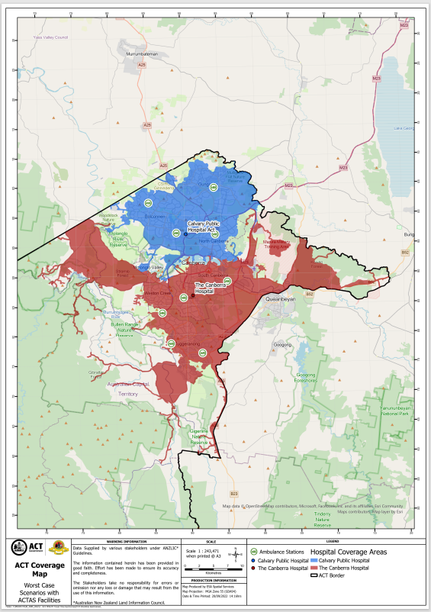

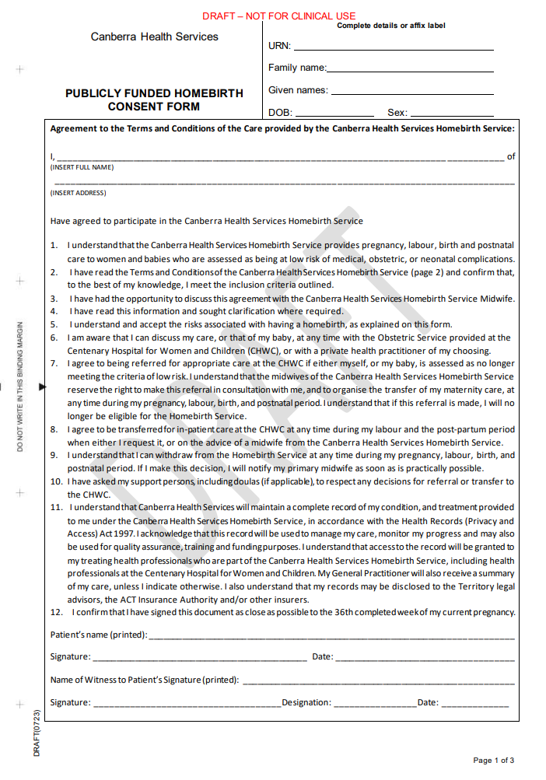
Attachment B – Publicly Funded Homebirths – Consent Form

SAMPLE
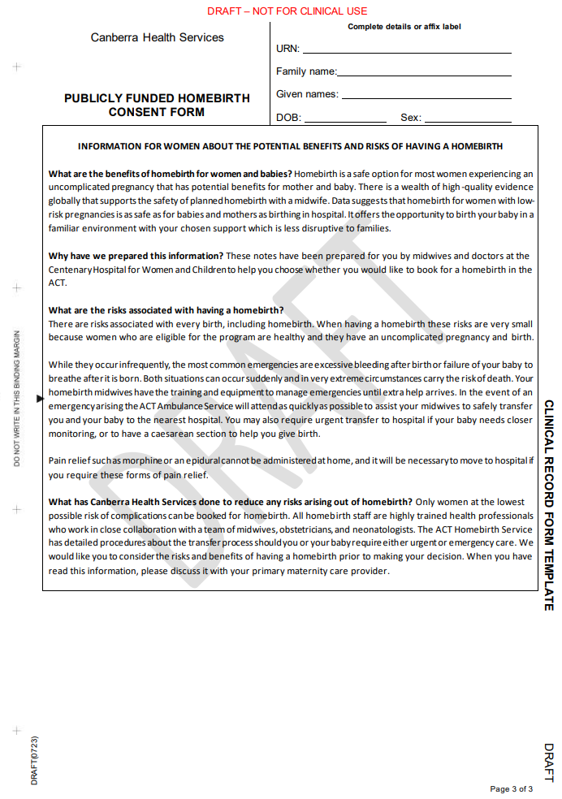
SAMPLE
SAMPLE

Attachment C – Birth Outside of a Hospital Form

Example of the first page of the form
SAMPLE

Attachment D – Continuity Homebirth Midwife Roles and Mentorship

All homebirths are attended by two midwives; one primary and one secondary if the woman consents to their presence.

Midwives authorised to provide homebirth care:
- must have successfully completed all relevant mandatory education
- be deemed suitable by the CMP Clinical Midwifery Manager.

Primary midwives must have completed a period of homebirth mentorship.

Homebirth Mentorship
Midwives bring a variety of knowledge, experience and skill to their midwifery roles and their support and practice development needs will differ as they transition into new ways of working. To better meet the practice development and support needs of midwives undertaking care of women during homebirth, an individualised approach will be taken. Each continuity homebirth midwife coming into the homebirth practice will undertake a review of their knowledge, experience and skill base with their manager/mentor and a plan for support and practice development will be developed, based on this review. To support each continuity homebirth midwife to undertake care of a woman planning a publicly funded homebirth a two-tier approach has been developed.

Intensive Mentoring
Intensive mentoring is provided to midwives who have less than two years of experience working in a continuity of midwifery care model and/or who do not feel confident with caring for a woman in their own home without the support of a mentor.
The mentor continuity homebirth midwife will attend as the second midwife to a minimum of five homebirths with this continuity homebirth midwife.

Self-reflection, peer review and discussions between the continuity homebirth midwife, manager and mentor will determine the level of support provided after this time. Once all parties agree that the continuity homebirth midwife no longer requires the presence of a mentor at the birth the continuity homebirth midwife will be nominated as a primary continuity homebirth midwife and may receive backup support from any member of the continuity homebirth midwives team.

Supportive Mentoring
Supportive mentoring is provided to midwives who have greater than two years of experience working in a continuity of midwifery care model and who feel confident with caring for a woman in their own home without the support of mentor who is present at the birth.

A mentor continuity homebirth midwife will attend as a second continuity homebirth midwife a minimum of two homebirths with this continuity homebirth midwife. Thereafter, this continuity homebirth midwife will be nominated as a primary continuity homebirth midwife and may receive backup support from any member of the continuity homebirth midwives’ team.

Self-reflection, peer review and discussions between the continuity homebirth midwife, manager and mentor will determine the level of support provided after this time. Once all parties agree that the continuity homebirth midwife no longer requires the presence of a mentor at the birth the continuity homebirth midwife will be nominated as a primary continuity homebirth midwife and may receive backup support from any member of the team.

The mentor’s role
The mentor will provide guidance, support and advice to the continuity homebirth midwife and assist in the preparation of ongoing practice development plans. In addition, the mentor will:
- review the case notes with the continuity homebirth midwife and provide advice in relation to suitability for homebirth
- attend the assessment home visit with the continuity homebirth midwife
- attend the birth as the second continuity homebirth midwife
- discuss the antenatal care, birth plan, labour and birth care and the postnatal care with the continuity homebirth midwife following the episode of care
- assist the continuity homebirth midwife to formulate an ongoing practice development plan.

NB. Mentoring that involves the mentor to attend the labour and birth can be undertaken for a longer period if the Primary continuity homebirth midwife wishes or if the mentor / manager / peers deem it necessary.

