Canberra Health Services
Procedure
Dhulwa (DMHU) and Gawanggal (GMHU) Leave Management

Contents

Contents 1
Purpose 3
Alerts…… 3
Scope 4
Section 1 – Leave Panel Committee 4
Role and Function 4
Section 2 – Leave Panel Committee Documentation and Decision 5
2.1 Application for Leave 5
2.2 Leave Application Discussion with Consumer 6
2.3 Security Category and Leave Entitlement (SCALE) 6
2.4 Leave Categories 6
2.5 Therapeutic Leave Plan 7
2.6 Approval Outcomes and Notification 7
2.7 Pre leave Assessments 7
2.8 Clinical Team member Post Leave Assessment 7
2.9 Post Leave Feedback Form 8
Section 3 – Types of Leave 8
3.1 Therapeutic Leave 8
3.2 Overnight Leave 8
3.3 Non Urgent Medical Leave 8
3.4 Urgent Medical Leave 9
3.5 Special Circumstances Leave 9
Section 5 – Contravention of Leave 9
5.1 Unauthorised leave 9
5.2 Suspension of Leave 9
5.3 Revocation of Leave 9
5.5 Consumer on a Forensic Mental Health Order – Detention Ordered by ACAT 10
5.6 Correctional Patient (detainees not subject to a mental health order) 11
Section 6 – Appear of Leave Decissions 11
Section 7 – Incident Report Requirments 11
7.1 Incidents 12
7.2 Team member Incidents 12
Evaluation 12
Related Policies, Procedures, Guidelines and Legislation 12
References 13
Definition of Terms (if applicable) 13
Search Terms 14
Attachments 14
Attachment 1 – Leave Process Flowchart 15
Attachment 3 – SCALE Application Form 18
Attachment 4 – Reviewable Decision Notice 20

Purpose

The purpose of this procedure is to provide Canberra Health Services (CHS) Dhulwa Mental Health Unit (Dhulwa) and Gawanggal Mental Health Unit (Gawanggal) team members with information regarding the processes for planning, assisting and supporting consumers to apply for leave. i.e., therapeutic leave, medical leave, special circumstance leave.

Consumer leave is an important part of the rehabilitation program, as well as planning for discharge in preparation for the transfer of care to a less restrictive setting.

Under the Human Rights Act 2004 CHS team members are delegated as public authorities, who have obligations to ensure the human rights of the person are upheld. These rights should be giving consideration when making decisions regarding leave:
- Protection from cruel, inhuman and degrading treatment
- Liberty and security of person
- Humane treatment when deprived of liberty
- Equal and effective protection against discrimination.
Back to Table of Contents

Alerts

Team member must refer to the Mental Health Act 2015, for understanding and explanation of the applicable legislation and requirements, particularly when making decisions under this Act.

The transfer of consumers requiring urgent medical treatment should never be delayed. Within 12 hours of the urgent transfer, the clinical need and reason of transfer is to be communicated to the Clinical Director, Forensic Mental Health Services (FMHS) or another Justice Health Service (JHS) Consultant Psychiatrist (business hours) or the Psychiatrist on call (after hours) and documented in the consumers Clinical record system.

The Chair of the Leave Panel Committee is authorised to approve leave for consumers at Dhulwa and Gawanggal.

A consumer detained by the Chief Psychiatrist (Forensic Psychiatric Treatment Order) or Care Coordinator/delegate (Forensic/Community Care Order), can approve leave for a consumer. However, if the consumer is detained by the ACT Civil and Administrative Tribunal (ACAT), only ACAT can approve their leave.

The Leave Panel Committee, following consultation and agreement from either the Chief Psychiatrist or ACAT, will approve the requested consumer leave in accordance with the Leave Panel Committee process.

From time-to-time leave may not be able to occur due to exceptional circumstances regarding staff member resourcing.

Prior to leave occurring, the safety of team members and the consumers is discussed and assessed in the daily huddle.
Back to Table of Contents

Scope

This procedure pertains to the CHS team member working at Dhulwa and Gawanggal.

This procedure does not pertain to ground access at Dhulwa which is assessed at the time of admission and is not viewed as leave.

Gawanggal is not included in the reference to ground access as it is not a secure mental health unit.
Back to Table of Contents

Section 1 – Leave Panel Committee

Role and Function
To ensure transparency and governance all consumer leave is considered by the Leave Panel Committee. This is to assess leave with the safety and security of the consumer, team members and the community.

The Leave Panel Committee will meet weekly to review all consumer applications for leave, or as required out of session. The Leave Panel Committee core members comprises of the clinical leadership team, (or their delegates):
    - Clinical Director, Forensic Mental Health (Chair)
    - Assistant Director of Nursing (ADON)
    - Allied Health Manager
    - Clinical Nurse Consultant (CNC)
    - Clinical Nurse Educator (CNE)
    - Clinical Development Nurse (CDN)
    - Consultant Psychiatrist
    - Psychiatry Registrar.

Other attendees:
    - Nursing Team Representatives
    - Allied Health Team Representatives
    - CHS Assistant Security Director and or delegate
    - Other people as deemed relevant by the Leave Panel Committee.

It is acknowledged that nursing and allied health team member provide direct care to consumers and are in a position to provide meaningful and contextual information. Nursing and allied health team members are invited to attend Leave Panel Committee to be involved in the leave application discussion and inform the decision making.

As per the Leave Panel Committee Terms of Reference which states that to meet quorum half of the committee members are required to be present.

While members of the Leave Panel Committee will come to a collaborative and consensus- based decision regarding leave, the FMHS Clinical Director as Chair of the Panel, retains the authority to make a binding decision. The discussions and decisions concerning consumer leave applications are documented in the meeting minutes.

The Chair of the Leave Panel Committee makes decisions on behalf of the Chief Psychiatrist. In the absence of the Clinical Director, the role of Chair of the Leave Panel Committee may be undertaken by a consultant psychiatrist, as a delegate of the Chief Psychiatrist.
Back to Table of Contents

Section 2 – Leave Panel Committee Documentation and Decision

See Attachment 1 – Leave Process Flowchart

Application for Leave
An application to the Leave Panel Committee for a consumer admitted to either Dhulwa or Gawanggal will be made using the Application for Leave form available on the clinical forms register (See Attachment 2).

Only consumers can apply for leave from either Dhulwa or Gawanggal. Consumers are provided with support and assistance from the clinical team member at either Dhulwa or Gawanggal to complete their application for leave.

Consumers are encouraged to engage with family and carers when applying for leave. A leave application can include, but not limited to:
    - Leave as per the consumer’s individual therapeutic leave plan, in its entirety or partially
    - Leave that is ongoing or for multiple dates and times i.e., daily, ongoing daily and/or multiple daily, ongoing weekly/biweekly and/or multiple weekly/biweekly, ongoing monthly/bimonthly and/or multiple monthly/bimonthly
    - Leave for a one-off date and time.

Minor adjustments to approved leave are supported and do not require further approval by the Leave Panel Committee, i.e., Leave to commence at 1.00pm changed to 1.30pm.

Significant adjustment to approved leave does require a new leave application for approval by the Leave Panel Committee, i.e., Leave to occur at a different location to the original application.

The application for leave for consumers at both Dhulwa and Gawanggal and appropriate clinical documents must be provided to the Leave Panel Committee via DMHU@act.gov.au by 4PM the day prior to the meeting. The centralised email address is used for applications for leave for consumers admitted to either Dhulwa or Gawanggal to prevent duplication, possible missed applications and provide easy access to all submitted leave applications.

Associated documents will be reviewed by the Leave Panel Committee in session via the clinical record system.

Leave Application Discussion with Consumer
The consumer’s primary/allocated nurse, Consultant Psychiatrist and any other relevant team members will discuss the leave application and the process with the consumer prior to submitting the application to the Leave Panel Committee. This will be documented in the clinical record system.

If the clinical team do not agree with leave, the leave application will not progress. The Leave Panel Committee should not be used as the mechanism to avoid the clinical team raising their concerns about leave directly with the consumer. The consumer’s rights and preferences regarding leave will be advocated for.

Security Category and Leave Entitlement (SCALE)
SCALE is a clinical tool used to determine the security and leave entitlement as clinically required. SCALE is assessed as part of the admission and clinical risk assessment, management process (See Attachment 3).

Leave Categories

External Leave
A – Escorted
  - – Controlled Escorted – Mechanical Restraint
  - – DMHU/GMHU Team member
  - – Responsible Person (DMHU/GMHU Team member, Support Worker, Carer, Family Member)
B – Unescorted

The Leave Panel Committee will endorse the initial or revised SCALE as part of consideration of leave. Any recommended change to the consumers SCALE rating will be forwarded to DMHU@act.gov.au for endorsement and consideration at the next Leave Panel Committee.

Therapeutic Leave Plan
The details of leave in the therapeutic leave plan must be included on the Application for Leave Form. Therapeutic leave may be granted to a consumer as part of their rehabilitation program and be developed in collaboration with the consumer, family, and carer, if relevant, as part of the Treatment, Placement, Restrictions, Implementation, Monitoring (TPRIM) assessment.

Leave is an important component of therapeutic rehabilitation when preparing for a consumer’s care to be transferred to a less secure approved mental health facility or to community-based care and treatment.

Approval Outcomes and Notification
At the conclusion of the Leave Panel Committee, on the same working day, the following will occur:
    - The Leave Panel Committee Secretariat will notify all Dhulwa and Gawanggal team member via email of the leave approval outcomes and SCALE. This will include any decision surrounding the leave and /or reasons for refusal of leave. Verbal discussion of the outcomes between team members is also encouraged as the nature of nurses’ role can prevent them from accessing their emails.
    - The Leave Panel Committee Secretariat will upload each signed approved leave application into the clinical record system
    - The primary/allocated nurse will discuss with the consumer (verbally or in writing) the decision made by the Leave Panel Committee, including any decisions surrounding the leave or any reasons leave may not have been approved
    - A member of the treating team is able to contact families and carers to discuss leave once consent is given by the consumer
    - When the date and time for the consumer’s leave is finalised, the clinical team will advise DMHU@act.gov.au for inclusion into either the Dhulwa or Gawanggal calendar.

Pre leave Assessments
On the day of the leave and prior to it occurring, the pre leave section of the Leave Checklist in clinical record system is be completed by the consumer’s primary/allocated nurse team.

Confirmation of leave and any change to consumer circumstances (i.e., safety/risks) is discussed at the daily huddle which will inform the completion of the pre leave assessment.

If leave has been suspended or revoked, see sections 5.2 and 5.3. The leave checklist does not need to be completed until the date the leave is confirmed to occur.

Clinical Team member Post Leave Assessment
At the conclusion of the consumer leave, the post leave section of the Leave Checklist in clinical record system, will be completed by the consumer’s primary/allocated nurse team, following a discussion with the consumer on their return from leave.
Any concerns relating to the episode of leave raised and discussed with the consumer are to be documented in this assessment and be escalated to the Nurse in Charge (NiC) or CNC.

Post Leave Feedback Form
NDIS support workers are required to complete a post leave feedback form. Family and carers can choose to provide written feedback using the post leave feedback form.

A team member will provide information about the post leave feedback option and form at the time of leave. The post leave feedback forms are located at both Dhulwa and Gawanggal reception desks.
Back to Table of Contents

Section 3 – Types of Leave

Therapeutic Leave
Therapeutic leave provides consumers with access to the community as part of their therapeutic program. Leave is an important part of the therapeutic rehabilitation program as it supports consumers in maintaining or reestablishing contact with family members, friends and other people during their admission to promote successful recovery, as well as planning for discharge in preparing for the transfer to a less restrictive setting.

Therapeutic leave is not available for detainees or consumers subject to a section 309 order under the Crimes Act 1900.

Overnight Leave
Overnight leave is a type of therapeutic leave provided to a consumer that allows overnight access to the community, at a predetermined location.

Application for overnight leave will require a separate leave application to the Leave Panel Committee and will ordinarily be considered after a period of successful unescorted leave.

Non Urgent Medical Leave
Non urgent medical leave may be granted for all consumers, including detainees, admitted to Dhulwa or Gawanggal. Non urgent medical leave to another health facility is to enable scheduled treatment, including planning medical treatment or investigations that cannot be provided at Dhulwa or Gawanggal.

If the consumer is a correctional patient, the delegate of the CEO may direct a detainee be transferred to another health facility for non urgent medical care.

CHS Security are responsible for the non urgent medical transfers to CHS.

Urgent Medical Leave
Urgent medical leave does not require the completion of an Application for Leave or approval by the Leave Panel Committee.

The transfer of a consumer requiring urgent medical treatment should not be delayed. A telephone order approval to transfer must be sought from the Clinical Director, FMHS or another JHS Consultant Psychiatrist (business hours) or the Psychiatrist on call (after hours) and be documented in the consumers clinical record system within 12 hours.

Special Circumstances Leave
Special circumstances leave may be granted for all consumers, including detainees, subject to a mental health order. Special circumstance may include to visit a family member with a life-threatening illness, injury, to attend a relative’s funeral or to attend court.

A correctional patient (see Definition of Terms) may be granted special circumstances leave if a delegate of the CEO is satisfied there are special circumstances and the safety of the correctional patient, someone else or the public will not be seriously endangered.

Back to Table of Contents

Section 5 – Contravention of Leave

Unauthorised leave
If a consumer takes unauthorised leave, fails to return from leave, or absconds during escorted leave, refer to the CHS Missing Patient Procedure.

Suspension of Leave
Refers to the temporary suspension of leave at the discretion of the Multi Disciplinary Team (MDT) and/or Leave Panel Committee in response to clinical deterioration or clinical reason. The reason to suspend leave is to be documented in the Clinical record system.

The decision and reasons for the suspension of leave will be discussed with the consumer who are encouraged to communicate the suspension of leave with their family and carer. Any concerns relating to safety or risks to the consumer and team member are to be considered when discussing the suspension with the consumer.

- Any member of the team can raise an issue of concern with the CNC/NiC who will review the leave provisions and escalate to the next MDT.
- Suspended leave can be reinstated by the MDT and the Leave Panel Committee.

NOTE: Suspension of leave does not affect ground access.

Revocation of Leave
Refers to revoking of all leave until a new application for leave is submitted to the Leave Panel Committee. Revocation of leave may occur following significant clinical incident or event, mental health deterioration, concerns for public safety or contravention of a condition of leave and the reason documented in the clinical record system.

The decision and reasons for the revocation of leave will be discussed with the consumer who are encouraged to communicate the revocation with their family and carer. Any concerns relating to safety or risks to the consumer and team members are to be considered when discussing the revocation with the consumer.

NOTE: Revoked leave cannot be reinstated by the MDT.
Revocation of leave does not affect ground access.
  - Consumer on a Forensic Mental Health Order – Detention Ordered by Chief Psychiatrist
Leave may be revoked by the Leave Panel Committee of its own initiative or on application by the Director General responsible for the corrections order.

Before revocation, the Leave Panel Committee must provide written notice that revocation of leave is being considered to the consumer and the relevant Director General for the correctional order (or delegate). Leave may be revoked if on reasonable grounds it is necessary to do so because the person:
    - Is doing or is likely to do serious harm to themselves or someone else, or
    - Is suffering, or is likely to suffer, serious mental or physical deterioration, or
    - Is seriously endangering, or is likely to seriously endanger, public safety or
    - The person contravenes a condition of leave.

If the decision is made to revoke the leave, written notice of the revocation must be provided to the consumer and the relevant Director General of the correctional order.

Consumer on a Forensic Mental Health Order – Detention Ordered by ACAT
Leave may be revoked by ACAT on its own initiative or on application by the Chief Psychiatrist/ or Delegate and the Director General responsible for the correctional order (or delegate).

Before revocation, ACAT must provide written notice that revocation of leave is being considered to the consumer, delegate of the Chief Psychiatrist and the relevant Director General for the correctional order (or delegate). Leave may be revoked if on reasonable grounds it is necessary to do so because the person:
    - Is doing or is likely to do serious harm to themselves or someone else, or
    - Is suffering, or is likely to suffer, serious mental or physical deterioration, or
    - Is seriously endangering, or is likely to seriously endanger, public safety or
    - The person contravenes a condition of leave.

Before revocation, consultation with the delegate of the Chief Psychiatrist and the relevant Director General for the correctional order (or delegate) must occur.

If the decision is made to revoke the leave, written notice of revocation must be provided to the consumer, delegate of the Chief Psychiatrist and the relevant Director General of the correctional order.

Correctional Patient (detainees not subject to a mental health order)
In special circumstances leave may be revoked if the consumer:
    - contravenes a condition of the leave
    - the Chief Psychiatrist (delegate) considered it is necessary because the consumer:
      - Is doing something or is likely to do serious harm to themselves or someone else, or
      - Is suffering, or is likely to suffer, serious mental or physical deterioration, or
      - Is seriously endangering, or is likely to seriously endanger, public safety.

Before revocation, consultation with the delegate of the Chief Psychiatrist and the relevant Director General for the correctional order (or delegate) must occur.
Back to Table of Contents

Section 6 – Appeal of Leave Decisions
Under the Mental Health Act 2015, certain decision regarding leave which directly affects consumer in Dhulwa are reviewable by ACAT. The following decisions concerning leave are reviewable:
    - Refusal to grant leave to a patient on a FMHO (s. 121)
    - Refusal to grant leave in emergency or special circumstances to a patient on FMHO (s. 122)
    - Revocation of leave by the Chief Psychiatrist (s. 123)
    - Refusal to grant leave to a correctional patient (s. 143)
    - Revocation of leave to a correctional patient (s. 144).

If a leave decision has been made by ACAT, the patient may also appeal that decision using the ACAT Application for Appeal Form.

The decision to refuse or revoke leave requires written notice signed by the decision maker, to be provided to the consumer who applied for the leave, which outlines the reasons for the decision. (See Attachment 4)

If the consumer who applied for leave is unhappy with the decision, they may apply to ACAT for a review of that decision. To make an application to ACAT, the consumer will need to complete the Application for Review of a Decision form and lodge it with the ACAT registry, within 28 days of the decision.
Back to Table of Contents

Section 7 – Incident Report Requirments

Incidents
Any incidents or near misses (see definition of terms) that occur while a consumer is on leave must be reported to the ADON/CNC or NiC and a clinical incident management report must be completed.

Any events that occurred during leave are to be reported to the NiC, escalated to the Safety Huddle and documented in the consumer’s clinical record system.

Team member Incidents
Any occupational violence, accident or injury to team members must be reported by the team member involved in the incident and a clinical incident management report must be completed.

Team member incident clinical incident management reports are reviewed at the Tier 3 Work Health and Safety meetings in line with existing CHS process.
Back to Table of Contents

Evaluation

Outcome
    - Reduction in consumer complaints regarding the leave processes
    - Simplification of leave application and associated documents
    - Simplified and streamlined leave approval process.

Measures
    - Proportion of leave applications approved
    - Proportion of leave suspended or revoked
    - Leave process outcomes evaluated through consumer experience and feedback.

Back to Table of Contents

Related Policies, Procedures, Guidelines and Legislation

Policies
    - Work Health and Safety
    - Incident Management – Clinical

Procedures
    - ProceduresOccupational Violence
    - Clinical Handover
    - Initial Management, Assessment and Intervention for People Vulnerable to Suicide
    - Dhulwa Mental Health Unit
    - Missing Patient
    - Incident Management – Clinical

Legislation
    - Mental Health Act 2015
    - Health Records (Privacy and Access) Act 1997
    - Human Rights Act 2004
    - Work Health and Safety Act 2011
    - Carers Recognition Act 2021
    - Corrections Management Act 2007
    - Crimes Act 1900

Other
    - Australian Charter of Healthcare Rights
    - ACT Charter of Rights for People who Experience Mental Health Illness

Back to Table of Contents

Definition of Terms (if applicable)

Correctional patient – A detainee who has been transferred from custody whom a mental health or forensic mental health order cannot be made.

Ground access (only applies to Dhulwa) – Is not classified as leave as it includes the Dhulwa walking track, basketball court, therapeutic corridor.

Near miss - An incident that could have caused harm but did not or an incident that was intercepted before reaching the patient/ client/ consumer.

Back to Table of Contents

Search Terms

Leave, Dhulwa, Gawanggal, application, leave panel committee, DMHU, GMHU

Back to Table of Contents

Attachments

Attachment 1 – Leave Process Flowchart
Attachment 2 – Leave Application Form
Attachment 3 – SCALE Application Form
Attachment 4 – Reviewable Decision Notice

Disclaimer: This document has been developed by Canberra Health Services specifically for its own use. Use of this document and any reliance on the information contained therein by any third party is at his or her own risk and Canberra Health Services assumes no responsibility whatsoever.

Policy Team ONLY to complete the following:
Date Amended | Section Amended | Divisional Approval | Final Approval
07/12/2023 | Complete Review | Katie Mckenzie ED MHJHADS | CHS Policy Committee

This document supersedes the following:
Document Number | Document Name
CHS21/170 | Dhulwa and Gawanggal Mental Health Units -Leave Management for People Admitted

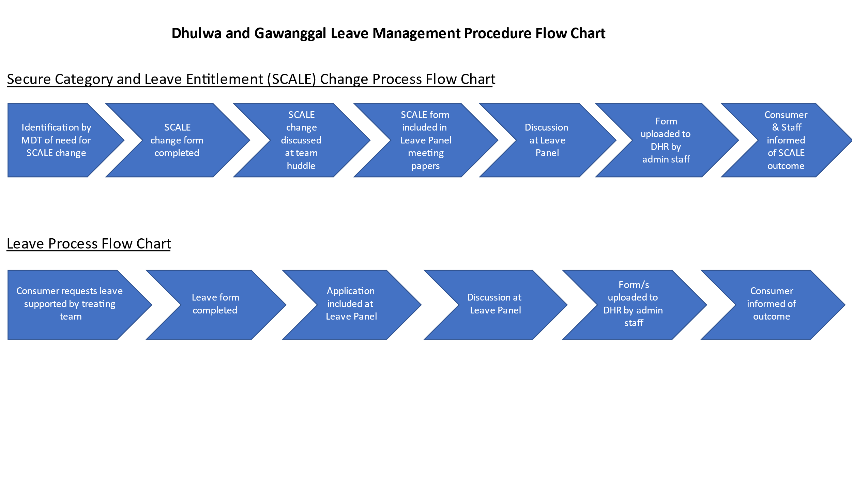
Attachment 1 – Leave Process Flowchart

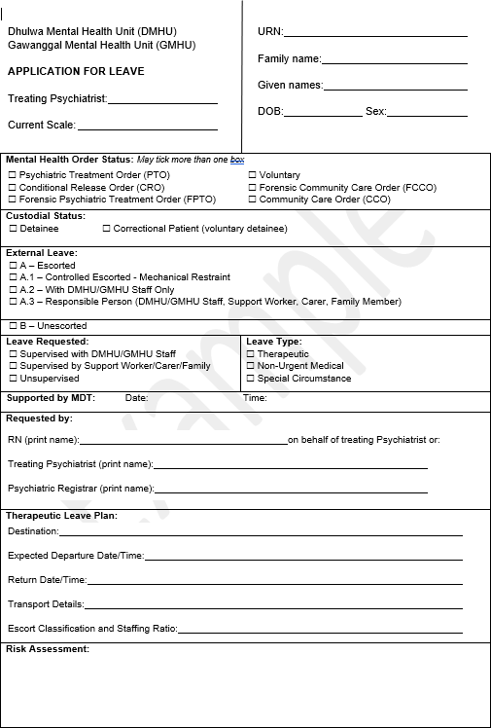
Attachment 2 – Leave Application Form
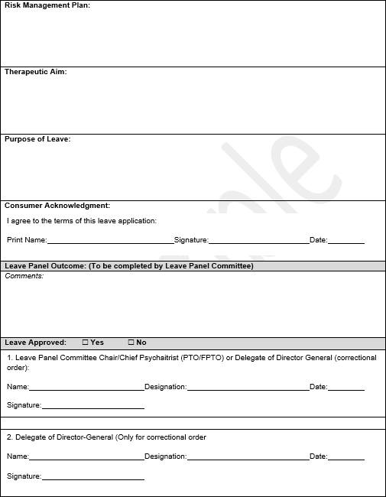

Attachment 3 – SCALE Application Form
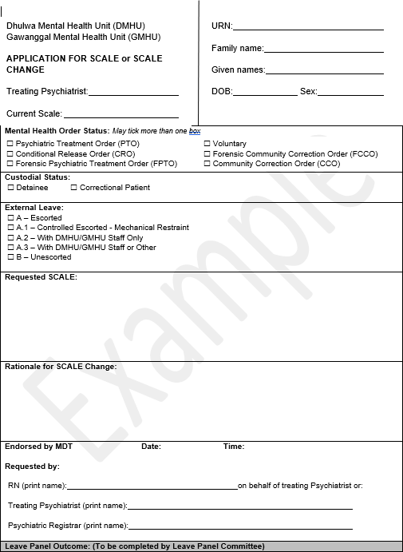

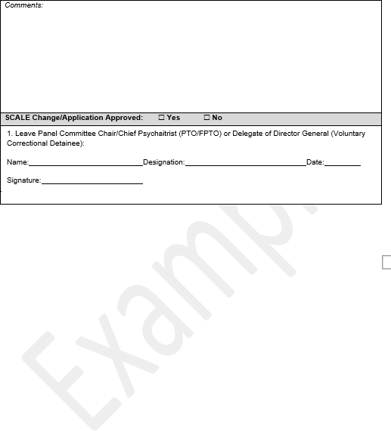

Attachment 4 – Reviewable Decision Notice
