Canberra Health Services
Canberra Health Services
Procedure
Cord Blood Collection for Blood Group, Direct Antiglobulin Test (DAT) and Blood Gas Sampling

Contents

Contents 1
Purpose 2
Scope 2
Alerts 2
Section 1 – Cord Blood collection for Group and DAT 2
Section 2 – Collection of Cord Blood for Umbilical Cord Blood Gas Sampling 5
Section 3 – Management of the baby with abnormal cord gases 6
Evaluation 7
Related Legislation, Policies and Standards 7
References 8
Definition of Terms 8
Search Terms 8
Attachments 9
Attachment 1: Flowchart for Cord Blood Collection in the Operating Theatre 10
Attachment 2: Management of Newborn Cord Gases 11

Purpose

This document informs Canberra Health Services (CHS) team members:
- How to identify babies who are at risk of haemolytic disease and who require cord blood collection for Blood Group and Direct Antiglobulin Test (DAT)
- How to identify babies who require Cord Blood Gas sampling
- Who is responsible for the blood collection
- The process for collecting the blood.

Back to Table of Contents

Scope
This procedure applies to newborn babies at Canberra Health Services Network. It applies to the following CHS Network facilities:
- Canberra Hospital
- Centenary Hospital for Women and Children
- North Canberra Hospital.

This procedure applies to the following staff working within their scope of practice:
- Medical Officers
- Midwives and Nurses who have been assessed competent in the procedure
- Student midwives/nurses under direct supervision.

Back to Table of Contents

Alerts

- Delaying clamping of the umbilical cord for 1-3 minutes after birth has been demonstrated to provide significant benefits for newborn babies. Delayed cord clamping should occur for babies of all gestations at birth where no precluding issues are affecting the woman or the baby. Refer to Section 8 of Labour and Birth: Care during First, Second, Third and Fourth Stage procedure.
- If required, Umbilical Cord Blood Gas Collection is a priority to cord blood collection, Refer to Section 2 of this document.

Back to Table of Contents

Section 1 – Cord Blood collection for Group and DAT

Indications for the collection of Blood Group and Direct Antiglobulin Test (DAT):

Maternal:
- Rhesus negative
- O positive
- Maternal Antibodies (e.g., Anti-K, Anti-c)

Fetal/Neonatal:
- Visibly jaundiced at birth
- Known isoimmunisation or haemolytic disease with in-utero transfusions or anaemia.

Formal Cross Matching is to be requested for:
- Babies born less than 28 weeks - Extreme Prematurity
- Known surgical condition requiring surgery in the newborn period e.g., gastroschisis or congenital diaphragmatic hernia.

Procedure

Equipment:
- EDTA 4mL (pink tube)
- BD Vacutainer – Blood Transfer Device
- Gallipot

Birthing Suite and Birth Centre
- Order pathology on Digital Health Record (DHR):
- Complete pathology order in baby record (pended or admitted baby): Cord blood group and DAT.
- Include clinical history e.g., O positive mother.

- Blood collection:
- Ensure appropriate hand hygiene process and specimen labelling processes are followed and personal protective equipment (PPE) is utilised as per Pathology Specimen Handling and Transportation Procedure
- Collect the cord blood from the baby’s cord into a gallipot.
- Draw up the collected blood into pink pathology tube using the blood transfer device, rotate the tube 6-8 times.
- ADMIT Newborn baby on DHR and print ID bands.
- Process pathology order.
- Print specimen label
- As per Patient Identification and Procedure Matching, ensure the baby’s details on the pathology label exactly match pathology order.
- Complete collection on DHR by scanning the baby’s ID band, followed by the pathology label.

Procedure – Operating Theatres:
Specimens collected in operating theatres and any other area where the Collector is scrubbed are not required to be personally labelled by the Collector. However, they must be labelled by a team member who was present when the specimen was collected and who has personally performed positive patient identification. Refer to Attachment 1: Flowchart for Cord Blood Collection in the Operating Theatre.

Midwife actions:
- Orders Cord Blood Group and DAT in pended baby record
- Provides the cord blood pack (pink blood tube, transfer device) to Scout Nurse
- Collects cord gas specimens (if indicated)
- Once born, admits pended baby in DHR, once admitted, prints specimen label for Cord Blood Group and DAT
- Confirms accuracy of printed label with scout nurse, hands specimen label to scout nurse.
- Completes documentation of specimen collection in DHR

Theatre Scrub Nurse actions:
- Alert the scout nurse that they are about to collect the cord blood so the scout nurse can witness the collection.
- Collect the cord blood for the baby’s cord into a gallipot.
- Draw up the collected blood into a 10mL syringe.
- Pass the collected blood in the syringe to the scout nurse.
- Once the specimen is labelled by the scout nurse, confirms the baby’s details on the pathology label match the order in DHR.

Theatre Scout Nurse Actions:
- Witness the cord blood collection.
- Aspirate the cord blood via the blood transfer device into the EDTA (pink tube)
- Rotate the tube 6-8 times to prevent clotting.
- Label cord blood specimen using baby pathology specimen stickers provided by attending midwife.
- Once the specimen is labelled, confirms with the scrub nurse the baby’s details on the pathology label match the order in DHR.
- Send labelled blood specimens to pathology.

Note: If the label printer fails to print, hand- write 3 patient identifiers and the corresponding DHR order number onto each container. Perform positive patient identification on the patient and pathology samples. Sample labelling and procedure matching as above.

Back to Table of Contents

Section 2 – Collection of Cord Blood for Umbilical Cord Blood Gas Sampling

Background
Umbilical cord blood sampling provides valuable information regarding the status of the fetal metabolic condition at birth. Sampling can occur in operating theatre or maternity.

Findings from the umbilical cord artery provide the most accurate information about fetal and newborn acid-base status, while the venous cord blood reflects a combination of maternal acid-base status and placental function.

Indications
Cord blood should be taken from the cord artery and vein after birth in the following situations:
- induction of labour
- meconium-stained liquor
- neonatologist/neonatal registrar/paediatrician present at birth
- preterm gestation
- planned Neonatal Intensive Care Unit (NICU) admission
- assisted vaginal birth
- emergency or non-elective caesarean section
- vaginal breech delivery
- shoulder dystocia
- maternal thyroid disease
- intrapartum haemorrhage
- small for gestational age
- twins
- fetal scalp pH during labour
- Apgar score < 5 at 1 minute or <7 at 5 minutes
- IRGDM
- All labours with Continuous Fetal monitoring (CEFM) regardless of classification.

Equipment required:
- gloves
- heparinised blood gas syringes x 2
- needles 21g x 2
- personal Protective Equipment (PPE), eye and face shield, gloves, gown
- cord clamps x 2
- Neonatal identification labels.

Cord Blood Gas Sampling Technique
For cord blood gas collection, double clamp a 10cm segment of the umbilical cord that is attached to the undelivered placenta and obtain paired arterial and venous samples.
A clamped segment of cord blood is stable for pH and blood gas analysis for at least 30 minutes post-delivery.

Procedure
- Use heparinised pre-packed blood gas syringe by attaching a 21g (green) needle to each syringe.
- Withdraw a minimum of 0.2 mL blood from the artery as it contains less blood than the umbilical vein. This sample provides the most accurate information regarding fetal and newborn acid-base status (artery has a smaller lumen, thicker wall).
- Expel any extra air from the syringe before capping with stopper provided.
- Ensure immediate mixing of the sample for 15 seconds to disperse heparin and prevent clotting.
- Label the syringe with all the following details:
- Baby’s Unique Record Number (URN)
- Mother’s family name
- Baby of (‘B/O’) and the mother’s given name
- ‘Baby 1 of’ and ‘Baby 2 of’ for multiple birth
- Date of birth
- Identify as arterial or venous.
- Obtain venous sample with second syringe, expel the extra air and cap the syringe with the stopper provided and label as above.
- Process blood gas samples at the nearest blood gas analyser located in Birthing, operating theatre or NICU as per Pathology Point-of-Care Testing (POCT) Procedure.
- Midwifery team member to inform neonatal and obstetric registrar/paediatrician if arterial cord gas blood pH result is <7.1, lactate >6.2) or base excess -10.

Normal cord blood gas and pH (during and post labour)
At term | pH | Base Excess  mmol/L | pO2 (mmHg) | pCO2 (mmHg) | Lactate  mmol/L
Arterial | 7.10-7.38 | -9.0 to 1.8 | 4 – 32 | 39 – 74 | <6.1
Venous | 7.20-7.44 | -7.7 to 1.9 | 14 – 43 | 30 – 57 | <6.1

Back to Table of Contents

Section 3 – Management of the baby with abnormal cord gases
Please refer to Attachment 2 for guidance on how to manage a baby with abnormal arterial cord gases (pH<7.2, lactate >6.2).

If the venous cord gas has a lower pH and a higher lactate than the arterial gas, manage the baby as per the venous gas.

Back to Table of Contents

Evaluation

Outcomes
- Babies who are at risk of haemolytic disease and who require cord blood collection for Blood Group and DAT are correctly identified.
- Babies who require cord blood gas sampling are correctly identified.
- Team members are aware of who is responsible for the blood collection and the process required for blood collection.

Measures
- Clinical incident reports relating to errors in collection/labelling of cord blood after birth will be identified by pathology team members and reviewed by the birthing suite clinical midwifery manager on a case-to-case basis. Follow up education will occur in conjunction with the midwifery education team, as required to ensure team members awareness in specimen labelling and collection.
- Second monthly audit of all cord blood gas samples by CHS ACT Pathology. Individual rates of collection error will be audited to determine if retraining is required. This is designed to optimise accuracy of collection and running of sample as per supplier recommendations.

Back to Table of Contents

Related Legislation, Policies and Standards
Policy
- Informed Consent – Clinical
- Nursing and Midwifery Board of Australia (NMBA) Requirements for Practice

Procedures
- Jaundice in the Newborn
- Labour and Birth: Care during First, Second, Third and Fourth Stage
- Patient Identification - Pathology Specimen Labelling
- Patient Identification and Procedure Matching
- Pathology Point of Care Testing (POCT)
- Pathology Specimen Handling and Transportation

Guidelines
- Collection of Cord Blood for the Purposes of Private Cord Blood Banking
- Prophylactic use of Rh D immunoglobulin in pregnancy care

Legislation
- Health Records (Privacy and Access) Act 1997
- Human Rights Act 2004
- Work Health and Safety Act 2011

Other
- Australian Charter of Healthcare Rights
Back to Table of Contents

References

- AlKhater SA, Albalwi RA, Alomar SA, Alsultan AA, Almuhaidib HR, Almousa RA, Alanezi SM, Alghamdi RK, Shash HA. Value of the Direct Antiglobulin Test in Predicting the Need for Phototherapy in Newborns. J Blood Med. 2021 Jan 29; 12:53-61. doi: 10.2147/JBM.S291606. PMID: 33542670; PMCID: PMC7853422. https://www.ncbi.nlm.nih.gov/pmc/articles/PMC7853422/
- King Edward Memorial Hospital (2022). Blood group management & clinically significant antibodies: Rh D negative & Rh D positive women
- Kuzniewicz MW, Escobar GJ, Wi S et al. Risk factors for severe hyperbilirubinemia among infants with borderline bilirubin levels: a nested case-control study. Journal of Paediatrics 2008; 153:(2)234-40.
- National Institute for Health and Clinical Excellence. The guidelines manual 2010. London: NICE; 2010.
- Royal Hospital for women (2017). Umbilical cord blood sampling guideline. Clinical Performance and Quality
- South Australian perinatal practice guidelines (2017) umbilical cord blood gas sampling

Back to Table of Contents

Definition of Terms

- Cord blood: blood taken from the umbilical cord at or just after birth.
- DAT - Direct Antiglobulin Test, blood test that detects red blood cells sensitized with IgG alloantibodies
- Jaundice -The yellow colouration of the sclera caused by the accumulation of bilirubin in the skin and mucous membranes.
- Visible Jaundice- Jaundice detected by visual inspection.

Back to Table of Contents

Search Terms

Jaundice, Cord, Blood, Direct Coomb’s Test, Rhesus Negative, Rh, Haemolysis, Group, DCT, gases, pH, lactate, gas, Arterial, Venous, DAT, Direct Antiglobulin Test, blood gas, cord gas

Back to Table of Contents

Attachments

Attachment 1: Flowchart for Cord Blood Collection in the Operating Theatre
Attachment 2: Management of Newborn Cord Gases

Disclaimer: This document has been developed by Canberra Health Services specifically for its own use. Use of this document and any reliance on the information contained therein by any third party is at his or her own risk and Canberra Health Services assumes no responsibility whatsoever.

Policy Team ONLY to complete the following:
Date Amended | Section Amended | Divisional Approval | Final Approval
02/01/2024 | Complete Review and DHR update | Suzanne Pilkington a/g ED WYC | CHS Policy Committee
18/04/2024 | Updated to include NCH | CHS Policy Team | CHS Policy Team

This document supersedes the following:
Document Number | Document Name
CHHS 21/173 | Cord Blood Collection for Blood Group, Direct Coomb’s test (DCT) and Blood Gas Sampling

Attachment 1: Flowchart for Cord Blood Collection in the Operating Theatre

Back to Table of Contents

Attachment 2: Management of Newborn Cord Gases

*Perform cord blood gas collection for ALL labours requiring CEFM*
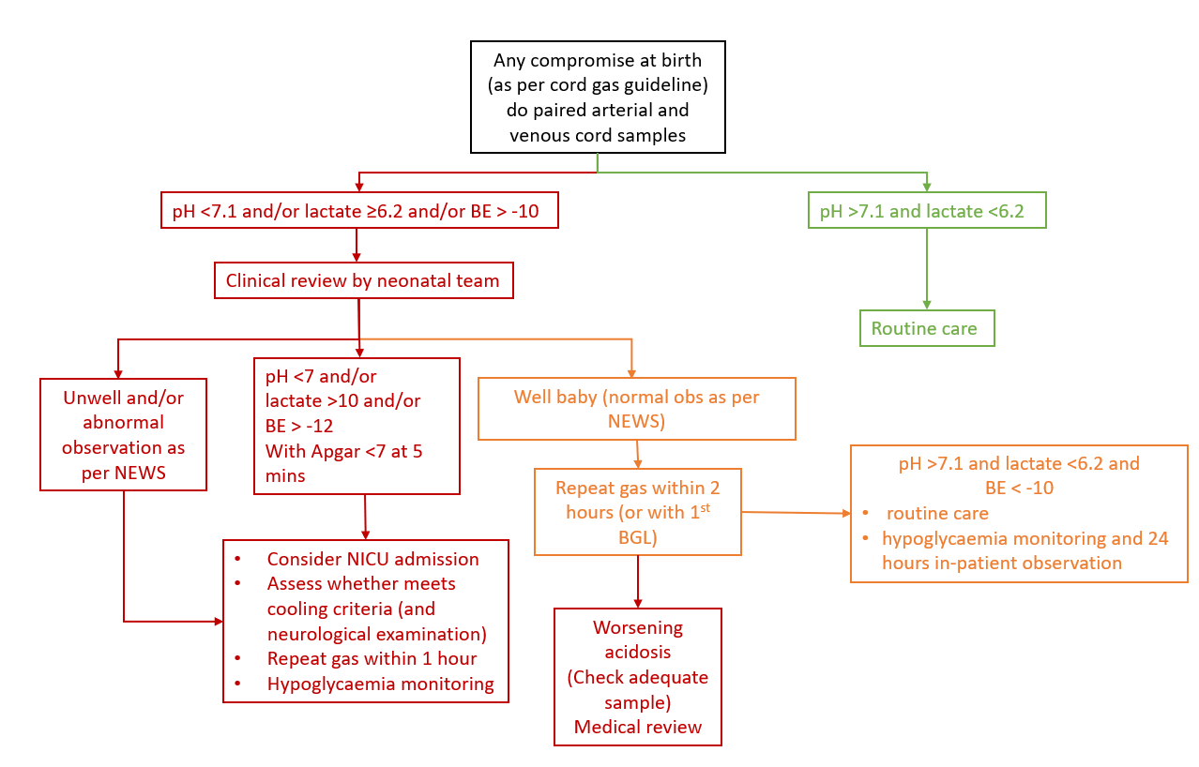

Back to Table of Contents

