Canberra Health Services
Clinical Guideline
Bladder Distension Injury Prevention – Maternity and Gynaecology

Contents

Contents 1
Guideline Statement 2
Scope 2
Background 2
Section 1 – Bladder Care during First Stage of Labour 3
Section 2 – Bladder Care during Second Stage of Labour 3
Section 3 – Bladder Care in Immediate Postpartum Period 3
Section 4 – Postnatal Trial of Void 4
Section 5 – Bladder Care following Gynaecology Surgery 6
Evaluation 6
Related Policies, Procedures, Guidelines and Legislation 6
References 7
Definition of Terms (if applicable) 7
Search Terms 7
Attachments 8
Attachment 1: Bladder Management Intrapartum and Postpartum 9
Attachment 2: Postpartum Bladder Management and Trial of Void Flow Chart 10
Attachment 3: Bladder management following Gynaecological Surgery 11

Guideline Statement

This document is intended to guide clinicians in the prevention of bladder injury and urinary retention during and following birth, by ensuring bladder care is maintained during labour, birth, the postpartum period, and post operatively.

This guideline also provides information for health professionals to follow a process for identifying normal bladder function post birth and postoperatively and implement appropriate management if there are any signs and symptoms of urinary retention.

Whenever an Indwelling Urinary Catheter (IDC) is inserted, it will be done in accordance with the following:
- Urinary Catheter Insertion and Management for Adults, Children, and Infants
- Aseptic Technique Procedure
- Infection Prevention Control and Healthcare Associated Infections Procedure.

Back to Table of Contents

Scope

This document applies across the Canberra Health Services (CHS) Network including the inpatient facilities at Canberra Hospital, Clare Holland House, North Canberra Hospital, and University of Canberra and community based services. It applies to the following staff, working within their scope of practice:
- Medical Officers
- Registered Midwives and Nurses
- Midwifery students under direct supervision

Back to Table of Contents

Background

All women have the potential to experience bladder dysfunction during their labour, birth or in the postpartum period, including those who have caesarean sections. All women should be screened for potential risk factors and increased likelihood of experiencing a bladder injury and preventative measures identified and commenced to avoid or minimise damage.

Gynaecological surgery: Women who have had gynaecological surgery require an individual plan for bladder management by the surgeon.
Back to Table of Contents

Section 1 – Bladder Care during First Stage of Labour

- Educate woman regarding the importance of optimal bladder care during labour and postpartum period.
- Encourage woman to void and empty bladder completely – at least every 2 hours during labour and prior to an epidural block.

Insert an indwelling urinary catheter (IDC) if:
- Epidural block has been inserted
- The woman has a palpable bladder but is unable to void
- If unable to void 4 hours from previous void (whilst ensuring the woman is not dehydrated).

See Attachment 1 for Bladder Management Intrapartum and Post-Partum
Back to Table of Contents

Section 2 – Bladder Care during Second Stage of Labour

- Encourage woman to void prior to commencement of active second stage, an in/out catheter may be inserted to drain bladder
- All IDCs are to be removed prior to active second stage
- The bladder is to be drained prior to all assisted vaginal births
- Continue to monitor and document all fluid intake and output volumes
- If prolonged active second stage (>2hrs), consider emptying bladder if unable to void (in/out catheter)
Back to Table of Contents

Section 3 – Bladder Care in Immediate Postpartum Period

Insert IDC immediately following birth if the following conditions or risk factors for urinary retention are present:
- Periurethral tears
- Extensive labia/perineal swelling likely to impede voiding
- Vulval haematoma
- Postpartum haemorrhage (PPH)
- 3rd or 4th degree tear
- Retained placenta
- Epidural anaesthesia

Women who have had epidural anaesthesia must have IDC in situ for a minimum of 6 hours after time of birth.
Women who have had spinal anaesthesia or epidural analgesia that has been topped up for a trial of instrumental birth or Caesarean Section must have an IDC in situ for a minimum of 12 hours after time of birth.

Other clinical indicators which should be considered as risk factors for urinary retention include:
- Primiparity
- Precipitant Labour
- Prolonged 1st and/ or 2nd stage of labour
- Instrumental birth
- Caesarean Section
- Birth weight >3.8 kg
- Regional anaesthesia (pudendal block)
- Inability to void or catheterisation in labour
- Obesity.

Back to Table of Contents

Section 4 – Postnatal Trial of Void

4.1 Trial of void after birth or removal of IDC
All women will have the timing and volume of their first two voids measured.

This is the responsibility of the midwife caring for the woman after birth or IDC removal.
- Measured void should be between 200-600ml with no signs of urinary retention.
- Record voided volume in the ‘Fluid Balance’ and ‘Postnatal Trial of Void’ section of flowsheets in the woman’s DHR record.

Symptoms of Urinary Retention include:
- Inability to void.
- Slow or intermittent stream
- Incontinence
- Bladder pain or discomfort
- Straining to void
- Urinary frequency
- Small, voided volumes
- Urgency
- No sensation to void.

For first void staff should:
- Discuss trial of void with the woman and educate on the importance of bladder care post-partum.
- Encourage the woman to void around two hours post time of birth or removal of IDC. If no sensation to void, or has attempted and is unable to void, early management includes:
  - Encouraging adequate fluid intake
  - Two hourly timed voiding
  - Ensuring appropriate pain management
  - Double voiding
  - Using running water to void.
- If symptoms of urinary retention persist despite management strategies, residual volume must be measured.
- Residual volumes should be measured with a bladder scanner or on intermittent catheterisation, immediately after the void.
- Bladder scanner should only be used only by clinicians who have been trained in use.

- If the woman has no sensation to void within four hours of birth, or removal of IDC, ask to attempt void. If unable to void, consider urinary retention.

Management of suspected urinary retention:
- Complete bladder scan (refer to Continence Assessment and Management Procedure)
- If volume is >150mls request urgent medical review, consideration for IDC insertion.
- If <150ml continue early management strategies above and monitor within an hour

4.2 Second void after birth
- Second measured void should be between 200-600ml with no signs of urinary retention.
- If urinary retention suspected, management as above for urinary retention.
- Women should be referred for physiotherapy review if they have urinary incontinence or their residual volume is > 700mL.

4.3 Management of women who require IDC insertion for urinary retention.
- All women with suspected urinary retention require Midstream urine (MSU) or Catheter specimen of urine (CSU) to exclude infection.
- IDC to be left insitu for 24-72 hours (dependant on risk analysis from medical team)

Trial of void after removal of IDC for management of urinary retention
- If post void residual <150mL, women should be encouraged to continue voiding strategies and follow up with their GP on discharge.
- If post void residual >150mL the woman has postnatal urinary retention. The indwelling urinary catheter is to stay in for a further 24 to 72 hours on the advice of the Obstetric Registrar/ Consultant.

Care for women who are discharged with IDC insitu is to be managed through the outpatient’s urology trial of void clinic. The clinician responsible for discharge should complete Medical Officer’s Orders for Urinary Catheter Management available on the Clinical Forms Register.

Documenting Trial of Void in the Clinical Records System
- Volume of void should be completed in fluid balance section of flow sheets should be completed before completing TOV flowsheet data.
- Complete all relevant flowsheets. If the patient flags concerns in the Voiding Prompts, more flowsheet rows will cascade out.
- If required, inpatient physiotherapy referral is completed through the Inpatient order section in DHR.
- If the woman requires physiotherapy referral and is being discharged, complete a DHR Outpatient order in the Future Outpatient orders, ensure correct health service is selected with Acute Allied Health Service as division.

Back to Table of Contents

Section 5 – Bladder Care following Gynaecology Surgery

Where a bladder management plan has been made by the surgeon, this should be followed. Please see Attachment 3: Bladder management following Gynaecological Surgery.

Back to Table of Contents

Evaluation

Outcome
- Staff will recognise urinary retention in labour, post-partum and post gynaecological surgery and escalate as per this guideline
- Women attending the CHS for labour and birth will be cared for as per this guideline and will be provided with individualised, woman centred care, pain relief and post birth care.
- Women receiving pre and post operative care for gynaecological surgery at CHS will receive bladder care per this guideline and will be provided with individualised, woman centred care, pain relief and post-surgical care.

Measures
- Data on urinary retention is benchmarked against similar Maternity units through Women’s Healthcare Australasia. Deviations from normal are investigated by the Departmental Quality and Safety Committee when deemed necessary.
- The data is collated from the following evidence and measured against appropriate indicators:
- Digital Health Record
- Risk Analysis System
- Women's Healthcare Australasia indicators.
Back to Table of Contents

Related Policies, Procedures, Guidelines and Legislation

Policies
- Nursing and Midwifery Board of Australia (NMBA) Requirements for Practice
- Informed Consent- Clinical

Procedures
- Continence Assessment and Management
- Infections Prevention and Control -Healthcare Associated Infections
- Patient Identification – Pathology Specimen Labelling
- Patient Identification and Procedure Matching
- Labour and Birth: Care during First, Second, Third and Fourth Stage
- Perineal Care – Maternity
- Urinary Catheter Insertion and Management for Adults, Children and Infants (Not Neonates)
- Vital Signs & Early Warning Scores-Maternity Early Warning Score (Maternity MEWS)

Guidelines
- Fasting Guidelines – Elective and Emergency Surgery
- National Midwifery Guidelines for Consultation and Referral
- Obstetric Emergency – Postpartum Haemorrhage

Legislation
- Health Records (Privacy and Access) Act 1997
- Human Rights Act 2004
- Work Health and Safety Act 2011

Other
- Australian Charter of Health Care Rights

Back to Table of Contents

References

- King Edward Memorial Hospital (2020). Bladder Management: During labour and the postnatal period. Available from: Bladder Management (health.wa.gov.au)
- National Institute for Clinical Excellence (NICE). 2021. Postnatal care up to 8 weeks after birth. Overview | Postnatal care | Guidance | NICE
- Royal Australian and New Zealand College of Obstetricians and Gynaecologists (RANZCOG) 2017: Provision of routine intrapartum care in the absence of pregnancy complications. Provision-of-routine-intrapartum-care-in-the-absence-of-pregnancy-complications-(C-Obs-31) review-July-2017.pdf (ranzcog.edu.au)
- Royal Hospital for Women (2020). Bladder care during Labour and the postpartum period. Available from: Bladder care during labour and the postpartum period (nsw.gov.au)
- Women’s and Children’s Health Network (2014). Multidisciplinary Clinical Guideline. Bladder Management during Labour and the Early Puerperium.

Back to Table of Contents

Definition of Terms (if applicable)

- Bladder over-distension – a measured bladder volume of >600ml
- Postpartum Urinary Retention (PUR) – inability to void, with often a painful palpable bladder which requires catheterisation for relief
- Detrusor muscle – smooth muscle found in the wall of the bladder

Back to Table of Contents

Search Terms

Trial of void, Urinary retention, Bladder care

Back to Table of Contents

Attachments

Attachment 1: Bladder Management Intrapartum and Postpartum

Attachment 2: Postpartum Bladder Management and Trial of Void Flow Chart

Attachment 3: Bladder management following Gynaecological Surgery

Disclaimer: This document has been developed by Canberra Health Services specifically for its own use. Use of this document and any reliance on the information contained therein by any third party is at his or her own risk and Canberra Health Services assumes no responsibility whatsoever.

Policy Team ONLY to complete the following:
Date Amended | Section Amended | Divisional Approval | Final Approval
29/04/2022 | Complete Review | Susan Freiberg-Executive Director WY&C | CHS Policy Committee
06/12/2023 | Guideline Statement, Section 4, Evaluation, Related Policies, Procedures, Guidelines and Legislation | Wendy Adler Assistant Director of Midwifery WY&C | CHS Policy Team

This document supersedes the following:
Document Number | Document Name
CHHS18/033 | Bladder Distension Injury Prevention – Maternity and Gynaecology

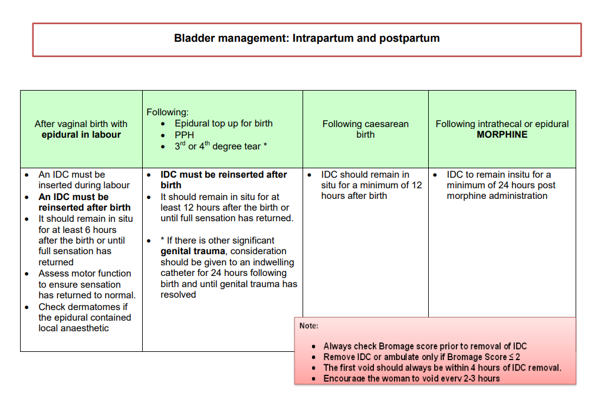
Attachment 1: Bladder Management Intrapartum and Postpartum

Attachment 2: Postpartum Bladder Management and Trial of Void Flow Chart

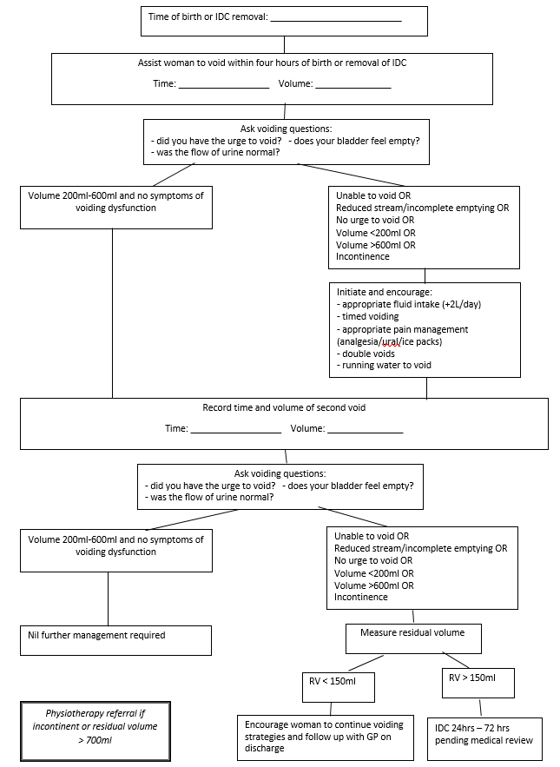

Attachment 3: Bladder management following Gynaecological Surgery
