Procedure | Canberra Health Services
Physiotherapy Initiated Pathology (PTIP)
CHS24/641

Contents
Purpose 2
Scope 2
Section 1 – Indications for Pathology Tests 2
Section 2 – Physiotherapy-Initiated Pathology Requests 3
Clinical Tests 5
Evaluation 9
Related policies, procedures, guidelines and legislation 9
Search terms 10
Attachments 10

Purpose
The purpose of this Clinical Procedure is to detail the processes that will streamline care for patients presenting to the Emergency Department (ED), by expediting pathology collection for select patient presentations, through the initiation of pathology requests by credentialed Advanced Musculoskeletal Physiotherapists (AMPs) and Extended Scope of Practice Physiotherapists (ESPs).
Back to Contents

Scope
This procedure primarily guides the clinical practice of credentialed AMPs and ESPs seeing adults (≥16years old) in the ED. It primarily describes the responsibilities of the AMP/ESP, but also those of the Emergency Registrars/Consultants and Nursing staff team members.

Ordering haematological and microbiological workup
This clinical procedure applies to AMPs and ESPs who have been successfully credentialed against sections C8.1-8.6 of the CHS Advanced Musculoskeletal Physiotherapy Standard of Practice (see Appendix A for this section of the standard).
Pathology orders initiated in ED are authorised by the Clinical Director of the Emergency Department.

Venepuncture and Blood collection
AMPs and ESPs who have completed section C8.7 (appendix A) of the CHS Advanced Musculoskeletal Physiotherapy Standard of Practice are able to perform blood collection.
Back to Contents

Section 1 – Indications for Pathology Tests
ED AMP and ESPs autonomously assess and manage patients presenting to ED with musculoskeletal conditions. They are senior decision makers in ED and are often consulted by other healthcare providers regarding musculoskeletal (MSK)presentations. Patients presenting to ED may have signs and symptoms that require differentiation or pre-op assessment by way of haematological and microbiological work-up. Common differential diagnoses include:
- Septic arthritis
- Gout
- Reactive arthritis
- Fractured neck of femur
- Fractures or joint conditions requiring operative management
Back to Contents

Section 2 – Physiotherapy-Initiated Pathology Requests
Under this guideline, AMPs or ESPs will:
- Obtain an appropriate history and conduct a clinical examination of the patient.
- Evaluate the patients’ symptoms against the assessment criteria for Physiotherapist-initiated orders.
- Select the appropriate physiotherapist-initiated orders based on the clinical presentation.
- Create the appropriate order with Digital Health Record (DHR).
- Ensure blood specimen/s are obtained and transferred to Pathology according to relevant policy and procedures.
- Evaluate results of the pathology tests and for abnormal results in collaboration with an ED Registrar or Consultant.
- Document results and subsequent treatment/action in the medical record and ED discharge summary.
- If qualified to perform blood collection:
- Comply with the Blood Culture Collection Procedure
- Comply with the Venepuncture Blood Specimen Collection Procedure
- Collect blood samples as per the Patient Identification and Procedure Matching Procedure
- If qualified to perform joint aspiration
- Comply with the Aseptic Technique Procedure
- If not qualified/able to perform blood collection arrange collection by qualified health professional
- If not qualified/able to perform joint aspirate arrange collection by qualified health professional
ED Registrars and Consultants will:
- Review abnormal findings within the physiotherapist-initiated pathology test results and use them to inform patient care.
- Reviewing the patient and the pathology test results if required.
- Arrange an “add on test” if required.
- Review and act upon delayed results when rostered to do so as per usual ED procedures.
- Rostered ED Staff Specialist (D3) to review preliminary finalised results of microbiology results from previous ED episodes of care within the relevant DHR work queue and action (usual practice for all investigations within ED).
Nursing Staff will:
- If qualified to perform blood collection:
- Comply with the Blood Culture Collection Procedure
- Comply with the Venepuncture Blood Specimen Collection Procedure
- Collect blood samples as per the Patient Identification and Procedure Matching Procedure
Back to Contents

Clinical Tests

Septic Arthritis
The following tests should be obtained to differentiate septic arthritis:
Test | Indication | Collection | Notes
Microscopy culture sensitivities (MCS) on joint aspirate | All patients | Arthrocentesis  To be performed by qualified Health Professional  For joint replacements – performed by, Orthopaedic specialists/surgeons preferably in theatre  At least 5ml of fluid should be placed into a sterile container for microscopy and culture. | Normal fluid is viscous, clear, and straw coloured  Normal cell count should be < 200 x 10⁶/L  Bacterial arthritis is associated with turbid or purulent synovial fluid, white cell counts > 50,000 x 10⁶L (mainly neutrophils).  These findings can also be present in other inflammatory joint conditions, eg, rheumatoid arthritis, rheumatic fever, and crystal arthropathy.  Cell counts > 100,000 x 10⁶ /L suggest septic arthritis.  Not all cases of bacterial infection are associated with an elevated white cell count.
Blood cultures (BC) | For patients with a temperature >38°C or features of systemic infection such as chills/rigors  And/or patients with confirmed septic arthritis. | 8-10mL drawn separately into four (4) BD Bactec ™ bottles  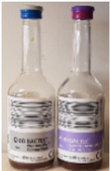 | The most common organism responsible for native joint septic arthritis in adults is Staphylococcus aureus. Occasionally beta-haemolytic Streptococci or Streptococcus pneumoniae (mainly in immunosuppressed patients) may be isolated. These organisms generally required at least 8-12 hours incubation to allow adequate growth for detection, however, will be incubated for a total of 5 days before considering negative.  Negative cultures do not exclude infection.  On occasions, positive cultures may represent a false positive result due to sub-optimal collection techniques.
Electrolytes, Urea & Creatine (EUC) | All patients | Gold top | Results will be evaluated utilising the pathology report within DHR  Potential for renal function and electrolyte abnormalities in patients who may be septic and/or require antibiotics which may be affected by renal function.
C-Reactive protein (CRP) | All patients | Gold Top | Results will be evaluated utilising the pathology report within DHR  Marked of inflammatory process including infectious and non-infectious causes. Normal or mildly elevated would make infection less likely.  Moderate to high levels would be consistent with infection but does not necessarily exclude non-infectious causes such as gout or trauma.
Full blood count (FBC), | All patients | Pink top | Results will be evaluated utilising the pathology report within DHR  Low lymphocyte count +/- low haemoglobin, high neutrophils and/or high platelets may be consistent with bacterial infection but are non-specific. In patients with severe sepsis low platelets can be associated with disseminated intravascular coagulation.
Chlamydia Trachomatis and/or  Neisseria gonorrhoeae NAT | Patients with a positive joint aspirate, confirmed septic arthritis | Male sex – first pass urine, +/- throat +/- rectal  Female sex – self collected vaginal swab, +/- throat +/- rectal | Chlamydia trachomatis and Neisseria gonorrhoeae are sexually transmitted infections which may be associated with reactive arthritis. The pathophysiology related to an immune response in the joint rather than infection of the joint.  The aim of testing is to detect the infection at the original site. If patients are symptomatic at these sites, then bacterial culture may also be indicated.

Gout and Acute Calcium Pyrophosphate Dihydrate Deposition (CPPD) Cystal arthritis (Pseudogout)
May require differentiation from septic arthritis. Haematology and microbiology should include that described above in Septic Arthritis

Test | Indication | Collection | Normal Results – adults
Joint aspirate | Suspected gout or CPPD arthropathy | Arthrocentesis  To be performed by qualified Health Professional  For joint replacements – performed by orthopaedics, preferable in theatre  (Canberra Health Services, 2023) | Joint fluid is routinely examined for crystals including urate acid and calcium pyrophosphate crystals. The presence of crystals is indicative of crystal arthropathy however does not exclude a dual diagnosis of infection.  Findings must be interpreted in conjunction with other results

Fractures
Some patients requiring operative management of their fracture need pre-operative haematological work-up. These include:
- Fractures for patients aged over 55
- Patients with fractured necks of femur
- Other patients as directed by orthopaedics
Test | Indication | Collection
Full blood count (FBC), | All patients | Pink top
Electrolytes, Urea & Creatine (EUC) | All patients | Gold top
Liver Function Tests (LFTs) | Patients with a fractured neck of femur | Gold or Green Top
Coagulation Profile (Coags) | Patients with a fractured neck of femur | Blue top

Other Patients
The AMPs or ESPs may be requested to order other haematological work up for patients under their care by Specialist Registrars or Specialist or Emergency Consultants. In this circumstance results will be followed-up with the requesting medical officer.
Back to Contents

Evaluation

Outcome
Patients meeting criteria for PTIP are managed as per this procedure.

Measures
A nominated supervising professional will review 10 randomly selected Physiotherapy-initiated pathology requests every twelve months and
- Audit the case and test requests for clinical appropriateness,
- Audit compliance with this procedure.
Back to Contents

Related policies, procedures, guidelines and legislation

Policies
- Work Health and Safety

Procedures
- Aseptic Technique Procedure
- Blood Culture Collection Procedure
- Credentialing and Defining the Scope of Clinical Practice for Allied Health
- Infection Prevention and Control
- Language Services- Interpreters and Translated Materials
- Pathology Specimen Handling and Transportation
- Patient Identification and Procedure Matching Procedure
- Venepuncture Blood Specimen Collection Procedure
- Orthopaedic Surgery – Pre and Post Operative Management in Adults

Guideline
Consent for Healthcare Treatment

Legislation
- Health Records (Privacy and Access) Act 1997
- Human Rights Act 2004
- Work Health and Safety Act 2011

Other
- Australian Charter of Healthcare Rights
Back to Contents

Search terms
Physiotherapy, pathology, bloods, advanced practice, extended scope, blood set, emergency department
Back to Contents

Attachments
Attachment A: Section Core 8 of the CHS Advanced Practice Standard of Practice

For Policy Team to complete:
Date amended | Section amended | Divisional approval | Final approval
23/12/2024 | New Document Added | Dr. Jo Morris, ED, Allied Health | Policy Document Review Panel
This document supersedes the following:
Document number | Document name

Disclaimer
This document has been developed by Canberra Health Services specifically for its own use. Use of this document and any reliance on the information contained therein by any third party is at his or her own risk and Canberra Health Services assumes no responsibility whatsoever.
Back to Contents

Acknowledgement of Country  Canberra Health Services acknowledges the Ngunnawal people as traditional custodians of the ACT and recognises any other people or families with connection to the lands of the ACT and region. We acknowledge and respect their continuing culture and contribution to the life of this region.  © Australian Capital Territory, Canberra 2024 | Accessibility  call (02) 5124 0000   Interpreter call 131 450  canberrahealthservices.act.gov.au/accessibility  

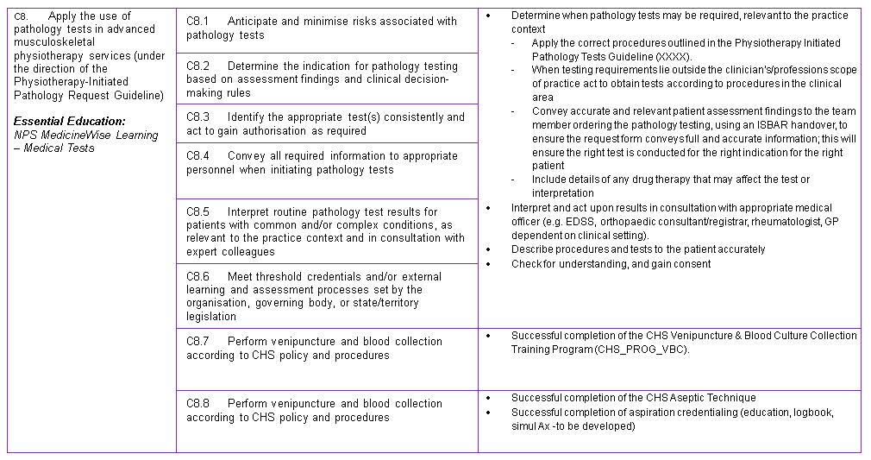
Attachment A: Section Core 8 of the CHS Advanced Practice Standard of Practice

