Guideline | Canberra Health Services
Management of Decreased Fetal Movements
CHS24/582

Contents
Guideline statement 2
Scope 2
Section 1 - Recommendations for information provision and advice about fetal movement monitoring 3
Section 2 – Recommendations for the investigation of decreased fetal movements 4
Section 3- Recommendations for management of women following assessment for DFM 6
Section 4- Investigations for DFM prior to 28 weeks’ gestation 9
Evaluation 9
Related policies, procedures, guidelines and legislation 10
References 10
Search terms 11
Attachments 11

Guideline statement
Background
Fetal movements are a reliable indicator of fetal well-being ^{6,11}. Decreased Fetal Movements (DFM) is strongly linked to adverse perinatal outcomes such as infection, umbilical cord complications, small for gestational age, fetal growth restriction and still birth ^{6,7,11}.
Recommendations in this guideline are directed by the Perinatal Society of Australia and New Zealand (PSANZ) Clinical Practice Guideline, Care of women with decreased fetal movements for women with a singleton pregnancy from 28 weeks' gestation ¹ and the Australian Commission on Safety and Quality in Health Care (ACSQHC) Stillbirth Clinical Care Standard, Quality statement 5 – Change in fetal movements ^{11.}
Key Objective
The Guideline will assist clinicians to standardise the management of women with a singleton pregnancy, presenting to Canberra Health Services (CHS) with concerns about fetal movements. It aims to:
- Provide an evidence-based approach to the management of women with DFM
- Improve consistency in the management of women with DFM
- Assist maternity care providers to counsel women with DFM
- Reduce maternal concern about fetal activity and self-monitoring
- Improve outcomes for women and their babies.
Alerts
These recommendations are for women with singleton pregnancy from 28 weeks gestation.
The management of women with specific pregnancy risk factors (for example: fetal growth restriction, hypertensive disease, diabetes etc, requires individual consideration and is beyond the scope of this guideline, as is the management of DFM in multiple pregnancy or before 28 weeks’ gestation.
Back to Contents

Scope
This document applies people who are pregnant and receiving care through the following CHS Network facilities:
- Centenary Hospital for Women and Children (CHWC)
- North Canberra Hospital (NCH).
- Community based Services.
This document applies to the following CHS staff working within their scope of practice:
- Medical Officers
- Registered Nurses and Registered Midwives
- Students working under direct supervision
Back to Contents

Section 1 - Recommendations for information provision and advice about fetal movement monitoring

Recommendation 1^{1,11}
- All pregnant women should be provided with verbal and written information about fetal movement, including what is considered normal fetal movement, and what to do if fetal movements stop or decrease.
- Information provided to pregnant women about normal fetal movement should include the following to ensure consistency of information:
- Perception of fetal movement is a sign of wellbeing
- Women can expect to perceive the first fetal movements at around 20 weeks of pregnancy and regular daily fetal movement from around 28 weeks
- Normal patterns of fetal movement involve periods of both activity and rest, with activity levels normally higher in the afternoon and evening
- Near term the fetus has longer rest periods but still moves every day right up to and including during labour
- The perception of increasing strength of movement as baby grows, is reassuring.
- From 28 weeks’ gestation clinicians should advise women to contact their care provider if there is a decrease in strength or frequency of fetal movements or if the movements stop.
Decreased frequency of fetal movement remains the most widely established fetal movement change associated with stillbirth. However, clinicians should be aware that some women with stillbirth may also have experienced an episode of excessive movement. A single episode of excessive fetal movement is seen more frequently in stillbirths at term than at earlier gestations. However, no study has demonstrated a reduction in adverse outcomes by investigating reports of increased fetal movement ¹.
Written information is available in English and translated information is available on the Clinical Excellence Commission Maternity and Neonatal Safety Program - Safer Baby webpage. Maternity and Neonatal Safety Program - Clinical Excellence Commission (nsw.gov.au)

Recommendation 2^{1,11}
- All women who report a concern about fetal movements to their healthcare provider should be invited to the health service for assessment without delay.
- Assessment for DFM should not be deferred to the following day, or the next appointment.
- Presentation should not be delayed through efforts to stimulate the baby by advising the woman to eat or drink.
- Maternal concern about DFM should not be attributed to anterior placenta or maternal body size.

Recommendation 3^{1,11}
- It is recommended pregnant women observe fetal movements daily from 28 weeks gestation, with or without counting movements.
- Subjective maternal concern about DFM overrides any definition of DFM based on numbers of fetal movements.
Back to Contents

Section 2 – Recommendations for the investigation of decreased fetal movements

Assessments on presentation to CHWC Maternity Assessment Unit or NCH Birthing Suite/Maternity Assessment Unit.
Initial assessment of DFM is to exclude imminent or actual fetal demise by listening to the fetal heart. Screening for the presence of any other maternal medical or pregnancy related factors that may indicate increased risk of adverse outcome should then be determined. A handheld Doppler can immediately confirm the presence of a fetal heartbeat¹.
Alert: Initial assessment of fetal heart rate should be attended within 15 minutes of presentation. If unit acuity is delaying assessment, escalation to maternity care co-ordinator/team leader is required to prioritise assessment.

Clinical history and fetal heart rate monitoring
- Attend baseline maternal observations - temperature, heart rate (HR), blood pressure (BP), respiration rate (RR).
- Measure symphysiofundal height (SFH) in centimetres (cm) and plot in fundal height section of the antenatal care flowsheet.
- Listen to fetal heart with handheld Doppler if < 24 weeks gestation or commence electronic fetal heart rate monitoring (cardiotocograph CTG) if ≥ 28 weeks gestation.
- Growth trajectory should be reviewed at each presentation of antenatal care by accessing the growth chart section of the woman’s DHR record.

Recommendation 4^{1,11}
- Women reporting DFM should be asked about their history of fetal movements including when fetal movements were last felt, previous presentations for DFM, any changes in strength or frequency, and whether the fetus was active the evening prior to presentation.
- When a woman reports DFM, a full antenatal examination should be undertaken to assess for clinical signs of fetal growth restriction, fetomaternal haemorrhage and coexisting conditions such as hypertension and diabetes. (See Table 1. Risk factors associated with adverse outcomes in DFM presentation).
- Medical consultation is needed at time of assessment if antenatal examination reveals any deviation to usual variances in pregnancy care.
Alert: Women reporting concerns about fetal movements from 28 weeks’ gestation should have care provided as per Perinatal Society of Australia and New Zealand (PSANZ) DFM care pathway (Attachment 1)1.

Recommendation 5¹
- Listening to the fetal heart rate by handheld Doppler, or electronic fetal heart rate monitoring (EFM) via cardiotocography (CTG), should be performed to exclude fetal death.
- In women 28 weeks or more, CTG should be performed to exclude acute fetal compromise and an urgent medical review should be undertaken where findings are abnormal.
- If the CTG and clinical assessment are normal, and during the CTG maternal perception of fetal movement resumes, no further investigations are required.

Recommendation 6¹
Note: There is no current evidence to recommend ultrasound assessment for all cases of women who present with DFM. Ultrasonography may be used for detecting conditions that contribute to DFM, this includes placental insufficiency and congenital abnormality1.

Ultrasound scans
- An Ultrasound scan should be included in the assessment of DFM if:
- SGA or FGR are suspected
- The woman continues to perceive absent or decreased fetal movements during the clinical encounter or has recurrent presentations for DFM ¹.
- Other clinical concerns are present (e.g. vaginal bleeding)
- The ultrasound scan should include fetal biometry, estimated fetal weight (if no growth scan has been performed in the last two weeks) and amniotic fluid volume assessment
- If SGA/FGR is present, umbilical artery doppler pulsatility index (PI) should be assessed
- If not already undertaken, and the woman agrees, a morphology scan should be arranged
- The timeframe to perform the ultrasound scan will depend on clinical urgency
- Where ultrasound findings are abnormal, discuss with a senior obstetrician.

Recommendation 7

Fetomaternal haemorrhage testing
- Fetomaternal haemorrhage (FMH) is a rare cause of DFM that is usually indicated by an abnormal CTG. If massive FMH is suspected based on clinical assessment a senior obstetrician should be consulted.
- If FMH is suspected, and immediate delivery is not indicated by CTG findings, senior obstetric input should be sought. Ultrasound assessment of Middle Cerebral Artery peak systolic velocity doppler and Kleihauer-Betke testing should be performed.
Back to Contents

Section 3- Recommendations for management of women after assessment for DFM

Recommendation 8^{1,11}
- If no objective evidence of fetal compromise is revealed during the clinical examination for DFM, the woman can be reassured that planned birth is not required.
- Women who report DFM should be reassured that they have done the right thing in presenting for assessment, even when no abnormal findings are found.
Most women who present with DFM will have normal findings and give birth to an appropriately grown, non-compromised baby at term. If no concerns are identified through clinical assessment and evaluation of risk factors for DFM (as per Table 1) women should return to routine antenatal care^{1.}
Table 1. Risk factors for adverse outcome in presentation with DFM (stillbirth or SGA)
Risk Factors associated with adverse outcomes in presentation with DFM
Abnormal CTG
Maternal age >35 years
Cigarette smoking
Maternal obesity or overweight (BMI >25)
Past obstetric history of SGA or Stillbirth
Past medical history (e.g. diabetes or hypertension)
Recurrent presentation for DFM (2 or more)
Delayed presentation (>24 hrs without movement)
Symphysis-fundal height <10th centile

Raised uterine artery PI in the 2nd trimester.
Source: PSANZ (2023) Guideline ‘Care of women with decreased fetal movements for women with a singleton pregnancy from 28 weeks'

Management of ongoing presentation with DFM
The most common reason for DFM is FGR (reported incidence of 16-24% of DFM cases). A larger retrospective cohort study of women reporting DFM beyond 36 weeks, found 16.6% of women had more than one presentation for DFM, and for women who experienced repeated episodes of DFM, 44% birthed an SGA baby and were more likely to have high uterine artery doppler resistance in second-trimester ultrasound.^{1.}

Recommendation 9^{1,11}
- Clinicians should be aware that risk of poor outcome is increased in women with recurrent DFM presentations.
- For women who represent with DFM, on second or subsequent occasions, manage as per initial presentation with the addition of ultrasound scan, and individualised care as per pregnancy risk factors.
- Women ≥39 weeks gestation should be informed that induction of labour is not associated with increased rates of caesarean birth or adverse maternal or fetal outcomes.
Management for women experiencing recurrent DFM requires informed and shared decision making that includes consideration of risk factors for stillbirth or SGA, the gestational age of the fetus, the woman’s individual situation and birth preferences, and her perception of fetal movement. Women presenting with repeated DFM episodes should be considered at high risk for placental dysfunction irrespective of antenatal ultrasound or Doppler assessment results ^{1,11}.
There is limited research to determine if induction of labour (IOL) for DFM is associated with an increased potential for adverse maternal outcome¹. Previous liberal approaches for management of recurrent DFM (e.g. IOL if gestation ≥ 37), may have led to inadvertent adverse outcomes such as increased rates of IOL, caesarean section and neonatal unit admissions, without decrease of stillbirth rates ^{1, 9.} Adverse outcomes from preterm birth are well understood. Early term birth (37-38 weeks’ gestation) is associated with increased short and longer- term mortality and morbidity, including the impact to developmental domains¹.
Reassuringly, observational, and interventional studies (on management of recurrent DFM), have demonstrated that planned birth at 39 weeks or more, was not associated with an increase in adverse maternal or neonatal outcomes. These studies have also noted when decision for IOL has occurred through clinician-based judgement, led by results of appropriate investigations, there was a reduction in both stillbirths and admissions for induction of labour^{1..}
When considering IOL for management for DFM, clinicians should refer to the PSANZ position statement, ‘Improving decision-making about the timing of birth, for women with risk factors for stillbirth’ to support decision making ¹⁰. TOB_Position-Statement_V2_Jan2023.pdf (stillbirthcre.org.au)
Attachment 2 provides adjusted odds ratios for the risk factors associated with still birth.

Recommended management for women experiencing persistent/ongoing DFM
- Management strategies should be individualised with consideration to the woman’s individual situation and birth preferences.
- Women presenting with repeated DFM episodes should be considered at high risk for placental dysfunction, irrespective of antenatal ultrasound or Doppler assessment results.
- Timing of birth should consider assessment of clinical observations, pregnancy risk factors for stillbirth and SGA, the gestational age of the fetus and the woman’s perception of fetal movement.
- If the CTG is abnormal and/or the ultrasound is not reassuring, then arrange urgent medical review by Senior Obstetric Registrar or Consultant.
- If there have been ≥3 presentations of DFM within the current pregnancy, notify and discuss with the Obstetric Consultant/Senior Obstetric Registrar for birth advice +/- a plan for surveillance.

If induction of labour is required
- Discuss timing of birth for woman with DFM at term. Birth should not be planned prior to 39 weeks unless clinically indicated.
- Ensure written and verbal explanations for induction methods, this includes discussion of the risks and benefits associated with timing of birth options.
- Document discussion and advice provided.
- Refer to Induction of Labour Guideline (CHWC or NCH) for procedure and process required for booking and commencing IOL.
- If discharge recommended, ensure follow-up plan for ongoing care has been organised (with usual antenatal care provider, or maternity triage).
To support shared decision making, women should be included in discussions related to IOL for DFM, this includes provision of written and verbal explanation regarding the risks and benefits associated with timing of birth options. Information for women on fetal development in the later stages of pregnancy can be found at http://everyweekcounts.com.au ^{10.}
Back to Contents

Section 4- Investigations for DFM prior to 28 weeks’ gestation
There is currently insufficient evidence to inform the management of women who report DFM prior to 28 weeks’ gestation. For women 24 to 28 weeks with DFM, auscultation of the fetal heart should be undertaken to exclude fetal death. CTG prior to 28 weeks’ can be difficult to interpret due to fetal immaturity and is not routinely recommended. Women who have not had an ultrasound scan for fetal morphology should be offered this.
Women reporting concerns with fetal movements before 28 weeks’ gestation should be monitored under the guidance of the Obstetric Consultant.
In general:
- Woman with pregnancy gestation 25 weeks to 28 weeks should use the same care pathway as for a gestation greater than 28 weeks
- Woman with pregnancy gestation less than 25 weeks gestation should be planned in consultation with a specialist obstetrician or fetal medicine specialist

Evaluation
Outcome
- Maternity care staff will provide consistent management for women who require assessment for decreased fetal movements when following this guideline.
- Women who are at risk of SGA will be identified when recommendations from this guideline are implemented.
- Women who are at risk of preventable stillbirth will be identified when recommendations from this guideline are implemented.
Measures
- Women who experience pregnancy complications related to reduced fetal movements will be identified through analysis of data collected through the CHS risk management system.
- Women at CHWC who experience pregnancy complications related to undiagnosed SGA < 3% will have their case reviewed at weekly maternity Mortality & Morbidity committee meetings to ensure procedures outlined in this document have been followed.
- Women at CHWC who experience pregnancy complications related to reduced fetal movements, will have their case reviewed at weekly maternity Mortality & Morbidity committee meetings.
- At CHWC and NCH, adverse pregnancy outcomes directly related to reduced fetal movements, will be reviewed at Maternity Mortality & Morbidity meeting.
Back to Contents

Related policies, procedures, guidelines and legislation

Policies
- Nursing and Midwifery Requirements for Practice

Procedures
- Infection Prevention and Control Procedure
- Patient Identification and Procedure Matching

Guidelines
- Consent for Healthcare Treatment
- Fasting Guidelines – Elective and Emergency Surgery
- Fetal Surveillance
- Induction of Labour

Legislation
- Health Records (Privacy and Access) Act 1997
- Human Rights Act 2004
- Work Health and Safety Act 2011
- Carers Recognition Act 2021

Other
- Australian Charter of Healthcare Rights
Back to Contents

References
- Perinatal Society of Australia and New Zealand and Centre of Research Excellence Stillbirth. Clinical practice guideline for the care of women with decreased fetal movements for women with a singleton pregnancy from 28 weeks’ gestation. Centre of Research Excellence in Stillbirth. Brisbane, Australia, September 2022. https://sanda.psanz.com.au/assets/Uploads/DFM-Clinical-Practice-Guideline-August-2019-revision-11102019.pdf
- New South Wales Government. Care Pathway for Women concerned about Fetal Movements. 2021. Care Pathway for Women Concerned About Fetal Movements (nsw.gov.au)
- Queensland Clinical Guidelines. Fetal movements. 2020 https://www.health.qld.gov.au/__data/assets/pdf_file/0025/728701/s-fetalmovement.pdf
- King Edward Memorial Hospital. Decreased Fetal Movements: Management of. Decreased Fetal Movements management of (health.wa.gov.au)
- Royal Hospital for Women, Sydney. 2022. FETAL MOVEMENTS – Identification and Management of Reduced Patterns. FETAL MOVEMENTS Identification and Management of Reduced Patterns (002).pdf (nsw.gov.au)
- Hug L, You D, Blencowe H, et al. Global, regional, and national estimates, and trends in stillbirths from 2000 to 2019: a systematic assessment. The Lancet 2021; 398(10302): 772-85 Global, regional, and national estimates and trends in stillbirths from 2000 to 2019: a systematic assessment - PubMed (nih.gov)
- de Bernis L, Kinney M, Stones W. Stillbirths: Ending preventable deaths by 2030. The Lancet 2016. https://pubmed.ncbi.nlm.nih.gov/26794079/
- Perinatal Society of Australia and New Zealand and Centre of Research Excellence in Stillbirth. Position statement: Improving decision-making about timing of birth for low-risk woman at term. Centre of Research Excellence in Stillbirth, Brisbane, Australia, December 2022.TOB_Position-Statement_V2_Jan2023.pdf (stillbirthcre.org.au)
- Yanan Hu, Jenny Gamble, Jyai Allen, Debra K. Creedy, Jocelyn Toohill, Emily Callander. A cost analysis of upscaling access to continuity of midwifery carer: Population-based microsimulation in Queensland, Australia. Midwifery, Volume 133,2024. A cost analysis of upscaling access to continuity of midwifery carer: Population-based microsimulation in Queensland, Australia - ScienceDirect
- Perinatal Society of Australia and New Zealand and Centre of Research Excellence in Stillbirth. Position statement: Improving decision-making about timing of birth for low-risk woman at term. Centre of Research Excellence in Stillbirth, Brisbane, Australia, December 2022. TOB_Position-Statement_V2_Jan2023.pdf (stillbirthcre.org.au)
- Australian Commission on Safety and Quality in Health Care. Stillbirth Clinical Care Standard (2022). Stillbirth Clinical Care Standard | Australian Commission on Safety and Quality in Health Care

Back to Contents

Search terms
DFM, decreased fetal movements, reduce fetal movements, North, NCH, stillbirth, GA
Back to Contents

Attachments
Attachment 1. Decreased Fetal Movement (DFM) Care Pathway
Attachment 2. Risk factors for Stillbirth.

Back to Contents

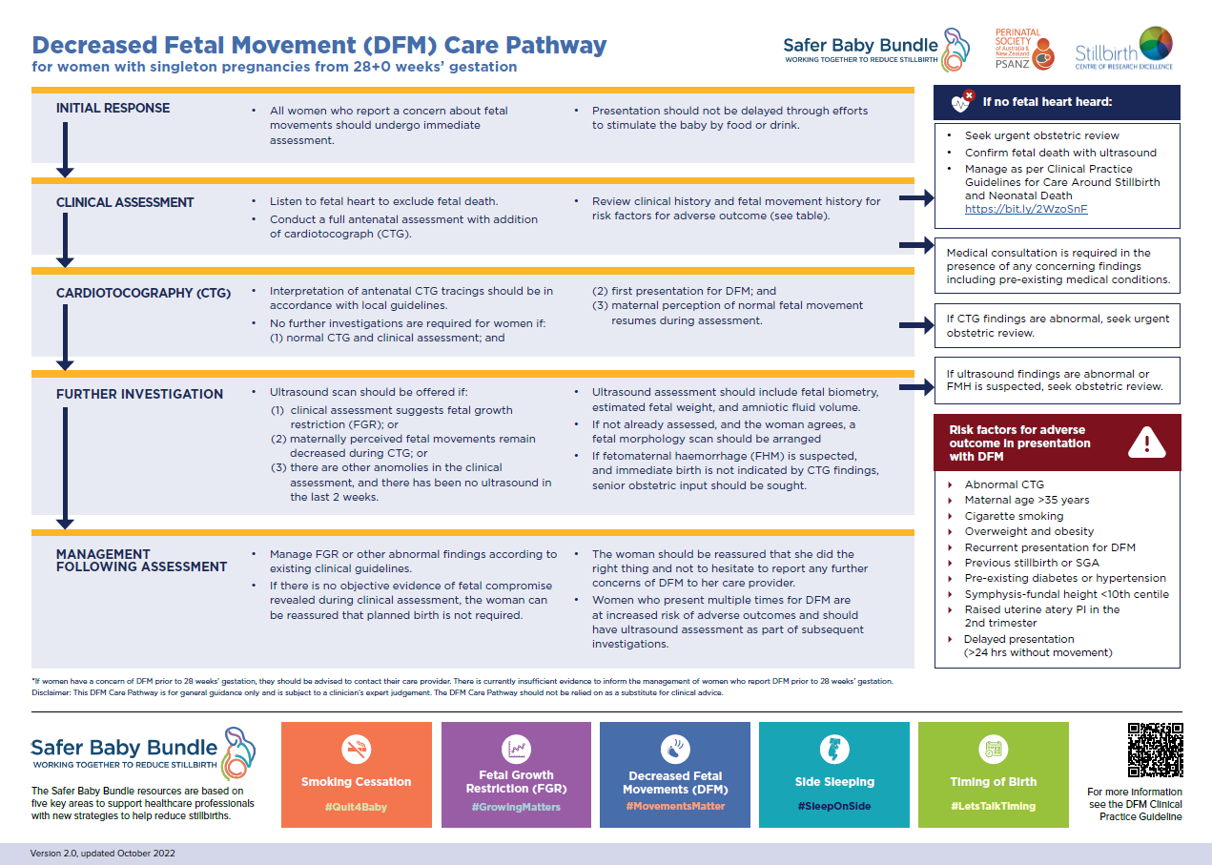
Attachment 1. Decreased Fetal Movement (DFM) Care Pathway

Attachment 2. Risk factors for Stillbirth.
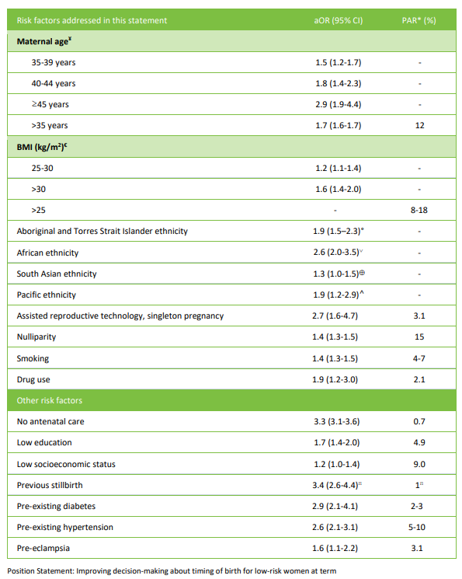
This table provides adjusted odds ratios (aORs) for stillbirth risk across gestational ages. The data presented here will be updated to reflect stillbirth risk at term (i.e. from 37 weeks’ gestation).

For Policy Team to complete:
Date amended | Section amended | Divisional approval | Final approval
03/12/2024 | New Document Added | Katherine Wakefield, A/g ED, WY&C | Policy Document Review Panel
This document supersedes the following:
Document number | Document name

Disclaimer
This document has been developed by Canberra Health Services specifically for its own use. Use of this document and any reliance on the information contained therein by any third party is at his or her own risk and Canberra Health Services assumes no responsibility whatsoever.
Back to Contents

Acknowledgement of Country  Canberra Health Services acknowledges the Ngunnawal people as traditional custodians of the ACT and recognises any other people or families with connection to the lands of the ACT and region. We acknowledge and respect their continuing culture and contribution to the life of this region.  © Australian Capital Territory, Canberra 2024 | Accessibility  call (02) 5124 0000   Interpreter call 131 450  canberrahealthservices.act.gov.au/accessibility  

