Canberra Health Services
Procedure
North Canberra Hospital (NCH) - Maternity Clinical Escalation

Contents

Contents 1
Purpose 2
Scope 2
Section 1 – Escalation Procedure 2
Related Policies, Procedures, Guidelines and Legislation 3
Search Terms 3
Attachments 4
Attachment A – Midwife Escalation (Public) 5
Attachment B – Midwife Escalation (Private) 6
Attachment C – Midwife Escalation (Special Care Nursery 7

Purpose

To provide midwives and medical officers with the process for escalation of concerns regarding patient safety and care within the North Canberra Hospital (NCH) Maternity Unit.

Back to Table of Contents

Scope

This Procedure applies to all NCH Maternity Unit who deal with patient safety. This includes:
- Maternity Management
- Midwives
- Medical officers
- All clinical staff
Back to Table of Contents

Section 1 – Escalation Procedure

Relevant Escalation Flow Chart
- Midwife Escalation: Public Patient - Attachment A
- Midwife Escalation: Private Patient – Attachment B
- Nurse/Midwife Escalation: Special Care Nursery – Attachment C

Midwife Escalation – Public Patient
- All staff to use ISBAR when requesting review.
- Registered midwife (RM) to notify Team leader (TL) of concerns and requirement for medical review.
- RM/TL to notify Obstetrics & Gynaecology (O&G) registrar that patient needs medical review.
- If situation requires further clinical input, O&G registrar to inform on-call O&G consultant and state need for attendance to review:
  - If O&G registrar is unable to escalate care (e.g. scrubbed in theatre) RM/TL to call on-call consultant.
- If on-call O&G consultant doesn’t or cannot attend then situation must be escalated.
- In hours – O&G registrar to inform Clinical Director:
  - If O&G registrar unavailable then TL to inform Clinical Director.
- After hours – O&G registrar/TL to inform After Hours Hospital Manager (AHHM)
  - AHHM will require approval from Executive on call to escalate to Clinical Director.

Midwife Escalation – Private Patient
- All staff to use ISBAR when requesting review.
- Registered midwife (RM) to notify Team leader (TL) of concerns and requirement for medical review.
- RM/TL to notify private obstetrician that their patient needs medical review.
- If private obstetrician doesn’t or cannot attend then situation must be escalated.
- In hours – RM/TL to inform clinical director.
- After hours – RM/TL to inform on-call O&G consultant.
- If private obstetrician is the on-call O&G consultant then escalate to Clinical Director via AHHM:
  - AHHM require approval from Executive on call to escalate to Clinical Director.

Nurse/Midwife Escalation – Special Care Nursery
- All staff to use ISBAR when requesting review
- Registered nurse/midwife to notify Team leader (TL) of concerns and requirement for medical review.
- RN/RM/TL to notify on-call paediatrician and request a medical review.
- If paediatrician doesn’t or cannot attend then situation must be escalated.
- In hours – RN/RM/TL to inform Clinical Director.
- After hours – RN/RM/TL to inform AHHM to escalate to Clinical Director:
  - AHHM require approval from Executive on call to escalate to Clinical Director.

Back to Table of Contents

Related Policies, Procedures, Guidelines and Legislation

Policy
- Nursing and Midwifery Board of Australia (NMBA) Requirements for Practice
- Informed Consent - Clinical
Procedure
- North Canberra Hospital (NCH) - Clinical Handover Procedure
- Patient Identification and Procedure Matching

Guidelines
- CHS Fetal Surveillance
- CHS Obstetric Emergencies

Legislation
- Health Records (Privacy and Access) Act 1997
- Human Rights Act 2004
- Charter of Health Care Rights 2019
- Work Health and Safety Act 2011

Other

- Australian Charter of Healthcare Rights
- National Safety and Quality Health Service (NSQHS) Standards
- ACM Consultation and Referral Guidelines
- RANZCOG Guidelines
- NICE Guidelines
Nursing and Midwifery Board Framework: Decision making framework for nursing and midwifery
Back to Table of Contents

Search Terms

Maternity, birth, childbirth, labour, special care nursery, SCN, special, nursery, fetal, obstetrics, gynaecology, escalate

Back to Table of Contents

Attachments

Attachment A – Midwife Escalation (Public)
Attachment B – Midwife Escalation (Private)
Attachment C – Midwife Escalation (Special Care Nursery

Disclaimer: This document has been developed by Canberra Health Services specifically for its own use. Use of this document and any reliance on the information contained therein by any third party is at his or her own risk and Canberra Health Services assumes no responsibility whatsoever.

Policy Team ONLY to complete the following:
Date Amended | Section Amended | Divisional Approval | Final Approval
19/02/2024 | NCH Transition Document | Michelle Thinius, NCH ED of Women & Children | CHS Policy Team

This document supersedes the following:
Document Number | Document Name
 | Maternity Clinical Escalation Procedure

Attachment A – Midwife Escalation (Public)
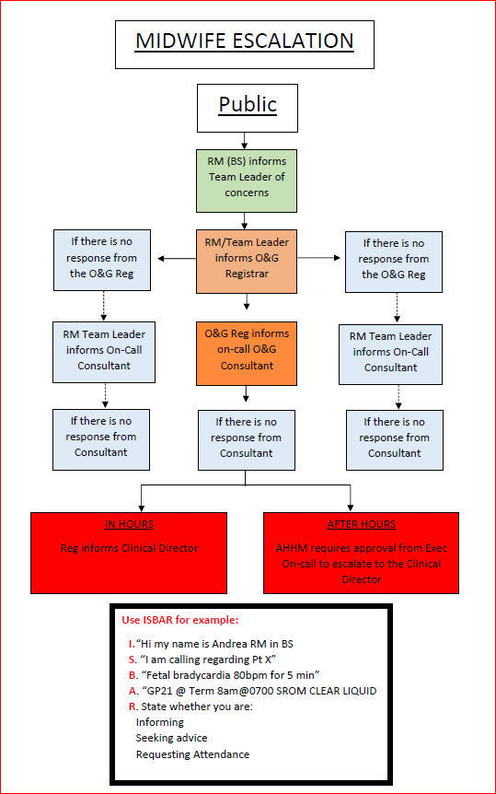

Attachment B – Midwife Escalation (Private)
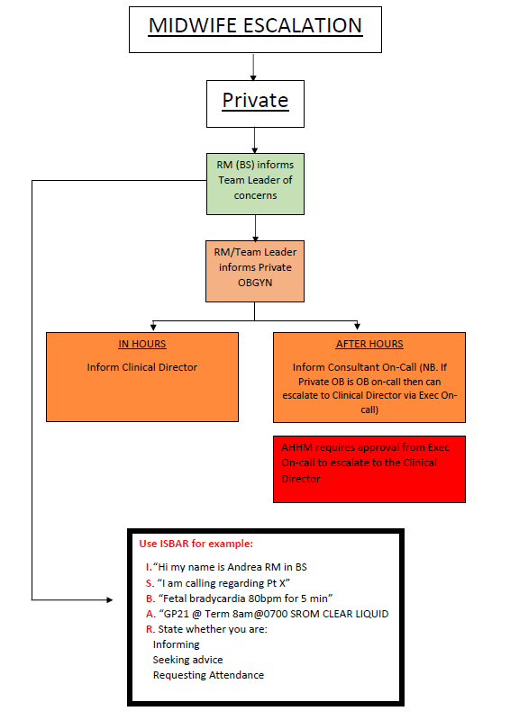

Attachment C – Midwife Escalation (Special Care Nursery


