Guideline | Canberra Health Services

Psychological Support for Staff – Manager’s Guide
CHS25/024
Contents
Guideline statement 2
Scope 2
Section 1 Introduction 3
Section 2 Risk and Protective Factors 4
Section 3 Support 6
Section 4 Onsite support 8
Section 5 Debriefing 9
Evaluation 11
Related policies, procedures, guidelines and legislation 12
Bibliography 13
Definition of terms 14
Search terms 14
Attachments 15
Attachment 1- What are your responsibilities? 16
Attachment 2- Mental Health Continuum 18
Attachment 3- Self Care 20
Attachment 4- Personal Reflection 23
Attachment 5- Support for staff 24
Attachment 6- RUOK? Model 26
Attachment 7- Psychological First Aid 28
Attachment 8- Responding to a colleague who is distressed or suicidal 31
Attachment 9- Managing staff affected by a life limiting illness 35
Attachment 10- Managing the death of a colleague 38
Attachment 11- EAP process following a critical incident 41
Attachment 12- Operational Debrief 43
Attachment 13- WHS Immediate Response Checklist 45
Attachment 14 - Quick Reference 47

Guideline statement

Background
Working in health care can be highly demanding and very rewarding, whether it’s in a health professional, medical officer, nursing or midwife, administrative, support or technical role. People often see working in healthcare as a vocation” for helping people, a strong sense of purpose and the feeling that the work is being appreciated and lead to compassion satisfaction. However, it can be repetitive, intense, and stressful at times, challenging staff personally and professionally. This can result in negative consequences such as compassion fatigue, vicarious trauma, post-traumatic stress, and/or burnout.
Taking care of workers’ mental health is crucial not only for their wellbeing but also for increased job satisfaction and team dynamics, reduced absenteeism, positive work culture and improved patient care and outcomes. Staff are encouraged to proactively engage in protective factors and /or seek help early from the range of support options available.

Key Objective
The purpose of this Guideline is to inform managers how to provide psychological support to staff day-to-day, as well as following any incident or event. This Guideline has been developed using trauma-informed practice principles - a strengths-based practice that responds to the impact of trauma and emphasises physical, psychological, spiritual and emotional safety for everyone, and creates hope and optimism for recovery.

Alerts
The safety and wellbeing of staff is always the priority.
Promoting and supporting the mental health and wellbeing of staff leads to better patient care and outcomes.
Managers have a responsibility to provide leadership, guidance, and support for the wellbeing of staff they supervise.
As an organisation we want to ensure staff have the support they need to deliver exceptional care.

Scope
This Guideline applies to all Canberra Health Services (CHS) staff, volunteers, contractors, and students. The Guideline applies to the CHS Network which includes the inpatient facilities at Canberra Hospital, Clare Holland House, North Canberra Hospital, and University of Canberra Hospital, community-based services and outpatient services.
Back to Contents

Section 1 Introduction
Promoting and supporting the mental health and wellbeing of staff leads to better patient care and outcomes, improved productivity, greater engagement and improved recruitment and retention.
As a manager you have a responsibility to look after your own wellbeing as well as provide leadership, guidance, and support for the wellbeing of staff you supervise. Refer to Attachment 1 - What are your responsibilities? Knowing when someone in the team is going through a tough time can help you provide support. Early detection of behavioural changes and providing information and support gives staff the best chance of resolving matters quickly. If identified and treated early, mental health concerns may be temporary and reversible.
Mental health is a state of wellness and is not merely the absence of illness. Mental health exists on a continuum (see diagram below) – a sliding scale from positive, healthy, and functioning at one end through to severe symptoms of mental health conditions at the other. People move along the scale from day-to-day in response to different family, work, or other life circumstances. Refer to Attachment 2 Mental Health Continuum.
Mental Health Continuum
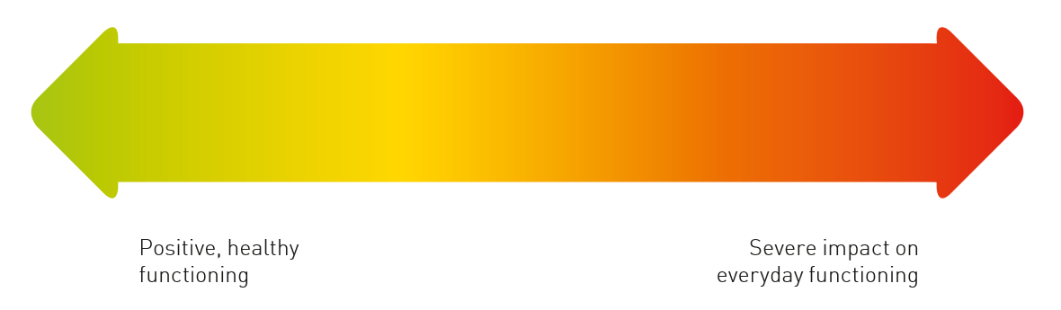
Any incident has the capacity to affect staff – it doesn’t have to be a critical incident. It can be the combination of accumulated stress rather than the incident itself that can cause an unusually strong emotional response. An accumulation of low impact incidents can gradually impact the staff member’s mental health. The reaction of the staff member makes it significant for that person, not the nature or size of the incident.
Staff may be impacted by the work they do at CHS. This can be through exposure to incidents directly or indirectly. Refer to the table over the page for examples of indirect and direct exposure.

Examples of Direct Exposure | Examples of Indirect Exposure
- Unexpected or extraordinary incident  - Death of a patient or colleague or providing end of life care  - Workplace incidents or injuries  - Occupational violence (including physical violence or verbal aggression)  - Unreasonable workplace behaviours  - Self-harm, unexpected death, or suicide  - Coroner’s inquest, court or media involvement  - Witnessing an incident that caused harm | - Reading and/or hearing people talk about an incident that caused harm  - Reading and/or hearing people talk about a patient or colleague that died or was providing end-of-life care  - Helping people after an incident  - Seeing people’s inability to improve their life circumstances
Back to Contents

Section 2 Risk and Protective Factors
The characteristics of people who work in health care and the nature of their work can contribute to their mental wellbeing and protect their mental health. Having meaningful work can also be linked to high levels of job satisfaction.
There are risk and protective factors that can influence a person’s mental health. Workplace risk factors include but are not limited to:
Examples of Risk Factors | Examples of Protective Factors
- Heavy workloads  - Long working hours  - Shift work  - High levels of responsibility  - Occupational violence1  - Lack of role clarity  - Poor support from supervisors and/or co-workers  - Lack of recognition  - Poorly managed relationships  - Poorly managed change  - Inappropriate behaviours  - Abuse/mistreatment from patients or patients’ families | - Physically and psychologically safe work environment  - Manageable workloads  - Role clarity  - Effective leadership  - Support from manager  - Peer support  - Self-care (Refer to Attachment 3 Self Care Plan)  - Reflective Practice (Refer to Attachment 4 Personal Reflection template)  - Culturally safe work environment, spiritual and cultural expression  Counselling services (Refer to Attachment 5 Support for staff)

There are also some groups of people who may be at greater risk of experiencing ill effects to their mental health and wellbeing due to previous exposure to traumatic events, including people who are:
- Health and welfare support workers
- Emergency service workers and/or volunteers
- Young people
- Refugees
- People who have had adverse childhood experiences
- Culturally and linguistically diverse
- Aboriginal and Torres Strait Islander
- Identify as Lesbian, Gay, Bisexual, Transgender, Queer, or Intersex Plus
- Veterans; or
- Have an underlying mental illness or
- Repeated exposure to death or violence.

Psychological Safety
Psychological safety positively impacts work engagement, team cohesion, learning, problem-solving, innovation, and clinical outcomes. Psychological safety also means staff feel safe to challenge the status quo to improve service delivery, are more inclined to share information, ask questions, speak up, and take the initiative to suggest improvements. Psychological safety impacts the staff member, the team and organisational performance. In newly formed teams, you may need to place greater emphasis on fostering psychological safety than in more established teams.
How do you create psychological safety?
As a manager you have a key role in creating and fostering a culture of psychological safety in the workplace. The following attributes and skills are critical for you to create and improve psychological safety in teams:
- Effectively communicate by listening, sharing information, facilitating communication, and encouraging individuals and teams to speak up and ask questions, fostering a sense of value and input, respecting each team member’s diverse skill sets.
- Support inclusion and diversity by respectfully and sensitively appreciating individual differences
- Encourage and model respectful behaviours and healthy work habits
- Provide constructive, regular, and supportive feedback on goal achievement, performance and development and actively seek feedback on your own performance
- Provide role clarity to reduce ambiguity and resolve task conflicts
- Foster team cohesion through fairness and building trust by encouraging team members to communicate respectfully and openly with each other and managing conflicts collaboratively
- Provide recognition, appreciation, and acknowledgement of staff member’s efforts
- Provide help to the team when required
- Encourage reflective practice opportunities and Clinical Supervision
- Encourage colleague and peer support.
Back to Contents

Section 3 Support

Support for managers
As a manager you need to care for yourself while caring for and encouraging your staff to do the same. Consider implementing wellbeing activities for the team, educate yourself about mental health in the workplace and utilise the range of resources available in this Guide.
CHS offer a wide range of counselling services to support staff including specialist helplines for youth, LGBTQI+, First Nations, Spiritual and Pastoral Care, Elder Care, Disability and Carers and Domestic and Family Violence.
Refer to Attachment 5 Support for Staff or on the CHS Health Hub - Emergency and Safety - Support for staff.
You can also reach out for professional guidance, support or advice to a senior manager or colleague, by emailing the CHS Work Health and Safety team, Human Resources Business Partners, Team CHS Wellbeing or contacting the Employee Assistance Program (EAP).

Manager Assist Hotline – 1300 687 327
CHS’ Employee Assistance Program (EAP) is delivered by Converge International (Converge EAP or EAP) –who offer coaching and support on how to proactively address any concerns you have about your staff, better manage your staff, manage a difficult situation or resolve any workplace issues, as well as provide you with personal support.

Support for staff – Converge EAP 1300 687 327
Converge EAP provides confidential 1:1 support for staff and their immediate family for work or non-work-related issues – a safe and private space to connect with a professional counsellor. EAP counsellors are qualified to support people with a broad range of issues and routinely practice in all areas relating to mental health and wellness. The Converge website have a range of resources available Username: converge; Organisation code: ACTEAP. Staff who are impacted directly or indirectly by incidents at work are encouraged, but not obliged, to attend EAP. If a staff member is referred to EAP the manager cannot receive information on the process without their written consent. Privacy is maintained unless details are required by law or there is a risk of the staff member harming themselves or someone else, in which case there is a duty of care for the EAP to refer to external mental health specialist services.
Preparing to providing support
Before offering support to a staff member, you need to reflect on whether you are the most suitable person to provide support, considering the relationship with that person. If you are not the most suitable person to provide support or if you are unable, you should consider who may be able to and arrange for another manager or colleague to assist to ensure it happens.
Before providing support managers need to make sure they are emotionally prepared and have capacity and space required referring to Attachment 6 the RUOK? Model for guidance.
You may also need to refer some staff for specialised support, (e.g. Canberra Grief Centre, Stand-By Support After Suicide Support Service), if they are unable to work due to their level of stress.
Psychological First Aid (PFA)
To support staff following a critical incident, you should follow the World Health Organisation’s Principles of PFA – a simple and practical way to provide emotional support to staff who have been exposed to a stressful or traumatic event. The aim of the Look, Listen and Link approach to PFA is to reduce the initial distress caused by trauma, enhance coping strategies, and connect people with ongoing support by promoting safety, calm, connectedness, self-efficacy and hope. Refer to Attachment 7 Psychological First Aid. You can book in to PFA training through the Learning Management System.
Formal Check-In process
If staff are undergoing a formal process it has the potential to impact their wellbeing. Some examples of these processes include:
- Preliminary assessments
- Misconduct and disciplinary process
- Post incident clinical review
- Medico-legal process
- Reviews by external bodies (e.g. WorkSafe ACT, AHPRA)
- Injury management, workers compensation
- Personal circumstances requiring longer term absences from the workplace.

The Formal Check-In Guide outlines key roles and responsibilities to support the mental wellbeing of staff. For further information refer to the Formal Check-In Guide Fact Sheet available on CHS Health Hub – Emergency and Safety – Support for Staff – I need support.
Suicidal ideation
Staff members who are expressing suicidal ideation need to be taken seriously every time. Refer to Attachment 8 Responding to a colleague who is distressed or suicidal.
Family Violence
There are many people in our workforce affected by family violence. Family violence is common. You have an important role in providing information and support to staff who disclose family violence. Further information available on the intranet.

Managing Staff affected by a life limiting illness
Supporting a staff member who may be facing a life-limiting illness or has a family member with a life limiting illness is a complex and delicate task. It requires sensitivity towards the affected staff member and clarity about the ability of the organisation to be flexible. It is important to know how to have these difficult conversations, share information, and support your staff. Managers also need to consider cultural responsibilities for Aboriginal or Torres Strait Islander staff and staff who are family members. Refer to Attachment 9 - Managing staff affected by a life limiting illness.
Managing the death of a colleague
The death of a colleague can have a profound effect on your team. As the manager, you may be the first to become aware of this event. It is your responsibility to sensitively communicate this, as appropriate, to your staff, clients, and suppliers and to communicate with the family of the staff member, with support available from your HR Business Partner. Managers also need to consider cultural responsibilities for Aboriginal or Torres Strait Islander staff and staff who are family members eg Sorry Business. Refer to Attachment 10 - Managing the Death of a Colleague. It is recommended you also use Attachments 6 and 10, RUOK? and Psychological First Aid.
Back to Contents

Section 4 Onsite support

Employee Assistance Program (EAP)
In addition to providing 24-hour free, professional, independent, and confidential counselling services to all staff and their immediate families, the EAP also offer on-site support for groups and one on one support following a critical incident. Refer to Attachment 11 - EAP process following a critical incident.
CHS Wellbeing Peer Support Officers (WPSO)
WPSO provide informal and confidential support to any staff members experiencing difficulties in the workplace or at home and refer them to internal or external support as relevant. Further details of WPSO can be found on the CHS Health Hub - Emergency and Safety - Support for staff - I need support.
Workplace Resolution and Support Service (WRSS)
WRSS is an internal conflict resolution service providing independent advice and support to all CHS Network staff. WRSS’ approach focuses on tailoring the most appropriate strategies and processes to create successful outcomes in the workplace. The WRSS offers staff guidance, debriefings, wellbeing checks, and resources and suggests referrals to external services where appropriate.
Staff can contact WRSS on 512 43656 (leaving a voicemail with contact details) or by emailing CHS-HDWorkplaceResolution@act.gov.au. Appointments can be offered on-site, virtually or off-site with individuals or at a team level. You can also make referrals to WRSS for your staff once you have confirmed with your staff member they are interested in being contacted by WRSS.
Spiritual Support
CHS Spiritual Support Services can facilitate a memorial service for teams on request by emailing SpiritualSupportServices@act.gov.au. Staff at NCH can reach out to the Pastoral and Spiritual Care Department for spiritual and emotional support by calling 5103 6665.
Stand-By Support After Suicide
Following a death by suicide, you may call the service that specialises in supporting people who have been affected by suicide – Stand-By Support After Suicide Support Service on 1300 727 247 - to provide on-site support for staff.
Back to Contents

Section 5 Debriefing
Debriefing is a structured, voluntary discussion aimed at putting a stressful event into perspective. It is not counselling.
Operational Debriefing involves reviewing organisational processes following an incident. The aim is to learn from the people who went through the process and involve them in improving processes, if applicable, evaluate the physical and emotional impact on staff, moderate any negative effects, and identify the need for counselling or support for staff involved. Refer to Attachment 12 for an Operational Debrief Guide and Attachment 13 WHS Immediate Response Checklist.
There are two types of Operational Debriefs:
- A Hot (Informal) Debrief
- Occurs immediately as possible after the event to generate insights into what has occurred and check-in with staff involved in the event. This usually takes 10-15 minutes.

- A Cold (Formal) Debrief
- Pre-arranged (1-2 days after the event or whenever reasonably practical for affected staff to attend) to analyse the events of the situation more critically and help improve processes in the future. This usually takes up to 1 hour.

Operational Debriefing involves getting together all staff involved– directly involved or indirectly affected (this may include but is not limited to clinical, administrative, security, food services, wards persons, cleaning, volunteers, students, contractors) as soon as practical to discuss if there was something that could have been done better. Participation in these sessions is voluntary and staff should be consulted as to whether they would like to participate.
The Operational Debrief should be conducted by a senior manager/supervisor who was not involved in the event. The purpose of the meeting should be explained to participants, setting the context, and explaining the situation and that what is said is confidential. Who was involved? What happened? Where did it happen? Why did it happen? What did we learn?
There may be times that staff who would like to participate in the debrief are not all available at the same time or may be unable to attend. In such cases, you should consider holding more than one formal debriefing session to provide affected staff the opportunity to participate.
In addition, where staff are unable to attend, they are to be reminded of the access to available supports, such as: Support for staff (Section 3) and On-site support (Section 4). When selecting a location to conduct a debrief, consideration should be given to the number of participants, ambience and privacy.
Following a critical incident psychological debriefing and other structured psychological interventions are no longer considered best practice. This has been shown in some cases to have the potential to cause harm by re-traumatising people or traumatising those who may not initially have been impacted by the incident. Psychological debriefing as an early intervention is not considered to be effective in preventing mental health problems and is not recommended. Psychological support services should be provided to staff as per Section 3 of this Guide.
Vicarious Trauma
Vicarious trauma is a common response that can occur when people are exposed to seeing, hearing or learning about other people’s trauma. More than feeling empathy for someone, vicarious trauma occurs when people suffer themselves as a result of having supported someone else. Vicarious trauma can happen after a one-off event or more commonly, through repeated exposure. Symptoms can manifest in various ways including intrusive thoughts, emotional distress, heightened anxiety, nightmares, changes in world view, avoidance behaviours, guilt or shame or emotional exhaustion.
It is important to seek help early. This range of strategies can be used to prevent and respond to vicarious trauma including:

Prevent: | Respond
- Regular consistent engagement with Clinical Supervision  - Self-awareness  - Reflective practice  - Self-care strategies  - Professional development | - Support from family and friends  - Peer support  - EAP  - Debriefing – low impact debriefing

Low Impact Debriefing
If staff experience a critical incident it is common that they may want to debrief with someone for support and validation. Staff need to know how to debrief effectively and informally and not pass the effect of the experience on to others. It may not be necessary to share all the graphic details which can lead to vicarious trauma for the person listening. Four strategies for low-impact debriefing include:

1. Increased self-awareness
Think about how you debrief, with whom, and how much detail do you give?
Who debriefs with you and how much detail do they give?

2. Before you start, provide fair warning to the listener that you want to talk about a critical incident.

3. Ask for consent. By asking for permission, it gives the listener the option to decline or clarify what they are able/not able to hear. “I need to debrief, is this a good time?”
4. Low impact disclosure. Start with the least traumatic information first. You may or may not need to provide all the graphic details depending on how distressing the incident or event has been.
Staff also need to be aware when having day-to-day conversations that information regarding critical incidents can potentially affect others they are speaking to or who may be listening. To help prevent vicarious trauma, if you feel uncomfortable with hearing information from a colleague, you could say “Did you realise providing that level of detail can be quite traumatising to me or others?”
Back to Contents

Evaluation

Outcome
- Internal evaluation as part of the Guide update
- The Guide is easily accessible and simple to use
- Feedback is reflected in improvements to the Guide
- Feedback is disseminated across the CHS Network in line with organisational objectives and priorities.

Measures
- Qualitative: Feedback is sought from staff across the organisation, through workshops and the Team CHS Wellbeing Champions Network, regarding accessibility and implementation. Problems and or opportunities for improvement are identified.
- Quantitative: Data is collected including access to the Guide on the intranet and the number of psychological incidents reported on staff incident reporting module on Riskman and critical incident support provided by EAP.

Back to Contents

Related policies, procedures, guidelines and legislation

Policies
- ACT Government Building Positive Work Attendance
- ACT Public Service Code of Conduct
- Child Protection
- Clinical Supervision
- Emergency Management Plans – Code Black
- Family Violence
- Occupational Violence
- Work Health and Safety Policy

Procedures
- Emergency Department and Mental Health Interface
- Family Violence Workplace Support
- Initial Management, Assessment and Intervention for People Vulnerable to Suicide
- Occupational Violence
- Work Health and Safety Management System

Strategies
- CHS Emergency Management Plan
- CHS Wellbeing Strategy 2023-2026

Guidelines
- ACT Government – Employee Assistance Program
- CHS – Resolving Workplace Issues - Work Bullying, Harassment and Discrimination
- Clinical Supervision for Allied Health Clinicians
- ACT Health Clinical Supervision Framework for ACT nurses and midwives

Legislation
- All ACT Public Sector Enterprise Agreements
- Human Rights Act 2004 (ACT)
- Mental Health Act 2015
- Public Sector Management Act 1994
- Work Health and Safety Act 2011 (ACT)

Other
Australian Charter of Healthcare Rights

Back to Contents

Bibliography
- Beyond Blue Mental Health Continuum
https://beyou.edu.au/resources/mental-health-continuum
- Ambulance Victoria, Mental Health and Wellbeing Strategy, 2016 – 2019 https://www.ambulance.vic.gov.au/wp-content/uploads/2016/10/ambulance-victoria-mental-health-strategy-2016-19.pdf
- Sax Institute Evidence Check Mental Wellbeing risk and protective factors
https://www.saxinstitute.org.au/wp-content/uploads/20.10_Evidence-Check_Mental-Wellbeing-Interventions.pdf
- Black Dog Institute, Importance of Self-Care Planning, COVID-19 Mental Health and Wellbeing Resources
https://www.blackdoginstitute.org.au/wp-content/uploads/2020/04/COVID-19_Self-Care-Planning_Black-Dog-Institute_Editable.pdf
- The University of Queensland, Supporting Staff Impacted by a Critical Incident https://staff.uq.edu.au/files/200/staff-support-critical-incidents.pdf
- https://www.ruok.org.au/how-to-ask
- Australian Psychological Society, Psychological First Aid - An Australian Guide to Supporting People Affected by Disaster
https://www.psychology.org.au/getmedia/c1846704-2fa3-41ae-bf53-7a7451af6246/Red-cross-psychological-first-aid-disasters.pdf
- Rose S, Bisson J, Churchill R, Wessely S. Psychological debriefing for preventing post-traumatic stress disorder. Cochrane Database of Systematic Reviews. 2002
https://www.cochrane.org/CD000560/DEPRESSN_psychological-debriefing-for-preventing-post-traumatic-stress-disorder-ptsd
- Compassion Fatigue, Low Impact Disclosure – How to Stop Sliming Each Other
http://www.compassionfatigue.org/pages/LowImpactDisclosure.pdf
- World Health Organisation, Health Topics – Adolescent Health
https://www.who.int/southeastasia/health-topics/adolescent-health
- Adapted from The Land 2017Glove Box Guide to Mental Health https://specialpubs.austcommunitymedia.com.au/e-mags/2019/TL5/1003_01/
- La Trobe University. what is Reflective Practice
https://latrobe.libguides.com/reflectivepractice
- Blue Knot Foundation. Trauma-informed Care and Practice
https://www.blueknot.org.au/Workers-Practitioners/For-Health-Professionals/Resources-for-Health-Professionals/Trauma-Informed-Care-and-practice
- Conversations Matter. When Someone is Thinking About Suicide
http://www.conversationsmatter.com.au/resources-community/someone-thinking-about-suicide
- Phillips EC, Smith SE, Tallentire V, Blair S. Systematic review of clinical debriefing tools: attributes and evidence for use. BMJ Quality & Safety. 2024 Mar 1;33(3):187-98.
- Evans TR, Burns C, Essex R, Finnerty G, Hatton E, Clements AJ, Breau G, Quinn F, Elliott H, Smith LD, Matthews B. A systematic scoping review on the evidence behind debriefing practices for the wellbeing/emotional outcomes of healthcare workers. Frontiers in Psychiatry. 2023 Mar 24;14:1078797.
- Billings J, Ching BC, Gkofa V, Greene T, Bloomfield M. Experiences of frontline healthcare workers and their views about support during COVID-19 and previous pandemics: a systematic review and qualitative meta-synthesis. BMC Health Services Research. 2021 Dec;21:1-7.
- Palliative Care ACT Guide ‘Life Limiting illnesses in the workplace- A toolkit for managers and HR professionals.
- Palliative Care ACT Guide ‘Life Limiting illnesses in the workplace – A toolkit for employees’.
- https://www.commonground.org.au/article/death-and-sorry-business
- https://www.indigenousmhspc.gov.au/topics/social-emotional-wellbeing#theframework
- https://pmc.ncbi.nlm.nih.gov/articles/PMC5673148/
Back to Contents

Definition of terms
- Burnout - Exhaustion of physical or emotional strength or motivation usually because of prolonged mental stress or frustration.
- Compassion Fatigue - The emotional withdrawal and physical and mental exhaustion experienced by those who care for sick or traumatised people over an extended period.
- Compassion Satisfaction - The amount of pleasure derived from helping others.
- Employee/Staff/Team member - Terms that are used interchangeably throughout the document to cover employees, students, volunteers, and contractors.
- Family Violence - The threat, force or intimidation used to control or manipulate a family member causing them to fear for the safety of themselves or another.
- Manager Includes managers, team leaders, supervisors who have responsibility for staff
- Post-Traumatic Stress (PTS) - A set of reactions that can develop in people who have been through a traumatic event which threatened their life or safety, or that of others around them.
- Psychological debriefing - Formal emotional and psychological counselling immediately following a traumatic event – no longer considered best practice.
- Sorry Business - a period of cultural practices that take place after someone's death.
- Trauma - A state of high arousal in which a person’s usual coping mechanism are overwhelmed in response to a real or perceived threat.
- Young people - covers the age range from 10 - 24 years2.
Back to Contents

Search terms
Support, critical incident, trauma, traumatic, staff support, EAP, coronial, coroner, media, inquest, psychological support, first aid, help, burnout, vicarious, compassion fatigue, counselling, mental health, wellbeing, emotional, self-harm, self-care, reflective practice, debriefing, debriefs, suicidal ideation, RUOK, low impact debriefing, suicide, self-harm, crisis, disaster, death
Back to Contents

Attachments
- Attachment 1- What are your responsibilities?
- Attachment 2- Mental Health Continuum
- Attachment 3- Self-Care Plan
- Attachment 4- Personal Reflection
- Attachment 5- Support for Staff
- Attachment 6- RUOK? Model
- Attachment 7- Psychological First Aid
- Attachment 8- Responding to a colleague who is distressed or suicidal
- Attachment 9- Managing staff affected by a life limiting illness
- Attachment 10- Managing the death of a colleague
- Attachment 11- EAP process following a critical incident
- Attachment 12- Operational Debrief
- Attachment 13- WHS Immediate Response Checklist
- Attachment 14- Quick Reference Guide

Attachment 1- What are your responsibilities?
As a manager you have a responsibility to provide leadership, guidance, and support for the wellbeing of staff you supervise. You need to maintain an understanding of what is happening in your team and how people are functioning, including their emotional wellbeing. Knowing when someone in the team is going through a tough time can help you provide support. Noticing behavioural changes early and providing staff with information and support will give them the best chance of resolving matters quickly.
Any incident has the capacity to affect staff – it doesn’t have to be a critical incident to have an effect. It can be the combination of accumulated stress rather than the incident itself that can cause an unusually strong emotional response. The reaction of the person makes it significant, not the nature or size of the incident. Managers should:
Recognise
- Workplace stressors and discuss how these may be mitigated.
- Changes in behaviour of staff members.
- Increase your own education of mental health in the workplace.
- What self-care you require.
- How to use the Psychological Support for Staff – Manager’s Guide (the Guide) day-to-day
including Attachments 1 – 4 What are your responsibilities?, Mental Health Continuum, Self-Care, Personal Reflection.

Respond: Following a critical incident use the following resources in the Guide including:
- Attachment 5 Support for Staff
- Attachment 6 RUOK? Model
- Attachment 7 Psychological First Aid
- Attachment 11 EAP process following a critical incident
- Attachment 12 Operational Debrief
- Attachment 13 WHS Immediate Response Checklist.
Where appropriate use the following resources:
- Attachment 8 Responding to a colleague who is distressed or suicidal
- Attachment 9 Managing staff affected by a life limiting illness
- Attachment 10 Managing the death of a colleague.

Support:
- Encourage staff to look after themselves and each other. Consider implementing wellbeing activities for the team. Review resources on Wellbeing pages of the Hub.
- Encourage and model respectful behaviours and communication.
- Demonstrate healthy work habits.
- Provide support to staff and/or refer staff to relevant support service.
- Provide peer support for other managers.
- Seek support for yourself, escalate through relevant channels if further support required.

Engage
- Connect with your staff on a regular basis, preferably face-to-face, (or video meeting if required) and ask about their wellbeing.
- Support staff to attend clinical supervision and programs that increase awareness and education of self-care and stress management.
Back to Contents

Attachment 2- Mental Health Continuum
Staff may be affected by the work that they do at Canberra Health Services. This can be through direct or indirect exposure to any incident or the accumulation of incidents that may have a significant impact on the wellbeing of staff or cause an unusually strong emotional response. An accumulation of low impact incidents can gradually impact mental health. The person’s reaction makes it significant for them, not the nature or size of the incident.
Looking after our mental health and wellbeing leads to better patient care and outcomes, improved productivity, and greater engagement. Mental health is a state of wellness and is not merely the absence of illness. Mental health exists on a continuum – a sliding scale from positive, healthy, and functioning at one end through to severe symptoms of mental health conditions at the other. We move along the scale, from day-to-day, in response to different family, work or other life circumstances.

- If a staff member is in the green area they are generally feeling well.
- Moving into the yellow area they may be having difficulty coping.
- In the orange area, as symptoms increase, it is recommended they seek support.
- At the red end of the continuum, they may be at risk of self-harm and needing support from a medical practitioner.

It is common to have a physical and or emotional reaction to stress. It is also common to have an intense reaction to incidents even if staff were not directly involved. The Mental Health Continuum is a tool to help identify how staff are feeling and when to get help.

 |   Well |   Reacting |   Injured |     Unwell
Feelings | Self-aware & calm | Irritable or impatient | Angry | Aggressive out of control
Stress Level | Coping well | Worried nervous | Highly nervous panicky | Very anxious panic attacks
Outlook | Positive outlook | Overwhelmed | Feeling hopeless | Depressed or suicidal thoughts
Productivity | Working productively | Putting things off, forgetting | Poor performance | Unable to perform
Sleep | Sleeping well | Trouble sleeping | Restless disturbed sleep | Sleeping too much or too little
Energy | Energetic | Low energy levels | Tired | Physical symptoms of illness
Activity | Keeping active | Decreasing activities | Little enjoyment from activities | Avoiding activities
Social | Feeling connected | Withdrawing from social activity | Irritated & frustrated with others | Isolated from others
 | Well | Reacting | Injured | Unwell
How can managers help their staff? | Encourage to keep it up! | Encourage support, be non-judgmental | Encourage to see a General Practitioner | Insist they get help and see a medical practitioner.
How can managers help their staff? | Encourage to identify and resolve problems early | Encourage talking to friends and family | Encourage not to put it off, and to act now | Help is available – Utilise Support for Staff options
How can managers help their staff? | Provide opportunities for rest | Encourage doing something enjoyable | Encourage contacting EAP - 1300 687 327 | Access Mental Health 1800 629 354
Adapted from The Land 2017Glove Box Guide to Mental Health
Back to Contents

Attachment 3- Self Care
Self-care - the things we do to support our wellbeing. Taking time to look after your own wellbeing can help you deal with challenging situations, avoid or reduce symptoms of stress and anxiety, help you be more productive and provide better care for others. Self-care is imperative but is often sacrificed when life is busy and stressful.
As a manager you should encourage and support staff to manage their mental health through regular self-care, encouraging regular breaks and leave. Taking time for yourself helps give you the energy, rest and activity needed to meet the daily demands of life. Follow these steps to develop your own self-care plan.
- Evaluate your coping skills
Start by honestly looking at what habits you currently have to deal with life’s demands and how you identify when you need to take a break. Do you use positive or negative coping strategies?

Positive | Negative
Deep breathing | Yelling
Listening to music | Smoking
Exercising | Pacing
Meditation or spiritual practices | Skipping meals
Reading | Drinking alcohol to excess
Connecting with others | Withdrawal from family and friends
Engaging in a hobby or community service | Biting fingernails

- Identify your daily self-care needs
Consider what you value in your everyday life as well as during difficult times. Spending time on a self-care plan now helps you into the future. Selfcare includes physical, psychological, emotional, spiritual, social, financial and workplace wellbeing.

- Reflect. Examine. Replace
Reflect on your existing coping strategies and identify what is and isn’t working for you. Examine how you can address any challenges to maintaining self-care.
Replace negative coping strategies by starting to reduce and then eliminate them. Choose one negative strategy and identify a positive strategy to replace it.

- Create your self-care plan
Write down your personal needs and strategies. This can be as simple or as detailed as you like. Print this Personal Self Care Plan, fill it out and look at it regularly.
This self-care plan offers a range of suggestions that staff can utilise in the domains of physical, emotional, spiritual, professional, social, financial, and psychological self-care.
Self-Care Area | Current Practices | Practices to Try
Physical
e.g., eat regular and healthy meals, good sleep habits, regular exercise, medical check-ups
Emotional
e.g., engage in positive activities. Acknowledge accomplishments, express emotions in a healthy way
Spiritual
e.g., read inspirational literature, self-reflection, spend time in nature, meditation, explore spiritual connections, prayer, religious practices
Professional
e.g., pursue meaningful work, maintain work-life balance, take regular breaks, utilise leave, positive relationships with co-workers, time management skills
Social
e.g., healthy relationships, be available for family/friends, schedule dates with partner/spouse, ask for support from family and friends, staff networks
Financial
e.g., understand how finances impact your quality of life, create a budget or financial plan, pay off debt
Psychological
e.g., take time for yourself, disconnect from electronic devices, learn new skills, access psychotherapy, life coaching or counselling through EAP, seek Clinical Supervisor for reflective practice

Adapted from: Black Dog Institute, Importance of Self-Care Planning, COVID-19 Mental Health and Wellbeing Resources
https://www.blackdoginstitute.org.au/wp-content/uploads/2020/04/COVID-19_Self-Care-Planning_Black-Dog-Institute_Editable.pdf

Another way to consider the domains of self-care is through the Aboriginal and Torres Strait Islander model of social and emotional wellbeing which includes connection to body, mind and emotions, family and kinship, community, culture, country, and spirit, spirituality and ancestors.

The ACT Government Yarning Brew Staff Network is also a self-care option available for Aboriginal or Torres Strait Islander staff.
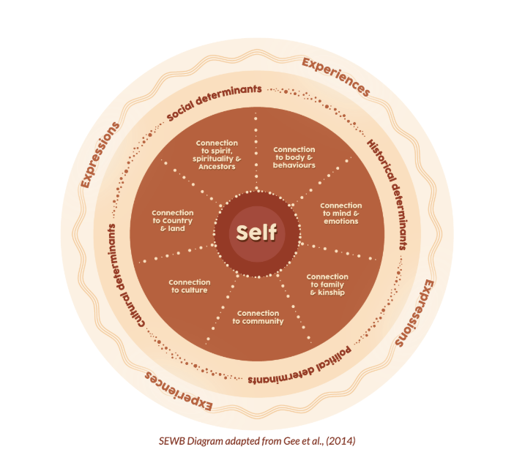
https://www.indigenousmhspc.gov.au/topics/social-emotional-wellbeing#theframework

Back to Contents

Attachment 4- Personal Reflection
The Personal Reflection Tool is often used by health professionals for professional development on a day-to-day basis as well as following a critical incident. The intention of reflective practice is to help identify changes you could make for future events and help improve the way you do your work. This individual reflective practice can help you explore an experience you’ve had and identify your behaviour, thinking and emotions around that experience.
Consider the points in the table below to help you reflect on an experience you’ve had.
Describe what happened, where did it happen and who else was involved?
How did you feel?

What were the best and worst aspects of the experience?

What sense can you make of this situation – why did it happen?

What will you remember most about this experience?

Could you have done anything differently?

If this situation arose again what would you do differently?

Back to Contents

Attachment 5- Support for staff
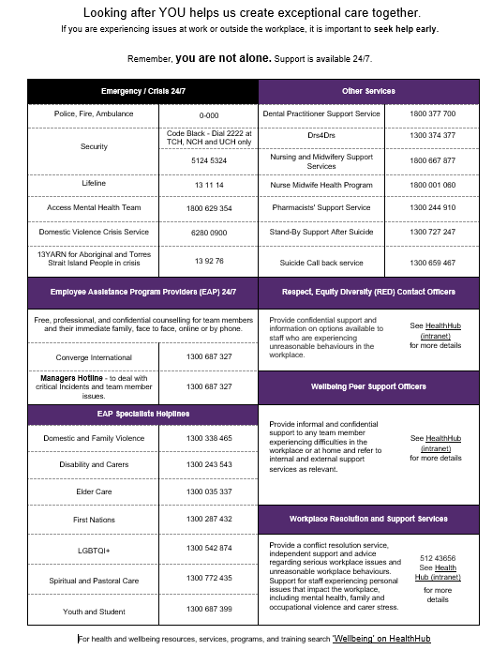

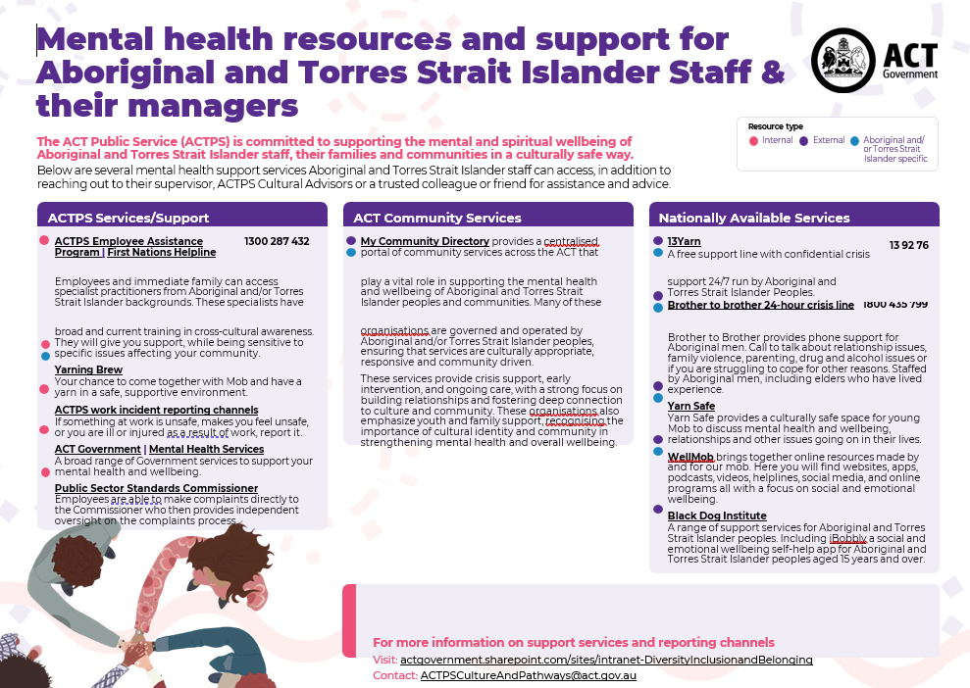

Attachment 6- RUOK? Model
The “RUOK?” Model is a tool which can assist in checking in on a colleague you are concerned about where there is no suicidal ideation.
Before you start you need to ask yourself: Am I the most suitable person? If you are not the most suitable person to check in on someone’s wellbeing, consider who may be able to provide that support and arrange for that to happen. You then need to ask yourself:
Am I ready? | Am I prepared? | Have I picked my moment?
Am I in a good head space? | Do I understand the answer could be “No I’m not going well?” | Have I chosen somewhere relatively private and comfortable?
Am I genuinely willing to listen? | Do I understand that I can’t fix everyone’s problems? | Have I figured out a time that will be good for them to chat?
Can I give as much time as needed? | Do I accept that they might not be ready to talk or might not want to talk to me? | Have I made sure I have enough time to chat properly?

Any person who has been exposed to a critical incident should be provided with early, practical, and emotional support through Psychological First Aid (refer to Attachment 7) and if in distress ensure they are supported using as a guide the Attachment 8 Responding to a colleague who is distressed or suicidal.

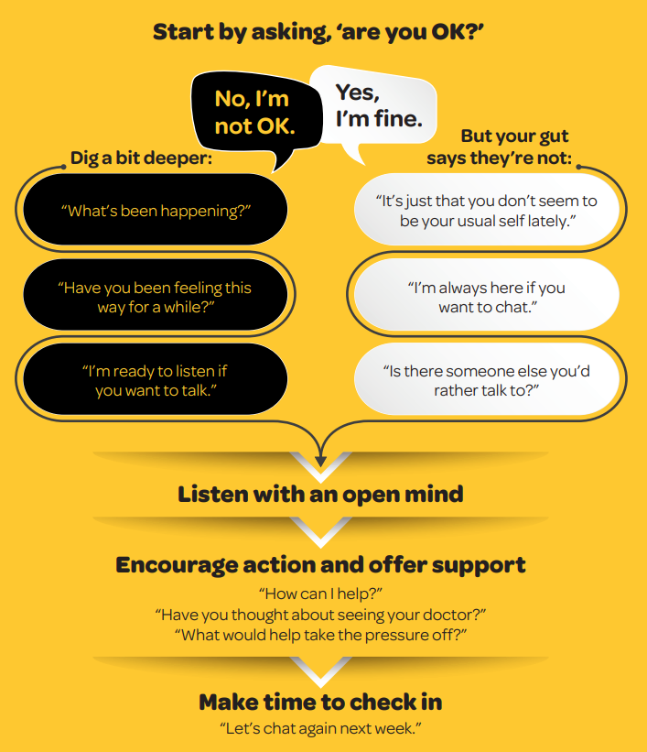

Adapted from the RUOK Model https://www.ruok.org.au/how-to-ask
Back to Contents

Attachment 7- Psychological First Aid
Psychological First Aid (PFA) is a simple and practical way to provide emotional support for people in times of stress. The aim of the Look, Listen, Link approach to PFA is to reduce the initial distress caused by trauma, enhance coping strategies, and connect people with ongoing support through promoting safety, calm, connectedness, self-efficacy and hope.
LOOK - Ensure Safety of self and others
- Are you ready to provide psychological first aid? If not find someone who is.
- Who needs help? Identify staff who may be directly or indirectly affected.
- Are staff in a safe place or is the area safe?
- Are any staff behaving different to usual or appear agitated? Get help / attend to immediate basic and practical needs e.g. physical safety and first aid.

LISTEN - Communicating with those in distress
- Approach
  - Check in with affected staff. Make yourself available for confidential, non-judgemental discussion about staff concerns, in a quiet, safe place.
  - You may need to introduce yourself, your role and what support you can offer right now.
- Focus
  - Actively listen to what is important to them right now. Provide feedback of key aspects, to communicate your understanding and show empathy.
- Acknowledge feelings
  - Reinforce that a variety of reactions are common and it’s okay to have no immediate reaction or share feelings of anxiety, fatigue and frustration.

LINK - Provide practical information and support
- Assist with practical issues
- What do staff need? E.g. time to debrief, contact next of kin, leave early, get assistance with writing up notes for the incident, a lift home, a follow up phone call or assistance contacting the police if required?
- Maintain routine so staff feel a sense of control.
- Give information. As soon as practical provide staff with:
- A short factual statement about what is known of the incident, clarify uncertainties and acknowledge the possible effects on those involved, what is being done for them and what is likely to happen in the future.
- Remind staff who’ve been affected that you will maintain regular check-ins including those who return to work immediately.
- Consider staff who are on the next shift and communicate what has already been communicated to other staff.
- Offer Support Options. Provide staff with:
- Common stress reactions – Mental Health Continuum (Attachment 2)
- Support options (Attachment 5).
- Contact the EAP within 24-72 hours of the incident to arrange a debriefing session in small groups or one-on-one depending on the situation. People are encouraged but not obliged to attend – EAP process (Attachment 11)
- Encourage connections with doctor, family, friends, peers.

Common reactions
There are some common reactions people may experience following traumatic events, however they may not always be immediate. Many people have no reaction which is also common.
Physical | Emotional | Cognitive | Behavioural
- Dry mouth  - Fatigue  - Fainting  - Symptoms of shock | - Anger  - Feeling overwhelmed  - Need for recognition of the experience | - Confusion  - Decreased concentration  - Preoccupation with the event | - Irritability  - Avoidance  - Blame  - Disturbed sleep

PFA is:
- Understanding through active listening
- Acknowledging and normalising feelings
- Sharing coping strategies
- Encouraging access to emotional support services.

PFA is not:
- Critical incident debriefing
- Treatment
- Labelling, diagnosing or therapy
- Obtaining details of traumatic experiences and losses
- Something everyone who has been affected by traumatic events will need.

DO NOT:
- Try to fix the problem
- Pressure the person to talk
- Re-examine the source of stress as it can be equally traumatic for staff
- Talk about or commence the discussion in an area where others may hear the conversation
- Trivialise or devalue their experience or feelings by using comparisons of similar situations or saying, “I know how you feel”, or “It will be fine.”

ALERT DO NOT: Utilise staff members from other areas and/or EAP to provide structured group or individual psychological debriefing, as it has been shown in some cases to have the potential to cause harm to people by re-traumatising them or traumatising those who may not initially have been impacted by an incident.

Adapted from Australian Psychological Society, Psychological First Aid - An Australian Guide to Supporting People Affected by Disaster
https://www.psychology.org.au/getmedia/c1846704-2fa3-41ae-bf53-7a7451af6246/Red-cross-psychological-first-aid-disasters.pdf
Back to Contents

Attachment 8- Responding to a colleague who is distressed or suicidal
This fact sheet provides guidance on responding to a colleague who may be distressed or suicidal. You need to take them seriously and respond without judgement. It may feel uncomfortable but it’s important to start the conversation.
If a colleague discloses they are suicidal, their manager needs to be made aware so they can be supported at work to gain the assistance and professional care they need. This may be something you support your colleague in discussing with their manager or you might need to speak to their manager if they are not ready. Where possible, obtaining the assistance of another colleague will make it easier to provide safe in the moment help.
If a colleague is in immediate danger:
For example, they are: | Take the following action
An immediate risk to the welfare or safety of themself or others | Call Code Black – Dial 2222 or 0-000 Police – if safe to do so, stay near them until help arrives
Seriously injured and in need of medical care | Reassure them you are seeking help.  If onsite at a hospital with an emergency department and safe to do so, arrange for your colleague to be taken to the Emergency Department or otherwise call a Code Blue (MET) or an Ambulance on 0-000
So distressed they are unable  to function | Reassure them you are seeking help.  If onsite at a hospital with an emergency department and safe to do so, arrange for your colleague to be taken to the Emergency Department or otherwise call a Code Blue  (MET) or an Ambulance on 0-000
Once support has been arranged, notify the person’s Next of Kin and their manager.
A person expressing suicidal intent might say:
- “I want to commit suicide”
- “If I was dead no one would have to worry about me” or
- “I just don’t want to be here anymore”

Before you start a conversation with your colleague:

Check-in with yourself:
- Are you the most suitable person, consider your relationship?
- Are you ready for wherever this conversation might go, are you in the right headspace?
- Are you prepared, do you have time and space?

What you can do:
- If you feel unable to have the conversation, take your colleague to someone who can.
- Notify their manager and your own manager that you need to provide support and cannot attend to your normal work duties – maintain confidentiality.
- Find a suitable private location where you won’t be interrupted, and you both will be safe.

Having the conversation:
- If you are concerned for their safety, call 0-000 immediately.
- Starting this conversation implies your agreement to listen, even if it’s hard to hear or feels uncomfortable.
- If you feel unsafe at any time, leave the room, and immediately call a Code Black or 0-000.

What you can do:
- Take them seriously every time and respond accordingly and without judgement.
- If they disclose risk to the welfare or safety of themself or others, advise you must share this information with their manager, and cannot keep that secret.

What you can say:
- Use the conversation guide on page 3 of this fact sheet to assist you.

Take care of yourself and your colleagues:
Dealing with colleagues in distress may have an impact on you. Seek support and/or talk to your manager about what you need following this event. Low impact debriefing may assist as well as non-urgent support options. Support for Staff options are available on the intranet.
Immediate support options, if a staff member’s life is not in immediate danger, are:
- Access Mental Health Team on 1800 629 354
- Lifeline on 13 11 14, or the
- Suicide Call Back Service on 1300 659 467.

Ongoing support options not recommended in the first instance include:
- the Employee Assistance Program (EAP) 1300 687 327
- General Practitioner
- Next Step (a mental health program developed by Beyond Blue).

Manager follow up:
- Further assistance for you as the manager can be obtained through Converge Manager Assist on 1300 687 327, or by emailing your HR Business Partner (HRBP), the Workplace Resolution and Support Service (WR&SS) and/or the Injury Management Team.

- After the interaction if your colleague doesn’t turn up to work and their Next of Kin cannot be reached, the manager should request a welfare check from the Police, by calling 0-000.
Conversation Guide with a distressed or suicidal colleague:
Create connection by making sure they know you are here to support them and using non-verbal cues like sitting beside them, nodding while they are talking, making mindful eye-contact, or put your hand on their hand if appropriate.
- Ask if they are OK
- Be open about your concerns, “I’ve noticed you’re not yourself lately and I’m worried about you.”
- Listen with empathy, without interruption or judgement. Once they finish speaking you might say, “Thank you for telling me how you’re feeling.”
- Acknowledge this is a difficult time for them - “It sounds like you’re going through a difficult time, and this is worrying for you”.

- Ask about their supports
- Check if they have available support – Ask “What supports do you have in place or have you used in the past?” e.g. “Do you have a GP or counsellor/psychologist?”
- Connect with support – Ask “Who can you contact to support you right now?”
- If they do have supports, ask “Would you like to make a call together to reach out?”
- If they don’t have support – “I’m very concerned about you, and I need you to be safe”
- If they do not want to seek support or don’t have any support, say “I’m sorry you feel that way, but I have a duty of care and I need to arrange for you to be medically assessed.”

- Ask about their current state
- You may need to ask: “Are you having thoughts about suicide?” and “Do you have a plan?”
- Let them know, “You’re not alone, many people feel overwhelmed from time to time”, or “Many people think about suicide”.
- Reassure them - “It’s important you are safe and get the support you need” and “We can find a way to get through this”.
- Seek manager support - If your colleague is suicidal, you must advise their manager.
- You can suggest having this conversation together, “Would you like me to go with you so I can support you to speak to your manager”?
- If they do not agree, say “I am concerned about your wellbeing and acknowledge that you have concerns with me talking to your manager. However, I am obliged to seek their support to help keep you safe.”
- Encourage action
- Connect them with additional support services - Provide ‘Support for staff’ options available on the Health Hub – Emergency Safety –Support for staff – I need support.

- Manager responsibilities
- Workplace support – Ask “What supports would be useful to access in the short term?” (e.g. medical, partner/family/friends, changing hours or time off work). They may not be able to answer immediately and need time to think.
- Continue to support your staff member – Ask “During the next little while, how often and in what way would you like me to check in with you? E.g. phone call, email or text?

ALERT: If at any time if you are concerned for your colleagues’ safety or the safety of others call 0-000

Back to Contents

Attachment 9- Managing staff affected by a life limiting illness
Supporting a staff member who may be facing a life-limiting illness or a family member with a life limiting illness is a complex and delicate task. It requires sensitivity towards them and clarity about the ability CHS has to be flexible. This fact sheet aims to help you have important conversations, share information, and support your staff. It is recommended you also use Attachments 6 and 7, RUOK? and Psychological First Aid.
The initial disclosure
The first discussion is critical to setting up a supportive work environment. As the manager your role is to speak directly to the affected staff member so the right support can be arranged.
The first conversation may be unexpected and quite short - your priority is to listen. Arrange or move to a private place without disruptions. Make another time to discuss how this may impact their ability to do their job, their rights and access to leave. Your Human Resources Business Partner (HRBP) can advise you about further supports available.

Having the conversation
In the first instance refer to the resources in this Fact Sheet. Begin by asking “What do you need from me right now?”, and then listen.
- Pay attention to what they are telling you and avoid interruptions.
- Acknowledge what they are saying without agreeing or disagreeing.
- Answer questions specifically and honestly.
- Summarise the key points and any actions you have both agreed upon.
- Follow up with an email summarising the key points to ensure you share expectations and have a record of what has been agreed.

Future conversations
What is agreed initially may change quickly or incrementally. Treatment of their illness will affect people differently. Your staff member might need reasonable adjustments made to support them to keep working, e.g. a modified work schedule, adjustment of their physical space, or they might need to take prolonged leave. As part of these conversations consider and listen to religious and cultural factors, preferences and requirements.
Your HRBP can help you both explore options regarding changing operational capacities and ability to retain their role and work entitlements. Make a future meeting date to review any reasonable adjustments or changing circumstances.
A staff member with a life-limiting illness or caring for a family member with a life-limiting illness is likely to be concerned about many things including:
- Will I be able to continue in my role or will I need to move to a different role that suits my current capacity better?
- What will happen if/when I can’t work anymore?

To establish trust between you and your staff member, agree upon a communication plan that includes:
- What you will, and will not tell others
- Who will share this information - you or your staff member
- How information will be shared - team meeting, email or individual discussions
- What and how to share where the person takes unplanned time off.
To maintain their privacy establish yourself (manager) as their single point of contact for communication and any work-related issues.
If and /or when they are no longer able to work, discuss options to ensure clear communication and a smooth transition when it is time for them to leave.
Support for affected staff and team
Having a colleague with a life-limiting illness, or knowing a colleague is caring for a family member with a life-limiting illness can be an emotional, yet important time for everyone in the team. As the manager, you can influence how the team respond. Important actions you can take include preparing to talk to the team guided by the communication plan you made with your staff member and only share what has been agreed.
When sharing the information with the team:
Arrange a private area so they can react to the news in private
Staff may react in different ways - some may be upset, others willing to help with workload, some may make it all about them. Have tissues available
Provide contact details for the EAP and other support for staff options
Be honest with staff and acknowledge that there are a lot of unknowns
Don’t dramatise or embellish the information
Outline known changes that will be made, and the need for flexibility
Be open to conversations or concerns from all staff
Staff may also feel awkward and unsure about how to approach their colleague Advise staff it is okay to acknowledge the situation and continue working - it does not diminish the care or concern they have for their colleague
Communicate the situation to senior management and provide regular updates about progress and your management of the situation as it develops
Understand the effects on a carer and assist as above.

A carer may be less likely to inform management, due to their fear of discrimination or missing out on promotional opportunities. Ensure they are provided with the same level of compassion, consideration, and privacy. In both cases, you may need to adjust job responsibilities and prepare for absenteeism.
It is not your role, or responsibility, to be a counsellor for staff. There are many resources who can provide your staff with expert care.
Returning to work following unplanned time off due to illness
Make time to meet with your staff member before their return to work to discuss their work plan and facilitate a smooth transition back to work.

Workplace regulations
The relevant legislation includes: The Privacy Act 1988, The Disability Discrimination Act 1992, and the Fair Work Act 2009.
Any consideration to terminate the employment of someone with a life-limiting illness, requires very clear grounds for dismissal and you need to ensure the reasons are lawful, not discriminatory or in breach of their relevant employment contract or Enterprise Agreement. Contact your HRBP to ensure an appropriate termination process if required and support.
Staff supports:
- Employee Assistance Program for managers, staff and immediate family
- Support for staff – intranet page

The staff member may also like to seek external advice re financial and estate planning assistance, early superannuation fund access, qualification for insurance, or early ill-health retirement.

Resources:
- Life Limiting illnesses in the workplace- A toolkit for managers and HR professionals
- ‘Life limiting illnesses in the workplace – A toolkit for employees’.
- Psychological Support for Staff – Manager’s Guide
- Your HR Business Partner (HRBP)
- CHS HR Advisory Service on 5124 9610, or CHSHRAdvisory@act.gov.au for HR support
- HR Fact sheets for leave options

Back to Contents

Attachment 10- Managing the death of a colleague
The death of a colleague can have a profound effect on your team. As the manager, you may be the first to become aware of this event. It is your responsibility to sensitively communicate this to your staff, clients, and suppliers (as appropriate) with support available from your Human Resources Business Partner (HRBP). This Fact Sheet suggests ways to hold conversations, share information, and support staff members. It is recommended you also use Attachments 6 and 7, RUOK? and Psychological First Aid.
Staff may experience a variety of emotions such as shock, sadness, or guilt. It is important to acknowledge with your team that these reactions are common. Each person may experience different emotions and present in different ways. With effective communication you can support them during this emotional time.
In the early days, grief can interfere with thought processes, concentration, and sleep patterns. This can result in fatigue, anxiety, and changes in mood that can impact on work participation and performance. It is not your role or responsibility to be a counsellor for staff. Psychological support is available through EAP and other Support for Staff options.
Announcing the death of a staff member
Depending on the role of your work area, clients, suppliers, and stakeholders may need to be informed. Consider your approach depending on the nature of the relationship and tailor communication accordingly, with sensitivity and respect. Consider that there may be cultural sensitivities and obligations, such as not using the name or image of a person who has died. Consult with the family as to cultural requirements.
Contact the Executive of the Division who will liaise with the family to:
- Seek permission from the family to announce the death, noting it may not be culturally appropriate for non-Indigenous staff to contact the next of kin following a death. For Aboriginal and Torres Strait Islander cultural practices advice should be sought from the ACTPS Culture and Pathways team by emailing ACTPSCultureAndPathways@act.gov.au.
- Be considerate of the information provided; the family may ask some details to remain private and not be shared further
- Let the family member know that EAP is available for them to access support.

Ask staff to attend an impromptu meeting
- Show compassion during this time as death may trigger emotional responses even if the colleague was not close to the deceased.
- News of a death is best delivered in person. If staff are away, please try to have them in this meeting either virtually or by phone.
- Be direct and sympathetic.
- Share memories of the deceased and allow others to share their own stories.
- Let staff know of supports available. Onsite EAP can be arranged to support staff during this time either individually or as a group. Spiritual Support Services can assist in facilitating a memorial service for the team.
- Some staff may need time off to process the event.
- Consider arranging other staff to provide coverage for those who are grieving.
- Share the news with those not in the office using guidelines above.

Discuss how to help the family
- Team members may want to offer meals, cards, flowers.
- Depending on the wishes of the family, advise colleagues of funeral arrangements and consider operational requirements to allow for staff who want to attend. Staff unable to attend for operational reasons may carry some level of grief or guilt around that.

Discuss the work expectations for the immediate future
- Ask that non-essential work be given an extended deadline.

Share the news with senior managers to provide information to Chief Executive Officer (CEO).
- CEO makes an announcement in the CEO Bulletin, setting the standard for compassion and empathy, providing a brief description of the death, ending the announcement with what supports are available for staff.
- The announcement should include a descriptive heading e.g. Sad loss for Team CHS or CHS mourns the loss of a valued team member or Vale Name of Person.

If possible, avoid making significant changes and demands to the workplace immediately following the person’s death. Allow time for colleagues and family to grieve and base your timing on the “pulse” of the team and operational needs. When the time is right, ensure open communication with immediate colleagues and plan together (as much as possible) to minimise any element of “surprise”. Changes may include:
- Work responsibilities
- Removing person’s name from work distribution lists
- Removing personal belongings and re-allocating the workspace
- Recovering work property from the family
- Returning personal belongings to the family.

Be mindful of setting precedents that the organisation might be expected to follow should the circumstances arise again. Be consistent and offer the same amount of support to all staff.
Under the Enterprise Agreements, Compassionate Leave is only for immediate family, however, your Executive Director can approve ‘Leave where other leave cannot be granted’ to attend a staff member’s funeral. In addition to Compassionate Leave, Aboriginal or Torres Strait Islander staff can use Other Leave to attend Aboriginal and Torres Strait Islander Ceremonies associated with the death of an immediate or extended family member.
Death of a colleague’s close family member
Death of a colleague’s close family member can also be deeply affecting for your team. As the manager, you may be the first to become aware of this event in your work area. It is important to ask the staff member if, or how, they would like you to communicate the death of their family member to other staff and if they would like you to advise colleagues of funeral arrangements. A team member can then be appointed as liaison to arrange expression of sympathy, card, flowers.
The death of a colleague’s close family member may cause some people in your team to experience a variety of emotions such as shock, sadness, or guilt. Even though they may not have known the person who died, it is important to acknowledge that these reactions are common.
When your colleague whose family member died is ready to return to work, they may still experience fatigue, anxiety, and changes in mood that can impact on their participation and work performance. Make time to meet with them before their scheduled return to discuss their options. Collaborate on a work plan that helps to facilitate a smooth transition back to work for them.
Workplace regulations
The relevant legislation is: The Privacy Act 1988, The Disability Discrimination Act 1992, and the Fair Work Act 2009.
Supports:
- Support for staff – CHS Health Hub – Emergency and Safety – Support for staff
- The staff member may also like to seek external advice re financial and estate planning assistance, early superannuation fund access, qualification for insurance, or early ill-health retirement.
If you have any questions relating to leave arrangements, flexible working arrangements or employment conditions or you require further HR support, you can contact the CHS HR Advisory Service on 5124 9610.
Resources:
- Life Limiting illnesses in the workplace- A toolkit for managers and HR professionals
- Psychological Support for Staff Manager Guide available on the Policy and Guidance Documents Register
- EAP 1300 687 327 – for staff, managers and family members
- Your HR Business Partner (HRBP)
- CHS HR Advisory Service on 5124 9610, or CHSHRAdvisory@act.gov.au for HR support
- HR Fact sheets for leave options.

Further information: CHS Psychological Support for Staff – A Manager’s Guide on CHS Health Hub Policy and Guidance Documents Register.
Back to Contents

Attachment 11- EAP process following a critical incident
Following a critical incident, in addition to arranging an Operational Debrief, the manager will contact EAP Rapid Response team on 1300 687 327 who will determine the appropriate action and guidance, including whether on-site support for staff is required. EAP can be contacted 24 hours a day, seven days a week. On-site support, if required, is generally provided during business hours, however after-hours on-site support will be considered on a case-by-case basis.
Initial Support:
This initial support is offered to reduce the impact of the incident and provide information on common stress reactions and support for staff to be at work, support options available and to check on the wellbeing of staff.
EAP can provide support face-to-face, via video link or over the phone, including welfare checks if required. EAP for on-site support is paid for by the requesting area’s cost centre.
Follow-Up Support:
Continued support can be provided for staff by Converge EAP either face-to-face, via video link or over the phone. After providing critical incident support for staff, EAP will provide feedback to the manager on any staff who may require work maintenance or reasonable adjustments.
Ongoing Support:
Attending or participating in an EAP session is voluntary. Staff showing only a few symptoms should be encouraged to access EAP. If, after the initial contact, staff are showing significant symptoms, they are followed up by EAP and offered counselling. The EAP will provide final confidential feedback to the referring manager.
See flow chart over page for EAP process following a critical incident.

Back to Contents

Attachment 12- Operational Debrief

An Operational Debrief is a structured and voluntary discussion aimed at putting a stressful event into perspective. It is not counselling.

There are two types of Operational Debrief:
- Hot (Informal) Debrief: Occurs immediately as possible after the event to generate insights into what has occurred and check-in with staff involved in the event. This should take no more than 15 minutes.
- Cold (Formal) Debrief: Pre-arranged 1-2 days after the event, or whenever reasonably practicable for affected staff to attend to analyse the situation more critically, to help improve processes in the future. This usually takes no more than 1 hour.

What are the goals of Operational Debriefing?:

To review organisational processes following an incident to allow staff who may have been directly or indirectly involved to:
- Learn from the people who went through the process
- Involve them in improving processes if applicable
- Evaluate the physical and emotional impact on staff
- Moderate any negative effects
- Identify the need for counselling or support for staff involved.

Who should be present?
- All staff (directly involved or indirectly affected) – this may include but is not limited to clinical, administrative, security, food services, wards persons, cleaners, volunteers, students, contractors etc.
- Supervisor (on-site).

Participation in the debrief is voluntary. Staff should be advised of the debrief and invited to participate. If not all staff are available to attend, more than one formal debrief may be required. If staff are unable to attend they are to be reminded of the access to available supports – see Support for Staff Poster on the CHS Health Hub – Emergency and Safety – Support for Staff.

Where should the debriefing take place?

Debriefs should occur in a location relative to the number of participants, ambience, and privacy.

Who should lead the debrief?

Debriefs should be led by a senior manager or supervisor who was not involved in the event. The person leading the debrief must take a non-judgmental approach, provide opportunities to reflect and learn from the event, and facilitate a shared understanding of the experiences of the people involved.

How to conduct a debrief?

These are some of the guiding questions to start the debrief:
What happened?
Who was involved – directly and indirectly
Why did it happen?
What did we learn?
What post-incident support has been provided to staff?
What other post-incident support is needed?

There is no requirement to record debriefs to provide staff a safe and confidential space to reflect, process and recover from critical incidents.

Conclusion

Focus on ending the meeting in a positive way. Thank people for attending. Identify where possible, where the situation was managed well. Support the recommendations made. Highlight support services available for staff to access if required. The supervisor or senior manager should include in the medical notes that a debrief occurred but details of the debriefing and attendance do not need to be included.

Back to Contents

Attachment 13- WHS Immediate Response Checklist
This checklist is designed to assist you as a manager to manage the immediate to short-term response to critical incidents.
Note:
- A critical incident is any incident or the accumulation of incidents (direct or indirect exposure), that may have a significant impact on the health and wellbeing of staff.
- If the incident relates to an emergency code event (e.g. code yellow), follow the emergency code actions and use this document as supplementary guide if appropriate.
- Actions described in this checklist may be delegated as appropriate.

Respond
- Ensure immediate safety of staff, patients and others affected by the incident.
- Facilitate medical treatment or psychological first aid for staff, patients and others (Refer to Attachment 7 Psychological First Aid Fact Sheet).
- Avoid unnecessary exposure of other staff, patients and others to the critical incident site, particularly where it may be potentially distressing.
- Ensure all relevant staff, patients, and others are accounted for.
- Gather facts and details of the critical incident – What happened? Who was involved (directly and indirectly)? Where did it happen? Why did it happen? How did it happen?

Support (Immediate)
- Conduct a hot debrief immediately after the incident (Refer to Attachment 12 Operational Debrief Factsheet).
- Determine staff who require timeout or time off to recover, and arranging staffing requirements to support this
  - Managers may assist with organising transport to home for affected staff.
- Check-in with patients, visitors and others on the support they require.
- Schedule a cold debrief 1-2 days after the incident or whenever reasonably practicable for staff to attend (Refer to Attachment 12 Operational Debrief Factsheet).
- Refer staff to CHS Staff Support system (see Staff Support Factsheet)
- If required utilise the Telephone Interpreter Service for those who have English as a second language.

Follow-up support
- Determine the method and frequency of check ins with the staff member, and regularly check in with them, including outside work hours if agreed upon e.g. via text message.
- Monitor for behavioural changes among staff and provide psychological first-aid as needed.
- Monitor your capacity to provide support using the RUOK? Model, and seek support to maintain your wellbeing
- Seek support/advice from senior management or on-site support services (i.e. EAP, WHS, Workplace Resolution and Support Services).
- Seek support from ALO for further support and information for cultural considerations for Aboriginal and or Torres Strait Islander people.

Communicate
- Alert Executive of the relevant area via reporting lines to provide an initial summary of the critical incident.
- With the affected staff member’s consent, contact next of kin to communicate relevant information such as injuries or their condition if required.
- Keep staff and other informed of any further impacts due to the critical incident i.e. partial ward closure etc.
- If appropriate, develop a short statement for staff detailing:
  - What is known of the incident (maintaining confidentiality)
  - Actions taken to ensure a safe system of work
  - Staff Supports available.
Report
- Ensure affected staff or staff who witnessed the incident lodge a staff incident report on Riskman, if they are unable to do so, report the incident on their behalf.
- Contact ACT Policing for incidents involving offences against the Crimes Act 1900, such as death of a person, assault, sexual assault, attempted assault, or property damage. Call 131 444 (non-emergencies) or 000 for emergencies.
- Notify WorkSafe ACT within 48 hours if the critical incident is a death of a person, serious injury or illness, dangerous incident, or sexual assault (suspected or actual). For more information please see WorkSafe Notifiable Incident Factsheet incl Sexual Assault
  - Ensure the preservation of potential evidence until cleared by Police or WorkSafe ACT (where appropriate).

Useful resources
- Psychological Support for Staff – A Manager’s Guide
- Psychological First Aid
- RUOK?
- Operational Debrief
- Support for Staff
- Police Engagement Factsheet (Towards A Safer Culture) – CHS Health Hub – Emergency and Safety – Occupational Violence - OV resources
- WorkSafe Notifiable Incident Factsheet

Back to Contents

Attachment 14 - Quick Reference
The Psychological Support for Staff – Manager’s Guide helps guide you to provide psychological support to staff day-to-day, as well as following any incident or event.

Your responsibilities as a manager
Leadership and support
- Provide leadership, guidance, and support for the wellbeing of staff you supervise (Attachment 1).

Early detection and support
- Use the Mental Health Continuum (Attachment 2) to identify early signs of declining staff wellbeing.
- Encourage staff to seek help early (Attachment 5).

Critical incident response
- Use the WHS Immediate Response Checklist (Attachment 13).
- Use the EAP Process (Attachment 11).
- Follow the Psychological First Aid principles (Attachment 7).
- Conduct Operational Debriefs regularly, and after incidents (Attachment 12).
- Provide support to staff who are distressed or suicidal (Attachment 8).

Support resources
- Encourage self-care and reflective practice (Attachments 3 and 4).
- Check in on colleagues using the RUOK Model (Attachment 6).
- Provide support for staff affected by life-limiting illnesses or the death of a colleague (Attachment 9 and 10).

The safety and wellbeing of staff is always the priority. Promoting and supporting their mental health and wellbeing leads to better patient care and outcomes. As an organisation we want to ensure all staff have the support they need to deliver exceptional care. For more information, read the Psychological Support for Staff – Managers Guide and refer to the relevant attachments.
Acknowledgement of Country  Canberra Health Services acknowledges the Ngunnawal people as traditional custodians of the ACT and recognises any other people or families with connection to the lands of the ACT and region. We acknowledge and respect their continuing culture and contribution to the life of this region.  © Australian Capital Territory, Canberra 2024 | Accessibility  call (02) 5124 0000   Interpreter call 131 450  canberrahealthservices.act.gov.au/accessibility  

For Policy Team to complete:
Date amended | Section amended | Divisional approval | Final approval
09/01/2025 | New Document Added | Andrew White, EGM, People & Culture | Policy Document Review Panel
This document supersedes the following:
Document number | Document name
CHS21/612 | Psychological Support for Staff - A Manager's Guide
Disclaimer
This document has been developed by Canberra Health Services specifically for its own use. Use of this document and any reliance on the information contained therein by any third party is at his or her own risk and Canberra Health Services assumes no responsibility whatsoever.

Acknowledgement of Country  Canberra Health Services acknowledges the Ngunnawal people as traditional custodians of the ACT and recognises any other people or families with connection to the lands of the ACT and region. We acknowledge and respect their continuing culture and contribution to the life of this region.  © Australian Capital Territory, Canberra 2024 | Accessibility call (02) 5124 0000  Interpreter call 131 450  canberrahealthservices.act.gov.au/accessibility

