Canberra Health Services

Guideline

University of Canberra Hospital (UCH) - Eligibility, Prioritisation and Referral Management to Brindabella Rehabilitation Service

Contents

Contents 1
Introduction 2
Scope 2
Alerts 3
Section 1 – Eligibility 3
Section 3 – Other Considerations 4
Section 4 - Referral Process 4
Section 5 – Patient Allocation Team 5
Section 6 – Prioritisation and booking instruction 6
Section 7 – Appointments 8
Section 8 – Discharging/closing referrals 9
Evaluation 9
Related Policies, Procedures, Guidelines and Legislation 9
Definition of Terms 10
Search Terms 10
Attachments 10
Attachment 1 – General Referral Intake Process 11

Introduction

This document provides an overarching guideline for the eligibility and prioritisation of patients accessing the University of Canberra Hospital (UCH) Brindabella Rehabilitation Service and management of referrals to the service. This document acts as a supplementary document to the Ambulatory Care Operations Manual that was established to articulate standards and promote consistent, best practice processes across all ambulatory care administrative services.

The UCH Brindabella Rehabilitation Service offers a number of specialised centre and home based rehabilitation services for patients who have experienced a recent health or medical event resulting in a loss of function and/or independence.

These services include:
- interdisciplinary and single profession Allied Health Clinics
- Consultant Rehabilitation Medicine Clinics.

These clinics provide specialist rehabilitation services to a particular patient cohort and share a number of common factors. These include providing evidence based, high quality interdisciplinary care, goal based, time limited services, and a focus on physical, psychosocial and communication rehabilitation needs.

Back to Table of Contents

Scope

The eligibility and prioritisation guidelines in this document pertain to staff working within the UCH Brindabella Rehabilitation Service and clinicians/individuals referring patients to the UCH Day and Ambulatory Rehabilitation services.

The referral management guidelines in this document apply to both internal and external Canberra Health Services (CHS) staff including, medical, nursing and allied health staff providing ambulatory services at UCH, administration staff, as well as GPs and specialists.

The ambulatory services that are covered by the referral management guidelines are: Rehabilitation Medicine, UCH Allied Health services and Aquatic Physiotherapy (Hydrotherapy).

Out of scope: Referrals for Geriatrics, Nurse Practitioner, inpatient and Mental Health rehabilitation.

Back to Table of Contents

Alerts
Specific details of eligibility requirements for the individual services below are not contained within this document.
- Aquatic Physiotherapy
- Memory Assessment Service
- Rehabilitation Consultant
- Driver Assessment Rehabilitation Service
- Vocational Assessment Rehabilitation Service
- Falls and Falls Injury Prevention Service.

Back to Table of Contents

Section 1 – Eligibility

To be eligible for the UCH Brindabella Rehabilitation Service people will either have:
- experienced a recent health or medical event resulting in a loss of function and/or independence, including communication deficits
- a progressive neurological condition e.g. Multiple Sclerosis, Motor Neurone Disease, Parkinson’s Disease/Syndrome where the primary aim of referral is for an interprofessional package of treatment for a functional change i.e. NOT when there is a single defined issue such as equipment review, housing modification, or pressure injury.

They will also meet the following criteria:
- have identified achievable, time appropriate rehabilitation goals
- be aged 16 years and older – referrals for children up to the age of 16 will be accepted for Aquatic Physiotherapy only
- reside within the ACT. By exception, Brindabella Rehabilitation Services can accept referrals for patients residing in NSW where all other service eligibility is met and where no equivalent service is available. Referrals received for NSW clients require approval from the RACS Executive Director or their delegate.
- consent to participate in a rehabilitation program
- possess both the cognitive and physical capacity to participate in a rehabilitation program.

The following people are not eligible for UCH Brindabella Rehabilitation Service.
People who:
- require ongoing allied health input for a program to maintain (rather than improve) their level of function or independence
- have severe behavioural disturbances
- have acute unstable medical conditions
- have mental health conditions that are unstable and need specialised/intensive mental health services, where the mental health condition impacts their ability to engage in a rehabilitation program
- have a permanent disability as a consequence of traumatic brain injury, disease process or condition diagnosed from birth to age 16 years
- People who reside in Residential Aged Care Facilities are not routinely eligible, however exception to this will be considered where intensive interdisciplinary rehabilitation would significantly improve a person’s functional capacity following a recent deterioration.

Back to Table of Contents

Section 3 – Other Considerations

The UCH Brindabella Rehabilitation Services are predominantly centre based, however treatment in the home or the community is provided for those patients where an assessment and/or intervention in the home or community environment is an appropriate component of therapy.

The UCH Brindabella Rehabilitation Services are unable to provide transport for patients. Patients are responsible for arranging their own transport to and from UCH.

Patients who are receiving ongoing neurological rehabilitation from an alternate rehabilitation service provider will need to provide care plans from other treating teams with consent to share information for their referral to UCH Brindabella Rehabilitation Services to be accepted. This is to ensure the continuity and co-ordination of the patient’s rehabilitation. It also allows for discussion between services and patient regarding any concerns about multiple service involvement.

Back to Table of Contents

Section 4 - Referral Process

The referral management processes for UCH Brindabella Rehabilitation Services is described in this section. This is a macro view of the process and does not encompass detailed instruction for management of referrals in the Clinical Portal. Further information can be found in the Ambulatory Services Operations Manual and Clinical Portal user guides. Attachment 1 shows a flow chart of the General Referral Intake Process.

- In line with the Single Intake model proposal, referrals for UCH will go to Central Health Intake (CHI) initially using Smart Forms where available or the existing CHI referral form. The referrals will be forwarded to the UCH Booking & Scheduling team for further management.
- Referral forms received by CHI will be emailed to the UCH Booking & Scheduling team at UCHIntake@act.gov.au. Self-referrals will be accepted via phone call to CHI and will be transferred to the UCH Booking & Scheduling team.
- The UCH Booking & Scheduling team will register the referral in the Clinical Portal and preliminary screening is to be completed as per the Ambulatory Services Operations Manual (page 37-38). Referrals are to be registered within 2 business days of receipt as per organisational Key Performance Indicators (KPI).
- Once registration has occurred, most referrals will be triaged by the Patient Allocation Team (PAT) using the Clinical Portal. A triage category must be assigned and booking instructions provided. Referrals to services outlined in Section 3 of this document do not go to the PAT; these will still be triaged in the Clinical Portal.
- The UCH Booking and Scheduling team will book appointments in ACTPAS based on the triage category and instruction provided by the PAT.
- Rejection of referral, request for additional information and close of referral post discharge will all occur as per the Ambulatory Services Operations Manual.

Back to Table of Contents

Section 5 – Patient Allocation Team

The Patient Allocation Team (PAT) will be responsible for triaging and allocation of referrals that require multidisciplinary assessment. The PAT will include representatives from allied health professional groups on a six monthly rotating roster. Any disciplines not represented on PAT are consulted regarding referrals if further professional advice is required.

The PAT will meet at a minimum of once per week and will increase frequency based on demand. A meeting of once per week will meet the organisational KPI of triage within seven days of registration.

All referrals that are for UCH Brindabella Rehabilitation Services will be allocated to the Rehabilitation specialty. Multidisciplinary referrals for the PAT will be allocated a sub specialty of ‘PAT’ for ease of searching for triage. Referrals for outpatient speech pathology will also be triaged via the PAT team.

During triage meetings, the PAT will use the search function in the Clinical Portal. They will search via sub specialty, date received from and date received to and status of registered. This will raise a list of all referrals waiting for triage (see Figure 1).

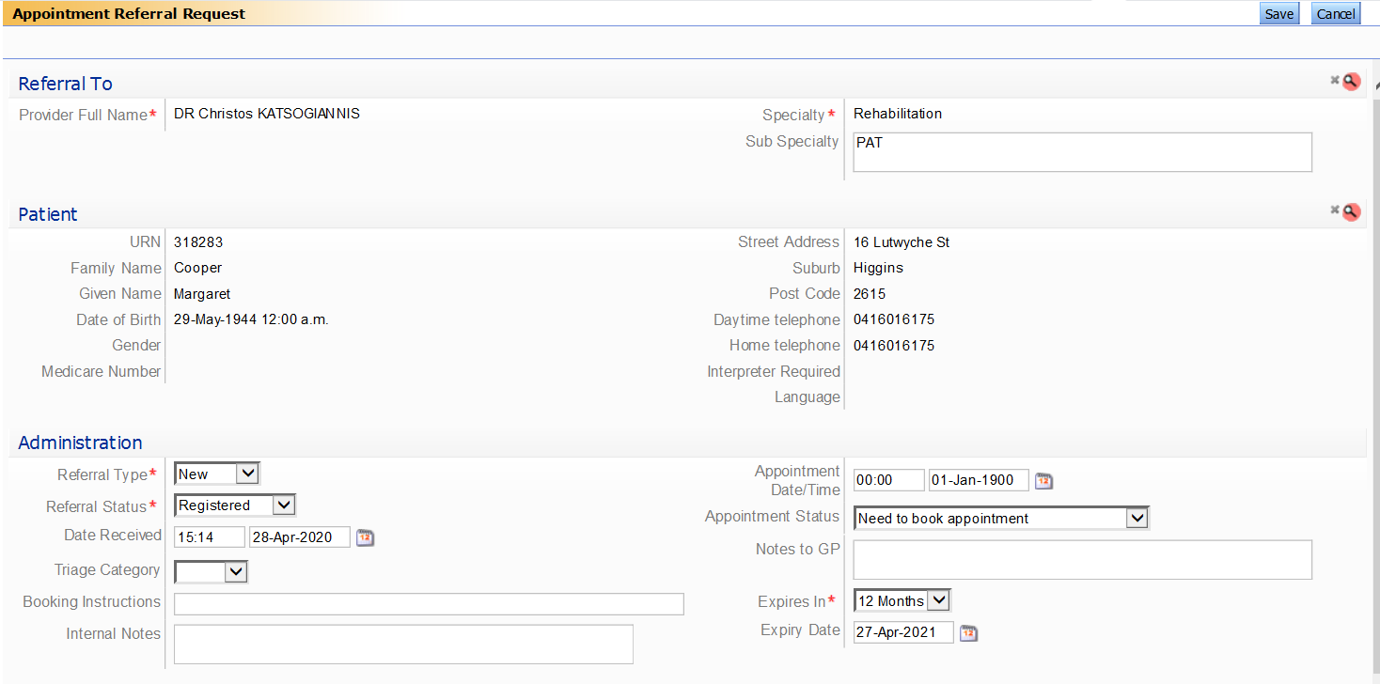
Figure 1 – Clinical Portal showing Sub speciality, status and date received.

Referrals that will not be assessed by the PAT include those that only require one specific service such as hydrotherapy and psychology. Referrals for hydrotherapy will have the ‘hydro’ subspecialty allocated and triage and booking instructions will be provided by the service manager via the Clinical Portal. Psychology referrals will be emailed to UCHpsychology@act.gov.au who will provide the relevant administration staff with booking instructions.

When a triage category and booking instructions have been set, the PAT will change the status of the referral to ‘triaged’ which will place it in a list for the booking and scheduling team to action.

Where it cannot be determined by administration staff whether a referral is for a specific discipline or requires multidisciplinary assessment, they will assign the ‘PAT’ subspecialty and the referral will be reviewed by the PAT team.

Back to Table of Contents

Section 6 – Prioritisation and booking instruction

In general, UCH Brindabella Rehabilitation Services prioritise patients who are at risk of an adverse health outcome if a service is not provided in a timely manner. This may include, but is not limited to, patients who are at risk of:
- falls
- pressure injuries
- avoidable admission to hospital or other care facilities
- significant psychosocial distress (including job loss), or
- their carers are at risk of injury or psychosocial distress.

The triage categories determine the timeframe in which the patient is to be seen and provides guidance to the administration staff booking the appointments. The triage categories adopted for these services are Category 1, Category 2 and Category 3 with exception of psychology (refer to CHS Rehabilitation Psychology and Counselling Services Procedure).

Triage categories as per the Ambulatory Services Operations Manual are:
Category | Definition
Urgent | (urgent) – Appointment to be made in 2 weeks (where clinician has clinics frequently enough to accommodate)
1 | (semi-urgent)—Appointment within 0 to 30 days desirable
2 | (semi-elective)—Appointment within 90 days desirable
3 | (elective)—Appointment within 365 days

Referrals identified as ‘Urgent’ during preliminary screening will be discussed with a senior clinician from the appropriate discipline to seek guidance on the appropriate management pathway.

In addition to triage categories being assigned, clear booking instructions must be provided in the booking instructions field. See Figure 2.

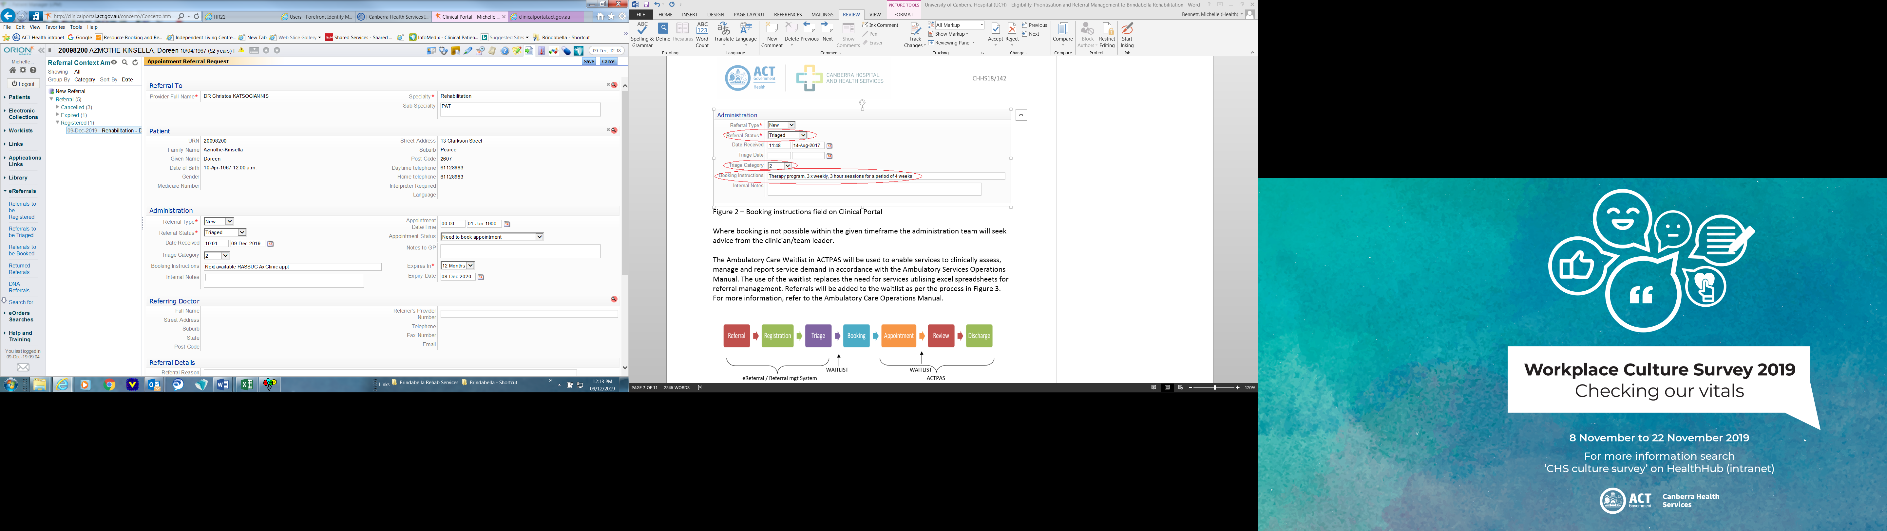
Figure 2 – Booking instructions field on Clinical Portal

The Ambulatory Care Waitlist in ACTPAS will be used to enable services to clinically assess, manage and report service demand in accordance with the Ambulatory Services Operations Manual. Referrals will be added to the waitlist as per the process in Figure 3. For more information, refer to the Ambulatory Care Operations Manual.

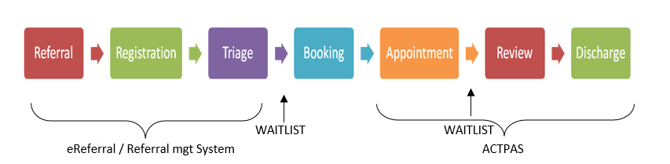
Figure 3 – Ambulatory Care ACTPAS Waitlist process

Back to Table of Contents

Section 7 – Appointments

The UCH booking and scheduling team will make appointments in ACTPAS based on the triage and booking instructions provided by the PAT/triaging clinician. Appropriate Medicare eligibility screening and addition of Medicare Benefits Schedule (MBS) codes to ACTPAS for specialist appointments will occur in line with the Ambulatory Services Operations Manual.

Patients will receive a phone call from the booking and scheduling team to book initial appointments and will also receive a confirmation letter and a reminder letter if required by the patient. For appointments booked within a two week timeframe letters will not be issued and patients will receive a phone call or email only. An SMS reminder will also be sent for all appointments where a mobile phone number is available.

On arrival, patients will either use the InTouch Flow Manager system to check in, or present to reception. Patients will be directed to the sub waiting area which is where they will be met by the clinician for their consultation. Clinicians will require access to the InTouch Flow Manager system to see arrivals of patients and register consultation data as per the InTouch Flow manager system operational requirements.

At the end of each consultation, clinicians will advise the patient of booking instructions for any follow up appointments required to be booked via InTouch Flow manager system or via a booking slip for Brindabella Day patients or other services as per local business rules. Follow up appointments will be made by the UCH Brindabella Rehabilitation Services reception team. For medical specialists, the Medicare item number should also be ticked to ensure accuracy of billing. Booking slips will be stocked in psychology clinic rooms and the Brindabella Gym.

For arrival/admission of day patients, refer to CHS Admission to Discharge Procedure.

Back to Table of Contents

Section 8 – Discharging/closing referrals

Referrals will be closed in ACTPAS by UCH administration staff upon this advice communicated via InTouch Flow Manager, or a booking slip for services who utilise these; or by each clinical service once all appropriate discharge paperwork has been completed.

For discharge of admitted day patients, refer to CHS Admission to Discharge Procedure.

Back to Table of Contents

Evaluation

Outcome
- Referrals are processed within appropriate timeframes.
- There are no significant incidents related to referral management.
- There will be a reduction in consumer complaints related to access and referral management.

Measures
- Reporting of referrals received and clinical activity
- Consumer feedback
- Monitoring of incident data.

Back to Table of Contents

Related Policies, Procedures, Guidelines and Legislation

Policies
- Consent and Treatment Policy

Procedures
- UCH Aquatic Physiotherapy Referral, Assessment and Service Delivery Procedure
- Patient Identification and Procedure Matching Procedure
- Rehabilitation at Home (RAH) Eligibility and Prioritisation Procedure
- Admission to Discharge Procedure
- UCH Patient Eligibility and Admission Criteria and Process Procedure
- Rehabilitation Psychology and Counselling Services Procedure

Guidelines
- Ambulatory Services Operations Manual

Legislation
- Health Professionals Act 2004
- Workplace Privacy Act 2011
- Health Records Act 2001
- Health Records (Privacy and Access) Act 1997
- Human Rights Act 2004
- Work Health and Safety Act 2011

Back to Table of Contents

Definition of Terms

Day patient - Refers to patients who meet the eligibility criteria as set out in the model of care for day admission to the therapy program.

Back to Table of Contents

Search Terms

Brindabella, BRS, CRT, UCH, UCPH, Referrals, Triage, Hydrotherapy, Aquatic, Physiotherapy,
Rehabilitation

Back to Table of Contents

Attachments

Attachment 1: General Referral Intake Process

Disclaimer: This document has been developed by Canberra Health Services specifically for its own use. Use of this document and any reliance on the information contained therein by any third party is at his or her own risk and Canberra Health Services assumes no responsibility whatsoever.

Policy Team ONLY to complete the following:
Date Amended | Section Amended | Divisional Approval | Final Approval
15/07/2020 | Complete Review | Linda Kohlhagen, ED RACS | CHS Policy Committee

This document supersedes the following:
Document Number | Document Name
CHHS18/142 | University of Canberra Hospital (UCH) - Eligibility, Prioritisation and Referral Management to Brindabella Rehabilitation Operational Guideline

Attachment 1 – General Referral Intake Process

