Procedure | Canberra Health Services

Providing Care After Death
CHS25/034
Contents
Purpose 3
Alerts 3
Scope 4
Section 1 – Verification of Death 4
Section 2 – Notification of death 6
Section 3- Viewing of the Deceased at Canberra Hospital and NCH 8
Section 4 - Documentation 10
Section 5- Care of the deceased and their Next of Kin/Family 12
Section 6- Transfer of the Deceased to the Mortuary 15
Section 7- Ritual Washing 18
Section 8- Releasing a deceased person from Mortuary 19
Section 8- Special Circumstances 21
Section 9- Coronial Matters 32
Evaluation 40
Related policies, procedures, guidelines and legislation 40
References 42
Definition of terms 42
Search terms 44
Attachments 44
Attachment A: When Death Occurs Inpatient Flowchart 46
Attachment B: When Death Occurs Community Flowchart 47
Attachment C: Coronial Criteria- Coroner’s Act 1997 Section 13(1) 48
Attachment D: Preparation of Deceased and Transfer to Mortuary 49
Attachment E: COVID-19 Infection Contained Herein Signage 52
Attachment F: Self-Assessment Tool: Verification of Death in the absence of Medical Officer CHS 53
Attachment G: Verification of Death Certificate 55
Attachment H: Sign to be placed and used for exposure to infectious diseases 56
Attachment I-Staff Options- Interaction with ACT policing following a Coronial death 57
Attachment J: Backup Plan Mortuary Register 59
Attachment K: No Identified Next of Kin form 60
Attachment L: Deceased Person with no next of kin flowchart 61
Attachment M: Acceptable Funeral Transfer Authorities 62
Attachment N: UCH Body Holding Register 65
Attachment O: NCH Mortuary Transfer for Long Term Storage Form 66

Purpose
This procedure outlines the steps to follow after the death of a patient who is in the care of Canberra Health Services (CHS) Network. It includes information for staff on coronial deaths, and noncoronial deaths processes.
This procedure supports CHS staff to:
- Ensure the appropriate processes are followed for notifying a death to the relevant parties
- Ensure documentation is completed appropriately, and
- Provide appropriate care for the deceased and their family/carers.
An overview of the process to follow after death of an inpatient can be found in the Flowchart at Attachment A and for death in the community setting at Attachment B.
Back to Contents

Alerts
The Coroners Act 1997 imposes a responsibility on all CHS staff to inform the ACT Policing Coroners team of a death if it meets the Coronial Criteria or if there are reasonable grounds to believe the death is one that a Coroner would have jurisdiction to hold an inquest about, and which has not previously been reported.
The Medical Officers (MO) must refer a death to the Coroner if it meets any of the criteria outlined in Section 13 of the Coroners Act 1997; see Attachment C.
It is an offence under the Coroners Act 1997 for a MO to provide a certificate of death if the death of the person is to be referred to the Coroner for investigation or they will receive/expect to receive property or financial benefit from the death.
Staff can contact the ACT Policing Coroner’s Team 24/7 at 0413 009 547 or through ACT Policing Operations at 131 444 for clarification regarding the procedure related to a specific death and any possible Coroner’s notification. It is recommended to seek guidance before taking further action.
The Coroners Act 1997 also states that all deaths that occur in custody or in care must be referred to the Coroner.
- Death in custody refers to a person in the care of a custodial officer (including ACT Policing, Corrections and Mental Health Officers) or at a correctional centre of detention place as defined in Section 3C and 3D Death Coroners Act 1997.
- Death in care refers to a person in the care of a custodial officer subject to an order under Mental Health Act 2015 or Crimes Act 1900 Section 309 as defined in Section 3BB Death Coroners Act 1997.

Under the Crimes Act 1900 a person who
(a) indecently interferes with any dead human body; or
(b) improperly interferes with, or offers any indignity to, any dead human body or human remains (whether buried or not).
is guilty of an offence punishable, on conviction, by imprisonment for 2 years.
Back to Contents

Scope
This procedure applies to the CHS Network staff involved in the care of deceased patients within the CHS network. CHS Network includes the inpatient facilities at Canberra Hospital, Clare Holland House, North Canberra Hospital, and University of Canberra Hospital, community-based services .
This procedure also supports registered nurses and registered midwives in the community setting to verify death across all practice settings except the Division of Mental Health, Justice Health Alcohol and Drugs.
This procedure also outlines circumstances which require consultation and alternative processes to be followed. This includes management of:
- Deaths in the community setting
- Non-coronial post mortems
- Perinatal deaths
- Patients with infectious diseases
- Patients who were treated with radioactive substances
- Bariatric and tall stature patients.
- Deceased person with no money or assets.
- Deceased person with no next of kin.
- Long term storage of a deceased.
Back to Contents

Section 1 – Verification of Death

Verification of death is a clinical or radiological assessment to establish a patient has died. Certification of death is when a medical officer documents a cause of death of the patient, this can only occur if the patient’s death is not being referred to the Coroner.

Assessment of the extinction of life and verification of death

It is the MO’s responsibility to certify death (except in coroner’s cases) and complete the associated documentation. If an MO is not present when a patient dies, a Registered Nurse (RN) may make a clinical assessment of the extinction of life and document this in the patient’s clinical record. Staff must then contact an MO as soon as practicable to certify death.

It is the MO’s documentation of date and time of death that will be used when registering the death on Digital Health Record (DHR).

Registered Nurses (RNs) may verify death (but not certify death) for patients they provide care to who are known to:
- ACT Palliative Care Services patients living in the community
- Hospital in the Home (HITH) patients living in the community
- Community nursing patients receiving palliative care and living in the community
For the purposes of this exception, RNs are solely defined as Registered Nurses working within the following teams:
- Specialist Palliative Care Consultation and Liaison Service Team
- Community Care Service including the LINK team
- Hospital in the Home (HITH) Team
- Community Specialist Palliative Care Service (CSPCS)
- Clare Holland House (CHH)
- Voluntary Assisted Dying Care Navigator Service (VAD CNS).

Clinical procedure for verifying death
Death is to be verified by demonstrating all of the following:
- No palpable carotid pulse (for infants or neonates femoral or radial pulse), and
- No heart sounds heard for two minutes, and
- No breath sounds heard for two minutes, and
- Fixed and dilated pupils.
In situations where the person has been deceased for some time (as evidenced by rigor mortis, dependent lividity or tissue decomposition) the death is considered obvious, and no clinical assessment is required.
It is the MO/General Practitioner’s (GP’s) responsibility to certify the death of a palliative patient in the community and complete the associated documentation, see Section 8: Special Circumstances- Deaths in the community setting.

Deceased Person Checklist
The Deceased Patient Navigator in the DHR must be completed for all deaths in an inpatient setting at CHS. When MOs verifies death, they must complete the Deceased Person Checklist available in the Deceased Person Navigator in the DHR to assist with determining whether to make a coronial referral.
The MO must check the clinical notes and Clinical Records Systems (e.g. DHR) regarding administrative alerts and warnings about patients. These alerts should be checked when deciding whether to refer to the ACT Policing Coroner’s Team. For example, a patient under a Mental Health Order who dies must be referred to the ACT Policing Coroner’s Team. Refer to Attachment C for Coronial Criteria.
At CHH, the MO completes the Deceased Patient Navigator in the DHR, but does not need to make further referral to Coroner's Team
Nursing and Allied Health staff are to complete the After Death Checklist as part of the Comfort Care Plan available on DHR.
For deaths in the community setting refer to Section 8- Special Circumstances.
Back to Contents

Section 2 – Notification of death

Notifying the DonateLife ACT (DL ACT)
DonateLife ACT and CHS are committed to respecting patient choices about their end-of-life care (EOLC). Patients notified to DL ACT before they have died may become organ donors after death has occurred.
Staff in critical care areas are to notify DL ACT of any patients where EOLC has been discussed or commenced. Notifications are made to the on-call Donation Specialist Nursing Coordinators (DSNCs) via the Canberra Hospital Switchboard (5124 0000), 24 hours a day, seven days a week.
DSNCs are informed of all deaths that occur across CHS via an automated notification in the DHR. Patient’s wishes around tissue donation and medical suitability are reviewed at that time. Timely notification of a person’s death in the DHR as well as an uploaded death certificate are necessary to facilitate eye tissue donation. More information is available in the Organ and Tissue Donation procedure available on the Policy and Guidance Documents Register.

Notifying the Coroner
Note: The below information does not relate to CHH
If any of the answers to question 1 – 6 on the Deceased Patient Navigator Checklist (detailed in Section 3) are “Yes”, the MO must notify the ACT Policing Coroner’s Team as soon as practicable after pronouncing death. Staff should then follow the process as per Section 9 - Coronial Matters.
Any staff member who feels it necessary (or is not sure) may also notify a death to the ACT Policing Coroner’s Team. Attachment C outlines the Coronial Criteria.
Staff can contact the ACT Policing Coroner’s Team 24/7 at 0413 009 547 or through ACT Policing Operations at 131 444.
A reportable coronial death does not exclude the possibility of organ and tissue donation. DLACT will contact the Coroner’s Team to discuss.
If all the answers to questions 1 – 6 on the Deceased Patient Navigator are “No”, the Coroner does not require notification, and staff should continue to follow Sections 3-7 of this procedure.
In circumstances where a patient previously marked as coroners has changed to non-coroners the MO must update the DHR to reflect the new status.

Notifying the next of kin
The next of kin (NOK) must be notified in a sensitive and timely manner by the MO or nursing/midwifery staff, and the discussion documented in the deceased person’s clinical record. This applies even if the deceased person had a substitute decision maker, such as Public Trustee and Guardian (PTG).
If the next of kin cannot be located, staff can inform ACT Policing (131 444) who will attempt to locate them. When the next of kin and/or family/carer arrive, staff will provide support and clear communication of what has happened and what will happen next.
Social work and Aboriginal Liaison Office provide support to families/carers after death including navigating next steps, bereavement follow up and viewings. Within MHJHADS, health professionals and psychologists can also provide this follow up support, and referrals.
Spiritual Support Services may be contacted on 5124 3849 during business hours (8am to 4pm Monday to Friday). The Pastoral and Spiritual Care Department at NCH can be contacted 24 hours a day via Switchboard on 6201 6111.

Notifying the General Practitioner (GP) – Canberra Hospital
The GP Liaison Unit will notify the death of a patient to the GP identified in patient’s clinical record during usual business hours. However, no clinical information is to be provided. A discharge summary is to be completed by the MO within 48 hours as per the Discharge Summary Completion-Inpatients procedure. If a discharge summary has not been completed or finalised, the MO receives a notification in the DHR to advise them to complete or finalise a discharge summary for the episode.

Notifying the GP – NCH
NCH Health Information Services (HIS) notify the patient’s GP once they run the Deceased reports, and/or receive the paperwork. They put an administrative flag in the DHR to indicate that GP has been notified. CHH do their own notifications to GPs.
A discharge summary is to be completed by the MO within 48 hours as per the Discharge Summary Completion-Inpatients procedure. If a discharge summary has not been completed or finalised, the MO receives a notification in the DHR to advise them to complete or finalise a discharge summary for the episode. Episodes with no discharge summary, or an incomplete discharge summary appear on a work queue that is monitored and actioned by NCH HIS Monday to Friday (excluding public holidays).

Patients who live in Residential Aged Care Facilities
If the patient lives in a Residential Aged Care Facility the MO or nursing staff are to notify the NOK/family/carer/RACF of the death during usual business hours. However, no clinical information is to be provided.

Release of information to the public
CHS staff must not release any information concerning the deceased person or the deceased person’s medical condition without consent from the deceased’s legal representative or if there is no legal representative, an immediate family member of the deceased. This is because the deceased person’s family must be made aware of all clinical information relating to the deceased prior to the information being made available for public release. Premature reporting can cause significant emotional distress, anger or the perception that the family’s interests have been ignored by authorities.
For NCH patients, the legal representative must contact NCH HIS to request copies of clinical records.

Section 3- Viewing of the Deceased at Canberra Hospital and NCH
Staff must ask the family/carer (if not already present) whether they would like to spend time with and view the deceased person. The timing of the transfer of the deceased person (see Section 6-Transfer) to the Mortuary should be accounted for and explained to facilitate the viewing. Viewings are not to be conducted on:
- Coroners cases without permission from ACT Policing, due to chain of custody and preservation of evidence.
- Covid-19 positive and List B infectious deceased (refer to Section 8 – Special Circumstances – Infectious Diseases) due to infection control protocols.

If the deceased person has been transferred to the Mortuary and the family/carer wanting to view the deceased:

For viewing of deceased patients at Canberra Hospital during Business Hours
The Canberra Hospital Mortuary standard operating hours are Monday to Friday 8am to 4pm. Mortuary staff require a minimum of 30 minutes notice for all deceased viewings. The family/carer should contact Social Work or be put through to Social Work, who will co-ordinate the visit of the family with the Mortuary staff and be present at the viewing to support the family.
- Social Work staff will contact the Mortuary staff on 5124 2116 to inform them when the family would like to view the body and who the family are coming to view (the name, Date of birth and unit record number (URN) of the deceased).
- The Mortuary staff will prepare the deceased person for viewing and move the deceased person to the viewing room.
- Social Work staff will arrange with the family/carer the details of the viewing, including time and meeting place. The family should be directed to the outside entrance to the Mortuary which is situated opposite the entrance to The National Capital Private Hospital and is signed “Relatives Room”.
- Social Work staff will remain with the family/carer during the viewing to facilitate the process and provide bereavement support.

For viewing of deceased patients at Canberra Hospital- Out of Office Hours
- Contact the After-Hours Hospital Manager( AHHM)
- Nursing staff and a wardsperson will prepare the deceased for viewing.
- The AHHM will meet the family/carer and be present with them during the viewing.
Note: After hours Social Work is also available until 9.30pm every day of the week if the family would like to be referred for bereavement support.

For Deceased Patients at NCH
Viewings are held in the hospital Viewing Room located next to the Mortuary. If a request is made during working hours, the Nurse/Midwife receiving a request should notify the Pastoral and Spiritual Care Department. After hours, the AHHM should be notified.

For viewing of deceased patients at NCH during Business Hours
- The Pastoral and Spiritual Care Practitioner should notify the Operations Manager – Ward Services of the request and the time of the viewing.
- The Operations Manager – Ward Services and two staff members, who may be nurses/midwives or Pastoral Carers, attend the Mortuary to prepare the viewing room and the body of the deceased.
- The deceased patient is to be draped with a sheet and a quilt in preparation for the viewing. Standard infection control precautions must continue to be adhered to - if prior to death there were requirements for additional precautions, these must also be continued in preparing a patient for viewing.
- All preparations of the deceased person should be completed prior to taking family members/carer to the viewing room.
- The Pastoral and Spiritual Care Practitioner will prepare the viewing room prior to arrival of family/carer (e.g. placement of religious symbols if requested or appropriate, candles, flowers and provision of tissues and water).
- The Pastoral and Spiritual Care Practitioner will inform the family/carer about what to expect when seeing the deceased person for the first time and will remain either in or in close proximity to the room for the duration of the viewing in order provide assistance.
- At the conclusion of the viewing the staff member will notify the Operations Manager – Ward Services (business hours) that the viewing has been completed.
- The Operations Manager – Ward Services or Ward Support Officer will move the deceased person from the viewing room to the Mortuary cooling room.

For viewing of deceased patients at NCH- Out of Office Hours
- Contact the After-Hours Hospital Manager( AHHM)
- Nursing staff and wardsperson will prepare the deceased for viewing.
- The AHHM will meet the family/carer and be present with them during the viewing.
- At the conclusion of the viewing the staff member will notify the ward support officer that the viewing has been completed.
- The Ward Support Officer will move the deceased person from the viewing room to the Mortuary cooling room.
Back to Contents

Section 4 - Documentation

Adult and Children Death Certification – Medical Certificate of Cause of Death
Once the MO determines the deceased person is not a Coronial case, they must ensure the Medical Certificate of Cause of Death form is completed in a timely manner. This form is available on all wards and is a carbon copy form that is completed in triplicate.
- The white copy (original) will be sent to Births, Deaths and Marriages by Health Information Services (HIS) staff,
- The green copy is the release form to be given to the collecting funeral director and
- The blue copy is scanned into the patient’s clinical record in DHR. The cause of death should be noted according to the Births Deaths and Marriages Practice Manual and the Information Paper – Cause of Death Certification (Reference: Australian Bureau of Statistics).
The Deceased Patient Navigator must also be completed by the MO declaring the death and the Cremation Safety Checklist must also be completed to alert Mortuary staff and Funeral Home staff to the presence of any implants in the deceased.
At Canberra Hospital a scanned copy of the Medical Certificate of Cause of Death must be provided to Mortuary staff so the body can be released to the collecting funeral home staff. HIS will email a scanned copy through to the Mortuary staff once they have received it.
At CHH the team leader is responsible for the administrative management of the Body Holding register, this is completed in the patient’s Clinical Record. Sufficient hard copies of the Body Holding Register will be available within an A3 folder in the Body Holding Room. The Green copy is stored in the Body Holding Room. At the end of the calendar year an official file will be ordered (as per the Administrative Records Management Policy) from Records Management to store the completed pages of the Register.
At NCH the ward clerk takes the full copy of the death certificate to the Patient Flow Unit (PFU) for entry by the medical records team. Once received and checked by the HIS Manager for completeness and accuracy, they are scanned into the DHR if they have not been scanned already. The funeral directors then collect the form from HIS.
At UCH the Green copy must be retained at UCH until the release of the deceased person. The UCH Assistant Director of Nursing (ADON) is responsible for the administrative management of the Body Holding Register, document template found in Attachment N.

Perinatal Death Certification - Medical Certificate of Cause of Perinatal Death
For CHS Perinatal deaths from greater than 20 weeks gestation, or less than 20 weeks gestation with signs of life, or greater than 400g if gestation unknown until 28 days post-delivery should be managed in accordance with the Neonatal Death, Bereavement, Palliative Care and Borderline of Viability Clinical Guideline. For NCH refer to Care of Families Experiencing Perinatal Loss at Greater than 20 Weeks -North Canberra Hospital procedure and Care of Families Experiencing Loss at Less than 20 weeks -North Canberra Hospital Procedure available on the Policy and Guidance Documents Register

Documentation
Timely documentation of all essential information will ensure that the process of releasing the deceased person occurs as soon as possible. Documentation must include the following:
- Progress notes of the events leading up to and after the death, including discussions with relatives
- any valuables noted
- any spiritual/cultural considerations when managing the deceased person. When it is identified that the patient is dying the Comfort Care Goals of Care should be utilised in the DHR to document care leading up to and after the death of the person. Comfort Care Pathway includes a Nursing Checklist for completion by nursing staff after the patient’s death
- completion of all section of the Deceased Patient Navigator in the DHR. In particular the date and time of death; this will trigger a notification to multiple teams and also cancel any future appointments.
- Cremation Safety Checklist – MO should complete the Cremation Safety Checklist form digitally; this allows the family to organise cremation of the deceased person and timely release of the deceased to a funeral home. Completion of Cremation Safety Checklist also alerts Mortuary staff and Funeral Home staff to the presence of any implants in the deceased. At Canberra Hospital the Mortuary staff will print the Cremation Safety Checklist and provide a copy to the funeral home. At NCH HIS will print the Cremation Safety Checklist and provide a copy to the funeral home when they come to pick up the body of the deceased.
Note: For deaths that are referred to the Coroner, the Medical Certificate of Cause of Death should not be completed. Refer to Section 9, Coronial Matters.
In cases of organ donations in critical care areas, forms that certify death such as Death on a Ventilator or Declaration of Brain Death may be completed by the treating team.
Back to Contents

Section 5- Care of the deceased and their Next of Kin/Family
Note: Refer to Attachment D for a summary of actions to prepare the deceased person and transfer them to the mortuary.
It is important that the dignity of the deceased patient is maintained at all times. CHS staff can maintain the dignity of the deceased patient by:
- Discussing any religious and cultural needs with the next of kin/family/carer including if there is a requirement for ritual washing, ritual at the bedside or within the relevant spaces within Mortuaries.
- Continuing to use caring and gentle touch when handling and transporting the patient, ask if there is any cultural considerations (such as male or female only touch)
- Seeking permission from the family/carer prior to performing any procedure or moving the deceased person
- If the death is not a Coronial matter, informing the family/carer that they and/or CHS staff can dress the patient in clothes of their choice before transfer to the mortuary and to the funeral home. If the family/carer have not provided clothing, the patient must be dressed in a disposable hospital gown. Paper gowns /yellow gowns are not to be used to dress deceased patients.
- Continence pants should be put on the patient to minimise urinal and faecal leakage.
- Aboriginal Liaison Service provides dreaming quits to Aboriginal and Torres Strait Islander patients
- If the death is not a Coronial matter, informing the parents of deceased neonates, that they can bath the baby, and mementos (footprints, hair lock, photos) can be arranged by the staff for the family/carer (with consent of the most senior NOK and paediatric patients (with parent consent). Mortuary staff at Canberra Hospital can do hand & footprints and cut locks of hair if requested by NOK. Supplies for legacy making are available in the ward Comfort Care Case or in the Comfort Care Cupboard on Ward 11B.’Holding Hearts’ and ‘Holding Crosses’ are available at Canberra Hospital through Spiritual Support Services. At NCH Birth Suite Staff deal with mementos for deceased neonates.
- Informing the family/carer that any valuables being worn by the deceased person can remain on their person. Any item remaining on the patient should be noted on the deceased person’s tag and in the nursing documentation section in the patient’s deceased navigator by the accompanying nurse at the time the person is transferred to the Mortuary. Any other valuables and personal effects belonging to the deceased person should be placed into a Comfort Care designated Patient Valuables bag and handed over to family members. Comfort Care designated Patient Valuables bags are available at the following locations:
- Canberra Hospital - on the ward or from the Comfort Care at End of Life cupboard in the 11B meeting room
- CHH – Treatment Room
- NCH – locked in the hospital safe
- UCH – all possessions are stored in the Locker facility Safe monitored by the UCH Security Team
- The personal effects and who they were handed to must be documented in the patient’s clinical record. If there is no next of kin or family/carer present, the belongings should be transferred along with the deceased person to the Mortuary The mortuary manager check off the personal effects when releasing the deceased to the Funeral Home.
- Family members/carer are encouraged to say their goodbyes before the deceased leaves the room.
- Informing family members/carer, they are welcome to view their loved one at any time by contacting Social Work (at Canberra Hospital), or by contacting the Pastoral and Spiritual Care Department (at NCH).
Note: There are times when a family member/carer may wish to go with the deceased patient to the Mortuary. This is not recommended and can only occur at Canberra Hospital and NCH.

At Canberra Hospital the Mortuary staff MUST be notified prior to any family/carer being escorted down in case there are any postmortem procedures taking place within the Mortuary. When family members/carer are accompanying a deceased patient to the Canberra Hospital Mortuary, please use the internal entrance.
- The patient’s treating team should check if there are any special circumstances as per Sections 6-8 which may impact on the care of the deceased and their family. The treating consultant can delegate the care of the deceased to an MO or nurse/midwife in the clinical area in which the deceased died. The treating team or palliative care team should liaise with the patient prior to death (wherever possible) and their family/carer to sensitively discuss spiritual, personal, and cultural preferences for the care of the deceased. Document these discussions and wishes in the clinical record.
- If the patient has an Advance Care Plan in place, staff must ensure to follow the wishes of the patient wherever possible. Staff should not begin preparation of the deceased person without prior discussion with the family/carer. All efforts should be made to uphold the preferences for the care of the deceased unless a referral has been made to the Coroner.
- If a patient has been referred to the Coroner, staff should discuss the families cultural, spiritual and personal requests with the ACT Policing Coroner’s Team. If the ACT Policing Coroner’s Team advises requests are unable to be performed because of their investigation requirements, then the family should be sensitively informed.
- All organ donation cases will have a DSNCs responsible to provide donor management and retrieval coordination along with continual family support throughout the donation pathway.
- Just prior to death, or at the time of death, the care team should ensure that all families/carer are provided with a Bereavement Booklet, When Someone Dies, which is available on the ward, or from Social Work or the Pastoral or Spiritual Care Service and/or ALO for support.
- Families/carer should be asked if they have an understanding of the process that next occurs. If family members/carer are unsure, the care team are to offer a referral to Social Work and/or ALO for support.
- During business hours 8.30am – 4.30pm Mon-Fri Canberra Hospital Social Work can be contacted on 5124 2316 or via switch board and Spiritual Support Services can be contacted on 5124 3849 during business hours (8am to 4pm Mon to Fri).
- NCH Pastoral and Spiritual Care and Social Work and Psychology can be contacted via the Hospital Switchboard on 6201 6111.
- ALO service during business hours on: Canberra Hospital - 5124 2055 and NCH and CHH – 6264 7097.
- Family/carer may view and spend time with the deceased person refer to section Limitations on Ritual Practices for Deceased Patients in Critical and Non-Critical Wards.
- Provide access to a quiet room and/or area for the next of kin and family.

Bereavement Support
The Volunteer Manager, Cancer and Ambulatory Services sends out a Bereavement card to the NOK to all patients who have died in the CHS inpatient settings two weeks after the death and bereavement support information three months after the death, unless there are other specific processes in place for bereavement support (e.g. paediatric, fetal or neonatal deaths).
Palliative Care ACT send out Bereavement card approximately one month after death and again at 3 months after death for all deaths that occur as an inpatient at CHH.
Where a staff member i.e. social worker / pastoral carer / spiritual care practitioner has an ongoing relationship with a family/carer a post death bereavement call may be made to the family member/carer. Where there has been no relationship, a bereavement call should not be made unless requested by the family/carer or staff. In some circumstances Social Work also follow up with a family post death particularly in Emergency Department and offer families an opportunity to meet with the treating team post death if they have any questions or things clarified.
Back to Contents

Section 6- Transfer of the Deceased to the Mortuary
Refer to Attachment D for a summary of actions to prepare the deceased person and transfer them to the mortuary.
Note:
- Where possible the deceased person is to be transferred to the Mortuary via staff only corridors and lifts and not through public thoroughfares.
- If deceased person is suspected or known to have been exposed to an infectious disease additional precautions apply see table in Section 8

Limitations on Ritual Practices for Deceased Patients in Critical and Non-Critical Wards
To ensure the respectful facilitation of religious rituals while maintaining operational efficiency, Canberra Hospital has set specific limitations for handling deceased patients in both critical and non-critical wards. These limitations address the need for timely bed turnover in critical areas and provide a balanced approach to performing rituals at the bedside in non-critical wards. The following points outline the restrictions and considerations for each setting.

- Critical Wards: In critical areas like the Emergency Department, where bed turnover is essential, deceased patients should be moved immediately to the mortuary for rituals.
If NOK/Family of a deceased patient have requested time to perform religious rituals, the Mortuary must be contacted as soon as possible.
Social Work should be contacted to arrange time in the mortuary as if it were a viewing of the deceased (outlined at Section 3). Spiritual Support Services can provide connection to religious leaders and community partners. If this is required, please contact Spiritual Support Services (02) 51243849 (Canberra Hospital) and at NCH via Switchboard on 6201 6111.
- Non-Critical Wards: In non-critical wards, rituals can be performed at the bedside with a maximum duration of nine hours.

These limitations aims to balance the need for operational efficiency with the respectful facilitation of religious practices.

Routine/Non-Coronial Deaths
- Plastic identification bands (ID) bands must be placed on the deceased patient’s wrist and an ankle. Do not use the paper ID bands as they are easily damaged by fluids. For care and respect of the deceased do not attach the label with cable ties, use a soft cloth material. Plastic ID labels are available from the Mortuary. Each label must have:
  - Patient sticker or deceased’s full name, date of birth and URN
  - Date and time of death
  - Ward
  - Valuables – yes or no
  - Signature of the Nurse
- The patient is to be dressed in the chosen clothing. Continence pants should be put on the deceased prior to dressing. If the family have not provided clothing the deceased must be dressed in a disposable hospital gown.
- The patient is to be placed in an appropriately sized body bag. Adult, Bariatric, Teen, and Infant body bags can be ordered through Purchasing and Inventory Control System (PICS). If the deceased is suspected of or known to have an infectious disease listed in Section 8 the label at Attachment H must also be attached to the body bag.
- An external ID tag must be attached to the outside of the body bag; this must be visible to all Staff. The ID tag must contain:
  - Patient sticker or deceased’s full name, date of birth and URN
  - Date and time of death
  - Ward
  - Valuables – yes or no
  - Signature of the Nurse

For non-coronial deaths- Canberra Hospital
A Ward person and a unit nurse/midwife transfer and escort the deceased person to the hospital Mortuary. This nurse may be a DSNC in organ donation cases. As a standard rule family/relatives are not permitted to accompany the deceased to the mortuary as it is a restricted area, but exceptions may be made for certain situations. The Mortuary staff MUST be phoned (5124 2116) to discuss any special requests.
The accompanying nurse is responsible for completing the Ward to Morgue transfer record in the deceased clinical record in DHR and at Canberra Hospital recording the deceased’s surname onto the mortuary whiteboard.

For non-coronial deaths- North Canberra Hospital
A Ward person and a unit nurse/midwife transfer and escort the deceased person to the hospital Mortuary. This nurse may be a DSNC in organ donation cases. The accompanying nurse is responsible for completing the Ward to Morgue transfer record in the deceased clinical record in DHR and at Canberra Hospital recording the deceased’s surname onto the mortuary whiteboard.
The transport staff are responsible for placing the deceased onto an appropriately sized tray and placing the deceased into the cool room.

Death of a known ACT Palliative Care Services patient living in the community,
Following the death of a known ACT Palliative Care Services patient living in the community, the family will arrange for transfer and/or release of the deceased person to the Funeral Director or other designated person/s.

Transport of a deceased person to the UCH Body Holding Room
- The Team Leader/Registered Nurse or Enrolled Nurse on the UCH Ward must contact the After Hours Hospital Manager (AHHM)/CNC or ADON (Nurse in Charge) to inform them that a person is deceased
- The Nurse in Charge will then contact the UCH Help Desk and request a “deceased person transport”
- A BGIS staff member will collect the body transfer trolley and attend the required location
- Once the body has been transferred to the trolley and trolley cover is in place, the nurse accompanies the BGIS staff member to the Body Holding Room
- The body is transferred into one of the body holding drawers
- The nurse must complete the body holding register (Attachment L) located on the desk in the Body Holding Room, including documenting any valuables transported with the deceased person
- The nurse must note any infectious diseases according to the procedure set out in Section 8, subsection Infectious Diseases
- BGIS staff clean the Body Transfer Trolley and return the trolley to storage.
Back to Contents

Section 7- Ritual Washing
For some religions it is a requirement that the body of a deceased person is ritually washed and shrouded before burial, and as soon as possible after death.
Ritual washing/s are not permitted on deceased patients with whom are suspected of or confirmed positive with a List A or B type disease.
Ritual washing is unable to occur for deaths referred to the Coroner. The MO should inform the family/carer of this when notifying them the death has been referred to the Coroner and the ACT Policing Coroner’s Team should be made aware of the family’s request for ritual washing.

For inpatients
Ritual Washing is not facilitated at UCH and CHH. Where this is required, arrangements should be made with the accepting Funeral Director. Please contact Spiritual Support Services for advice (02) 51243849. For NCH contact Pastoral and Spiritual Care Department (via switch board 6201 6111)
Ritual washing is performed on Canberra Hospital/NCH premises by religious representatives who are appointed by their faith group and appropriately credentialled by CHS. The process of ritual washing and shrouding can take up to 2 hours. For Ritual washing please refer to:
- CHS procedure Ritual Washings of patients
- NCH – Ritual Washing Guideline

For Palliative Care patients in the Community
Following the death of a known ACT Palliative Care Services patient living in the community the family will need to arrange for ritual washing to occur in the patient’s home or a Funeral Home.
Back to Contents

Section 8- Releasing a deceased person from Mortuary

Releasing a deceased person from the Canberra Hospital Mortuary
Only CHS authorised staff are permitted to release a deceased person from the Canberra Hospital Mortuary. CHS authorised staff include:
- Mortuary Staff
- Director of Nursing (DON)/Director of Midwifery (DOM)
- ADON/ADOM
- After-Hours Nursing Shift Managers
A deceased person (not including coroners deceased) is only cleared for release when the following has been done:
Medical Certificate of Cause of Death and the Cremation Safety Checklist are completed, and a signed Funeral Transfer Authority has been received (Refer to attachment M – Acceptable Funeral Transfer Authorities).
The Canberra Hospital authorised staff member will then:
- Liaise with the Funeral Home, Funeral Transfer Company, Authorised person, or ACT Policing Coroner’s Team regarding a suitable time to collect the deceased person.
- Meet the Funeral Home, Funeral Transfer Company, Authorised person, or ACT Policing Coroner’s Team representative at the Mortuary garage roller door.
- Check credentials of Funeral Home, Funeral Transfer Company, Authorised person, or ACT Policing Coroner’s Team representative.
- Complete the release section in the patient’s DHR - deceased navigator (this includes typing in the date and time of release, the name and signature of the person collecting the deceased, the name and signature of the person releasing the deceased and any valuables/ property that the deceased has on them).
- Using the hydraulic body trolley, remove the deceased from the Mortuary Cool Room, and check all ID tags on the deceased to ensure it is the correct patient.
- Assist with moving the deceased onto the transport trolley.
- Wipe down the empty body tray with hospital approved cleaning wipes.

Releasing a deceased person from NCH Mortuary
Only NCH authorised staff are permitted to release a deceased person from the North Canberra Hospital Mortuary. NCH authorised staff include:
- Director of Nursing Patient Flow
- Operations Manager – Ward Services
- After Hours Hospital Manager
- CNC Birth Suite for Neonatal
A deceased person (not including coroners deceased) is only cleared for release when the following has been done:
Medical Certificate of Cause of Death and the Cremation Safety Checklist are completed, and a signed Funeral Transfer Authority has been received (Refer to attachment M – Acceptable Funeral Transfer Authorities).

Process
- Funeral homes contact HIS to confirm if the deceased is ready for pick up
- HIS will confirm that they have all the paperwork ready, and also let funeral home know if deceased is a bariatric or infectious disease alert so that they can be prepared.
- Funeral home will indicate a date and time as to when they will arrive
- HIS record this information in the deceased person’s checklist
- HIS check credentials of Funeral Home, Funeral Transfer Company, Authorised person, or ACT Policing Coroner’s Team representative
- The funeral home staff will pick up the paperwork from HIS reception
- HIS staff will call the Operations Manager - Ward Services to advise that the funeral home staff are at the hospital mortuary to collect the deceased. Afterhours contact the AHHM
- HIS are to contact the Operations Manager - Ward Services. If they aren't available, then Patient Flow Officer Manager can be contacted
- Operations Manager Ward Support Services complete the release section in the patient’s DHR - deceased navigator (this includes typing in the date and time of release, the name and signature of the person collecting the deceased, the name and signature of the person releasing the deceased and any valuables/ property that the deceased has on them).
- Using the hydraulic body trolley, remove the deceased from the Mortuary Cool Room, and check all ID tags on the deceased to ensure it is the correct patient.
- Assist Funeral home staff with moving the deceased onto the transport trolley.
- Wipe down the empty body tray with hospital approved cleaning wipes.

Releasing a deceased person from the UCH Body Holding Room
Only authorised staff are permitted to release a deceased person from the UCH Body Holding Room. Authorised staff include:
- DON
- ADON
- AHHM
- CNC
Once a body has been cleared for release to a Funeral Home (i.e. Medical Certificate of Cause of Death and Deceased Patient Navigator are completed) or to the ACT Policing Coroner’s Team, the authorised staff member will:
- Liaise with the Funeral Home or ACT Policing Coroner’s Team regarding a suitable time to collect the deceased person
- Advise UCH Helpdesk of expected arrival time (if known) so BGIS staff can meet and escort the Funeral Home or ACT Policing Coroner’s Team representative to the Body Holding Room
- Meet the Funeral Home or ACT Policing Coroner’s Team representative at the Body Holding Room
- Check credentials of Funeral Home or ACT Policing Coroner’s Team representative
- Complete DON/ADON/CNC/AHHM section of the Body Holding Register
- Escort the Funeral Home or ACT Policing Coroner’s Team representative and deceased person to the transport vehicle.
Transport of a body from UCH may be undertaken by:
- The Funeral Home that will manage the funeral arrangements, or
- The Funeral Director contracted to provide service for Coroner’s Team in the case of a coronial enquiry.
BGIS staff will:
- Meet the Funeral Home or ACT Policing Coroner’s Team representative at the loading dock
- Escort the Funeral Home or ACT Policing Coroner’s Team representative to the Body Holding Room
- Assist transfer of the deceased person to the trolley and into the transport vehicle
- Accompany Funeral Home or ACT Policing Coroner’s Team representative and DON/ADON/CNC/AHHM to the transport vehicle.
Back to Contents

Section 8- Special Circumstances

Deaths in the community setting:
When attending a patient in the community, staff must first assess the situation by following basic life support principles. If there are any signs of life, contact ACT Ambulance Services and provide any known history that may assist.
Verification of death can be completed by an RN where the GP is not available. The body cannot be removed from the house until verification of death is completed. The death certificate and the cremation safety checklist are not needed to remove the body from the house. Registered Nurses’s (RN’s) who verify death must have completed the self-assessment tool at Attachment F and completed training before they are able to verify death.
It is recommended that for expected deaths in the community, the medical team has developed a plan for who will verify and certify death wherever possible. The patients GP should always be encouraged to attend post death to verify death and attend to death certificate / cremation safety checklist.
Where a death is obvious but unexpected, staff must contact ACT Policing by calling 131 444. The ACT Ambulance Service is unable to certify that life is extinct and will also contact ACT Policing in this instance.
Where the death in the community was an expected death, and this is known to the staff member who discovers the death, for example:
- Death follows on from a period of illness which has been identified as terminal
- Palliative care services are involved in the care
- When there is a formal agreement between the treating team and the family that there be no active intervention to prolong life.
- Death following administration of voluntary assisted dying substance in accordance with the Voluntary Assisted Dying Act 2024 (ACT).
In these instances, the staff member must contact the relevant MO/GP to attend in order to certify death.
Note: Registered Nurses* who provide care to known ACT Palliative Care Services patients living in the community may verify death for a palliative patient in the community. A MO/GP must still certify death.
*Specifically, Registered Nurses working within the following teams:
- Specialist Palliative Care Consultation and Liaison Service Team
- Community Nursing Team
- HITH
- CPCS and CHH
- VAD CNS.
Refer to Section 1 for details.
If there are any signs of life, contact the ACT Ambulance Services and provide any known history including Advance Care Planning information.
If the RN is not certain if the person is deceased, they should seek the opinion of a second health professional e.g. MO for HITH patient, or GP. It is reasonable for the attending RN to wait and repeat the above clinical assessments after a clinically appropriate time has elapsed. A second opinion may be sought from a qualified paramedic by calling an ambulance if necessary.
When verifying death, a RN will make a clinical assessment of the extinction of life and document this in the clinical record. RN must then contact the patient’s GP to certify death. It is the MO/GP’s responsibility to certify the death of a patient in the community and complete the associated documentation.
RN’s / registered midwives (RM’s) who are assessing and verifying death must use the Verification of Death Certificate (Attachment G). The original certificate is provided to the funeral director and a copy is saved in the patient’s clinical record.
- RNs should only verify death when the GP is not available to attend.
- RNs should not complete the verification of death unless there is a concrete plan for completion of the Death certificate and Cremation safety checklist. This plan should include:
  - the name of the doctor completing the certificate/checklist
  - the time frame for completion
- Death certificates must be completed within 48 hours of death. If this is not possible, please notify the coroner to discuss. In this situation, do not complete the verification of death without approval from the coroner’s office.
- RNs should not complete verification of death if there is any suggestion the death might be a coroner’s case. If unsure, discuss with relevant PCMO. See Attachment C for definition of the coronial criteria.
- If staff believe the death falls into any of the categories the matter must be discussed with the appropriate PCMO and the Coroners Court representative (i.e., the Coroner’s Offices at ACT Policing) as soon as possible.
The arrangements which follow (i.e. certifying death, contacting the Funeral Home) are the responsibility of the family and the MO/GP. Any assistance provided by CHS staff must not include moving or preparing the deceased person in any way until the MO/GP has confirmed they will complete a death certificate with cause of death.
Note: Even when death is expected (e.g., for a patient receiving palliative care), a referral to the Coroner may still be required where the death is due to an unrelated or unexpected event (e.g., due to a fall, overdose on medications etc.). All deaths of consumers on an order under the Mental Health Act 2015 must be referred to the Coroner, even if cause of death is known.
Note: Provided that the death of an eligible individual from VAD substance administration is in accordance with the Voluntary Assisted Dying Act, there is no need to report the eligible individual's ‘death in care’ or ‘death in custody’ (as defined in the Coroners Act) i.e. the ACT Policing Coroner’s team does not need to be notified.
Staff should document what occurred in relation to the death in the patient’s clinical record.
RN’s may at their discretion opt out of verifying death for a palliative patient in the community. In this instance they should contact an MO/GP who is willing and available to verify death for that patient.

Completion of Medical Certificate of Cause of Death Certificate
- Medical Certificate of Couse of Death certificate (hard copy) must be completed by a doctor. The doctor must either:
  - Know the patient (seen in previous six months)
  - Be from the same GP practice
The body does not have to be viewed to complete a death certificate
- Cremation Safety Checklist (in DHR, printed copy to be provided to funeral home) must be completed by a doctor who knows the patient and has viewed the body. This can be in the home or at the funeral home. If the patient is for cremation, please ensure the doctor writing the death certificate is aware. If they do not attend the home to view the body, they will have to attend the funeral home.

Other considerations
Staff should:
- contact the funeral director to let them know:
  - that the verification of death certificate is complete
  - if there are any known or suspected infectious diseases
  - if there are any implantable devices
  - if there are any considerations around organ donation
- Leave the original copy in the home for the funeral director and file the carbon copy in deceased clinical record.
An overview of the process to follow can be found in the Flowchart at Attachment B.

Post Mortem – non-coronial:
Information regarding the process can be found in the Adult Post Mortem Procedure (Non-coronial cases) or Perinatal and Paediatric Post Mortem Examinations and Retention of Body Tissue, with the associated forms located on the Clinical Forms Register. Informed consent must be obtained from the patient’s next of kin. The Canberra Hospital Mortuary must be contacted (5124 2116) to discuss the request with the relevant pathologist.

Perinatal deaths:
Where there is a question around the cause and nature of a perinatal death (see definition of terms), the nurse/midwife or Registrar should contact the on-call neonatologist and/or obstetrician, who will determine whether the coroner should be notified. The baby must have exhibited an objective sign of life once separated from the mother to be referred to the Coroner (i.e. breath, limb movement, pulse or pulseless electrical activity).
Note: At Canberra Hospital only any birth at less than 20 weeks gestation or when weight is less than 400 grams should be managed in accordance with Management of Termination of Pregnancy, Miscarriage or Fetal Death Clinical Guideline.
For NCH refer to Care of Families Experiencing Perinatal Loss at Greater than 20 Weeks -North Canberra Hospital procedure and Care of Families Experiencing Loss at Less than 20 weeks -North Canberra Hospital Procedure available on the Policy and Guidance Documents Register

Infectious diseases:
Infectious diseases are categorised into List A and List B (see table below). If a deceased person is suspected or known to have been exposed to these, additional precautions apply. Diseases identified that are not listed require standard precautions when caring for the deceased patient and the deceased person may be touched/viewed/handled by family members if so desired
List A | List B
Does not require hermetically sealed bag | Does require hermetically sealed bag
Acquired Immunodeficiency Syndrome (AIDS) | Anthrax
Acute Viral Hepatitis (Unclassified) | Diphtheria
Hepatitis A, B, C, D | Creutzfeldt-Jakob Disease (CJD)
Human Immunodeficiency Virus Infection (HIV) | Plague
Meningococcal Disease | Small Pox
Rabies | Yellow Fever
Active tuberculosis | (Any) Viral Haemorrhagic Fever including:  - Lassa  - Marburg  - Ebola  - Congo Crimean Fevers
COVID-19
Each case needs to be individually assessed regarding any additional precautions and the use of personal protective equipment (PPE). In the likelihood of a splash with blood or body fluids, PPE must be worn and removed as per the Infection Prevention and Control procedure.
If a patient is suspected or known to be exposed to a disease from List A then the patient should be cared for in death with the same precautions as they were in life. A label “Infectious Disease List A/B-Handle with Care” (Attachment H) should be attached once the person has been placed in a body bag.
A deceased person with exposure to a disease on List B requires the following:
- Place the deceased into two body bags
- Notify Mortuary staff/Ward Services so that they attend with the necessary BioSeal equipment.
- The second bag should be hermetically(bio) sealed - the equipment to hermetically seal the bag is kept in the Mortuary and mortuary staff are trained to conduct the sealing.
- If death occurs after hours and mortuary staff are not present and deceased has suspected List B infectious decease, the deceased must be placed into 2 standard body bags, labelled with “Infectious Disease List A/B – Handle with Care” and placed into the secondary cool room, isolated from any other deceased patients. All deceased currently in that cool room should be relocated to the main cool room (including perinatal). For NCH the process is same except there is no second cool room.
- A label “Infectious Disease List A/B – Handle with Care” (Attachment H) must be attached to the outside of the hermetically sealed body bag
- Viewing the body is not permitted.
- Staff should contact Infection Prevention and Control for advice and assistance on
  - For NCH and UCH 6201 6684 or 6264 7061
  - For Canberra Hospital 5124 5848 or extension 45848
- Staff should advise the appropriate people (e.g. Funeral Directors) of further precautions when the deceased person is released.

Death of a Patient in the Perioperative Unit
If the death of a person occurs within the Perioperative unit, the perioperative staff caring for the patient need to notify the Patient Flow Co-Ordinator or the Theatre Team Leader on duty who are then responsible for notifying the Assistant Director of Nursing Perioperative Services of the death. If the death of a patient occurs in the perioperative unit after hours the After-Hours Hospital Manager is to be notified.
For non-Coronial deaths the management, transfer, and escort of the deceased person to the hospital Mortuary is to occur as per Sections 1 to 8.If the person’s death has been referred to the Coroner, the management of the deceased person and their belongings is to occur as per Section 9 – Coronial Matters.
For deaths referred to the ACT Coroner, Perioperative Unit staff are to:
- Leave all tubes, drains, cannula, airway devices and dressings are to remain in situ on the deceased person. Permission for the removal of any device or equipment should be sought from ACT Policing and must be noted in the patient’s clinical record and on the Deceased Person Checklist (including the asset number of equipment, if labelled) and staff should consider describing the site of the device or equipment with a sketch/diagram.
- Not place anything in or on the deceased person, including surgical packs, dressings, and drains.
- Not take foot and/or handprints without ACT Policing permission in the case of a death of a child/neonate.
- Not wash the deceased person’s body. If the body is going to be viewed by relatives before leaving the perioperative unit to go to the Mortuary, ask for instruction from ACT Policing prior to removing any blood or fluid from the body.
- If ACT Policing give permission for the deceased person to be viewed by relatives or have rights administered by a Minister of Religion and have given permission for the deceased person to be moved, the deceased person may be moved out of the theatre and into a nearby room such as the bariatric/Donate Life closed room in Building 5 Post-Anaesthesia Care Unit . The deceased person is to be covered with a clean sheet.
- Ensure the deceased person’s identification is checked as correct and identification tags are attached to the deceased person’s ankle and wrist. After the patient identification process has been completed and the police are instructed by the coroner’s office, the deceased person may be removed from the theatre complex. Do not remove the body until instructed to do so by the Police.
- When transferring the deceased person refer to Attachment D, a wardsperson is to be contacted to assist with placing the deceased person into a body bag and transferring them to the Mortuary.
- If requested to give a statement to ACT Policing, please refer to Attachment I “Staff Options - interaction with ACT Policing following a Coronial death”

Radioactive or Cytotoxic substances
If death occurs during or following treatment with radioactive substances, the treating MO and the Medical Physics Expert (MPE) or, if no MPE is available, the Radiation Safety Officer (RSO) must be contacted via the Canberra Hospital switchboard (5124 0000) for information on the level of hazard remaining. Written advice required for burial or cremation is to be provided by the MPE or appropriate RSO.
For patients treated with radioiodine staff should follow the Inpatient Radioactive Iodine – 131 Therapy: Care and Discharge Procedure. In addition, the following principles should be observed:
- Handling the deceased person should be minimised
- Any viewing or handling of the deceased by the family should not be permitted until consultation with the MPE or appropriate RSO occurs
- Any temporarily implanted sealed source or radioactive applicator should be removed in consultation with the MPE or appropriate RSO
- Consideration should be given as to whether a permanent radioactive implant or tissue containing unsealed radioactive material is to be excised in consultation with the MPE. When post-mortem procedures are planned further advice may also be needed from MPE or appropriate RSO.
- Staff should advise the appropriate people (e.g. Funeral Directors) of further precautions when the deceased person is released following the above steps.
- A certificate must be signed by the MPE or appropriate RSO indicating the levels of remnant radioactivity, precautionary advice and the type of radioactive material to be identified for burial, cremation or embalming.
- In the community setting, staff should contact the treating MPE or appropriate RSO about precautions to be taken following treatment with radioactive substances and provide the advice to the family.
- If death occurs during or following treatment with cytotoxic substances cytotoxic personal protective equipment (PPE) should be used when handling or transferring the patient. PPE for cytotoxic precautions include wearing purple Nitrile gloves when handling the patient. If there is a risk of exposure to the patient’s body fluids staff should wear goggles and disposable gown made of impermeable material. PPE is to be disposed of into a purple cytotoxic waste bag.

Bariatric and tall stature patients in inpatient settings
All CHS Mortuaries have limited size storage facilities. Therefore, the body of a bariatric or tall stature patient may not be able to be stored on a rack in the Mortuary cool rooms. A bariatric or tall stature patient is someone who weighs more than 120kg or who has a girth of over 72cm at the widest part of the abdomen when supine or is over 7 feet (213cm) tall. Staff should proceed as follows:

Canberra Hospital- For patients who weigh over 300kg
During Mortuary business hours (Monday to Friday 8am to 4pm) notify Mortuary staff on 5124 2116, who will arrange transportation of the deceased person. In this instance, provide the Mortuary staff member with the weight, height and girth measurements (around the widest part of the abdomen when supine) of the deceased person.
If after business hours staff should contact the AHHM, who will make arrangements as appropriate.
Canberra Hospital Mortuary cool room body racking system weight limits are as follows:
- Each tray, regardless of standard or bariatric sized can hold a maximum of 500kg.
- Each tier of 4 can only hold a maximum of 1200kg.
- The hydraulic body trolley can hold a maximum of 413kg.
Alert: Any deceased who is over 300kg should be left in their hospital bed and not placed onto the racking system.

For deaths at CHH
Within 4 hours of the deceased person death the team leader is required to contact the designated Funeral Home as specified in the patient’s clinical records. If a funeral home has not been specified, the team leader is required to contact the Next of Kin to arrange. All deceased bodies are allowed to stay in their room overnight for collection during business hours.

For deaths at NCH
The NCH mortuary has capacity to store Bariatric and tall statured patients to a width of 1950mm x 690mm and a weight for the entire rack of up to 1000kg, this can be divided between the patients to accommodate patients.

For deaths at UCH
The UCH ADON is responsible for management of the UCH Body Holding Room, located in the basement of the UCH building. Only CHS Registered Nurses or Medical Officers are permitted secure access to the Body Holding Room. Contracted staff (BGIS/Medirest) may only enter the room under the supervision of CHS staff.
The UCH Body Holding Room can hold two deceased persons, with additional capacity to be available at a later date. The AHHM and CNC must include in their shift handover to each other that there is a deceased person in the Body Holding Room until they are collected.
A deceased person up to 350 kg can be accommodated in the Body Holding Room. If the deceased person is larger than this, then the RN will need to arrange for the deceased to be released as soon as possible to the Funeral Home as below. UCH staff are responsible for organising the paperwork and transfer of the body to the Funeral Home.
A deceased person may be stored in the Body Holding Room for up to five days. If the storage time is likely to exceed five days, then an authorised staff member will need to contact the Canberra Hospital Mortuary on 5124 2116 or 5124 2879 to discuss other storage options.
Larger sized body bags are available from CHS Ward Services. If the bariatric or tall stature patient is in the infectious category and requires a ‘sealed’ body bag (see Infectious Diseases above) these are obtained from Canberra Hospital Mortuary staff.
The deceased person must be transported on their bed.
Note: The deceased person may need to be collected by a Funeral Director directly from the ward. Mortuary staff or AHHM will make arrangements and provide the weight, height and girth measurements of the patient to the service provider.

Deceased person with no money or assets
When a deceased person has no money or assets, and their NOK /family/friend/carer are unable to pay for the cost of a cremation or burial they may be eligible for funeral assistance that may be accessed to help pay for the deceased person’s funeral. Social work can assist the NOK/family/friend with information about the steps to take to access funeral assistance programs. A consumer handout Funeral Financial Assistance is available on the Policy and Guidance Register. The ACT Funeral Assistance Program is only offered by a select few funeral homes in Canberra and requires those Funeral Directors signatures on the application.
Where the NOK/family/friend/carer of the deceased person are unable to pay for a basic cremation or funeral as they are in financial hardship or paying would put the person into financial hardship and they are not eligible for the ACT Funeral Assistance Program they can be referred to the Public Trustee and Guardian (PTG) at: ptg@act.gov.au

Deceased person who’s NOK are unable to claim them
Where the deceased received Social Work services while alive, Social Work may work with the NOK/family/friend/carer to organise a burial or cremation.
If social work is unable to assist the NOK/family/friend/carer with a burial or cremation, the deceased person’s treating team and Executive Director of the Division (or their delegate) the deceased patient was admitted under, is responsible for communicating with NOK/family/friend of the deceased person about the management of the deceased person.
The deceased person’s treating team are to collect evidence of the NOK/family/friend/carer being unable or unwilling to claim them and provide it to their Divisional Executive Office within two weeks of the person’s death.
Where the NOK/family/friend/carer of the deceased person refuses to claim the deceased person’s body and organise funeral arrangements the Executive Director of the Division the patient was admitted under (or their delegate) will negotiate with them a solution agreeable by all parties.
Where a solution cannot be found by the Executive Director (or their delegate) they will inform the NOK/family/friend/carer that CHS will be referring the matter to the PTG, who may then organise for the loved one to be buried or cremated. Mortuary staff will make the referral to the PTG.
At NCH HIS will advise PFU and Social Work (if deceased were seen by a Social Worker) that the body has been in the morgue for seven days or more when doing the daily checks against deceased and morgue entries, if they have not been contacted by a funeral home.
Deceased persons can be referred to PTG where the NOK/family/friend may be unwilling to claim the deceased person if:
- The person had little contact with the deceased person in the years before their death.
- Family dysfunction arising from but not limited to indifference, conflict, fraud, or abuse.

Deceased person with no NOK
If a deceased person does not have a NOK recorded, CHS will make reasonable inquiries with ACT Policing to identify the NOK. If NOK cannot be located staff should refer the matter over to the PTG straight away. If at Canberra Hospital – Mortuary staff will make the referral to the PTG.
To establish if a deceased person has a next of kin/family/friends the treating team or a delegated nurse should check the patient’s DHR and all clinical record systems at CHS for contact details of a next of kin/family member/friend.
If the patient has a GP listed in their clinical record the treating team or delegated nurse can contact the GP to see if they have a recorded NOK/family member/friend and/or their contact details for the patient.
As part of the attempt to identify a NOK the Department of Veteran’s Affairs can be contacted to see if the deceased person was an Australian Ex-Service member. Department of Veteran’s Affairs can be contacted Monday to Friday 8am to 5pm on 1800 838372. Department of Veteran’s Affairs will pay a certain amount towards the funeral expenses of an ex-service member.
Where the deceased person does not have an identified NOK/family member/friend/carer the treating team need to inform their Divisional Executive Office via email and the respective mortuary (if at Canberra Hospital the Canberra Hospital Mortuary staff via phone 5124 2116, if at NCH call the NCH Mortuary via NCH Switch Board).
If the patient received services from Social Work while alive, Social Worker may be able to assist in the identification of an appropriate person to organise a burial/cremation. Where a deceased identifies themselves as Aboriginal and/or Torres Strait Islander, the ALO Service can be contacted to assist with the identification of an appropriate person to organise a burial/cremation
Long-term storage of a deceased
When a deceased person is not claimed within 3 to 4 weeks of admission to the Mortuary, their body may be transferred to the Canberra Hospital Mortuary for long-term storage.
Staff must phone the Canberra Hospital Mortuary staff on 5124 2116 to discuss the possibility of transfer.
Please refer to Attachment O: NCH Mortuary Transfer for Long Term Storage Form.
It is the responsibility of the facility where the patient died to make the referral to the PTG and to provide regular updates to the Canberra Hospital Mortuary staff about how the referral is progressing. The Canberra Hospital Mortuary will act as a holding facility only, and the deceased patient still remains under the administration of the requesting CHS facility.
If the Canberra Hospital Mortuary is unable to accept due to limited capacity, then a referral for long-term freezer storage can be made to the FMC in Phillip for storage. Transfers to the FMC will be in accordance with the FMC Procedure for the Storage of Non-coronial cases, which includes a referral being made to the PTG before they will be accepted. The cost of the FMC storage will be invoiced to the deceased person’s NOK/family/friend of the deceased person.
The treating team completes the No Identified Next of Kin form, Attachment J, and gives it to the mortuary staff. Once the treating team has notified the Mortuary staff of no known NOK, the Canberra Hospital Mortuary staff will make a referral to the PTG. The PTG have a much larger search database to be able to locate family members, than the AFP do. If the PTG cannot locate any NOK, they will take over the care of the deceased and organise a burial or cremation.
An overview of the process to follow can be found in the Flowchart at Attachment L.
Back to Contents

Section 9- Coronial Matters
The death of a person that occurs in the ACT that need to be investigated by the Coroner (regardless of the state the person resides, or an accident occurs) are referred to the ACT Coroner.

Notifying the Coroner and the next of kin
Once the MO certifying death determines that the death of a patient is a matter for the Coroner, they are responsible for informing the ACT Policing Coroner’s Team as soon as practicable (0413 009 547 or through ACT Policing Operations on 131 444).
Parents/carers/legal guardians need to be informed of this, and the process and implications explained by the MO.
Staff should notify ACT Policing if the deceased person:
- was exposed to any infectious diseases
- was undergoing treatment with any radioactive substances
- is a bariatric or tall stature patient which may impact on the transportation or handling of the deceased person.
Note: For perinatal deaths, the neonatologist/paediatrician should liaise with the ACT Policing Coroner’s Team and request that they do not attend CHS in uniform. The ACT Policing Coroner’s Team will facilitate this request where possible.

Note: Section 26(1) of the Coroners Act 1997 states if the Coroner has reasonable grounds for believing a person has died in circumstances that the Coroner has jurisdiction to hold an inquest, the Coroner may issue a warrant to a police officer authorising them to take and remove a deceased person to a stated place for post mortem examination.
If this occurs, staff should:
- Ask the police officer for proof of identification
- Ask for a copy of the warrant, which is required to take the deceased person
- Telephone the ACT Policing Coroner’s Team on 0413 009 547
- Confirm the identification of the representative present and the warrant with the Coroner’s Court Representative and document this in the patient’s clinical record
- Inform their direct line managers that this has occurred.
All discussions with the ACT Policing Coroner’s Team must be documented in the patient’s clinical record.
The MO is required to advise the NOK that the death has been referred to the Coroner and sensitively communicate to the next of kin/family/carer that:
- ACT Policing will need to attend the scene of the death and may need to photograph the deceased person
- ACT Policing will require the next of kin or person who has known the deceased for a minimum of two years to identify the deceased person
- ACT Policing will need to interview the next of kin and/or the family, and
- some requests such as ritual washing or other preparations of the deceased person may not be able to be carried out until the Coroner gives permission.
All discussions with NOK/family about the Coronial process must be documented in the clinical record. The NOK/family can be provided with the consumer handout If your Family Members Death is to be Reported to the Coroner and referred to the ACT Coronial Counselling Service provided by Relationships Australia ACT, contact details 6122 7191 (9am to 5pm Monday to Friday). The family can also be provided the contact number for the ACT Policing Coroner’s Liaison Team (02 5126 9116) for further explanation of the process if the referral to the coroner is accepted.
If ACT Policing advise that the death does not need to be reported, this must be documented on the Deceased Persons Checklist including:
- The name of the person who provided the advice
- The date and time of this conversation, and
- If/when the NOK were notified.
Alert: Do not certify death if referred to the Coroner.
Deaths referred to the Coroner must not have a Medical Certificate of Cause of Death form completed. The Deceased Patient Navigator must be filled out in order to determine the need for a referral.
Note: In cases of organ donations in critical care areas that are referred to the Coroner, forms that certify death such as Death on a Ventilator or Declaration of Brain Death may be completed by the treating team. Refer to Organ and Tissue Donation – Adults, Adolescents, Children and Neonates Procedure

CHS staff must NOT carry out any of the following without first confirming with the ACT Police Coroner’s Team Representative:
- All tubes, drains, cannula, airway devices and dressings are to remain in situ on the deceased person, unless they present a safety risk during transportation or to Mortuary staff (i.e., needles).
- Permission for the removal of any device or equipment should be sought from ACT Policing. If permission is granted by ACT Policing, removal of any device or equipment must be noted in the clinical record and on the Deceased Person Checklist (including the asset number of equipment, if labelled) and staff should consider describing the site with a sketch/diagram.
- Not place anything in or on the deceased person, including surgical packs, dressings, and drains.
- Not take foot and/or handprints without ACT Policing permission in the case of a death of a child/neonate.
- Not wash the deceased person’s body. If the body is going to be viewed by relatives before leaving the perioperative unit to go to the Mortuary, ask for instruction from ACT Policing prior to removing any blood or fluid from the body.
- If ACT Policing give permission for the deceased person to be viewed by relatives or have rights administered by a Minister of Religion and have given permission for the deceased person to be moved, the deceased person may be moved out to a suitable location. If in theatre move into a nearby room such as the Canberra Hospital perioperative tutorial room. The deceased person is to be covered with a clean sheet.
- Ensure the deceased person’s identification is checked as correct and identification tags are attached to the deceased person’s ankle and wrist. Do not remove the body until instructed to do so by the Police. When transferring the deceased person, a wardsperson is to be contacted to assist with placing the deceased person into a body bag and transferring them to the Mortuary.
- If requested to give a statement to ACT Policing, please refer to Attachment I “Staff Options - interaction with ACT Policing following a coronial death”
- CHS staff are encouraged to engage with ACT Policing officers investigating a death at CHS on behalf of the Coroner.
- Staff must advise ACT Policing of any identified religious or cultural considerations as expressed by the deceased person prior to their death or as indicated by their family.

Documentation
Documentation of all essential information is to be completed immediately by CHS staff. Timely documentation will ensure that the process of releasing the body to the Coroner occurs as soon as possible. Required documentation includes:
- Completion of Decease Patient Navigator in DHR
- A completed Verification of Death Form when death is verified by a Registered Nurse
- A completed ACT Police Life Extinct Statement available in hard copy triplicate in inpatient clinical areas (note this can be completed when death is verified, or when the ACT Policing Coroner’s Team attends)
- Documentation of discussions with the ACT Policing and any other relevant information e.g. devices that have been removed following permission from the ACT Policing
- Documentation of discussions with next of kin/ family.

Care of the deceased and their family/belongings
Once a death has been referred to the Coroner, management of the deceased person and their belongings becomes the responsibility of ACT Policing. If there is no NOK, the deceased person’s belongings are signed over to the PTG by ACT Policing. The NOK and family/carer may view the body with staff present and in consultation with ACT Policing.

Transfer of the deceased to the Mortuary
Note: If the deceased is suspected or known to have been exposed to an infectious disease additional precautions apply; refer to Section 8.
- An ACT police officer will place two white plastic name tags (white plastic name tags are available in the Canberra Hospital Mortuary) on the deceased person, one on their wrist and one their ankle. For care and respect of the deceased do not attach the labels with cable ties, use a soft cloth material. Each label will have:
  - Deceased full name and date of birth
  - Police station the officer is from
  - Police officer name and their ID number.
- The deceased is placed into a body bag when directed by the ACT Police Officer.
- The ACT police officer will securely seal the body bag with a light green or/blue bag seal tag and record the unique number printed on it.
- The body bag is labelled with a card label that is visible to all the Mortuary staff with the following information:
  - “Coroners”
  - Patient identification sticker (full name, URN, Date of birth, sex, address)
  - Date of death
  - Time of death
  - Valuables – yes or no
  - Ward
  - Signature of nurse
- ACT Police officer will accompany the deceased person to the Canberra Hospital/NCH mortuary or the coroner’s transport vehicle. Family/relatives are not permitted to accompany the deceased to the mortuary as it is a restricted area.
- It is the responsibility of the nurse to complete the Ward to Morgue transfer record in the Nursing Documentation section in the DHR, within the deceased clinical record.
- The deceased’s surname must be recorded on the Mortuary whiteboard.
- It is the responsibility of the transport staff to place the deceased on an appropriately sized tray and place them into the cool room.
- The deceased person will be stored in the Mortuary cool room until they can be transferred to FMC.

Note: In cases of organ donations, DSNCs are delegated by the Coroner to perform the above duties.

Release of deceased to coroners
A coroners deceased can be released when the ACT Government contracted funeral home rings to confirm the transfer with the authorised staff member (Mortuary staff or After-Hours Nursing Shift Managers).
For NCH the ACT Coroners to contact operations Manager (02 51033 855) to confirm collection of the deceased. For afterhours contact AHHM via NCH Switch board.
A coroners deceased needs no paperwork to be released (i.e., no Medical Certificate of Cause of Death, Cremation Safety Checklist, and no Funeral Transfer Authority is required).
The funeral home who is contracted by the ACT government to transfer the coroners deceased receive notification from the ACT Policing Coroners Team authorising them to transfer the deceased from the NCH/Canberra Hospital Mortuary to the ACT Forensic Medicine Centre (FMC)
When releasing a coroners deceased, it is important to remember not to open the sealed body bag, and only the ID tag on the outside of the body bag should be checked.
Occasionally, the coroner will decide not to conduct a full post mortem on a deceased (and instead will conduct a full medical record review), and will sign a Coroner’s Release Certificate, authorising the deceased to be released directly from the Canberra Hospital Mortuary, and not needing to be transferred to the FMC.
For these specific cases the process is as follows:
- The FMC staff will phone the Canberra Hospital Mortuary staff and advise them of the coroner’s intention not to conduct a full PM and have the deceased released directly from Canberra Hospital Mortuary.
- The chosen funeral home, funeral transfer company, or authorised person must contact The Forensic Medicine Centre to obtain the Coroner’s Release Certificate and must provide the FMC with a signed FMC funeral transfer authority.
The FMC will forward a copy of the Funeral Transfer Authority to the Canberra Hospital Mortuary staff along with the Coroner’s Release Certificate and approve Canberra Hospital Mortuary Staff to release the deceased to the nominated funeral home.

The Canberra Hospital authorised staff member will then release the deceased person as per standard deceased release procedures, with the exception of having to provide a Medical Certificate of Cause of Death. It is okay to break the body bag seal to complete the identification of the body, if the Coroner’s Certificate has been received.

Release of information to the ACT Policing Coroner’s Team
It is usual practice for the Coroner to make a formal request via a written court order to the relevant agency for a copy of the clinical record. ACT Policing may request to look at the clinical record and may request details to be included into the clinical record but are not able to have access to the DHR. When an Order to Release Clinical Records is signed by the Coroner, it is then presented by the ACT Policing to the Medico-Legal Team or Health Information Services to action. A copy of every document in the clinical record for the deceased person’s admission must be provided. Additional records may be requested by the Coroner. This will be included in the Order to Release Clinical Records form.
Note: The Coroner has power under Section 66 of the Coroners Act 1997 to issue a search warrant to attend in person (or send a representative) to enter, search, take measurements and/or photos and seize the clinical record or other documents if they deem it necessary.
If this occurs, staff should:
- Ask the representative for proof of identification
- Ask for a copy of the warrant, which is required in order to seize the record
- Telephone the ACT Policing Coroner’s Team on 0413 009 547
- Confirm the identification of the representative present and the warrant with the ACT Policing Coroner’s Team and document this in the clinical record
- Inform their direct line managers and the HIS that this has occurred.
The Coroner may subpoena additional clinical records, and any other documents believed relevant to the investigation. For Canberra Hospital, the subpoena must be directed to Office of the Chief Executive Officer, CHS, Level 2, Building 28, Canberra Hospital. For NCH, they are sent via email to NCH HIS for actioning.

Information provided verbally to ACT Policing
When ACT Policing attend a death at a CHS facility staff are able to provide the following information as soon as practicable after time of death:
- Names of staff involved
- Consumers demographic information (e.g. age, date of birth, address, contact details)
- Medical details (including if the patient was under a psychiatric treatment order).
- What procedures were carried out, and
- Any information relating to notification of the NOK.
In the course of investigating a coronial death, the ACT Policing (on behalf of the Coroner) may ask to formally interview staff in relation to the death. Staff are not obliged to be interviewed and should contact the Medico-Legal Team during business hours:
- For Canberra Hospital on 5124 9556 or 5124 2451
- For NCH on 5103 7149 or 0421 606 013
If the death occurs out of hours, staff have the right to decline an interview and request that ACT Policing contact the Medico-Legal Team during business hours. The Medico-Legal Team will liaise with the staff member regarding their preferences in response to this request. The NCH Medico-Legal Team can be contacted after hours on 0421 606 013.
It is advised that staff make notes of their involvement with the patient for them to refer to at a later date if formally interviewed by ACT Police or subpoenaed to provide a statement to the coroner.
Please see Attachment I – Staff Options – Interactions with ACT Policing following a Coronial death.

Release of information to the public
CHS staff must not release any information concerning the deceased person or the deceased person’s medical condition without consent from the deceased’s legal representative or if there is no legal representative, an immediate family member of the deceased. This is because the deceased person’s family must be made aware of all clinical information relating to the deceased prior to the information being made available for public release. Premature reporting can cause significant emotional distress, anger or the perception that the family’s interests have been ignored by authorities.
At NCH, requests for clinical records for deceased patients must be submitted to NCH HIS for actioning.
CHS staff must inform ACT Policing and the ACT Coroner before making public statement about deaths referred to the coroner.

Special Circumstances:

Deaths in a correctional facility or Youth Justice Centre
All deaths that occur when a person is in a correctional facility or Youth Justice Centre must be referred to the Coroner, pursuant to the Coroners Act 1997. Deaths in these facilities are the responsibility of the relevant justice agency, ACT Corrective Services or the Community Services Directorate.
Note: For the purposes of this section, Dhulwa is not considered a correctional facility, as it is a health facility, and jurisdiction for deaths where patients are under psychiatric treatment order (PTO) or orders under the Crimes Act 1900 are referred to the Coroner as death in care and is subject to mandatory reporting to the Coroner. The responsibility for the referral remains with CHS.
The correctional facilities this section refers to are as follows:
- Alexander Maconochie Centre (AMC)
- Bimberi Youth Justice Centre
- Court Transport Unit
CHS staff at these facilities must:
- Provide any appropriate care required by the person until death has been verified e.g., resuscitation or first aid
- Record complete, accurate and detailed information in all necessary clinical records and relevant software applications and electronic patient files (e.g. DHR and Riskman)
- Report all deaths to line managers and appropriate operational areas
- Provide all clinical records to the appropriate area for storage as soon as practicable.
CHS Staff at these facilities must NOT:
- Contact ACT Policing
- Refer to the Coroner
- Wash the deceased person
- Remove any devices or equipment from the deceased person or the area/cell inhabited by the deceased person at time of death, until permission is granted by the ACT Policing Coroner’s Team
- Remove anything or place anything on, or in, the deceased person.
These tasks, if required, are the responsibility of the relevant justice agency, ACT Corrective Services or the Community Services Directorate (Youth Directorate).

Deaths in Care
Patients who are inpatients in a psychiatric facility under a PTO must be referred to the coroner.
Back to Contents

Evaluation

Outcome
People who die while in the care of CHS are managed as per this procedure.

Measure
Annual review of clinical incident reports related to the care of a person after death
Annual review of consumer feedback relating to care provided to a person or their family after their death
Back to Contents

Related policies, procedures, guidelines and legislation

Policies
- Incident Management -Clinical

Procedures
- Infection Prevention and Control
- Australian Guidelines for the Prevention and Control of Infection in Healthcare
- Organ and Tissue Donation
- Inpatient Radioactive Iodine – I131 Therapy (Adults Only)
- Adult Hospital Post Mortem Procedure (Non-coronial cases)
- Perinatal and Paediatric Post-Mortem Examinations and the Retention of Body Tissue
- Incident Management-Clinical
- Incident Management Clinical- North Canberra Hospital
- Language Services- Interpreters and Translated Materials
- Care of Families Experiencing Perinatal Loss at Greater than 20 Weeks -North Canberra Hospital procedure
- Care of Families Experiencing Loss at Less than 20 weeks -North Canberra Hospital Procedure
- Ritual Washing – Canberra Hospital

Guideline
- Neonatal Death, Bereavement, Palliative Care and Borderline of Viability
- Termination of Pregnancy, Miscarriage or Fetal Death
- Comfort Care Pathway Guideline (Adults only)
- North Canberra Hospital (NCH)- Pastoral and Spiritual Care
- Advance Care Planning (Adults)
- Ritual Washing Guideline- North Canberra Hospital (NCH)
- End of Life and Palliative Care for Detainees at Alexander Maconochie Centre

Legislation
- Public Health Act 1997
- Births, Deaths and Marriages Registration Act 1997
- Cemeteries and Crematoria Act 2003
- Cemeteries and Crematoria Regulation 2003
- Coroners Act 1997 & Coroners Exclusion List 1994
- Crimes Act 1900
- Health Records (Privacy and Access) Act 1997
- Health Act 1993
- Mental Health Act 2015
- Privacy Act 1988
- Public Sector Management Act 1994
- Transplantation and Anatomy Act 1978
- Human Rights Act 2000
- Public Trustee and Guardian Act 1985
- Carers Recognition Act 2022

Other
- Australian Charter of Healthcare Rights
Back to Contents

References
- Australian Bureau of Statistics 2008: Information Paper, Cause of Death Certification, Australia; viewed March 2013 at www.abs.gov.au.
- ACT Government Justice and Community Safety 2012: Births, Deaths and Marriages Practice Manual; viewed March 2013 at http://www.ors.act.gov.au/publication/view/1524/title/births-deaths-and-marriages-practice

Back to Contents

Definition of terms
ACT Policing Coroner’s Team- A team of ACT Policing acting on behalf of the Coroner.
Assessment of the extinction of life -A clinical assessment process is undertaken to establish that life is extinct. The clinical assessment includes assessing the absence of pulse, heart sounds, respiratory effort and papillary response, movement or any other signs of life for at least one minute.
Autopsy- see definition of Post Mortem
Bariatric Patient-A person who weighs more than 120kg or who has a girth of over 72cm at the widest part of the abdomen when supine.
Certification of Death-This refers to the process of pronouncing of identifying the deceased persons cause of death and completing the Medical Certificate of Cause of Death to meet the requirements of the Births, Deaths and Marriages Registration Act (1997). This can only be done by a MO.
Coronial Criteria- Criteria for reporting a death to the Coroner, which are listed in the Coroners Act 1997. See Attachment C.
Death in custody-Death in the care of a custodial officer as defined in Section 3C Death Coroners Act 1997 e.g. ACT Policing, Corrections and Mental Health Officers. It includes deaths of all people subject to an order under the Mental Health Act 2015, and deaths that arise while being taken into or detained in custody. This applies to deaths that occur in hospital or in the community where a person is subject to a Mental Health Order.
DonateLife ACT-ACT Organ and tissue donation service. Available 24 hours a day. Located in ICU, Canberra Hospital as well as other locations.
Digital Health Record (DHR)- CHS Network clinical information system.
Family-For the purposes of this procedure, “family” refers to next of kin, health attorney, Enduring Power of Attorney, significant other or any person who the deceased person may have nominated to be listed as a contact and/or arrange their affairs after death.
Hermetically sealed-Completely sealed and impermeable against the escape or entry of air and microorganisms.
Medical Certificate of Cause of Death-The form that is completed, once death is verified, by a MO/GP who meets the criteria as per the Births, Deaths and Marriages Registration Act (1997) to complete the form. Also known as a Death Certificate.
Medical Officer-A conditionally registered or unconditionally registered MO employed by or contracted to CHS
Next of Kin/Personal Contact/Emergency Contact-The person nominated by the patient on admission to CHS and recorded as such on the patient’s clinical records.
Oral Interview- A taped record of the oral interview with the staff member and ACT Policing.
Patient-In this procedure, the term patient is used to refer to any person under the care of CHS Network
Perinatal death-This term refers to two types of death.
- Fetal death: that of a stillborn fetus delivered at greater than 20 weeks gestation or greater than 400gm if gestation unknown
- Neonatal death: death of a live born neonate at greater than 20 weeks gestation or less than 20 weeks gestation with signs of life or greater than 400gm if gestation unknown until 28 days post-delivery.
Planned end of life-It is known that a patient will not survive their injury or disease, and palliation or comfort care has been discussed or initiated. Patients that die despite active treatment will not have a planned end of life.
Post-Mortem-Also known as an autopsy. A medical examination of a deceased person in order to determine the cause and manner of the person’s death.
Tall Stature Patient-A person who is over 7 feet (213cm) tall
Verification of Death-This refers to the process of undertaking an assessment that life is extinct and may be undertaken by the MO or a registered nurse in the community setting as per section 1. Death is to be verified only by demonstrating all of the following:
- No palpable carotid pulse, and
- No heart sounds heard for two minutes, and
- No breath sounds heard for two minutes, and
- Fixed and dilated pupils.
Written Statement -A statement written by staff and provided to the ACT Policing following review by a supervisor or the Australian Capital Territory Government Solicitors (ACTGS).
Back to Contents

Search terms
Death, Deceased, DonateLife, Organ Donation, Coroner, Coronial, Ritual Washing, Perinatal, Bariatric, Infectious, Autopsy, Post-mortem, Post Mortem, Hermetically Sealed, Certification, Verification, Death Certificate, Police, Life Extinct
Back to Contents

Attachments
Attachment A: When Death Occurs Inpatient Flowchart
Attachment B: When Death Occurs Community Flowchart
Attachment C: Coronial Criteria
Attachment D: Preparation of Deceased and Transfer to Mortuary
Attachment E: COVID-19 Infection Contained Herein Signage
Attachment F: Self-assessment tool verification of Death in the absence of Medical Officers CHS
Attachment G: Verification of Death certificate
Attachment H: Sign to be printed and used for exposure to infectious diseases
Attachment I: Staff Options - Interaction with ACT Policing following a coronial death
Attachment J: Backup Plan Mortuary Register
Attachment K: Identified Next of Kin form
Attachment L: Deceased Person with no next of kin flowchart
Attachment M: Acceptable Funeral Transfer Authorities
Attachment N: UCH Body Holding Register
Attachment O: NCH Mortuary Transfer for Long Term Storage Form
Back to Contents
For Policy Team to complete:
Date amended | Section amended | Divisional approval | Final approval
24/01/2025 | New Document Added | Josephine Smith, EGM, Quality, Safety & Governance | Policy Document Review Panel
17 September 2025 | Amendments to include information about Voluntary Assisted Dying in Section 1 and 8. | Melissa O’Brien, ED CAS | Jacqui Clissold, Director of Policy and Consumer Handouts
This document supersedes the following:
Document number | Document name
CHS21/531 | Providing Care After Death Procedure
Disclaimer
This document has been developed by Canberra Health Services specifically for its own use. Use of this document and any reliance on the information contained therein by any third party is at his or her own risk and Canberra Health Services assumes no responsibility whatsoever.
Back to Contents

Acknowledgement of Country  Canberra Health Services acknowledges the Ngunnawal people as traditional custodians of the ACT and recognises any other people or families with connection to the lands of the ACT and region. We acknowledge and respect their continuing culture and contribution to the life of this region.  © Australian Capital Territory, Canberra 2024 | Accessibility  call (02) 5124 0000   Interpreter call 131 450  canberrahealthservices.act.gov.au/accessibility  

Attachment A: When Death Occurs Inpatient Flowchart

Attachment B: When Death Occurs Community Flowchart

Attachment C: Coronial Criteria- Coroner’s Act 1997 Section 13(1)
13 Coroner’s jurisdiction in relation to deaths
(1) A coroner must hold an inquest into the manner and cause of death of a person who—
(a) dies violently, or unnaturally, in unknown circumstances; or
(b) dies under suspicious circumstances; or
(c) dies and the death appears to be completely or partly attributable to an operation or procedure¹ or
(d) dies after having undergone an operation or procedure and in circumstances that, in the opinion of the Chief Coroner, should be better ascertained; or
(e) dies and a doctor has not given a certificate about the cause of death; or
(f) dies not having been attended by a doctor at any time within the period commencing 6 months before the death; or
(g) dies after an accident where the cause of death appears to be directly attributable to the accident; or
(h) dies, or is suspected to have died, in circumstances that, in the opinion of the Attorney-General, should be better ascertained; or
(i) dies in care or custody.

1 operation or procedure means—
(a) an operation of a medical, surgical, dental or similar nature; or
(b) an invasive medical or diagnostic procedure.

Attachment D: Preparation of Deceased and Transfer to Mortuary
These processes apply to standard hours and after-hours settings.
Coroner Cases | Non-Coronial / Routine Cases
DISCHARGE – Deceased must be discharged from the ward. | DISCHARGE – Deceased must be discharged from the ward.
ID TAGS – ACT Police Officers will place White Plastic ID bands on the deceased. White Plastic ID bands are available from the Mortuary if required. These are in the Mortuary reception area underneath the PC.  - Note: Do NOT use the hospital paper bands as they do not meet requirements i.e. Are easily damaged by fluids prior to transport/ examination.  - It is the responsibility of attending police to write on the ID Bands. One attached to the wrist, and one attached to the ankle.  - Each label must have:  - Deceased Full Name, DOB  - Police Station the officer is from  - Police officer name & Officer ID number  For the care and respect of the deceased DO NOT attach the labels with cable ties. Only use a soft cloth material. | ID TAGS - Plastic ID bands must be placed on the deceased. Plastic ID bands are available from the Mortuary if required. These are in the Mortuary reception area underneath the PC.  - Note: Do NOT use the hospital paper bands as they do not meet requirements i.e. Are easily damaged by fluids prior to transport/ examination.  - One attached to the wrist, and one attached to the ankle.  - Each label must have:  - Patient sticker or deceased’s full name, DOB and MRN  - Date and Time of Death  - Ward  - Valuables – Yes or No  - Signature of Nurse  For the care and respect of the deceased DO NOT attach the labels with cable ties. Only use a soft cloth material.
PLACE INTO BODY BAG  - When directed by the ACT Police Officers the deceased must be placed into a body bag before being transported to the Mortuary, they must be placed in the exact condition they passed away.  - DO NOT attempt to dress or remove any item from the deceased.  - If the deceased is suspected or known to be exposed to a disease from List A then the patient should be cared for in death with the same precautions as they were in life. The label “Infectious Disease List A/B - Handle with Care” (Attachment G) must be attached to the bag once the deceased has been placed in the body bag.  - Different sized body bags can be ordered through PICS (XL, XXL, XXXL, child and infant). | DRESS / PLACE INTO DISPOSABLE GOWN  - Dress the deceased in chosen clothing before transferring to the Mortuary.  - If the family have not provided clothing, the deceased MUST be dressed in a disposable gown.  - Continence pants should also be put on the deceased to minimise leakage.  - If the deceased is suspected or known to be exposed to a disease from List A then the patient should be cared for in death with the same precautions as they were in life. Refer to Section 6
EXTERNAL ID TAGS ON THE BAG  - A card label used must be attached to the outside of the body bag, this must be visible to Mortuary Staff.  - Please write “Coroners” on this in addition to the Patient details:  - Patient sticker (Full name, MRN, Date of Birth, Sex, Address)  - Date of Death  - Time of Death  - Valuables - Yes or No  - Ward  - Signature of Nurse | PLACE INTO BODY BAG  - ALL deceased must be placed into a body bag before being transported to the Mortuary.  - If the deceased is suspected or known to have an infectious disease the label “Infectious Disease List A/B - Handle with Care” (Attachment G) must be attached to the bag once the deceased has been placed in the body bag.  - Different sized body bags can be ordered through PICS (XL, XXL, XXXL, child and infant).
SEAL THE BODY BAG  - The Act Police Officer will use the blue or green seal that is supplied with the body bag to seal the bag.  - The ACT Police Officers must record the tag number. | EXTERNAL ID TAGS ON THE BAG  - A card label must be attached to the outside of the body bag, this must be visible to Mortuary Staff.
TRANSFER TO THE MORTUARY  - ACT Police Officer must accompany Deceased to the Mortuary or to the coroner’s transport vehicle.  - Family/ relatives are NOT permitted to accompany the deceased to the Mortuary as it is a restricted area. | TRANSFER TO THE MORTUARY  - A nurse must accompany the transport wardsman down to the Mortuary.  - Family/relatives are NOT permitted to accompany the deceased to the Mortuary as it is a restricted area.
ADMIT INTO THE MORGUE VIA DHR  - It is the responsibility of the Nurse to sign in to DHR and complete the Ward to Morgue transfer record.  - Coroner’s cases transferred to the Mortuary must be documented on the Ward to Morgue transfer record in their DHR clinical record.  - Record the deceased’s surname onto the Mortuary whiteboard. | ADMIT INTO THE MORGUE VIA DHR  - It is the responsibility of the Nurse to sign in to DHR and complete the Ward to Morgue transfer record.  - ALL deceased transferred to the Mortuary must be documented in their DHR clinical record by completing the Ward to Morgue transfer record.  - Record the deceased’s surname onto the Mortuary whiteboard.
PLACE INTO COOL ROOM  - It is the responsibility of the transport staff to place the deceased onto an appropriately sized tray and into the cool room. | PLACE INTO COOL ROOM  - It is the responsibility of the transport staff to place the deceased onto an appropriately sized tray and into the cool room.

Attachment E: COVID-19 Infection Contained Herein Signage

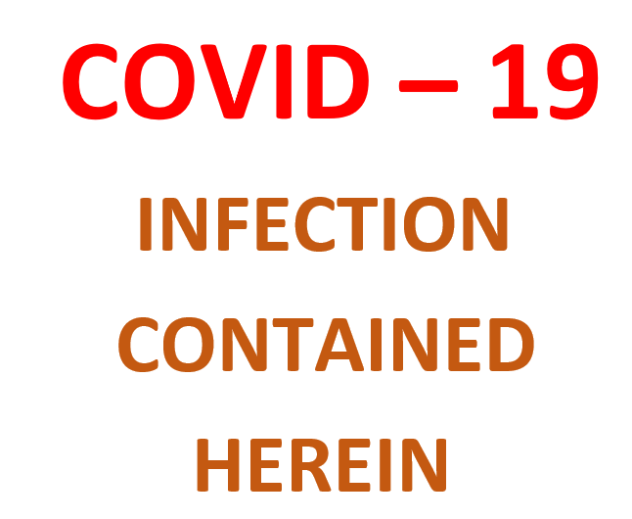

Attachment F: Self-Assessment Tool: Verification of Death in the absence of Medical Officer CHS
Self-Assessment Tool: Verification of Death in the absence of Medical Officer
Competency Title: |  | Verification of Death in the absence of a Medical Officer
Competency Aim: |  | To demonstrate appropriate knowledge to verify death in the absence of Medical Staff
Applicable Staff: |  | Registered Nurses working in the community who may be called on to verify death of known palliative patients
Frequency of Assessment: |  | Once | Date:
Achievement through self-assessment |  |  |  |  |  |  | Signed
I have read and understand these Home Based Palliative Care (HBPC) documents
- HBPC Verification of death factsheet
- HBPC Policy: Care of the deceased patient in the community
I have attended an education session on Verification of Death at CHH
I understand the difference between the following forms:
- Death Certificates,
- Verification of Death (pronouncing life extinct)
- And a Cremation Certificate?
I understand the indications for a referral to the coroner
I understand the situations in which a nurse CANNOT complete the verification of death form
I understand the need for three identifiers (Address, URN, Name, DOB)
I understand the need to be able to identify:
- The presence of relevant infectious diseases (I have read the relevant section in the infection control manual)
- The presence of implantable devices
- Patients for tissue donation
I understand the 4 assessments required to verify death
I understand the correct procedure for documentation of verification of death
- Uses patient sticker where at all possible
- Leave original in patient home for funeral director
- Scan and save copy into the patient record
- Document in the progress notes
Candidates Name: |  |  |  |  | Sign:
CNC Name &  Designation: |  |  |  |  | Sign:

Attachment G: Verification of Death Certificate
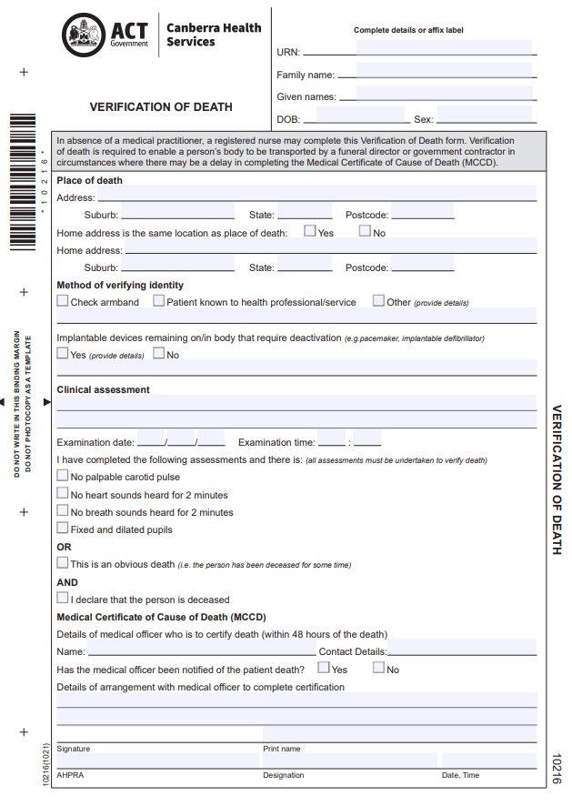
Sample

Attachment H: Sign to be placed and used for exposure to infectious diseases


Attachment I-Staff Options- Interaction with ACT policing following a Coronial death
A staff member may be asked to provide information in a coronial matter as a witness of fact. This is to provide assistance to the Coroner to make a determination on the manner and cause of death.
Staff may be asked to provide a written statement or participate in a record of interview/ conversation with ACT Policing. Staff are not required to provide a written statement to ACT Policing in a Coronial matter or required to participate in a record of interview/ conversation with ACT Policing. The level of interaction with ACT Policing is determined by the individual staff member. However, CHS encourages and asks for staff member’s cooperation in Coronial matters.
Note: Section 99B of the Coroners Act 1997 states a person may give information to the coroner (or their representative) if they reasonably believe it is related to the coroner’s functions under the Act. If the person gives information to the coroner under this section, the giving of the information is not a breach of confidence or professional ethics or rule of professional conduct and does not incur civil or criminal liability or disciplinary action or dismissal because of giving the information.
For example, information provided to the coroner from a theatre nurse who was present during an operation where a patient died unexpectedly.
The ACT Government Solicitor (ACTGS) represents the Territory – CHS and its employees in coronial matters. The ACTGS, in conjunction with the Medico-Legal Team, provide support to staff members throughout the coronial process, including during their interactions with ACT Policing.
When asked to provide information to ACT Policing, staff are encouraged to advise their preference for how they provide that information to the Medico-Legal Team. The Medico-Legal Team are then available to provide assistance to staff during the process including answering any questions or queries.
The options for staff are outlined below, noting that staff can choose as many of the options as is their preference:
Written Statement
A written statement usually provides information about the staff member’s involvement, and provision of care and treatment to the deceased person.
Staff should be aware it is expected that their statement be developed with access to the deceased person’s clinical records to ensure accurate information regarding the deceased person’s clinical care and treatment is included. If operational issues are to be included in the statement (i.e. number of staff on the roster, design of the building or information about policies and procedures) the staff will have access to the information at the time of drafting to inform their statement.
Staff can draft their statement themselves, or with the assistance of ACTGS. The statement will be reviewed by ACTGS prior to finalisation and provision to the ACT Policing Coroner’s Team ensure that all relevant information is included, and it is in a format which will be accepted by the Court.
It is the expectation of CHS that staff complete the written statement as soon as practicable following a request from the Medico-Legal Team.
Interview with ACT Policing
ACT Policing may request to obtain information directly from the staff member to seek their account of their involvement and provision of care and treatment to the deceased person. The request to speak to staff may occur relatively close to the time of the person’s death (i.e. an hour after the death), or at a later date.
The interview with ACT Policing can occur at the site of the death or ACT Policing may request the staff member attend an ACT Policing Station for the interview.
Staff should be aware they will have very limited access to clinical record during this process, as the records will be closed in preparation for provision to the Coroner’s Court. If the interview occurs at an ACT Policing Station, staff are not permitted to take clinical records to that interview.
Staff should also be aware if asked about operational issues (i.e. number of staff on the roster, design of the building or information about policies and procedures) any response will be to the best of their knowledge at the time, as they may not have access to those documents at the time of the interview with ACT Policing.
Staff should request a copy of their interview with ACT Policing for their records.
Combination of Options
Staff can choose to provide a written statement and undergo an interview with ACT Policing or to only undertake one of the above options.
Do Nothing
Staff can express their preference to not provide a written statement or participate in an interview with ACT Policing.
Staff should be aware if the Coroner is satisfied that a person may be able to give material evidence relevant to the inquest, the Coroner can issue a subpoena requiring the person to appear at the inquest and give evidence even if they have chosen to neither provide a statement nor speak directly to ACT Policing.

Attachment J: Backup Plan Mortuary Register

Attachment K: No Identified Next of Kin form
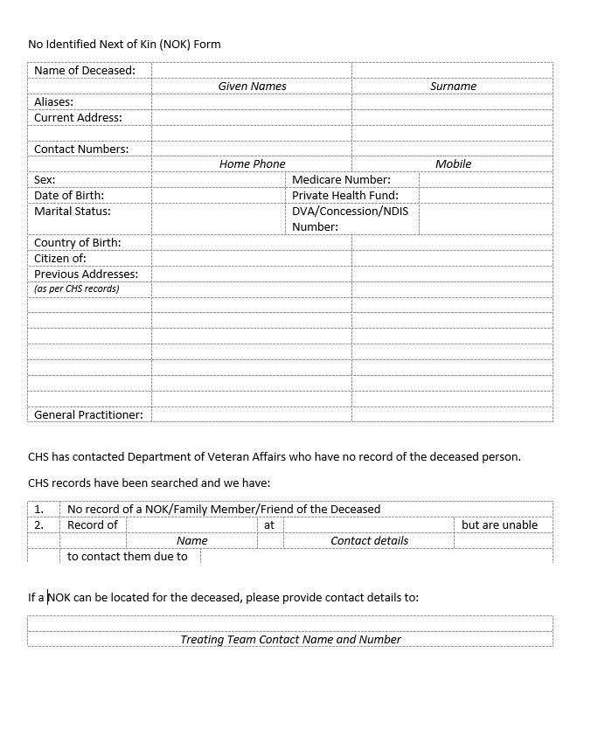

Attachment L: Deceased Person with no next of kin flowchart

Attachment M: Acceptable Funeral Transfer Authorities
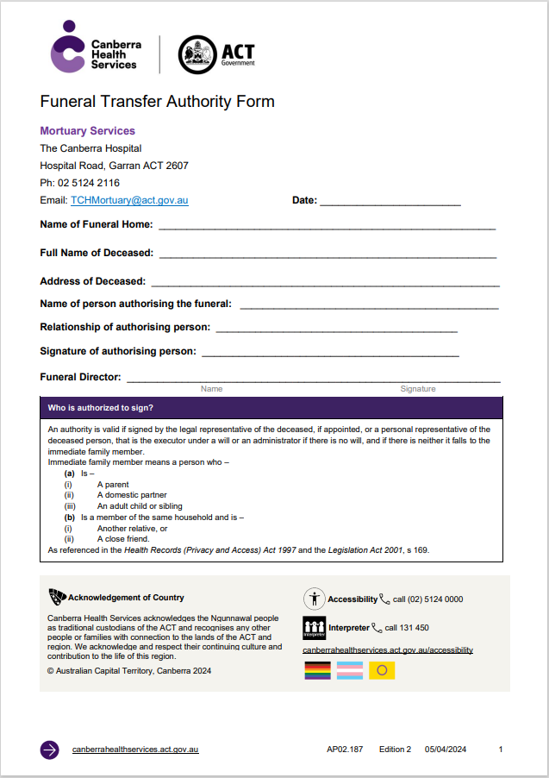
CHS Funeral Transfer Authority Form

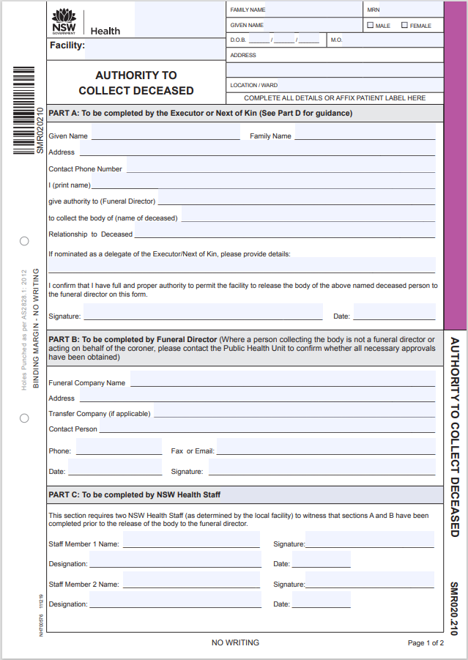
NSW Authority to Collect Deceased

Sample
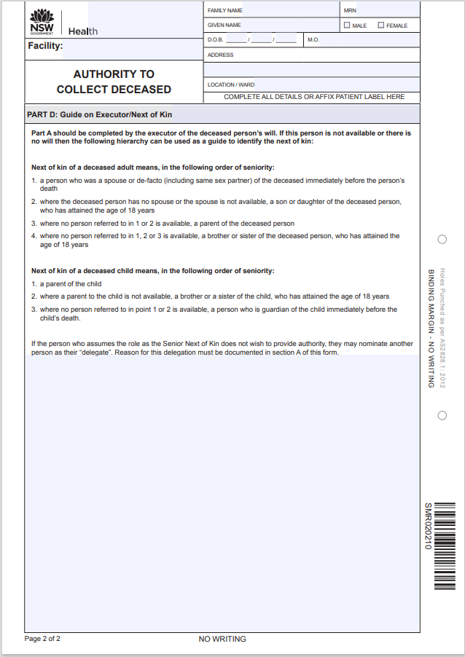

Sample

Attachment N: UCH Body Holding Register

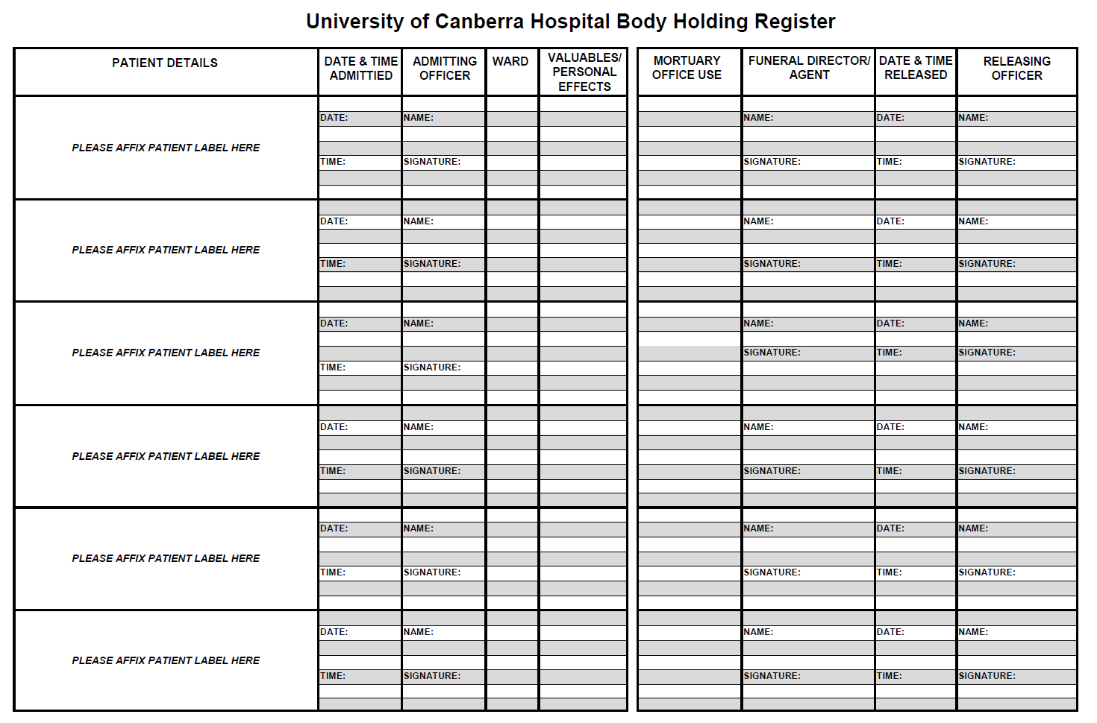

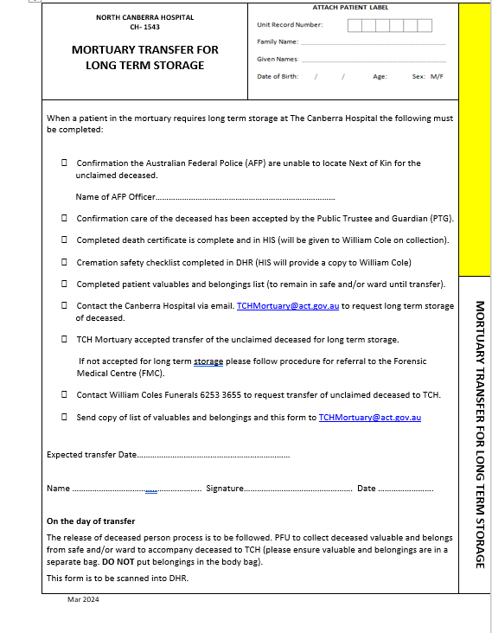
Attachment O: NCH Mortuary Transfer for Long Term Storage Form
Sample

