Canberra Health Services
Procedure
Operating Theatres – Management of Emergency and Non-Elective Theatres

Contents

Contents 1
Purpose 2
Alerts 2
Scope 2
Section 1 – Procedure 3
Section 2 – Priorities 4
Evaluation 4
Related Policies, Procedures, Guidelines and Legislation 4
References 5
Definition of Terms 5
Search Terms 6
Attachments 6
Attachment 1: Request for Emergency Operating Time for Inpatients form 7

Purpose

The purpose of this procedure is to inform staff how to manage emergency and non-elective operating theatres by:
- Documenting the booking process for emergency and non-elective surgery to ensure the correct information is supplied by the appropriate Medical Officer.
- Avoiding inappropriate delays in the surgical treatment of emergency and non-elective cases.
- Avoiding confusion as to the nature of cases that may be performed in the Emergency Operating Theatre and Non-elective Operating Theatre.

Back to Table of Contents

Alerts

Emergency and Non-elective Operating Theatre time may be booked by Consultants or Registrars through the Operating Theatre Team Leader in consultation with the Operating Room Coordinator (ORC). These bookings will be triaged and assigned to theatres by the Operating Theatre Team Leader in consultation with the ORC based on clinical urgency, resource availability and time of booking.

Back to Table of Contents

Scope

This procedure applies to all paediatric and adult patients who undergo emergency or non-elective surgical procedures at the Canberra Hospital.

This procedure applies to the following Canberra Health Services (CHS) staff working within their scope of practice:
- Medical Officers (MO)
- Nurses and Midwives.

This procedure does not cover elective surgery procedures. Elective surgery medical procedures are booked through Surgical Bookings via an Request For Admission (RFA), refer to Elective Surgery Access Policy. Elective surgery is any procedure that falls outside the definition of emergency and non-elective cases.

Back to Table of Contents

Section 1 – Procedure

- The overall management of the Emergency and Non-elective Operating Theatres is the responsibility of the ORC during business hours and the on-call Anaesthetic Consultant out of hours. The ORC is responsible for ensuring that appropriate handover occurs when responsibility is transferred to the on-call Anaesthetic Consultant
- It is the responsibility of the Department of Anaesthesia to assign Anaesthetists to the ORC role in Emergency and Non-elective Operating Theatres
- It is the responsibility of the ORC, in consultation with the Operating Theatre Patient Flow and/or Team Leader to prioritise and arrange the sequence of patients for both the Emergency and Non-elective Operating Theatres
- All Emergency cases are to be booked through the Operating Theatre Team Leader and the ORC. The Operating Theatre Team Leader will record the details of the case on the ‘Request for Emergency and Non-Elective Operating Time for inpatients’ form (number 10230), available on the Clinical Forms Register and example at Attachment 1. The Team Leader will then request the team to call the ORC on extension 27778 who will discuss and document the category status and patient condition. Out of hours and in the absence of the ORC the emergency Anaesthetic Consultant will take on the responsibilities of the ORC.
- Cases must be booked by a Consultant or Registrar.
- During business hours the ORC and the Operating Theatre Team Leader will liaise with the operating theatre staff and the Anaesthetist involved regarding the patients who are to be allocated to their theatre.
- After hours the Operating Theatre Team Leader in collaboration with the emergency Anaesthetic Consultant will continue the above role.
- All bookings are provisional and dependant on the Anaesthetists’ availability.
- Cases will generally be done in order of medical/surgical emergency priority.
- Emergency cases are those with a genuine requirement for operative care within the following 24 hours and are to be scheduled to the Emergency Operating Theatre within this timeframe
- Coordination of Loan implants/instruments is to be taken into consideration when booking a case and when sending for the patient. There needs to be clear communication between the Resource Team and the person booking the case that a Loan set is needed and to confirm that the equipment resources are available at the time.
- Non-elective cases are those with a requirement for operative care which are considered capable of being deferred to a window beyond 24 hours but within 3 days.

Back to Table of Contents

Section 2 – Priorities

- Emergency cases will be prioritised firstly based on the medical team’s clinical assessment and patient category status, followed by the number of times a patient has been cancelled and time of booking.
- Cases are to proceed as soon as the Emergency Operating Theatre is available and preoperative preparation has been completed.
- Where a concurrent emergency occurs, this case will be accommodated into the Non-elective Operating Theatre. If the Non-elective Operating Theatre is not available, the next available Elective Operating Theatre must be utilised
- There needs to be a plan at all times to facilitate extra Emergency Operating Theatre access should the need arise.
- Every effort should be made to fully utilise the Emergency Operating Theatre within the hours 0800 - 2100 Monday to Friday, 7 days a week. The Emergency Operating Theatre should only be used for “life or limb threatening” surgery within the hours of 2100 – 0800.
- The Non-elective Operating Theatre is available only between the hours of 0800 to 1700, 7 days a week.
- Postponements due to workload will be considered based on clinical factors as well as waiting times or previous postponements.

Back to Table of Contents

Evaluation

Outcome
Any patient (Adult & Paediatric), who requires emergency or non-elective surgery are added to the Emergency Acute List, and as a result appropriate and timely care is planned and implemented.

Measures
- Monthly review of the Emergency Demand Report, which is completed twice a day at 07:00 and 15:00.
- Annual review of clinical incident data to determine if any patients were recorded as not being booked appropriately.

Back to Table of Contents

Related Policies, Procedures, Guidelines and Legislation

Policies
- Informed Consent (Clinical)
- Elective Surgery Access
Procedures
- Infection Prevention and Control - Healthcare Associated Infections
- Patient Identification and Procedure Matching
- Clinical Handover
- Patient Escort and Transport within Canberra Hospital campus

Guidelines
- Fasting Guidelines for Patients Requiring Sedation or Anaesthesia
- Non-Elective Caesarean Section (including Classification of Urgency)

Legislation
- Health Records (Privacy and Access) Act 1997
- Human Rights Act 2004
- Work Health and Safety Act 2011

Other
- Australian Charter of Healthcare Rights

Back to Table of Contents

References

- METeOR Metadata Online Registry, Emergency Surgery http://meteor.aihw.gov.au/content/index.phtml/itemId/534125
viewed 29/11/2017

Back to Table of Contents

Definition of Terms

Caesarean categorisation codes
Patients requiring a caesarean are classified depending on how quickly the baby should be delivered:
Category A - Delivery within 30 minutes
Category B - Delivery within 60 minutes
Category C - Delivery within 6 hours
Category D - Time to suit operating theatre and delivery suite

Emergency and Non-Elective surgery: Emergency and non-elective surgery is surgery to treat trauma or acute illness subsequent to an emergency presentation. These bookings are triaged in order of urgency with the following categories:
- Life threatening – within 1 hour
- Organ threatening – within 4 hours
- Non-critical but emergent – within 8 hours
- Non-critical, non-emergent but urgent – within 24 hours
- Subacute – between 24 to 72 hours

ORC: The Operating Room Coordinator is a member of the Anaesthetic Department. The aim of the ORC is to work with the Operating Theatre Patient Flow and/or Team Leader and the Assistant Director of Nursing of the Perioperative Unit to meet agreed surgical requirements of the perioperative patient. The ORC role is supernumerary to that of clinical anaesthetic staff on any given day.

RFA: Request For Admission

Back to Table of Contents

Search Terms

Emergency Operating Theatre, Non-elective Operating Theatre, emergency surgical procedure, non-elective surgical procedure

Back to Table of Contents

Attachments

Attachment 1: Request for Emergency Operating Time for Inpatients form

Disclaimer: This document has been developed by Canberra Health Services specifically for its own use. Use of this document and any reliance on the information contained therein by any third party is at his or her own risk and Canberra Health Services assumes no responsibility whatsoever.

Policy Team ONLY to complete the following:
Date Amended | Section Amended | Divisional Approval | Final Approval
03/03/2022 | Complete review | Lisa Gilmore ED Surgery | CHS Policy Committee

This document supersedes the following:
Document Number | Document Name
CHHS18/072 | Operating Theatres- Management of Emergency and Non-elective Theatres

Attachment 1: Request for Emergency Operating Time for Inpatients form

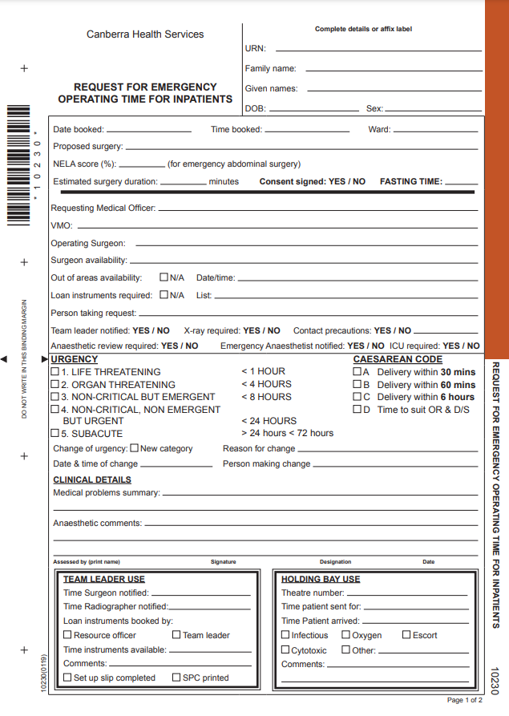
Sample
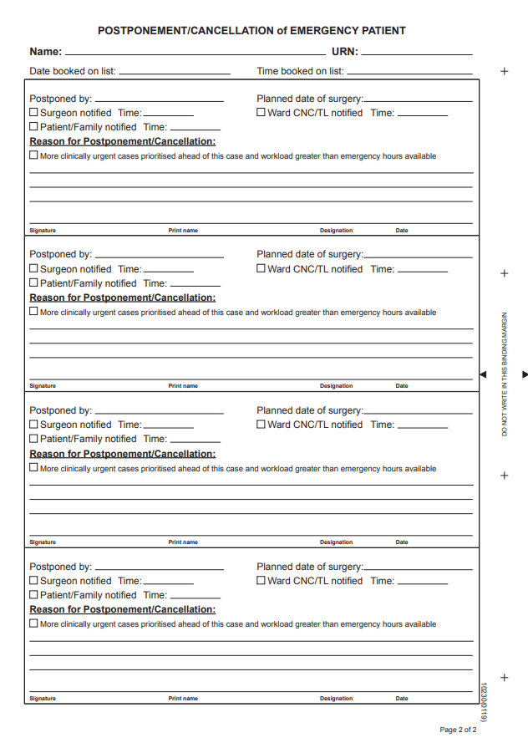
Sample

