Canberra Health Services
Guideline
Non-Invasive Ventilation (NIV) in Children over 10 kg in the Emergency Department

Contents

Contents 1
Guideline Statement 2
Scope 2
Section 1 – Mechanism of Action of Non-Invasive Ventilation (NIV) Therapy 3
Section 2 – Indications and Contraindications 3
Section 3 – COVID-19 Aspects Regarding the Use of NIV in Children 4
Section 4 – Complications of NIV Therapy in Children 4
Section 5 – Initiation of NIV therapy - Nursing Management 5
Section 6 – Other Patient Management Issues 6
Section 7 – NIV Monitoring Requirements 6
Section 8 – Sedation of a Child on NIV Therapy 8
Section 9 – Disposition of a Child on NIV Therapy 8
Section 10 – Equipment and Set Up of Hamilton T1 Ventilator for Non-Invasive Ventilation 9
Section 11 – Advanced troubleshooting: Air leak, patient tolerance and obstructive respiratory pathophysiology 10
Section 12 – Weaning of NIV 11
Section 13 – Ceasing of NIV 11
Evaluation 12
Related Policies, Procedures, Guidelines and Legislation 12
References 13
Definition of Terms 13
Search Terms 13

Guideline Statement

Background
- Respiratory distress of any cause should be treated initially with oxygen therapy in all age groups.
- High flow nasal prongs are a valuable therapy for all age groups from infants to adults but provide limited amount of Positive End Expiratory Pressure (PEEP).
- Bubble CPAP is a therapy used in neonates and infants at Canberra health Services (CHS) but has limited evidence for effectiveness in older children over 10 kg.

Key Objective
This guideline outlines the safe use of non-invasive ventilation (NIV) using the Hamilton T1 ventilator for children over 10 kg in the Emergency Department (ED) of Canberra Hospital.

Alerts
In all cases an ED consultant (any consultant during the day or the on-call ED consultant overnight) and the ED Navigator must be consulted/informed prior to the commencement of NIV. In addition to the ED consultant early notification should go to:
- a paediatric anaesthetist (contact early for support and in case of need for intubation) via switch
- a paediatrician (for further advice)
- the Neonatal Emergency Transport Service (NETS) team (to arrange retrieval).

Other valuable sources of advice for management may include:
- CHS Intensive Care Unit (ICU) service
- CHS Neonatal Intensive Care Unit (NICU) service for patients less than 2 years of age
- a paediatric intensive care unit (PICU) service (Children’s Hospital Westmead or Sydney Children’s Hospital).

Back to Table of Contents

Scope

This guideline relates to the treatment of paediatric patients over 10 kg with respiratory distress requiring the use of NIV using the Hamilton T1 ventilator in the ED of The Canberra Hospital.

This guideline applies to the following staff working within their scope of practice:
- medical officers
- registered nurses
- students working under direct supervision.

Back to Table of Contents

Section 1 – Mechanism of Action of Non-Invasive Ventilation (NIV) Therapy

The mechanism of action of NIV in children is similar to the mechanism in adult patients. NIV:
- improves pulmonary mechanics and oxygenation by recruiting alveoli, increasing functional residual capacity, and improving ventilation-perfusion relationships, thus correcting hypoxaemia and hypercapnia
- partially unloads respiratory muscles thereby decreasing work of breathing
- decreases right ventricular preload and left ventricular afterload.

Back to Table of Contents

Section 2 – Indications and Contraindications

Indications and appropriate selection of patients
Indications include:
- respiratory distress or respiratory failure (hypoxia and/or hypercapnia) caused by:
- respiratory infection
- asthma
- pulmonary oedema
- critically ill patients prior to planned intubation.

In selecting paediatric patients for use of NIV it is essential to assess:
- presence of contraindications to NIV (see below)
- likelihood that patient will tolerate the therapy
- expectation that NIV will stabilise and/or reverse the current condition
- potential risk of complications secondary to failing to secure the airway with an endotracheal tube at the appropriate time.

Literature suggests that predictors of failure of NIV in children include:
- evidence of multi-organ dysfunction
- significant respiratory acidosis
- underlying diagnosis of sepsis
- oncological disease
- high oxygen requirement prior to initiation of therapy.

These factors do not preclude the initial use of NIV as a temporising measure to optimise the clinical state of the patient prior to intubation.

Relative contraindications
Consider intubation and invasive ventilation for patients with:
- persistent respiratory failure despite NIV (partial pressure carbon dioxide [pCO2] remains elevated, persisting hypoxaemia)
- apnoea or inadequate spontaneous respiratory effort/rate
- inability to maintain own airway/need for secure airway
- upper airway abnormalities precluding adequate mask seal
- pneumothorax
- active vomiting
- tracheo-oesophageal fistula
- severe cardiovascular instability
- recent abdominal surgery
- abdominal distension.

Back to Table of Contents

Section 3 – COVID-19 Aspects Regarding the Use of NIV in Children

The Emergency Medicine Specialist on duty/on call must be immediately involved and senior consultation throughout must occur.
In a child who is at risk for COVID-19 infection and is likely to benefit from NIV:
- Place the patient in a negative pressure room in the ED (R4 or R5).
- Staff are to adhere to airborne precautions.
- A swab is taken immediately for COVID testing (Rapid test request to Microbiologist).
- Commence NIV. Ensure a Heat Moisture Exchange (HME) filter is in the circuit. Take care to minimise mask leaks
- Discuss early with Intensive Care Specialist and/or NETS.
- After initial resuscitation, if ventilating appropriately, consider if the patient can be transported using the Hamilton T1 ventilator on NIV setting. If not, the patient will likely require endotracheal intubation. In this situation, NIV should be used to optimise preoxygenation prior to induction.
- Immediately prior to removing the mask from the patient’s face, put the Hamilton T1 ventilator on stand-by mode (press: ‘Power’ then ‘Activate standby’).

Back to Table of Contents

Section 4 – Complications of NIV Therapy in Children

The initiation of NIV therapy has the potential to make the child’s condition worsen, sometimes rapidly. This may be due to:
- patient agitation from a feeling of suffocation or pressure or discomfort, impeding their compliance with the treatment and worsening their respiratory function
- atelectasis: diffuse alveolar collapse caused by decreased alveolar ventilation, pneumothorax or retention of secretions
- air leak syndromes
- pneumothorax
- pneumomediastinum
- subcutaneous emphysema
- pulmonary interstitial emphysema
- cardiovascular impairment: intrathoracic pressure changes can reduce venous return to the right side of the heart, reducing flow to the lungs and resulting in decreased cardiac output.

Other short to medium term complications can include
- skin integrity:
- pressure sores from ill fitted masks
- eye irritation and conjunctivitis from air leakage into eyes
- gastrointestinal tract complications: gastric distension from air ingestion.

Patients on NIV for longer periods of time may have the potential to experience:
- oxygen toxicity from parenchymal changes due to prolonged exposure to O2 levels > 50%.
- acute lung injury from over-distension of alveoli.

Back to Table of Contents

Section 5 – Initiation of NIV therapy - Nursing Management

Training:
All NIV must be initiated and supervised by competent medical and nursing staff. For competency nursing staff must complete the self-directed e-learning ‘CHS - Non-invasive Ventilation’ on HRIMS. Before caring for a patient receiving NIV therapy nursing staff must then be assessed as competent by a clinical development nurse (CDN) or another nurse trained to assess competency.

Initiation of therapy:
- Explain the procedure to the patient and/or carer and gain consent as appropriate.
- Hand hygiene is to be performed using either alcohol-based hand rub (ABHR) or hand washing prior to the procedure maintaining the 5 moments of hand hygiene (see the Infection Prevention and Control Procedure, available on the Policy and Guidance Documents Register). Hand hygiene is to be performed before and after patient contact and before and after any procedure.
- Paediatric patients commencing on NIV require a nurse ratio of 1:1 or 1:2 dependent on the patient’s needs. Refer to the Increased Patient Care and or Supervision Procedure, (available on the Policy and Guidance Documents Register).
- NIV machines should be plugged into essential power outlets, which are marked red.
- Reassure the patient receiving NIV to minimise anxiety and improve compliance.
- Position the patient in an upright or semi-recumbent position by elevating the head to approximately 30 degrees to assist with ventilation.
- Ensure the mask is comfortable. A non-vented full-face mask should be applied in the ED environment for patients having NIV treatment with the Hamilton T1 ventilator. The mask should be fitted as per manufacturer’s instructions and size guide. The mask should achieve the best seal possible to minimise air leaks and the least tension in the straps to avoid skin erosions. It is important to ensure that air is not blowing directly into the patient’s eyes.
- Regular breaks from NIV therapy to attend to oral hygiene, eye care and pressure area care to the bridge of nose and ears are essential. Application of a hydrocolloid flexible dressing may be helpful in preventing patients developing a pressure area over the nasal bridge. Ensure adequate oxygenation of the patient when off NIV. Refer to the Pressure Injury Prevention and Management – Adults, Children and Neonates Procedure (available on the Policy and Guidance Documents Register). Any pressure injury is to be reported in a clinical incident report.

Back to Table of Contents

Section 6 – Other Patient Management Issues

- Patients should have 2 x intravenous cannula access (note need for sampling cannula for repeat venous blood gas monitoring).
- Patients require a form of IV fluid therapy with the rate depending on the patient condition (for most respiratory conditions 2/3 maintenance rate with sodium chloride 0.9% and glucose 5% +/- potassium chloride).
- A nasogastric (NG) tube should be placed at the earliest possible convenience (minimum size 8F). Prolonged NIV without any NG carries risk of gastric distension, vomiting and aspiration. The NG tube should be left on free drainage and regularly aspirated (every 4hrs).
- All patients should be nil by mouth.

Back to Table of Contents

Section 7 – NIV Monitoring Requirements

All patients receiving NIV require regular monitoring of the following:
- Vital signs and NIV observations need to be recorded in the patient’s clinical record. They are completed half hourly for the first four hours, then hourly for the first 24 hours recording the following:
- oxygen saturation
- heart rate
- blood pressure
- respiratory rate
- percentage of oxygen delivery
- end tidal CO2 (for monitoring of ventilation qualitatively not quantitatively- quantitative measurement will be difficult with any leakage)
- NIV settings
- time on and time off machine.

In addition to parameters on the patient’s clinical record add:
- Awake, Verbal, Pain, Unresponsive (AVPU) score
- work of breathing.

Complete the following additional monitoring:
- fluid balance chart (4 hourly)
- weight (every 24 hours)
- mouth and eye care and assessment of skin integrity every 4 hours

Observe the patient for:
- comfort and use of accessory muscles
- patient mask comfort and leakage (see Target leakage in ‘Section 10 - Equipment and Set Up of Hamilton T1 Ventilator’)
- coordination of respiratory effort with the ventilator
- abdominal distension due to aerophagia (see NG tube management above in Section 6)
- skin integrity – check at all pressure points i.e., bridge of nose, tips of ears as well as sacrum and heels
- nausea and vomiting.

Record observations in the patient’s clinical record.

Alert: If the patient meets MET criteria, has increasing Paediatric Early Warning Score (PEWS) or the clinician is worried about the patient, escalate to the ED staff specialist immediately.

Observations should continue to be recorded on the patient’s clinical record to allow trending of observations. Refer to Vital Signs and Early Warning Score – The Canberra Hospital Inpatients Procedure (available on the Policy and Guidance Documents Register).

Oxygen saturation (SpO2) should be maintained at >94% (in the absence of relevant co-morbidities e.g., chronic lung disease) unless otherwise stated. Improvements in tachypnoea and level of consciousness are usually seen within 1-2 hours. Blood gases should be performed 1-2 hours after commencing NIV unless otherwise specified. The treating medical officer in ED should review the patient and the blood gas results and document a plan for the frequency of further blood gas monitoring.

Treatment Failure
The following findings indicate treatment failure and will require urgent medical assessment of the patient:
- decreasing level of consciousness
- increasing agitation
- worsening respiratory distress, e.g., tachypnoea, increased use of accessory muscles
- worsening gas exchange, e.g., fall in oxygen saturation, increasing oxygen requirement or worsening blood gases
- increasing PEWS
- poor synchrony between patient and ventilator
- intolerance of therapy.

If any of the above occur the ED staff specialist should be contacted to review the patient urgently. The Intensive Care Unit and/or NETS should be consulted at this stage if medically appropriate.

Back to Table of Contents

Section 8 – Sedation of a Child on NIV Therapy

Many infants cope with NIV without sedation being required. Older children and adolescents may require some level of sedation due to the discomfort of the mask on the face and the abnormal feeling of breathing against positive pressure. It must be kept in mind that patients being placed on this therapy are significantly if not critically unwell. The use of sedation has the potential to worsen the patient’s condition. Doses of drugs commonly used for procedural sedation may not be appropriate.

The type of sedation and level of sedation should be tailored to this context and should only be performed under the direction of the ED consultant, paediatric anaesthetist, ICU/PICU consultant or retrieval team. Sedative medications to be considered include low dose ketamine or clonidine.

NETS suggested doses for ketamine and clonidine:

Medication | Initial STAT dose | Continuing IV Infusion dose
ketamine | IV: 0.1-0.3 mg/kg | 1-2 microg/kg/min
clonidine | Oral: 1-2 microg/kg | commence at 0.5-1 microg/kg/hr and may increase up to 2 microg/kg/hr
clonidine | IV: 0.5-1 microg/kg dose over 5-10 mins

Back to Table of Contents

Section 9 – Disposition of a Child on NIV Therapy

Any patient over 10 kg requiring NIV as a level of support at CHS can only be managed in:
- The ED for a short period of up to several hours with a plan to either:
- wean from NIV therapy after improvement in condition
- retrieve the patient via NETS
- intubate the patient in the ED or
- take the patient to the operating theatre for intubation by Anaesthetics.
- ICU will consider accepting any patient over 2 years of age on NIV therapy for interim management.

Back to Table of Contents

Section 10 – Equipment and Set Up of Hamilton T1 Ventilator for Non-Invasive Ventilation

Equipment
- Hamilton T1 ventilator
- Adult circuit (note neonatal circuit only used for patients under 10 kg)
- Adult HME filter (green filter) for patients > 30 kg and Paediatric HME filter for patients < 30 kg.
- Masks: XS, S and full face (sized as per packet guide).

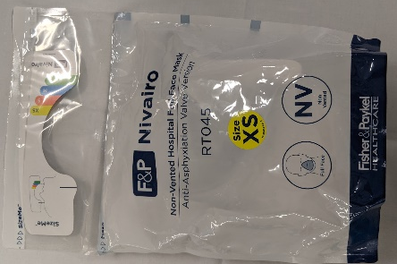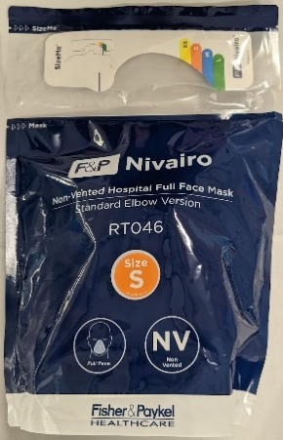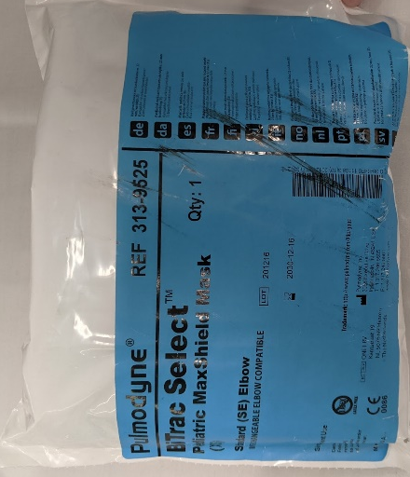

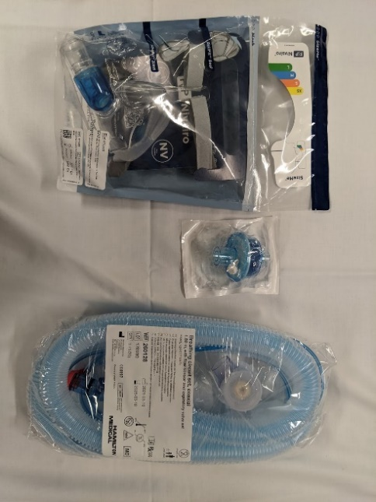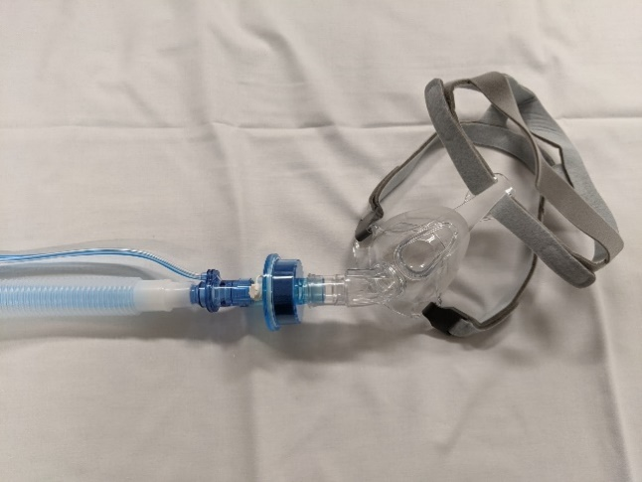

Set up of Hamilton T1 ventilator:
- NIV mode (not NIV-ST)
- Enter patient height: ventilator will calculate ideal body weight
- It should be noted that when using the NIV mode with the Hamilton T1 ventilator that Pressure Support (PS) is additive to PEEP when calculating the peak pressure
- Initial settings:
- PEEP 5 cmH₂0
- Psupport 5 cmH₂0
- FiO₂ 100%
- Increase PEEP to maintain adequate oxygenation (usually 6-8 cmH₂0, max 10 cmH₂0)
- Increase Psupport to improve CO2 clearance (usually 5-10 cmH20, max 15 cmH20)
- Maximum suggested pressures of 25/10 cmH20 (Psupport of 15 and PEEP of 10 on machine settings).
- Target leak < 20% (Press monitoring tab -> values -> 2 -> V _{leak})
- After stabilisation of the therapy FIO2 should be titrated to a target saturation of > 94%.

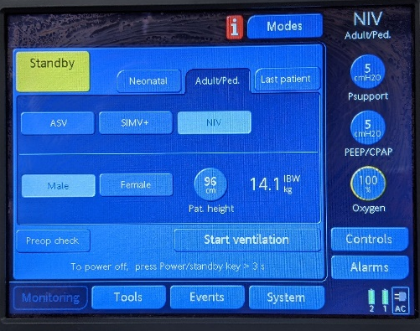

Back to Table of Contents

Section 11 – Advanced troubleshooting: Air leak, patient tolerance and obstructive respiratory pathophysiology

The following advice deals with the problem of air leak (usually around the mask) and patients with obstructive respiratory pathophysiology.
- The Hamilton T1 ventilator has two settings that dictate the length of the expiratory phase before an inspiratory cycle is triggered. These are ETS (Expiratory Trigger Sensitivity) and TI (Inspiratory time).
- ETS (Expiratory Trigger Sensitivity) is the time at which the inspiratory flow drops below a certain level (default is 25%) in which case the ventilator will cycle into the expiratory phase (no pressure support in this phase, just PEEP).
- TI (inspiratory time) is a time at which the ventilator will switch to expiration phase regardless of the flow at that moment. Adjusting the TI max setting increases or decreases the allowable inspiratory time.
- The ventilator is set so that usually ETS is the trigger for expiration and TI is set as a backup in case this fails. When ETS is the trigger for expiration this is usually more comfortable for the patient.
- If there is a large leak, then the ventilator will sense that inspiration appears to be ongoing and therefore flow may never fall to less than the ETS trigger. The ventilator will then only cycle into expiration as dictated to by the TI.
- The best method of resolving this problem is to resolve the leak (as ETS as a trigger will be better for the patient).
- In addition, increasing the ETS above the default 25% will allow the ventilator to terminate inspiration at a higher flow to accommodate larger leaks.
- If the leak cannot be easily resolved, then it may be necessary to alter the TI setting to match the patient’s comfort and needs. Remember that a longer TI will lead to a longer inspiratory time and a relatively shorter expiration phase. The opposite applies for a shorter TI.
- In an obstructive respiratory problem, setting the ETS above 25% (assuming no significant interfering leak) will cycle the ventilator from inspiration to expiration earlier and therefore increase the relative length of the expiratory time. This will avoid gas trapping and auto PEEP. For the same reason in patients with an obstructive problem it may be necessary to set the TI shorter to limit the maximum inspiratory time.

Back to Table of Contents

Section 12 – Weaning of NIV

- The decision to wean the patient off NIV is made by the ED staff specialist in consultation with NETS and CHS specialist services (Paediatrics, Intensive Care, Paediatric Anaesthetics).
- Weaning of non-invasive ventilation may be appropriate once the patient’s condition has stabilised.
- Weaning of NIV must be monitored closely with regular blood gas measurements (most commonly venous gases) to ensure the patient’s pCO2 remains within a described target range each time the parameters of NIV are altered.
Back to Table of Contents

Section 13 – Ceasing of NIV
Alert: NIV is to cease immediately if continuation of NIV appears to pose greater risk to the patient than a pause to the therapy. This might be the case where there is vomiting, significant agitation or an unexplained deterioration. Senior medical help must be sought immediately. In the first instance replace with high flow oxygen via a non-rebreather mask.
Ceasing of NIV is a medical decision. The decision should be made by the ED staff specialist following medical assessment of the patient. The assessment and decision must be documented in patient’s clinical record progress notes.
NIV may be ceased for the following reasons:
- NIV is no longer required because of clinical improvement
- NIV is not tolerated by the patient
- the patient is vomiting and at risk of aspiration
- there has been a complication to NIV i.e., pneumothorax
- endotracheal intubation is required because of NIV treatment failure.

Back to Table of Contents

Evaluation

Outcome
All NIV management for paediatric patients over 10kg in the Canberra Hospital ED will be conducted in accordance with this procedure.

Measures
All cases of NIV use in children over 10 kg will be reviewed at a scheduled multi-disciplinary 3 monthly paediatric critical care case review meeting coordinated by the ED.

Back to Table of Contents

Related Policies, Procedures, Guidelines and Legislation

Policies
- Nursing and Midwifery Board of Australia (NMBA) Requirements for Practice
- Informed Consent - Clinical
- Incident Management - Clinical

Procedures
- Infection Prevention and Control
- Vital Signs and Early Warning Scores - The Canberra Hospital Inpatients
- Increased Nursing Patient Care and or Supervision
- Pressure Injury Prevention and Management – Adults, Children and Neonates
- Incident Management – Clinical
- Neonatal Emergency Transport Service Australian Capital Territory (NETS ACT) Back-transfer, Elective Retrievals, Retrievals and Paediatric Stabilisations
- Increased Patient Care and or Supervision

Guidelines
- Oxygen Therapy and Non-Invasive Ventilation (Paediatrics 0-16)
- Fasting Guidelines for Patients Requiring Sedation or Anaesthesia

Legislation
- Health Records (Privacy and Access) Act 1997
- Human Rights Act (ACT) 2004
- Health Records (Privacy and Access) Act (ACT) 1997
- Work Health and Safety Act (ACT) 2011
- Carers Recognition Act (ACT) 2021

Other
- Australian Charter of Healthcare Rights
Back to Table of Contents

References

- Non-Invasive Ventilation in PICU-CHW Policy: Sydney Children’s Hospital Network. https://www.schn.health.nsw.gov.au/_policies/pdf/2012-0012.pdf (Accessed online 05/07/2023)
- Fedor, K. Noninvasive respiratory support in infants and children. Respiratory care. 2017; 62(6):699-717
- www.uptodate.com/contents/noninvasive-ventilation-for-acute-and-impending-respiratory-failure-in-children (Accessed 05/07/2023)
- Marohn K and Panisello J. Noninvasive ventilation in pediatric intensive care. Current Opinion in Pediatrics 2013; 25:290-296
- Sedation In Non-Invasive Ventilation- NETS Guideline No: 2020-195 v1
- Brill, A. How to avoid interface problems in acute noninvasive ventilation. Breathe 2014; 10: 230-242.
- Clinical Guidelines (Nursing) : Oxygen delivery Guideline The Royal Children's Hospital Melbourne https://www.rch.org.au/rchcpg/hospital_clinical_guideline_index/Oxygen_delivery/
(Accessed 05/07/2023)

Back to Table of Contents

Definition of Terms

NIV is the delivery of mechanically assisted or generated breaths without placement of an artificial airway using a mask or similar interface. This technique is distinguished from those which bypass the upper airway with an endotracheal tube, laryngeal mask, or tracheostomy and are therefore considered invasive. This is the preferred term and supersedes BPAP, BiPAP and BIPAP. BiPAP and BIPAP are registered trade names for NIV modes on ventilators from specific manufacturers.

Positive End Expiratory Pressure (PEEP) is positive airway pressure therapy throughout the respiratory cycle to spontaneously breathing patients. PEEP splints the airway open throughout the respiratory cycle thereby maintaining oxygen saturation, functional residual capacity and preventing alveolar collapse.

Pressure Support (Psupport) is additional supportive positive pressure provided by the ventilator above the level of PEEP during the inspiratory phase. In NIV mode on the Hamilton T1 ventilator it is triggered by the patient initiating a breath. It can be titrated to maintain tidal volume, to support and augment ventilation, to reduce the work of breathing, and thereby to reduce CO2 retention.

Back to Table of Contents

Search Terms

Emergency Department, Paediatric, Children, Ventilation, NIV, Non-invasive, Positive End Expiratory Pressure, PEEP, Pressure Support, Psupport, Hamilton.

Disclaimer: This document has been developed by Canberra Health Services specifically for its own use. Use of this document and any reliance on the information contained therein by any third party is at his or her own risk and Canberra Health Services assumes no responsibility whatsoever.

Policy Team ONLY to complete the following:
Date Amended | Section Amended | Divisional Approval | Final Approval
07/07/2023 | Complete Review | Brendan Docherty, ED of Medicine | CHS Policy Committee

This document supersedes the following:
Document Number | Document Name
CHS22/076 | Non-Invasive Ventilation (NIV) in Children over 10 kg in the Emergency Department

Back to Table of Contents

