Canberra Health Services
Intraoperative Cell Salvage Guideline

Purpose

Canberra Health Services (CHS) endorses the use of the National Blood Authority (NBA) Guidance for the Provision of Intraoperative Cell Salvage Guideline.

Guidance for the Provision of Intraoperative Cell Salvage is a National Guideline with clinical recommendations based on the best scientific evidence available at the time of publication.

This guideline has been written to support the implementation of the use of washed red blood cells for re-infusion known as Intraoperative Cell Salvage (ICS). The intraoperative collection and re-infusion of the patient’s own red blood cells provides an important contribution to reducing the demand for allogenic blood for transfusion.

Utilising appropriate alternatives to blood transfusion is cost-effective, complies with
clinical governance requirements and falls within the scope of the National Safety and Quality Health Service Standards (NSQHS) Blood Management Standard (https://www.safetyandquality.gov.au/standards/nsqhs-standards/blood-management-standard)

Key Objectives
The key objectives of this document are:
- To guide the use of ICS at CHS Perioperative Unit
- To appropriately identify suitable patients, undergoing elective and/or emergency
- surgical procedures, where ICS could be of benefit
- To safely utilise ICS in an effective manner.

Documentation
Access to the Digital Health Record (DHR) ICS documentation is gained through the following steps:
- Login into DHR
- Navigate to Anaesthetic Nurse OR Intraoperative activities section
- Select PROCEDURE and subheading EQUIPMENT on left side of page
- Select +ADD and choose CELL SAVER
- Cell Saver Documentation page opens.

Documented re-processed blood to be recorded through the DHR in Anaesthetic Chart by the Anaesthetist.

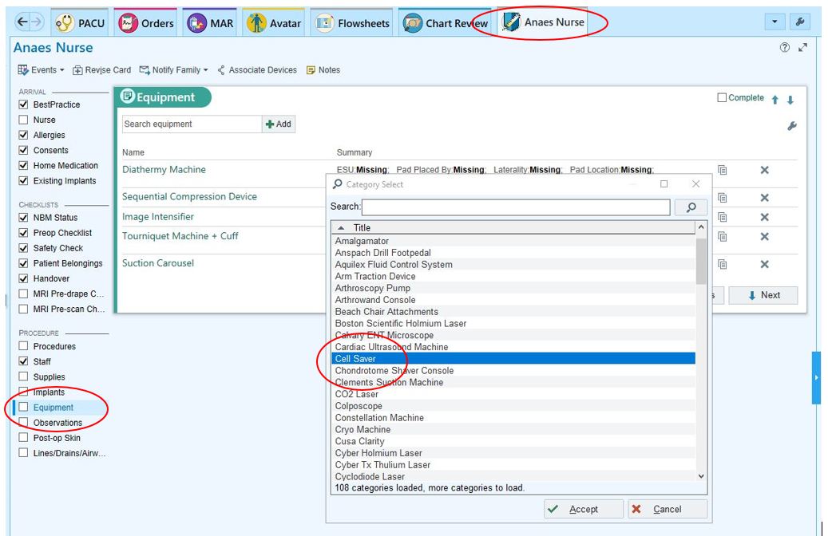

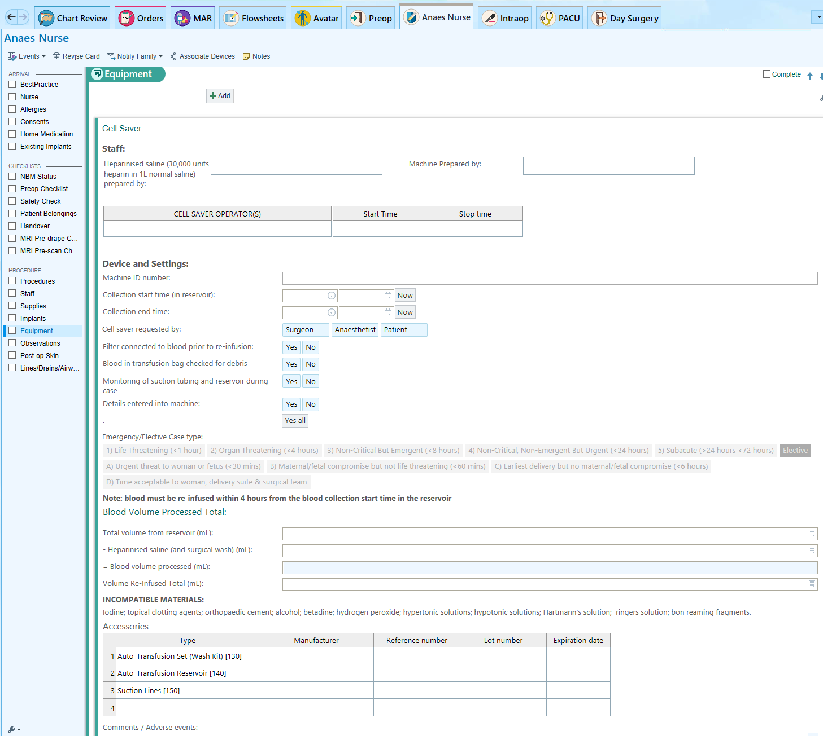

Scope

ICS should be considered in surgery in a clean operative field where substantial blood loss is anticipated.

This guideline applies to the following CHS staff working within their scope of practice:
- Medical staff
- Registered Nurses and Midwives
- Endorsed Enrolled Nurses.

Which area in Canberra Health Services can I contact for more information?

Clinical Nurse Consultant, Anaesthetics
Phone office: 02 5124 4218. Perioperative Department 02 5124 2765
Perioperative Unit, Division Surgery, Canberra Health Services, ACT Government
Building 12, Level 3, Canberra Hospital | PO Box 11, Woden ACT 2606 | act.gov.au

ADON Perioperative Unit.
Phone office: 02 5124 3051. Perioperative Department 02 5124 2765
Perioperative Unit, Division Surgery, Canberra Health Services, ACT Government
Building 12, Level 3, Canberra Hospital | PO Box 11, Woden ACT 2606 | act.gov.au

Director of Anaesthesia and Pain Management.
Phone: 02 5124 3245
Department of Anaesthesia Division Surgery, Canberra Health Services, ACT Government
Building 12, Level 3, Canberra Hospital | PO Box 11, Woden ACT 2606 | act.gov.au

How can I access the document?

The guideline can be accessed through the National Blood Authority website:
- Intraoperative Cell Salvage Guidance.pdf (blood.gov.au)
- https://www.blood.gov.au/ics

Search Terms

Intraoperative Cell Salvage, Cell Saver, Cell Saving, Washed Blood, DHR

Disclaimer: This document has been developed by Canberra Health Services specifically for its own use. Use of this document and any reliance on the information contained therein by any third party is at his or her own risk and Canberra Health Services assumes no responsibility whatsoever.

Policy Team ONLY to complete the following:
Date Amended | Section Amended | Divisional Approval | Final Approval
10/08/2023 | Complete Review | Lisa Gilmore, ED Surgery | Chair, CHS Policy Committee

This document supersedes the following:
Document Number | Document Name
CHS20/205 | Intraoperative Cell Salvage Guideline

