Canberra Health Services
Procedure
Flexible Working Arrangements Relating to Private Practice or Other Commitments – Specialists and Senior Specialists

Contents

Contents 1
Purpose 2
Scope 2
Section 1 – Applying for flexible working arrangements – 4 day working week 2
Section 2 – Consideration of application 3
Section 3 – Approval period 3
Section 4 – Recording attendance 4
Section 5 – Suspected breaches of flexible working arrangements relating to private practice and other commitments 4
Evaluation 5
Related Policies, Procedures, Guidelines and Legislation 5
Search Terms 6
Attachments 6
Attachment 1 – Application For Flexible Working Arrangements Relating To Private Practice: Specialists And Senior Specialists (May 2021) 7
Instructions 7

Purpose

This procedure provides processes for specialists and senior specialists to follow when seeking access to flexible working arrangements to facilitate their private practice or other commitments.

This procedure also aims to ensure that, when employees seek to access flexible working arrangements, there is no conflict of interest for those undertaking work outside of their employment with Canberra Health Services (CHS).

When accessing flexible working arrangements specialists and senior specialists must complete their normal working hours over a period of no fewer than 4 days per week, and the following principles must be adhered to:
- Any approval is subject to reasonable business grounds;
- An applicant’s normal hours will remain unchanged under these arrangements;
- Permission must be sought in advance for any outside employment; and
- There is no provision within the MPEA for “banking” or accruing of weekly time off, to be taken together at a later date.

Back to Table of Contents

Alerts

The flexible working arrangements described in this procedure relate only to subclauses 23.12 to 23.18 (inclusive) of the ACT Public Sector Medical Practitioners Enterprise Agreement 2017 – 2021 (MPEA).

Employees should note that where an application for flexible working arrangements has been approved a Conflict of Interest Declaration may be required and the Second Job procedure will need to be followed.

Back to Table of Contents

Scope

This procedure applies to full-time specialists and senior specialists who are covered by the MPEA and who are working flexibly to facilitate their private practice or other commitments.

Back to Table of Contents

Section 1 – Applying for flexible working arrangements – 4 day working week

An application for flexible working arrangements is made to the relevant Line Management (usually the Clinical Director) by completing the Application for Flexible Working Arrangements – Specialists and Senior Specialists form, which can be found on the HealthHUB under Workforce Relations (https://healthhub.act.gov.au/employment-resources/employee-services/hr-forms) - see Attachment 1.

The application must include the following:
- Reasons for the application;
- A proposed schedule of working hours, including how this will impact on existing work arrangements – e.g. clinics, surgical sessions, etc; and
- Details relevant to any existing agreements regarding work ratios of clinical and non-clinical time (subclause 23.3 of the MPEA).

Where a specialist or senior specialist seeks approval for outside employment in conjunction with working flexibly under this procedure, including any private practice commitments, a completed Application for Approval for Work Outside the Service form must also be submitted, available on the Shared Services Intranet, in accordance with the Second Job procedure.

Back to Table of Contents

Section 2 – Consideration of application

In considering applications, the Clinical Director/Line Management will:
- consider operational requirements;
- consider if a request for outside employment may constitute any potential or actual conflict of interest;
- ensure that the applicant will continue to work their normal hours over a period of no fewer than 4 days per week;
- ensure that the arrangement will not adversely affect the work performance of the employee in their CHS position; and
- provide applicants with a response within a reasonable timeframe (4 weeks where practicable).

There may be rare circumstances where a response cannot be provided within 4 weeks. In such circumstances, the applicant will be notified within the 4-week period of the anticipated delay in the response. The Head of Service (or delegate) will provide applicants with a response as soon as is reasonably practicable.

If an application is denied, the Head of Service (or delegate) will provide reasons to the applicant in writing. An employee who has had their application denied may seek an internal review of that decision in accordance with Section P of the MPEA.

Back to Table of Contents

Section 3 – Approval period

In accordance with subclause 23.15 of the MPEA, approvals will be granted only for the current calendar year in which the approval was made.

It will be the responsibility of the employee to ensure that they reapply annually with sufficient time for renewed approval prior to the expiration of the year. The approving delegate will provide a response to the application as soon as is reasonably practicable and, subject to Section 2, not more than 4 weeks after the application was made.

If approval is not obtained before the commencement of the next calendar year then the employee is not authorised to continue the arrangement and will revert to their previous working arrangements.

Any alteration to the approval will require agreement between the Head of Service (or delegate) and the employee.

Approvals may be suspended by the Head of Service (or delegate) for extenuating circumstances by notice in writing.

Agreements relating to flexible working arrangements by specialists and senior specialists to facilitate their private practice or other commitments, which are in place at the time of endorsement of this procedure, will be honoured and will continue in force, until the beginning of the next calendar year, so long as there is no conflict with any provision contained in the MPEA or any part of this procedure.

Back to Table of Contents

Section 4 – Recording attendance

All specialists and senior specialists will be required to keep appropriate records of their attendance for duty.

This record will be kept in a manner stipulated by the Executive Director of Medical Services but may include for example diary entries, attendance sheets or electronic records.

These records will be made available when requested, including for the purposes of auditing.

Any absence during normal working hours will require the submission of an appropriate leave form, unless arrangements are made in advance with the Clinical Director to vary hours on a short-term basis, subject to annual review per subclause 23.15 of the MPEA.

Back to Table of Contents

Section 5 – Suspected breaches of flexible working arrangements relating to private practice and other commitments

If there is a suspected breach in the arrangements that have been approved by the Head of Service (or delegate), then an investigation will be carried out consistent with the MPEA. In circumstances of a suspected breach, the Clinical Director or Executive Director suspecting the breach should contact either the Senior Director HR Operations or the Senior Director Employment Specialist Services in People and Culture for advice on how to proceed.

Where an investigation confirms that a breach in the flexible working arrangement has occurred, the Head of Service may cancel the arrangement and initiate disciplinary action.

Back to Table of Contents

Evaluation

Outcome Measures
- All applications, made by Specialists and Senior Specialist, will be completedusing the Application for Flexible Working Arrangements – Specialists and Senior Specialists (May 2021) form.
- Divisions will maintain a list of Specialists and Senior Specialists from their work areas who have approved flexible working arrangements for reporting purposes.

Method
- Executive Director/Executive Group Manager will provide reports of all staff on flexible working arrangements to the Chief Executive Officer in July of each calendar year.

Back to Table of Contents

Related Policies, Procedures, Guidelines and Legislation

Policies
- Recruitment

Procedures
- Second Job
- Recruitment
- Credentialing and Defining the Scope of Clinical Practice for Senior Medical and Dental Practitioners
- Conflict of Interest

Guidelines
- ACT Public Service Code of Conduct 2012

Legislation
- Public Sector Management Act 2004 (ACT)
- Public Sector Management Standards 2006 (ACT)
- Financial Management Act 1996 (ACT)
- Privacy Act 1988 (Cth)

Enterprise Agreements
- ACT Public Service Medical Practitioners Enterprise Agreement 2017-2021

Back to Table of Contents

Search Terms

Flexible Working Arrangements, Specialists and Senior Specialists, Senior Medical Practitioners, work life balance, Medical Practitioners Enterprise Agreement 2017-2021, process, application, private practice.

Back to Table of Contents

Attachments

Attachment 1 – Application for Flexible Working Arrangements Relating to Private Practice: Specialists and Senior Specialists (May 2021)

Disclaimer: This document has been developed by Canberra Health Services specifically for its own use. Use of this document and any reliance on the information contained therein by any third party is at his or her own risk and Canberra Health Services assumes no responsibility whatsoever.

Policy Team ONLY to complete the following:
Date Amended | Section Amended | Divisional Approval | Final Approval
17 June 2021 | Complete Review | Raelene Burke,EGM, People & Culture | CHS Policy Committee

This document supersedes the following:
Document Number | Document Name
CHHS14/020 | Flexible Working Arrangements – Specialists and Senior Specialists

Attachment 1 – Application For Flexible Working Arrangements Relating To Private Practice: Specialists And Senior Specialists (May 2021)

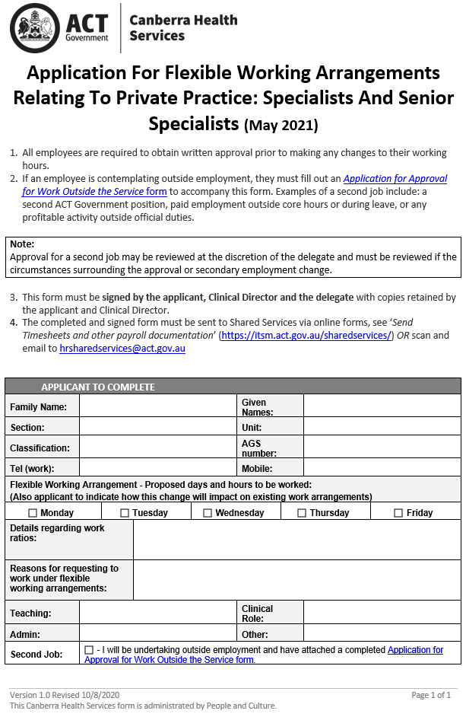

SAMPLE
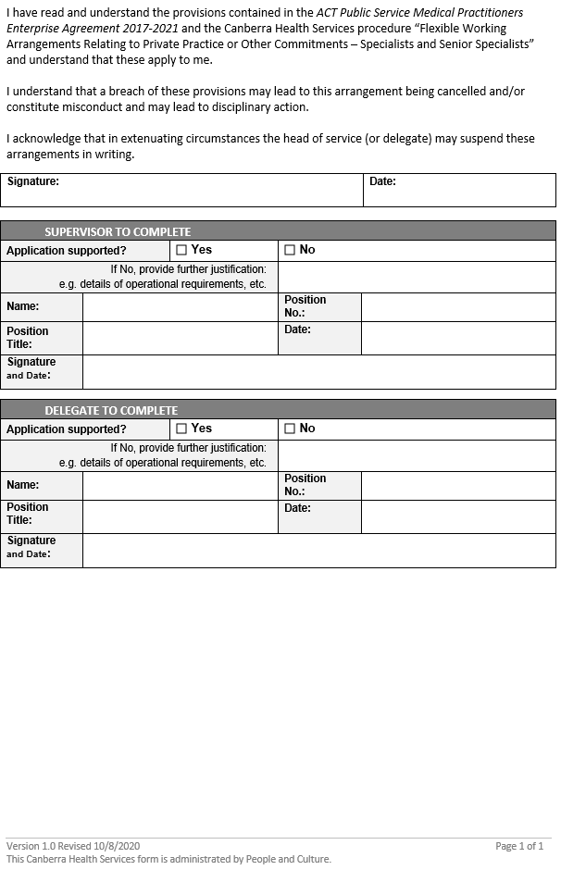

SAMPLE

