Guideline | Canberra Health Services
Early Pregnancy Service (EPS): First trimester complications
CHS24/449

Contents
Guideline statement 2
Scope 2
Background 2
Section 1 – Emergency Presentation 3
Section 2 – Assessment – Bleeding and Pain in Early Pregnancy 3
Section 3 – Pregnancy Viability 5
Section 4 – Management of Miscarriage 8
Section 5 – Ectopic Pregnancy 13
Section 6 – Gestational Trophoblastic Disease (GTD) 19
Section 7 – Psychological Support and Provision of Information 21
Evaluation 22
Related policies, procedures, guidelines and legislation 23
References 24
Definition of terms 27
Search terms 28
Attachments 28

Guideline statement
This guideline covers diagnosis and management of first trimester pregnancy complications including vaginal bleeding, miscarriage, ectopic pregnancies, and gestational trophoblastic disease.
The aim of this document is to ensure appropriate diagnosis and management of early pregnancy complications and enable the provision of supports. The terms 'woman' and 'women' are used throughout this document, recommendations also apply to people who do not identify as women but are pregnant or have given birth.
Back to Contents

Scope
This document applies to the following staff working within their scope of practice:
- Medical Officers
- Midwives and Nurses
- Student Midwives and Nurses under direct supervision
- Medical students under direct supervision.
Back to Contents

Background
First trimester complications such as miscarriage and ectopic pregnancy can cause significant maternal morbidity and mortality. Physical consequences can include infection, haemorrhage and damage to uterus and associated structures. Psychological complications such as grief, depression and anxiety are common.
- Miscarriage occurs in 12-15% of recognised pregnancies and vaginal bleeding that does not lead to miscarriage has been linked to pre-term birth, stillbirth, and low birth weight.
- Ectopic pregnancy is increasing in incidence due to earlier diagnosis along with an increased use of assisted conception. Incidence rates for ectopic pregnancy are between 1-2% of pregnancies with 92-95% occurring in the fallopian tube.
- Gestational trophoblastic disease or molar pregnancy occurs in approximately 1 in 1000 pregnancies. If diagnosed, appropriate follow up and treatment is essential for safest maternal outcome, and to safeguard future pregnancies.
There are limited interventions to protect a threatened pregnancy from miscarriage. However, high quality care can increase levels of satisfaction with care, minimise negative outcomes, and support women and their families to navigate their way through an emotional and highly stressful time.
Back to Contents

Section 1 – Emergency Presentation
Women who are believed to be pregnant, with haemodynamic instability and vaginal bleeding and/or pain (abdominal, diaphragmatic or shoulder tip pain) require urgent intervention and should be reviewed in the nearest Emergency Department.
Women who are experiencing early pregnancy complications and/or early pregnancy loss, and are haemodynamically stable, should seek care through referral pathways as described in the Early Pregnancy Service (EPS) model of care. Also refer to:
- Attachment 1 Ultrasound Pathway for First Trimester Pregnancy Presentations at CHS Emergency Department
Back to Contents
Routine administration of prophylactic Rh D immunoglobulin for vaginal bleeding in pregnancy less than 12 weeks is not recommended. However, if vaginal bleeding is heavy, ongoing, or associated significant pelvic trauma or abdominal pain, immunoprophylaxis may be considered in women with no preformed anti-D antibodies.
Refer to CHS Guideline Prophylactic use of Rh D immunoglobulin in pregnancy care National Blood Authority (2024)³¹

Section 2 – Assessment – Bleeding and Pain in Early Pregnancy

It is imperative to determine haemodynamic stability. Frequency of observations are directed from the women’s modified Early Warning Score (MEWS). All elements of antenatal MEWs require consideration (including vital signs, pain level and assessment of ongoing vaginal bleeding)
Vital signs should be recorded contemporaneously in the appropriate section of the woman’s digital health record (DHR)
- Symptoms such as hypotension, tachycardia and shoulder pain may suggest a ruptured ectopic or sepsis, both require urgent management.
- First set of clinical observations and the woman’s weight should be recorded in the arrival, discharge, and transfer section (ADT) of DHR to ensure correct episode of care is commenced and accuracy of medication calculations as required.
- See Attachment 2 Bleeding/Pain algorithm early pregnancy.

Table 1: Clinical Assessment-Bleeding and Pain in Early pregnancy
Aspect | Consideration
Haemodynamic instability | Initial assessment of haemodynamic stability is essential
History | Menstrual history and last normal menstrual period (LNMP)  Date of positive pregnancy test/Symptoms of early pregnancy  Previous pregnancies and outcomes, particularly miscarriages  Medical history including other significant gynaecological history and allergies  If assisted conception, identify method of conception  Relevant ultrasound scan (USS) and quantitative β-hCG
Clinical signs and symptoms | Vaginal bleeding (review timing, extent, and severity)  Passage of Products of Conception (POC)  Pain (lower abdominal cramping/backache shoulder tip/diaphragmatic/with defecation)  Vomiting  Signs of shock
Confirm pregnancy | Perform an urgent serum quantitative β-hCG on women of reproductive age presenting with suspected Early Pregnancy Loss (EPL), irrespective of last known menstrual period (LMNP), contraception, history of sterilisation or reported sexual inactivity.  - Negative serum β-hCG can excludes ectopic pregnancy (except in the unusual circumstance of a chronic ectopic where β-hCG has been positive in the recent past)
Physical examination | Baseline observations (temperature, heart rate, respiratory rate, blood pressure)  Abdominal examination  - Tenderness (rigidity and guarding)  - Distension  Vaginal blood loss  Vaginal examination (only if clinically indicated)  - Speculum examination:  - Source and amount of bleeding.  - Evidence of POC in the cervical os (if present, remove and submit for histology)  - Bi-manual examination (if clinically indicated):  Cervical motion tenderness & state of internal cervical os  Assess for adnexal masses (ectopic pregnancy or other masses)  Size of uterus relative to menstrual dates
Ultrasound scan | Bedside point of care ultrasound (POCUS) is useful to determine a fetal heart or the presence of free fluid.  If unable to perform POCUS, formal USS should be arranged urgently if clinically indicated
Other investigations and management | Collect blood group and antibody screen & full blood count,  Review routine maternal blood tests (Section 5, Australian Pregnancy Care Guidelines). Consider screening for infectious serology, if not completed. Screen for sexually transmitted infections, as clinically indicated.³³  If indicated, prescribe Anti-D for Rhesus negative women according to CHS Guideline: Prophylactic use of Rh D Immunoglobulin in Pregnancy Care³¹
Back to Contents

Section 3 – Pregnancy Viability

Sonographic anatomy and landmarks

Table 2. Determining viability and location of pregnancy
Aspect | Consideration
Normal β-hCG ^{19, 20} | - Serum β-hCG first becomes positive at 9 days post conception β-hCG greater than 5 IU/L confirms pregnant.  Mean doubling time for β-hCG is 1.4–2.1 days
Ultrasound scan ^{19, 20} | Transvaginal ultrasound (TVS) by an experienced sonographer is the gold standard in first trimester.  - If TVS unavailable, recognise that Transabdominal Ultrasound (TAS) may be less accurate.  An intra-uterine pregnancy (IUP) is usually visible on TVS when mean sac diameter (MSD) is ≥ to 3 mm.  Ultrasound Scan (USS) may be less reliable if.  - β-hCG >1500-2000  - fibroids/adenomyosis/multiple pregnancy
Serial β-hCG ^{19,20} | Serial β-hCG is recommended if woman is haemodynamically stable.  Repeat β-hCG 48 hours (up to 72 hours) after initial level.  A single β-hCG value:  Does not differentiate between a viable and nonviable pregnancy.  Cannot be used to determine pregnancy location
Discriminatory zone ^{19, 20} | When serum level of β-hCG is above which all normal intrauterine pregnancies should be seen  - No consensus on what β-hCG level defines the discriminatory zone with TVS.  - A single β-hCG value is not considered discriminatory.  - 1000 IU/L to 3500 IU/L if TVS  - Higher β-hCG levels are required if TAS only is used
Combined assessment variables | Quantitative serial serum β-hCG levels used in conjunction with serial TVS are often the only way to distinguish between an early non-viable pregnancy and an ectopic pregnancy in gestations less than 6–7 weeks  If β-hCG levels and TVS are not performed simultaneously, interpret results cautiously  Combined variables in prediction models outperform any variable in isolation  All management protocols are designed to be predictive, and risk stratify women, and not used as diagnostic tools
Source. Queensland Clinical Guidelines, 2022. Early Pregnancy Loss. Also available from Australasian Society of Ultrasound Medicine guidelines http://www.asum.com.au/

Table 3 Diagnosis of non-viable intrauterine pregnancy
Aspect | Consideration
Context | Diagnosis of non-viable IUP requires High quality TVS equipment and experienced operator  Criteria for excluding a viable pregnancy must be stringent enough to avoid interventions that inadvertently damage a viable pregnancy
Findings suspicious but not diagnostic | Mean Sac Diameter (MSD) 16–24 mm and no embryo visible  Crown rump length (CRL) less than 7 mm and no heartbeat  Absence of embryo with heartbeat 7–13 days after USS that showed a gestational sac without a yolk sac  Absence of embryo with heartbeat, 7–10 days after USS that showed a gestational sac with a yolk sac  Absence of embryo 6 weeks or more after LNMP  Empty amnion (amnion seen adjacent to yolk sac with no visible embryo)  Enlarged yolk sac (greater than 7 mm)  Small gestational sac in relation to the size of the embryo (less than 5 mm difference between MSD and CRL)
TVS diagnostic criteria | MSD is greater than or equal to 25 mm and no fetus present  Fetus with CRL greater than or equal to 7 mm is visible, but no fetal heart movements demonstrated after observation of at least 30 seconds  Absence of embryo with heartbeat:  - 14 days or more after USS that showed a gestational sac without a yolk sac  - 11 days or more after USS that showed a gestational sac with a yolk sac  - Absence of embryo with heartbeat 7 days or more after USS that showed a fetal pole less than 7 mm with no cardiac activity  - In an embryo that previously demonstrated cardiac activity
Repeat TVS interval | When no fetal pole is visible, diagnosis cannot be made until the MSD is (or has failed to reach) 25 mm. Therefore, the interval between initial and subsequent USS is dependent on the MSD at initial presentation  Estimate TVS interval based on expected normal gestational sac growth rate of 1 mm/day  Example: If MSD = 12 mm, repeat TVS in 13 days or more (12 mm MSD+13 mm growth over 13 days = expected MSD of 25 mm)

Table 4: Pregnancy outcomes
Aspect | Consideration
Complete miscarriage^{19,20} | IUP can only be confirmed conclusively after identification of a yolk sac  If no prior report or evidence of an IUP, a diagnosis of complete miscarriage cannot be made based on TVS findings of an ‘empty uterus’  Diagnosis of complete miscarriage requires follow-up with serum quantitative β-hCG until negative and TVS if clinically indicated, to exclude undiagnosed ectopic pregnancy
Threatened miscarriage^{19,20} | Follow-up with GP may be appropriate  PV Progesterone may improve live birth outcome in women with one or more previous miscarriages and early pregnancy bleeding ⁷  No improvement in live birth outcome in women with no previous miscarriage and early pregnancy bleeding ⁷
Pregnancy of unknown location (PUL)²¹ | PUL is a classification not a final diagnosis  PUL should be considered ectopic until proven otherwise  Perform serial β-hCG (48–72 hours apart), a single cut-off level for β-hCG, cannot be clinically interpreted in isolation  Perform TVS as clinically indicated  Specialist review and close follow-up is essential until resolution  If serial β-hCG rises more than 66%  An IUP is more likely (ectopic cannot be excluded)  If serial β-hCG falls 50% or more  A non-viable pregnancy is more likely (IUP or ectopic)  If serial β-hCG rises less than 66% or falls less than 50%  If no IUP on repeat TVS, suspect ectopic pregnancy.
Back to Contents

Section 4 – Management of Miscarriage
There is no significant difference in maternal outcomes between expectant, medical and surgical management for a non-viable IUP. Surgical management has the timeliest resolution (defined in most studies as complete emptying of the uterus and lack of need for unplanned surgery). The individual preferences and values of the woman as well as the clinical situation determine the choice of management ²⁴

Table 5. Expectant management of non-viable intrauterine pregnancy
Aspect | Consideration
Indications | Woman’s preference  Most suited to the management of incomplete miscarriage  The lower the β-hCG, the higher the likelihood of success
Contraindications | Suspected GTD (refer to section 6)  Haemodynamically unstable  Intrauterine device (requires removal)  Women at increased risk of haemorrhage (e.g. late in first trimester)  Evidence of infection  Consider the patient’s location and distance from the nearest hospital
Risk/Benefit ²⁴ | Less effective (defined as need for further treatment) than either medical or surgical management  More days of bleeding and a greater amount of bleeding compared to surgical treatment  Fertility is similar after both medical and expectant management  Timeframe to complete miscarriage is unpredictable  - No differences between medical and expectant management for short and long-term emotional distress
Ongoing Management | Phone consultation from EPS staff on day 7 to evaluate if clinical history is consistent with the passing of pregnancy  If indicated, prescribe Anti-D for Rhesus negative women according to CHS Guideline: Prophylactic use of Rh D Immunoglobulin in Pregnancy Care³¹  Advise repeat urinary bHCG in 2 weeks  Second phone consultation day 14. If expectant management successful, transfer of care to General Practitioner (GP). DHR discharge summary of care will be forwarded at this time.  For USS and repeat bHCG if clinically indicated to assess for retained POC  Discuss options for continued expectant management or surgical or medical management:  At the woman’s request  If there is ongoing heavy bleeding, pain or persistent intrauterine gestational sac identified on USS  If other clinical concerns identified (e.g., heavy bleeding, pain)  If infection suspected, recommend early surgical management with antibiotic cover  Failure to return to normal menstruation by 4–6 weeks  Ongoing abnormal bleeding
Advice for women | Expect bleeding for up to two weeks (or longer in individual cases)  Provide advice on how much bleeding is too much  Advise surgical or medical management can be chosen at a later date.  Provide advice on pain relief and where and when to get help in an emergency  Ensure appropriate fact sheets are offered  - Fact sheets about miscarriage - Miscarriage Australia  - The Pink Elephants Support Network - Understanding Miscarriage  .

Table 6. Medical management of non-viable intrauterine pregnancy
Aspect | Consideration
Indications | Woman’s Preference  Missed or incomplete miscarriage
Mifepristone and misoprostol¹ | If missed miscarriage, mifepristone and misoprostol combined regimen may be more effective than misoprostol alone and may reduce surgical intervention
Contraindications | Suspected GTD (see section 9)  Haemodynamically unstable  Increased risk of haemorrhage (e.g. late first trimester)  Evidence of infection  Intrauterine device (requires removal)  Medical contraindications (e.g. uncontrolled hypertension, allergy to prostaglandins)
Risk/Benefit ²⁴ | Effective alternative to surgical evacuation for miscarriage  If missed miscarriage, medical management is more effective than expectant management  If incomplete miscarriage, no significant difference in effectiveness between medical and expectant management  Bleeding is heavier and more prolonged after medical treatment with misoprostol than with surgical management
Administration | Treatment can be offered as an outpatient or day procedure if gestation < 63 days.  Medical management for gestations > 63 days require inpatient management after cervical priming.  Offer oral analgesia and anti-emetics as per Australian Therapeutic Guidelines recommendations for oral drugs for moderate acute nociceptive pain in adults
Ongoing Management | EPS phone will contact call day 2-3 to confirm if first dose of misoprostol has been successful.  If Rhesus negative, prescribe Anti-D according to Prophylactic use of Rh D Immunoglobulin in Pregnancy Care Guideline  Follow up USS is not indicated if the clinical history indicates successful medical management.  Recommend urinary pregnancy test at 3–6 weeks^{14.}  USS may be indicated if:  bleeding is heavier than the normal menstrual period or contains clots  cramping persists  bleeding settled but has restarted and is as heavy as the person’s normal period for at least the past 24 hours  Surgical management not indicated within one week of medical management unless:  The woman requests it  There are clinical concerns (e.g., ongoing heavy bleeding, pain)
Advice for women | Inform women:  Bleeding heavier than menses is likely  Cramping may accompany bleeding  If bleeding has not commenced by 24 hours following treatment  Contact healthcare provider to determine ongoing care  Potential side-effects include pain, diarrhoea and vomiting
Medication Dosage ¹ | For prescription use First Trimester Pregnancy Complications Order Set- Medical Management  - Order sets are gestationally appropriate and allow individualised choices for analgesia.  - evidence supports paracetamol and nonsteroidal anti-inflammatory drug and oral opioid (Therapeutic Guidelines analgesia recommendations- oral drugs for moderate acute nociceptive pain in adults)  Medical Management for missed miscarriage <63 days.  - Day 0: Mifepristone 200mg (clinic administered)  - Day 1: Misoprostol 800 micrograms PV or buccal (24 hours after mifepristone)  Medical Management for incomplete miscarriage <63 days  - Day 1: misoprostol 800 micrograms PV or buccal  If there is no clinical history of products of conception being passed an additional dose of misoprostol can be given:  - Day 2 or Day 3: repeat misoprostol 800 micrograms PV, or buccal  - This order can also be used if mifepristone contraindicated for missed miscarriage.  Medical Management for Miscarriage >63 days  - Day 0: Mifepristone 200mg (clinic administered)  - Day 2: Inpatient management for misoprostol as per Perinatal Loss and Abortion care guidelines

Table 7. Surgical management of non-viable intrauterine pregnancy
Aspect | Consideration
Indications | Woman’s preference  Unsuccessful medical or expectant management  Recommend if:  - Haemodynamic instability  - Persistent excessive vaginal bleeding  - Evidence of infected retained tissue  - Suspected GTD  Suction curettage is the recommended method, with consideration of intraoperative ultrasound
Cautions²⁵ | Caution if:  - Increased risk of haemorrhage (e.g., suspected GTD, suspected arteriovenous malformation or coagulopathy)  - Previous uterine perforation
Risk/Benefit ^{1,24,25,26} | As a primary approach, surgical management results in a more immediate outcome with less follow-up  Standard risks associated with procedure and anaesthesia
Cervical Priming ^{1,24,25,26} | Clinical experience supports the use of cervical ripening agents prior to surgical evacuation.  For prescription Use First Trimester Pregnancy Complications order set – Surgical Management  Recommended dose ¹  - Misoprostol 400 micrograms, buccal 1-2 hours prior to surgery for first trimester miscarriage or retained products of conception.  - Consider a longer administration time +/- mifepristone for later gestations.
Follow Up | Advise GP follow-up if ongoing clinical concerns.  β-hCG not routinely indicated  USS not routinely recommended.  Histology results should be checked by the operating surgeon and/or EPS  If Rhesus negative, prescribe Anti-D according to Prophylactic use of Rh D Immunoglobulin in Pregnancy Care Guideline
Repeat Curettage | Consider initial hysteroscopy or USS guided curettage to facilitate uterine evacuation and minimise risk of Asherman’s syndrome  Administer antibiotics as per Therapeutic Guidelines, Antibiotic recommendations for non-severe postpartum endometritis  Therapeutic Guidelines can be accessed via the CHS HealthHub home page “Clinical Apps”
Back to Contents

Section 5 – Ectopic Pregnancy
Ectopic pregnancy is a pregnancy that is not located in the uterus with the fertilised egg implanting in a location other than the endometrium. The large majority (95%) of ectopic pregnancies occur in the fallopian tube.
Ectopic pregnancy is suspected when a woman presents with a history of amenorrhea, positive β-hCG in urine and/or blood serum with combination of pelvic pain and/or abnormal bleeding in the first trimester of pregnancy. Risk factors associated with ectopic pregnancy are outlined in Attachment 3. Clinical presentation and treatment as per Table 8.

Table 8: Ectopic pregnancy presentation and treatment options
Aspect | Consideration
Context ^{10,11} | Occurs in 1–2% of pregnancies with 92–95% occurring in the fallopian tube ^{10,11}  Increasing rates of non-tubal ectopic pregnancy (i.e., caesarean scar, cervical, heterotopic, ovarian, and abdominal), especially caesarean scar pregnancy ¹¹  Failure to promptly diagnose and manage an ectopic pregnancy can be life threatening ¹¹  Responsible for 80% of maternal deaths in the first trimester ¹¹
Clinical Presentation ^{1, 10} | Absence of menses  Irregular vaginal bleeding/spotting (not all cases)  Abdominal pain, tenderness, and palpable adnexal mass in 50% of women  Cervical motion tenderness (some cases)  Absence of IUP on TVS with positive serum β-hCG  Suspect a ruptured ectopic if:  - Shoulder tip or diaphragmatic pain (10–20% of ruptured ectopic)  - Intra-abdominal free fluid on US  - Tachycardia/hypotension (from intraperitoneal haemorrhage)
Options for Treatment ¹² | Expectant, medical, and surgical treatments are available depending upon the clinical situation and the patient’s preference. Refer to:  - Table 9. Expectant management of ectopic pregnancy  - Table 10. Medical management of ectopic pregnancy  - Table 11. CHS Methotrexate prescription and dispensing requirements  Falling or stationary β-hCG does not exclude the risk of rupture following medical or expectant management
Non fallopian tube ectopic ¹¹ | Expectant, surgical or medical may be appropriate depending on individual circumstances (e.g., location, gestation, and urgency of treatment)  Individualise management, seek expert advice as per  - Table 13. Interstitial and non-tubal ectopic pregnancies  - Table 14. Methotrexate multidose regime

Table 9: Expectant management of ectopic pregnancy
Aspect | Consideration
Context | Advances in imaging technology has enabled earlier and accurate diagnosis of ectopic pregnancy ^{1,10}  Among selected women (early gestation, with β-hCG values below 1000 IU/L and decreasing) up to 70% reported to resolve spontaneously without therapy ¹⁰
Suitability Criteria ^{1,10} | Haemodynamically stable  Low and falling β-hCG (less than 1500 IU/L at initial presentation)  - Physical resolution is positively correlated with initial and maximum βhCG  Tubal mass less than 3 cm  No FHR  No pain  Nil to minimal evidence of blood in the pelvis on USS  Woman not geographically isolated  Not recommended where reliability of compliance with follow-up is uncertain
Ongoing management | Follow up occurs through EPS  Repeat β-hCG:  - Every 48 hours initially  - Weekly depending on trend.  USS as clinically indicated.  - consider if β-hCG not consistently falling or clinically indicated.  Consider surgical or medical management:  - If there is ongoing or increasing pain or bleeding  - If β-hCG is not consistently falling  - If tubal rupture with haemoperitoneum occurs
Advice for women | Provide the following information.  - Tubal rupture remains a risk despite decreasing β-hCG  - Sexual intercourse may increase risk of rupture in acute phase of resolution.  - Recommend an early USS in next pregnancy (5–6 weeks gestation) due to increased risk of ectopic in future pregnancies.  Patient resources for Ectopic Pregnancy available from the following CHS approved websites:  - https://brochures.mater.org.au/brochures/mater-mothers-hospital  - https://www.thewomens.org.au/health-information/pregnancy-and-birth/pregnancy-problems/early-pregnancy-problems/ectopic-pregnancy/
Source: Adapted from Queensland Clinical Guidelines (2022) Early Pregnancy Loss

Table 10. Medical management of ectopic pregnancy - Methotrexate
Aspect | Consideration
Context | Methotrexate (MTX) is a folic acid antagonist which prevents the growth of rapidly dividing cells by interfering with DNA synthesis
Indications | Unruptured ectopic pregnancy with fetal sac less than 3.5 cm  NO Fetal Heart Rate (FHR)  Low initial serum β-hCG <3000 IU/L  - Haemodynamically stable and no signs of active bleeding ^{1,11,12}  Full Blood Count (FBC), electrolytes and liver function tests (LFT) within normal range  Unusual sites (e.g., cervical, caesarean scar) ⁹
Contraindications ¹ | Haemodynamically unstable  Hypersensitivity to MTX  Evidence of haemoperitoneum on TVS  Renal disease/insufficiency (methotrexate cleared via the renal system)  Abnormal FBC and/or ELFT  Acute liver disease, aplastic anaemia, thrombocytopenia  Immunodeficiency  Active pulmonary disease  Active peptic ulcer disease  Coexistent viable IUP (heterotopic pregnancy)  Breastfeeding  Unable to participate in prolonged follow-up (35–109 days)  Geographic isolation
Cautions ¹ | Baseline serum β-hCG greater than 3000 IU/L  Ectopic pregnancy greater than 3–4 cm diameter on TVS  Presence of fetal heart motion on TVS  When blood transfusion is not acceptable to the woman
Post Procedural Care | Refer to Table 12: Methotrexate-Administration and post procedural care for ectopic pregnancy.  Post procedural care is through EPS.
Source: Adapted from Queensland Clinical Guidelines (2022) Early Pregnancy Loss

Table 11. CHS Methotrexate prescription and dispensing requirements
Methotrexate prescription and dispensing requirements
Maximum dose (50mg/m²) capped at 2m² maximum dose of 100 mg in patients with normal renal function.

Methotrexate is dispensed in pre-filled syringes in the following strengths: 10mg, 25mg, 50mg and 80mg.
Ensure documentation of current height and weight in the woman’s DHR record for BMI calculation.
Methotrexate is ordered per inpatient or outpatient status.
Dose is rounded to the nearest 5mg, Rounding down is preferable to limit any toxicities.
Ensure appropriate patient education and provide written information prior to administration. Methotrexate for ectopic pregnancy (worldssl.net)

Table 12. Methotrexate-Administration and post procedural care for ectopic pregnancy
Intramuscular Injection (IM) Methotrexate for Ectopic Pregnancy
Prior to commencement | Collection of FBC, Group & Hold, U&Es, LFTs & β-hCG prior to each injection of methotrexate  If Rhesus negative, prescribe Anti-D according to Prophylactic use of Rh D Immunoglobulin in Pregnancy Care Guideline  Antiemetic 30 minutes prior to methotrexate
Post-dose | Monitor for 30 minutes post methotrexate administration for hypersensitivity reactions (rare)  Ensure prescription for antiemetic BD PRN for 2 days
Day 1 (Treatment Day) | Methotrexate 50 mg/m2 BSA capped at 2m² (maximum dose of 100 mg) IM injection. Prescription per Table 11.  Administer IM into the buttock or lateral thigh by chemotherapy competent clinician.  Women with dosage requirements that exceed BSA of 2m² are more likely to require an additional dose to achieve resolution
Day 4 | β-hCG level
Day 7 | β-hCG level  Repeat USS in one week and thereafter as clinically indicated.  If day 7 β-hCG reduction is less than 15% of day 4 β-hCG, seek medical review for consideration for second dose of methotrexate 50 mg/m2 BSA IM injection
Day 14 | β-hCG  USS if clinically indicated.  If β-hCG reduction is less than 15% of day 7 or FHR on USS for immediate medical review  If β-hCG not consistently falling, ectopic site may be other than fallopian tube
Ongoing Monitoring | Monitor the β-hCG weekly until less than 5 IU/L

Table 13. Interstitial and non-tubal ectopic pregnancies
Aspect | Consideration
Interstitial and non-tubal ectopic pregnancies  (ovarian, cervical, and caesarean section (CS) scar pregnancy (CSP)) | Incidence increasing with rising CS rate and advanced imaging modalities^{9,11}  With one or more previous CS, the incidence is estimated as 1 per 531 women ⁹  Limited evidence to inform optimal management ^{9,11, 34}  Expectant management of CSP can result in live birth, but also severe morbidity (e.g. uterine rupture, placenta accreta, haemorrhage) ^{9,11, 34}  When diagnosis of CSP is made and parents wish to continue pregnancy, they should be informed that uterine rupture may unexpectedly occur at any time during pregnancy ³⁴  Treatment of interstitial and non-tubal ectopic pregnancies needs to be individualized with Specialist Gynaecologist, Gynaecology Oncology Consultant or Medical Oncologist

Table 14. Methotrexate multidose regime
There is no authoritative therapeutic guideline for multidose regimens for administration of Methotrexate. The following regimen may be suitable in these circumstances. ^{9,11,21,23,29}
Regimen | Monitoring
Administer methotrexate, 1mg/kg IM, on alternate days (days 1,3,5,7) – maximum 4 doses, according to HCG levels | BHCG weekly until <5 IU/L
Administer leucovorin calcium 7.5mg oral tablets or 6mg IM on alternate days (days 2,4,6,8) | Initial blood count platelets and liver enzymes, repeat day 7
Continue until BHCG drops by >15% in 48 hours or 4 doses methotrexate given
Back to Contents

Section 6 – Gestational Trophoblastic Disease (GTD)
Gestational trophoblastic disease (GTD) is a spectrum of conditions arising from abnormal trophoblastic tissue. The incidence of molar pregnancies is approximately 1:1000 pregnancies. GTD has cure rates approaching almost 100% and, in most cases, the woman can have further normal pregnancies (RANZCOG, 2019). Trophoblast disease is classified as pre-malignant or malignant forms as below.

Table 15: Classification of Gestational Trophoblastic disease
Classification | Includes
Non-neoplastic lesions | Exaggerated placental site reaction.  Benign placental site nodule
Molar pregnancies  Pre-malignant | Partial hydatiform mole (HM)  Complete hydatiform mole (HM)
Gestational Trophoblastic Neoplasms (GTN) Malignant | Persistent GTD (invasive mole)  Gestational choriocarcinoma  Placental site trophoblastic tumour (PSTT)  Atypical placental site nodule (APSN)  Epithelioid trophoblastic tumour (ETT)

Table 16. Immediate Management of GTD
Aspect | Consideration
Clinical Presentation ^{27,28} | Most common: abnormal vaginal bleeding  Incidental finding on pelvic ultrasound in first trimester  Less common (due to earlier USS diagnosis): excessive hyperemesis, hyperthyroidism, early onset pre-eclampsia, excessive uterine enlargement ²⁷  Consider GTD as differential diagnosis if abnormally high β-hCG ^{27,28}
Diagnosis | Complete HM are more likely than partial HM to be identified by their characteristic USS features ²⁷  Normal USS does not exclude the diagnosis of a HM  - Definitive diagnosis is made by histological examination of the POC.
Interventions ^{27,28} | Requires specialist Obstetric/Gynae Oncology input, recommend suction curettage ^{27.}  Consider:  - Misoprostol for pre-surgical cervical priming is appropriate  - Performance may be assisted by USS guidance  - The use of oxytocin during the procedure should be avoided if possible  If retained POC a possibility, ongoing care requires discussion with gynae/oncology registrar prior to booking procedure  If future fertility not desired, hysterectomy may be an alternative, however usually reserved for selected cases of persistent GTD ²⁸  Medically induced evacuations of known molar pregnancies not usually recommended ²⁷  Prescribe Anti-D for Rhesus negative women as per CHS Guideline: Prophylactic use of Rh D Immunoglobulin in Pregnancy Care

Table 17. Ongoing Management of GTD
Aspect | Consideration
Follow up ^{27,28} | Pregnancy should be avoided in the follow up periods, appropriate contraception should be discussed.  Partial HM  Weekly serum β-hCG (T) levels until negative for three consecutive weeks ²⁷  Advise can try to conceive following completion of surveillance.  Complete HM  Weekly serum β-hCG (T) until negative for three consecutive weeks²⁷  Then monthly for 6 months after the third negative result ²⁷  Perform β-hCG levels 6 weeks after any future pregnancy.  Failure of resolution of serum bHCG requires prompt discussion with gynae oncology.  Provide counselling and written patient information on the importance of follow-up. Document discussion in clinical record.  Patient resources available from the following CHS approved websites.  https://ranzcog.edu.au/wp-content/uploads/2022/05/Gestational-Trophablastic-Disease.pdf  https://thewomens.r.worldssl.net/images/uploads/fact-sheets/Hydatidiform-Mole.pdf
Future fertility | Recommend effective contraception to avoid pregnancy until β-hCG follow-up is complete  Hormonal contraception during follow-up does not increase risk or severity of GTN nor postpone normalisation of β-hCG ²⁷  Intrauterine device insertion after normalisation of β-hCG levels ²⁷  Perform β-hCG levels 6 weeks after any future pregnancy ²⁸  Risk of recurrent GTD approximately 1 per 100 future pregnancies ^{27,28}
Post molar GTN | Overall incidence of post-molar GTD is approximately 20% for complete mole and > 1% for partial mole ³²  Risks for development include: β-hCG at diagnosis greater than 100,000 IU/L, excessive uterine size, and maternal age more than 40 years ³²  Consider persistent disease after surgical evacuation where there is:  - Plateauing of β-hCG (+/-10%) for 4 consecutive values over 3 weeks (i.e. day 1, 7, 14, 21)  - A rise in β-hCG levels (10% or more) for 3 values over 2 weeks (i.e. day 1,7,14)  - Histologic diagnosis of choriocarcinoma or clinical and/or radiologic evidence of metastases  Refer to Attachment 4: Pathway for GTD follow up.
Back to Contents

Section 7 – Psychological Support and Provision of Information
Treat all women with early pregnancy complications with dignity and respect. Provide all women with information and support in a sensitive manner, and appropriate to their individual circumstances.
- Healthcare professionals should be aware that complications in early pregnancy can cause significant distress for women and their partners. They should also be aware that women will react to pregnancy complications or the loss of a pregnancy in different ways.
- Non-clinical staff, such as receptionists, working in settings where early pregnancy care is provided should be given training on how to communicate sensitively with women who experience early pregnancy complications. For more guidance about support, see Red Nose Australia, professional hub. Professionals’ hub | Red Nose Australia
- After an early pregnancy loss, offer the woman the option of a follow-up appointment with a healthcare professional of her choice.
Ensure provision of evidence-based information include (as appropriate):
- when and how to seek help if existing symptoms worsen or new symptoms develop, including a 24-hour contact telephone number.
- what to expect during the time she is waiting for an ultrasound scan, what to expect during her care, such as the potential length and extent of pain and/or bleeding, and possible side effects; this information should be tailored to the care she receives.
- information about postoperative care (for women undergoing surgery).
- what to expect during the recovery period – e.g., when it is possible to resume sexual activity and/or try to conceive again, and what to do if she becomes pregnant again (this information should be tailored to the care she receives).
- where to access support and counselling services, including leaflets, web addresses and helpline numbers for support organisations.
Fact sheets for women and their partner/support person/families can be resourced from
- Miscarriage Australia Fact sheets about miscarriage - Miscarriage Australia
- Pink Elephants Support Network The Pink Elephants Support Network - Home
Back to Contents

Evaluation
Outcome
- Women with early pregnancy complications such as missed or incomplete miscarriage, suspected ectopic pregnancy or suspected molar pregnancy will have appropriate referrals, management of care and follow up as per this guideline.

Measures
- Review of all women who require early pregnancy assessment and management through the EPS model of care will occur at monthly gynaecology and EPS audit meeting to ensure appropriate management and follow up has occurred.
Back to Contents

Related policies, procedures, guidelines and legislation

Policies
- Work Health and Safety Management Policy
- Work Health and Safety Policy

Procedures
- Health Care Associated Infections Clinical Procedure
- Patient Identification and Procedure Matching Policy

Guidelines
- Consent for Healthcare Treatment
- Admissions from the Emergency Department to Ward Procedure
- Chemotherapy Care of the Adult Patient (eviQ)
- Fasting Guidelines for Patients Requiring Sedation or Anaesthesia
- Post Operative Handover and Observations - Adult Patients (First 24 hours)
- Prophylactic use of Rh D Immunoglobulin in Pregnancy Care
- Vital Signs & Early Warning Scores – The Canberra Hospital Inpatients

Legislation
- Health Records (Privacy and Access) Act 1997
- Human Rights Act 2004
- Work Health and Safety Act 2011
- Carers Recognition Act 2021

Other
- Australian Charter of Healthcare Rights
Back to Contents

References
- The Royal Australian and New Zealand College of Obstetricians and Gynaecologists. RANZCOG recommendations Ectopic pregnancy and Miscarriage.2023. Available from: https://www.ranzcog.edu.au
- The Royal Australian and New Zealand College of Obstetricians and Gynaecologists. RANZCOG Statement for the management of gestational trophoblastic disease. 2017. Available from: https://www.ranzcog.edu.au
- Quenby S, Gallos ID, Dhillon-Smith RK, Podesek M, Stephenson MD, Fisher J, et al. Miscarriage matters: the epidemiological, physical, psychological, and economic costs of early pregnancy loss. The Lancet 2021;397(10285):1658-67. Miscarriage matters: the epidemiological, physical, psychological, and economic costs of early pregnancy loss - PubMed (nih.gov)
- Hendriks E, Rosenberg R, Prine L. Ectopic Pregnancy: Diagnosis and Management. Am Fam Physician. 2020 May 15;101(10):599-606. PMID: 32412215. Ectopic Pregnancy: Diagnosis and Management - PubMed (nih.gov)
- National Institute for Health and Care Excellence (NICE). 2019. Ectopic pregnancy and miscarriage: Diagnosis and initial management in early pregnancy of ectopic pregnancy and miscarriage, NICE guidelines (NG126). Ectopic pregnancy and miscarriage: diagnosis and initial management (nice.org.uk)
- Dainty KN, Seaton MB, McLeod S, Tunde-Byass M, Tolhurst E, Rojas-Luengas V, et al. Reframing how early pregnancy loss is viewed in the emergency department. Qualitative Health Research 2021;31(6):1119-28 Reframing How Early Pregnancy Loss Is Viewed in the Emergency Department - PubMed (nih.gov)
- Magnus, M.C., Hockey, R.L., Håberg, S.E. et al. Pre-pregnancy lifestyle characteristics and risk of miscarriage: the Australian Longitudinal Study on Women’s Health. BMC Pregnancy Childbirth 22, 169 (2022). https://doi.org/10.1186/s12884-022-04482-9 Pre-pregnancy lifestyle characteristics and risk of miscarriage: the Australian Longitudinal Study on Women’s Health | BMC Pregnancy and Childbirth | Full Text (biomedcentral.com)
- Palmer AD, Murphy-Oikonen J. Social work intervention for women experiencing early pregnancy loss in the emergency department. Social Work in Health Care 2019;58(4):392-411. Social work intervention for women experiencing early pregnancy loss in the emergency department - PubMed (nih.gov)
- Tanaka K, Coghill E, Ballard E, Sekar R, Amoako A, Khalil A, Baartz, D. Management of caesarean scar pregnancy with high dose intravenous methotrexate infusion therapy: 10-year experience at a single tertiary centre. European Journal of Obstetrics & Gynecology and Reproductive Biology 2019;237:28-32. https://www.researchgate.net/publication/336091963_Caesarean_Scar_Ectopic_Pregnancy
- Xiao C, Shi Q, Cheng Q, Xu J. Non-surgical management of tubal ectopic pregnancy: A systematic review and meta-analysis. Medicine (Baltimore) 2021;100(50). https://pubmed.ncbi.nlm.nih.gov/34918633/
- Long Y, Zhu H, Hu Y, Shen L, Fu J, Huang W. Interventions for non-tubal ectopic pregnancy. Cochrane Database of Systematic Reviews. [Internet]. 2020, [cited 2022 April 05]. Issue 7. Art No.: CD011174 https://www.ncbi.nlm.nih.gov/pmc/articles/PMC7389314/
- Colombo GE, Leonardi M, Armour M, Di Somma H, Dinh T, da Silva Costa F. Efficacy, and safety of expectant management in the treatment of tubal ectopic pregnancy: a systematic review and meta-analysis. Human Reproduction Open 2020;2020(4). https://pubmed.ncbi.nlm.nih.gov/33134560/
- King Edwards Memorial Hospital (2019). Pregnancy care: First trimester complications. Pregnancy First Trimester KEMH 23.pdf
- Queensland Clinical Guidelines (2021) Early Pregnancy Loss. Guideline: Early pregnancy loss (health.qld.gov.au)
- Royal Women’s Hospital Victoria (reviewed 2023). Health information Ectopic pregnancy: management. https://www.thewomens.org.au/health-information/pregnancy-and-birth/pregnancy-problems/early-pregnancy-problems/ectopic-pregnancy/
- Mater Mothers Information Group (reviewed 2023). Ectopic Pregnancy https://brochures.mater.org.au/brochures/mater-mothers-hospital
- Queensland Health-Having a Miscarriage (reviewed 2023) https://www.health.qld.gov.au/__data/assets/pdf_file/0039/1189596/c-epl-after-miscarriage.pdf
- Queensland Health-Ectopic Pregnancy (reviewed 2023) https://www.health.qld.gov.au/__data/assets/pdf_file/0028/651583/c-epl-ectopic.pdf
- Doubilet PM, Benson CB, Bourne T, Blaivas M. Diagnostic criteria for nonviable pregnancy early in the first trimester. New England Journal of Medicine 2013;369(15):1443-51. https://www.nejm.org/doi/full/10.1056/nejmra1302417
- Bobdiwala S, Kyriacou C, Christodoulou E, Farren J, Mitchell-Jones N, Al-Memar M, et al. Evaluating cut-off levels for progesterone, beta human chorionic gonadotropin and beta human chorionic gonadotropin ratio to exclude pregnancy viability in women with a pregnancy of unknown location: A prospective multicentre cohort study. Acta Obstetricia et Gynecologica Scandinavica 2021;101(1):46-55. https://www.ncbi.nlm.nih.gov/pmc/articles/PMC9564682/
- Bobdiwala S, Saso S, Verbakel JY, Al‐Memar M, Van Calster B, Timmerman D, et al. Diagnostic protocols for the management of pregnancy of unknown location: a systematic review and meta‐analysis. British Journal of Obstetrics and Gynaecology 2019;126(2):190-8. https://obgyn.onlinelibrary.wiley.com/doi/full/10.1111/1471-0528.15442
- Royal Women’s Hospital Victoria.2020. Ectopic Pregnancy management. Ectopic Pregnancy Management (worldssl.net)
- Hamed HO, Ahmed SR, Alghasham AA. Comparison of double- and single-dose methotrexate protocols for treatment of ectopic pregnancy. Int J Gynaecol Obstet. 2012 Jan;116(1):67-71. doi: 10.1016/j.ijgo.2011.08.009. Comparison of double- and single-dose methotrexate protocols for treatment of ectopic pregnancy - PubMed (nih.gov)
- Chu J, Hardy P, Beeson L, Coomarasamy A. What is the best method for managing early miscarriage? British Medical Journal (BMJ) 2020;368: l6438-l. What is the best method for managing early miscarriage? - PubMed (nih.gov)
- Ghosh J, Papadopoulou A, Devall AJ, Jeffery H, Beeson L, Do V, et al. Methods for managing miscarriage: a network meta-analysis (review). Cochrane Database of Systematic Reviews. [Internet]. 2021, [cited 22 April 08]. Issue 6. Art No.: CD012602. DOI: 10.1002/14651858.CD012602.pub2. https://pubmed.ncbi.nlm.nih.gov/34061352/
- Australian Medicines Handbook. Misoprostol. [Internet]. Adelaide: Australian Medicines Handbook Pty Ltd; January 2022. Available from https://amhonline.amh.net.au/
- Tidy J, Seckl M, Hancock B, on behalf of the Royal College of Obstetricians and Gynaecologists. Management of gestational trophoblastic disease (Green-top Guideline No.38). British Journal of Obstetrics and Gynaecology 2021;128:e1- e27. https://pubmed.ncbi.nlm.nih.gov/32996207/
- Horowitz NS, Eskander RN, Adelman MR, Burke W. Epidemiology, diagnosis, and treatment of gestational trophoblastic disease: a Society of Gynecologic Oncology evidenced-based review and recommendation. Gynecologic Oncology 2021;163(3):605-13. https://pubmed.ncbi.nlm.nih.gov/34686354/
- Keikha F, Ardkeen SS, Parsaei M, Zargarzadeh N, Hadizadeh A, Tarafdari A. Methotrexate as the first-line treatment of unruptured tubular ectopic pregnancies with high initial human chorionic gonadotropin levels: A retrospective cohort. Eur J Obstet Gynecol Reprod Biol X. 2024 Feb 7;21:100286. doi: 10.1016/j.eurox.2024.100286. PMID: 38371725; PMCID: PMC10869305.
- Medical Abortion (published 2020). In: Therapeutic Guidelines. Sexual and Reproductive Health. Melbourne: Therapeutic Guidelines Limited (2023)
- National Blood Authority, 2024. Guideline for the prophylactic use of Rh D immunoglobulin in pregnancy care. Guideline for the prophylactic use of Rh D immunoglobulin in pregnancy care (blood.gov.au)
- Albright BB, Shorter JM, Mastroyannis SA, Ko EM, Schreiber CA, Sonalkar S. Gestational trophoblastic neoplasia after human chorionic gonadotropin normalization following molar pregnancy: a systematic review and meta-analysis. Obstetrics & Gynecology 2020;135(1). Gestational Trophoblastic Neoplasia After Human Chorionic Gonadotropin Normalization Following Molar Pregnancy: A Systematic Review and Meta-analysis - PubMed (nih.gov)
- Core Practices in Maternity Care. Section 5. Australian Pregnancy Care Guidelines. 2024. Living Evidence for Australian Pregnancy and Postnatal Care (LEAPP). Australian Living Evidence Collaboration. https://livingevidence.org.au/living-guidelines/leapp/
- D'Antonio F, Cali G, Khalil A, Timor-Tritsch T: Caesarean Scar Pregnancy, Visual Encyclopedia of Ultrasound in Obstetrics and Gynecology, www.isuog.org, February 2022. https://www.isuog.org/education/visuog/obstetrics/early-pregnancy/ectopic-pregnancy/uterine-ectopic-pregnancy/cesarean-scar-pregnancy.html
- Pink Elephants Support Network.
Back to Contents

Definition of terms
β-hCG: Beta Human chorionic gonadotrophin
BMI: Body Mass Index
EPS: Early Pregnancy Service
FBC: Full blood Count
GP: General Practitioner
GTD: Gestational Trophoblastic Disease
GTN: Gestational Trophoblastic Neoplasm
MSD: Mean sac diameter
POC: Products of conception
PUL: Pregnancy of unknown location
LFT’s: Liver Function Tests
TAS: Transabdominal ultrasound
TVS: Transvaginal ultrasound
UEC: Urea Electrolyte and Creatinine
USS: Ultrasound Scan
Back to Contents

Search terms
Maternity, Early pregnancy care unit, EPS, Miscarriage, Emergency, Pregnancy, Misoprostol, Methotrexate, Gestational Trophoblastic Disease, Molar Pregnancy
Back to Contents

Attachments
Attachment 1-Bleeding/Pain algorithm early pregnancy
Attachment 2-Expectant Management of Ectopic Pregnancy
Attachment 3- Body Surface Area Table for calculation of single dose methotrexate regime
Attachment 4- Pathway for GTD follow up.
Attachment 5. Body Surface Area Table for calculation of single dose methotrexate regime
Attachment 6: Pathway for GTD follow up.
Back to Contents

For Policy Team to complete:
Date amended | Section amended | Divisional approval | Final approval
10/10/2024 | New Document Added | Sarah Watson, A/G Executive Director, WY&C | Policy Document Review Panel
This document supersedes the following:
Document number | Document name
CHHS18/079 | Early Pregnancy Assessment Unit (EPAU)

Disclaimer
This document has been developed by Canberra Health Services specifically for its own use. Use of this document and any reliance on the information contained therein by any third party is at his or her own risk and Canberra Health Services assumes no responsibility whatsoever.
Back to Contents
Acknowledgement of Country  Canberra Health Services acknowledges the Ngunnawal people as traditional custodians of the ACT and recognises any other people or families with connection to the lands of the ACT and region. We acknowledge and respect their continuing culture and contribution to the life of this region.  © Australian Capital Territory, Canberra 2024 | Accessibility  call (02) 5124 0000   Interpreter call 131 450  canberrahealthservices.act.gov.au/accessibility  

Attachment 1: Ultrasound and referral Pathway for early pregnancy presentation to CHS Emergency with PV bleeding/pelvic pain
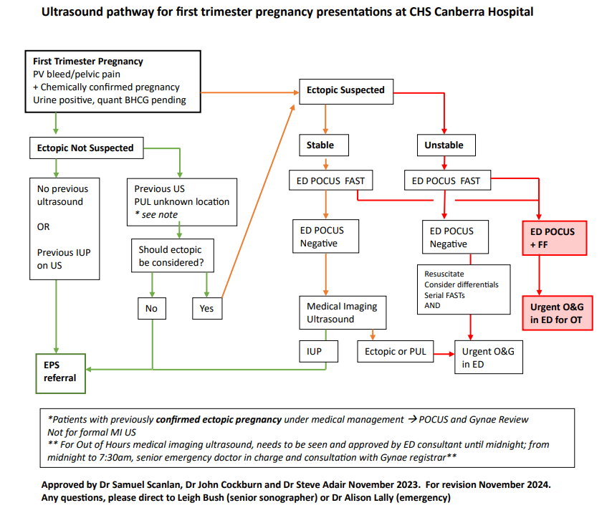

Attachment 2 – Bleeding/Pain algorithm early pregnancy

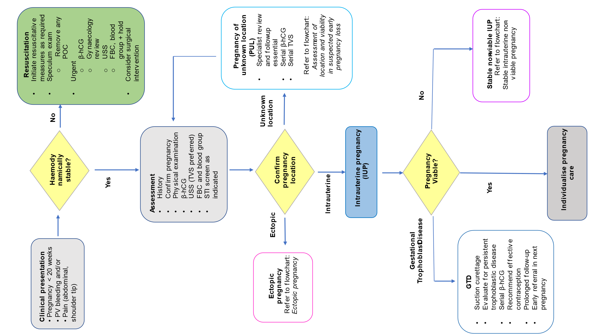

Attachment 3 – Risk Factors for Ectopic pregnancy
Adapted from Queensland Clinical Guidelines (2022) Early Pregnancy Loss
Risk Factors | (Adjusted*) OR | 95% CI
Sterilisation | 9.3 | 4.9 to 18.0
Previous ectopic pregnancy (increased risk if > 1) | 8.3 | 6.0 to 11.5
Previous tubal surgery | 4.0 | 2.6 to 6.1
Documented tubal pathology | 3.7 | 1.2 to 4.8
Previous genital infection confirmed | 3.4 | 2.4 to 5.0
Previous miscarriage | 3.0 | >2
Intrauterine device use more than 2 years | 2.9 | 1.4 to 2.3
Aged 40 or older (compared to 25-29 years) | 2.9 | 1.4 to 6.1
Infertility (risk increases with length of) | 2.1 to 2.7 | -
Current smoker (risk increases with amount/day) | 1.7 to 3.9 | -
Smoking (past or ever) | 1.5 | 1.2 to 2.2

Attachment 4 - Expectant Management of Ectopic pregnancy
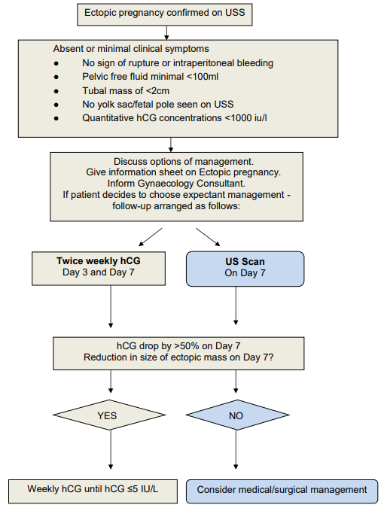

Source: King Edward Memorial Hospital Guidelines.
Pregnancy, First trimester Complications (2020)

Attachment 5. Body Surface Area Table for calculation of single dose methotrexate regime
Body Surface Area Table (m²)
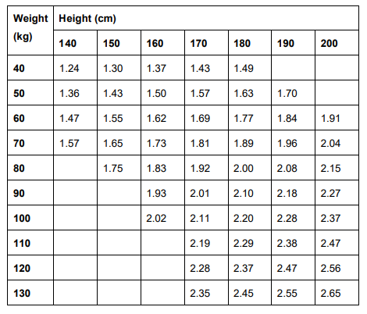

Treatment of ectopic pregnancy uses MTX dose 50 mg/m² body surface area [BSA] with maximum dose of 100 mg in patients with normal renal function.

Body surface area calculator - Australian Medicines Handbook (amh.net.au)

Attachment 6: Pathway for GTD follow up.


