Canberra Health Services
Guideline
Developmental Dysplasia of the Hip

Contents

Contents 1
Guideline Statement 2
Key Objective 2
Alerts 2
Scope 2
Section 1 – Assessment of DDH at Centenary Hospital for Women and Children 3
Section 2 - Assessment of DDH in Maternal and Child Health (MACH) 4
Evaluation 5
Related Policies, Procedures, Guidelines and Legislation 5
References 6
Definition of Terms 7
Search Terms 7
Attachments 7
Attachment A – Screening examination at birth 9
Attachment B – Neonatology Follow up clinic flowcharts – Patients at risk of DDH 10
Attachment C – Neonatology Follow up clinic flowcharts – Patients in a Pavlik Harness 11
Attachment D - Shenton’s Line 12
Attachment E – Acetabular Index or Angle 13
Attachment F – DDH Assessment of newborn to 3 months of age 14
Attachment G – DDH Assessment of infants 3 months of age to walking 16
Attachment H – DDH Assessment of infant/child when walking 17
Attachment I – Developmental Dysplasia of the Hip Consumer Handout 18
Attachment J – Physiotherapy Handout, Pavlik’s Harness 20

Guideline Statement

Background
Developmental Dysplasia of the Hip (DDH) refers to the abnormal development of the hip joint. It may be present at birth or develop in infancy or early childhood. The incidence is 1:1000 live births. Early detection and intervention are crucial to the restoration of normal hip function. If treatment is delayed, the deformity can be more severe and the outcome for the infant is less favourable.

DDH leads to unstable hip joints where the femoral head is:
- dislocated completely or partially (subluxed) from the acetabulum or
- in the acetabulum but is dislocatable

Usually, a shallow acetabulum is the primary abnormality allowing the femoral head a greater range of movement.

On examination the femoral head is felt to move (partially or completely) out of the acetabulum and/or “clunk” back in. This needs to be differentiated from so called “Clicky” hips which often refers to ligamentous clicks on examination in otherwise stable hips.
Long term complications include leg length discrepancies, decreased range of movement of the joint and osteoarthritis.

Key Objective
To ensure timely and appropriate assessment, treatment, and management of neonates/infants with developmental dysplasia of the hip

Alerts
- All newborns should be risk assessed for DDH. Those with risk factors should have a hip ultrasound (US) performed at 6-8 weeks of corrected age.
- All newborns should have their hips examined following birth and those with an abnormal hip examination should be referred for senior medical review.

Back to Table of Contents

Scope

This document applies to the following Canberra Health Services clinical staff working within their scope of practice:
- Medical Officers
- Nurses, Midwives and Maternal & Child Health (MACH) Nurses
- Nursing and Midwifery students
- Physiotherapists and Physiotherapy students
Back to Table of Contents

Section 1 – Assessment of DDH at Centenary Hospital for Women and Children

Routine Newborn Examination
- All baby’s hips are examined routinely by a midwife or doctor before discharge home as part of the newborn examination. Abnormal findings should be reviewed by a Neonatal Advanced Trainee or consultant prior to discharge.
- Neonates with “clicky” hips should not be referred for a hip US if the examination is otherwise normal. All staff performing well-baby examinations of the newborn should be aware that clicky hips are a variation of normal and that routine U/S is not required if the remaining clinical examination is normal and there are no other risk factors. Refer to Assessment of the Newborn Guideline.
- All neonates should be seen by their local GP at 6 weeks of age for repeat examination

Criteria for Hip Ultrasound Referral at 6 weeks:
Newborn with risk factors for DDH but a normal examination at birth should be referred for a routine hip ultrasound at 6 weeks of age (or corrected age if preterm). Risk factors include:
- Non-vertex presentation (i.e., breech or transverse) term or preterm
- Fixed talipes, metatarsus adductus and positional talipes calcaneovalgus
- Neuromuscular disease
- Family history of DDH

Follow up should be as per Attachment B – Neonatology Follow up clinic flowcharts- Patients at risk of DDH

Hip Ultrasound:
- The definitive diagnostic tool for diagnosis of DDH is an AP Xray of the hip. This can only be performed once ossification of the femoral heads has occurred (between 3 and 6 months)
- Prior to 6 months of age hip US is used to screen for DDH
- All hip US should report femoral head coverage at rest. Femoral head coverage under stress can also be reported (providing the patient is not in a Pavlik harness and doesn’t have clinically dislocatable hips)
- All hip US should report alpha angle
- Patients in a Pavlik Harness can have their ultrasound performed in the harness providing the posterior strap is loosened. Patients in a Pavlik should not have stress views performed.

Neonates with Confirmed Dislocatable Hips and Pavlik Harness:
- Prior to discharge from the hospital, a neonate who has a confirmed dislocatable hip on initial examination (“clunk” or positive Barlow’s manoeuvre) should have a physiotherapy referral made to arrange application of a Pavlik Harness sometime in the following 3-7 days. Refer to Attachment A – Hip examination and screening following birth. A Neonatologist, CMO or Neonatal advanced trainee should examine the hips prior to physiotherapy referral.
- To refer neonate/infant to physiotherapy review, follow current hospital referral processes (e.g., Patient Journey Board).
- A hip US may be arranged at this time, and a repeat US after 8 weeks in the Pavlik Harness.
- A repeat hip US should be performed in the harness to check that hips are enlocated
- Follow the flow chart for femoral head coverage and alpha angle measurements to determine when the harness can be removed (Refer to Attachment C)
- Referral to an Orthopaedic surgeon is required for fixed hip dislocation at birth, or if after 12 weeks of Pavlik harness treatment there is abnormal femoral head coverage or an abnormal alpha angle (Refer to Attachment C)
- Following removal of the harness a repeat USS should be arranged 6 weeks later. An AP X-ray of the pelvis should be arranged in preference to an USS if the patient will be 6 months old or older at the time of repeated imaging.
- An AP Xray of the pelvis should be performed at 6 months of age in all patients who have undergone bracing in the neonatal period.
- If there is delay in ossification, abnormal Shenton’s line or acetabular index (>27 degrees) a referral should be made to an Orthopaedic Surgeon. Refer to Attachment C, D and E.

Back to Table of Contents

Section 2 - Assessment of DDH in Maternal and Child Health (MACH)

Assessment
Obtain history of child and family during MACH clinic or home visit:
- Gender of infant (female newborns have a 6-fold higher incidence of DDH)
- Birth order (first born have a higher incidence of DDH)
- Family history of DDH
- Intrauterine position (any other than vertex)
- Type of birth (breech births have a higher incidence of DDH)
- Infant positioning during the first year of life (avoid hip extension through swaddling)
- The Safe Wrapping Consumer Handout can be found via Red Nose website.

Examination
- Explain the procedure to parent or care giver
- Ensure infant is as relaxed as possible
- Place infant on firm surface
- Attend appropriate DDH indicators and assessment for infants/child:
- Newborn to 3 months of age. Refer to Attachment F
- Infants 3 months of age to walking. Refer to Attachment G
- Infant/Child when walking. Refer to Attachment H.

Management
- Explanation of findings to parent
- Written referral to GP for further assessment if any one of the indicators are noted
- Document findings and actions as a variance in the clinical Child Health Record
- Following US examination infant may be placed in a Pavlik’s Harness or an alternative brace depending on their age. Babies diagnosed over 3 months of age will be referred to a paediatric orthopaedic surgeon
- X-ray is not performed prior to 5-6 months as ossification does not occur until 3-6 months of age
- If DDH diagnosed after 6 months of age:
- Infants require referral to a paediatric orthopaedic surgeon (either privately in Canberra or publicly to one of the children’s hospitals in Sydney). Following diagnosis by x-ray the infant may require a general anaesthetic, closed reduction, spica body cast for 2-4 months until the hip is stable and then a flexion-abduction brace is applied.
- Staff to provide Caring for your Baby/Child in Hip Spica consumer handout

Back to Table of Contents

Evaluation

Outcome
- Timely and appropriate diagnosis of developmental hip dysplasia in neonates and infants.
- Staff aware of appropriate pathways for referral and treatment.
- Optimum outcomes to prevent known complications of developmental hip dysplasia

Measures
- Review of clinical incident data entered into RiskMan in relation to hip dysplasia and its management and treatment. Any adverse events to be reported at the Neonatal Quality and Safety meeting.
- Monitor patient case at multidisciplinary meetings which includes physiotherapist.

Back to Table of Contents

Related Policies, Procedures, Guidelines and Legislation
Policy
- Informed Consent (Clinical)

Procedures
- Infection Prevention Control
- Maternal and Child Health Procedures in the ACT
- Patient Identification and Procedure Matching

Guidelines
- Neonatal Routine Care
- Developmental Care in the Neonatal Intensive Care and Special Care Nursery
- Assessment of the Newborn
- Safe Sleeping Guidelines: Neonates and Infants up to 12 months of age
- Home Visiting
- National Framework for Universal Child and Family Health Services

Consumer Handouts
- Caring for your Baby/Child in a Hip Spica

Legislation
- Health Records (Privacy and Access) Act 1997
- Human Rights Act 2004
- Work Health and Safety Act 2011
- Carers Recognition Act 2021

Other
- Australian Charter of Healthcare Rights
- Competency Standards for the Maternal and Child Health Nurse in Victoria

Back to Table of Contents

References
- Jennifer Bracken, Ton Tran and Michael Ditchfield “Developmental dysplasia of the hip: Controversies and current concepts”j” Journal of Paediatrics and Child Health 48 (2012) 963–973.
- Christopher L Talbot, Robin W Paton “Screening of selected risk factors in developmental dysplasia of the hip: an observational study” Arch Dis Child 2013;98:692–696. doi:10.1136/archdischild-2013-303647.
- Jennifer B, Ton T, Michael D. “Developmental Dysplasia of hip: controversies and currentconcepts” Pediatrics. 2012; 48:963-973.
- Roposch A., Liu L.Q., Hefti F., et al: Standardized diagnostic criteria for developmental dysplasia of the hip in early infancy. Clin Orthop Relat Res 2011; 469. (12): 3451-3461.
- Gulati, V., et al: Developmental Dysplasia of the Hip in the Newborn: A systematic review
- Alsaleem, M., Set, K. K., & Saadeh, L. (2015). Developmental Dysplasia of Hip. Clinical Pediatrics, 54(10), 921-928 8p. doi:10.1177/0009922814555978
- Perry, S.E., Hockenberry, M.J., Lowedermilk, D.L., Wilson, D. (2010) Maternal Child Nursing Care 4th Ed. Missouri: Mosby Elsevier
- Pillitteri, A. (2010) Maternal & Child Health Nursing: Care of the Childbearing & Childrearing Family 6th Ed. Philadelphia: Lippincott Williams & Wilkins
- http://hipdysplasia.org/developmental-dysplasia-of-the-hip/infant-signs-and-symptoms/asymmetry/
- http://www.yalemedicalgroup.org/stw/images/125967.jpg
- Swarup I, Penny C and Dodwell R, Developmental dysplasia of the hip: an update on diagnosis and management from birth to 6 months, Curr Opin Pediatr 2018, 30:84-92
- Yan S, Zusman N, Lieverman E, Golstein R, Developmental Dysplasia of the hip, Pediatrics 2019;143(1):e20181147
- Edmonds E, Hughes J, Bomar J, Brooks J, Upasani V, Ultrasonography in the Diagnosis and Management of Developmental Dysplasia of the Hip, JBJS REVIEWS 2019;7(12): e5
- Haberg O, Foss O, Lian O, Holen K, Is foot deformity associated with developmental dysplasia of the hip? Bone Joint J 2020 Nov; 102-B(11):1582-1586.
Back to Table of Contents

Definition of Terms

- Acetabular Dysplasia - Mildest form of DDH, delay in acetabular development
- Alpha Angle (AA) - the angle between the acetabular roof and vertical cortex of the ilium
- AP- Antero-Posterior
- Dislocation - The femoral head loses contact with the acetabulum
- Femoral Head Coverage (FHC)- The ultrasound measured femoral head coverage with the hip in coronal flexion and adduction
- Subluxation - Largest percentage of DDH, intermediate state between dysplasia and full dislocation
Back to Table of Contents

Search Terms

Hip Dysplasia, Neonatal, Maternity, Post-natal, Maternal and Child Health, Postnatal baby assessment, Pavlik Harness, Physiotherapy, NICU
Back to Table of Contents

Attachments
Attachment A – Screening examination at birth
Attachment B – Neonatology Follow up clinic flowcharts – Patients at risk of DDH
Attachment C – Neonatology Follow up clinic flowcharts – Patients in a Pavlik Harness
Attachment D - Shenton’s Line
Attachment E – Acetabular Index or Angle
Attachment F – DDH Assessment of newborn to 3 months of age
Attachment G – DDH Assessment of infants 3 months of age to walking
Attachment H – DDH Assessment of infant/child when walking
Attachment I – Developmental Dysplasia of the Hip Consumer Handout
Attachment J – Physiotherapy Handout, Pavlik’s Harness

Disclaimer: This document has been developed by Canberra Health Services specifically for its own use. Use of this document and any reliance on the information contained therein by any third party is at his or her own risk and Canberra Health Services assumes no responsibility whatsoever.

Policy Team ONLY to complete the following:
Date Amended | Section Amended | Divisional Approval | Final Approval
14/11/2022 | Full review | Susan Freiburg ED WYC | CHS Policy Committee

This document supersedes the following:
Document Number | Document Name
CHHS17/049 | Developmental Dysplasia of the Hip

Attachment A – Screening examination at birth

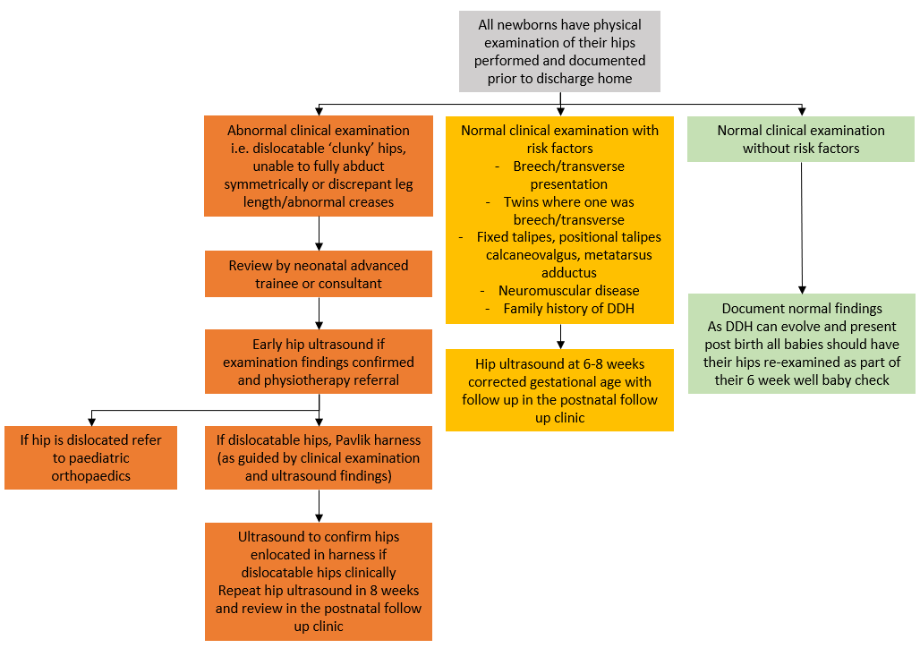

Attachment B – Neonatology Follow up clinic flowcharts – Patients at risk of DDH

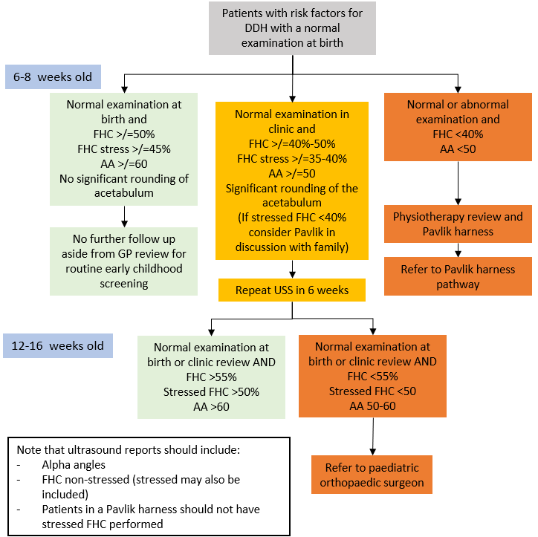

Attachment C – Neonatology Follow up clinic flowcharts – Patients in a Pavlik Harness

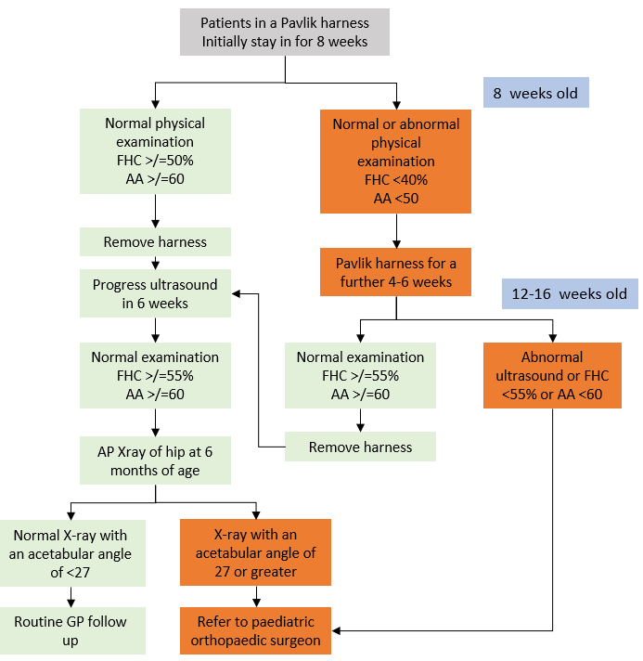

Attachment D - Shenton’s Line

Shenton’s line is an imaginary line drawn along the inferior border of the superior pubic ramus (superior border of the obturator foramen) and along the inferomedial border of the neck of femur. This line should be continuous and smooth.

Radiological Example of Right Dislocated Hip

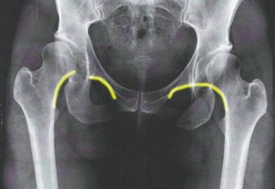

http://radiopaedia.org/articles/shenton-line

Attachment E – Acetabular Index or Angle

The acetabular angle is a radiographic measurement used for evaluating ongoing potential developmental dysplasia of the hip (DDH) following Pavlik harness treatment. It is most useful in patients where the femoral head epiphysis has begun to ossify.
The angle is formed by a horizontal line connecting both triradiate cartilages (Hilgenreiner line) and a second line which extends along the acetabular roofs.

Normal values in children
The acetabular angle using Hilgenreiner's line should be less than 28 degrees at birth. The angle should become progressively shallower with age.
Radiological Example of Left Dislocated Hip

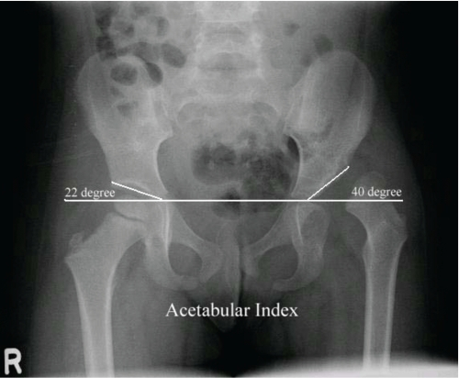

https://www.google.com.au/search?q=acetabular+index&es_sm=93&biw=1920&bih=1091&source=lnms&tbm=isch&sa=X&sqi=2&ved=0CAYQ_AUoAWoVChMI0vDh3LKbyAIVZdimCh3dtwSg#imgrc=mTUhMPxv5nmjEM%3A

Attachment F – DDH Assessment of newborn to 3 months of age

- Infant in supine position. Extend the legs. Ensure the pelvis is horizontal and check legs together for unequal leg length

- Galeazzi Sign:
Place infant supine with hips and knees flexed to 90deg. The examiner should determine if the knees are of the same height. Unequal knee heights suggest that there is femoral shortening which may be due to hip dislocation. (Fig 1)

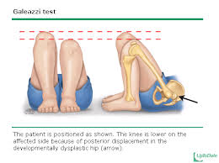

Figure 1: Galeazzi Sign
http://pediatrics.uchicago.edu/chiefs/documents/FinalDDH.pdf

- Assess symmetry of anterior and posterior thigh and buttock creases
- Figure 2: Asymmetrical thigh creases

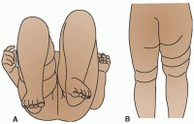

https://quizlet.com/3541339/musculoskeletal-disorder-test-3-pediatrics-flash-cards/

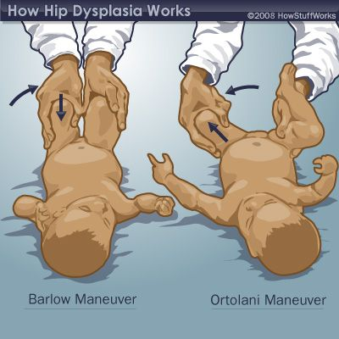

Figure 3: Right: Ortolani manoeuvre
Left: Barlow manoeuvre

https://www.pinterest.com/pin/138063544799464210/

Ortolani’s Manoeuvre:
Infant is supine. Hold the infant’s thigh with thumb on inner aspect of thigh and middle finger on the greater trochanter. The hip is flexed to 90degrees. Lift the leg while gently abducting the hip (Fig3). When the test is positive the femoral head will move into the acetabulum with a palpable and sometimes audible “clunk”.

Barlow’s Manoeuvre:
Infant is supine. Hold the infant’s thigh with thumb on inner aspect of thigh and middle finger on the greater trochanter. The hip is flexed to 90 degrees. The hip is adducted and a gentle downward pressure is applied in an attempt to dislocate the femoral head from the acetabulum (Fig 3). When the test is positive a palpable “clunk” is felt. Can be repeated to ensure infant is relaxed.

Attachment G – DDH Assessment of infants 3 months of age to walking
- Infant in supine position. Extend the legs. Ensure the pelvis is horizontal and check legs together for unequal leg length
- Limited hip abduction either unilateral or bilateral is the most reliable indication of DDH

Attachment H – DDH Assessment of infant/child when walking

- Infant/child in supine position. Extend the legs. Ensure the pelvis is horizontal and check legs together for unequal leg length
- Restricted hip abduction either unilateral or bilateral is the most reliable indicator of DDH
- Galeazzi Sign: (Appendix E)
- Assess symmetry of anterior and posterior thigh and buttock creases
- Gait abnormalities eg limp or waddling
- Trendelenberg sign is positive in DDH. If the child stands on the affected leg, the pelvis drops to the opposite side and the trunk leans toward the affected side

Attachment I – Developmental Dysplasia of the Hip Consumer Handout

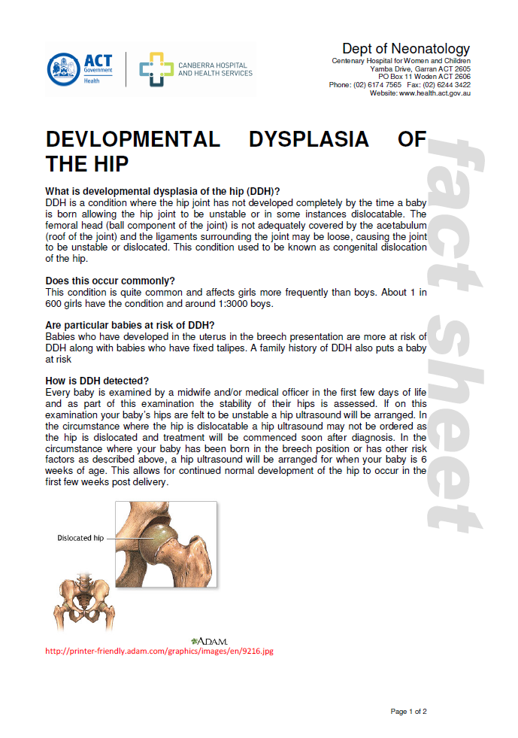
SAMPLE
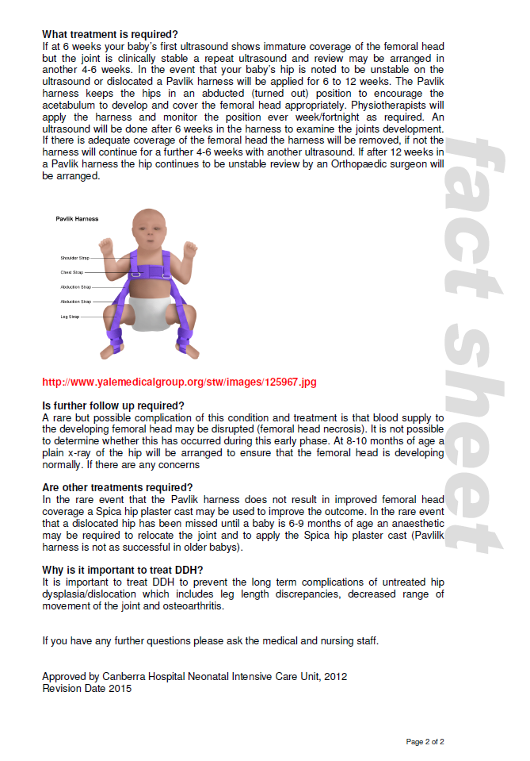
SAMPLE

Attachment J – Physiotherapy Handout, Pavlik’s Harness

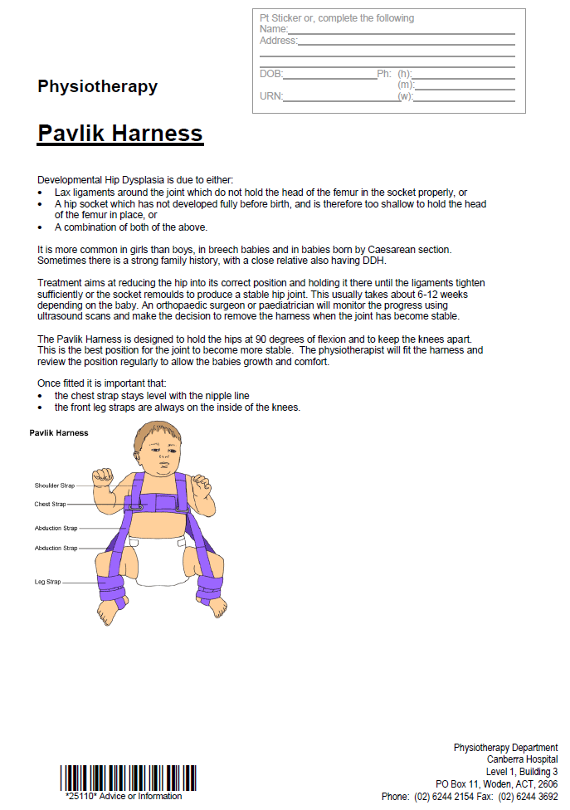
SAMPLE

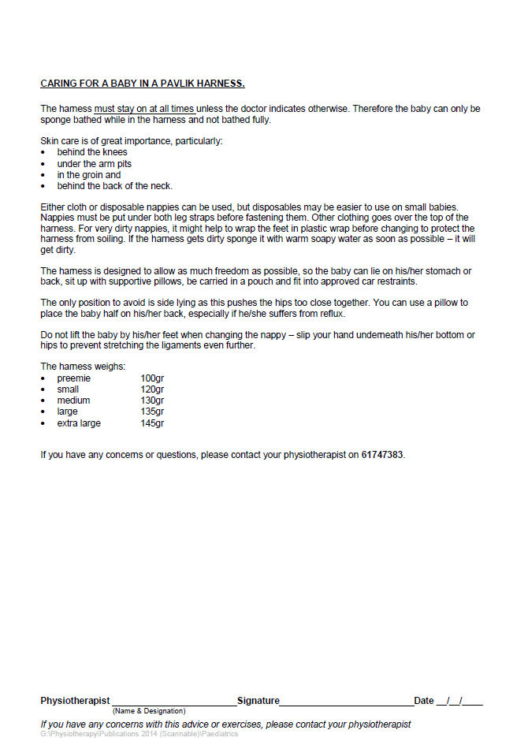
SAMPLE

