Canberra Health Services
Procedure
Continuous Renal Replacement Therapy in Intensive Care

Contents

Canberra Health Services 1
Contents 1
Purpose 3
Alerts 3
Scope 4
Section 1 – Theoretical Knowledge of CRRT 4
Section 2 – Vascular Access for CRRT 7
Section 3 – Prescription of CRRT 8
Section 4 – CRRT Machine Setup 9
Section 5 – Systemic Heparin Anticoagulation Protocol 10
Section 6 – Regional Citrate Anticoagulation Protocol 12
Section 7 – No Anticoagulation Protocol 14
Section 8 – Connecting CRRT to Patient 15
Section 9 – Monitoring and Management During Treatment 17
Section 10 – Common Alarms and Troubleshooting 20
Section 11 – End of Treatment 23
Section 12 – Nursing Care 25
Evaluation 28
Related Policies, Procedures, Guidelines and Legislation 28
References 29
Abbreviations 30
Search Terms 31
Attachments 31
Attachment 1: CRRT Setup Steps 33
Attachment 2: Emergency lumen swap instructions 35
Attachment 3: CRRT Prescription and order forms 36
Attachment 4: Manual air removal 38
Attachment 5: Saline Recirculation 39
Attachment 6: PrisMax machine parts 40
Attachment 7: Electrolytes replacement through CRRT solution bags guideline 41

Purpose

The purpose of this Continuous Renal Replacement Therapy (CRRT) procedure is to outline the safe and effective management of patients requiring CRRT in the Intensive Care Unit at Canberra Health Services (CHS).

Back to Table of Contents

Alerts

- The position of new vascular access (named as vascath in this document) for CRRT must be confirmed by pressure transducer, chest x-ray and medical team before use.
- Always aspirate both vascath lumens and discard blood before flushing and connecting to the patient to avoid inadvertently delivering a high concentration of anticoagulation.
- 50mL Terumo luer lock syringe is the default syringe to be used in the syringe driver on PrismaFlex and PrisMax dialysis machines.
- Calcium Chloride infusion line must be connected to the blue return line.
- Filter set must be reprimed if it is not connected to the patient within 30 minutes.
- Hypotension can be a complication of CRRT. It is important to monitor the patient’s haemodynamics closely, especially at the start of therapy.
- Filter set must be changed after 72 hours of use. Continued use beyond these limits could result in rupture of the pump segments and may result in patient injury or death.
- PrisMax will stop if the blood pump is stationary for 10 minutes. The filter must be discarded and changed, and blood cannot be returned to the patient.
- Attend to alarms swiftly to avoid stasis in the circuit. Seek help immediately if unable to troubleshoot.
- Inspect the filter flow path for signs of clotting before returning the blood in the set to the patient. If clotting is suspected, do not return the blood to the patient.
- Do not collect blood samples from the Vascath unless approved by ICU medical team.
- Emergency disconnection equipment must be available at the bedside for duration of therapy.
- If CRRT is being run through an ECMO circuit, the access pressures are positive rather than negative. Both Prismaflex and PrisMax machines can detect this and adjust pressure limits.

Back to Table of Contents

Scope

This document applies to CHS Intensive Care staff, working within their scope of practice, involved in the care and management of patients on Continuous Renal Replacement Therapy (CRRT) including:
- Medical Officers
- Nurses and Midwives
- Physiotherapists
- Students under direct supervision

Back to Table of Contents

Section 1 – Theoretical Knowledge of CRRT

Continuous Renal Replacement Therapy (CRRT) is an extracorporeal blood purification therapy used for impaired renal function. This therapy runs continuously, 24 hours per day, sometimes for up to weeks at a time. This is in contrast with Intermittent Haemodialysis, which runs for 3-5 hours usually 3 times per week in patients with chronic renal failure.

There are four mechanisms used in CRRT:
- Ultrafiltration: movement of fluid through a semipermeable membrane along a pressure gradient.
- Convection: movement of solutes by ultrafiltration across a semipermeable membrane (also called ‘solvent drag’).
- Diffusion: spontaneous movement of molecules (or solutes) from an area of relatively high concentration to an area of lower concentration.
- Adsorption: adherence of molecules in solution or suspension to the surface or interior of a solid substance, which, in dialysis, is a semipermeable membrane.

  - Indication for CRRT in ICU
- Oliguric/aneuric renal failure
- Hyperkalaemia (serum potassium values ≥ 6.5mmol/L)
- Metabolic acidosis (pH <7.1)
- Refractory volume overload or refractory pulmonary oedema
- Azotemia (Urea >40mmoL/L) or signs/complications of uraemia
- Intoxication or overdose with dialysable toxins (for e.g., barbiturates, lithium, alcohols, salicylates, valproate, metformin, etc.)
- Refractory septic shock
- Acute liver failure
- Severe tumour lysis syndrome
- Hyperthermia (temperature >40º C)
- Hypercalcemia (refractory)

1.2 Modalities of CRRT
CRRT represents a spectrum of modalities, including:
- Slow continuous ultrafiltration (SCUF)
- Continuous venovenous haemofiltration (CVVH)
- Continuous venovenous haemodialysis (CVVHD)
- Continuous venovenous haemodiafiltration (CVVHDF)

  - Anticoagulation methods of CRRT
Anticoagulation is recommended during renal replacement therapy if a patient does not have an increased bleeding risk or impaired coagulation and is not already receiving systemic anticoagulation. Regional citrate anticoagulation (RCA) is suggested as the first-line treatment for CRRT in critically unwell patients. Systemic heparin anticoagulation is recommended if there is any contraindication to using citrate.

    - Regional citrate anticoagulation (RCA)
Citrate is added to the circulating blood in the CRRT set, where it binds (or chelates) ionised calcium, causing the concentration of ionised calcium in the circuit to fall to very low levels (<0.4mmol/L), thereby inhibiting coagulation. Up to 60% of Citrate-calcium complexes will be cleared through the filter and lost in the effluent due to its low molecular weight, along with some ionised calcium. The lost calcium must be replaced to maintain a normal serum ionised calcium level of 1.0-1.3mmol/L. To prevent the patient becoming hypocalcaemic and therefore systematically anticoagulated, calcium is infused into the circuit at the return line. The use of citrate requires additional monitoring of the patient’s ionised calcium, magnesium, sodium, bicarbonate and pH levels. This type of anticoagulation therapy may lead to metabolic derangements and citrate accumulation or toxicity.
Regional citrate anticoagulation is commonly used as first-line anticoagulation for CRRT at Canberra Hospital ICU.

Specific indications:
- Increased bleeding risk
- Heparin-induced thrombocytopenia (HIT)

Relative contraindications:
- Patient therapeutically/systemically anticoagulated (should not need any circuit anticoagulation)
- Conditions associated with severely reduced tissue and/or liver perfusion (shock/septic shock with hyperlactatemia) predispose to citrate toxicity
- Previous citrate toxicity
- Severe liver failure/liver cirrhosis
- Citrate intolerance
1.3.2 Heparin
Heparin inhibits the clotting of blood by enhancing the rate at which antithrombin III neutralises thrombin and activated factor X (Xa). This therapy targets an aPTT of 50 - 70 seconds. In critically ill patients, heparin is associated with an increased risk of bleeding, heparin induced thrombocytopenia (HIT) and antithrombin-mediated pro-inflammatory effects.

Cautions for use:
- Advanced hepatic disease
- High risk of bleeding
- HIT
- Recent surgical procedure

Contraindications:
- Active bleeding
- Heparin allergy
- Thrombocytopaenia (Platelets ≤50 X 10⁹/L)

  - Common complications of CRRT
Vascular Access | - Pneumonia  - Haemothorax  - Arteriovenous fistula formation  - Haematoma  - Arrhythmias  - Air embolism  - Recirculation  - Thrombus  - Catheter-related bacteraemia | Anticoagulation Related (Heparin) | - Bleeding  - Thrombocytopaenia  - Heparin-induced thrombocytopaenia
Vascular Access |  | Anticoagulation related (Citrate) | - Metabolic alkalosis  - Metabolic acidosis  - Hyper/hypocalcaemia  - Hyper/hyponatraemia  - Citrate accumulation/ toxicity
Haemodynamics | - Hypotension  - Hypovolaemia | Electrolytes and acid-base | - Hypophosphataemia  - Hypokalaemia  - Hyper/hyponatraemia  - Hyper/hypocalcaemia  - Hypomagnesaemia  - Metabolic alkalosis
Extracorporeal circuit | - Air embolism  - Anaphylaxis  - Hypothermia  - Fluid removal errors  - Line disconnection  - Immunologic activation | Electrolytes and acid-base

Nutrition | - Protein losses  - Vitamin deficiencies  - Mineral deficiencies | Drug administration | - Altered drug clearance  - Drug toxicity  - Inadequate dosing

Back to Table of Contents

Section 2 – Vascular Access for CRRT

A large bore, non-tunnelled, double-lumen Catheter (vascath) is required for CRRT. A tunnelled vascath can also be used. Arteriovenous (AV) fistula or grafts are not routinely used in ICU.
A vascath is inserted into a large vein, preferably the right internal jugular vein, or left internal jugular vein or femoral vein. The subclavian vein is not recommended for CRRT. Insertion of a vascath should follow the procedure outlined in the Central Venous Access Device (CVAD) Management guideline. Insertion date and position of vascath must be documented in MetaVision.

Note: if the patient has an arterial venous fistula (AVF) in place and it is accessed by an accredited cannulator the AVF can be used as vascular access for up to 12 hours. ICU team are to consult with the patient’s nephrologist.

Prophylactic antithrombotic catheter locking
After catheter placement and after each use, the vascath should be flushed with 0.9% sodium chloride to evacuate any residual blood. Each lumen of the catheter is then ‘locked’ with an antithrombotic solution to maintain patency. Heparin 5000 unit/mL is used unless contraindicated, with 4% citrate in patients with HIT or a heparin allergy. A locked vascath must be aspirated (5mLs aspirated and discarded), flushed with 0.9% sodium chloride and then relocked and labelled as locked every 72 hours when not in use.

Removal of Catheter
A vascath should be removed as early as possible if there is no indication for further CRRT treatment or when long-term dialysis vascular access is established. If the patient is being transferred to a general ward, the vascath should be removed prior to transfer, unless ICU and ward medical teams agree it should remain. If the vascath is to remain in situ after the patient is discharged from ICU, it must be documented on the intrahospital transfer form and handed over to ward staff. ICU medical team must specify a date for vascath removal on the ward, and if ongoing dialysis is anticipated, a tunnelled vascath insertion should be arranged.
The removal of a vascath should be performed during business hours. Before removal, the patients’ anticoagulation profile should be checked. Platelets should be above 50 X 10⁹/L and aPTT<45 seconds before vascath removal. Removal of a vascath should be done according to CHS Central Venous Access Device (CVAD) Management Guideline.

Back to Table of Contents

Section 3 – Prescription of CRRT

Medical prescription should include clear values for the following:
- Modality
- Anticoagulation
- Blood flow (mL/min)
- Pre-Blood Pump fluid order
- Dialysate fluid order
- Replacement Fluid order
- Fluid removal
- Dose
- Anticoagulation order
- Potassium replacement

A NEW CRRT ORDER FORM MUST BE COMPLETED EVERY 24 HOURS – OR IT IS NOT VALID.
Select “New Session” to complete a new order form on MetaVison. Do not change an existing order.

CRRT modality
CVVHDF is the standard default setting at CHS.

Anticoagulation
Regional citrate anticoagulation (RCA) and systemic unfractionated heparin anticoagulation are the most common anticoagulation methods used at CHS.
For a citrate circuit, the default citrate dose is 3.0 mmol/L, range of 2mmol/L – 4mmol/L mmol/L. The calcium compensation default start dose is 100%. The actual rate is calculated by the CRRT machine using the BFR.
For a heparin circuit, the starting dose of heparin should be 10u/kg/hr, targeting an aPTT of 50-70 seconds, which is approximately 1.5X the normal aPTT target.
If the patient has contraindications for anticoagulation, systemic anticoagulation should be avoided.

Blood Flow Rate (BFR)
Regional Citrate: Patient weight <70kg, aim for BFR of 120-150mL/min.
Patient weight >70kg, aim for BFR of 150-180mL/min.
Heparin or no anticoagulation: aim for BFR of 200 – 250mL/min.

CRRT dose
The dose is defined by the effluent flow rate. Effluent rate is the total of PBP rate, dialysate rate, replacement rate and fluid removal rate. In most cases, CRRT dose is set at 25-30 ml/Kg/hr. Potential indications for higher dose treatment include: refractory metabolic acidosis, refractory shock, and severe rhabdomyolysis (CK>20,000). There should be caution in prescribing high dose of CRRT, as these are not based on robust scientific evidence and must only be prescribed in consultation with the intensive care specialist.

CRRT solutions
 | Regional Citrate | Heparin or no anticoagulation
Pre-Blood Pump | Prismocitrate 18/0 | Hemosol B0
Dialysate | Prism0cal B22 | Hemosol B0
Replacement | Hemosol B0 | Hemosol B0

No potassium chloride (KCl) is added to Prisma0cal bag as the bag already contains 20mmol of KCl. KCl should be prescribed to add to Prismocitrate 18/0 bag and Hemosol B0 bag depending on patient’s potassium level. Addition of KCl to the solution bags must follow strict aseptic precautions, and bags must be labelled as per hospital policy.

Patient fluid removal rate
Patient fluid removal (PFR) rate is dependent on the patient’s existing fluid balance, haemodynamic status, and desired fluid balance.
Back to Table of Contents

Section 4 – CRRT Machine Setup

ST 100 set filter is used for CRRT treatment. ST 100 set has 1m² of effective surface area and holds 152mLs of blood.

If the patient requires a higher CRRT dose, either an ST 150 set or Oxiris filter may be used as both have 1.5m² of effective surface area and hold 189mLs of blood. The Oxiris filter is designed to effectively remove cytokines, toxins, and endotoxins. The decision to use an ST150 set or Oxiris filter must be made in consultation with the intensive care specialist. They must not be used unless prescribed.

4.1 Machine set up
4.1.1 Prepare Equipment

Equipment | Additional equipment for Heparin anticoagulation | Additional equipment for Regional Citrate anticoagulation
- Dialysis machine  - ST 100 set  - Auto-effluent or effluent bag  - TherMax warmer or blood warmer extension set  - 1000mL 0.9% sodium chloride for priming  - 50mL Luer Lock Terumo syringe  - 20mL syringe  - Drawing up needle  - Additive stickers  - Spare accessory spike | - 3 X 5000units heparin in 1mL (5000 units for priming, 10,000 units for infusion)  - 1 X 5mL syringe  - 3 X Hemosol B0 5L  - Potassium Chloride 10mL ampoules, as per order | - 5 X 10% Calcium Chloride 10mL  - CA 250 calcium line  - Y-Connector  - 1 X Prismocitrate 18/0 5L  - 1 X Prisma0cal B22 5L  - 1 X Hemosol B0 5L  - Potassium chloride 10mL ampoules, as per order

Notes:
If machine requires re-priming, use another 1000mL 0.9% sodium chloride bag to reprime, do not add heparin to second bag.
If the patient is allergic to heparin or is HITS positive, do not add heparin to priming solution.
If the patient has a contraindication to anticoagulation but does not have HITS/heparin allergy, prime filter with heparin bag and then reprime with 0.9% sodium chloride to flush the heparin from filter.

4.1.2 Set up of Prismaflex and PrisMax machines

Plug the machine into the site-specific ICU emergency outlet and turn on. If using PrisMax, plug in and turn on TherMax at the same time. Follow the on-screen instructions to go through all the steps.
See Attachment 1 for step-by-step instructions.

Back to Table of Contents

Section 5 – Systemic Heparin Anticoagulation Protocol

5.1 Dose of Heparin
Prepare Heparin 10,000 units in 50mLs of 0.9% sodium chloride (200units/mL) using the 50mL luer lock syringe and infuse via the on-board syringe driver. The starting rate of Heparin infusion is 10u/kg/hr and adjusted according to aPTT. For patients with normal coagulation profile (INR <1.5, aPTT ratio <1.5, Platelets>50,000) and no evidence of bleeding, a bolus of heparin (5-10 unit/kg) may be ordered and administered via the CRRT circuit.

5.2 Priming
Circuit priming: 1000mL of 0.9% sodium chloride with 5,000units heparin added.

5.3 Target of anticoagulation
A patient requiring heparin anticoagulation for the CRRT circuit (without any requirement for systemic anticoagulation) does not need therapeutic anticoagulation targets. A target aPTT 45 - 60 seconds or an aPTT heparin ratio of 1.5-2.0 should be enough to achieve adequate anticoagulation for the CRRT circuit. Heparin infusion rate should not follow the hospital heparin infusion protocol. If the filter is clotting frequently, aim for a slightly higher aPTT of 50 – 70 seconds.
If circuit clots and is restarted within an hour, heparin to be restarted at the same rate.

5.4 Patient monitoring during heparin anticoagulation
- aPPT to be checked at 6 and then 12-hours post start of treatment and then daily once aPTT therapeutic for duration of therapy. If the results are abnormal refer to medical advice.
- Increased risk of bleeding. Monitor wounds, drains and line insertion sites for ooze. Check haemoglobin daily.
- Monitor for signs of heparin-induced thrombocytopenia

5.5 Initial settings
Blood flow: 150 - 200mL/min
Note: When commencing therapy, start BFR at a lower rate (e.g. 100mL/min). Monitor haemodynamics and increase BFR over 5-10 minutes as tolerated.
Pre-Blood Pump: Hemosol B0 (with KCl added as per medical order), default rate 800mL/h
Dialysate: 5L Hemosol B0 (with KCl added as per medical order), default rate 1000mL/h
Replacement: 5L Hemosol B0 (with KCl added as per medical order), default rate 200mL/h

These rates may be adjusted by ICU consultant according to patient weight.
Back to Table of Contents

Section 6 – Regional Citrate Anticoagulation Protocol

6.1 Dose of Citrate
The default Citrate dose on MetaVision is 3.0mmol/L but can be adjusted from 2 - 4mmol/L. Prismocitrate 18/0 solution enters the circuit through the PBP line. The amount of citrate depends on the citrate dose and the blood flow rate.
PBP rate cannot be set/adjusted in this case.

6.2 Priming
1000mL 0.9% sodium chloride. No heparin added.

6.3 Mechanism of action
Citrate chelates the ionized calcium before blood enters the filter. The amount of citrate that enters the filter depends on the set citrate dose and the blood flow rate.

6.4 Initial settings
Blood flow: Patient weight <70kg, aim for BFR of 120-150mL/min.
Patient weight >70kg, aim for BFR of 150-180mL/min.

Note: When commencing therapy, start BFR at a lower rate (e.g. 100mL/min). Monitor haemodynamics and increase BFR over 5-10 minutes as tolerated.

Pre-Blood Pump: 5L Prismocitrate 18/0 (with KCl added as per medical order), rate calculated automatically.
Dialysate: 5L Prism0cal B22 (no KCl added, as the bag contains 20mmol KCL already), default rate 1000mL/hr
Replacement: 5L Hemosol (with KCl added as per medical order), default rate 200mL/h

The default Citrate dose on MetaVision is 3.0 mmol/L but can be adjusted from 2.5-3.5mmol/L.

6.5 Target of anticoagulation
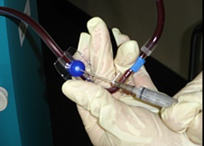
The targeted ionized calcium (iCa²⁺ ) level of the extracorporeal circuit is 0.2 - 0.4mmol/L. This is not routinely checked at CHS but may be considered if the filter repeatedly clots within 24 hours of commencement. To check the iCa²⁺ level from post filter, a blood sample is taken 1 hour post start of CRRT from the blue sample port of the filter set and analysed by an ABG device or laboratory. This is a diluted blood sample, so only the iCa²⁺ value is used, other values should not be recorded, and it must be marked ‘venous’ or ‘circuit’ sample.
6.6 Calcium replacement rate
The default calcium compensation rate is 100%.
Prepare 5 X 10% calcium chloride 10ml in 50mL Terumo luer lock syringe. Calcium is infused via onboard syringe driver into the return line just before the vascath, to maintain patient serum ionized calcium level at 1.0 - 1.2mmol/L.

Alert: Ensure the calcium replacement line (CA 250 calcium line) is always connected to the blue return line.

6.7 Patient monitoring during citrate anticoagulation

Ionised calcium
- Ionised calcium should be checked before commencing RCA CRRT.
- If corrected ionised calcium (iCa²⁺) < 1.1mmol/L but > 0.9mmol/L, Calcium Gluconate 2.2mmol (10% Calcium Gluconate 10 mL) is to be ordered and given over 10 minutes.
- If corrected ionised calcium (iCa²⁺ ) < 0.9mmol/L, Calcium Chloride 6.8 mmol (10% Calcium Chloride 10mL) is to be ordered and given over 10 minutes through central venous access.
- If corrected ionised calcium (iCa²⁺ ) > 1.4mmol/L, Calcium compensation rate to start at 80%, recheck ionised calcium 1 hour after commencing CRRT. If still > 1.4mmol/L, inform ICU Registrar or Consultant. Calcium compensation rate can be decreased further to 60%, and ionised calcium to be rechecked 1 hour post rate change.
- Ionised calcium must be checked 6 hourly while therapy running, and compensation rate adjusted according to Calcium Replacement protocol (see below).
- If circuit clots and is restarted within an hour, calcium compensation is to be restarted at the same rate.

Total calcium and Ca_{tot}/Ca_{ion} Ratio
Total calcium level should be monitored daily to detect citrate accumulation when the calcium-citrate complex metabolism is impaired (Normal range: 2.2-2.5mmol/L). Ca_{tot}/Ca_{ion} ratio is calculated when total calcium level result is available. A ratio greater than 2.5 strongly suggests citrate accumulation, and ICU team may consider decreasing citrate dose, dialysate, or blood flow rate, or changing to a different anticoagulation method.

Citrate accumulation/toxicity
Citrate accumulates in the blood if the liver and muscles fail to metabolise citric acid. This may happen in decompensated liver cirrhosis or severe shock. Symptoms may include tetany, arrhythmia, hypotension, hypokalaemia, and acid-base disturbances. Indications of citrate accumulation include:
- Increasing calcium replacement requirement (e.g. >130%)
- Persistently low ionised serum calcium (iCa2+) (<0.9mmol/L)
- Increased total calcium/ionised calcium ratio (≥2.5:1)
- Worsening High Anion Gap Metabolic Acidosis

If citrate toxicity is suspected, the following steps should be taken:
- Inform ICU senior registrar or Consultant
- Decrease blood flow rate. ICU team may consider increasing dialysate flow rate to remove citrate.
- Decrease Citrate dose to 2.5mmol (From default rate of 3.0mmol/L)
- Consider ceasing RCA treatment and changing to an alternative anticoagulation method.

Calcium replacement protocol for RCA CRRT
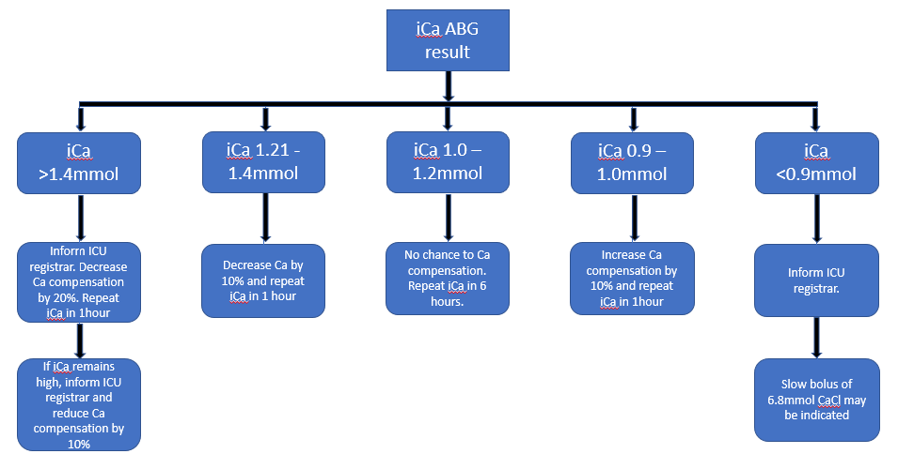

Back to Table of Contents

Section 7 – No Anticoagulation Protocol

7.1 Indication
Patients with liver impairment, clotting abnormalities or at an increased risk of bleeding may require no anticoagulation.

7.2 Priming
1000mL 0.9% sodium chloride with no heparin added.
50mL on-board syringe to be filled with 50mL 0.9% sodium chloride, select Heparin anticoagulation on dialysis machine and set rate to 0mL/h. If the patient then requires heparin to be added to the circuit, this can be done without changing the set.

7.3 Initial Settings
Blood flow: 200mL/min
Note: When commencing therapy, start BFR at a lower rate (e.g. 100 – 150mL/min). Monitor haemodynamics and increase BFR over 5-10 minutes as tolerated.

Pre-Blood Pump: Hemosol B0 (with KCl added as per medical order), default rate 800mL/h
Dialysate: 5L Hemosol B0 (with KCl added as per medical order), default rate 1000mL/h
Replacement: 5L Hemosol B0 (with KCl added as per medical order), default rate 200mL/h

7.4 Monitoring
Observe circuit for signs of clotting, particularly in the filter and deaeration chamber.
Consider changing to regional anticoagulation if the circuit clots within 6 hours.
A higher blood flow rate may be required to avoid filter clotting.

Back to Table of Contents

Section 8 – Connecting CRRT to Patient

Two accredited registered nurses are required to connect filter to the patient. The primary nurse puts on sterile gloves and uses aseptic non-touch technique to prepare vascular access and connect lines to vascath. The assisting nurse manages the dialysis machine screen and helps to disconnect and connect lines.
The steps for connecting Prismaflex and PrisMax are the same. Using autoeffluent on PrisMax has some additional setps. Follow instructions on the dialysis machine screen.
BFR is usually started at a low rate (e.g. 100ml/min) and increased to prescribed rate over 3-5 minutes while monitoring hemodynamics. It may be advisable to withold fluid removal if patient is haemodynamically unstable. Consult medical team as indicated.

8.1 Connecting to patient
Check patient ID. If possible, provide education and obtain consent.

8.1.1 Prepare equipment
- Dressing pack
- Sterile gloves
- Goggles, mask, gown
- 3M Chlorhexidine swabs
- 4 X 10 mL syringes
- 2 X drawing up needle (19 gauge)
- 2 X 0.9% Sodium chloride 10 mL vial
- Gauze

8.1.2 Prepare vascular access (vascath)
- Perform hand hygiene.
- Set up sterile field and place sterile equipment on sterile field.
- Wash hands.
- Apply gown, goggles, mask, and sterile gloves.
- Draw up 2 syringes of 10mL 0.9% sodium chloride.
- Place paper towel (sterile drape) under the vascath.
- Aspirate the Red lumen: Clean lumen with chlorhexidine swab for 20 seconds. Make sure the red lumen is clamped, remove red cap, attach empty 10mL syringe to red lumen and unclamp, withdraw 5mLs of blood, reclamp lumen, disconnect syringe and discard blood onto gauze to assess for blood clots. If clots present, repeat aspiration. Assess ease of aspiration to ensure good flow once therapy established.
- Flush the Red lumen: Connect 10 mL syringe filled with 0.9% sodium chloride to the red lumen, undo clamp, flush the lumen, then re-clamp and disconnect syringe.
- Repeat steps 8 and 9 with blue lumen.

8.1.3 Connect ST100 set to vascath
- Make sure all clamps on all lines and lumens are clamped.
- Disconnect the Red access line from the Y-connector, connect to red lumen of vascath.
- Disconnect the Blue return line from the autoeffluent set or effluent bag, connect to blue lumen of vascath.
- Disconnect the yellow effluent line from the Y-connector, connect to the autoeffluent set or effluent bag.
- For Regional Citrate Anticoagulation therapy, use the Y-connector (or prime a new Y-connector), attach the calcium line to one lumen of the Y-connector, attach the blue return line to the other lumen of the Y-connector. Connect the Y-connector to the return lumen of vascath.
- (Optional) If re-using the autoeffluent set on the same patient, remove the extra 5L effluent bag from the effluent scale.
- Unclamp all lines and lumens.
- Press the confirm all softkey.
- Press the Start Treatment softkey to enter Therapy mode.

Back to Table of Contents

Section 9 – Monitoring and Management During Treatment

During the CRRT treatment, the dialysis machine should be closely monitored and meticulously managed. It is important to make sure that:
- Treatment settings are consistent with medial prescription order.
- Pressures are within acceptable range.
- Return line is clear of air.
- Access connection, catheter, lines are within visual range and not leaking or clamped.
- Deaeration chamber level is at an appropriate level.
- Fluid bags and syringes are changed in a timely manner.

9.1 Pressure monitoring
Pressure sensor pods and deaeration chamber
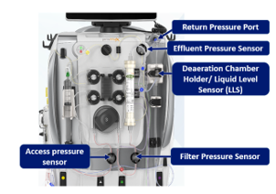
Pressure screen on PrisMax. Green is acceptable limits.

PrisMax and Prismaflex machines continually calculate and monitor:
- Access pressure
- Return pressure
- Effluent pressure
- Transmembrane pressure
- Filter pressure
- Pressure drop

A sudden increase or decrease in pressures are likely to be access-related issues which can usually be resolved by one or more of the following:
- Patient, line or vascath repositioning
- Checking clamps all undone
- Disconnecting, flushing/aspirating vascath and reconnecting (must be done rapidly using aseptic technique)
- Reversing vascath lumens (must be done using aseptic technique)
- Temporarily reducing BFR

Transmembrane Pressure (TMP) is the pressure gradient across the filter membrane – difference in pressure between blood and dialysis compartment. During treatment, permeability of the membrane decreases due to protein coating (clogging), causing TMP to increase.

“TMP too high”
This alarm is triggered when TMP >300 mmHg

“TMP Excessive alarm”
This alarm is triggered when TMP>450 mmHg.

When TMP gradually increases to consistently above 250mmHg even after trouble shooting, consider returning blood and ending treatment.

TMP is calculated by the following equation:
TMP = (Filter pressure +return pressure)/2 - effluent pressure – 18 (Hydrostatic pressure biases)

Filter Pressure is a measure of how hard the machine is pushing blood into the filter.

Filter Pressure Drop (ΔP) is the difference between return and filter pressures and depends on the number of patent capillaries in the filter and the patients’ blood viscosity. Microclotting occurs in the hollow fibres during treatment, eventually leading to gross clotting and the need to change to a new set. A slow and continuous rise of filter pressure drop is an indicator of filter clotting (hollow fibre occlusion).

9.2 Changing treatment settings

To change a flow rate on a PrisMax (including syringe infusion rate and patient fluid removal rate), tap the flow value that needs to be changed, then use the pop-up flow-rate adjustor to adjust rate. For Prismaflex, tap ADJUST on the Prescription screen/Anticoagulation screen to make changes.

9.3 Changing fluid bags and syringe

To change a bag or syringe on PrisMax, tap relevant graphic, then follow the on-screen instructions. For Prismaflex, tap the Change Bag or Change Syringe soft key, then follow the instructions.

9.4 Review fluid removal history
Tap the History soft key to check the past fluid removal history for PrismaFlex. PrisMax displays previous hours PFR on the main screen.

9.5 Monitor Blood Warmer Temperature
Always make sure the Blood Warmer is turned on. On PrismaFlex the blood warmer is a separate unit, so the machine cannot monitor blood warmer temperature. To avoid the patient becoming hypothermic, this should be checked regularly. The PrisMax automatically monitors warmer temperature and will alarm if out of range. Do not turn the blood warmer off as the PrisMax will malfunction. The patient’s temperature must be monitored hourly for the first 4 hours and every 2nd hourly while on CRRT, as therapy will mask a pyrexia.

9.6 Adjust deaeration chamber
On both machines, the fluid level in the deaeration chamber must be checked hourly. Automatic fluid levelling may be disabled on PrisMax, which is indicated by an override symbol on the main screen. If fluid level is too low or high, adjust accordingly using up/down arrows.

9.8 Collection of fluid/blood sample from set sample ports
Samples may be taken from the circuit if specifically requested by the ICU medical team. A 21-gauge needle or smaller must be used. Use of larger needles can cause holes in the sample sites, resulting in external leak, blood loss or air embolism.

Alert: DO NOT TAKE BLOOD SAMPLES FROM THE CIRCUIT UNLESS ORDERED BY ICU MEDCAL TEAM.
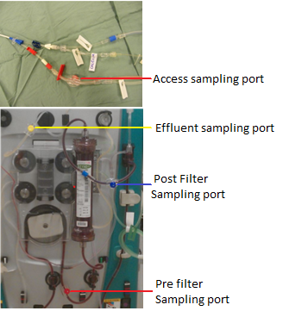
- Access Sampling port: Blood sample can be collected for Venous Blood Gases (VBGs) or formal blood samples. To ensure accurate blood samples, stop Pre Blood Pump(PBP), wait 15 seconds, then take blood sample. A 10mL syringe must be used to aspirate blood, NOT a blood gas syringe, as this part of the circuit is under negative pressure and air may be introduced inadvertently.

- Effluent sampling port: Effluent fluids to be taken from this port for blood cell analysis in case of blood leak detected alarm.

- Post Filter sampling port: Blood sample collected from this port used for post filter ionised calcium level to evaluate the effectiveness of citrate anticoagulation.

- Pre filter sampling port: Rarely used as the blood is diluted with Pre-blood pump solutions.

Back to Table of Contents

Section 10 – Common Alarms and Troubleshooting

The PrisMax/PrismaFlex machines are continually monitoring the state of the device and the therapy. If an unexpected problem is encountered, an alarm will sound. Alarms are organized by priority and the screen displays the highest priority alarm. For high-priority and some medium-priority alarms, the PrisMax/PrismaFlex enters a “safe state”, which may involve stopping the blood pump, fluid pump or syringe pump, or closing the return line clamp. Actions taken by the machine will depend on the cause of the problem.

When responding to any alarm, carefully follow the onscreen instructions. Alarms should be responded to quickly to minimise stasis time in the circuit. If alarm cannot be corrected, call for help and escalate immediately.

PrisMax has back-up battery, which can support full system operation for 30 mins upon temporary power disconnect. PrismaFlex has back-up battery, which enables 10+ minutes of uninterrupted therapy delivery upon temporary power disconnect.

For more information on specific alarms and troubleshooting, please refer to the operator manual for PrisMax and PrismaFlex machines.
CRRT common high/medium priority alarms and troubleshooting guide
Alarm | Causes/ Risks | Management
Air in blood | - Leaking or disconnected catheter  - Air entry from a bag, blood warmer, syringe line, access or PBP lines  - Set not fully primed | Inspect the entire set for leaks or disconnections.  Look for air/foam in the tubing below air detector.  Inspect level of fluid in the deaeration chamber and adjust if needed.  Tap the Remove Air button and follow the onscreen instructions for air removal (Refer to Attachment 4: Air Removal Procedures).  If air is present in the entire return line, change the set. Do not return blood.
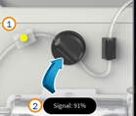  Blood leak detected | - The Blood Leak Detector (BLD) detects blood in the effluent line, which can indicate a ruptured filter membrane.  - Tubing is cloudy or debris in the tubing path  - Air in the effluent line | Check if the effluent fluid is pink/red tinged and identify the cause of colour change (differentiate haemolysis from filter membrane rupture).  If blood is in the effluent line, change the set.  Check for air bubbles in effluent line in BLD.  Tap the Alarm Off button to dislodge bubble.  Clean the tubing path and effluent line with a lint-free cloth and dry thoroughly if there is liquid or debris.
Access extremely negative  (Pressure < -250 mmHg)  Check Access (P113) | - Patient is moving, coughing, or being suctioned  - Catheter blocked, kinked, clotted or out of position in vein.  - Vascath is sucking against vessel wall.  - Access line clamped or kinked  - Hypovolemia  - Blood flow rate too high for catheter | Wait 15-20 secs for possible self-clearing.  Flush/aspirate or reposition patient.  Rotate catheter.  Correct kinked or clamped line.  Reduce blood flow rate.  Swap lumens if repeated alarm.
Access extremely positive  (Pressure > 300 mmHg) | - Kinked or clamped lines  - Blood flow rate is too low  - External device (if in use, e.g., ECMO) is delivering blood at too high a pressure | Correct kinked or clamped lines.  Consider increasing blood flow rate.  Check Vascath position.  Flush/aspirate or reposition or rotate access catheter using aseptic technique.
Return extremely positive  (Pressure > 350 mmHg) | - Patient is moving, coughing, or being suctioned  - Blocked or clotted catheter  - Clamped or kinked return line  - Blood flow rate too high  - Vascath was inserted into an artery | Correct kinked or clamped lines.  Reposition or rotate catheter (will require RMO).  Reposition patient.  Aspirate and flush catheter.  Confirm Vascath position.
Filter extremely positive /High Filter pressure | - High filter pressure detected  - Clamped or kinked lines  - Filter has clotted  - Too high blood flow | Correct kinked or clamped lines.  Consider decreasing blood flow rate.  Consider returning blood (if possible) and change filter (if clots present, do not return blood).
Transmembrane pressure (TMP) Excessive  (Pressure > 450 mmHg)  or  TMP too high (Prismaflex)  (Pressure >300 mmHg) | - High transmembrane pressure (TMP)  - High Replacement, PBP, or PFR flow rate  - Low Blood flow rate setting  - Kinked or clamped effluent line | Consider returning blood (if possible) and changing filter.  Consider decreasing Replacement, PBP, or PFR flow rates  Consider increasing BFR.  Correct kinked or clamped effluent line.

Aspirating/flushing and Swapping Vascath lumens
If the dialysis machine is showing any of the following alarms (and basic troubleshooting has been unsuccessful), consider aspirating and vigorously flushing the vascath lumens. Indications may include:
- Frequent access extremely negative alarm
- Frequent Return extremely positive alarm
- Sudden rapid increase of TMP pressure and/or Filter pressure triggering alarm
- Possible blood clot in vascath lumen
This must be done quickly and safely by a qualified registered nurse. The longer the machine is static, the higher the risk of clotting, meaning blood cannot be returned. The procedure must be performed using sterile, non-touch technique.

Back to Table of Contents

Section 11 – End of Treatment

Treatment may be terminated for one or more of the following reasons:
- Treatment order ceased by medical team.
- Patient is planned for procedures/scans.
- Filter running for >72 hours.
- TMP gradually increasing over time approaching >300mmHg.
- Filter pressure gradually increasing over time, triggering alarms which are unresponsive to troubleshooting.
- Troubleshooting not successful after machine alarms.

Alert: Before returning blood upon cessation of therapy, inspect the set for signs of clotting or air. If present, DO NOT return blood to the patient.

Autoeffluent sets can be reused for up to 6 days and do not need to be discarded at every filter change.
Before restarting therapy, consult ICU medical team regarding CRRT plan.

There are 4 options on the Stop Treatment screen on the PrisMax machine.
- End treatment
- Discard set
- Recirculate blood (Not recommended at CHS ICU)
- Recirculate saline (Please refer to Attachment 6)

There are 3 options on the Stop Treatment screen on Prismaflex machine.
- End treatment
- Change set
- Recirculate saline (Please refer to Attachment 6)

Equipment for returning blood, disconnecting circuit, and instilling anticoagulation lock in a Vascath
- 1000mL 0.9% sodium chloride
- Spike
- Dressing pack
- Sterile gloves
- Chlorhexidine swabs
- 4X 10mL syringes
- 2X 3mL syringe
- 2X drawing up needles
- 4X 10mL 0.9% sodium chloride
- Extra gauze packets
- 2X red lock bungs
- 3-4X 5000unit/mL heparin vials (4% Citrate if patient is HITS positive)
- Heparin lock labels (Citrate lock labels)
- Blue pad (bluey)

Preparation:
- Ensure you have all required equipment and a second nurse to assist with procedure.
- Perform hand hygiene.
- Hang 1000mL 0.9% sodium chloride bag on side of the dialysis machine.
- Clean dressing trolley.
- Set up sterile dressing pack with above equipment.
- Apply PPE (gown, face shield).
- Perform hand hygiene and apply sterile gloves.
- Draw up 2 X 10mLs of 0.9% sodium chloride using drawing up needle.
- Draw up correct amount of heparin (or Citrate) for both vascath lumens (volume labelled on the vascath) with drawing up needle.
- Apply sterile drape under vascath lumens.

Non-sterile Nurse
- Perform hand hygiene and apply standard precaution PPE.
- Clamp access and return lines on circuit and vascath.
- Press Stop Treatment on dialysis machine screen and follow prompts.
- Assist with connection of access line to 1L 0.9% sodium chloride bag.
- Press Return Blood.
- Press Auto Return to return correct amount of blood. Alternatively, press and hold Manual Return to return desired volume.
- Assess circuit for signs of clots on return. Immediately cease blood return if clots detected.

Sterile Nurse
- Using gauze to pick up line and lumen, disconnect access line from vascath and hand to non-sterile nurse to attach to spiked bag of 0.9% sodium chloride.

TIP: Consider one hand as ‘clean’ and other as ‘dirty’. Dirty hand will hold vascath, clean hand will clean lumens and connect syringes etc.

- Clean access line/lumen connection side and vascath with chlorhexidine swab for 20 seconds.
- Connect empty 10mL syringe to the access lumen and unclamp lumen
- Withdraw 5mLs of blood, clamp the lumen, disconnect syringe, and discard blood onto gauze pads to assess for clots.
- If any clots are present, repeat this process.
- Attach 10mL syringe filled with 0.9% sodium chloride to the access lumen, unclamp and flush the lumen.
- Clamp lumen and disconnect 10mL syringe.
- Attach 3mL syringe filled with correct amount of heparin or citrate to access lumen, unclamp lumen and administer heparin.
- Clamp access lumen and disconnect heparin syringe.
- Attach sterile red bung to end of access lumen.
- Once blood has been returned, repeat this process for the return lumen on vascath.
- Label each lumen as heparin/citrate locked.

Unload circuit according to PrisMax/Prismaflex screen instruction
Patient must be disconnected from circuit before unloading circuit.
- Clamp all lines on the circuit/filter.
- Press unload button.
- Disconnect pressure pods and deaeration chamber.
- Empty fluid bags in pan room.
- Remove blood warmer from its holder.
- Remove circuit and discard.
- Document time of cessation of therapy in MetaVision.

Back to Table of Contents

Section 12 – Nursing Care

Nursing care before patient is connected to CRRT
- If possible, informed consent must be obtained and education provided.
- Patient should be positioned in comfortable position with easy and safe access to vascath lumens.
- Vascath to be confirmed in the right position, properly labelled with anticoagulation labels dated.
- Baseline pathology results including Full Blood Count (FBC), Urea Electrolytes and Creatinine (UEC), coagulation files and Liver function tests (LFT) (for regional Citrate coagulation) should be obtained immediately prior to treatment.
- Check CRRT orders and ensure correct solution bags (with correct order of KCl) prepared and correct medication in syringe.
- Weigh patient daily.
Nursing care during CRRT
- When commencing CRRT, haemodynamic status should be closely monitored, especially blood pressure. Start blood flow rate at 100-120mL/min (no less than 100mL/min) and patient fluid removal rate of 0, gradually increase BFR and PFR over 10 – 15 minutes as tolerated by patient.
- Closely monitor patient fluid balance, document input and output hourly.
- Closely monitor electrolytes, (especially serum potassium level), and replace as per protocol/medical order.
- Closely monitor patient’s temperature to prevent CRRT-induced hypothermia, Temperature must be checked hourly for the first 4 hours, then 2nd hourly while on CRRT.
- Blood sugar levels should be checked 4-6 hourly or more often if indicated.
- Follow RCA calcium replacement policy, closely monitor ionised calcium, total calcium, and other related pathology results and adjust calcium compensation rate accordingly. Monitor for citrate toxicity.
- For systematic heparin anticoagulation, check aPTT and adjust heparin infusion as per protocol. Monitor Hb and watch for signs of bleeding.
- Manage the PrisMax/Prismaflex machine as per on-screen instruction, change bags and attend to alarms promptly. Monitoring and interventions through CRRT machine include the following:
- Pressure monitoring
- Changing treatment settings
- Changing fluid bags and syringe
- Changing fluid bags
- Reviewing fluid removal history
- Monitoring Blood Warmer Temperature
- Checking deaeration chamber hourly and documenting
- Normalising blood leak detector
- Collecting fluid/blood sample from set sample ports as ordered by ICU medical team
- Dietitian support is strongly recommended, as malnutrition is common in renal failure.
- Haemofilters may reduce the concentration of therapeutic drugs, so the dose may need to be adjusted and concentration of drug closely monitored.

Checklist for patient on CRRT
Check items |  | Comments
CRRT order is valid (New order daily)
CRRT flow settings match CRRT order
Blood warmer is on
Heparin | Rate of heparin
Heparin | aPTT result
Heparin | Next due aPTT check
Citrate | Dose of Citrate
Citrate | Calcium compensation rate
Citrate | Ionised Calcium level
Citrate | Next due ionised Calcium check
Citrate | Calcium line connected to Blue striped line
Correct fluid bag on PBP, Dialysis and Replacement scale
Correct potassium chloride volume in bags and in date
Filter lifetime and signs of clots
Emergency return pack at the bedside

Vascath care
- Position of vascath is to be confirmed by pressure transducer, chest x-ray and medical team before use.
- If vascath is not in use, it is to be locked with an anticoagulant (Heparin or Citrate), labelled, and dated.
- Inspect vascath position, ensure length of vascath is clearly documented and unchanged.
- Verify vascath is secured to the skin. Assess for signs of infection and change the dressing according to hospital CVAD guideline.
- During CRRT therapy, vascath should be visible at all times.
- Coagulation profile should be checked. Ensure INR<2.0 and platelets count >50 before Vascath removal.
- Vascath removed as per CVAD guideline. Digital pressure should be applied to the insertion site for 10-15 minutes or longer until bleeding stops. Vascath tip sent for culture if ordered. Patient should rest in bed for at least one hour and the site should be closely monitored.

Back to Table of Contents

Evaluation

Outcome Measures
- The outcome measures for CRRT therapy to be considered in terms of improved performance in the domains of safe practice and prevention/reduction of potential complications.
- This includes:
- >95% Compliance against Clinical Procedural guidelines.
- Reduced complications related to CRRT therapy.

Method
- Clinical Audits of compliance against Clinical procedural guidelines as conducted by Clinical Support/Development Nurses and reported on at Staff Unit Meetings.
- Any mechanical patient incidence or complication related to CRRT as reported via incident management system.

Back to Table of Contents

Related Policies, Procedures, Guidelines and Legislation

Policies
- Informed Consent - Clinical
- Nursing and Midwifery Continuing Competence
- Clinical Supervision

Procedures
- Central Venous Access Device (CVAD) Management – Children, Adolescents and Adults (NOT Neonates)
- Infection Prevention and Control - Healthcare Associated Infections
- Aseptic Technique
- Incident Management
- Accessing, De-accessing and Changing VASCATHS/GamCaths and ‘Combi’ stopper change for Apheresis (not for haemodialysis) – Adults Only

Legislation
- Health Practitioner Regulation National Law (ACT) Act 2010
- Health Records (Privacy and Access) Act 1997
- Human Rights Act 2004
- Medical Treatment (Health Directions) Act 2006
- Work Health and Safety Act 2011
Other
- Australian Charter Health Care Rights

Back to Table of Contents

References

Instructions from the website www.portal.baxter.semcon.com

ICU nursing education booklet Orange module.

Central catheters for acute and chronic hemodialysis access and their management. Uptodate 2020.

Prismaflex operator’s manual.

PrisMax operator’s Manual Program Version: 2.XX AW8005 Rev NOV 2018.

Citrate anticoagulation using the PrismaflexR ystem. Renal Intensive Care Self-learning module. GAMBRO.
Baldwin I and Dirkes S. (2019) Chapter 18, Suport of renal function, in Aitken L, Marshall A, Chaboyer W. Critical Care Nursing (4th ed.). Elsevier.

Astle S. (2017). Proceduer 119, Continuous Renal Replacement Therapies, in Wiegand, D. L. ACCCN Procedure Manual for High Acuity, Progeressive and Critical Care (7th ed.). St. Louis, MO: Elsevier.

Harms, J., Wille, K., & Tolwani, A. (2016). Complications of Continuous Renal Replacement Therapy (CRRT). In Core Concepts in Dialysis and Continuous Therapies (pp. 211–219). Springer US. https://doi.org/10.1007/978-1-4899-7657-4_17.

Zarbock A, Küllmar M, Kindgen-Milles D, et al. Effect of Regional Citrate Anticoagulation vs Systemic Heparin Anticoagulation During Continuous Kidney Replacement Therapy on Dialysis Filter Life Span and Mortality Among Critically Ill Patients With Acute Kidney Injury: A Randomized Clinical Trial. JAMA. 2020;324(16):1629–1639. doi:10.1001/jama.2020.18618.

Meersch M, Küllmar M, Wempe C SepNet Critical Care Trials Group, et alRegional citrate versus systemic heparin anticoagulation for continuous renal replacement therapy in critically ill patients with acute kidney injury (RICH) trial: study protocol for a multicentre, randomised controlled trialBMJ Open 2019;9:e024411. doi: 10.1136/bmjopen-2018-024411.

Brandenburger, T., Dimski, T., Slowinski, T., & Kindgen-Milles, D. (2017). Renal replacement therapy and anticoagulation. Best practice & research. Clinical anaesthesiology, 31(3), 387–401. https://doi.org/10.1016/j.bpa.2017.08.005.

Kidney Disease: Improving Global Outcomes (KDIGO) Acute Kidney Injury Work Group. KDIGO Clinical Practice Guideline for Acute Kidney Injury. Kidney International Supplements. 2012; 2: 1-138.

Lok CE, Huber TS, Lee T, et al. KDOQI Clinical Practice Guideline for Vascular Access: 2019 Update [published correction appears in American Journal of Kidney Diseases. 2021 Apr;77(4):551]. American Journal of Kidney Diseases. 2020;75(4 Suppl 2):S1-S164.

C.E. Lok, T.S. Huber, T. Lee, et al. KDOQI clinical practice guideline for vascular access 2019 update. Am J Kidney Dis, 75 (suppl 2) (2020), pp. S1-S164.

Effect of Regional Citrate Anticoagulation vs Systemic Heparin Anticoagulation During Continuous Kidney Replacement Therapy on Dialysis Filter Life Span and Mortality Among Critically Ill Patients With Acute Kidney Injury: A Randomized Clinical Trial. JAMA. 2020 Oct 27;324(16):1629-1639.

Golper, T. A. (2021). Continuous renal replacement therapy in acute kidney injury. UpToDate. Retrieved April 20. 2021.

Davenport, A. (2021). Anticoagulation for continuous kidney replacement therapy. UpToDate. Retrieved April 20. 2021.

Bander, S. J., & You, T. H. (2021). Central catheters for acute and chronic hemodialysis access and their management. UpToDate. Retrieved April 20. 2021.

Back to Table of Contents

Abbreviations

AE – Autoeffluent
aPTT – activated partial thromboplastin time
AVF – Arteriovenous fistula
AVG – Arteriovenous graft
BLD – Blood leak detector
CK – Creatinine kinase
CRRT – Continuous renal replacement therapy
CVAD – Central venous access device
CVVH – Continuous venovenous haemofiltration
CVVHD – Continual venovenous haemodialysis
CVVHDF – Continual venovenous haemodiafiltration
ECMO – Extra corporeal membrane oxygenation
EUC – Electrolytes, urea and creatinine
HAGMA – High anion gap metabolic acidosis
Hct - Haematocrit
FBC – Full blood count
HIT – Heparin-induced thrombocytopenia
ICU – Intensive care unit
INR – International normalised ratio
KCl – Potassium chloride
LFT – Liver function test
PBP – Pre-blood pump
PFR – Patient fluid removal
PPE – Personal protective equipment
RCA – Regional citrate anticoagulation
SCUF – Slow continuous ultrafiltration
TMP – Transmembrane pressure
TPE – Therapeutic plasma exchange
VBG – Venous blood gas
ΔP – Filter pressure drop

Back to Table of Contents

Search Terms

CRRT, RCA, CVVHDF, dialysis, renal, haemodialysis

Back to Table of Contents

Attachments

Attachment 1: Setup steps
Attachment 2: Emergency lumen swap instructions
Attachment 3: CRRT prescription and order forms on MetaVision
Attachment 4: Manual air removal
Attachment 5: Saline Recirculation
Attachment 6: PrisMax machine parts
Attachment 7: Electrolytes replacement through CRRT solution bags guideline

Disclaimer: This document has been developed by Canberra Health Services specifically for its own use. Use of this document and any reliance on the information contained therein by any third party is at his or her own risk and Canberra Health Services assumes no responsibility whatsoever.

Policy Team ONLY to complete the following:
Date Amended | Section Amended | Divisional Approval | Final Approval
30 November 2021 | New Document | Lisa Gilmore, ED-Surgery | CHS Policy Committee

This document supersedes the following:
Document Number | Document Name

Attachment 1: CRRT Setup Steps

Name of steps | Instructions for each step
1. Patient | - Select New Patient.  - Enter patient ID, weight, and Haematocrit (Hct).
2. Therapy | - Select CRRT, then select CVVHDF mode.  - Select set – ST 100 (select as appropriate)  - Select anticoagulation method as per order. If no anticoagulation is required at the beginning of treatment, it is advisable to select syringe anticoagulation and connect a syringe filled with 0.9% sodium chloride. This ensures the syringe line is primed during the automatic priming cycle and anticoagulation with heparin can be added to the circuit at any time during treatment by changing the syringe.  - Select accessories: Auto Effluent or None (normal effluent bag)  - PrisMax: Select accessories - Blood warmer: TherMax.
3. Prescription | - Select and enter Blood Flow Rate first.  - Enter PBP rate (enter Citrate dose if on RCA), dialysate rate, replacement fluid rate (select Post Replacement), Fluid Removal Rate, Syringe rate.  - Enter Set Temperature
4. Sets | - Scan ST100 barcode and load set.  - PrisMax: scan Auto-Effluent (AE) barcode if using and install set. Install TherMax disposable bag and connect to set.  - PrismaFlex: Install SP420 Extension line onto Prismatherm II Blood warmer and connect to set. Pushing the line into the grooves from the front to back of the warmer.
5. Fluids | - Prepare and connect priming bags.  - Prepare and connect solution bags.  Add correct amount of potassium chloride (maximum 20mmol) to Prismocitrate bag and Hemosol bag as per prescription.  For Citrate Anticoagulation:  - Hang Prismocitrate 18/0 on the white scale (PBP)  - Hang Prisma0cal on the green scale (Dialysate)  - Hang Hemosol B0 on the purple scale (Replacement)  - Prepare and connect syringe.  For Citrate Anticoagulation:  Machine will automatically prime calcium line.  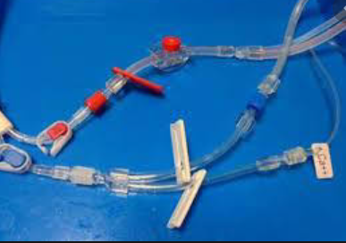
6. Priming | - PrismaFlex: Press Prime & Test  - PrisMax: Press Prime softkey to start priming.  - Monitor the process of priming.  Leave PrisMax on “Prime completed” or “Prime Test Passed” screen until ready to start treatment. Do not press Accept Softkey unless treatment is to start immediately.  Alert: The set cannot be primed any further once the user moves forward from the “Prime completed” screen.  If CRRT therapy cannot be initiated within 60 minutes after priming is complete, the ST100 set must be reprimed with 1000mL 0.9% sodium chloride. This requires a new bag of priming solution.
7. Review | - Ensure treatment settings and flow rates are entered as per prescription.  - Check order and set with second accredited registered nurse.
8. Connect to patient | - Connect dialysis machine to the patient.

Attachment 2: Emergency lumen swap instructions

Emergency disconnection equipment should be ready at the bedside. In the event of unsuccessful troubleshooting, the access and return lines may need to be swapped.

Equipment
- PPE (gloves, mask/face shield)
- 4 X 10mL syringes
- 2 X 10mL vial 0.9% sodium chloride
- Gauze packets

            - Press Stop Treatment on dialysis screen.
            - Clamp both access and return lumens on Vascath.
            - Using aseptic, non-touch technique, disconnect access line from vascath. Attach 10mL syringe, unclamp lumen and aspirate 10mLs rapidly. Reclamp and disconnect syringe.
            - Eject syringe contents onto gauze and inspect for clots. If visible, repeat step 3.
            - If not clots seen, attach 10mL syringe with 0.9% sodium chloride to access line, unclamp and rapidly inject into vascath. Reclamp lumen and disconnect syringe.
            - Repeat steps 3-4 on return lumen.
            - If clots have been removed, it may be possible to reconnect correct line to lumen (access to red, return to blue). If not, swap lumens by connecting access lumen to blue line and return lumen to access line.
            - Unclamp all lines.
            - Restart dialysis by pressing Resume.
            - If circuit will not restart, proceed to disconnection. Blood return may not be possible if the circuit has been idle for too long.

This procedure must be performed rapidly to prevent filter clotting.

Attachment 3: CRRT Prescription and order forms

Prescription for CRRT using Citrate

Citrate CRRT Orders | Anticoagulation
Citrate Mode: CVVHDF | Anticoagulation: Citrate  Citrate dose: mmol/L  Default 3mmol/L  Range 2.5-3.5mmol/L  Calcium compensation: %  Default: 100%  Range: 60-150%  50ml 10% calcium chloride (100mg/ml)  50ml luer lock syringe  Details of Anticoagulation:
Blood Flow Rate: ml/min
(Default: 150 ml/min, Range: 120-200ml/min)
Replacement rate: ml/hr
(Default: 200ml/hr)
Dialysate rate: ml/hr
(Default 1000ml/hr Range 1000-1500ml/hr)
PBP rate: ml/hr
Leave blank – machine calculates automatically in citrate mode
Target fluid removal: ml/hr
Target effluent rate: ml/kg/hr
(Default 25-30ml/kg/hr)
Targe effluent rate calculation:
(Replacement + PBP + dialysate + fluid removal)/weight
Solutions
Pre-blood Pump solution: Prismocitrate 18/0 KCl: mmol
(maximum 20 mmol KCl per bag)
Dialysate solution: Prism0cal B22 (Prism0cal B22 bags contain 20 mmol KCl)
Post-dilution Replacement: Hemosol KCl: mmol (maximum 20 mmol KCl per bag)

Prescription for CRRT using Heparin Other or no anticoagulation

CRRT Orders | Anticoagulation
Therapy Mode: SCUF/CVVH/CVVHD/CVVHDF/TPE | Anticoagulation:  Heparin  Other  None
Blood Flow Rate: ml/min  (Default: 200 ml/min. Range: 150-280ml/min) | Anticoagulation:  Heparin  Other  None
Replacement rate: ml/hr  (Default: 200ml/hr) | Anticoagulation:  Heparin  Other  None
Dialysate rate: ml/hr  (Default 1000ml/hr Range 1000-1500ml/hr) | Anticoagulation:  Heparin  Other  None
PBP Rate: ml/hr  (Default 800ml/hr Range 500-1500ml/hr) | Anticoagulation:  Heparin  Other  None
Target fluid removal: ml/hr | Anticoagulation:  Heparin  Other  None
Target effluent rate: ml/kg/hr  (Default 25-30ml/kg/hr)  Targe effluent rate calculation:  (Replacement + PBP + dialysate + fluid removal)/weight | Anticoagulation:  Heparin  Other  None
Solutions
Pre-blood Pump Solution: Hemosol KCl: mmol (maximum 20mmol KCl per bag)
Dialysate solution: Hemosol KCl: mmol (maximum 20mmol KCl per bag)
Post-dilution replacement: Hemosol KCl: mmol (maximum 20mmol KCl per bag)

Citrate order form on MetaVision
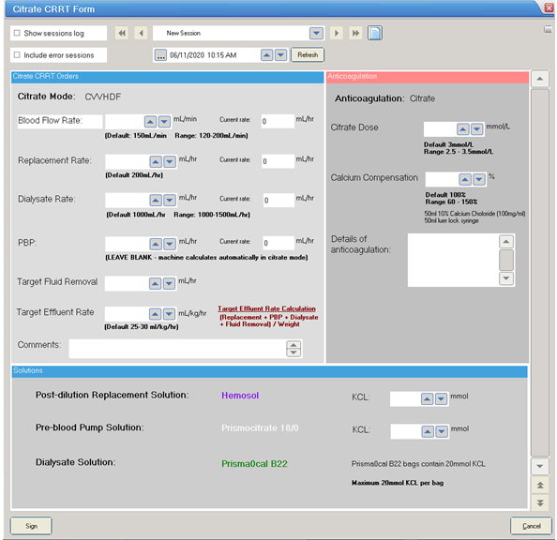

Heparin/no anticoagulation/other
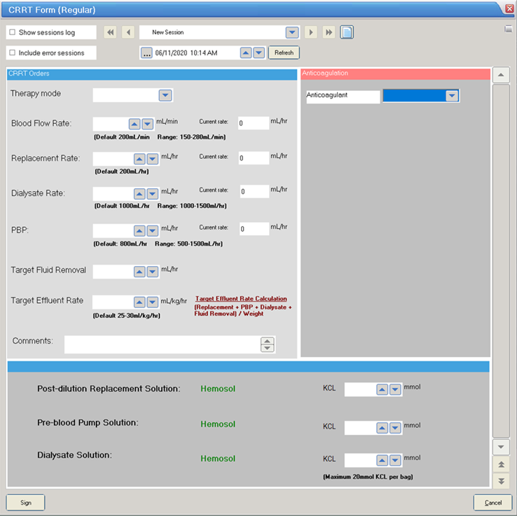

A new order form is to be completed every 24 hours. Expired orders are invalid.
Select “new session” to complete a new order form – do not change an existing order.

Attachment 4: Manual air removal

- Clean the blue sample site on the return line.
- Insert a 20-gauge needle with syringe into the blue return line.
- Aspirate air/blood until the return pressure reaches a negative value (0 to -100 mmHg).
- Remove the needle.
- Tap the Open Clamp button to remove air and draw blood from patient into the return line/deaeration chamber.
- Verify that the alarm stops and the return line clamp opens. Air in the return line is drawn into the chamber monitor line and automatically eliminated from the set through the return pressure port. Blood is drawn from the patient into the return line and deaeration chamber.

Attachment 5: Saline Recirculation

Alert:
If blood clots are noted in the filter, recirculation and blood return is not possible. The set must be discarded.

Saline recirculation may be considered if;
- The filter is less than 24 hours old.
- The filter is free of clots.
- CRRT will resume within 2 hours (maximum saline recirculation time).
If CRRT cannot be resumed within the timeframe, the set must be discarded.
Saline recirculation steps on PrisMax:
Extra equipment from end of treatment: Y line for recirculation, new effluent bag, extra 1000mL 0.9% sodium chloride for priming before reconnecting to patient.
- Press Stop, select option Recirculate Saline.
- Hang 0.9% sodium chloride 1000mL on priming hook, connect and prime Y-line, then clamp both extensions. Press Next.
- Prepare blood return: Clamp red access line on catheter and set, disconnect red access line from patient and connect to 0.9% sodium chloride via Y-line. Unclamp red access line and its connected Y-line, press Confirm All, then Next.
- Return Blood: Enter the blood volume (maximum volume of set and accessory), enter the return rate (maximum 100 mL/hr), press Return Blood to start automatic return. If necessary, press and hold Manual Return to manual return blood (maximum 50% of set volume). Press Disconnect when blood return is completed.
- Disconnect patient: Clamp return line on catheter and set; disconnect blue return line from patient catheter and connect to 0.9% sodium chloride via free Y-line; unclamp all lines, press Confirm All, then press Start Recirc.
- Saline recirculation: Press Blood Flow Rate to increase BFR up to maximum 100mL/min.
- End Recirculation: Press Stop, then press Reconnect Patient, then Resume.
- Prime set: Hang new 1000mL 0.9% sodium chloride bag on priming hook and hang a new empty effluent bag. Clamp access and return lines, disconnect access line from Y-line and connect to new priming solution bag, disconnect return line from Y-line and connect to effluent bag, unclamp access and return lines; Press Prime.
- Prime completed: Inspect entire set for air. Select Manual Prime if needed. Press Accept.
- Connect to patient: Clamp both Y-lines on priming bag, clamp and disconnect red access line from Priming bag, clamp line on collection bag, clamp and disconnect blue return line from collection bag, Press Next, connect blue return line to vascath, connect Red access line to Vascath, unclamp lines, press Confirm All, Press Start Treatment to resume treatment.

Attachment 6: PrisMax machine parts

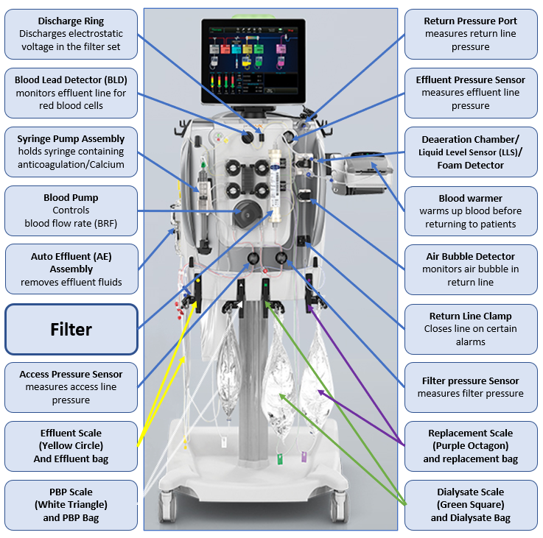

Attachment 7: Electrolytes replacement through CRRT solution bags guideline

Composition of solutions
 | Pre-Blood Pump | Dialysis | Replacement
 | Prismocitrate 18/0 | Prism0cal B22 | Hemosol B0
Citrate (mmol/l) | 18 | - | -
Sodium (mmol/l) | 140 | 140 | 140
Potassium (mmol/l) | - | 4 | -
Chloride (mmol/l) | 86 | 120.5 | 109.5
Bicarbonate (mmol/l) | - | 22 | 32
Lactate (mmol/l) | - | 3 | 3.3
Calcium (mmol/l) | - | - | 1.75
Magnesium (mmol/l) | - | 0.75 | 0.5
Glucose (mmol/l) | - | 6.1 | -

Potassium replacement guidelines for CRRT dialysate
Serum Potassium | KCL added into Hemosol | KCL added into Prismocitrate
>5.5mmol/L | Nil = 0mmol/L | Nil = 0mmol/L
5 – 5.5mmol/L | 10mmol = 2mmol/L | 10mmol = 2mmol/L
4.5 – 4.9mmol/L | 15mmol = 3mmol/L | 15mmol = 3mmol/L
- – 4.4mmol/L | 20mmol = 4mmol/L | 20mmol = 4mmol/L
< 3.5mmol/L | 20mmol = 4mmol/L | 20mmol = 4mmol/L
< 3.5mmol/L | Extra potassium to be replaced through central venous access, at the discretion of medical team.

Note:
Magnesium and phosphate must not be added to CRRT solution bags.

